

Data Technician

Name:
Course Date:
Table of contents
Day 1: Task 1 3
Day 1: Task 2 3
Day 3: Task 1 4
Day 4: Task 1: Written 6
Day 4: Task 2: SQL Practical 9
Course Notes 19
Additional Information 19

Day 1: Task 1

Please research and complete the below questions relating to key concepts of databases.

What is a primary key? | A primary key is the unique ID for each row in a database table.  Examples:  CustomerID in a customers table.  ISBN in a books table.  ProductCode in a products table.  It ensures each entry is distinct.
How does this differ from a secondary key? | Primary Key: The unique ID for each person in a Customers table (like a CustomerID). No two customers have the same CustomerID.  Secondary Key: The LastName column in the Customers table. Many customers can have the same last name, but it helps you quickly find all the "Smiths".
How are primary and foreign keys related? | The foreign key column in one table refers back to the primary key column in another table.  The values in the foreign key column should usually match values in the primary key column it refers to (to keep the link valid).  CustomerID in the Orders table links each order back to the correct customer in the Customers table.
Provide a real-world example of a one-to-one relationship | A person and their passport.  One person typically has one current, valid passport.  One passport typically belongs to one person.  While a person might have had previous passports, at any given current time, the relationship between a person and their active passport is generally one-to-one.
Provide a real-world example of a one-to-many relationship | Mother and her children.  One mother can have many children.  Each child has one mother.  company and its employees.  One company can have many employees.  Each employee works for one company (in a typical primary employment scenario).
Provide a real-world example of a many-to-many relationship | Students and courses.  Many students can enroll in many different courses.  One course can have many students enrolled in it.

Day 1: Task 2

Please research and complete the below questions relating to key concepts of databases.

What is the difference between a relational and non-relational database? | Relational Database: A meticulously organized physical filing cabinet with labeled folders (tables) and cross-referencing slips (keys) to link related documents. You need to decide the structure of your folders beforehand.  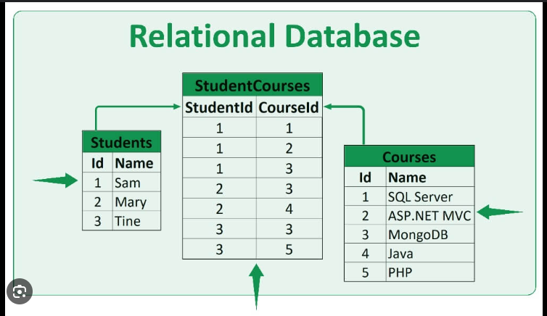  Non-Relational Database: A more flexible digital storage system. You might have individual documents (Document DB), a giant key-value list (Key-Value Store), or a network of interconnected notes (Graph DB). You have more freedom in how you store things.  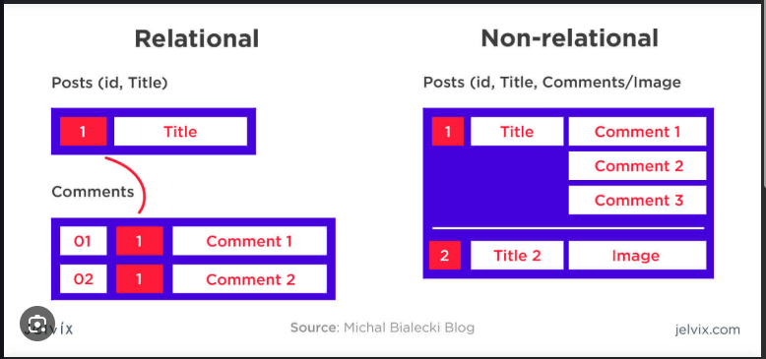
What type of data would benefit off the non-relational model?  Why? | Non-relational databases are best for flexible, changing, and large amounts of data that doesn't fit neatly into tables.  Examples:  Product details that vary a lot (document data).  Website session info needing fast access (key-value data).  Social network connections (graph data).  Sensor readings over time (time-series data).  Because non-relational databases are designed with flexibility and scalability as core strengths:  Flexibility: They don't force your data into rigid tables, making it easier to handle data that has different structures or changes frequently.  Scalability: Many are built to easily spread data across multiple computers, allowing them to handle massive amounts of information and high traffic that can overwhelm traditional relational databases.

Day 3: Task 1

Please research the below ‘JOIN’ types, explain what they are and provide an example of the types of data it would be used on.

Self-join | Self-join: Joining a table to itself to compare rows within that same table.  Why? When information about relationships exists within the table itself (like an employee having a "ManagerID" that's also an "EmployeeID").  Example:  Imagine a list of employees where each employee might have a boss who's also on the same list. A self-join lets you show each employee next to their boss's name by matching the "Boss's ID" of one employee with the "Employee's ID" of another.
Right join | Right Join: "Give me everything from the right table, and matching info from the left if it's there. If not, the left side is empty."  Example:  Imagine two lists: Students (left) and Math Club Members (right).  A Right Join shows you all Math Club Members. If a Math Club member is also on the Students list, their other student info is shown too. If a Math Club member isn't on the Students list, their student info will be blank.
Full join | Full Join: "Give me everything from both tables. If there's a match, combine the info. If not, show the info from one table and leave the other side empty."  Think of it as: Combining two lists completely. If something is on both lists, you see the combined details. If it's only on one list, you still see it, but the information from the other list will be blank.  Imagine two lists: Customers and People Who Placed Orders.  A Full Join would show:  All Customers, with their order info if they placed one. If they didn't order, the order info will be empty.  All People Who Placed Orders, with their customer info if they are in the customer list. If they aren't in the customer list, their customer info will be empty.  You get a complete view of everyone in either list and how they might relate.
Inner join | Inner Join: "Give me only the rows where there's a match in both tables."  Think of it as: Showing only the overlap between two lists. If something is in one list but not the other, you don't see it.  Simple Example:  Imagine two lists: Customers and People Who Placed Orders.  An Inner Join would show you only the people who are on both lists (i.e., they are customers and they placed an order). You wouldn't see customers who haven't ordered, or people who placed an order but aren't in the customer list.
Cross join | Cross Join: "Combine every single row from the first table with every single row from the second table."  Think of it as: Making every possible pair of items from two different lists.  Simple Example:  Imagine two lists:  Colors: Red, Blue  Sizes: Small, Large  A Cross Join would create these combinations:  Red, Small  Red, Large  Blue, Small  Blue, Large  It makes all possible pairings, without needing any matching information.
Left join | Left Join: "Give me everything from the left table, and matching info from the right table if it's there. If not, the right side is empty."  Think of it as: Showing all the items on your main list (the left table), and adding any extra details from a second list (the right table) if they match. If there's no match in the second list, you still see the item from your main list, but the extra detail will be blank.  Simple Example:  Imagine two lists: All Students (left) and Students in the Math Club (right).  A Left Join would show you all students. If a student is in the Math Club, their Math Club info would be shown. If a student is not in the Math Club, their Math Club info would just be empty.

Day 4: Task 1: Written

In your groups, discuss and complete the below activity. You can either nominate one writer or split the elements between you. Everyone however must have the completed work below:

Imagine you have been hired by a small retail business that wants to streamline its operations by creating a new database system. This database will be used to manage inventory, sales, and customer information. The business is a small corner shop that sells a range of groceries and domestic products. It might help to picture your local convenience store and think of what they sell. They also have a loyalty program, which you will need to consider when deciding what tables to create.

Write a 500-word essay explaining the steps you would take to set up and create this database. Your essay should cover the following points:
- Understanding the Business Requirements:
  - What kind of data will the database need to store?
  - Who will be the users of the database, and what will they need to accomplish?
- Designing the Database Schema:
  - How would you structure the database tables to efficiently store inventory, sales, and customer information?
  - What relationships between tables are necessary (e.g., how sales relate to inventory and customers)?
- Implementing the Database:
  - What SQL commands would you use to create the database and its tables?
  - Provide examples of SQL statements for creating tables and defining relationships between them.
- Populating the Database:
  - How would you input initial data into the database? Give examples of SQL INSERT statements.
- Maintaining the Database:
  - What measures would you take to ensure the database remains accurate and up to date?
  - How would you handle backups and data security?

Your essay should include specific examples of SQL commands and explain why each step is necessary for creating a functional and efficient database for the retail business.

Please write your 500-word essay here | Setting up a database for a small retail business like a corner shop is a great way to keep things organised and efficient. The main goal is to create a system that tracks products, sales, and customers, including their loyalty program details. This helps the business better understand stock levels, customer habits, and overall performance.  1. Understanding the Business Requirements:  The first step is to understand what kind of data the shop needs to manage. This includes product details (name, price, stock level), sales records (what was sold, when, and to whom), and customer information (name, contact details, loyalty points). Users of the database will mainly be shop staff and managers. Staff will use it to process sales and check stock, while managers might use it to view reports and make decisions.  2. Designing the Database Schema:  To keep the data organised, I would create the following tables:  - Products: stores information like product ID, name, category, price, and stock.  - Customers: includes customer ID, name, email, phone number, and loyalty points.  - Sales: tracks each sale, including sale ID, date, customer ID, and total amount.  - Sale_Items: connects each product sold in a sale, storing sale ID, product ID, and quantity.  These tables are related: each sale is linked to a customer, and each sale can have multiple items. This is a one-to-many relationship between customers and sales, and between sales and sale items.  3. Implementing the Database:  Since the SQL file containing the database and table structures has already been provided, the focus would shift to reviewing and understanding the setup to ensure it aligns with the needs of the small retail business. Key tables such as Products, Customers, Sales, and Sale_Items would already exist, along with any primary and foreign key relationships. If any fields were missing, such as a column for tracking loyalty points in the customer table, adjustments would be made using a simple SQL command like:  ALTER TABLE Customers ADD COLUMN loyalty_points INT;  This ensures the database structure fully supports all business functions.  4. Populating the Database:  After confirming that the tables are correctly structured, the next step would be to insert sample or real data into the tables to reflect the store’s actual inventory and customer base, but data is already included.  5. Maintaining the Database:  To keep the system accurate, I’d make sure stock levels are updated after each sale using:  UPDATE Products SET stock = stock - 2 WHERE product_id = 1;  I’d also regularly check for errors like duplicate customer entries and ensure the loyalty points are updated. For data security and backup, I’d set up regular automatic backups and restrict access to only trusted staff. This way, the database remains safe and useful for daily business operations.

Day 4: Task 2: SQL Practical

In your groups, work together to answer the below questions. It may be of benefit if one of you shares your screen with the group and as a team answer / take screen shots from there.

Setting up the database:

- Download world_db(1)
- Follow each step to create your database

For each question I would like to see both the syntax used and the output.

- Count Cities in USA: Scenario: You've been tasked with conducting a demographic analysis of cities in the United States. Your first step is to determine the total number of cities within the country to provide a baseline for further analysis.

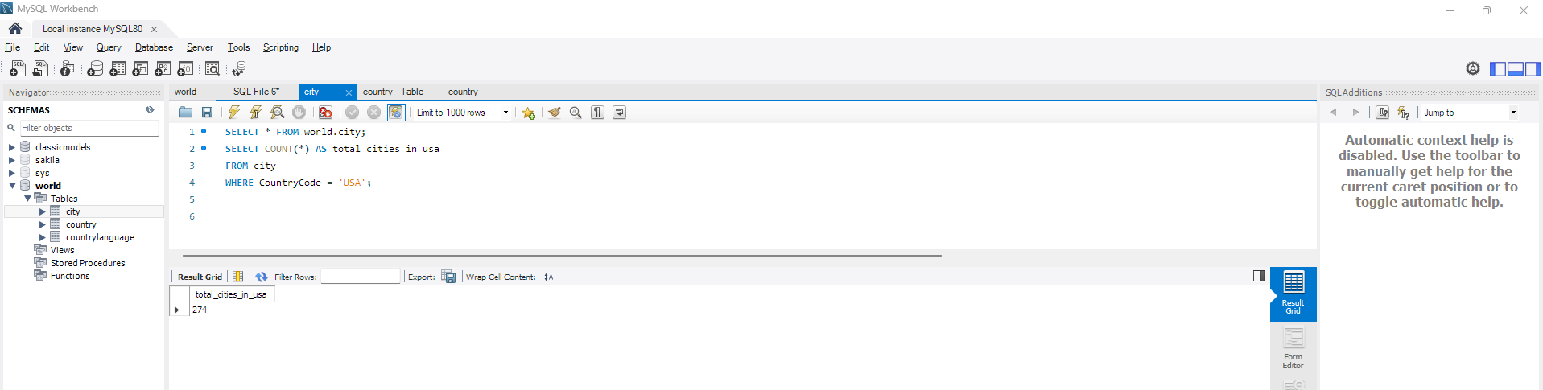

SELECT COUNT(*) AS total_cities_in_usa
FROM city
WHERE CountryCode = 'USA';

- Country with Highest Life Expectancy: Scenario: As part of a global health initiative, you've been assigned to identify the country with the highest life expectancy. This information will be crucial for prioritising healthcare resources and interventions.

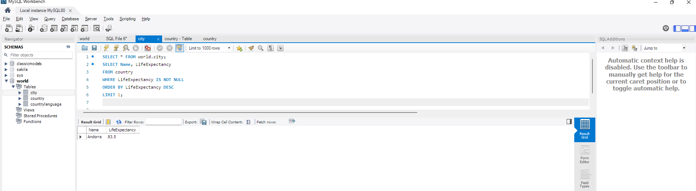
SELECT Name, LifeExpectancy
FROM country
WHERE LifeExpectancy IS NOT NULL
ORDER BY LifeExpectancy DESC
LIMIT 1;

- "New Year Promotion: Featuring Cities with 'New : Scenario: In anticipation of the upcoming New Year, your travel agency is gearing up for a special promotion featuring cities with names including the word 'New'. You're tasked with swiftly compiling a list of all cities from around the world. This curated selection will be essential in creating promotional materials and enticing travellers with exciting destinations to kick off the New Year in style.

SELECT Name, CountryCode, District, Population
FROM city
WHERE Name LIKE '%New%';

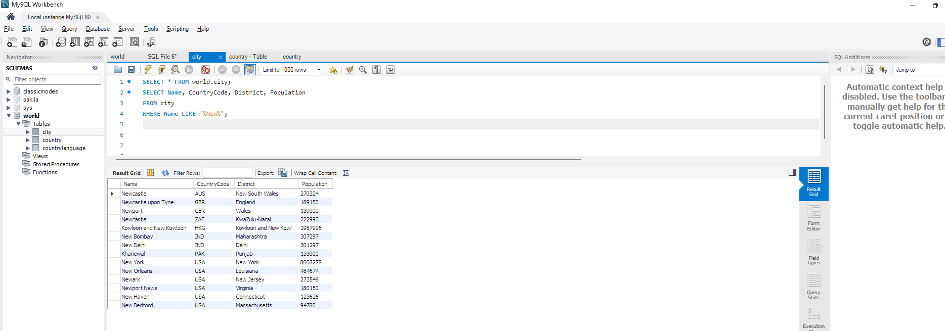

- Display Columns with Limit (First 10 Rows): Scenario: You're tasked with providing a brief overview of the most populous cities in the world. To keep the report concise, you're instructed to list only the first 10 cities by population from the database.

SELECT Name, CountryCode, District, Population
FROM city
ORDER BY Population DESC
LIMIT 10;

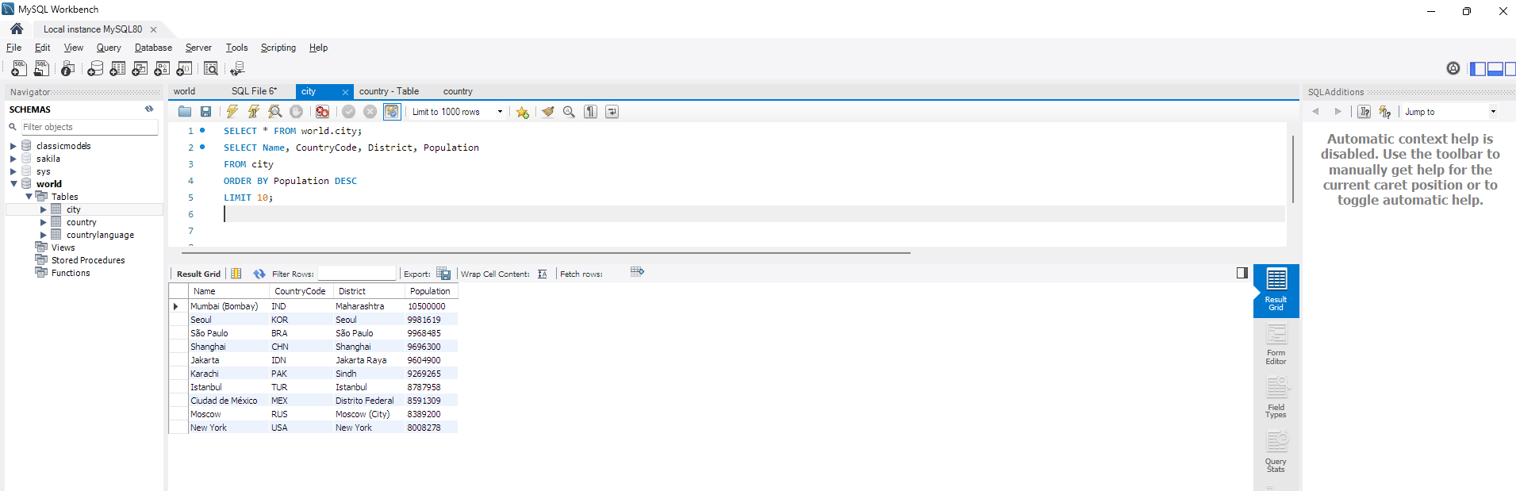

- Cities with Population Larger than 2,000,000: Scenario: A real estate developer is interested in cities with substantial population sizes for potential investment opportunities. You're tasked with identifying cities from the database with populations exceeding 2 million to focus their research efforts.

SELECT Name, CountryCode, District, Population
FROM city
WHERE Population > 2000000;
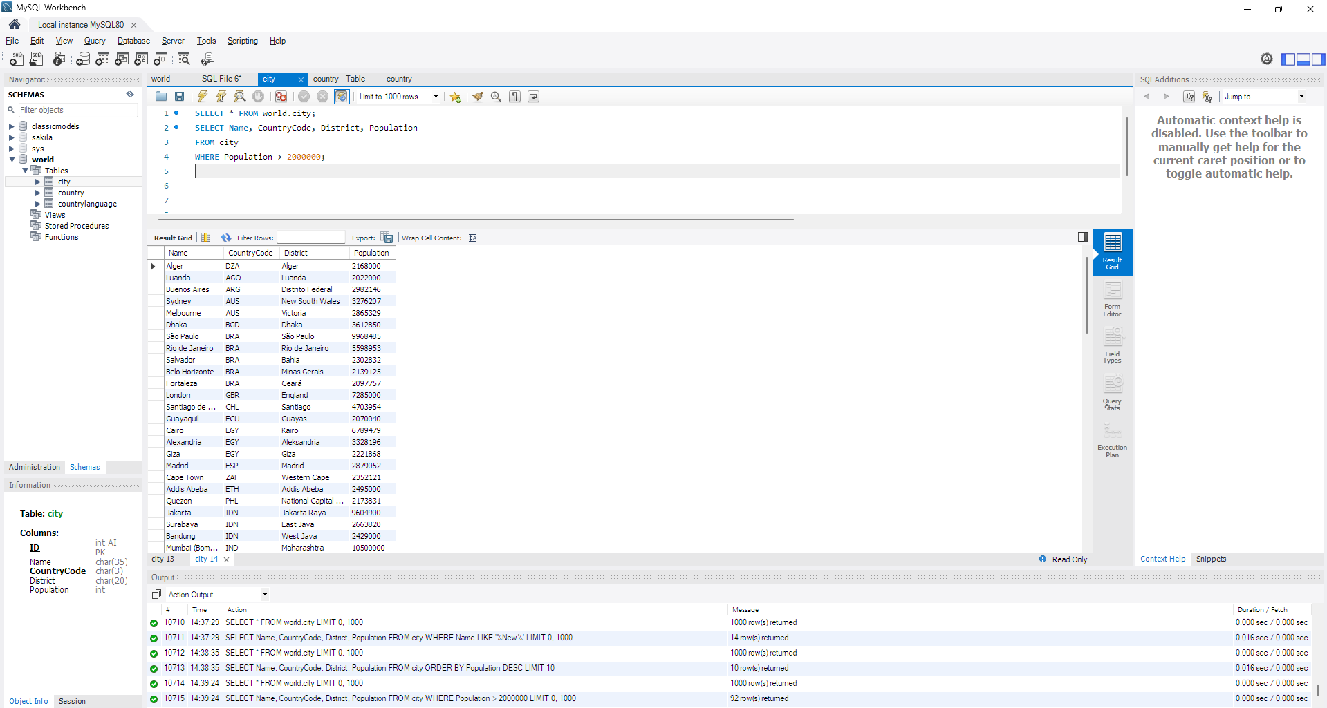

- Cities Beginning with 'Be' Prefix: Scenario: A travel blogger is planning a series of articles featuring cities with unique names. You're tasked with compiling a list of cities from the database that start with the prefix 'Be' to assist in the blogger's content creation process.

SELECT Name, CountryCode, District, Population
FROM city
WHERE Name LIKE 'Be%';

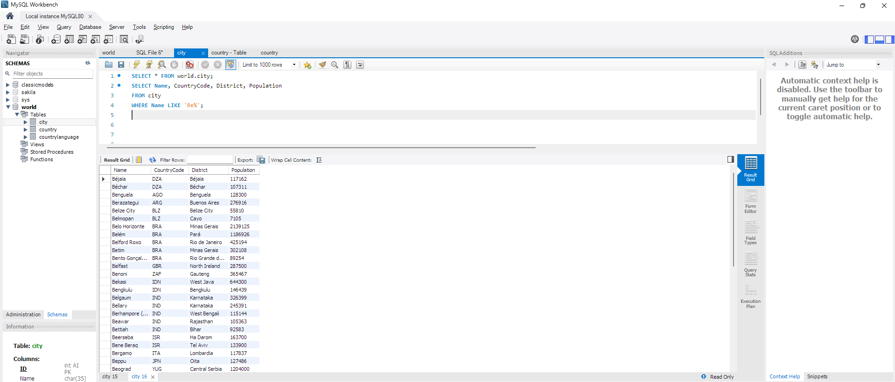

- Cities with Population Between 500,000-1,000,000: Scenario: An urban planning committee needs to identify mid-sized cities suitable for infrastructure development projects. You're tasked with identifying cities with populations ranging between 500,000 and 1 million to inform their decision-making process.

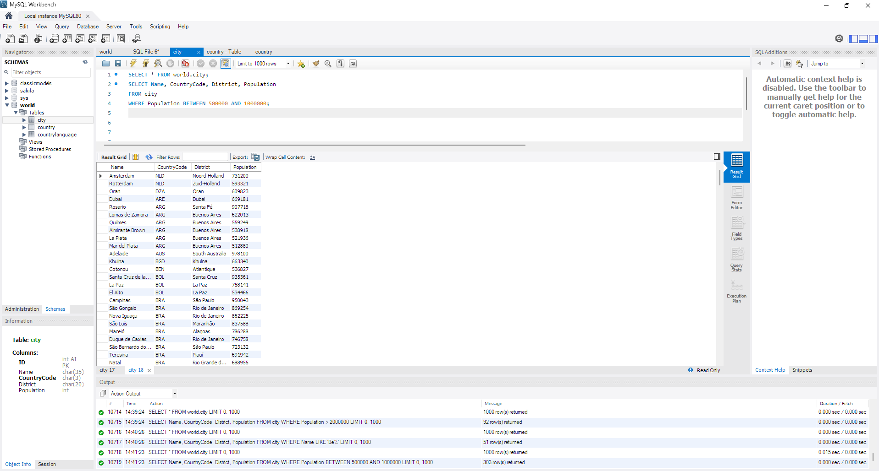
SELECT Name, CountryCode, District, Population
FROM city
WHERE Population BETWEEN 500000 AND 1000000;

- Display Cities Sorted by Name in Ascending Order: Scenario: A geography teacher is preparing a lesson on alphabetical order using city names. You're tasked with providing a sorted list of cities from the database in ascending order by name to support the lesson plan.

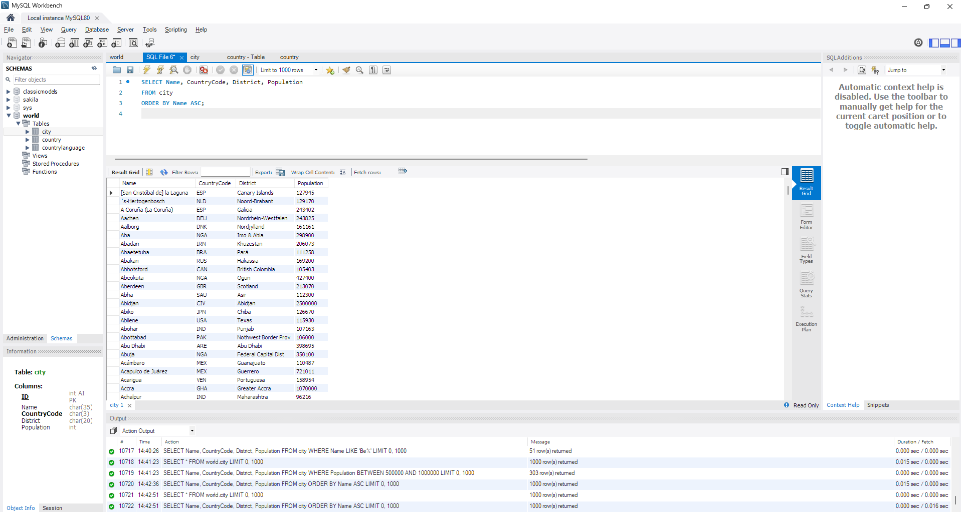

SELECT Name, CountryCode, District, Population
FROM city
ORDER BY Name ASC;

- Most Populated City: Scenario: A real estate investment firm is interested in cities with significant population densities for potential development projects. You're tasked with identifying the most populated city from the database to guide their investment decisions and strategic planning.

SELECT Name, CountryCode, Population
FROM city
ORDER BY Population DESC
LIMIT 1;
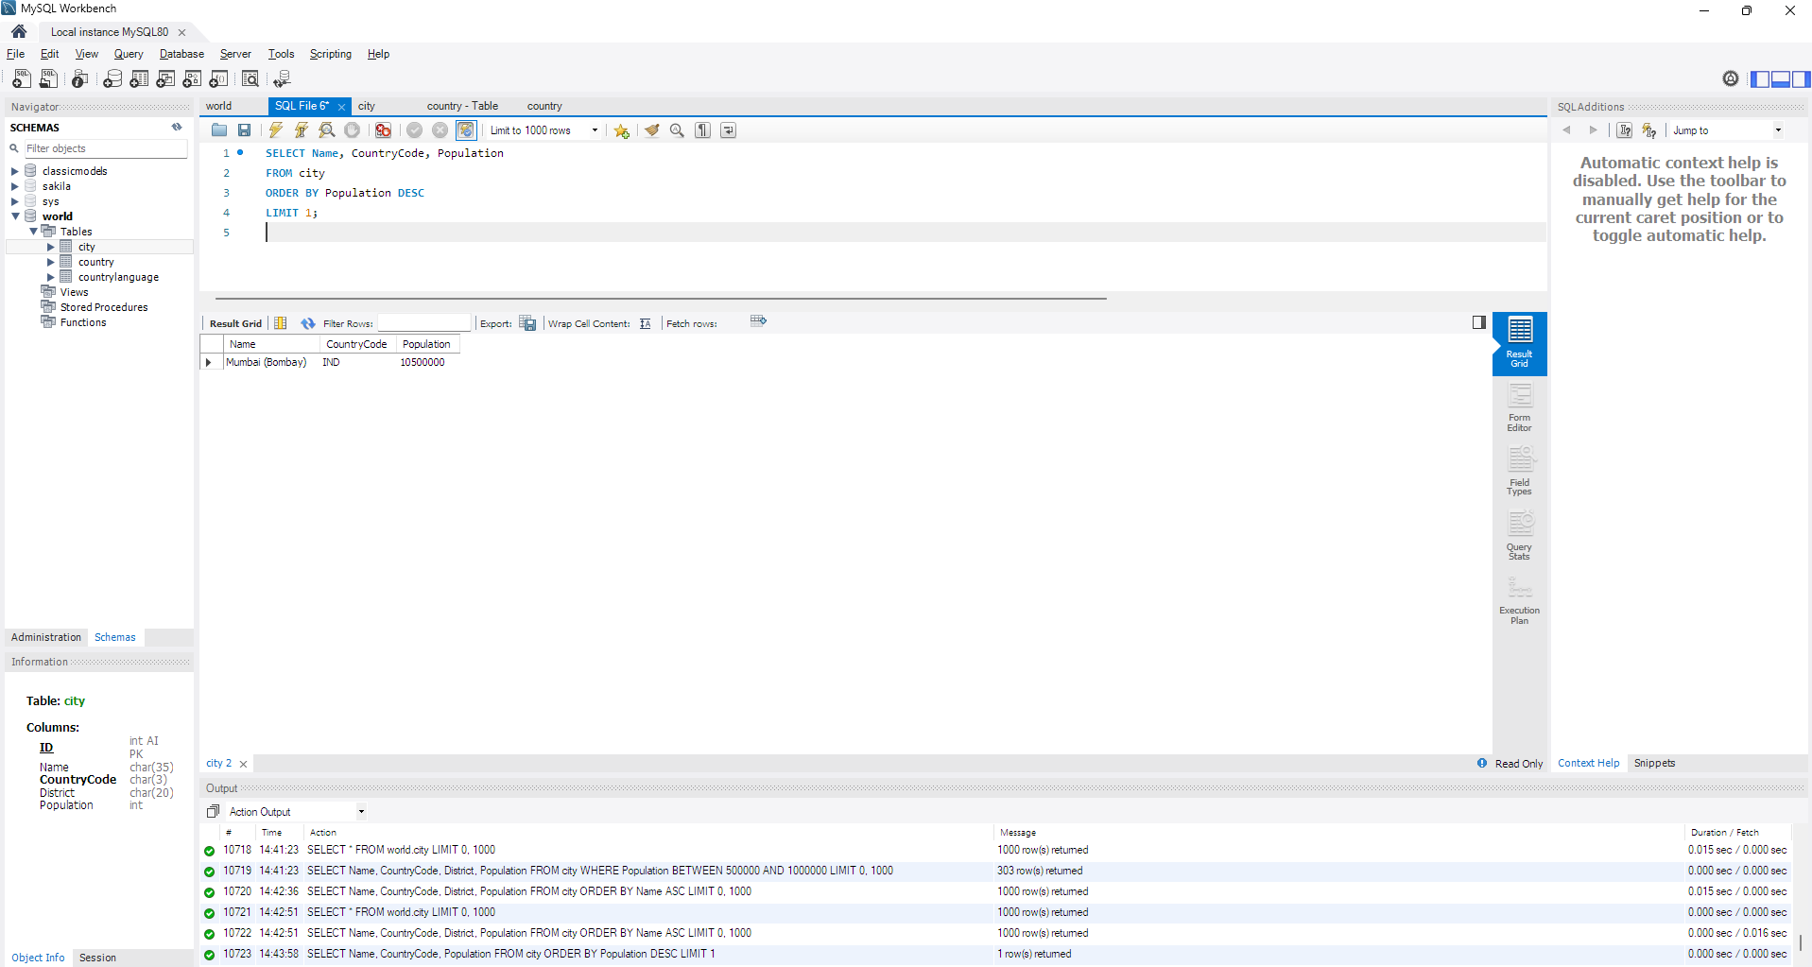

- City Name Frequency Analysis: Supporting Geography Education Scenario: In a geography class, students are learning about the distribution of city names around the world. The teacher, in preparation for a lesson on city name frequencies, wants to provide students with a list of unique city names sorted alphabetically, along with their respective counts of occurrences in the database. You're tasked with this sorted list to support the geography teacher.

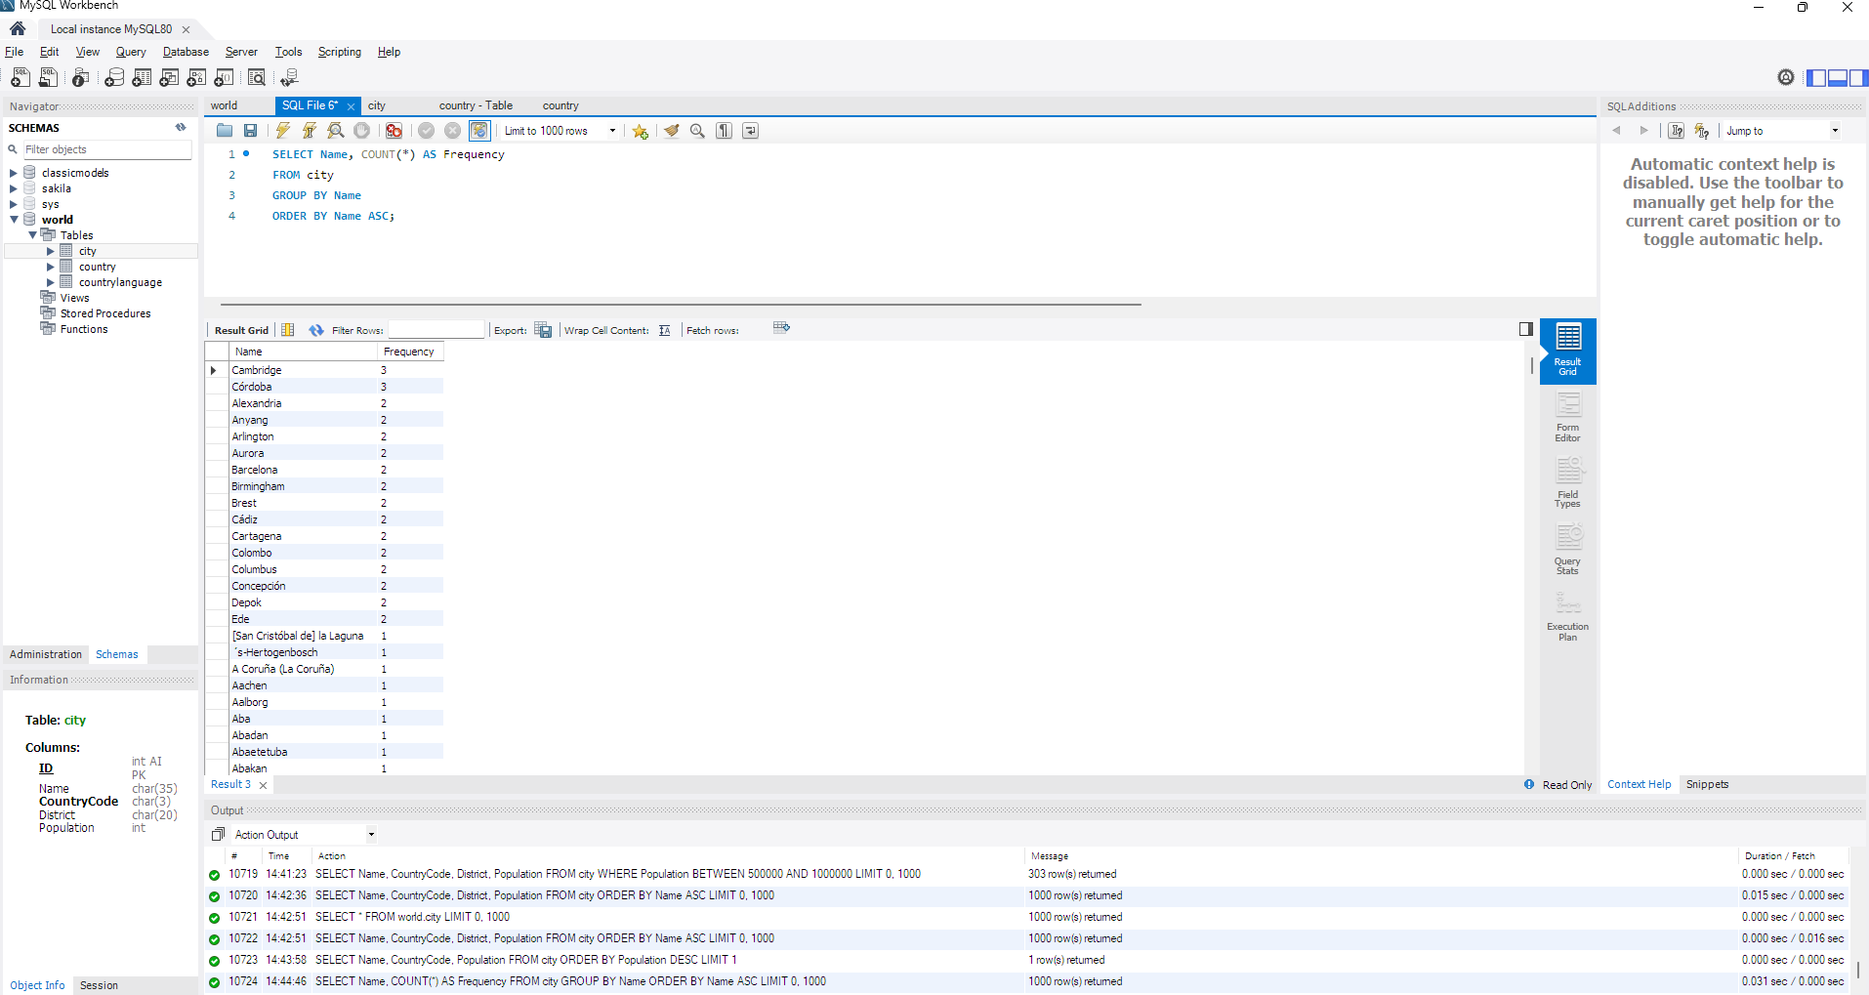

SELECT Name, COUNT(*) AS Frequency
FROM city
GROUP BY Name
ORDER BY Name ASC;

- City with the Lowest Population: Scenario: A census bureau is conducting an analysis of urban population distribution. You're tasked with identifying the city with the lowest population from the database to provide a comprehensive overview of demographic trends.

SELECT Name, Population
FROM city
ORDER BY Population ASC
LIMIT 1; 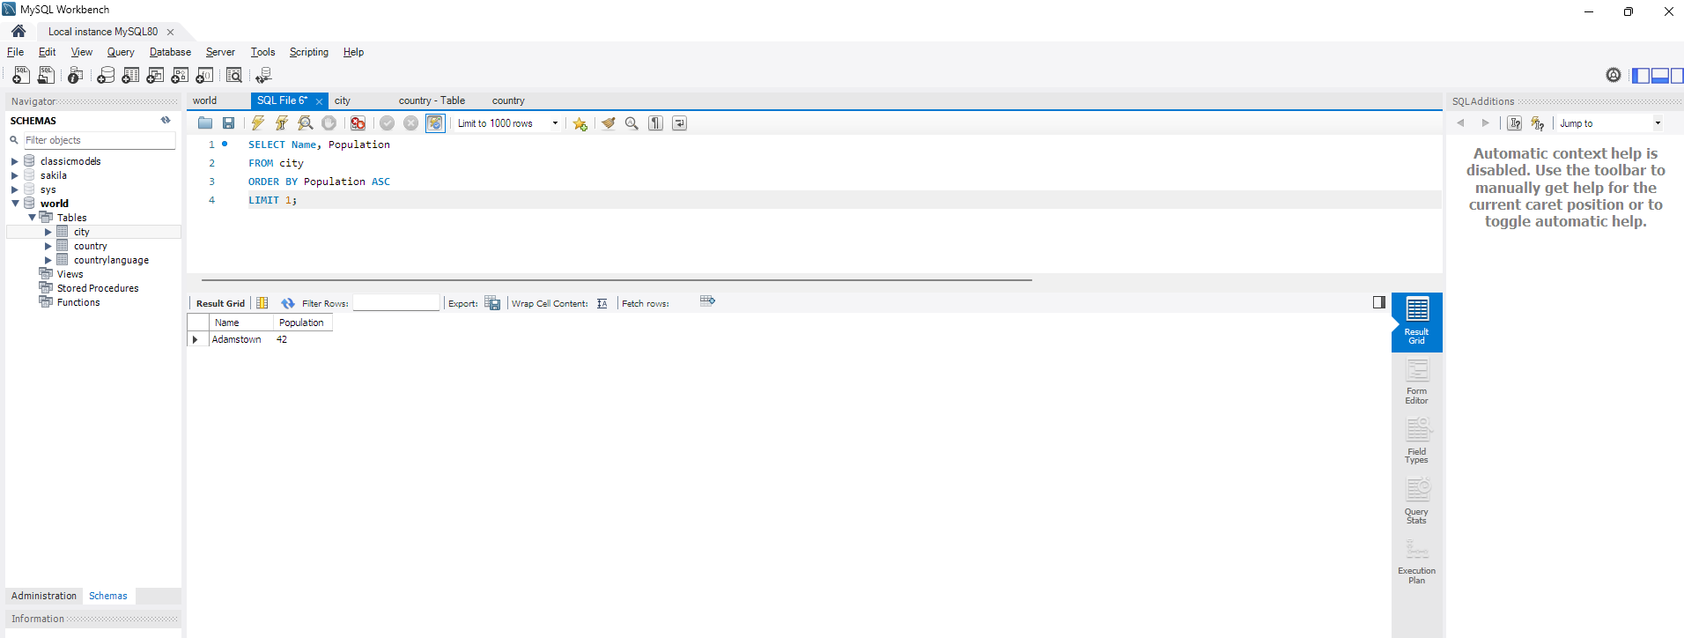

- Country with Largest Population: Scenario: A global economic research institute requires data on countries with the largest populations for a comprehensive analysis. You're tasked with identifying the country with the highest population from the database to provide valuable insights into demographic trends.

SELECT Name, Population
FROM country
ORDER BY Population DESC
LIMIT 1;
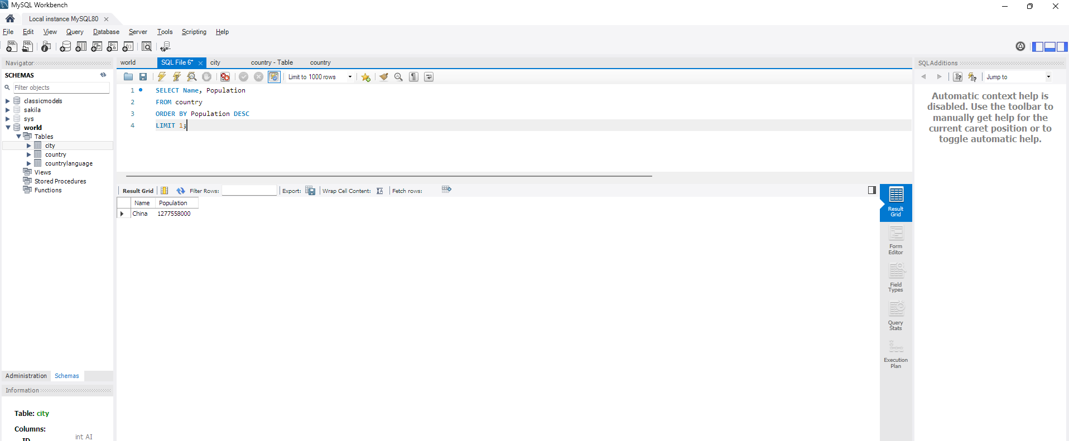

- Capital of Spain: Scenario: A travel agency is organising tours across Europe and needs accurate information on capital cities. You're tasked with identifying the capital of Spain from the database to ensure itinerary accuracy and provide travellers with essential destination information.

SELECT Capital
FROM country
WHERE Name = 'Spain';
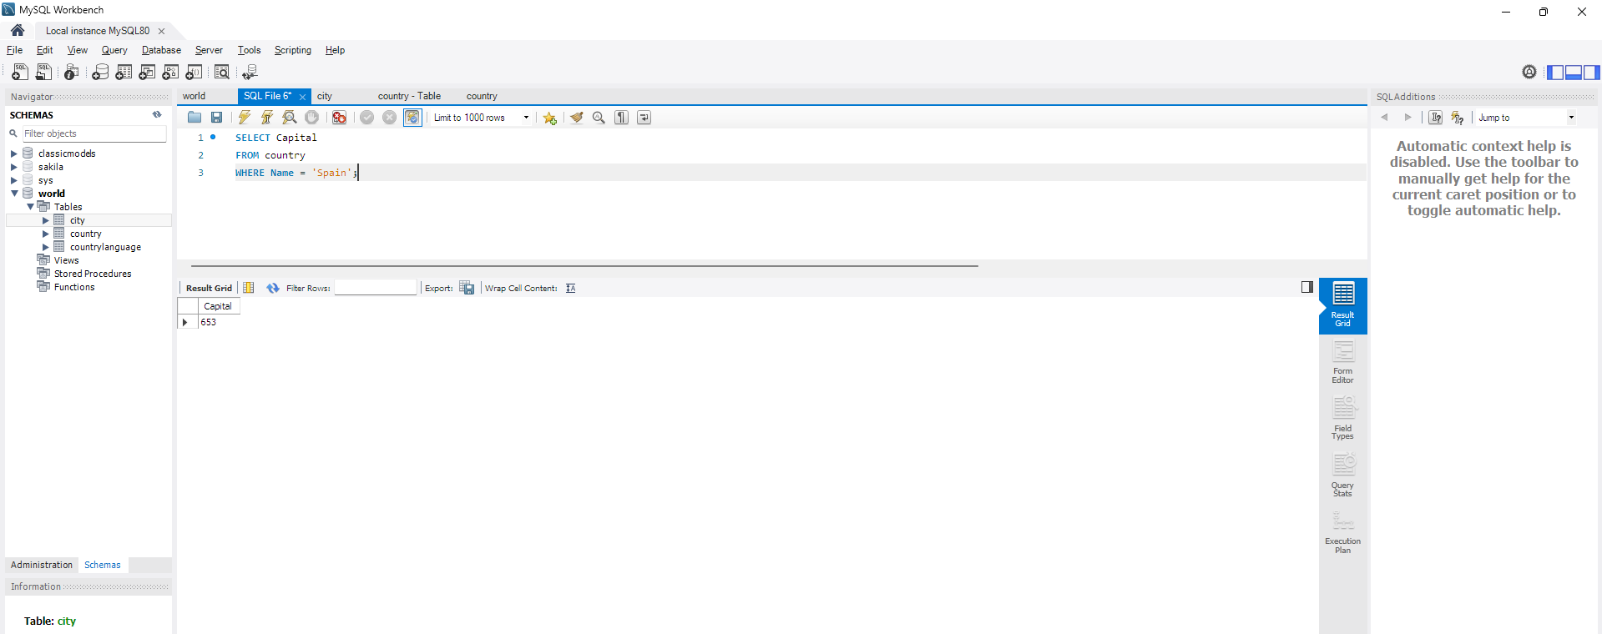

- Country with Highest Life Expectancy: Scenario: A healthcare foundation is conducting research on global health indicators. You're tasked with identifying the country with the highest life expectancy from the database to inform their efforts in improving healthcare systems and policies.

SELECT Name, LifeExpectancy
FROM country
ORDER BY LifeExpectancy DESC
LIMIT 1;
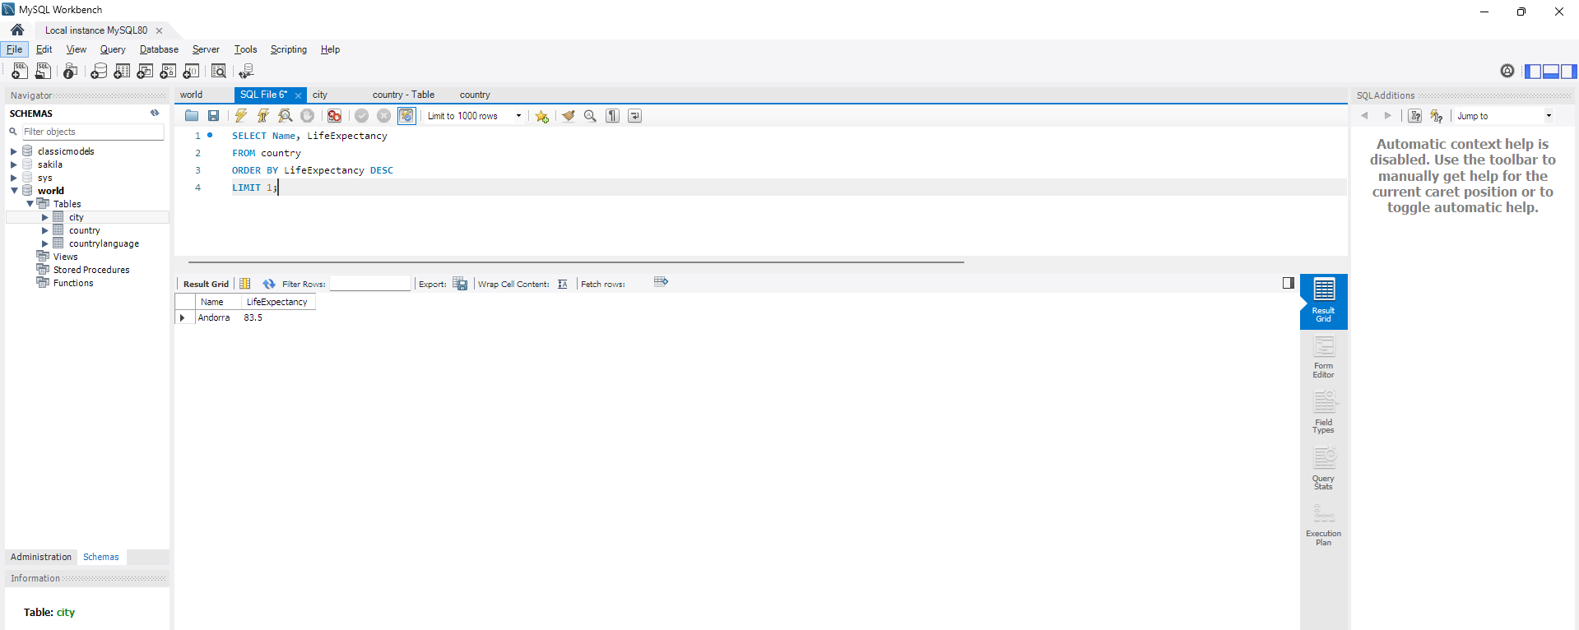

- Cities in Europe: Scenario: A European cultural exchange program is seeking to connect students with cities across the continent. You're tasked with compiling a list of cities located in Europe from the database to facilitate program planning and student engagement.
SELECT c.Name AS CityName
FROM city c
JOIN country co ON c.CountryCode = co.Code
WHERE co.Continent = 'Europe';
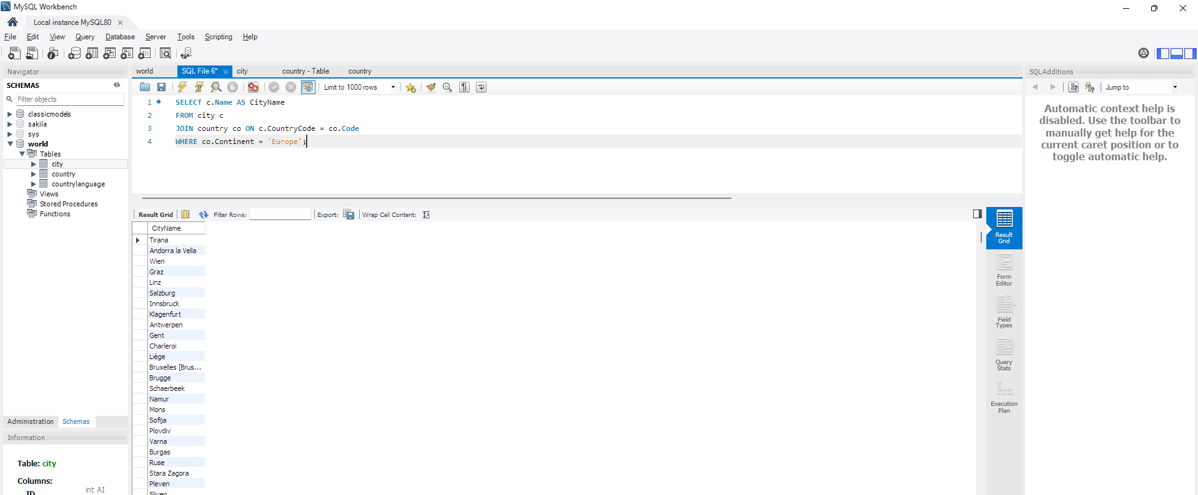

- Average Population by Country: Scenario: A demographic research team is conducting a comparative analysis of population distributions across countries. You're tasked with calculating the average population for each country from the database to provide valuable insights into global population trends.

SELECT co.Name AS CountryName, AVG(ci.Population) AS AveragePopulation
FROM country co
JOIN city ci ON co.Code = ci.CountryCode
GROUP BY co.Name
ORDER BY AveragePopulation DESC;
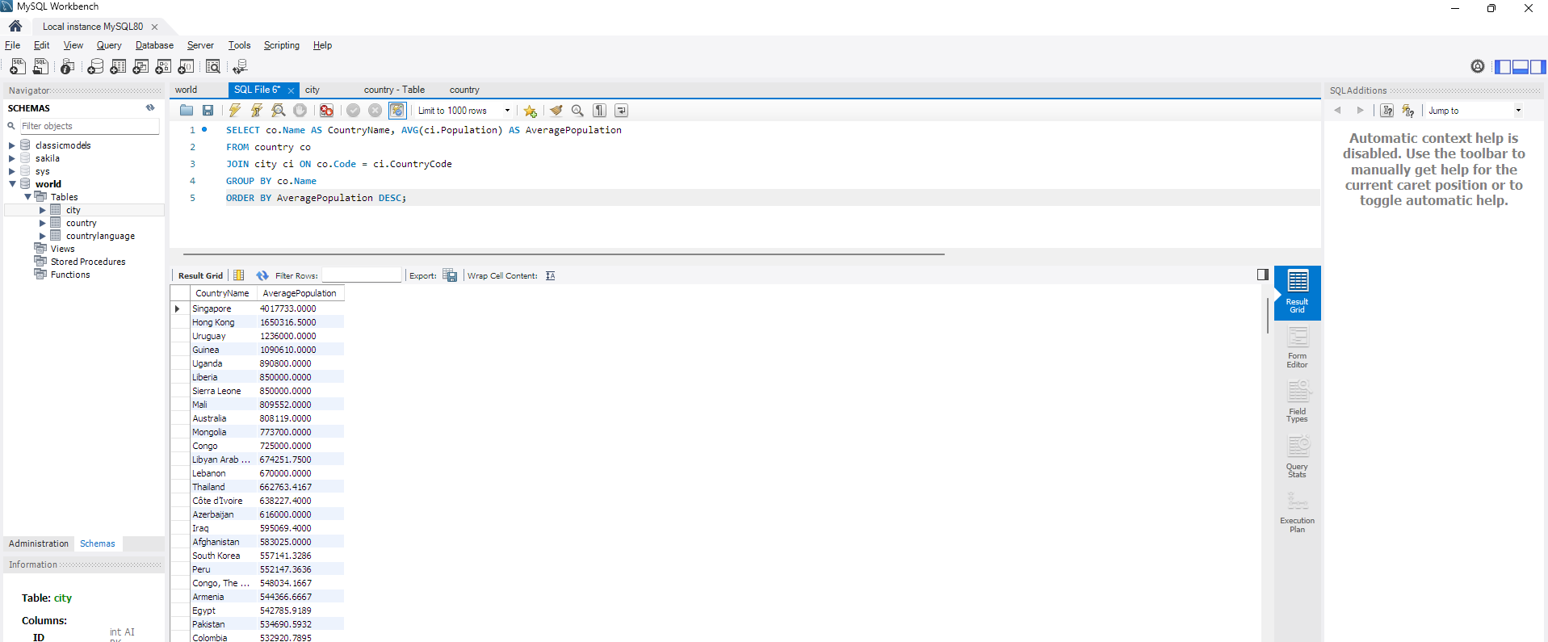

- Capital Cities Population Comparison: Scenario: A statistical analysis firm is examining population distributions between capital cities worldwide. You're tasked with comparing the populations of capital cities from different countries to identify trends and patterns in urban demographics.

SELECT
co.Name AS CountryName,
cap.Name AS CapitalCity,
cap.Population AS CapitalPopulation
FROM
country co
JOIN
city cap ON co.Capital = cap.ID
ORDER BY
cap.Population DESC;
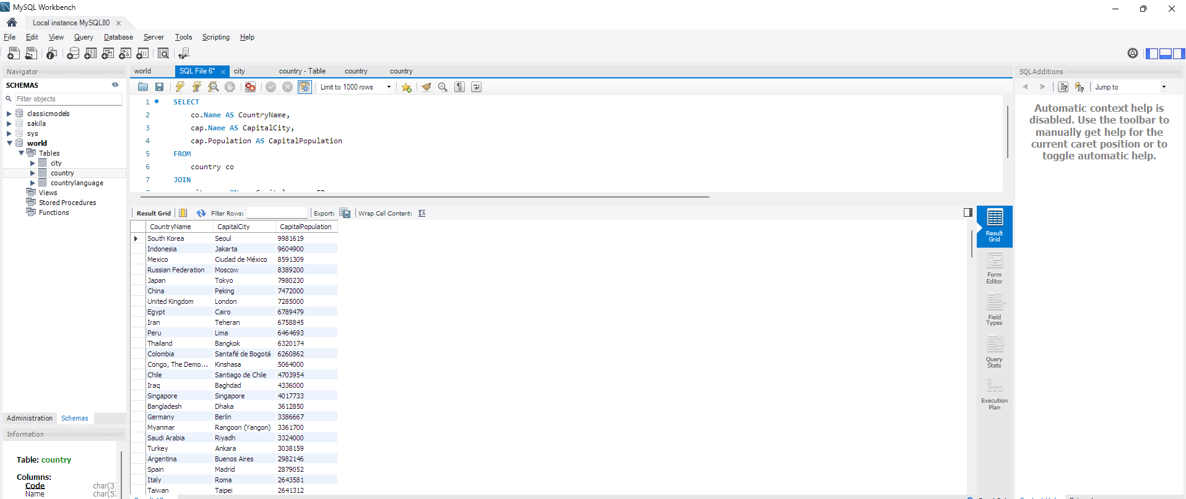

- Countries with Low Population Density: Scenario: An agricultural research institute is studying countries with low population densities for potential agricultural development projects. You're tasked with identifying countries with sparse populations from the database to support the institute's research efforts.

SELECT
co.Name AS CountryName,
cap.Name AS CapitalCity,
cap.Population AS CapitalPopulation
FROM
country co
JOIN
city cap ON co.Capital = cap.ID
ORDER BY
cap.Population DESC;
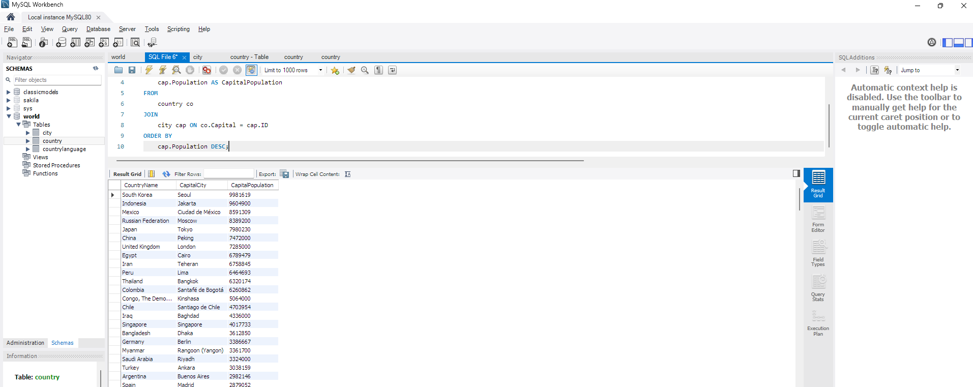

- Cities with High GDP per Capita: Scenario: An economic consulting firm is analysing cities with high GDP per capita for investment opportunities. You're tasked with identifying cities with above-average GDP per capita from the database to assist the firm in identifying potential investment destinations.

- Display Columns with Limit (Rows 31-40): Scenario: A market research firm requires detailed information on cities beyond the top rankings for a comprehensive analysis. You're tasked with providing data on cities ranked between 31st and 40th by population to ensure a thorough understanding of urban demographics.

SELECT Name, Population
FROM city
ORDER BY Population DESC
LIMIT 10 OFFSET 30;

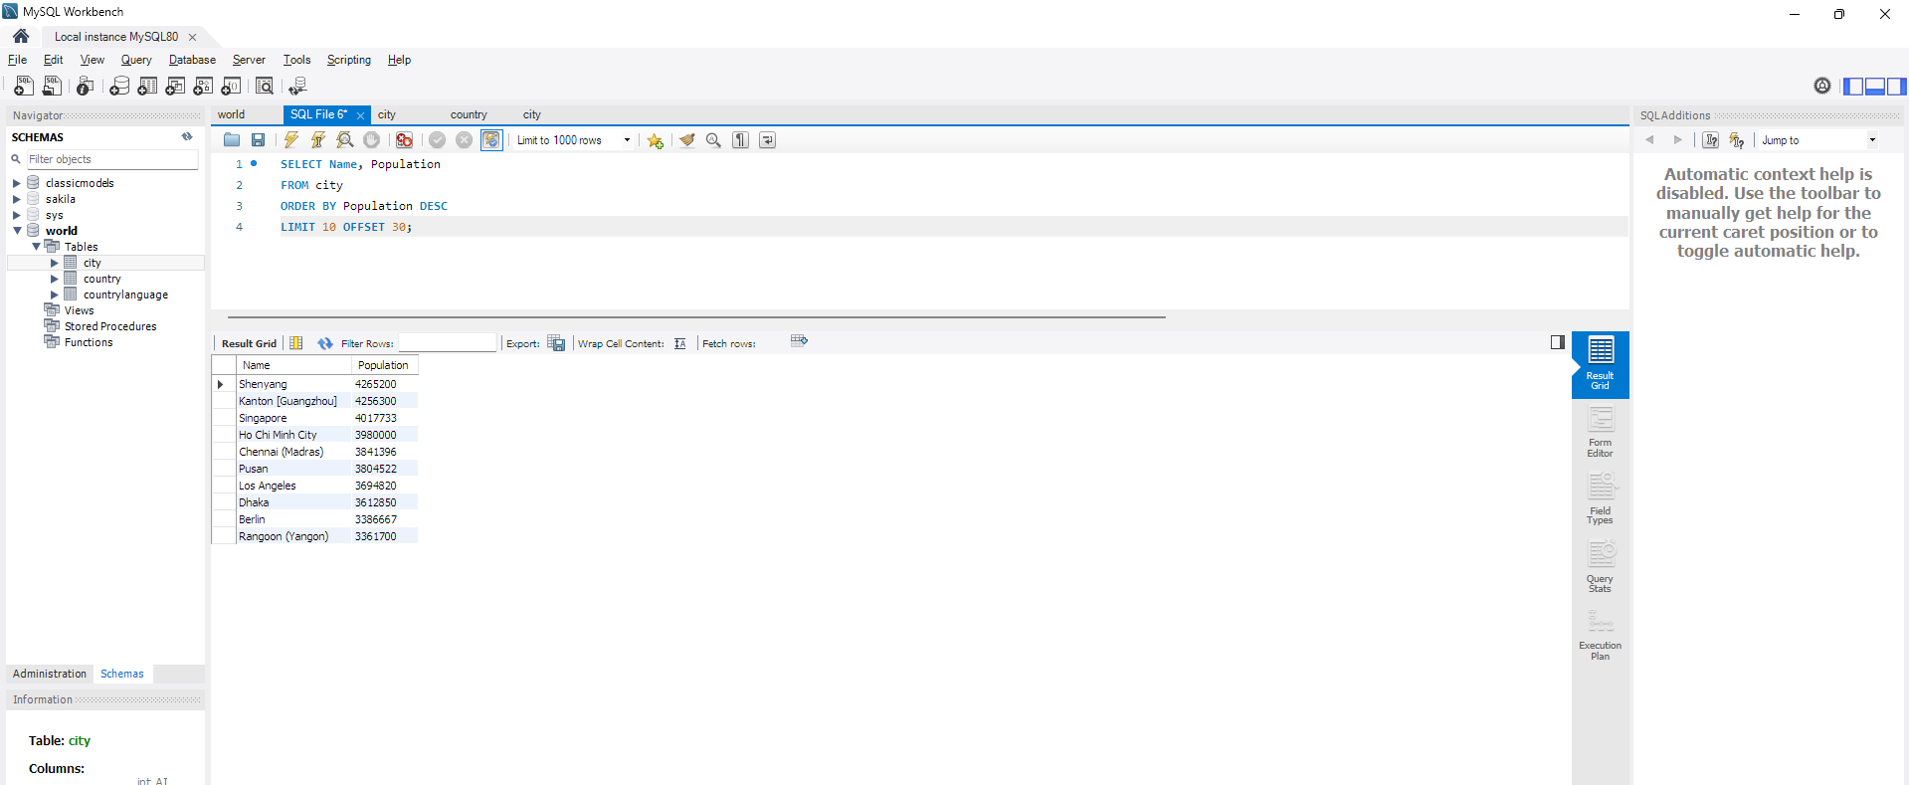

Course Notes

It is recommended to take notes from the course, use the space below to do so, or use the revision guide shared with the class:

Additional Information

We have included a range of additional links to further resources and information that you may find useful, these can be found within your revision guide.

END OF WORKBOOK

Please check through your work thoroughly before submitting and update the table of contents if required.

Please send your completed work booklet to your trainer.

