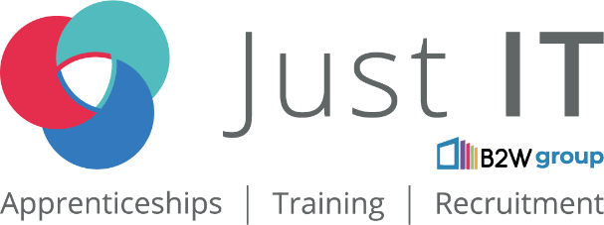

Data Technician

Name: Adeniran Ilesanmi
Course Date:12 May 2025
Table of contents
Day 1: Task 1 3
Day 1: Task 2 3
Day 1: Task 3 4
Day 2: Task 1 5
Day 3: Task 1 9
Day 3: Task 2 10
Day 3: Task 3 11
Day 4: Task 1 12
Day 4: Task 2 13
1. Scenario Background 13
2. Data Laws and Regulations 14
3. Azure Service Recommendations 14
4. Data Types and Data Modelling 14
5. Data Storage Formats and Structures in Azure 14
6. Additional Considerations 15
Submission Guidelines: 15
Course Notes 17
Additional Information 17

Day 1: Task 1

Please research and complete the below questions relating to key concepts of cloud.

Be prepared to discuss the below in the group following this task.

What can cloud computing do for us in the real-world? | Cloud computing means using computer services like storing files and running software over the internet. Instead of keeping everything on your own computer, you use the "cloud" – which is a network of computers owned by other companies.
How can it benefit a business? | Costs Less: Renting online services is cheaper than buying and managing your own equipment.  Grows Easily: Quickly add or remove computing power as needed.  Works Anywhere: Employees can access data and tools from any device.  Keeps Data Safe: Cloud providers have strong security and backup systems.  Faster Setup: Getting new software and resources is quicker.  Automatic Updates: Software updates happen automatically.  Focus on Business: Less time spent on IT, more on your actual work.
What’s the alternative to cloud computing? | The main alternative to cloud computing is on-premises infrastructure, also known as traditional IT infrastructure. This means a business owns, manages, and maintains all of its computing hardware (servers, storage, networking equipment) and software within its own physical facilities.
What cloud providers can we use, what are their features and functions? | Amazon Web Services (AWS): Huge range of services (compute, storage, databases, AI, etc.). Very scalable and widely adopted.  Microsoft Azure: Integrates well with Microsoft products. Strong in hybrid cloud and enterprise solutions. Offers many similar services to AWS.  • Google Cloud Platform (GCP): Known for strengths in data analytics, AI, and container technology (Kubernetes). Scalable infrastructure.

Day 1: Task 2

Please research the below cloud offerings, explain what they are and examples of use cases.

Cloud Offerings | Explain what it is | When / how might you use this service in the real-world?
IaaS (Infrastructure as a service) | Renting basic IT like servers and storage online, letting you control the software but not the physical hardware. | Good for moving existing apps to the cloud, test environments, and scaling websites. Examples: AWS EC2, Azure Virtual Machines, Google Compute Engine.
PaaS (Platform as a service) | Renting a ready-to-use platform online (operating system, programming tools, databases) to build and run applications without managing the underlying infrastructure. | Good for developers to quickly deploy and scale apps. Examples: AWS Elastic Beanstalk, Azure App Service, Google App Engine.
SaaS (Software as a service) | Using software applications online without installing or managing them; the provider handles everything. You typically pay a subscription. | Good for readily available applications like email, CRM, and office suites. Examples: Gmail, Salesforce, Microsoft 365.

Day 1: Task 3

Please research the below terms and explain what they are, when they would be appropriate and a real-world example of where it could be implemented (i.e. what type of organisation).

Public Cloud | Shared infrastructure for anyone online. Good for scalability and cost savings. Example: E-commerce website using AWS.
Private Cloud | Dedicated infrastructure for one organization. Good for high security and specific needs. Example: Bank's internal data center cloud.
Hybrid Cloud | Mix of public and private. Good for gradual migration and handling sensitive data with public cloud scalability. Example: Manufacturer using private for IP, public for CRM.
Community Cloud | Shared infrastructure for organizations with common needs. Good for shared compliance and collaboration. Example: Group of government agencies sharing a cloud.

Day 2: Task 1

Describe, with examples, the three major areas that the Computer Misuse Act deals with.

Area | Description | Example
1. Unauthorised Access to Computer Material (Section 1) | Gaining access to any program or data held in a computer without permission. The intent doesn't matter; simply accessing it without authorization is the offense. | An employee looks through files on a company server that they are not authorized to access, even if they don't copy, delete, or change anything. A hacker uses a vulnerability to view files on a website's database.
2. Unauthorised Access with Intent to Commit or Facilitate Further Offences (Section 2) | Gaining unauthorised access to computer material with the intention of committing or facilitating the commission of a more serious offense (which doesn't necessarily have to involve a computer). | Someone hacks into a company's network with the intention of stealing customer credit card details to commit fraud. An individual accesses a database containing personal information with the aim of using it for identity theft.
3. Unauthorised Acts with Intent to Impair Operation, etc. of Computer(s) (Section 3) | Performing unauthorised acts that are intended to prevent or hinder access to a computer, or to impair its operation, reliability, or security, or to impair the operation of any program or the reliability of data stored in it. This often involves causing damage or disruption. | Releasing a virus or malware onto a company's network to disrupt their systems and prevent employees from working. Launching a Distributed Denial of Service (DDoS) attack against a website to make it unavailable to users.

The computer misuse act 1990 is an act where an individual can be criminalised because of computer related offense. Describe three extra powers that the Police and Justice Act 2006 (Computer Misuse) has added.

Description
Creation of a Specific Offence for Denial of Service (DoS) Attacks
- Before 2006: DoS attacks were not clearly covered by the CMA.
- After 2006: Section 3 was revised to explicitly criminalise unauthorised acts intended to impair the operation of a computer. This closed a loophole that had previously made prosecuting DoS attacks difficult.

Increased Penalties
- Section 1 (unauthorised access to computer material): The maximum penalty increased from 6 months to 2 years imprisonment.
- Section 3 (unauthorised modification of computer material): Penalty increased to 10 years imprisonment (previously 5 years).

Introduction of a New Offence (Section 3A) – Making, Supplying or Obtaining Articles for Use in Offences
- Targets the creation or distribution of hacking tools, such as password crackers or malware.
- Covers those who create or distribute such tools with intent or believing they are likely to be used to commit an offence under Sections 1 or 3.

Look at the below website to answer the questions:
https://www.gov.uk/personal-data-my-employer-can-keep-about-me

Write down three items of data which a company can store about an employee.
Full name and contact details (e.g., phone number, email address)

National Insurance number or other tax identification

Job title and salary information

Give three more examples of data that an employer can only store if they first get the employee’s permission.
Medical or health information (e.g., details of disabilities or medical conditions)

Biometric data (e.g., fingerprints or facial recognition for access systems)

Details about religious beliefs or political opinions

Conduct further research to answer the below questions.

Question | Answer
Provide one example of: Copyright infringement | An employee downloads and shares a copyrighted movie from a file-sharing website without the permission of the copyright owner.  This violates the copyright holder’s exclusive rights to distribute and reproduce the work.
Provide one example of: Plagiarism | A student copies paragraphs from a website into their school essay without citing the source and submits it as their own work.  This is plagiarism because it presents someone else's ideas or words as original without giving proper credit.
What are two consequences of copyright infringement and software piracy? | Legal consequences – Individuals or businesses can face fines, lawsuits, or even criminal charges, depending on the severity of the offence.  Loss of trust and reputation – Being caught using pirated software or infringing copyright can damage a person’s or company’s credibility and professional reputation.
Give three possible consequences for individuals when using pirated software | Legal action – They could face fines or prosecution for violating copyright laws.  Malware and security risks – Pirated software often contains viruses or spyware that can harm the device or steal personal data.  Lack of support and updates – Users don’t receive official updates or technical support, which can lead to poor performance and security vulnerabilities.

Listed below are some laws which we have covered today:

1. Computer Misuse Act 1990
2. Police and Justice Act 2006 (Computer Misuse)
3. Copyright, Designs and Patents Act 1988
4. Copyright (Computer Programs) Regulations 1992
5. The Health and Safety (Display Screen Equipment) Regulations 1992
6. Data Protection Act 2018
7. Consumer Rights Act 2015

- Insert a number in the first column of each row to match each of the statements with one of the above Acts.

- One of statements is incorrect and not illegal. For this statement, write ‘Not illegal’.

Act number | Clause
4 | With some exceptions, it is illegal to use unlicensed software
7 | Any product, digital or otherwise, must be fit for the purpose it is supplied for
1 | Unauthorised modification of computer material is illegal
Not illegal | It is illegal to create or use a hacking tool for penetration testing
6 | Personal data may only be used for specified, explicit purposes
5 | Employers must provide their computer users with adequate health and safety training for any workstation they work at
2 | It is illegal to distribute hacking tools for criminal purposes
3 | It is illegal to distribute an illicit recording
6 | Personal data may not be kept longer than necessary
1 | Gaining unauthorised access to a computer system is illegal
5 | Employers must ensure that employees take regular and adequate breaks from looking at their screens
2 | It is illegal to prevent or hinder access (e.g. by a denial-of-service attack) to any program or data held in any computer
6 | Personal data must be accurate and where necessary kept up to date

Day 3: Task 1

Please complete the below lab (3) ‘Explore relational data in Azure’ and paste evidence of the completed lab in the box provided.

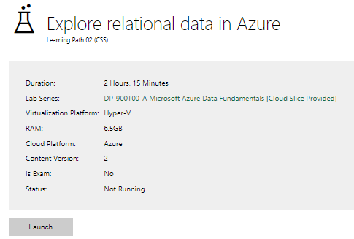

Completed lab

Day 3: Task 2

Please complete the below lab (4) ‘Explore non-relational data in Azure’ and paste evidence of the completed lab in the box provided.

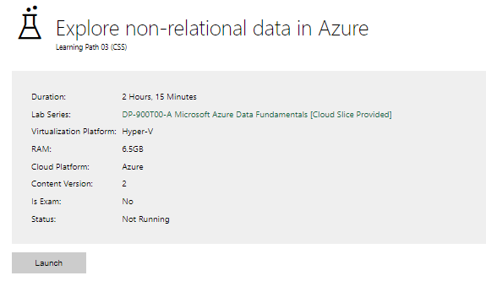

Completed lab

Day 3: Task 3

Please complete the below lab (5) ‘Explore data analytics in Azure’ and paste evidence of the completed lab in the box provided.

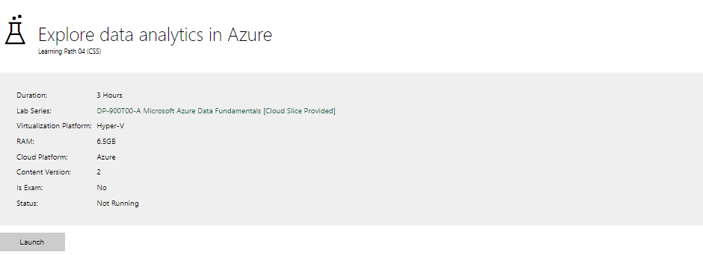

Completed lab

Day 4: Task 1

In your teams, complete the Azure DP-900 practice exam and paste your result below – this is open book and please research and discuss your answers as a team.

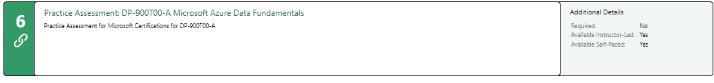
Result

Day 4: Task 2

1. Scenario Background
"Paws & Whiskers" is a growing pet shop that aims to improve its business by analysing sales, customer information, and inventory data. Currently, the data is collected manually or stored in spreadsheets. Management is interested in transitioning to Microsoft Azure to streamline data storage, analysis, and reporting, enabling them to make data-driven decisions.

2. Data Laws and Regulations
Identify and explain the data laws and regulations relevant to handling customer data within the proposal. Ensure you cover the following points:
- GDPR Compliance: Highlight the importance of adhering to the General Data Protection Regulation (GDPR), particularly as it relates to storing and processing customer information.
- Data Protection Act (DPA) 2018: Outline how the DPA 2018 may affect the way "Paws & Whiskers" collects and stores data, ensuring compliance with UK laws on data privacy.
- Other Industry Standards: Research any additional data protection standards or regulations that may apply to pet shop data, particularly if they involve sensitive or payment information.

3. Azure Service Recommendations
Recommend Microsoft Azure services that would suit the company’s data analysis needs and explain why these services are suitable. Your recommendations should include:
- Data Storage: Identify suitable storage options, such as Azure Blob Storage or Azure SQL Database, and discuss the benefits of each for storing large datasets, including inventory, sales transactions, and customer details.
- Data Analysis Tools: Recommend tools such as Azure Machine Learning for customer behaviour analysis or Azure Synapse Analytics for analysing sales trends.
- Data Integration and Automation: Explain how services like Azure Data Factory could automate data collection and integration processes, improving efficiency.

4. Data Types and Data Modelling
Define the types of data "Paws & Whiskers" will need to work with and describe your approach to data modelling:
- Data Categories: Identify key data types, such as customer demographics, transaction history, pet inventory, and product categories.
- Data Modelling Approach: Outline how you would structure this data using a relational model or a data warehouse approach, considering factors like tables, entities, relationships, and primary keys.

5. Data Storage Formats and Structures in Azure
Discuss how you would store data within Azure and the formats you would recommend:
- Data Formats: Specify recommended formats (e.g., CSV for raw data imports, JSON for structured data, Parquet for analytics) and explain why these formats are suitable for specific data types.
- Data Security and Encryption: Include recommendations for securing data using Azure’s built-in encryption features and access controls to ensure compliance with data privacy regulations.

6. Additional Considerations
Provide any other considerations that might enhance data handling and efficiency in Azure, such as:
- Backup and Disaster Recovery: Outline a backup plan using Azure Backup or Azure Site Recovery to safeguard against data loss.
- Data Visualisation: Discuss potential use of Power BI within Azure for creating dashboards that provide management with real-time insights into sales and customer trends.
- Future Scalability: Comment on how Azure services can scale as the business grows, accommodating larger datasets and more complex analyses.

Submission Guidelines:
- Structure: Ensure your report is well-organised, with sections for each task (e.g., Data Laws, Azure Services, Data Types, etc.).
- Formatting: Include headings, bullet points where appropriate, and any visuals or diagrams that support your explanations.
- References: Cite any resources or regulations referenced in the report.
- Length: Aim for 1500-2000 words.

Data Laws and Regulations
General Data Protection Regulation (GDPR) Compliance
The General Data Protection Regulation (GDPR) applies to all businesses operating in the UK and EU that handle personal data. For "Paws & Whiskers," compliance with GDPR is critical when storing and processing customer information. Key principles include:
- Lawful processing: Customer data must be collected for specified, explicit, and legitimate purposes.
- Consent: Customers must give informed consent before their data is used.
- Right to access and erasure: Customers can request access to their data and ask for it to be deleted.
- Data minimisation: Only necessary data should be collected and retained.
- Security: Data must be protected against unauthorised access and breaches.
Failure to comply can lead to fines of up to €20 million or 4% of annual global turnover.
Data Protection Act (DPA) 2018
The DPA 2018 is the UK’s implementation of GDPR, with some additional national rules. It reinforces the GDPR principles and provides specific guidance for UK-based data controllers. For "Paws & Whiskers," this means:
- Implementing data governance policies to ensure proper data handling.
- Maintaining transparency in how customer data is used.
- Training staff on data protection responsibilities.
Other Industry Standards
While not subject to specific industry-only regulations, "Paws & Whiskers" must adhere to:
- PCI DSS (Payment Card Industry Data Security Standard): If accepting card payments, systems must comply with PCI DSS to protect payment data.
- Consumer Protection Laws: These require transparent handling of customer transactions and data.
Azure Service Recommendations
Data Storage
- Azure Blob Storage: Ideal for storing unstructured data such as images, raw CSV files, and backups. Benefits:
  - Scalable and cost-effective
  - Supports multiple data formats
  - Integrated with Azure Data Lake for analytics
- Azure SQL Database: Suitable for structured data like customer profiles, sales transactions, and inventory. Benefits:
  - Relational database with high availability
  - Automated backups and scaling
  - Built-in threat detection and encryption
Data Analysis Tools
- Azure Synapse Analytics:
  - Integrates big data and data warehousing
  - Enables deep analysis of sales trends and inventory patterns
  - Supports SQL and Spark queries
- Azure Machine Learning:
  - Ideal for customer segmentation and behaviour prediction
  - Automates model training and deployment
Data Integration and Automation
- Azure Data Factory:
  - Automates data ingestion from spreadsheets and other sources
  - Supports ETL (Extract, Transform, Load) workflows
  - Enables data synchronisation between systems

Data Types and Data Modelling
Data Categories
"Paws & Whiskers" will work with the following data types:
- Customer Demographics: Name, contact details, pet ownership, purchase history
- Sales Transactions: Product, quantity, price, payment method
- Pet Inventory: Species, breed, age, availability, health status
- Product Categories: Food, accessories, grooming, toys
Data Modelling Approach
Using a relational database model (e.g., Azure SQL Database):
- Tables:
  - Customers (CustomerID, Name, Email, etc.)
  - Transactions (TransactionID, CustomerID, Date, Total)
  - Products (ProductID, CategoryID, Price, Stock)
  - Pets (PetID, Species, Age, Status)
  - Categories (CategoryID, Name)
- Relationships:
  - One-to-many: Customers to Transactions
  - One-to-many: Categories to Products
- Primary Keys: Ensure data integrity and support indexing for fast queries.

Data Storage Formats and Structures in Azure
Data Formats
- CSV: Suitable for importing raw sales and inventory data; simple and widely compatible.
- JSON: Ideal for structured web or app data, such as customer feedback or order APIs.
- Parquet: Optimised for analytics; efficient storage and processing within Azure Synapse or Data Lake.
Data Security and Encryption
- Azure Encryption:
  - Data encrypted at rest using AES-256
  - TLS encryption for data in transit
- Access Controls:
  - Role-Based Access Control (RBAC)
  - Multi-factor authentication for admin access
- Monitoring:
  - Azure Security Center for threat detection
  - Audit logs for compliance tracking

Additional Considerations
Backup and Disaster Recovery
- Azure Backup:
  - Automated daily backups of SQL databases and file storage
  - Long-term retention policies
- Azure Site Recovery:
  - Business continuity during outages
  - Replication of critical workloads to a secondary region
Data Visualisation
- Power BI:
  - Directly integrates with Azure services
  - Dashboards for sales trends, customer retention, and inventory alerts
  - Accessible on mobile and web platforms
Future Scalability
- Azure supports:
  - Vertical scaling of databases and compute power as needed
  - Horizontal scaling through sharding and distributed data services
  - Flexible pricing models to grow with the business

Course Notes

It is recommended to take notes from the course, use the space below to do so, or use the revision guide shared with the class:

Additional Information

We have included a range of additional links to further resources and information that you may find useful, these can be found within your revision guide.

END OF WORKBOOK

Please check through your work thoroughly before submitting and update the table of contents if required.

Please send your completed work booklet to your trainer.

