THE UNITED REPUBLIC OF TANZANIA
MINISTRY OF HEALTH AND
SOCIAL WELFARE




Integrated Logistics System (ILS)
Procedures Manual

Roll-Out Version

March 2006
This manual has been prepared as part of DELIVER Technical Assistance support to the Ministry of Health and Social welfare of the United Republic of Tanzania, through the Pharmaceutical Supplies Unit and aims to strengthen logistics management of health commodities.
DELIVER, a six-year worldwide technical assistance support contract funded by the U.S. Agency for International Development (USAID) and the US President’s Emergency Plan for AIDS Relief (PEPFAR).
Implemented by John Snow, Inc. (JSI), (contract no. HRN-C-00-00-00010-00) and subcontractors (Manoff Group, Program for Appropriate Technology in Health [PATH], and Social Sectors Development Strategies, Inc.), DELIVER strengthens the supply chains of health and family planning programs in developing countries to ensure the availability of critical health products for customers. DELIVER also provides technical management of USAID’s central contraceptive management information system

IX. Supervision of the ILS

This section of the manual generally refers to supervision of health facilities (dispensaries, health centers and hospitals). However, this section is also applicable to regional, zonal, and central-level supervision of districts as well.

A. Overview of Personnel Supervision and Performance Monitoring
Two of the most important responsibilities logistics personnel carry out are monitoring and supervision. Monitoring and supervision are the backbone of an effective logistics system. Without continuous monitoring of logistics activities and supervision of the personnel who carry out these responsibilities, the overall quality of the logistics system may weaken, which in turn may jeopardize the availability of supplies and the quality of service provided to clients.

There are several reasons why logistics activities should be monitored and personnel supervised on a regular basis:
- to ensure that all records are correctly maintained and reports are submitted in a timely manner;
- to ensure that planned logistics activities are being carried out according to schedule; and
- to ensure that clients are getting the health supplies they need when they need them.
- to ensure that established logistics guidelines and procedures are being followed.
- to identify performance weaknesses and to improve performance by providing immediate on-the-job training as needed; and
- to ensure they have the knowledge and skills they need to effectively manage the logistics system.

Most supervisors agree that if they are to be truly effective supervisors they must know how to complete the tasks they are supervising. In the logistics system this means that supervisors must be able to effectively carry out all of the responsibilities of the personnel at the level below them.

In general, most logistics activities can be monitored by reviewing records and reports. These reviews can frequently be done from an office. For example, checking reports can determine if a facility is maintaining stock balances between maximum and reorder levels, or if there are unusual quantities of supplies expiring or lost.

Effective supervision, on the other hand, can only take place in the presence of the facility staff. Supervisors should plan to spend time supervising and providing on-the-job training during each supervisory visit

B. How to Measure the Facilities’ Logistics Performance
1) While monitoring the logistics system from reports look for the following indicators:
- Timeliness of reports: Did the reports arrive within the designated time period? (by the 10th of the first month of the ordering cycle)
- Accuracy of the reports: Are the calculations correct? Do the ending balances from one report equal the beginning balances of the following report? Do the numbers reported make sense?
- Completeness of reports: Is all information required included in the report?
- Completeness of reporting: Are reports received from all the facilities that should report?
- Consistency of reports: Do the quantities issued from one level equal the total quantities received at the next level?
- Stockouts: Do the reports indicate any stockouts of any supplies?
- Stocked according to maximum and reorder levels: Are the stock levels within the designated maximum and reorder levels for that facility?
- Losses: What quantities of stock were lost due to theft, damage or expiry?

2) Logistics indicators at the facility
- Orderly arrangement in the stores and the dispensing area
- Proper record keeping
- Stores ledgers are up to date
- Dispensing registers in place
- Cleanliness of the stores
- Cleanliness of the staff
- Adequate storage space

Problems that are found during routine reviews of reports received should be discussed during the next supervisory visit to the facility concerned.

C. How to Conduct Supervision
The following list provides suggestions for how to conduct logistics supervision during a supervisory visit, so that the visit is useful for the person doing the supervision and for the people who are receiving the visit as well. These suggestions can be applied when the supervision is done from a higher level, or when it is done within a facility:

- Conduct supervisory visits based on objective criteria such as job descriptions, motivation of health workers, techniques, the work plan of a given unit, the objectives of the supervisory visit, and the calendar of visits.
- Select the most important observations; organize observations into those that are general observations and those that are specific to the person supervised; provide feedback by giving specific examples of things that need changing and do this in a non-threatening, friendly manner.
- Help the person being supervised to participate in the process: It is important to help the person being supervised to participate because it lets him/her know that his/her opinions are important, that he/she is part of the solution and can do something about resolving the problem.
- Be ready to provide technical or other assistance when needed. Offer help without removing responsibility for action. When you provide on the job training or coaching do not take over the actual execution of the activity.
- Hold organized and productive meetings with an agenda that meets the needs of the participants (health workers, district supervisors, etc.). Be conscious of workers’ needs that can be responded to.
- Show interest in employees but give them independence and responsibility.
- Reinforce positive behavior!
- Take appropriate measures to correct negative behavior!
- Give feedback in a timely manner.
- If discipline is required, be specific and consistent with all employees.
- Ensure that all tasks that are appropriate for the removal of expired/damaged/excess supplies are undertaken.

Worksheet 2: ILS Supervision Checklist includes areas for Supervisors to review and discuss when supervising the ILS.

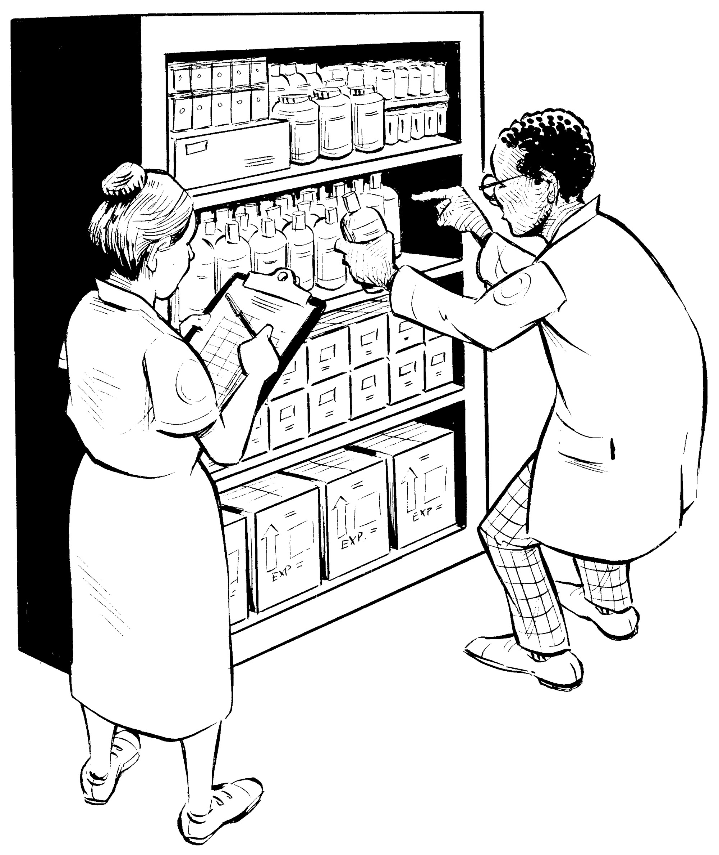
Worksheet 2: Supervision Checklist

Council/Region:
Health facility Name:
Date of supervision visit:
Date of last supervision visit: _____________________
Name and title of the staff member(s) interviewed:
Name and title of the supervisor:

Supervision for health centre/dispensary

A. Preparation for a supervision visit
- Develop an objective for the visit.
- Arrange for transport and allowances at least one week prior to visit.
- Notify the dispensary or health center of your visit after you have confirmed transport.
- Liaise with the DMO to obtain and review Forms 2A-C: Report & Request for Medicines, Related Supplies and Equipment completed since the last visit.
- Review the report from the last visit and the recommendations that were made.
- Take along an ILS Procedures Manual, ILS supervision checklist and a calculator.

B. Upon arriving at the facility
- Meet with the facility in-charge, make introductions, give your objectives for the visit, and ask for permission to visit with the staff (e.g. pharmacy, lab, and other providers).
- Assemble the staff when appropriate.
- Make any necessary introductions.
- Explain the objectives of your visit.
- Enquire and verify if an ILS Manual is available in the facility and kept in the areas where ILS functions are undertaken for reference purposes.
C. Check Storage Area
Use the following key to score your observations of the storage area:
Very Weak 1
Weak 2
Satisfactory 3
Good 4
Excellent 5

Step | Criteria | Score |  |  |  |  | Remarks
Step | Criteria | 1 | 2 | 3 | 4 | 5 | Remarks
1 | Determine if the storeroom is clean and disinfected regularly.
2 | Is the Store room well lit, — protected from direct sunlight?
3 | Is the Store well ventilated?
4 | Is the storeroom adequately protected from leakage or flooding?
5 | Is appropriate fire safety equipment available, accessible, and functional, and are employees trained to use it?
6 | Are latex supplies kept away from electric motors and fluorescent lights? E.g. gloves, condoms, catheters
7 | Is cold chain maintained as required? (equipment working well and temperature chart updated).
8 | Is storage area access limited to authorized personnel?
9 | Are Controlled substances stored in a secure cabinet, under lock and key?
10 | Are stacked cartons at least 10 cm off the floor (on pallets), 30 cm away from the walls and not stacked so high as to show signs of crumbling?.
11 | Are cartons arranged with arrows pointing up (⬆), and with identification labels, expiry dates, and manufacturing dates clearly visible?
12 | Are supplies stored to facilitate “first-to-expire, first-out” (FEFO) procedures and stock management?
13 | Are supplies stored away from insecticides, chemicals, flammable supplies and hazardous materials?
14 | Are damaged Separate damaged and expired health supplies separated from usable supplies?
 | TOTAL SCORE

D. Stores Ledger
Review entries in the stores ledger and score your observations using the following key in the following criteria:
Very Weak 1
Weak 2
Satisfactory 3
Good 4
Excellent 5

Step | Criteria | Score |  |  |  |  | Remarks
Step | Criteria | 1 | 2 | 3 | 4 | 5 | Remarks
1 | Do quantities noted on Stores Ledger match the physical stock (selected/tracer items)?
2 | Is Stores Ledger correctly and completely filled out (in units, with dates, etc.)?
3 | Are physical inventory results noted at least monthly for Priority Supplies?
4 | Ledger entries are mathematically correct.
5 | Are Losses and adjustments (due to pilferage, expiration and damage) noted, with the reasons, in Stores Ledgers?
 | TOTAL SCORE

E: ILS R & R forms

Review ILS forms and score your observations using the following key for each criterion listed below.
Very Weak 1
Weak 2
Satisfactory 3
Good 4
Excellent 5

Step | Criteria | Score |  |  |  |  | Remarks
Step | Criteria | 1 | 2 | 3 | 4 | 5 | Remarks
1 | Are the forms filed, organized and accessible.
2 | Check R&R for correctness of the following
a | The opening Balance (A) for the current report equal to the closing Balance (D) from the previous report.
b | the Estimated Consumption (E) equal (E=A+B±C-D)
c | the Quantity Required (F) equal (F=[E÷3]X7-D)
d | The Cost equals (I=GXH)
e | Timely Report submission
 | Total score

Responsiveness and facility satisfaction

Step | Criteria | Score |  |  |  |  | Remarks
Step | Criteria | 1 | 2 | 3 | 4 | 5 | Remarks
1 | Do supplies arrive on time?
2 | Is the VHC participating well?
3 | Do you have adequate supply of management tools?
4 | Review sales invoice and allocated issue voucher from the district for timeliness of order receipts
 | Total score

F. Review previous action plan for recommendations that have not been implemented or problems that have not been resolved

G. Describe any new problems identified during the current supervisory visit.

H. Action plan for problems identified:
Have a joint supervisor/supervisee session to develop the action plan to address the problems identified. Make sure a copy is left at the facility.
# | Problem | Possible solutions | Actions
1
2
3

1. Summary of the visit

- Positive Observations:

- Areas for improvement:

- Any other Recommendations:

Supervisee Signature Supervisor Signature

