# JavaScript Skills Test

This document contains a fairly rudimentary JavaScript skills test, which allows SDL to get more insight into your JavaScript abilities, such as is relevant for a future job in the SDL Web Content Management Solutions R&D department.

You are allowed to use any tools you want, but no third party libraries are allowed. We are simply curious as to which approach you take to solve this problem. Please note that there is not one good solution for this problem.

The assignment is fairly simple. We want you to write a program, which will dynamically divide the browser window up into a grid consisting of an arbitrary number of rows and columns. The cells should have a randomly generated color. The cells in the grid should all have the same size and should fill the entire available screen. We want your code to be as dynamic as possible.

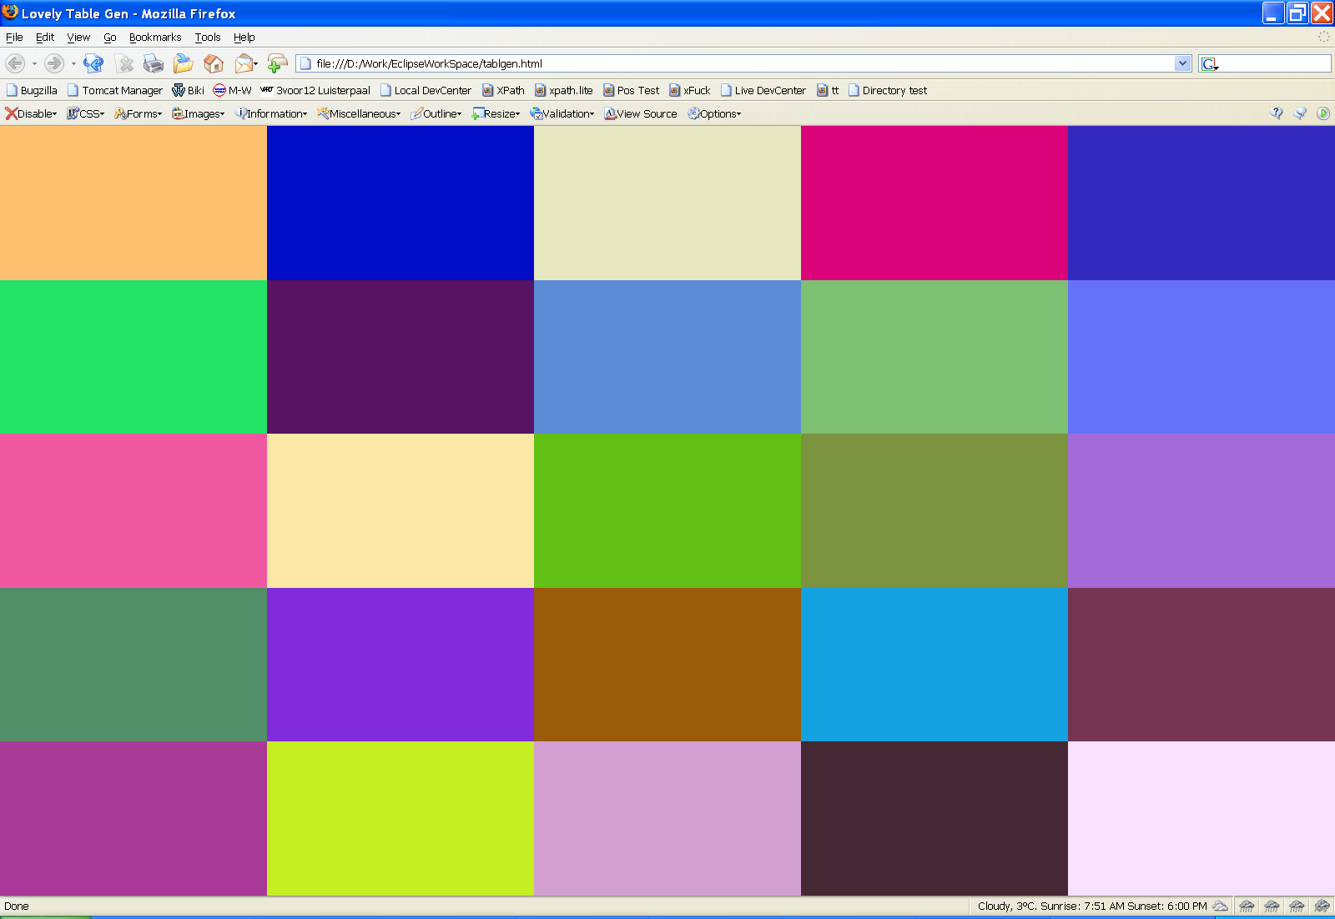**Screen shot with example of screen.**

**Bonus Points** are available. Suggestions for obtaining bonus points:

Update the screen, giving it a fresh set of colors at a fixed interval; e.g. every 2 seconds.

Allow the user to specify the number of rows, the number of columns and even the duration of the timeout, before you create the grid.

**Points to consider:**

It's got to perform.

We hate Page Reloads. Think SPI (Single Page Interface).

Ideally you should think of this page being a module within a larger system.