1.
#include <stdio.h>
#include <string.h>
int main( ) {

char str[100];
int arr [10];
char *token;
printf( "Enter a text :");
fgets(str, 100, stdin);
for(int i = strlen(str);i >= 0;i--){
printf("%c",str[i]);
}
printf("\n");

return 0;
}

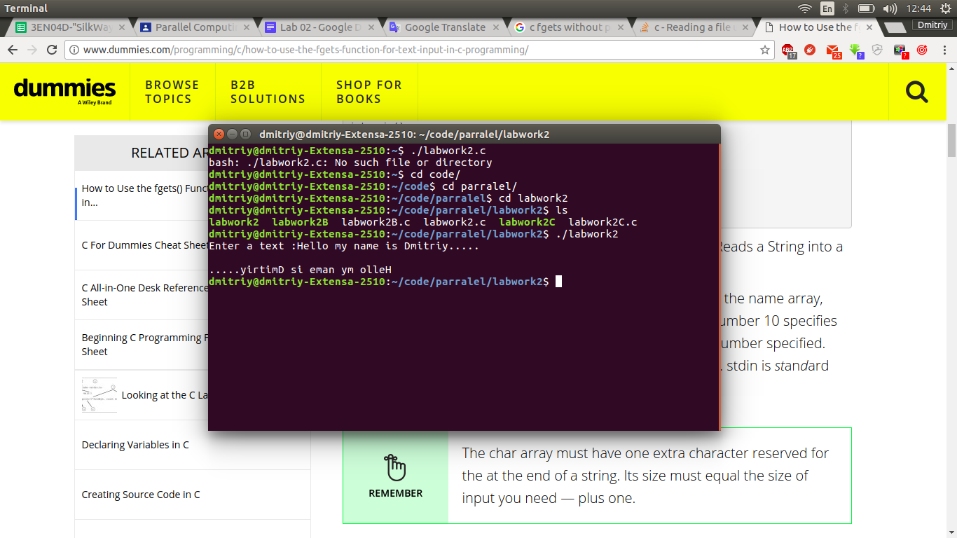

2.
/* strtok example */
#include <stdio.h>
#include <string.h>
#include <stdlib.h>

int main ()
{
char str[1000];
char * tok;
int n [1000];
int t = 0;
printf( "Enter numbers :");
fgets(str, 100, stdin);
tok = strtok (str," ");
int s;
while (tok != NULL)
{
int num = atoi(tok);
n[t] = num;
t++;
tok = strtok (NULL, " ");
}
for (int i = 0; i < t-1;i++){
for (int j = i +1; j < t;j++){
if(n[i] > n[j]){
int temp = n[i];
n[i] = n[j];
n[j] =temp;
}
}
}
for (int i = 0; i < t; i ++){
printf("%d ",n[i]);
}
printf("\n");
return 0;
}
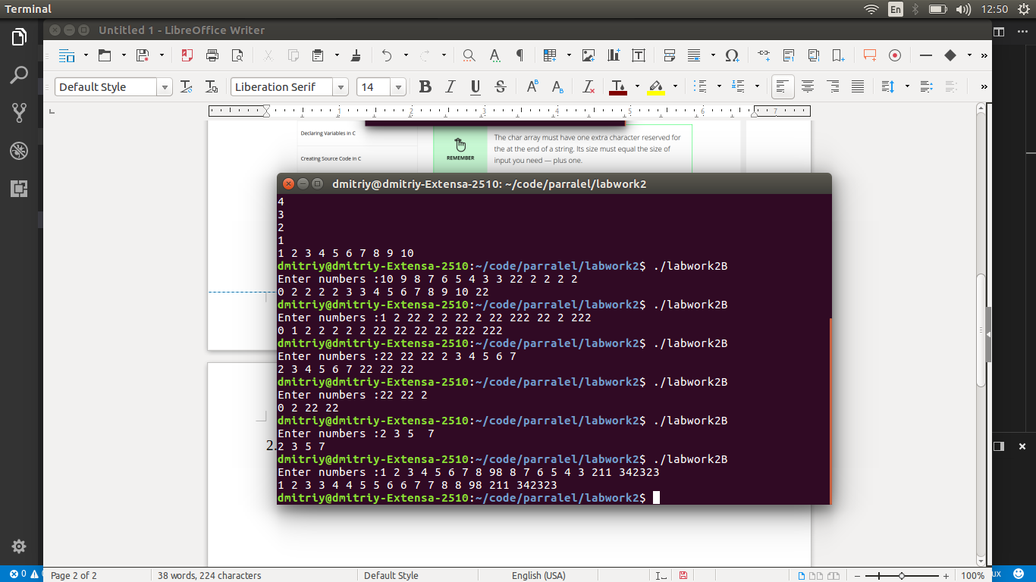

3.
/* strtok example */
#include <stdio.h>
#include <string.h>
#include <time.h>
#include <stdlib.h>
#include <ctype.h>

int main ()
{

char article[5][10] = {"the","a","one","some","any"};
char noun[5][10] = { "boy","girl", "dog","town","car"};
char verb[5][10] = {"drove","jumped","ran","walked","skipped"};
char preposition[5][10] = {"to","from","over","under","on"};
int size;
time_t ti;
size = 5;
/* Intializes random number generator */
srand((unsigned)time(&ti));

/* Print 5 random numbers from 0 to 49 */
for( int i = 0 ; i < 20 ; i++ ) {
int temp = rand() % size;
article[temp][0] = (char)((int)article[temp][0]-32);
printf("%s ",article[temp]);
article[temp][0] = (char)((int)article[temp][0]+32);
printf("%s ",noun[rand() % size]);
printf("%s ",verb[rand() % size]);
printf("%s ",preposition[rand() % size]);
printf("%s ",article[rand() % size]);
printf("%s. \n",noun[rand() % size]);
}
//article, noun, verb, preposition, article and noun
return 0;
}
