1 st lab

#include <stdio.h>
#include <string.h>
#include <time.h>
#include <stdlib.h>
#include <ctype.h>

int main (int argc, char** argv)
{
char symb ;
unsigned char symb1;
char *s = "";
int num=0;
char * str2;
int count=0;
int i=0;
int sum = 0;

// FILE file = fopen(argv[1], "r");
FILE *FileIn= fopen(argv[1], "r");

if(FileIn == NULL){
printf("Error opening file");
}
//fscanf (file, "%d", &i);
// (symb=getc(FileIn))!=EOF
while ((symb=getc(FileIn))!=EOF)
{
//fscanf (file, "%d", &i);
//printf ("%d ", i);
if( isdigit( symb ) != 0 || symb == ' ' || symb == '\n' || symb =='-'){
size_t len = strlen(s);
str2 = malloc(len + 1 + 1 );
strcpy(str2, s);
str2[len] = symb;
str2[len + 1] = '\0';
//strcat( s, symb);
s = str2;
//printf("%s",s);
}
// if( isdigit(symb) != 0 ){
// size_t len = strlen(s);
// char *str2 = malloc(len + 1 + 1 );
// strcpy(str2, s);
// str2[len] = symb;
// str2[len + 1] = '\0';
// //strcat( s, symb);
// printf("%s",s);
// }
}
while (sscanf(s, "%d%n", &num,&i) == 1){
//printf ("number: %d\n",num);
sum = sum + num;
s+=i;
count++;
}
printf ("%d\n",sum);
// while (fgets(buff,1000, file)!=NULL)
// printf("%s",buff);
fclose(FileIn);
return 0;
}

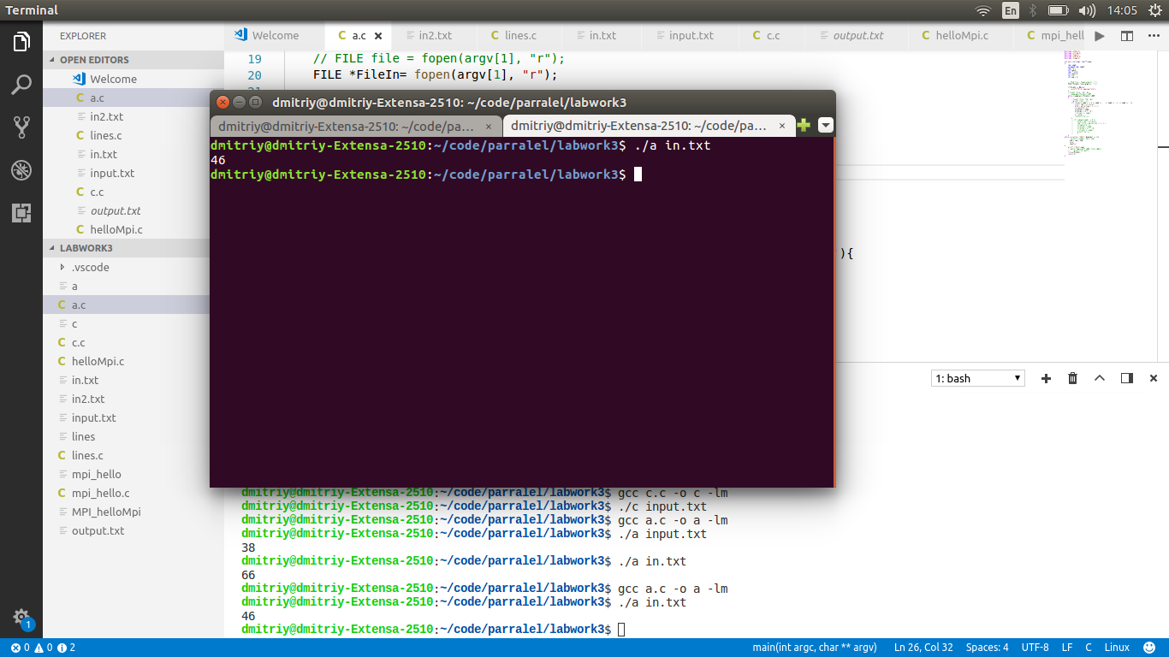

2 nd work

#include <stdio.h>
#include <string.h>
#include <time.h>
#include <stdlib.h>
#include <ctype.h>

int main (int argc, char** argv)
{
char symb ;
char symb1;
int count1=0;
int count2 = 0;
FILE *FileIn= fopen(argv[1], "r");
FILE *FileIn2= fopen(argv[2], "r");
if(FileIn == NULL){
printf("Error opening file");
}
while ((symb=getc(FileIn))!=EOF)
{
if(symb == '\n'){
count1++;
}
}
while ((symb1=getc(FileIn2))!=EOF)
{
if(symb1 == '\n'){
count2++;
}
}
printf("%d %d\n",count1,count2);
fclose(FileIn);
return 0;
}
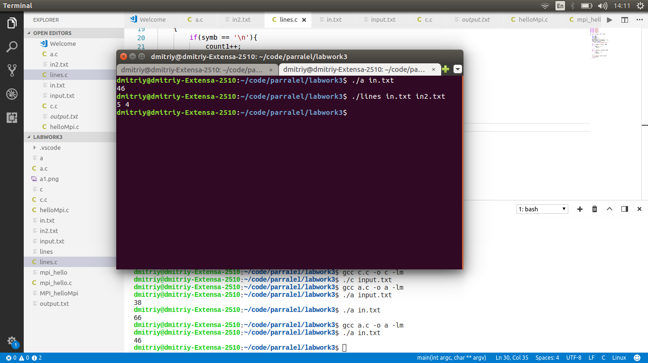

3 rd work
#include <stdio.h>
#include <string.h>
#include <time.h>
#include <stdlib.h>
#include <ctype.h>

int main (int argc, char** argv)
{
char symb ;
char symb1;
char *s = "";
int num=0;
int j = 0;
int numbers[1000];
char * str2;
int count=0;
int i=0;
int sum = 0;

// FILE file = fopen(argv[1], "r");
FILE *FileIn= fopen(argv[1], "r");

if(FileIn == NULL){
printf("Error opening file");
}
//fscanf (file, "%d", &i);
// (symb=getc(FileIn))!=EOF
while ((symb=getc(FileIn))!=EOF)
{
//fscanf (file, "%d", &i);
//printf ("%d ", i);
if( isdigit( symb ) != 0 || symb == ' ' || symb == '\n' || symb == '-'){
size_t len = strlen(s);
str2 = malloc(len + 1 + 1 );
strcpy(str2, s);
str2[len] = symb;
str2[len + 1] = '\0';
//strcat( s, symb);
s = str2;
//printf("%s",s);
}
// if( isdigit(symb) != 0 ){
// size_t len = strlen(s);
// char *str2 = malloc(len + 1 + 1 );
// strcpy(str2, s);
// str2[len] = symb;
// str2[len + 1] = '\0';
// //strcat( s, symb);
// printf("%s",s);
// }
}
while (sscanf(s, "%i%n", &num,&i) == 1){
numbers[j] = num;
s+=i;
count++;
j++;
}
int n = numbers[0];
int m = numbers[1];
int n2 = 2;
int n3 = n2;
int m2 = 2;
int m3 = m2;
int arr [1000];
int arr2[1000];
int col = 0;
int row = 0;
for(int i = 0; i < n;i++){
int ar2 [m];
for (int j =0; j< m; j++){
ar2[j] = numbers[m2];
m2++;
}
for (int y = 0; y< m-1; y++){
for (int y2 = y+1;y2 < m;y2++){
if (ar2[y] > ar2[y2]){
int temp = ar2[y];
ar2[y] = ar2[y2];
ar2[y2] = temp;
}
}
}
int temp2 = ar2[0];
arr[row] = temp2;
row++;

// printf("\n");
}
// for (int j =0; j< row; j++){
// printf("%i",arr[j]);
// }
// printf("\n");

for (int i = 0; i < m;i++){
int ar [n];
for (int j = 0;j< n;j++){
ar[j]=numbers[n2];
n2 = n2+m;
}
for (int y = 0; y< n-1; y++){
for (int y2 = y+1;y2 < n;y2++){
if (ar[y] > ar[y2]){
int temp = ar[y];
ar[y] = ar[y2];
ar[y2] = temp;
}
}
}
int temp3 = ar[0];
arr2[col] = temp3;
col++;

// printf("\n");

// for (int y = 0; y< n; y++){
// printf("%i",ar[y]);
// }
// printf("\n");
n3++;
n2 = n3;

}
// for (int j =0; j< col; j++){
// printf("%i",arr2[j]);
// }
//3 5 1 2 3 4 5 2 3 4 5 5 3 4 5 -1 5
//printf ("%d\n",sum);
// while (fgets(buff,1000, file)!=NULL)
// printf("%s",buff);
fclose(FileIn);
FILE * fp;
/* open the file for writing*/
fp = fopen ("output.txt","w");
/* write 10 lines of text into the file stream*/
fprintf (fp, "minimum by column: ");
for(int i = 0; i < col;i++){
fprintf (fp, "%d ",arr2[i]);
}
fprintf (fp, "\n");
fprintf (fp, "minimum by row: ");
for(int i = 0; i < row;i++){
fprintf (fp, "%d ",arr[i]);
}
fprintf (fp, "\n");
/* close the file*/
fclose (fp);
return 0;
}

