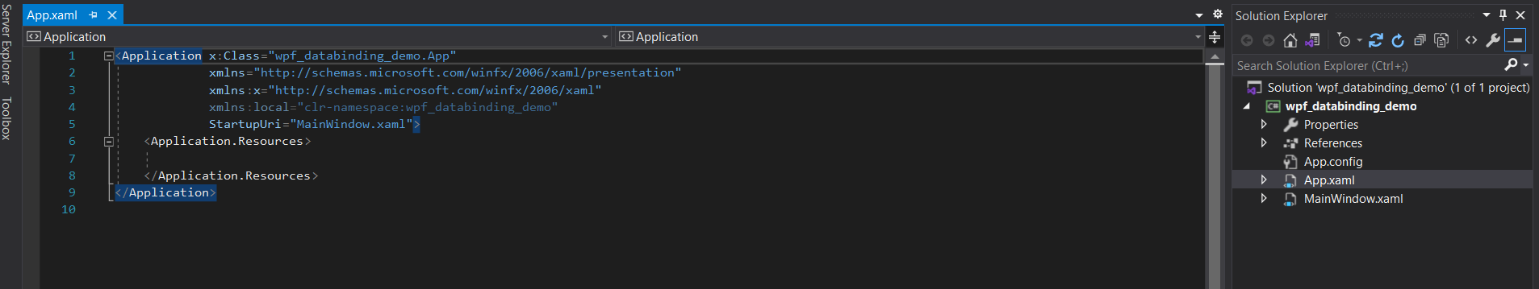

<Window x:Class="wpf_databinding_demo.MainWindow"

xmlns="http://schemas.microsoft.com/winfx/2006/xaml/presentation"

xmlns:x="http://schemas.microsoft.com/winfx/2006/xaml"

xmlns:d="http://schemas.microsoft.com/expression/blend/2008"

xmlns:mc="http://schemas.openxmlformats.org/markup-compatibility/2006"

xmlns:local="clr-namespace:wpf_databinding_demo"

mc:Ignorable="d" FontSize="18"

Title="MainWindow" Height="450" Width="800">

<Grid>

<Grid.ColumnDefinitions>

<ColumnDefinition Width="20"/>

<ColumnDefinition Width="auto"/>

<ColumnDefinition Width="auto"/>

<ColumnDefinition Width="auto"/>

<ColumnDefinition Width="*"/>

<ColumnDefinition Width="20"/>

</Grid.ColumnDefinitions>

<Grid.RowDefinitions>

<RowDefinition Height="20"/>

<RowDefinition Height="auto"/>

<RowDefinition Height="auto"/>

<RowDefinition Height="auto"/>

<RowDefinition Height="*"/>

<RowDefinition Height="20"/>

</Grid.RowDefinitions>

<TextBlock Grid.Column="1" Grid.Row="1" Grid.ColumnSpan="3" FontSize="36" Margin="0,10" >Data Binding</TextBlock>

<TextBlock Grid.Column="1" Grid.Row="2" Margin="5" >First Name</TextBlock>

<TextBox x:Name="txtFirstName" Grid.Column="2" Grid.Row="2" Margin="5" Width="350" Text="{Binding Path=FirstName, Mode=TwoWay, UpdateSourceTrigger=PropertyChanged}" ></TextBox>

<TextBlock x:Name="lblFirstName" Grid.Column="2" Grid.Row="3" Margin="5" FontSize="30"

Text="{Binding Path=FirstName, Mode=TwoWay, UpdateSourceTrigger=PropertyChanged}"></TextBlock>

</Grid>

</Window>

