1)

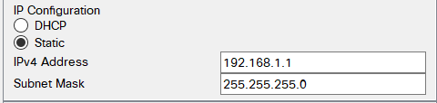

Subnet mask: 255.255.255.0 means 3 bytes describe the network and last byte describes the host.

255.255.0.0 means 2 bytes describe the network and last two bytes describe the host.

2)

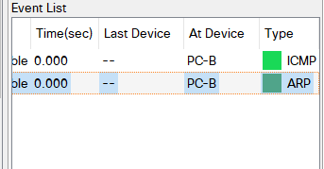

Initially to know the mac address an arp packet is send. After finding the destination mac only the data packet is send. After mac address being known data packets can be send directly without any arp packets for certain period of time.

After certain amount of time arp cache(ram memory allocated) is emptied.

3)

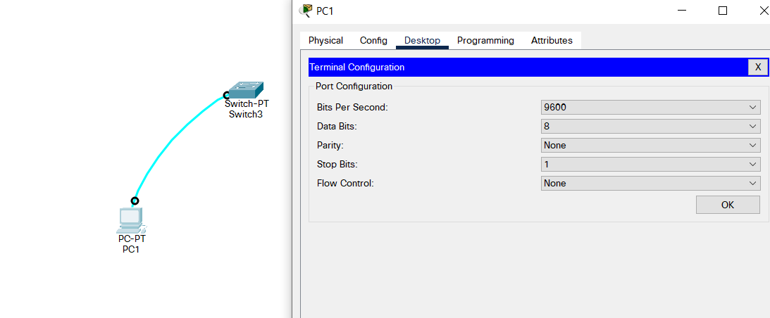

4)Terminal command when setting a switch

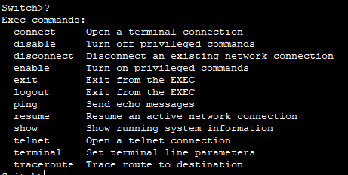

5)enable & to exit



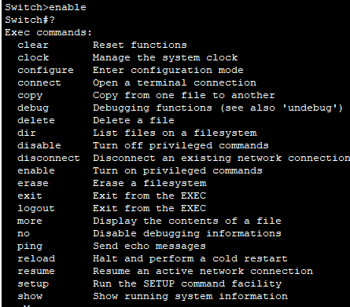



6)Verify Default Switch Configuration

If a wrong input was entered, to get rid of the lock up press ***ctrl+shit+6***

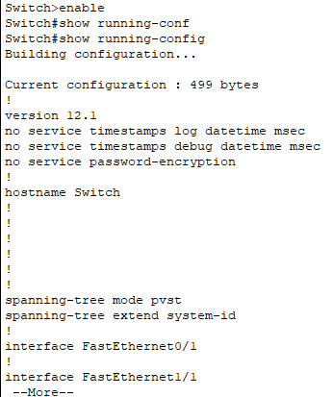

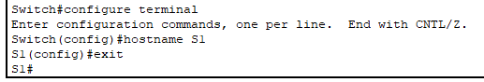

Set up password for login

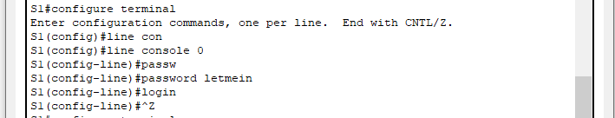

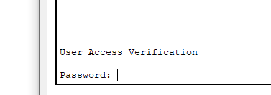

Enable password for editing privileges

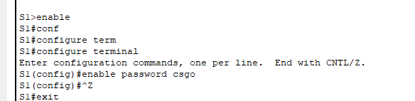

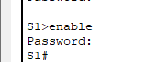

This below command overrides the password for editing privileges

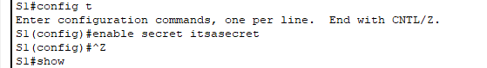

To hide the password when entered

To display a banner when login in

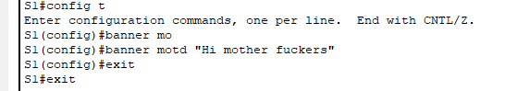

To save all the configurations we made

