1. Classes and constructors

OR

Output:

__________________________________________________________________________________

2)inheritance

3)

To check the files in directory,to make directory, to rm directory

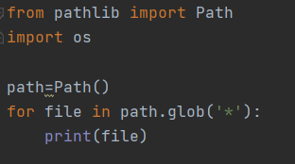

4)spit words

5)Reading excel file’s column in terminal

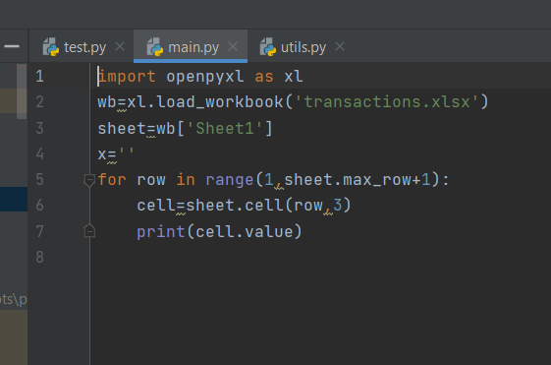

­6)Update tables with new cells

7)Add bar charts to values of excel coumns

**Using jupyter (pandas)**

**Numpy in jupyter**

**1)**

**2)**

**3)**

**4)**

**5)**

**6)**

**7)**

**8)**

**9)**

**10)**

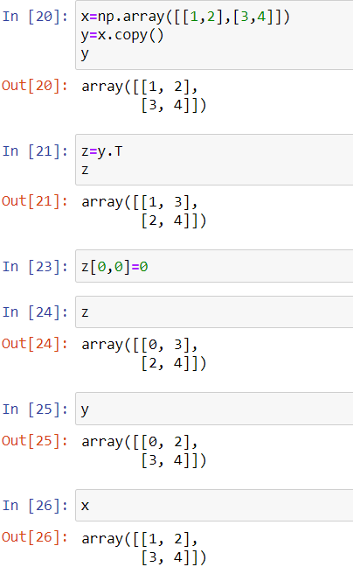

**11)**

**12).**

**13)**

**14)**

**15)**

**Pandas**

**16)**

**17)**

**18)**

**19)**

**20)**

**21)**

**Matplotlib**

**22)**

**23)**

**24)Boxplot**

**25)**

**26)**

**27)**

