Bullish Patterns
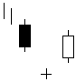  Abandoned Baby | 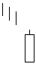  Belt Hold | 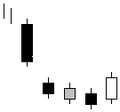  Breakaway
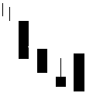  Concealing Baby Swallow | 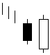  Engulfing | 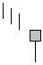  Hammer/  Dragonfly Doji
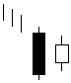  Harami | 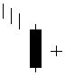  Harami Cross | 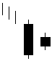  Homing Pigeon
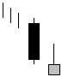  Inverted Hammer/  Gravestone Doji | 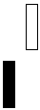  Kicking | 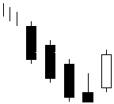  Ladder Bottom
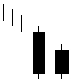  Matching Low | 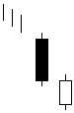  Meeting Lines | 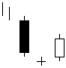  Morning Doji Star
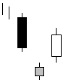  Morning Star | 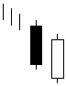  Piercing Line | 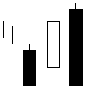  Stick Sandwich
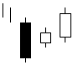  Three Inside Up | 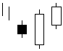  Three Outside Up | 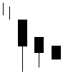  Three Stars In The South
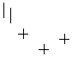  Tri Star | 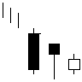  Unique Three River Bottom | 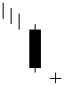  Doji Star
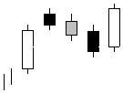  Mat Hold | 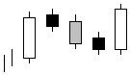  Rising Three Methods | 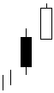  Separating Lines
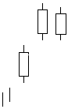  Side By Side White Lines | 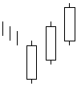  Three White Soldiers | 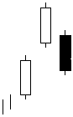  Upside Gap Three Methods
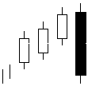  Three Line Strike |  | 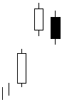  Upside Tasuki Gap

Bearish Patterns
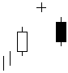  Abandoned Baby | 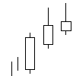  Advance Block | 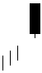  Belt Hold
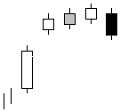  Breakaway | 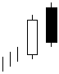  Dark Cloud Cover | 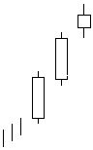  Deliberation
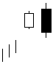  Engulfing | 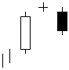  Evening Doji Star | 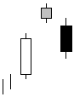  Evening Star
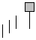  Hanging Man/  Dragonfly Doji | 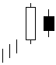  Harami | 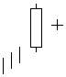  Harami Cross
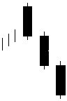  Identical Three Crows | 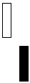  Kicking | 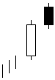  Meeting Lines
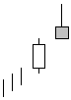  Shooting Star/  Gravestone Doji | 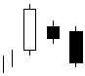  Three Inside Down | 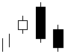  Three Outside Down
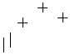  Tri Star | 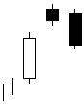  Two Crows | 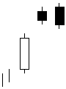  Upside Gap Two Crows
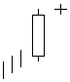  Doji Star | 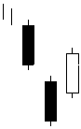  Downside Gap Three Methods | 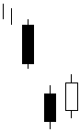  Downside Tasuki Gap
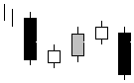  Falling Three Methods | 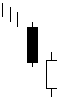  In Neck | 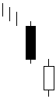  On Neck
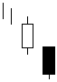  Separating Lines | 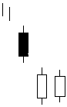  Side By Side White Lines | 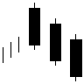  Three Black Crows
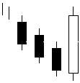  Three Line Strike |  | 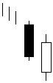  Thrusting

