**Creating and editing a project**

**Creating a project**

To create a project, first navigate to the opening webpage of GeoSight and click on “Admin” on the top right dropdown menu. Then go to the “Project” pan on the left and click on “Add new Project”.

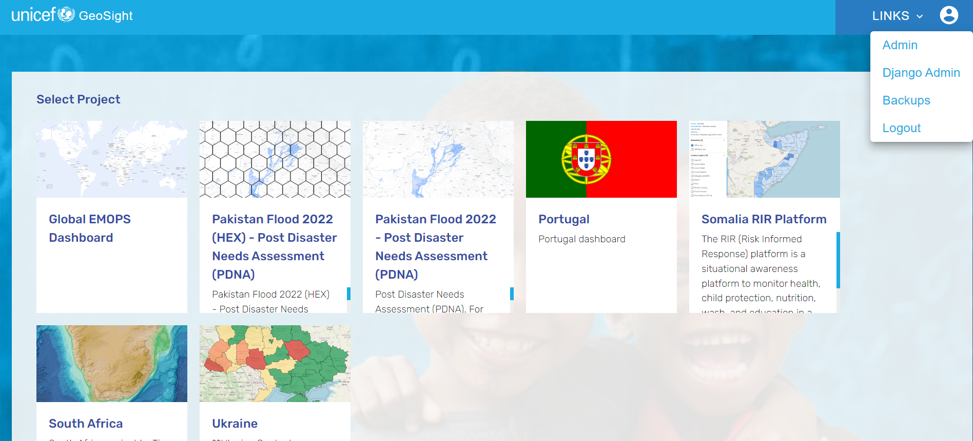

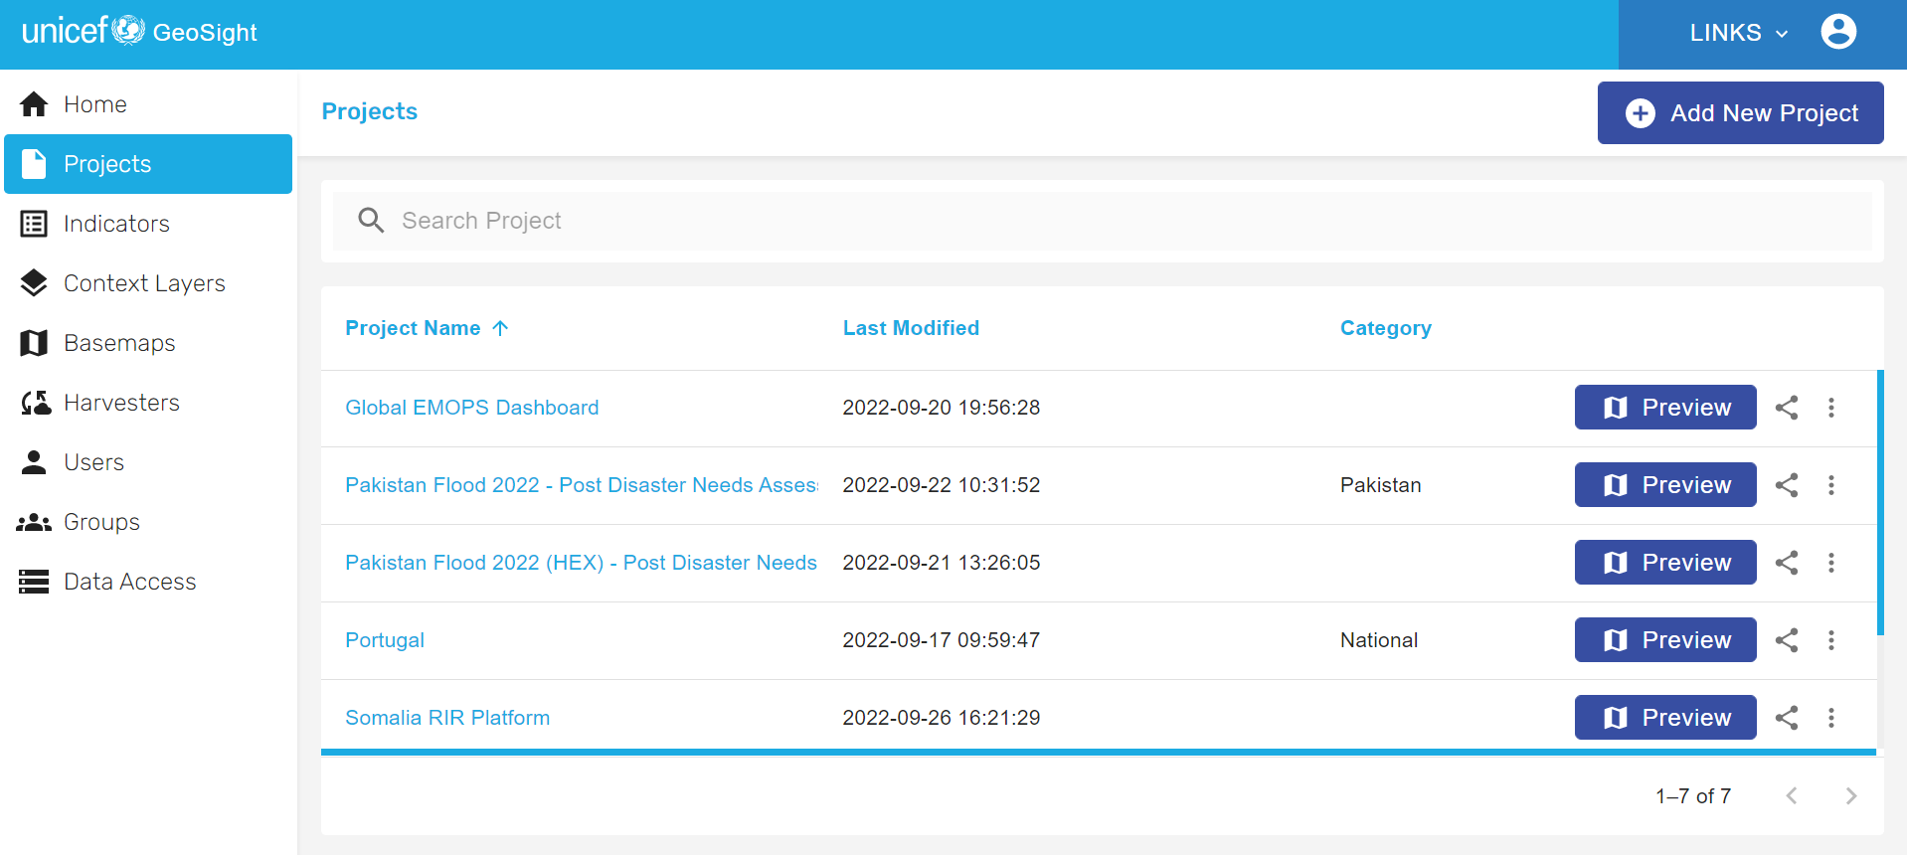

A series of tab will open. In the “summary” tab you can give your project a **name** and a custom **geographic extent** and select its **reference** **dataset.** If your project includes global data, select “World”. Additionally, in the other tabs you can add and manage indicators, context layers, basemaps, filters and widgets. All these functionalities will be subjects of further tutorials.

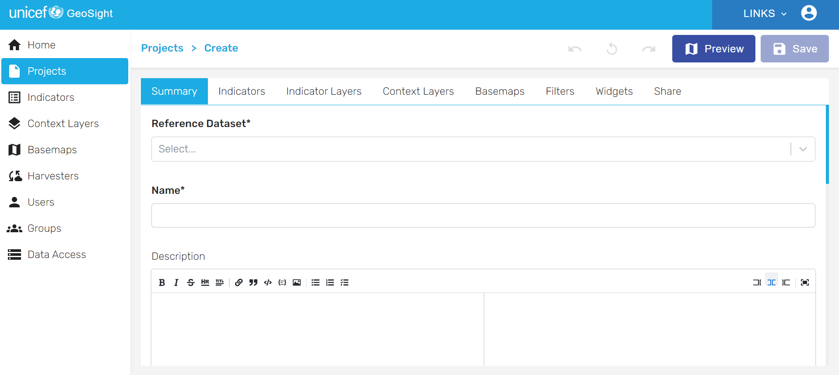

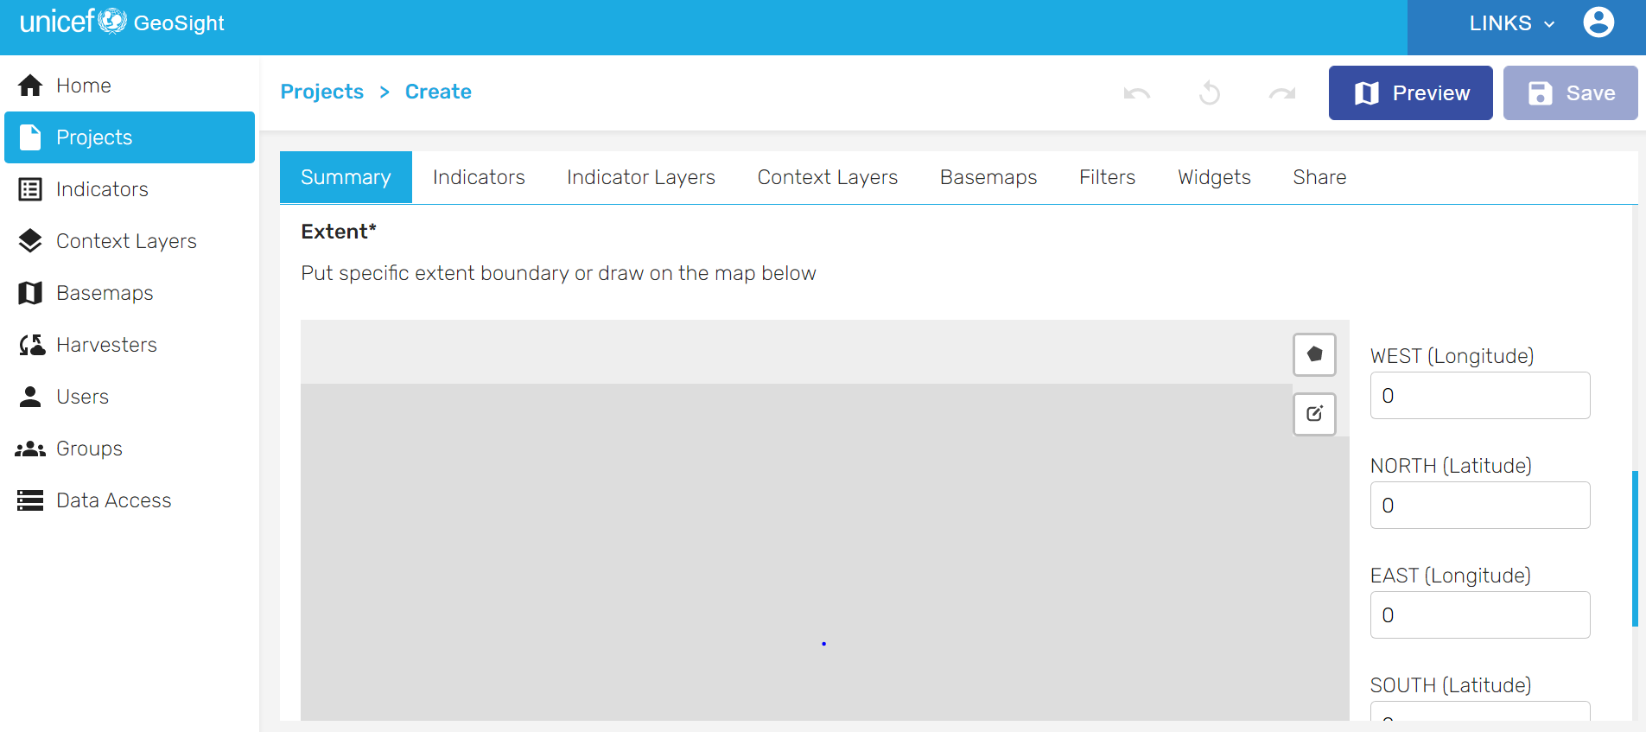

Once you have completed this operation, your newly created project will automatically appear among the projects in the Project list.

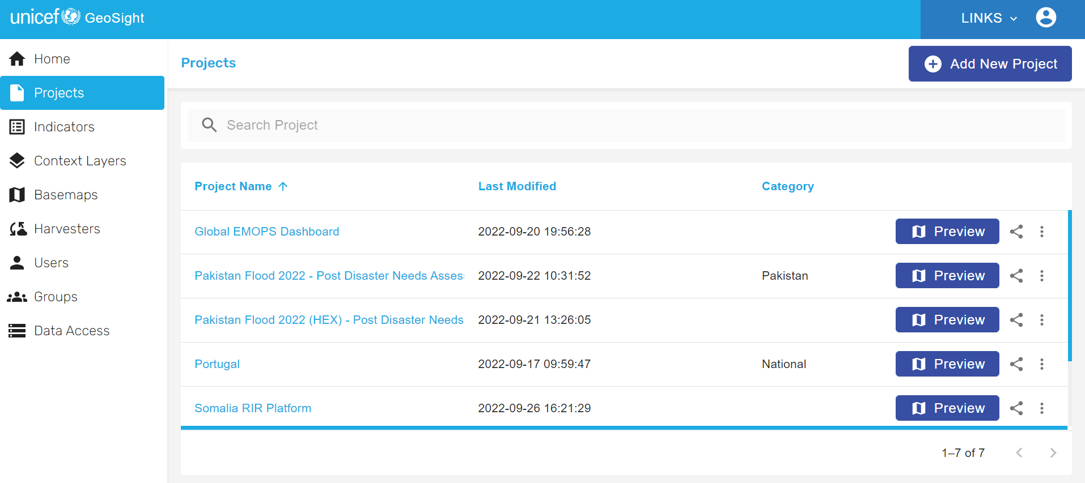

**Editing a project**

To edit a project, simply navigate to the other tabs in the “Project” pane. Under the tab “indicator layers” you can add indicators that you then will manage in the “indicator” tab as shown (see “Add Indicator” tutorial). You can also **add, remove or change the visibility of context layers and basemaps** (see “Add context layers” and “Add basemaps” tutorials), or **assign filters** to manage access and visibility of certain data for certain user. Finally, you can **add widgets** to your projects to expand its functionalities, or **share it with external viewers.**

