Laboratory work #2

Part A. Normalization

Task 1. Normal-form violations
Booking_receipt is not in 1NF because seat_numbers may contain a list such as "12A, 12B" in one cell. 1NF requires one atomic value in each cell. The original table therefore cannot be in 2NF or 3NF either.
After splitting the list into passenger-seat rows, there are still partial dependencies: booking_id determines the flight, while passenger_passport_number determines passenger_full_name. Flight and airport information creates transitive dependencies. These problems are solved in Tasks 2 and 3.
Assumption: each passenger has one assigned seat per booking and ticket_price is the price of one passenger ticket. A receipt with two seat numbers needs the passenger manifest to identify which seat belongs to which passenger.

Task 2. Step-by-step normalization
Notation: underlined = Primary Key (PK); bold = Foreign Key (FK). Underlined and bold means the column is both PK and FK.

1NF - one seat in each row
Booking_receipt_1NF(booking_id, passenger_passport_number, passenger_full_name, flight_number, departure_airport_name, departure_city, arrival_airport_name, arrival_city, airline_name, seat_number, ticket_price)
One row represents one passenger on one booking. For booking 101, the seats 12A and 12B become separate rows. There are no foreign keys yet.

2NF - separate facts depending on part of the key
Booking_2NF(booking_id, flight_number, departure_airport_name, departure_city, arrival_airport_name, arrival_city, airline_name)
Passenger_2NF(passenger_passport_number, passenger_full_name)
Booking_ticket_2NF(booking_id, passenger_passport_number, seat_number, ticket_price)
Booking_ticket_2NF.booking_id -> Booking_2NF.booking_id; Booking_ticket_2NF.passenger_passport_number -> Passenger_2NF.passenger_passport_number. This removes partial dependencies, but Booking_2NF still contains repeated flight and airport facts.

3NF - separate flight, airport, and airline facts
Airline(airline_id, airline_name)
Airport(airport_id, airport_name, city)
Flight(flight_number, departing_airport_id, arriving_airport_id, airline_id)
Booking(booking_id, flight_number)
Passenger(passenger_passport_number, passenger_full_name)
Booking_ticket(booking_id, passenger_passport_number, seat_number, ticket_price)
Flight has two different foreign keys to Airport, one for departure and one for arrival. It also references Airline. Booking references Flight, while Booking_ticket references Booking and Passenger.
For this small exercise, flight_number identifies one flight instance. In a real airline system the same number is reused on other dates, so flight_id or a date-based composite key would be needed.

Task 3. Functional dependencies
booking_id -> flight_number
passenger_passport_number -> passenger_full_name
(booking_id,passenger_passport_number) -> seat_number,ticket_price
flight_number -> departure_airport_name,arrival_airport_name,airline_name
departure_airport_name -> departure_city
arrival_airport_name -> arrival_city
flight_number -> departing_airport_id,arriving_airport_id,airline_id (in 3NF)
airport_id -> airport_name,city (in 3NF)
airline_id -> airline_name (in 3NF)
1NF removes the repeated seat list. 2NF removes booking-only and passenger-only data from the composite-key table. 3NF separates flight and airport details so that non-key columns no longer determine other non-key columns in the same table.

Task 4. Is Flights in 3NF?
Yes, based on the specified structure. The primary key is flight_id. Its functional dependency is:
flight_id -> sch_departure_time,sch_arrival_time,departing_airport_id,arriving_airport_id,departing_gate,arriving_gate,airline_id,act_departure_time,act_arrival_time,created_at,updated_at
Flights stores airport and airline IDs, not airport_name,city or airline_name. Those details are stored in Airport and Airline. No transitive dependency among the listed non-key columns is shown in Flights. A one-column primary key also means there are no partial key dependencies.

Task 5. Implement the 3NF tables and insert sample data
The sample starts with 5 bookings and 7 passenger tickets. Two bookings contain two passengers. It becomes 5 airlines, 6 airports, 5 flights, 5 bookings, 7 passengers and 7 tickets after normalization. All names and passport numbers are fictional.

A. Source data expanded into 1NF
The following CREATE TABLE and INSERT statements record the seven source rows before splitting the data into 3NF tables.
CREATE TABLE receipt_3nf.raw_booking_receipt_1nf(
booking_id INT NOT NULL,
passenger_full_name VARCHAR(100) NOT NULL,
passenger_passport_number VARCHAR(20) NOT NULL,
flight_number VARCHAR(15) NOT NULL,
departure_airport_name VARCHAR(100) NOT NULL,
departure_city VARCHAR(50) NOT NULL,
arrival_airport_name VARCHAR(100) NOT NULL,
arrival_city VARCHAR(50) NOT NULL,
airline_name VARCHAR(50) NOT NULL,
seat_number VARCHAR(10) NOT NULL,
ticket_price NUMERIC(7,2) NOT NULL,
PRIMARY KEY(booking_id,passenger_passport_number)
);
INSERT INTO receipt_3nf.raw_booking_receipt_1nf VALUES
(101,'Aida Sadykova','SAMPLE001','KC101','Almaty International','Almaty',
'Astana International','Astana','Air Astana','12A',42000.00),
(101,'Timur Sadykov','SAMPLE002','KC101','Almaty International','Almaty',
'Astana International','Astana','Air Astana','12B',42000.00),
(102,'Dana Omarova','SAMPLE003','DV201','Astana International','Astana',
'Shymkent International','Shymkent','SCAT Airlines','15C',28000.00),
(103,'Miras Aliev','SAMPLE004','TK351','Almaty International','Almaty',
'Istanbul Airport','Istanbul','Turkish Airlines','14C',97500.00),
(103,'Aruzhan Bek','SAMPLE005','TK351','Almaty International','Almaty',
'Istanbul Airport','Istanbul','Turkish Airlines','14D',97500.00),
(104,'Nura Kim','SAMPLE006','LH649','Astana International','Astana',
'Frankfurt Airport','Frankfurt','Lufthansa','8A',89000.00),
(105,'Adil Nur','SAMPLE007','QR390','Almaty International','Almaty',
'Hamad International','Doha','Qatar Airways','9F',94000.00);
SELECT * FROM receipt_3nf.raw_booking_receipt_1nf
ORDER BY booking_id,seat_number;
Screenshot 1. 1NF source records - 7 passenger-seat rows.
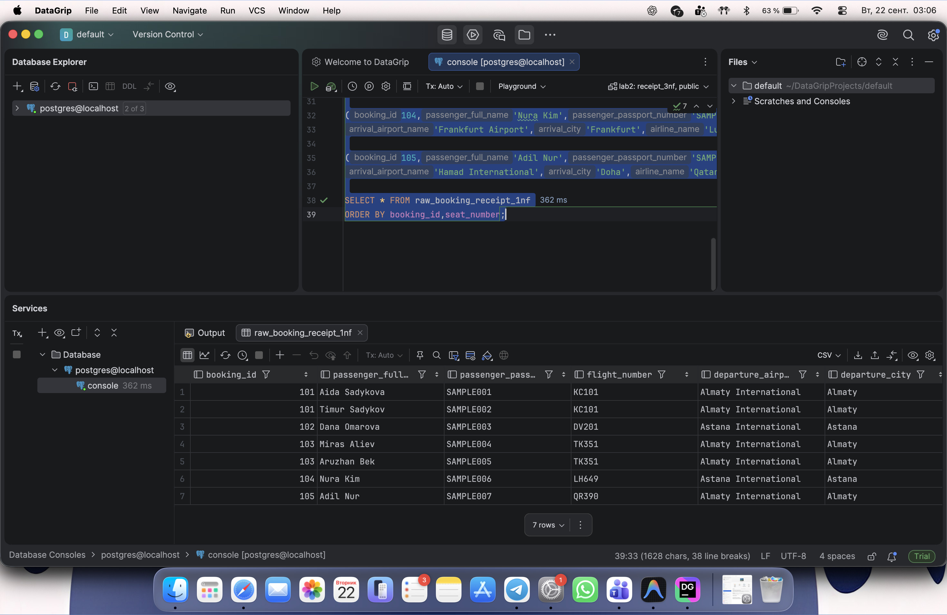

B. Create six final 3NF tables
CREATE TABLE receipt_3nf.airline(
airline_id INT PRIMARY KEY,
airline_name VARCHAR(50) NOT NULL UNIQUE
);
CREATE TABLE receipt_3nf.airport(
airport_id INT PRIMARY KEY,
airport_name VARCHAR(100) NOT NULL UNIQUE,
city VARCHAR(50) NOT NULL
);
CREATE TABLE receipt_3nf.flight(
flight_number VARCHAR(15) PRIMARY KEY,
departing_airport_id INT NOT NULL REFERENCES receipt_3nf.airport(airport_id),
arriving_airport_id INT NOT NULL REFERENCES receipt_3nf.airport(airport_id),
airline_id INT NOT NULL REFERENCES receipt_3nf.airline(airline_id)
);
CREATE TABLE receipt_3nf.booking(
booking_id INT PRIMARY KEY,
flight_number VARCHAR(15) NOT NULL REFERENCES receipt_3nf.flight(flight_number)
);
CREATE TABLE receipt_3nf.passenger(
passenger_passport_number VARCHAR(20) PRIMARY KEY,
passenger_full_name VARCHAR(100) NOT NULL
);
CREATE TABLE receipt_3nf.booking_ticket(
booking_id INT NOT NULL REFERENCES receipt_3nf.booking(booking_id),
passenger_passport_number VARCHAR(20) NOT NULL
REFERENCES receipt_3nf.passenger(passenger_passport_number),
seat_number VARCHAR(10) NOT NULL,
ticket_price NUMERIC(7,2) NOT NULL,
PRIMARY KEY(booking_id,passenger_passport_number),
UNIQUE(booking_id,seat_number)
);
Screenshot 2. CREATE TABLE statements executed in DataGrip.
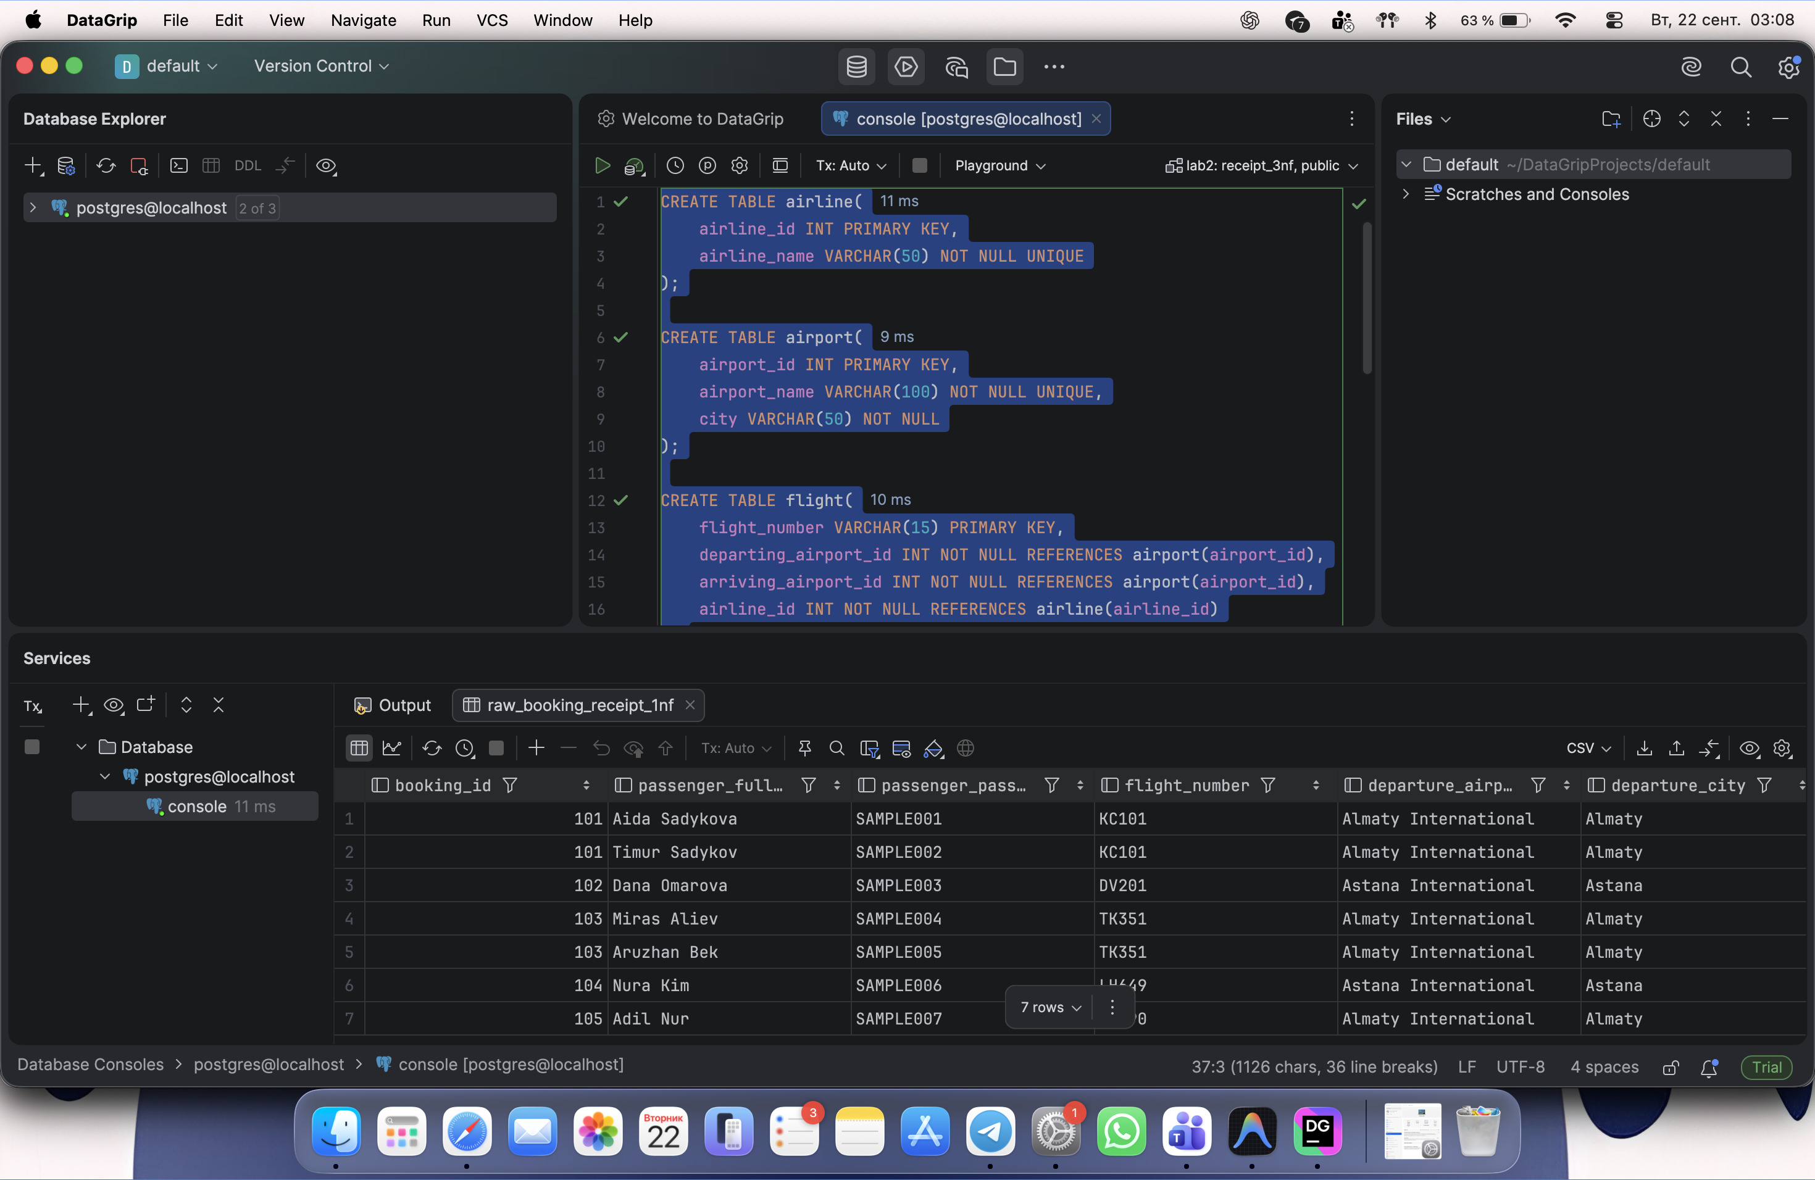

C. Populate the 3NF tables from the source
INSERT INTO receipt_3nf.airline(airline_id,airline_name)
SELECT ROW_NUMBER() OVER(ORDER BY airline_name),airline_name
FROM(SELECT DISTINCT airline_name
FROM receipt_3nf.raw_booking_receipt_1nf) AS a;
INSERT INTO receipt_3nf.airport(airport_id,airport_name,city)
SELECT ROW_NUMBER() OVER(ORDER BY airport_name),airport_name,city
FROM(
SELECT departure_airport_name AS airport_name,departure_city AS city
FROM receipt_3nf.raw_booking_receipt_1nf
UNION
SELECT arrival_airport_name,arrival_city
FROM receipt_3nf.raw_booking_receipt_1nf
) AS a;
INSERT INTO receipt_3nf.flight(
flight_number,departing_airport_id,arriving_airport_id,airline_id
)
SELECT DISTINCT r.flight_number,d.airport_id,a.airport_id,al.airline_id
FROM receipt_3nf.raw_booking_receipt_1nf r
JOIN receipt_3nf.airport d
ON r.departure_airport_name=d.airport_name
JOIN receipt_3nf.airport a
ON r.arrival_airport_name=a.airport_name
JOIN receipt_3nf.airline al
ON r.airline_name=al.airline_name;
INSERT INTO receipt_3nf.booking(booking_id,flight_number)
SELECT DISTINCT booking_id,flight_number
FROM receipt_3nf.raw_booking_receipt_1nf;
INSERT INTO receipt_3nf.passenger(
passenger_passport_number,passenger_full_name
)
SELECT DISTINCT passenger_passport_number,passenger_full_name
FROM receipt_3nf.raw_booking_receipt_1nf;
INSERT INTO receipt_3nf.booking_ticket(
booking_id,passenger_passport_number,seat_number,ticket_price
)
SELECT booking_id,passenger_passport_number,seat_number,ticket_price
FROM receipt_3nf.raw_booking_receipt_1nf;
Screenshot 3. INSERT...SELECT statements executed.
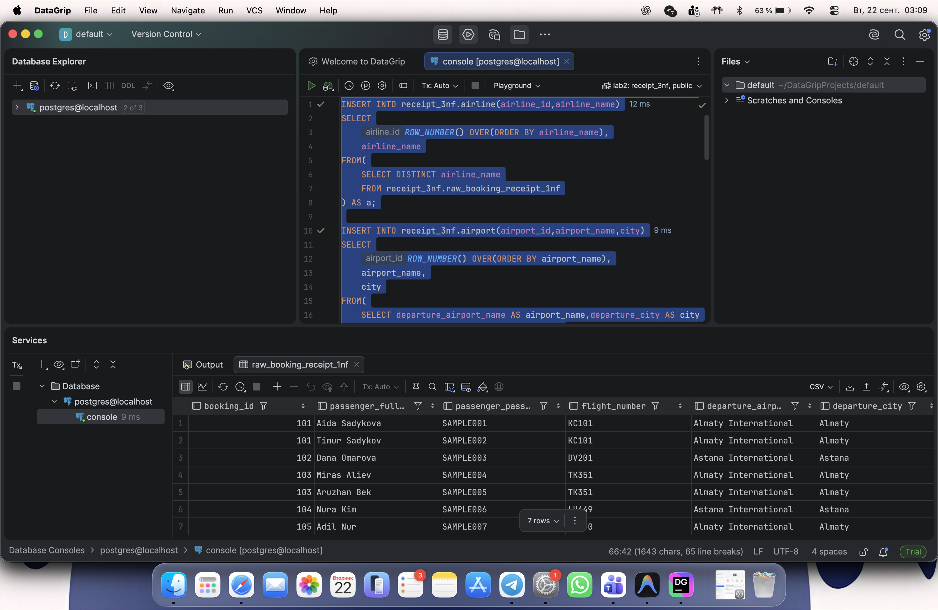

D. Check all six tables
SELECT 'airline' AS table_name,COUNT(*) AS total_rows FROM receipt_3nf.airline
UNION ALL SELECT 'airport',COUNT(*) FROM receipt_3nf.airport
UNION ALL SELECT 'flight',COUNT(*) FROM receipt_3nf.flight
UNION ALL SELECT 'booking',COUNT(*) FROM receipt_3nf.booking
UNION ALL SELECT 'passenger',COUNT(*) FROM receipt_3nf.passenger
UNION ALL SELECT 'booking_ticket',COUNT(*) FROM receipt_3nf.booking_ticket;
Screenshot 4. The six 3NF tables contain 5, 6, 5, 5, 7 and 7 rows.
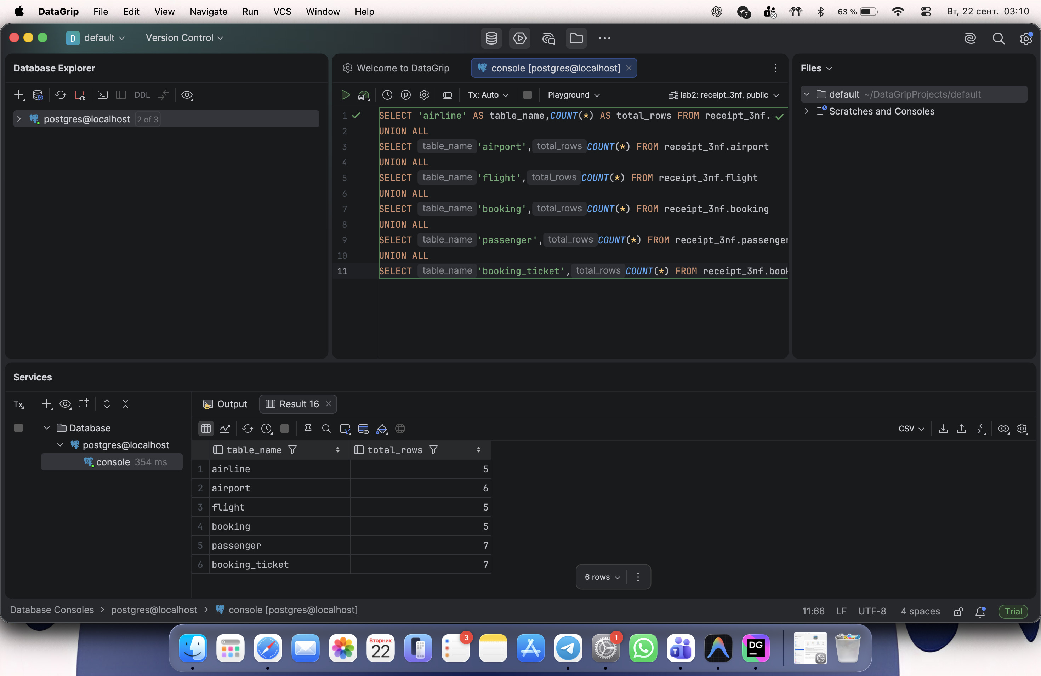

E. Reconstruct the original receipt data
SELECT b.booking_id,p.passenger_full_name,f.flight_number,
d.airport_name AS departure_airport,
a.airport_name AS arrival_airport,
al.airline_name,t.seat_number,t.ticket_price
FROM receipt_3nf.booking_ticket t
JOIN receipt_3nf.booking b ON t.booking_id=b.booking_id
JOIN receipt_3nf.passenger p
ON t.passenger_passport_number=p.passenger_passport_number
JOIN receipt_3nf.flight f ON b.flight_number=f.flight_number
JOIN receipt_3nf.airport d ON f.departing_airport_id=d.airport_id
JOIN receipt_3nf.airport a ON f.arriving_airport_id=a.airport_id
JOIN receipt_3nf.airline al ON f.airline_id=al.airline_id
ORDER BY b.booking_id,t.seat_number;
Screenshot 5. JOIN restores passenger, flight, airport, airline and seat information.
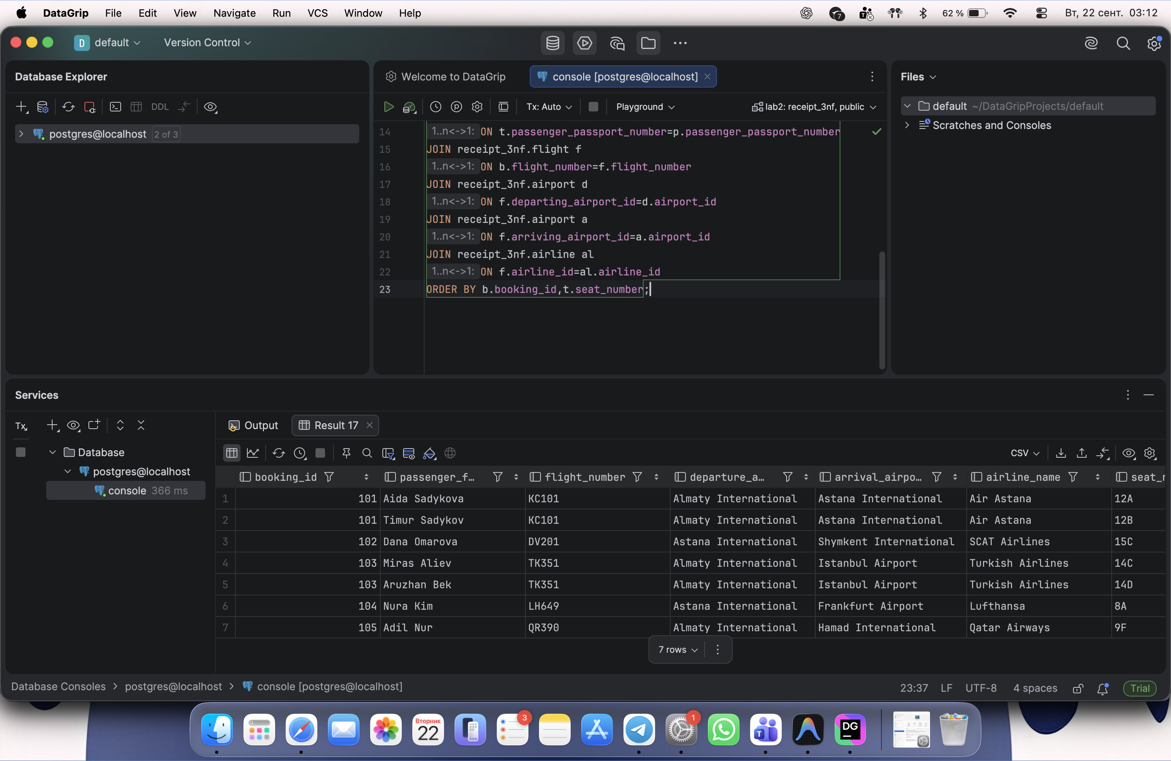
SELECT b.booking_id,p.passenger_full_name,
p.passenger_passport_number,t.seat_number,t.ticket_price
FROM receipt_3nf.booking_ticket t
JOIN receipt_3nf.booking b ON t.booking_id=b.booking_id
JOIN receipt_3nf.passenger p
ON t.passenger_passport_number=p.passenger_passport_number
ORDER BY b.booking_id,t.seat_number;
Screenshot 6. All 7 passenger tickets and ticket prices are preserved.
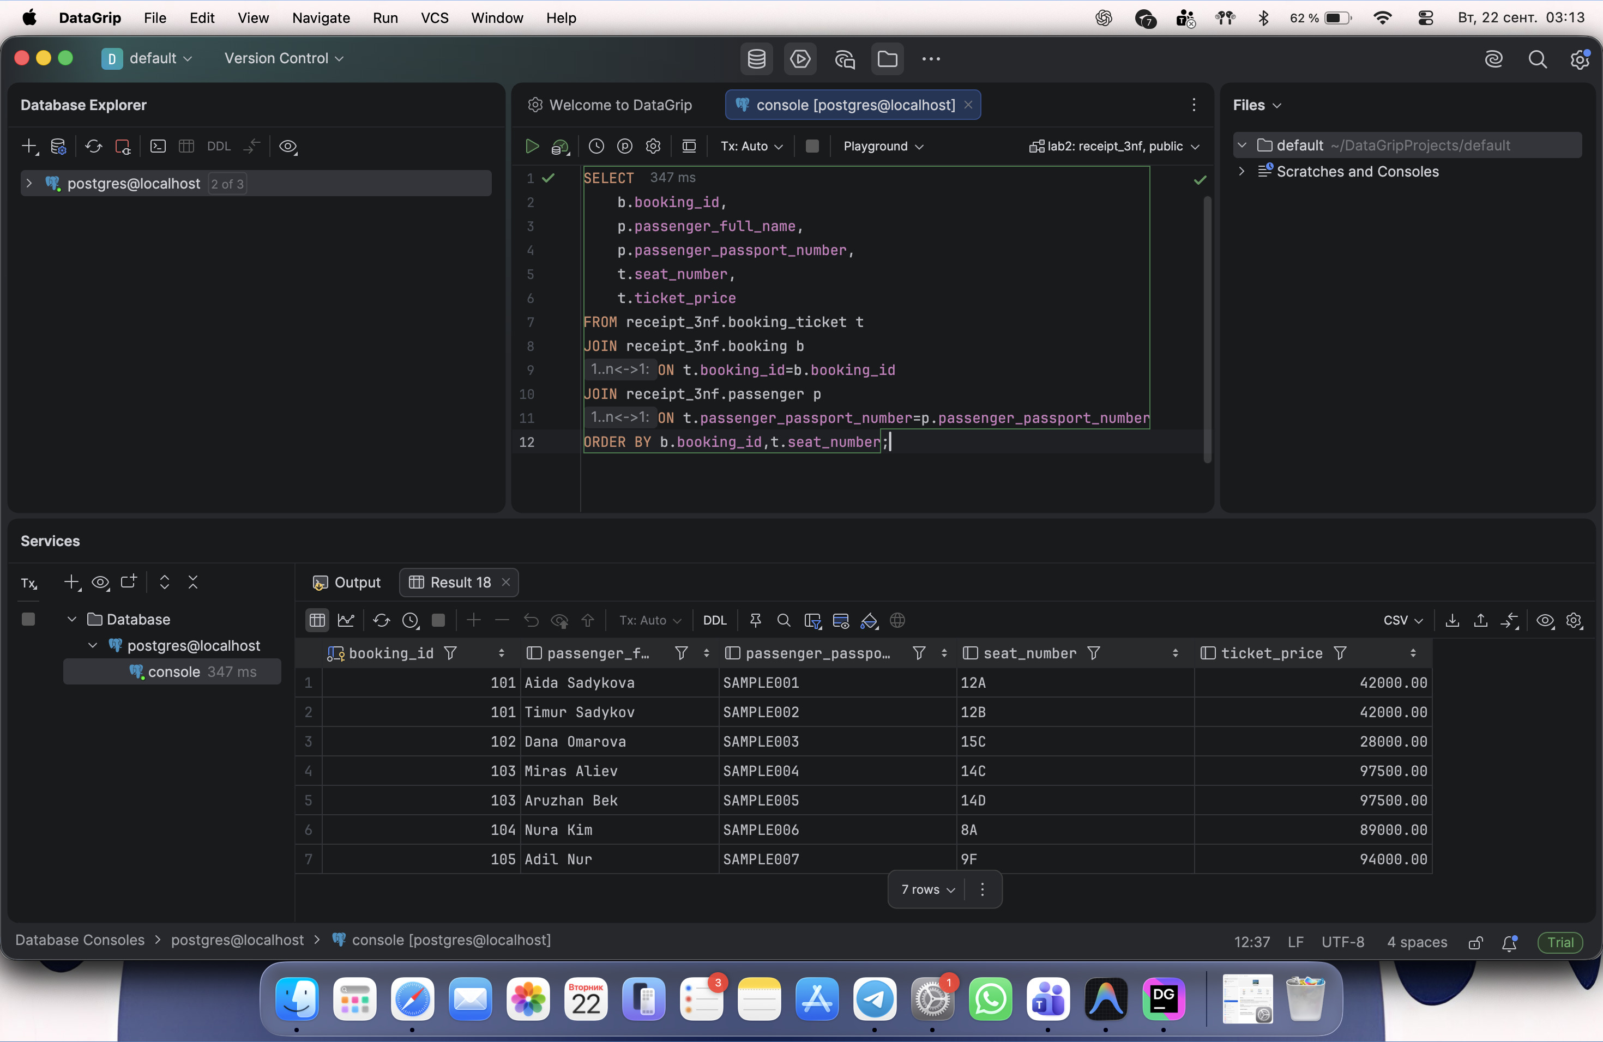

Part B. DDL
These are the separate ten-table airport database exercises. The tables are in the public schema of lab2, not the receipt_3nf schema used in Part A.

DDL Task 1. Create the 10 requested tables
CREATE TABLE public.airline_info(
airline_id INT,airline_code VARCHAR(30),airline_name VARCHAR(50),
airline_country VARCHAR(50),created_at TIMESTAMP,
updated_at TIMESTAMP,info VARCHAR(50)
);
CREATE TABLE public.airport(
airport_id INT,airport_name VARCHAR(50),country VARCHAR(50),
state VARCHAR(50),city VARCHAR(50),
created_at TIMESTAMP,updated_at TIMESTAMP
);
CREATE TABLE public.passengers(
passenger_id INT,first_name VARCHAR(50),last_name VARCHAR(50),
date_of_birth DATE,gender VARCHAR(50),
country_of_citizenship VARCHAR(50),country_of_residence VARCHAR(50),
passport_number VARCHAR(20),created_at TIMESTAMP,
updated_at TIMESTAMP
);
CREATE TABLE public.flights(
flight_id INT,sch_departure_time TIMESTAMP,sch_arrival_time TIMESTAMP,
departing_airport_id INT,arriving_airport_id INT,
departing_gate VARCHAR(50),arriving_gate VARCHAR(50),
airline_id INT,act_departure_time TIMESTAMP,act_arrival_time TIMESTAMP,
created_at TIMESTAMP,updated_at TIMESTAMP
);
CREATE TABLE public.booking(
booking_id INT,flight_id INT,passenger_id INT,
booking_platform VARCHAR(50),created_at TIMESTAMP,
updated_at TIMESTAMP,status VARCHAR(50),price DECIMAL(7,2)
);
CREATE TABLE public.baggage_check(
baggage_check_id INT,check_result VARCHAR(50),
created_at TIMESTAMP,updated_at TIMESTAMP,
booking_id INT,passenger_id INT
);
CREATE TABLE public.baggage(
baggage_id INT,weight_in_kg DECIMAL(4,2),
created_at TIMESTAMP,updated_at TIMESTAMP,booking_id INT
);
CREATE TABLE public.boarding_pass(
boarding_pass_id INT,booking_id INT,seat VARCHAR(50),
boarding_time TIMESTAMP,created_at TIMESTAMP,updated_at TIMESTAMP
);
CREATE TABLE public.booking_flight(
booking_flight_id INT,booking_id INT,flight_id INT,
created_at TIMESTAMP,updated_at TIMESTAMP
);
CREATE TABLE public.security_check(
security_check_id INT,check_result VARCHAR(20),
created_at TIMESTAMP,updated_at TIMESTAMP,passenger_id INT
);
SELECT table_name
FROM information_schema.tables
WHERE table_schema='public'
ORDER BY table_name;
Screenshot 7. The original ten DDL tables listed before renaming.
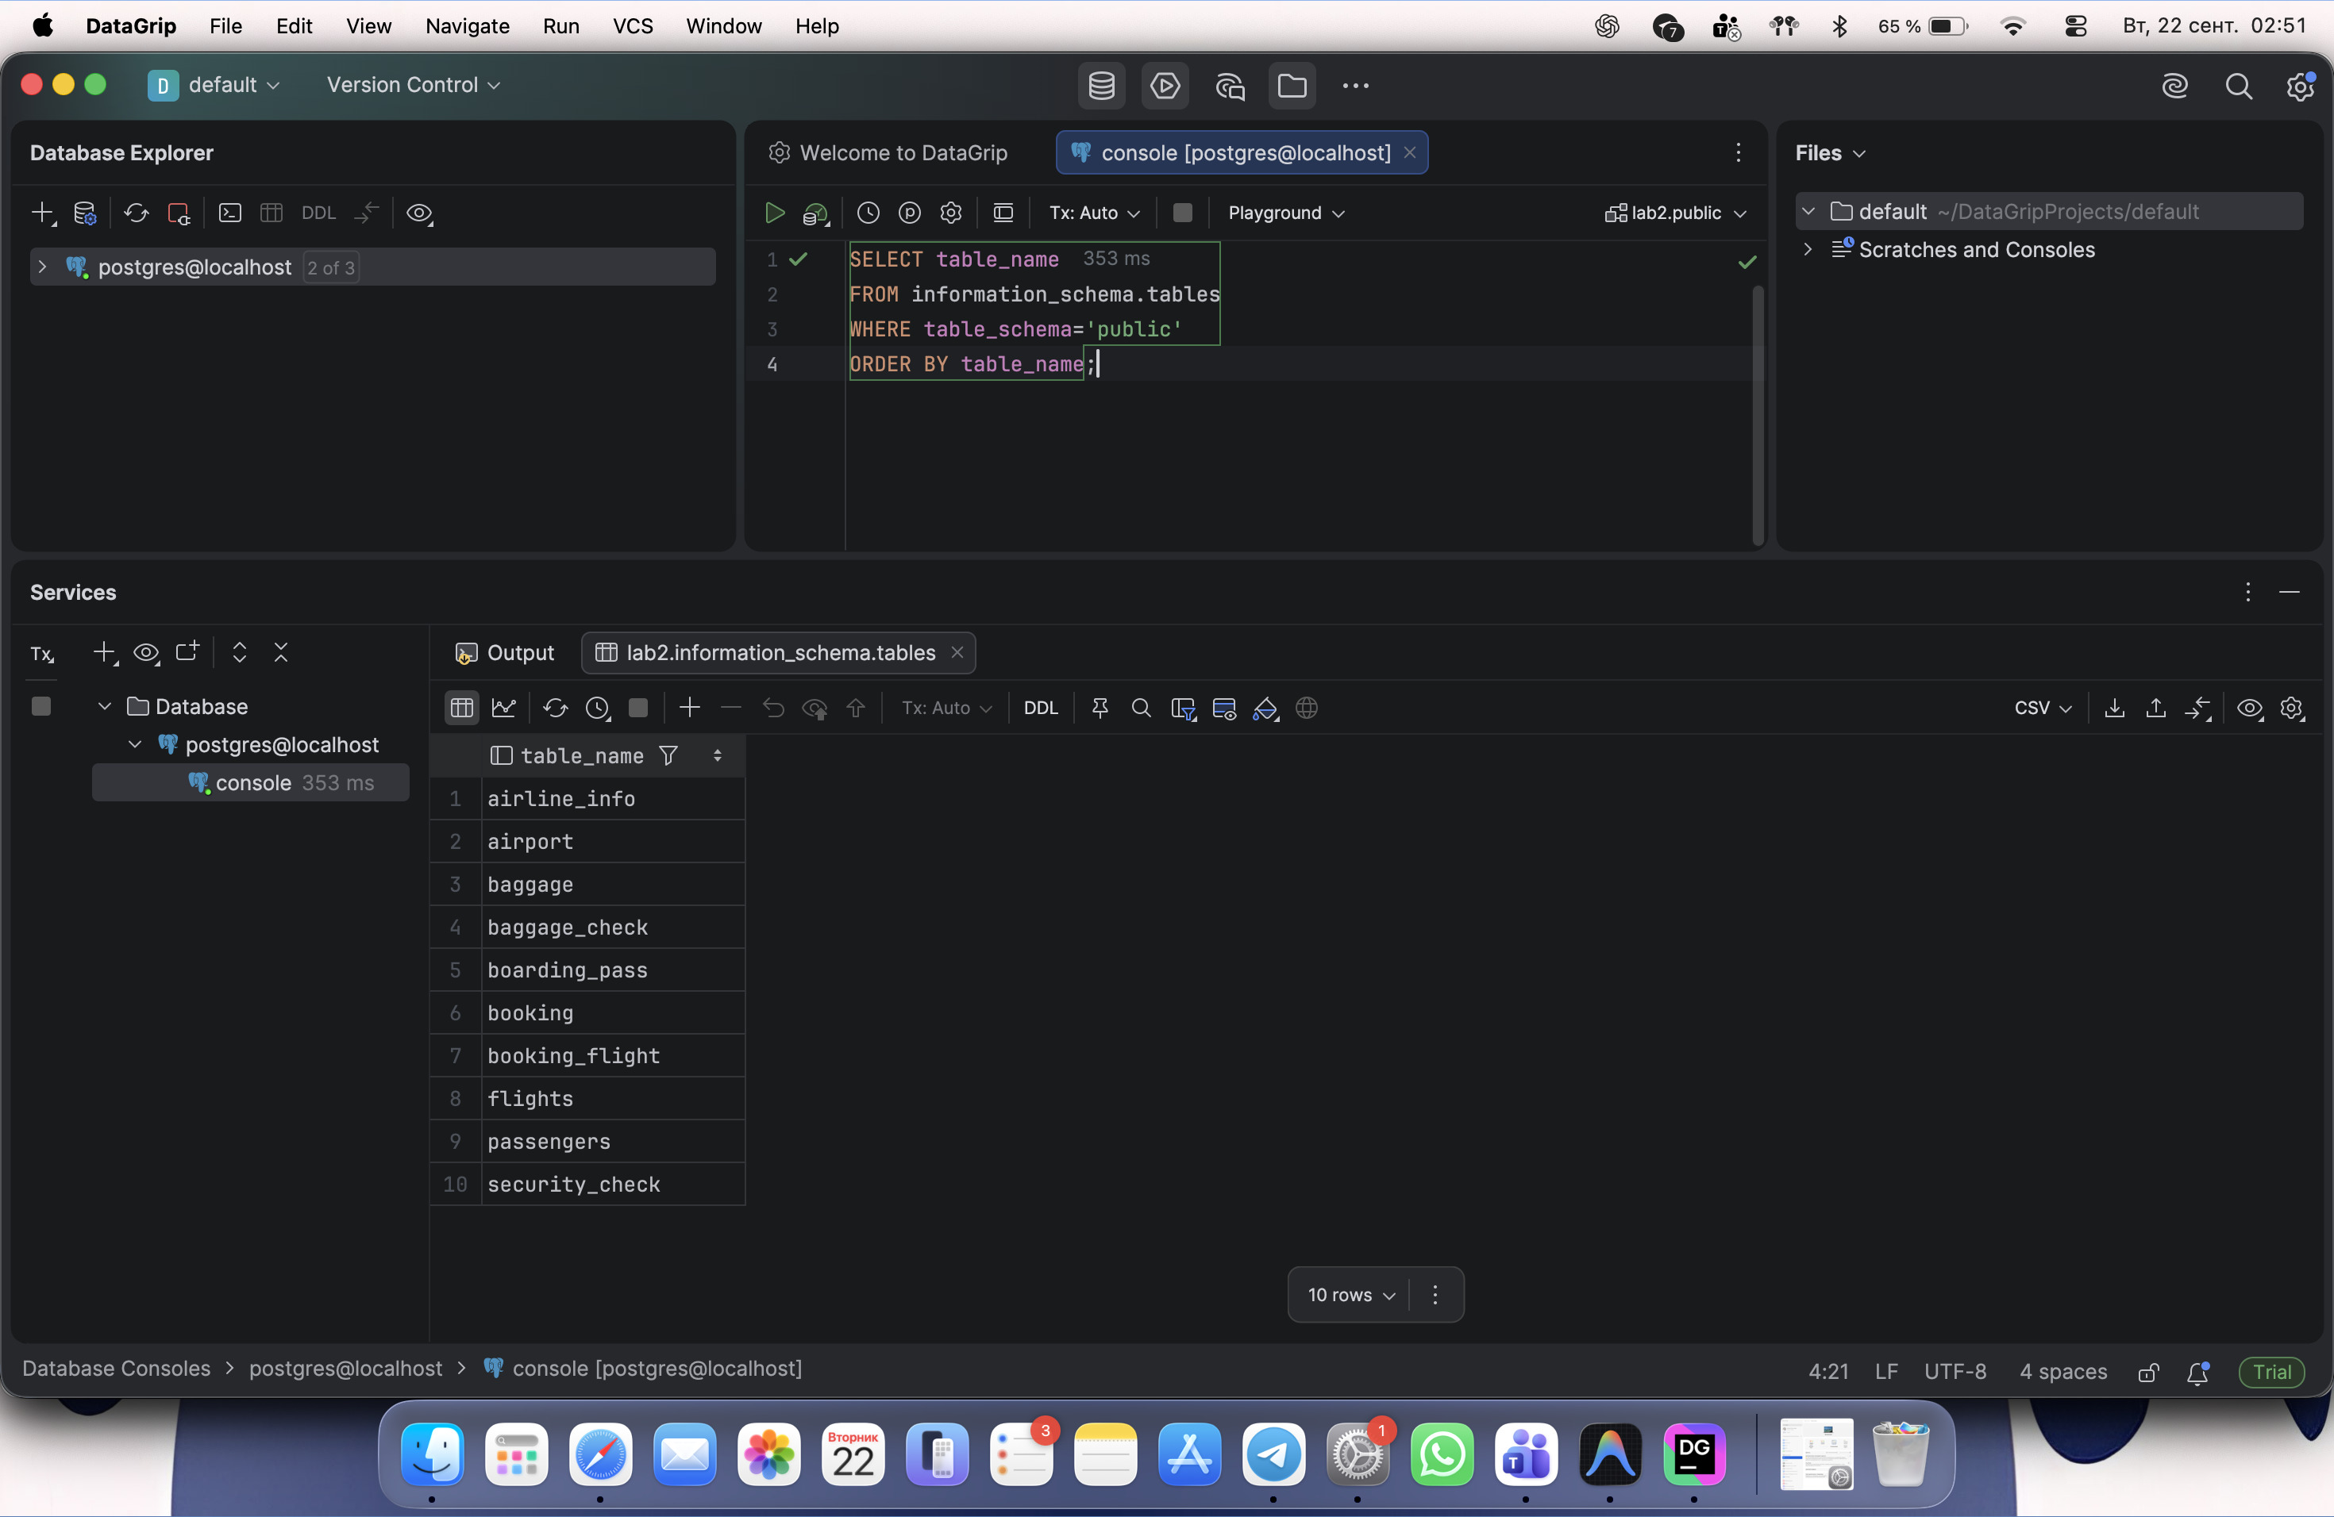

DDL Task 2. Add primary keys
ALTER TABLE public.airline_info ADD PRIMARY KEY(airline_id);
ALTER TABLE public.airport ADD PRIMARY KEY(airport_id);
ALTER TABLE public.passengers ADD PRIMARY KEY(passenger_id);
ALTER TABLE public.flights ADD PRIMARY KEY(flight_id);
ALTER TABLE public.booking ADD PRIMARY KEY(booking_id);
ALTER TABLE public.baggage_check ADD PRIMARY KEY(baggage_check_id);
ALTER TABLE public.baggage ADD PRIMARY KEY(baggage_id);
ALTER TABLE public.boarding_pass ADD PRIMARY KEY(boarding_pass_id);
ALTER TABLE public.booking_flight ADD PRIMARY KEY(booking_flight_id);
ALTER TABLE public.security_check ADD PRIMARY KEY(security_check_id);
Screenshot 8. Primary keys added to all ten tables.
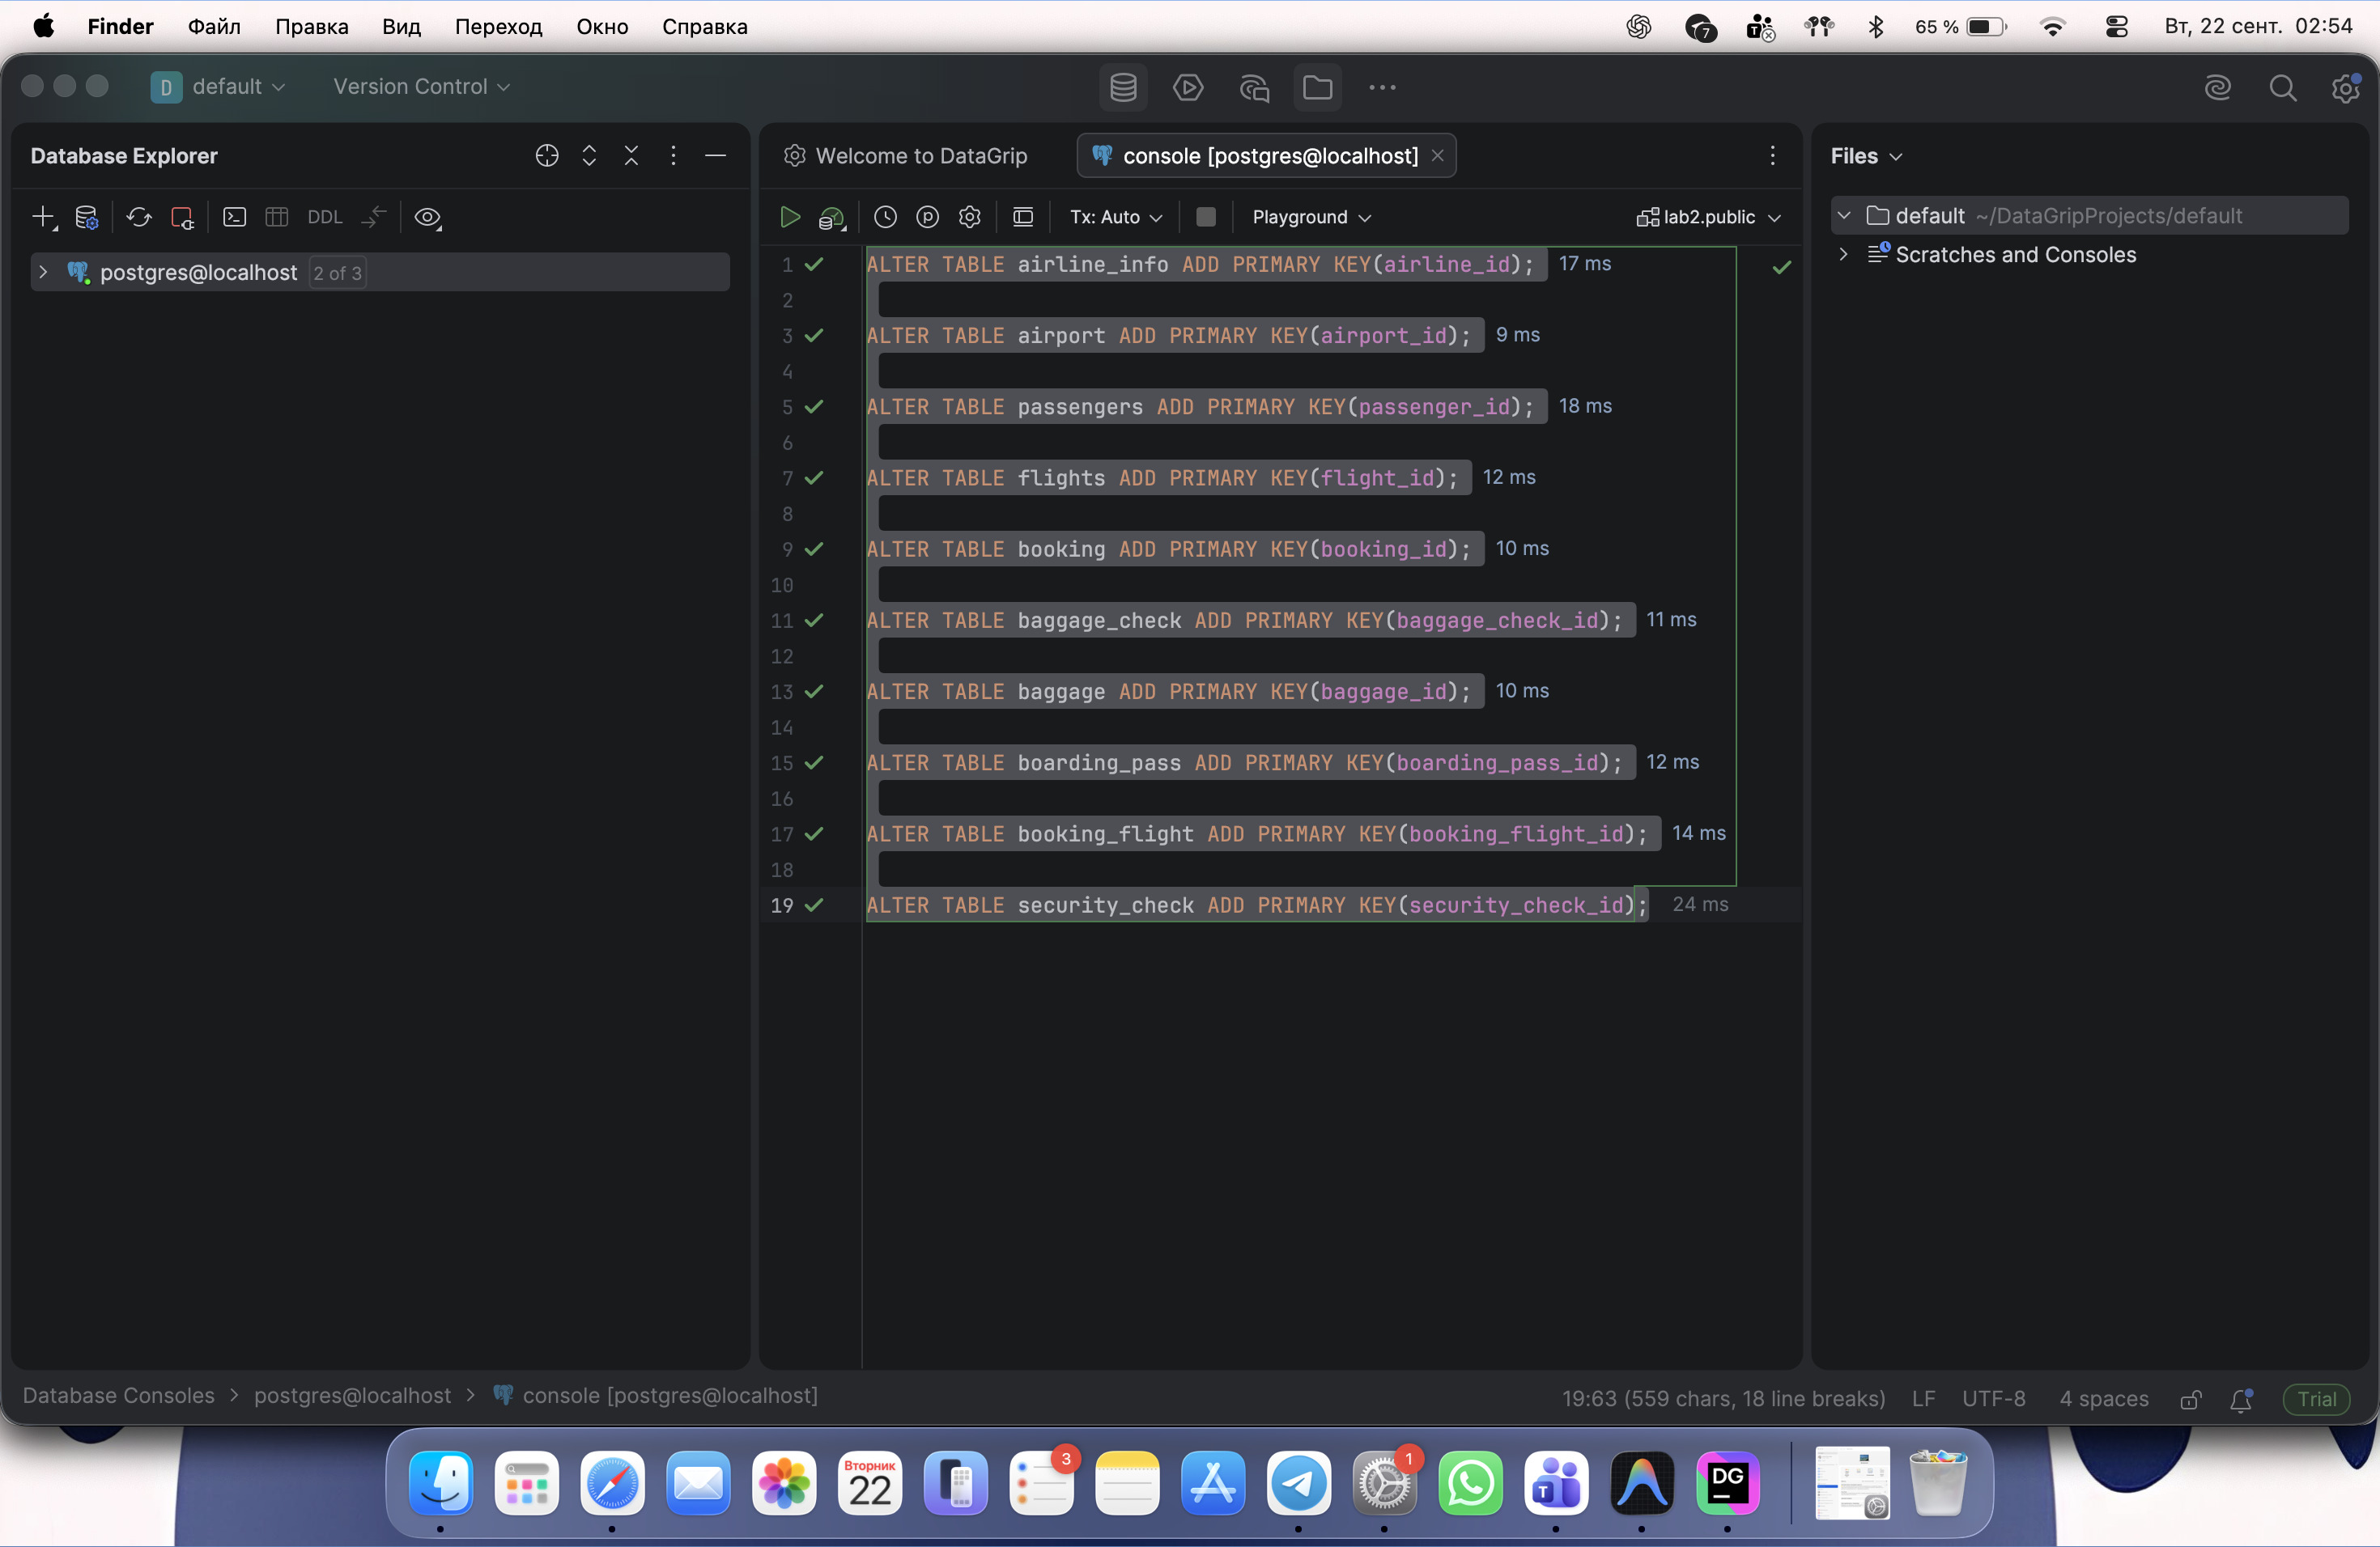

DDL Task 4. Apply NOT NULL to every column
A PostgreSQL DO block applies the constraint to every column of every table in the public schema. At this stage the schema contained only these ten laboratory tables.
DO $$
DECLARE col RECORD;
BEGIN
FOR col IN
SELECT table_name,column_name
FROM information_schema.columns
WHERE table_schema='public'
LOOP
EXECUTE format(
'ALTER TABLE %I.%I ALTER COLUMN %I SET NOT NULL',
'public',col.table_name,col.column_name
);
END LOOP;
END $$;
SELECT table_name,COUNT(*) AS total_columns,
COUNT(*) FILTER(WHERE is_nullable='NO') AS not_null_columns
FROM information_schema.columns
WHERE table_schema='public'
GROUP BY table_name
ORDER BY table_name;
Screenshot 9. Each table has the same total_columns and not_null_columns values.
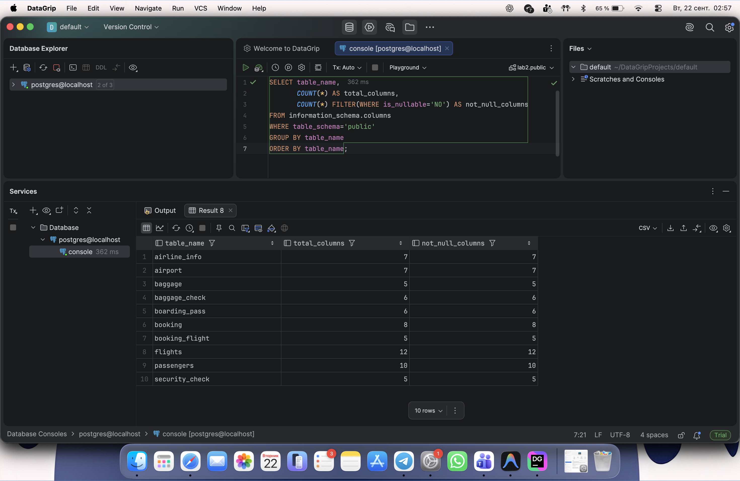

DDL Tasks 5-8. Rename, modify and drop
ALTER TABLE public.airline_info RENAME TO airline;
ALTER TABLE public.booking RENAME COLUMN price TO ticket_price;
ALTER TABLE public.flights ALTER COLUMN departing_gate TYPE TEXT;
ALTER TABLE public.airline DROP COLUMN info;
Screenshot 10. The four requested ALTER TABLE changes completed.
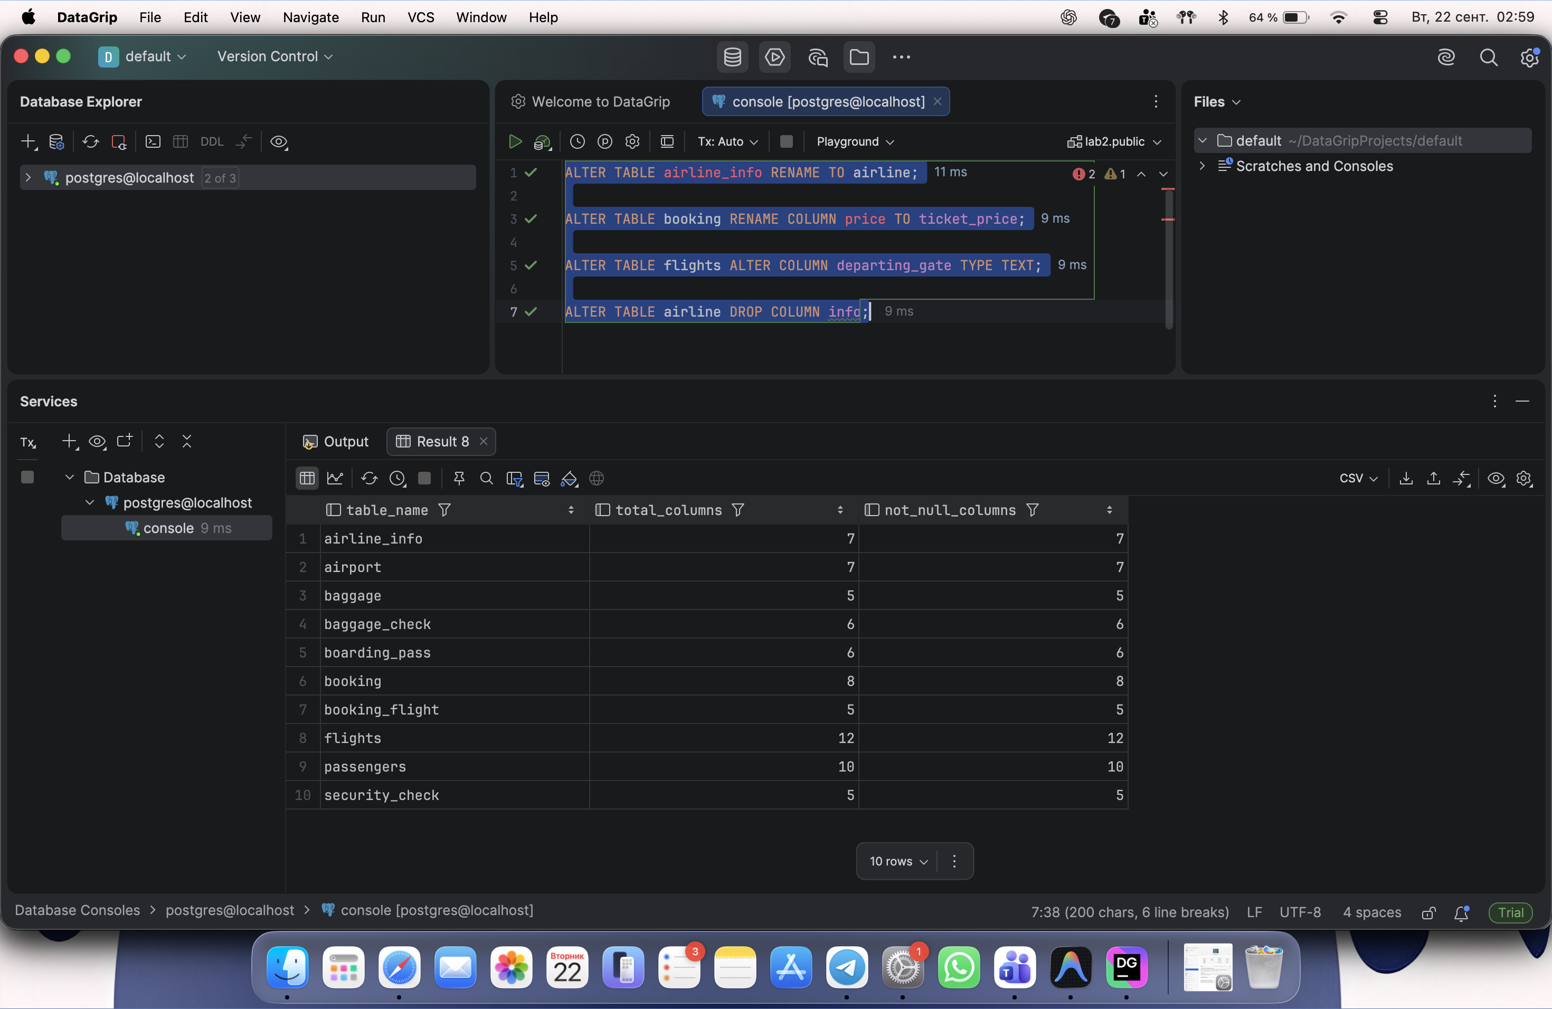

DDL Task 9. Create the relationships
Booking.flight_id -> Flights.flight_id is also included because the given Booking table contains that column. In total, 12 foreign keys were added.
ALTER TABLE public.security_check
ADD FOREIGN KEY(passenger_id) REFERENCES public.passengers(passenger_id);
ALTER TABLE public.booking
ADD FOREIGN KEY(passenger_id) REFERENCES public.passengers(passenger_id);
ALTER TABLE public.booking
ADD FOREIGN KEY(flight_id) REFERENCES public.flights(flight_id);
ALTER TABLE public.baggage_check
ADD FOREIGN KEY(passenger_id) REFERENCES public.passengers(passenger_id);
ALTER TABLE public.baggage_check
ADD FOREIGN KEY(booking_id) REFERENCES public.booking(booking_id);
ALTER TABLE public.baggage
ADD FOREIGN KEY(booking_id) REFERENCES public.booking(booking_id);
ALTER TABLE public.boarding_pass
ADD FOREIGN KEY(booking_id) REFERENCES public.booking(booking_id);
ALTER TABLE public.booking_flight
ADD FOREIGN KEY(booking_id) REFERENCES public.booking(booking_id);
ALTER TABLE public.booking_flight
ADD FOREIGN KEY(flight_id) REFERENCES public.flights(flight_id);
ALTER TABLE public.flights
ADD FOREIGN KEY(departing_airport_id) REFERENCES public.airport(airport_id);
ALTER TABLE public.flights
ADD FOREIGN KEY(arriving_airport_id) REFERENCES public.airport(airport_id);
ALTER TABLE public.flights
ADD FOREIGN KEY(airline_id) REFERENCES public.airline(airline_id);
Screenshot 11. ALTER TABLE statements adding the foreign keys.
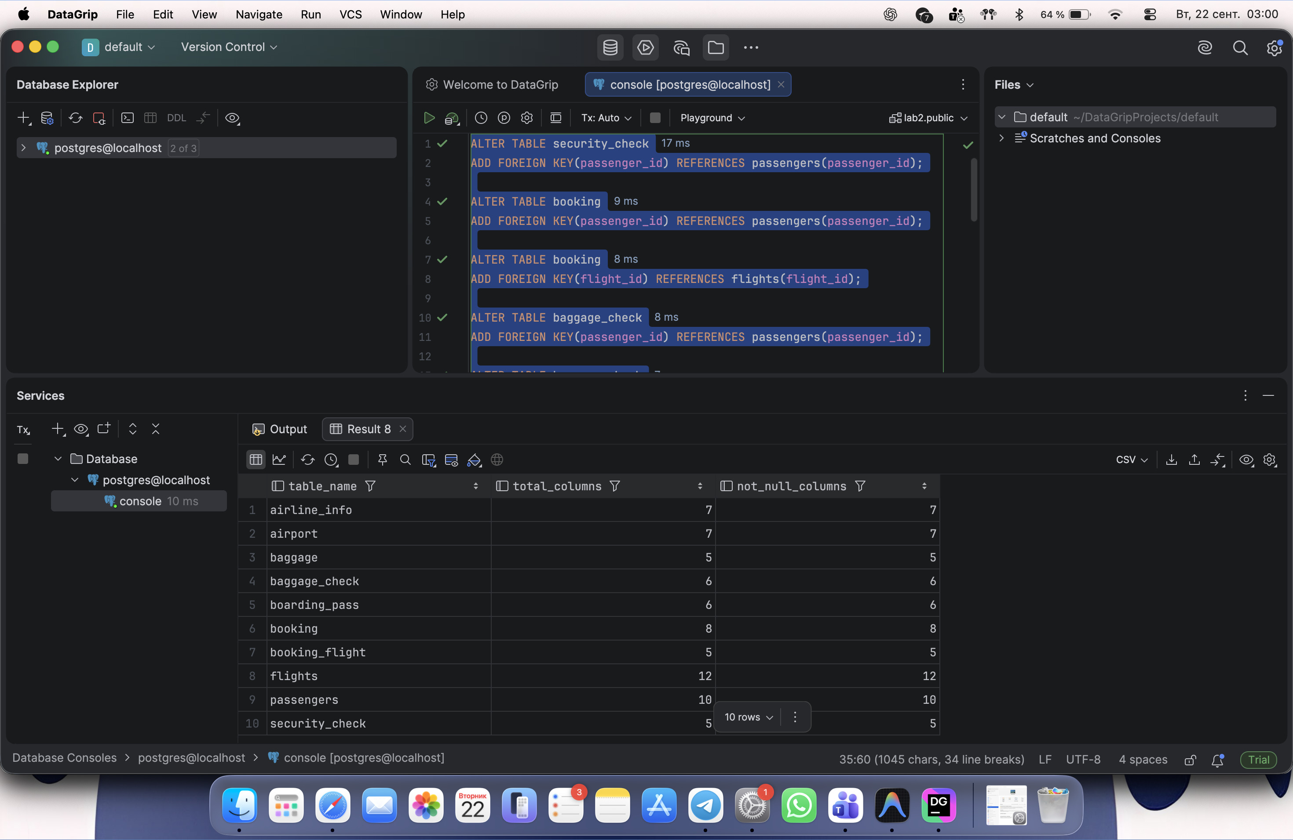
SELECT tc.table_name,kcu.column_name,
ccu.table_name AS referenced_table,
ccu.column_name AS referenced_column
FROM information_schema.table_constraints tc
JOIN information_schema.key_column_usage kcu
ON tc.constraint_name=kcu.constraint_name
AND tc.table_schema=kcu.table_schema
JOIN information_schema.constraint_column_usage ccu
ON tc.constraint_name=ccu.constraint_name
AND tc.table_schema=ccu.table_schema
WHERE tc.constraint_type='FOREIGN KEY'
AND tc.table_schema='public'
ORDER BY tc.table_name;
Screenshot 12. All 12 foreign-key relationships are listed in DataGrip.
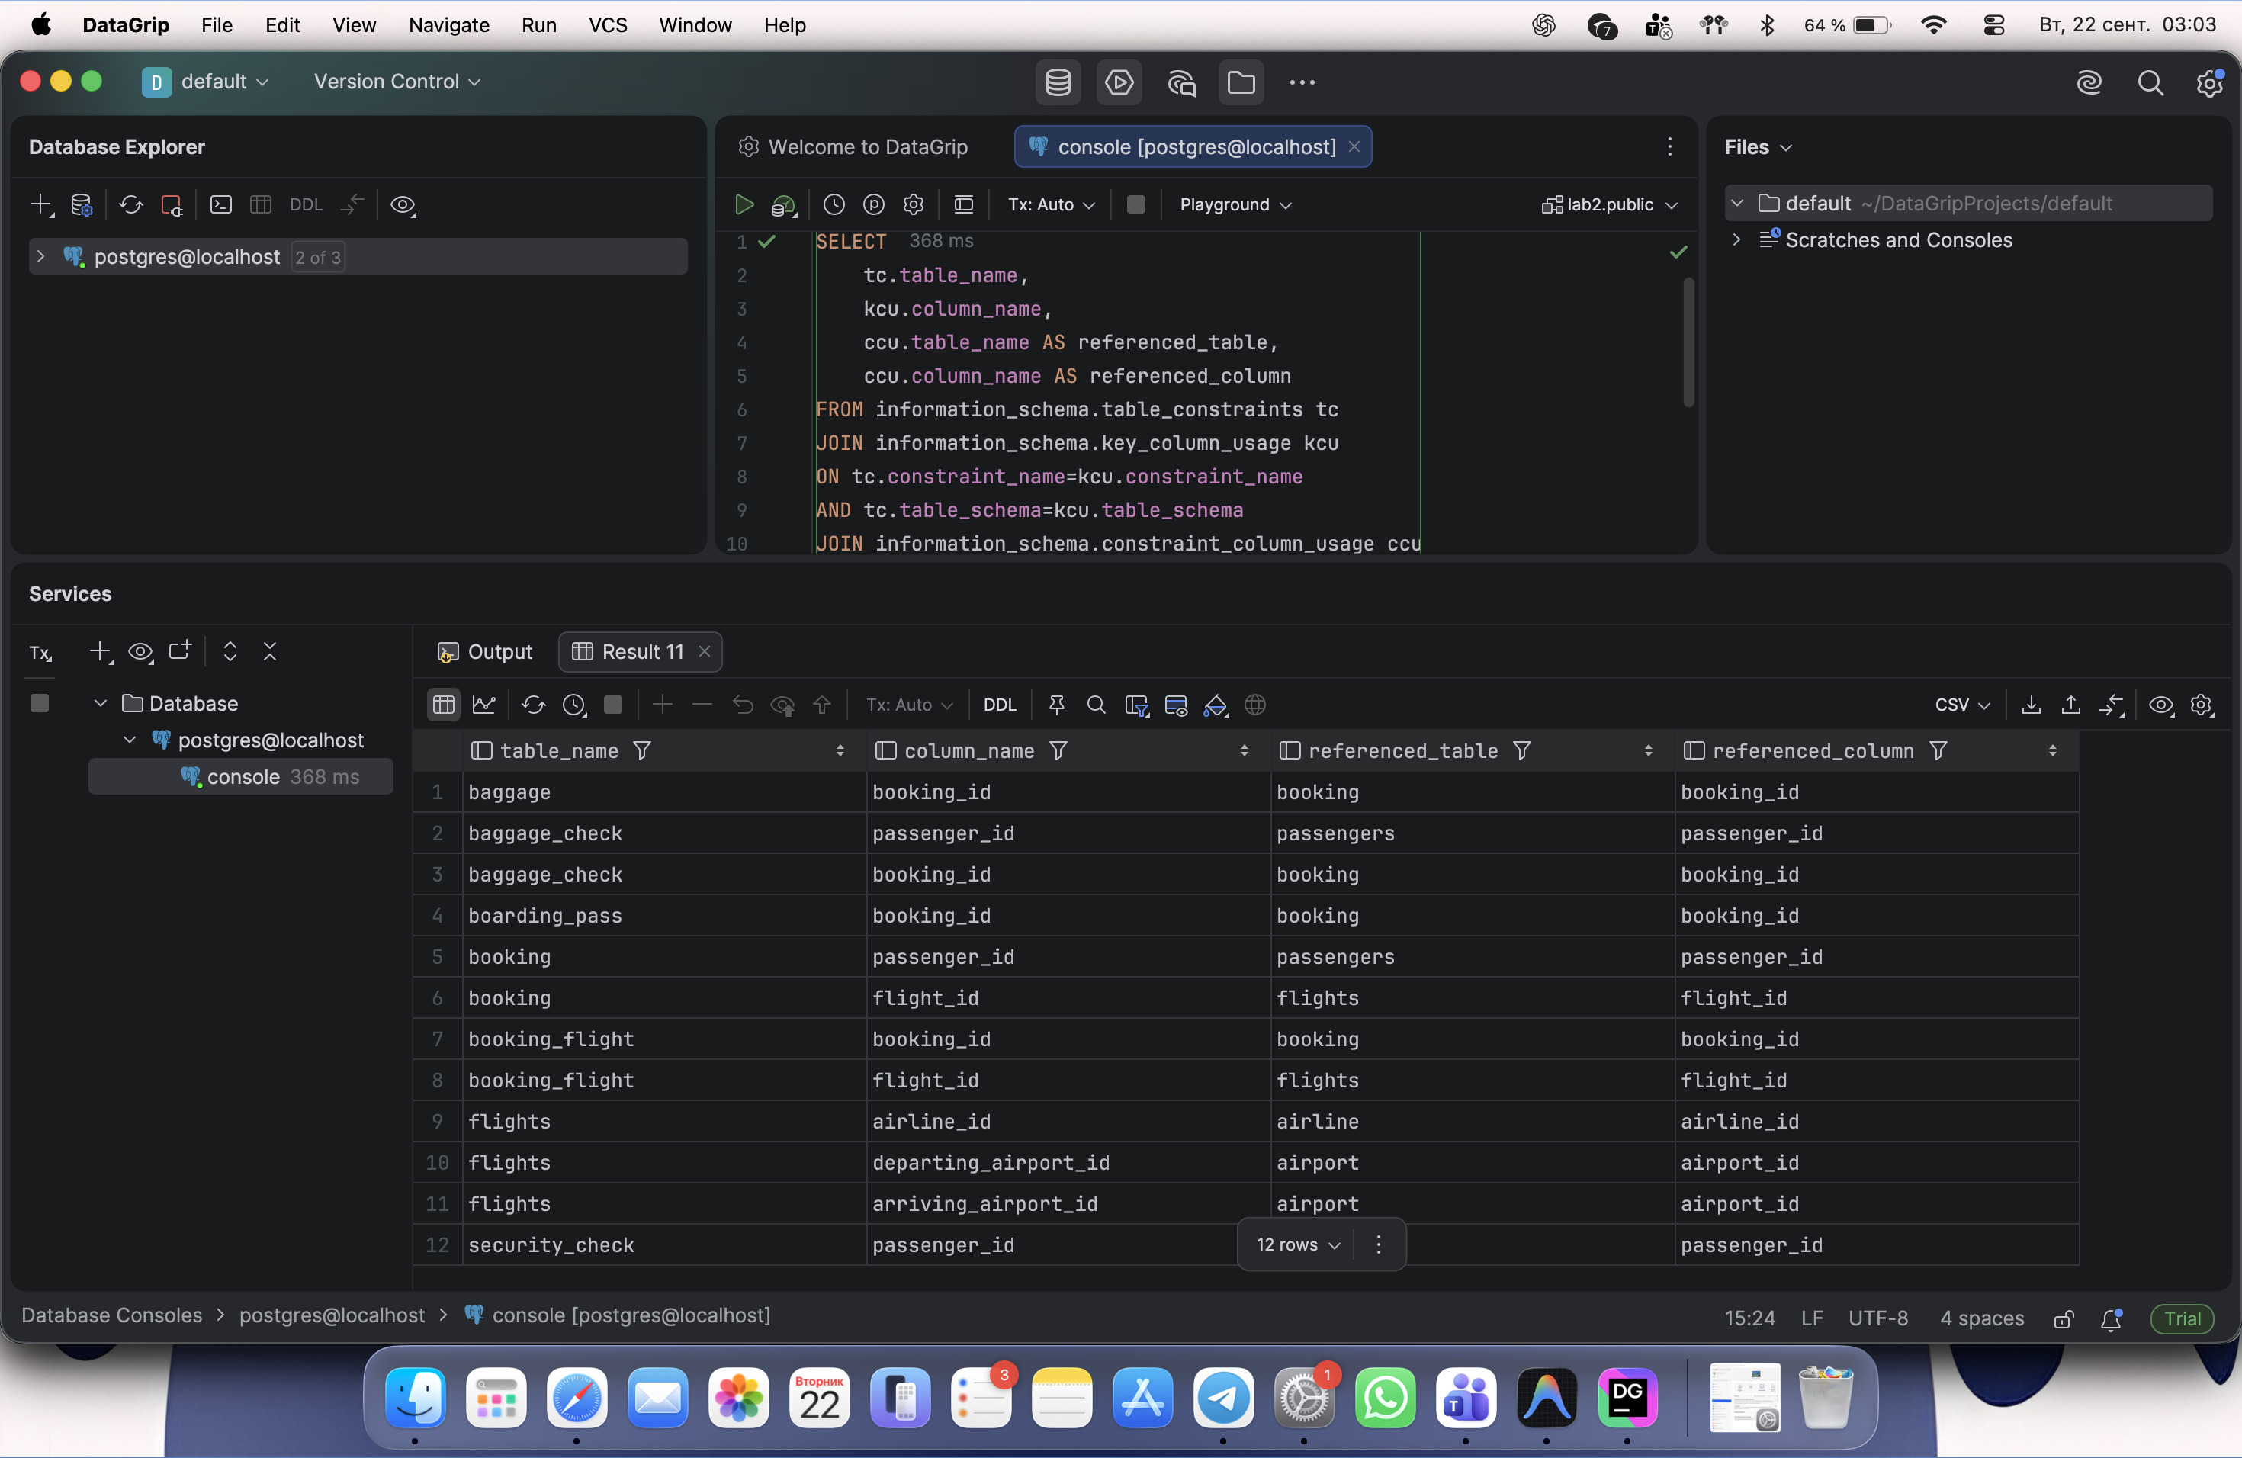
Result: The airport DDL contains the 10 requested tables and 12 foreign keys. The separate receipt_3nf schema contains the normalized example and its sample records. Screenshots show the actual SQL execution and SELECT results.

