Київський національний університет імені Тараса Шевченка  
Факультет інформаційних технологій  
Кафедра кібербезпеки і захисту інформації

Звіт лабораторної роботи № 13  
з дисципліни “Технологія програмування захищених систем ”

Студента ІI курсу

Шутенко Дмитра Валентиновича

Київ 2019

Task 1

using System;

using System.Collections.Generic;

using System.Linq;

using System.Text;

namespace lab_13

{

class Product

{

private string name;

private int price;

private int production;

private int quantity;

public string Name

{

get

{

return name;

}

}

public int Price

{

set

{

if (value <= 10)

price = 10;

else if (value >= 250)

price = 250;

else

price = value;

}

get

{

return price;

}

}

public int Production

{

get

{

return production;

}

}

public int Quantity

{

set

{

if (value < 0)

quantity = 0;

else if (value > 100)

quantity = 100;

else

quantity = value;

}

get

{

return quantity;

}

}

public Product(string name, int price, int production, int quantity)

{

this.name = name;

this.price = price;

this.production = production;

this.quantity = quantity;

}

public static Product TheMostExpensiveProduct(Product[] products)

{

Product pricy = products[0];

for (int i = 1; i < 5; i++)

{

if (products[i].Price > pricy.Price)

pricy = products[i];

}

return pricy;

}

public static Product TheBiggestQuantity(Product[] products)

{

Product high_number = products[0];

for (int i = 1; i < 5; i++)

{

if (products[i].Quantity > high_number.Quantity)

high_number = products[i];

}

return high_number;

}

}

class Program

{

static void Main(string[] args)

{

Console.WriteLine("Our goods:");

Product [] Products = new Product[5];

Products[0] = new Product("Ball", 200, 2018, 50);

Products[1] = new Product("Hat", 150, 2017, 30);

Products[2] = new Product("Cup", 80, 2017, 60);

Products[3] = new Product("Bat", 250, 2018, 10);

Products[4] = new Product("Sneakers", 240, 2019, 90);

for (int i = 0; i < 5; i++)

{

Console.WriteLine("\n"+ (i+1) + " product is " + Products[i].Name + ".\nThe price is " + Products[i].Price + ".\nThe product was produced in " + Products[i].Production + ".\n" + Products[i].Quantity + " items aveilable. ");

}

Console.WriteLine("\n\nThe most expensive product is " + Product.TheMostExpensiveProduct(Products).Name);

Console.WriteLine("\n\nThe biggest number of product: " + Product.TheBiggestQuantity(Products).Name + ".\n" + Product.TheBiggestQuantity(Products).Quantity + " products of this kind are aveilable.\nWith 10% discount product costs " + Product.TheBiggestQuantity(Products).Price*0.9);

Console.ReadLine();

}

}

}

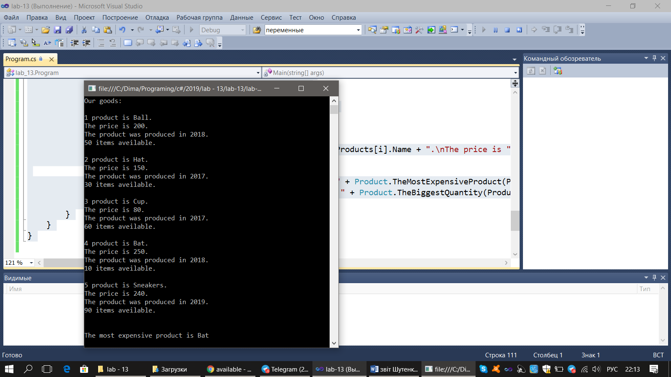

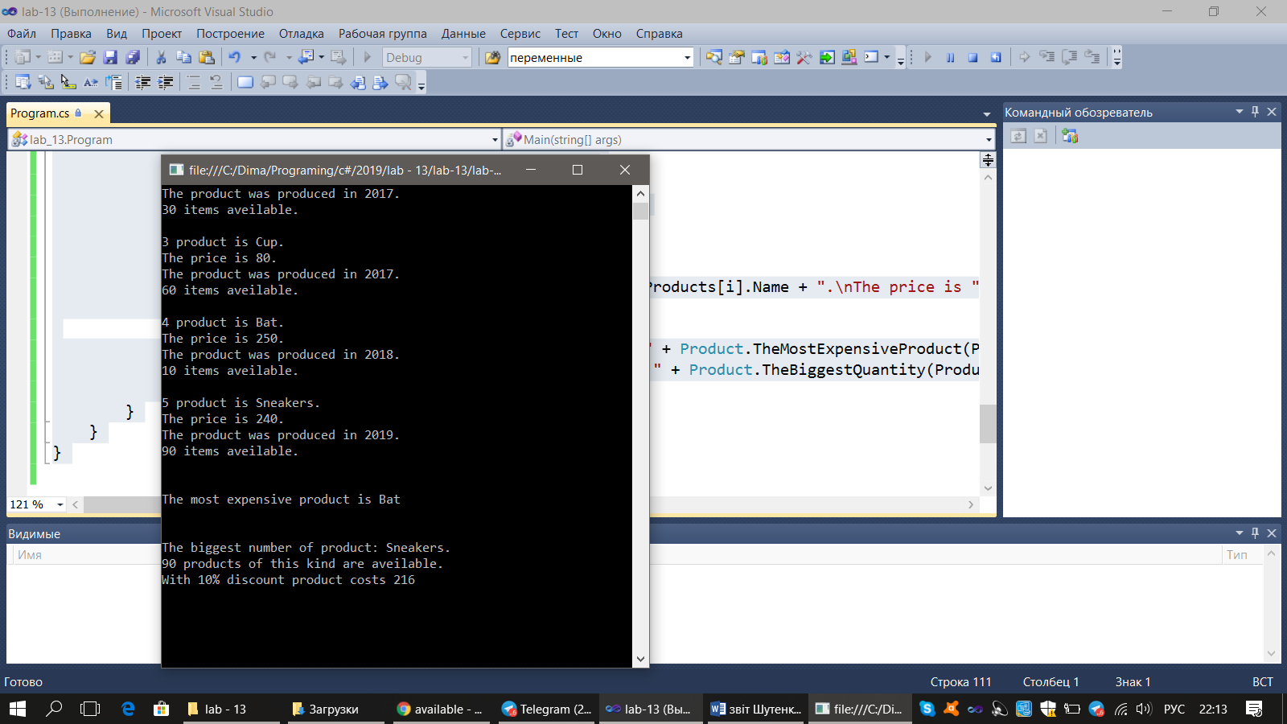

Task2

using System;

using System.Collections.Generic;

using System.Linq;

using System.Text;

namespace lab_13_Интерфейсные_ссылки

{

public interface IClient

{

void Info();

}

class Client

{

public string Name;

public Client(string name)

{

Name = name;

}

}

class Saver : Client, IClient

{

public Saver(string name) : base(name) { }

public void Info()

{

Console.WriteLine("Info about Saver " + base.Name + ": has a deposit.");

}

}

class Borrower : Client, IClient

{

public Borrower(string name) : base(name) { }

public void Info()

{

Console.WriteLine("Info about Borrower " + base.Name + ": has a loan.");

}

}

class Program

{

static void Main()

{

List<Client> Clients = new List<Client>();

while (true)

{

Console.Write("\nDo you want to enter a client (yes/no)? ");

string go = Convert.ToString(Console.ReadLine());

if (go == "yes")

{

Console.Write("\nEnter type of client: 1 - Saver, 2 - Borrower. Your choice: ");

int answer = int.Parse(Console.ReadLine());

if (answer == 1)

{

Console.Write("What is the saver's name? ");

string name = Convert.ToString(Console.ReadLine());

Clients.Add(new Saver(name));

}

else if (answer == 2)

{

Console.Write("What is the borrower's name? ");

string name = Convert.ToString(Console.ReadLine());

Clients.Add(new Borrower(name));

}

else

Console.WriteLine("Invalid input. Try again)");

}

else if (go == "no")

{

Console.Write("Press any button to continue");

Console.ReadKey();

break;

}

else

Console.WriteLine("Invalid input. Try again)");

}

Console.WriteLine("\n\n\nHere are all the savers");

foreach (Client client in Clients)

{

if (client is Saver)

((Saver)client).Info();

}

Console.WriteLine("\n\nHere are all the borrowers");

foreach (Client client in Clients)

{

if(client is Borrower)

((Borrower)client).Info();

}

Console.ReadLine();

}

}

}

