1. Inner join asc

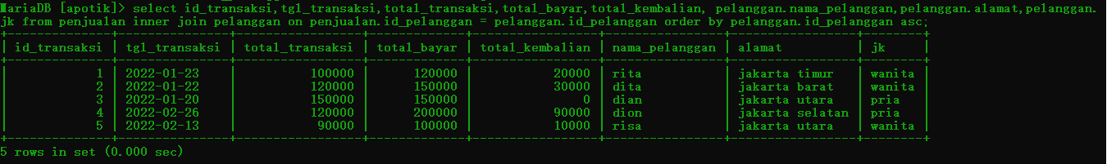

1. Inner join asc

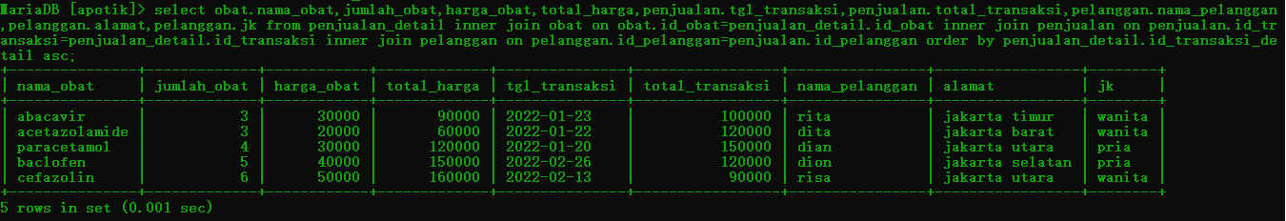

1. Inner join like and asc

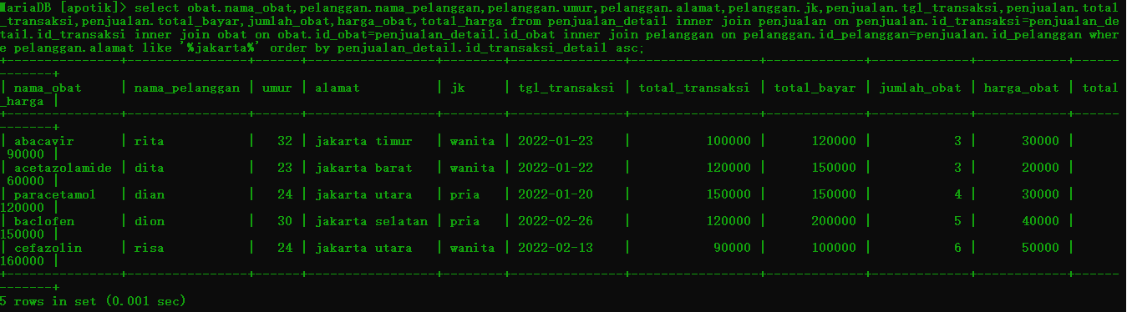

1. Left join

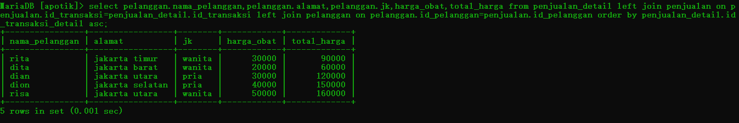

1. Right join

