1. Insert

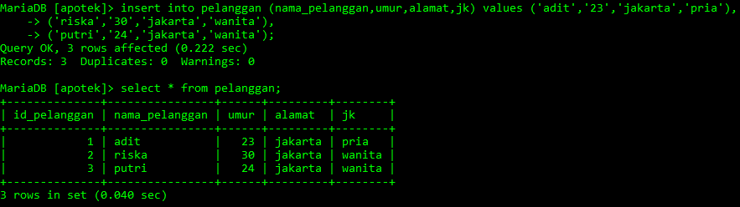

1. Select menggunakan order by

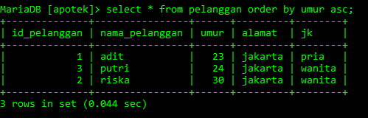

1. Update

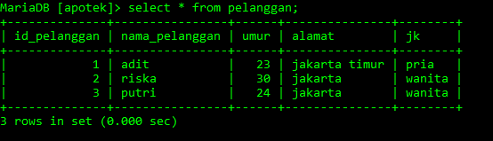

1. Select count

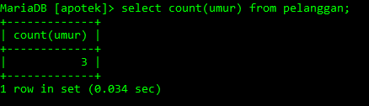

1. Select avg

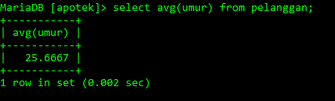

1. Select sum

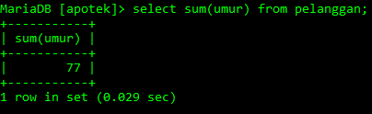

1. Select min

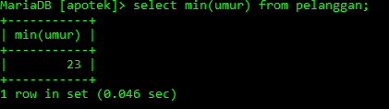

1. Select max

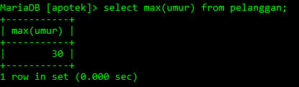

1. Select not like

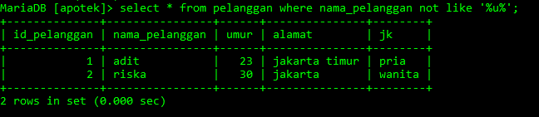

1. Select where

