**3 Query Mutiple Join Sql**

1. 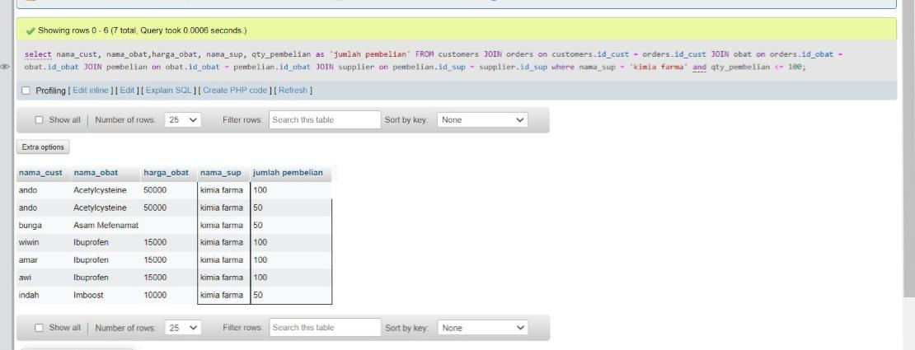Select nama_cust, nama_obat,harga_obat, nama_sup, qty_pembelian as ‘jumlah pembelian’ FROM customers JOIN orders on customers.id_cust = orders.id_cust JOIN obat on orders.id_obat = obat.id_obat JOIN pembelian on obat.id_obat = pembelian.id_obat JOIN supplier on pembelian.id_sup = supplier.id_sup where nama_sup = ‘kimia farma’ and qty_pembelian <= 100;
2. Select nama_cust, tgl_order, nama_obat,nama_sup, tgl_pembelian FROM customers

JOIN orders on customers.id_cust = orders.id_cust

JOIN obat on orders.id_obat = obat.id_obat

JOIN pembelian on obat.id_obat = pembelian.id_obat

JOIN supplier on pembelian.id_sup = supplier.id_sup;

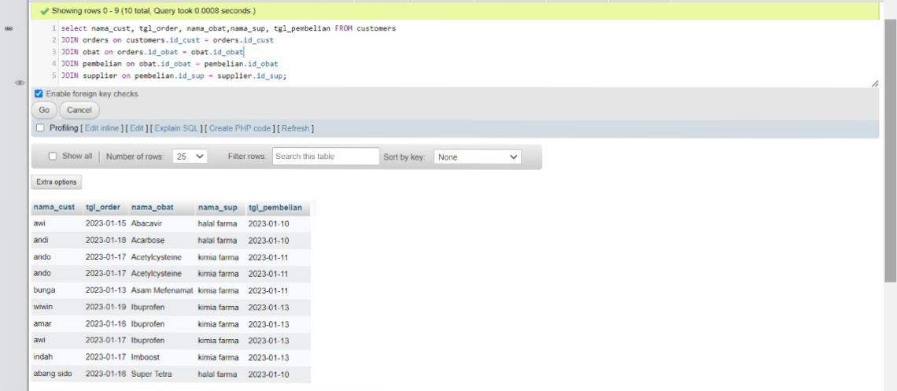

1. 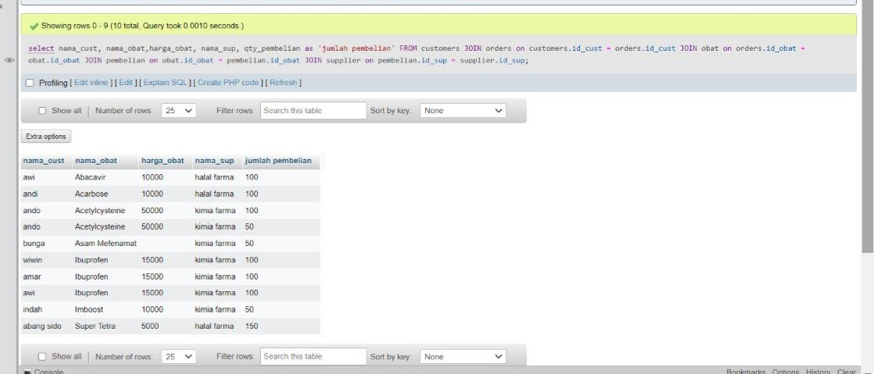select nama_cust, nama_obat,harga_obat, nama_sup, qty_pembelian as 'jumlah pembelian' FROM customers JOIN orders on customers.id_cust = orders.id_cust JOIN obat on orders.id_obat = obat.id_obat JOIN pembelian on obat.id_obat = pembelian.id_obat JOIN supplier on pembelian.id_sup = supplier.id_sup;