1. 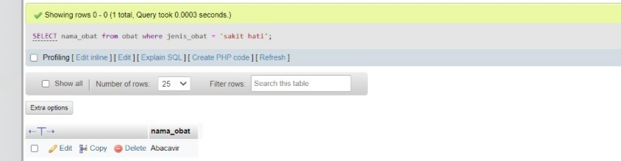***select nama_obat from obat where jenis_obat = ‘sakit hati’;***
2. 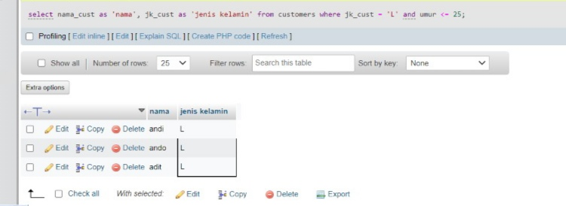***Select nama_cust as nama, jk_cust as "jenis kelamin" from customers where jk_cust = 'L' and umur <= 25;***
3. ***Select obat.id_obat, obat.nama_obat, sum(order s.jumlah_order) as total_order from obat inner join orders on obat.id_obat = orders.id_obat;***

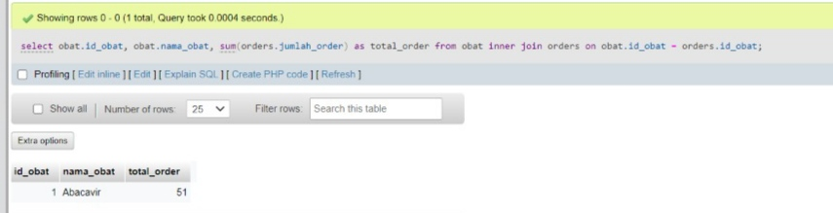

1. 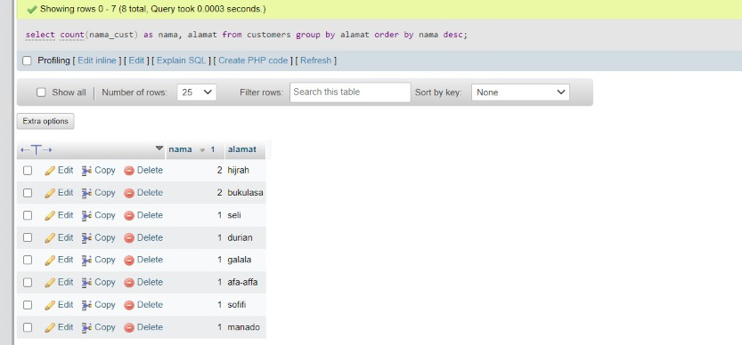***Select count(nama_cust) as nama, alamat from customers group by alamat order by nama desc;***
2. 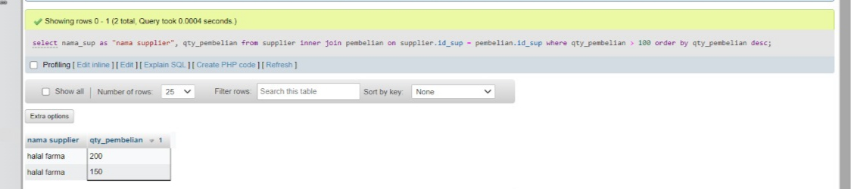***Select nama_sup as ‘nama supplier’, qty_pembelian from supplier inner join pembelian on supplier.id_sup = pembelian.id_sup where qty pembelian > 100 order by qty_pembelian;***
3. 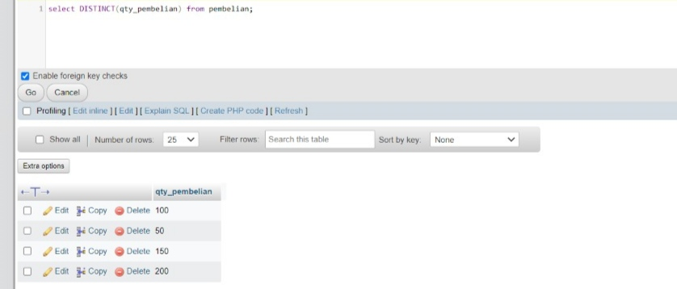***Select distinct (qty_pembelian) from pembelian;***
4. ***Select nama_cust as nama, jumlah_order from customers inner join orders on customers.id_cust = orders.id_order order by jumlah_order desc limit 5;***

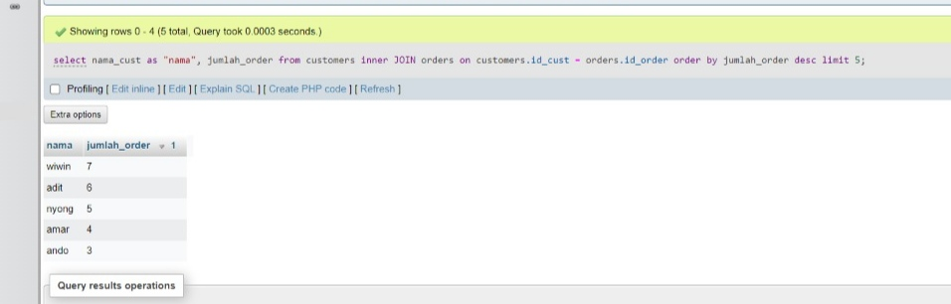

1. 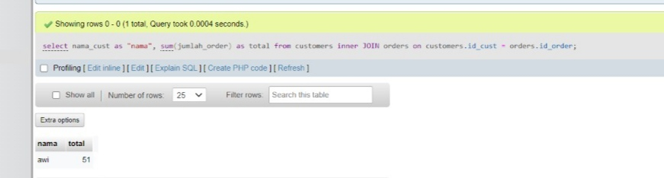***Select nama_cust as nama, sum(jumlah_order) as total from customers inner join orders on customers.id_cust = orders.id_order;***
2. 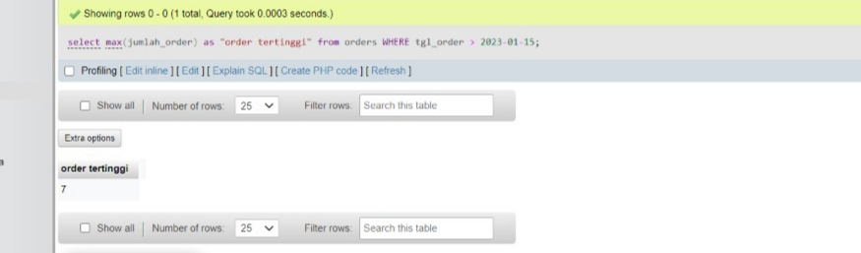***Select max(jumlah order) as ‘order tertinggi’ from orders where tgl_order > 2023-01-15;***
3. 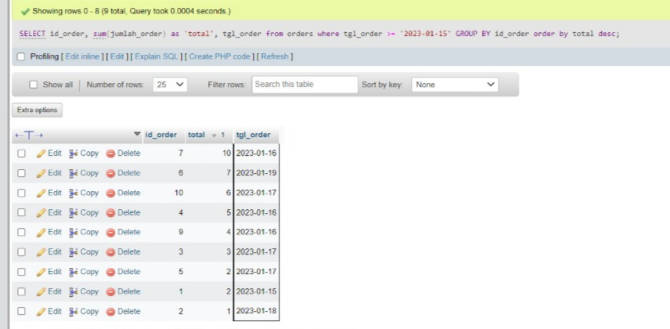***Select id_order, sum(jumlah_order) as total, tgl_order from orders where tgl_order >= '2023-01-15' group by id_order order by total desc;***