**5 Query Join Sql**

1. 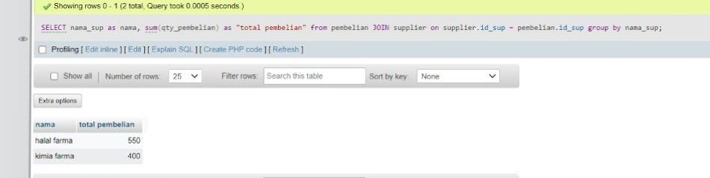***SELECT nama_sup as nama, sum(qty_pembelian) as “total pembelian” from pembelian JOIN supplier on supplier.id_sup = pembelian.id_sup group by nama_sup;***
2. ***select orders.id_order, orders.tgl_order, obat.nama_obat, obat.stok_obat from obat left join orders on obat.id_obat = orders.id_order where nama_obat like 'a%' and harga_obat < 20000 order by harga_obat desc limit 5;*** 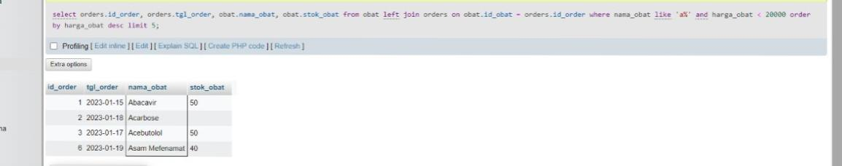
3. ***select orders.id_order, orders.tgl_order, obat.nama_obat, obat.stok_obat from obat RIGHT join orders on obat.id_obat = orders.id_order where stok_obat is not null order by stok_obat desc limit 7;***

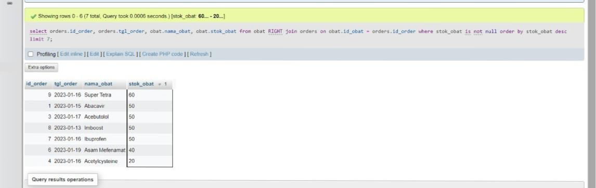

1. ***Select obat.nama_obat, obat.stok_obat, orders.tgl_order from obat join orders on obat.id_obat = orders.id_order where stok_obat is not null order by stok_obat asc limit 5;***

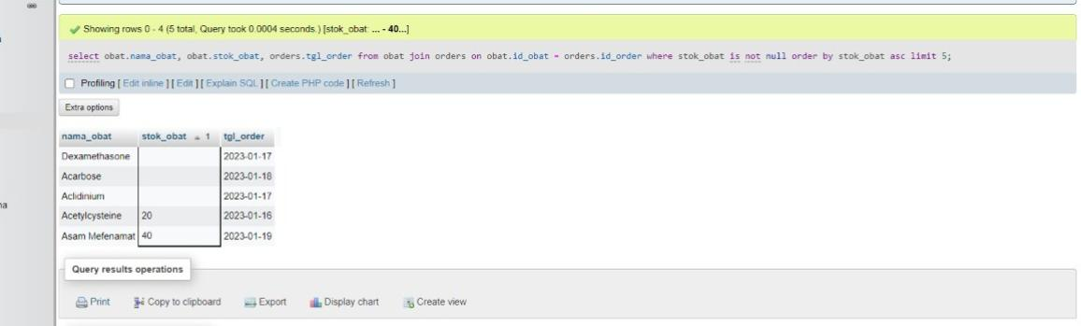

1. ***Select nama_cust, customers.alamat, orders.id_cust, orders.jumlah_order from customers right join orders on customers.id_cust = orders.id_cust where alamat like ‘%bukulasa%’ and alamat is not null order by id_cust asc;***

