**Eldyn** Mohammad Qosim  
  
1. SELECT * FROM `obat` ORDER BY nama DESC;  
*output*:  
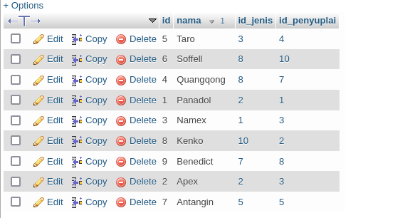  
  
  
2. SELECT * FROM `pasien` ORDER BY nama ASC;  
*output*:  
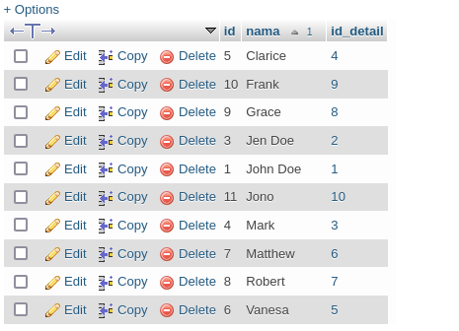

3. SELECT * FROM `obat` WHERE nama LIKE '%x%';  
*output*:  
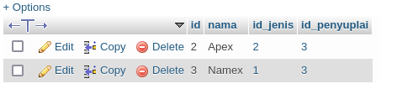  
  
  
4. SELECT * FROM `pasien` WHERE nama LIKE '%a%';  
*output*:  
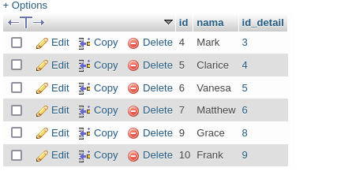  
  
  
5. SELECT nama AS nama_pasien FROM `pasien` WHERE nama LIKE '%m%';  
*output*:  
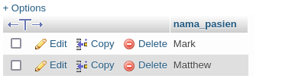  
  
  
6. SELECT nama AS nama_obat FROM `obat` WHERE nama LIKE '%a%';  
*output*:  
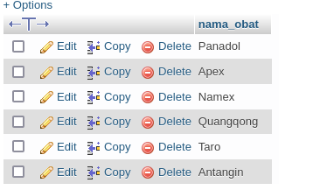

7. SELECT nama AS nama_obat FROM `obat` WHERE nama LIKE '%a%' ORDER BY nama DESC;  
*output*:  
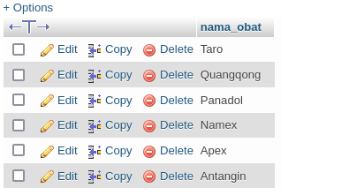  
  
  
8. SELECT MAX(id) id_obat FROM `obat`;  
*output*:  
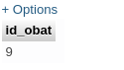  
  
  
9. SELECT MIN(id) id_pasien FROM `pasien`;  
*output*:  
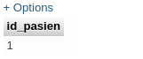  
  
  
10. SELECT nama, umur AS umur FROM pasien t1

INNER JOIN detail_pasien t2

ON t1.id_detail = t2.id;  
  
*output*:  
