**Eldyn** Mohammad Qosim  
  
1. SELECT obat.nama, penyuplai_obat.nama AS penyuplai FROM obat

JOIN penyuplai_obat ON obat.id_penyuplai = penyuplai_obat.id

ORDER BY nama ASC;  
  
*output:*  
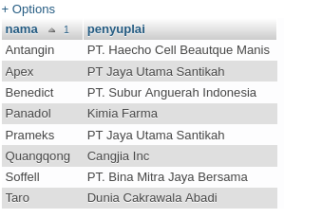  
  
  
2. SELECT nama,umur,golongan_darah,berat_badan,tinggi_badan FROM pasien

JOIN detail_pasien ON pasien.id_detail = detail_pasien.id

WHERE pasien.id = 3;  
  
*output:*  
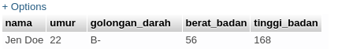  
  
  
3. SELECT obat.nama,jenis_obat.nama AS jenis FROM obat

JOIN jenis_obat ON obat.id_jenis = jenis_obat.id

WHERE obat.nama LIKE '%n%';  
  
*output:*  
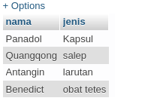

1. SELECT obat.nama,jenis_obat.nama AS jenis FROM obat

LEFT JOIN jenis_obat ON obat.id_jenis = jenis_obat.id

ORDER BY obat.nama;  
  
*output:*  
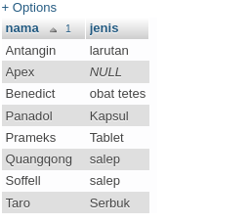  
  
  
5. SELECT nama,golongan_darah,umur FROM pasien

RIGHT JOIN detail_pasien ON pasien.id_detail = detail_pasien.id

WHERE pasien.id = 4;  
  
*output:*  
