1. [SELECT](http://localhost/phpmyadmin/url.php?url=https://dev.mysql.com/doc/refman/8.0/en/select.html) obat.nama, fungsi, obat.id_distributor, distributor.nama, alamat FROM `obat` JOIN distributor ON obat.id_distributor = distributor.id ORDER BY `obat`.`id_distributor` ASC

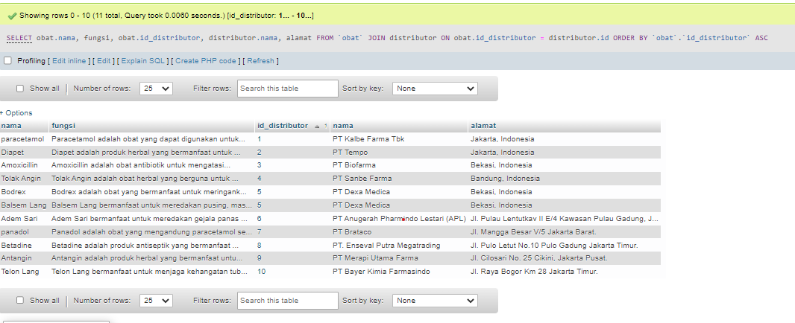

2. [SELECT](http://localhost/phpmyadmin/url.php?url=https://dev.mysql.com/doc/refman/8.0/en/select.html) obat.nama, fungsi, obat.id_distributor, distributor.nama, alamat FROM `obat` [RIGHT](http://localhost/phpmyadmin/url.php?url=https://dev.mysql.com/doc/refman/8.0/en/string-functions.html#function_right) JOIN distributor ON obat.id_distributor = distributor.id ORDER BY `obat`.`id_distributor` ASC;

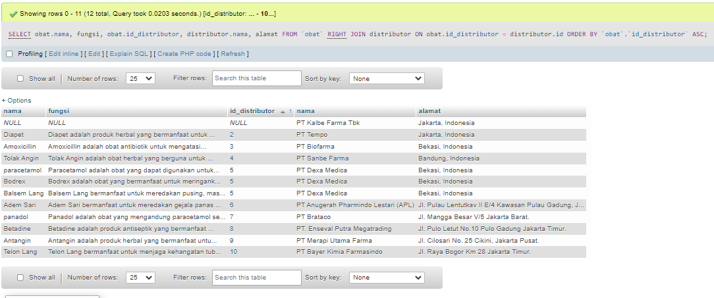

3. [SELECT](http://localhost/phpmyadmin/url.php?url=https://dev.mysql.com/doc/refman/8.0/en/select.html) obat.nama, fungsi, obat.id_distributor, distributor.nama, alamat FROM `obat` LEFT JOIN distributor ON obat.id_distributor = distributor.id ORDER BY `obat`.`id_distributor` ASC;

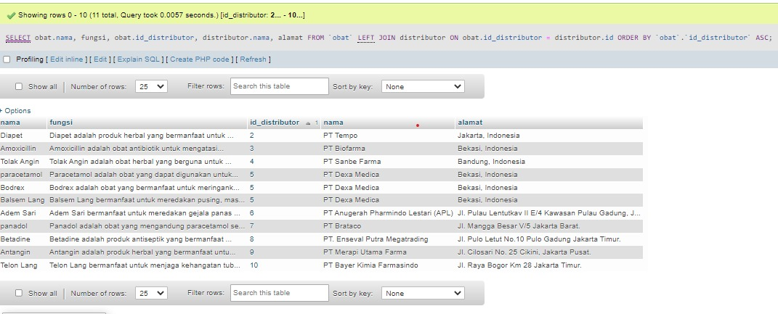

4. [SELECT](http://localhost/phpmyadmin/url.php?url=https://dev.mysql.com/doc/refman/8.0/en/select.html) obat.nama, fungsi, obat.id_distributor, distributor.nama, alamat FROM `obat`JOIN distributor ON obat.id_distributor = distributor.id WHERE alamat [LIKE](http://localhost/phpmyadmin/url.php?url=https://dev.mysql.com/doc/refman/8.0/en/string-comparison-functions.html#operator_like) '%Jakarta%' ORDER BY `obat`.`id_distributor` ASC;

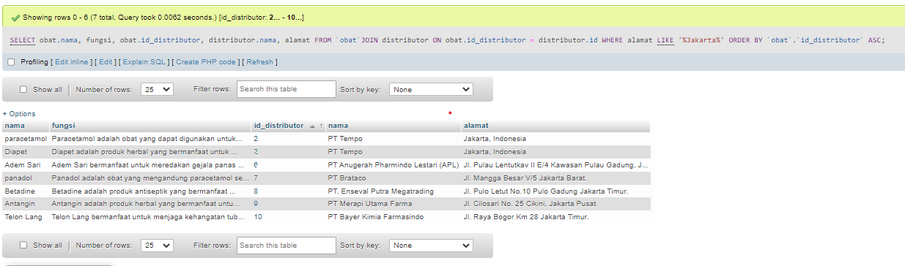

5. [SELECT](http://localhost/phpmyadmin/url.php?url=https://dev.mysql.com/doc/refman/8.0/en/select.html) obat.nama, fungsi, obat.id_distributor, distributor.nama, alamat FROM `obat`[RIGHT](http://localhost/phpmyadmin/url.php?url=https://dev.mysql.com/doc/refman/8.0/en/string-functions.html#function_right) JOIN distributor ON obat.id_distributor = distributor.id WHERE distributor.nama [LIKE](http://localhost/phpmyadmin/url.php?url=https://dev.mysql.com/doc/refman/8.0/en/string-comparison-functions.html#operator_like) '%farma%' ORDER BY `obat`.`id_distributor` ASC;

