1. [SELECT](http://localhost/phpmyadmin/url.php?url=https://dev.mysql.com/doc/refman/8.0/en/select.html) * FROM `obat` ORDER BY nama DESC;

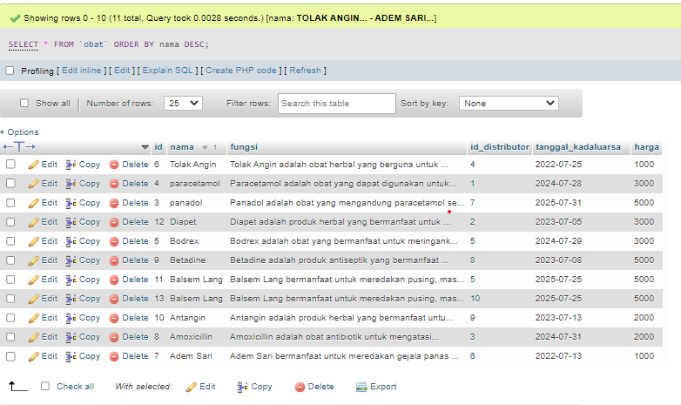

2. [SELECT](http://localhost/phpmyadmin/url.php?url=https://dev.mysql.com/doc/refman/8.0/en/select.html) * FROM `obat` ORDER BY tanggal_kadaluarsa ASC;

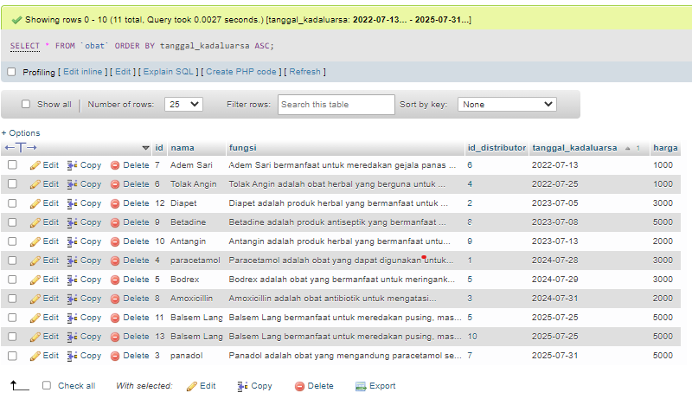

3. [SELECT](http://localhost/phpmyadmin/url.php?url=https://dev.mysql.com/doc/refman/8.0/en/select.html) * FROM `obat` WHERE fungsi [LIKE](http://localhost/phpmyadmin/url.php?url=https://dev.mysql.com/doc/refman/8.0/en/string-comparison-functions.html#operator_like) '%meredakan%';

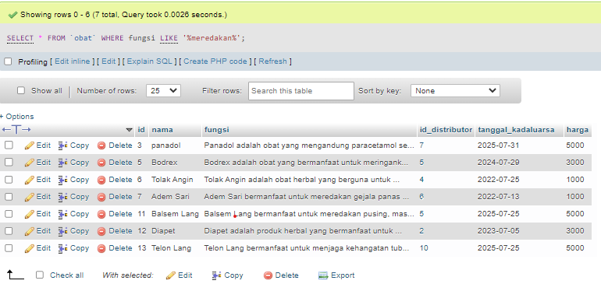

4. [SELECT](http://localhost/phpmyadmin/url.php?url=https://dev.mysql.com/doc/refman/8.0/en/select.html) * FROM `obat` WHERE nama [LIKE](http://localhost/phpmyadmin/url.php?url=https://dev.mysql.com/doc/refman/8.0/en/string-comparison-functions.html#operator_like) '%Lang%';

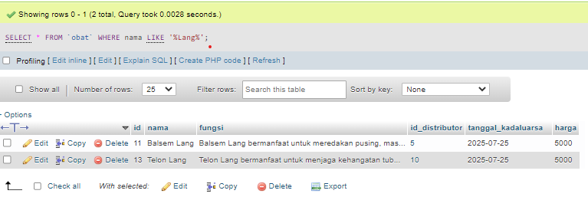

5. [SELECT](http://localhost/phpmyadmin/url.php?url=https://dev.mysql.com/doc/refman/8.0/en/select.html) nama, fungsi, harga FROM `obat`;

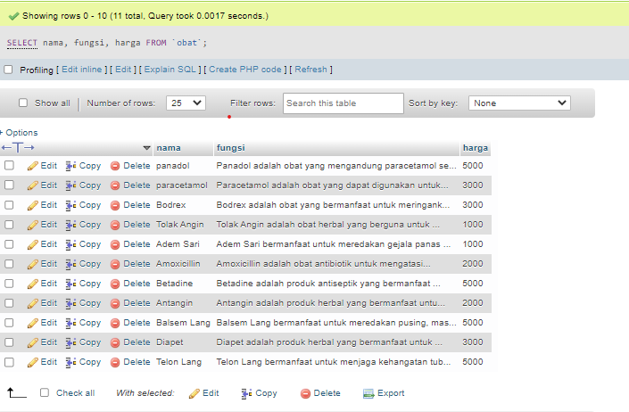

6. [SELECT](http://localhost/phpmyadmin/url.php?url=https://dev.mysql.com/doc/refman/8.0/en/select.html) * FROM `obat` WHERE harga >= 3000;

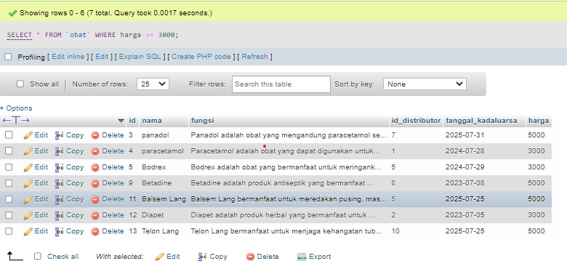

7. [SELECT](http://localhost/phpmyadmin/url.php?url=https://dev.mysql.com/doc/refman/8.0/en/select.html) * FROM `distributor` WHERE alamat [LIKE](http://localhost/phpmyadmin/url.php?url=https://dev.mysql.com/doc/refman/8.0/en/string-comparison-functions.html#operator_like) '%jakarta%';

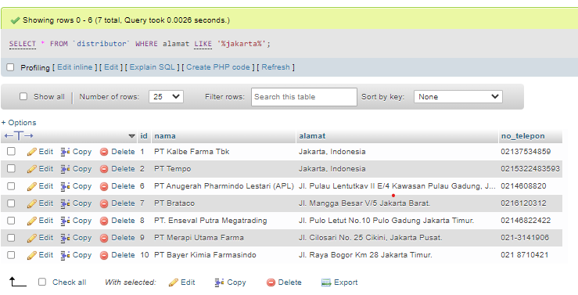

8. [SELECT](http://localhost/phpmyadmin/url.php?url=https://dev.mysql.com/doc/refman/8.0/en/select.html) * FROM `distributor` ORDER BY nama ASC;

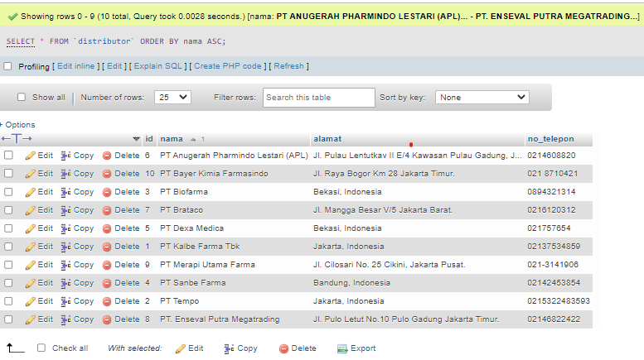

9. [SELECT](http://localhost/phpmyadmin/url.php?url=https://dev.mysql.com/doc/refman/8.0/en/select.html) * FROM `distributor` WHERE nama [LIKE](http://localhost/phpmyadmin/url.php?url=https://dev.mysql.com/doc/refman/8.0/en/string-comparison-functions.html#operator_like) '%farma%'ORDER BY nama DESC;

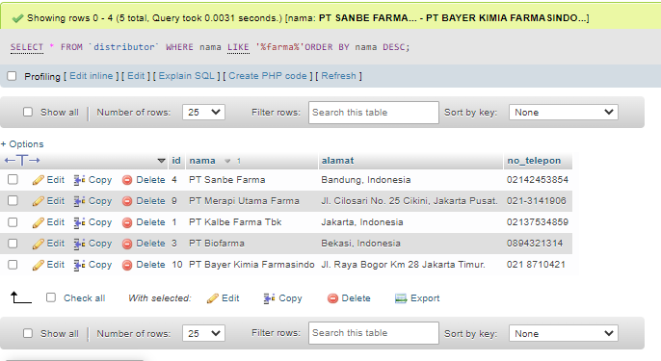

10. [SELECT](http://localhost/phpmyadmin/url.php?url=https://dev.mysql.com/doc/refman/8.0/en/select.html) * FROM `distributor` WHERE alamat [LIKE](http://localhost/phpmyadmin/url.php?url=https://dev.mysql.com/doc/refman/8.0/en/string-comparison-functions.html#operator_like) '%jakarta%'ORDER BY nama DESC;

