1. [SELECT](http://localhost/phpmyadmin/url.php?url=https://dev.mysql.com/doc/refman/8.0/en/select.html) * FROM `anggota` WHERE role [LIKE](http://localhost/phpmyadmin/url.php?url=https://dev.mysql.com/doc/refman/8.0/en/string-comparison-functions.html#operator_like) '%ADMIN%';



2. [SELECT](http://localhost/phpmyadmin/url.php?url=https://dev.mysql.com/doc/refman/8.0/en/select.html) * FROM `anggota` WHERE role [LIKE](http://localhost/phpmyadmin/url.php?url=https://dev.mysql.com/doc/refman/8.0/en/string-comparison-functions.html#operator_like) '%USER%';

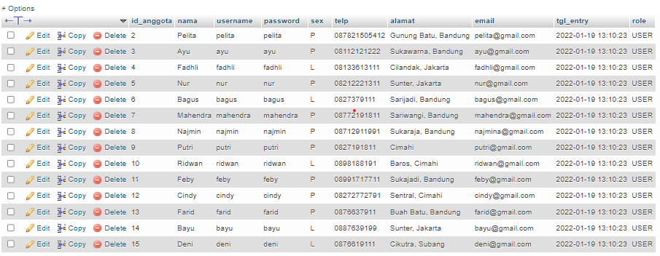

3. [SELECT](http://localhost/phpmyadmin/url.php?url=https://dev.mysql.com/doc/refman/8.0/en/select.html) anggota.id_anggota, nama FROM `anggota` [LEFT](http://localhost/phpmyadmin/url.php?url=https://dev.mysql.com/doc/refman/8.0/en/string-functions.html#function_left) JOIN peminjaman ON peminjaman.id_anggota = anggota.id_anggota WHERE tgl_pinjam [is](http://localhost/phpmyadmin/url.php?url=https://dev.mysql.com/doc/refman/8.0/en/comparison-operators.html#operator_is) NULL ORDER BY id_anggota ASC;

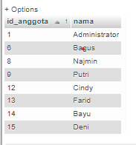

4. [SELECT](http://localhost/phpmyadmin/url.php?url=https://dev.mysql.com/doc/refman/8.0/en/select.html) anggota.id_anggota, nama, telp FROM `anggota` JOIN peminjaman ON peminjaman.id_anggota = anggota.id_anggota ORDER BY id_anggota ASC;

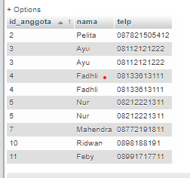

5. [SELECT](http://localhost/phpmyadmin/url.php?url=https://dev.mysql.com/doc/refman/8.0/en/select.html) anggota.id_anggota, nama, telp, qty FROM `anggota` JOIN peminjaman ON peminjaman.id_anggota = anggota.id_anggota JOIN detail_peminjaman ON detail_peminjaman.id_pinjam = peminjaman.id_pinjam WHERE qty > 1;

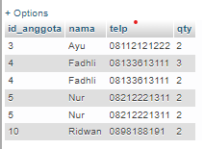

6. [SELECT](http://localhost/phpmyadmin/url.php?url=https://dev.mysql.com/doc/refman/8.0/en/select.html) nama, telp, alamat, tgl_pinjam, tgl_kembali FROM `anggota` JOIN peminjaman ON peminjaman.id_anggota = anggota.id_anggota;

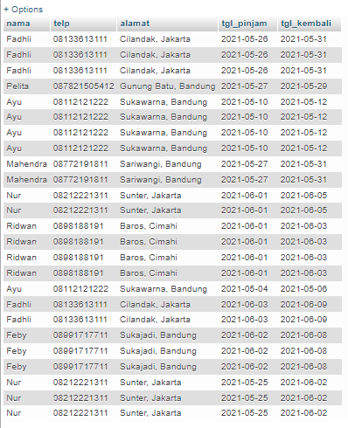

7. [SELECT](http://localhost/phpmyadmin/url.php?url=https://dev.mysql.com/doc/refman/8.0/en/select.html) nama, telp, alamat, tgl_pinjam, tgl_kembali FROM `anggota` JOIN peminjaman ON peminjaman.id_anggota = anggota.id_anggota WHERE tgl_kembali > 20210600;

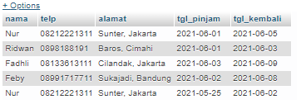

8. [SELECT](http://localhost/phpmyadmin/url.php?url=https://dev.mysql.com/doc/refman/8.0/en/select.html) nama, telp, alamat, tgl_pinjam, tgl_kembali FROM `anggota` JOIN peminjaman ON peminjaman.id_anggota = anggota.id_anggota WHERE tgl_pinjam < 20210600;

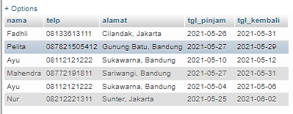

9. [SELECT](http://localhost/phpmyadmin/url.php?url=https://dev.mysql.com/doc/refman/8.0/en/select.html) nama, telp, alamat, tgl_pinjam, tgl_kembali FROM `anggota` JOIN peminjaman ON peminjaman.id_anggota = anggota.id_anggota WHERE tgl_pinjam >= 20210600 [AND](http://localhost/phpmyadmin/url.php?url=https://dev.mysql.com/doc/refman/8.0/en/logical-operators.html#operator_and) tgl_kembali > 20210600;

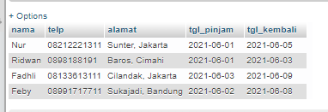

10. [SELECT](http://localhost/phpmyadmin/url.php?url=https://dev.mysql.com/doc/refman/8.0/en/select.html) nama, telp, alamat, tgl_pinjam, tgl_kembali FROM `anggota` JOIN peminjaman ON peminjaman.id_anggota = anggota.id_anggota WHERE alamat [LIKE](http://localhost/phpmyadmin/url.php?url=https://dev.mysql.com/doc/refman/8.0/en/string-comparison-functions.html#operator_like) '%Bandung%';

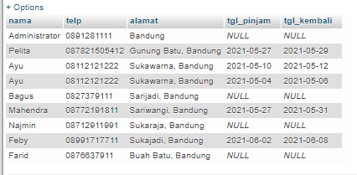

11. [SELECT](http://localhost/phpmyadmin/url.php?url=https://dev.mysql.com/doc/refman/8.0/en/select.html) nama, telp, alamat, tgl_pinjam, tgl_kembali FROM `anggota` [LEFT](http://localhost/phpmyadmin/url.php?url=https://dev.mysql.com/doc/refman/8.0/en/string-functions.html#function_left) JOIN peminjaman ON peminjaman.id_anggota = anggota.id_anggota WHERE alamat [LIKE](http://localhost/phpmyadmin/url.php?url=https://dev.mysql.com/doc/refman/8.0/en/string-comparison-functions.html#operator_like) '%Bandung%' [AND](http://localhost/phpmyadmin/url.php?url=https://dev.mysql.com/doc/refman/8.0/en/logical-operators.html#operator_and) sex [LIKE](http://localhost/phpmyadmin/url.php?url=https://dev.mysql.com/doc/refman/8.0/en/string-comparison-functions.html#operator_like) '%P%';

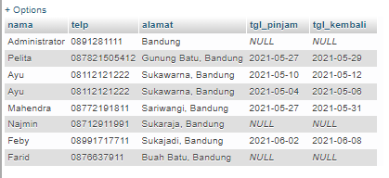

12. [SELECT](http://localhost/phpmyadmin/url.php?url=https://dev.mysql.com/doc/refman/8.0/en/select.html) nama, telp, alamat, tgl_pinjam, tgl_kembali, isbn, qty FROM `anggota` [LEFT](http://localhost/phpmyadmin/url.php?url=https://dev.mysql.com/doc/refman/8.0/en/string-functions.html#function_left) JOIN peminjaman ON peminjaman.id_anggota = anggota.id_anggota [LEFT](http://localhost/phpmyadmin/url.php?url=https://dev.mysql.com/doc/refman/8.0/en/string-functions.html#function_left) JOIN detail_peminjaman ON detail_peminjaman.id_pinjam = peminjaman.id_pinjam WHERE qty > 1;

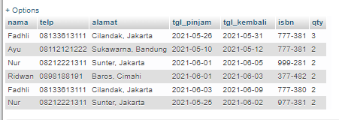

13. [SELECT](http://localhost/phpmyadmin/url.php?url=https://dev.mysql.com/doc/refman/8.0/en/select.html) nama, telp, alamat, tgl_pinjam, tgl_kembali, detail_peminjaman.isbn, qty, judul, harga_pinjam, (qty * harga_pinjam) AS total_harga FROM `anggota` [RIGHT](http://localhost/phpmyadmin/url.php?url=https://dev.mysql.com/doc/refman/8.0/en/string-functions.html#function_right) JOIN peminjaman ON peminjaman.id_anggota = anggota.id_anggota [RIGHT](http://localhost/phpmyadmin/url.php?url=https://dev.mysql.com/doc/refman/8.0/en/string-functions.html#function_right) JOIN detail_peminjaman ON detail_peminjaman.id_pinjam = peminjaman.id_pinjam [RIGHT](http://localhost/phpmyadmin/url.php?url=https://dev.mysql.com/doc/refman/8.0/en/string-functions.html#function_right) JOIN buku ON buku.isbn = detail_peminjaman.isbn;

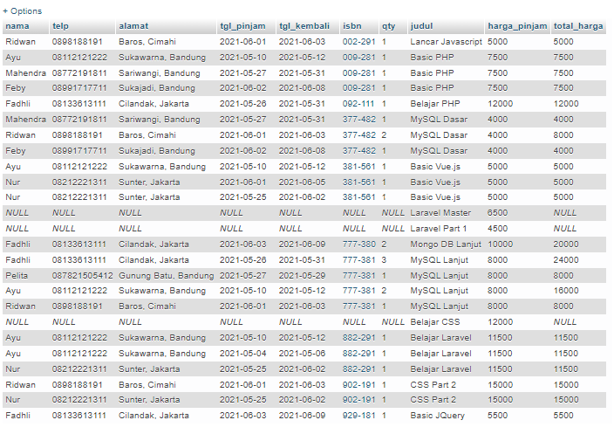

14. [SELECT](http://localhost/phpmyadmin/url.php?url=https://dev.mysql.com/doc/refman/8.0/en/select.html) anggota.nama, anggota.telp, anggota.alamat, tgl_pinjam, tgl_kembali, detail_peminjaman.isbn, qty, judul, nama_penerbit, nama_pengarang, katalog.nama FROM `anggota` [RIGHT](http://localhost/phpmyadmin/url.php?url=https://dev.mysql.com/doc/refman/8.0/en/string-functions.html#function_right) JOIN peminjaman ON peminjaman.id_anggota = anggota.id_anggota [RIGHT](http://localhost/phpmyadmin/url.php?url=https://dev.mysql.com/doc/refman/8.0/en/string-functions.html#function_right) JOIN detail_peminjaman ON detail_peminjaman.id_pinjam = peminjaman.id_pinjam [RIGHT](http://localhost/phpmyadmin/url.php?url=https://dev.mysql.com/doc/refman/8.0/en/string-functions.html#function_right) JOIN buku ON buku.isbn = detail_peminjaman.isbn [RIGHT](http://localhost/phpmyadmin/url.php?url=https://dev.mysql.com/doc/refman/8.0/en/string-functions.html#function_right) JOIN penerbit ON penerbit.id_penerbit = buku.id_penerbit [RIGHT](http://localhost/phpmyadmin/url.php?url=https://dev.mysql.com/doc/refman/8.0/en/string-functions.html#function_right) JOIN pengarang ON pengarang.id_pengarang = buku.id_pengarang [RIGHT](http://localhost/phpmyadmin/url.php?url=https://dev.mysql.com/doc/refman/8.0/en/string-functions.html#function_right) JOIN katalog ON katalog.id_katalog = buku.id_katalog;

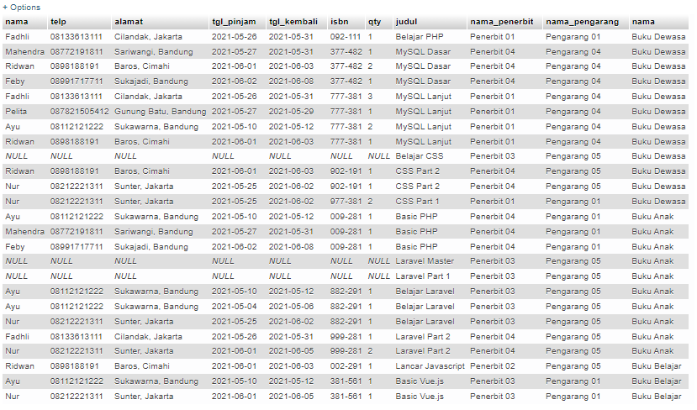

15. [SELECT](http://localhost/phpmyadmin/url.php?url=https://dev.mysql.com/doc/refman/8.0/en/select.html) katalog.id_katalog, katalog.nama, judul FROM `anggota` [RIGHT](http://localhost/phpmyadmin/url.php?url=https://dev.mysql.com/doc/refman/8.0/en/string-functions.html#function_right) JOIN peminjaman ON peminjaman.id_anggota = anggota.id_anggota [RIGHT](http://localhost/phpmyadmin/url.php?url=https://dev.mysql.com/doc/refman/8.0/en/string-functions.html#function_right) JOIN detail_peminjaman ON detail_peminjaman.id_pinjam = peminjaman.id_pinjam [RIGHT](http://localhost/phpmyadmin/url.php?url=https://dev.mysql.com/doc/refman/8.0/en/string-functions.html#function_right) JOIN buku ON buku.isbn = detail_peminjaman.isbn [RIGHT](http://localhost/phpmyadmin/url.php?url=https://dev.mysql.com/doc/refman/8.0/en/string-functions.html#function_right) JOIN penerbit ON penerbit.id_penerbit = buku.id_penerbit [RIGHT](http://localhost/phpmyadmin/url.php?url=https://dev.mysql.com/doc/refman/8.0/en/string-functions.html#function_right) JOIN pengarang ON pengarang.id_pengarang = buku.id_pengarang [RIGHT](http://localhost/phpmyadmin/url.php?url=https://dev.mysql.com/doc/refman/8.0/en/string-functions.html#function_right) JOIN katalog ON katalog.id_katalog = buku.id_katalog;

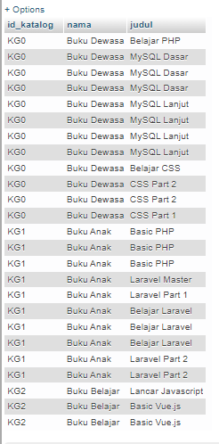

16. [SELECT](http://localhost/phpmyadmin/url.php?url=https://dev.mysql.com/doc/refman/8.0/en/select.html) buku.isbn, judul, tahun, buku.id_penerbit, buku.id_pengarang, buku.id_katalog, qty_stok, harga_pinjam, nama_penerbit FROM `anggota` [RIGHT](http://localhost/phpmyadmin/url.php?url=https://dev.mysql.com/doc/refman/8.0/en/string-functions.html#function_right) JOIN peminjaman ON peminjaman.id_anggota = anggota.id_anggota [RIGHT](http://localhost/phpmyadmin/url.php?url=https://dev.mysql.com/doc/refman/8.0/en/string-functions.html#function_right) JOIN detail_peminjaman ON detail_peminjaman.id_pinjam = peminjaman.id_pinjam [LEFT](http://localhost/phpmyadmin/url.php?url=https://dev.mysql.com/doc/refman/8.0/en/string-functions.html#function_left) JOIN buku ON buku.isbn = detail_peminjaman.isbn [LEFT](http://localhost/phpmyadmin/url.php?url=https://dev.mysql.com/doc/refman/8.0/en/string-functions.html#function_left) JOIN penerbit ON penerbit.id_penerbit = buku.id_penerbit [RIGHT](http://localhost/phpmyadmin/url.php?url=https://dev.mysql.com/doc/refman/8.0/en/string-functions.html#function_right) JOIN pengarang ON pengarang.id_pengarang = buku.id_pengarang [RIGHT](http://localhost/phpmyadmin/url.php?url=https://dev.mysql.com/doc/refman/8.0/en/string-functions.html#function_right) JOIN katalog ON katalog.id_katalog = buku.id_katalog;

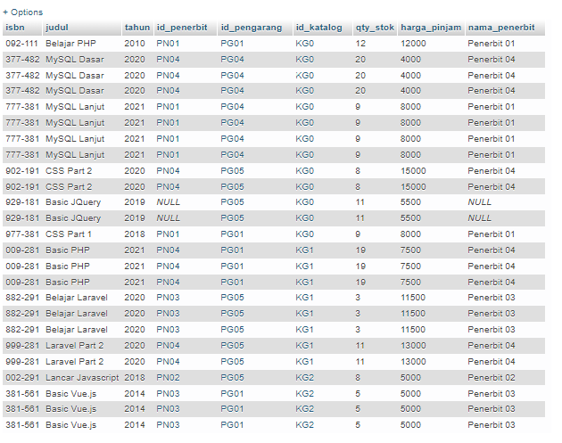

17. [SELECT](http://localhost/phpmyadmin/url.php?url=https://dev.mysql.com/doc/refman/8.0/en/select.html) id_pengarang, [COUNT](http://localhost/phpmyadmin/url.php?url=https://dev.mysql.com/doc/refman/8.0/en/group-by-functions.html#function_count)(id_pengarang) AS jumlah FROM `buku` WHERE id_pengarang [LIKE](http://localhost/phpmyadmin/url.php?url=https://dev.mysql.com/doc/refman/8.0/en/string-comparison-functions.html#operator_like) '%PG05%' GROUP BY id_pengarang;

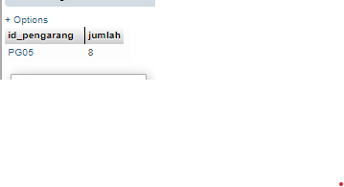

18. [SELECT](http://localhost/phpmyadmin/url.php?url=https://dev.mysql.com/doc/refman/8.0/en/select.html) isbn, judul, tahun, id_penerbit, id_pengarang, id_katalog, qty_stok, harga_pinjam FROM `buku` WHERE harga_pinjam >10000;

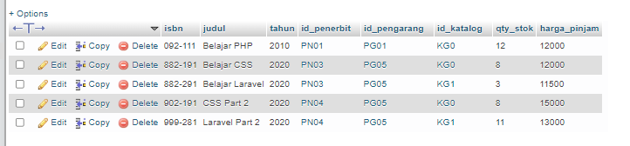

19. [SELECT](http://localhost/phpmyadmin/url.php?url=https://dev.mysql.com/doc/refman/8.0/en/select.html) isbn, judul, tahun, id_penerbit, id_pengarang, id_katalog, qty_stok, harga_pinjam FROM `buku` WHERE id_penerbit [LIKE](http://localhost/phpmyadmin/url.php?url=https://dev.mysql.com/doc/refman/8.0/en/string-comparison-functions.html#operator_like) '%PN01%' [AND](http://localhost/phpmyadmin/url.php?url=https://dev.mysql.com/doc/refman/8.0/en/logical-operators.html#operator_and) qty_stok > 10;

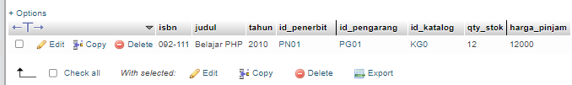

20. [SELECT](http://localhost/phpmyadmin/url.php?url=https://dev.mysql.com/doc/refman/8.0/en/select.html) * FROM `anggota` WHERE tgl_entry >= 20220615;

