1. SELECT * FROM `detail_transaksi` ORDER BY jumlah_obat DESC

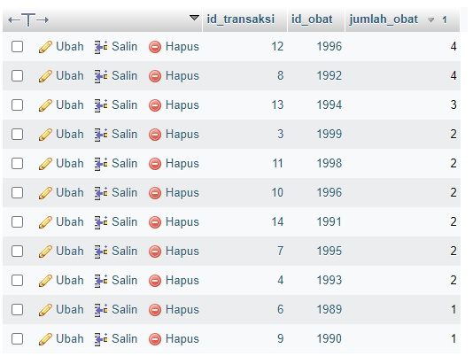

1. SELECT * FROM `detail_transaksi` ORDER BY jumlah_obat ASC

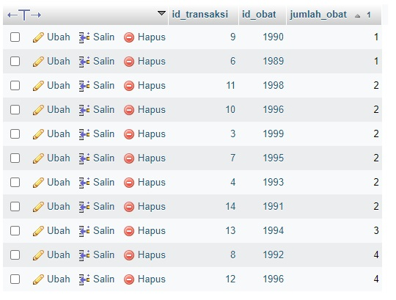

1. SELECT * FROM `obat` WHERE nama_obat LIKE '%OBAT%'

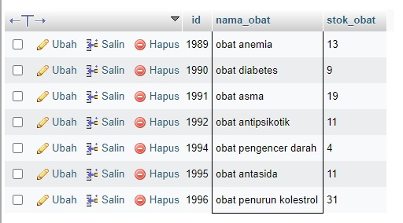

1. SELECT * FROM `obat` WHERE nama_obat LIKE '%darah%'

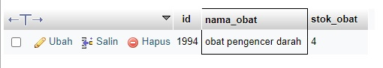

1. SELECT id, SUM(stok_obat) as total FROM `obat` GROUP BY id

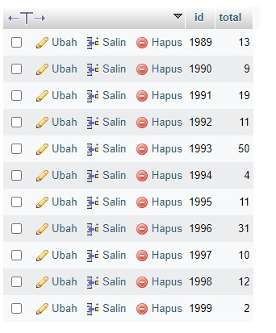

1. SELECT nama_obat, SUM(stok_obat) as total FROM `obat` GROUP BY nama_obat

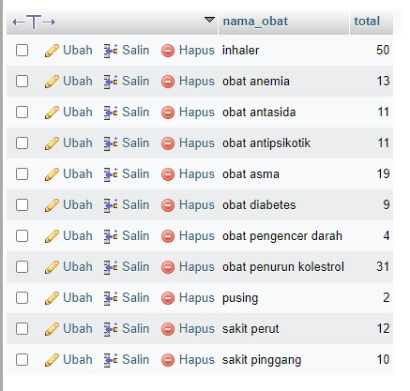

1. SELECT id_transaksi, SUM(jumlah_obat) as total FROM `detail_transaksi` GROUP BY id_transaksi

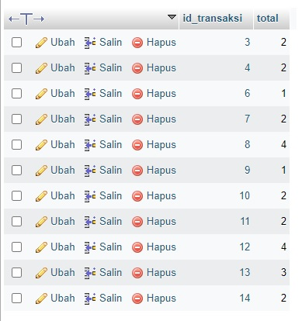

1. SELECT id_obat, SUM(jumlah_obat) as total FROM `detail_transaksi` WHERE id_obat >= 1990 GROUP BY id_obat DESC

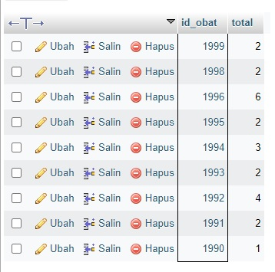

1. SELECT id_obat, SUM(jumlah_obat) as total FROM `detail_transaksi` GROUP BY id_obat ORDER BY id_obat ASC

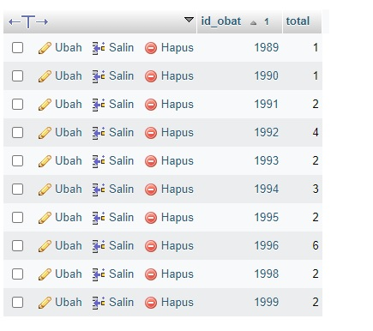

1. SELECT id_obat, SUM(jumlah_obat) as total FROM `detail_transaksi` GROUP BY id_obat ORDER BY id_obat DESC

