1. [SELECT](http://localhost/phpmyadmin/url.php?url=https://dev.mysql.com/doc/refman/8.0/en/select.html" \t "http://localhost/phpmyadmin/index.php?route=/table/mysql_doc) \* FROM `transaksi` ORDER BY harga DESC;

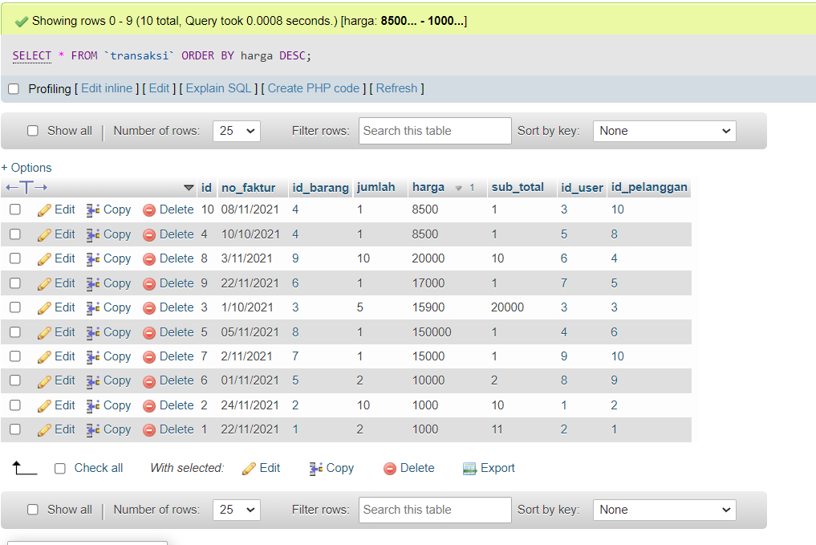

Dekripsi

Menampilkan ‘transaksi ‘ dari harga terbesar sampai terkecil

1. [SELECT](http://localhost/phpmyadmin/url.php?url=https://dev.mysql.com/doc/refman/8.0/en/select.html" \t "http://localhost/phpmyadmin/index.php?route=/table/mysql_doc) \* FROM `transaksi` ORDER BY harga ASC;

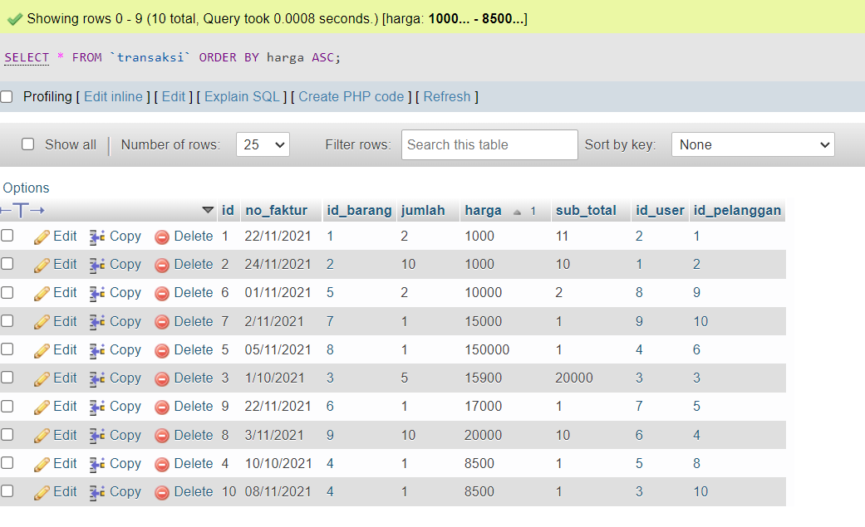

Dekripsi

Menampilkan ‘transaksi ‘ dari “harga” termurah sampai termahal

1. [SELECT](http://localhost/phpmyadmin/url.php?url=https://dev.mysql.com/doc/refman/8.0/en/select.html" \t "http://localhost/phpmyadmin/index.php?route=/table/mysql_doc) \* FROM `pelanggan` WHERE alamat [LIKE](http://localhost/phpmyadmin/url.php?url=https://dev.mysql.com/doc/refman/8.0/en/string-comparison-functions.html" \l "operator_like" \t "http://localhost/phpmyadmin/index.php?route=/table/mysql_doc) 'laweyan';

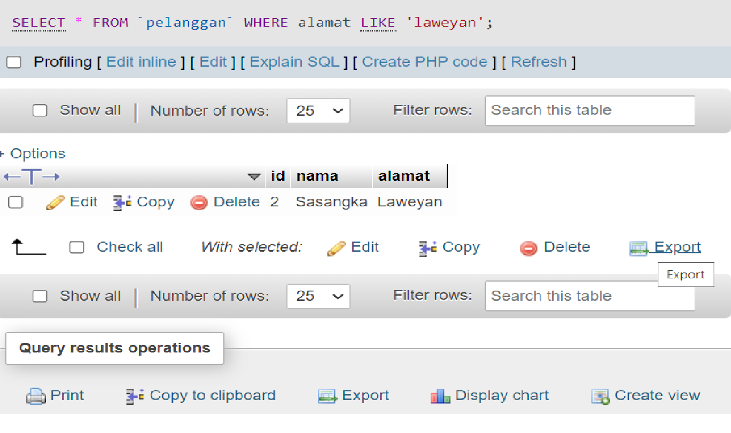

Dekrispsi : Mencari kata laweyan di tabel pelanggan

4.SELECT \* FROM `pelanggan` WHERE nama LIKE '%a%';

5.[SELECT](http://localhost/phpmyadmin/url.php?url=https://dev.mysql.com/doc/refman/8.0/en/select.html" \t "http://localhost/phpmyadmin/index.php?route=/table/mysql_doc) nama AS alamat FROM `pelanggan` WHERE nama [LIKE](http://localhost/phpmyadmin/url.php?url=https://dev.mysql.com/doc/refman/8.0/en/string-comparison-functions.html" \l "operator_like" \t "http://localhost/phpmyadmin/index.php?route=/table/mysql_doc) '%d%';

6.SELECT nama\_barang AS kd\_satuan FROM `obat` WHERE nama LIKE '%25%';

7SELECT nama AS nama\_obat FROM `obat` WHERE nama LIKE '%P%' ORDER BY nama DESC;

8.SELECT MAX(kd\_satuan) harga\_beli FROM `obat`;

9.SELECT MIN(nama) password FROM `user`;

10.SELECT harga, id\_barang AS id\_user FROM user1

INNER JOIN user

ON sub\_total = user1.id;