**MEMBUAT QUERY JOIN MYSQL**

1. **JOIN**

**Syntax : SELECT \* FROM `obat` INNER JOIN jenis\_obat;**

**Hasil :**

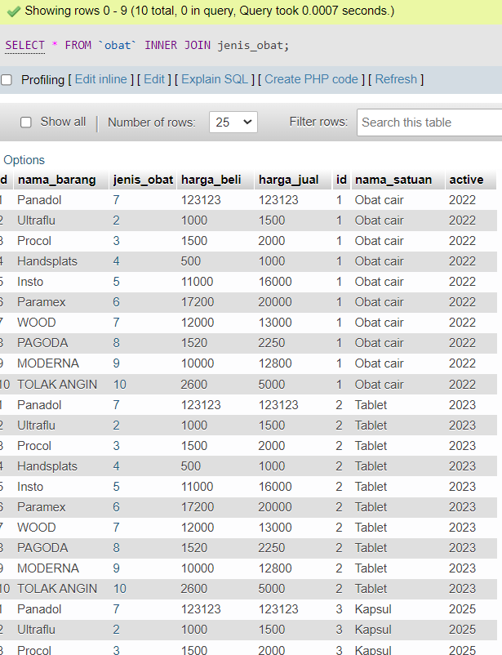

1. **Left JOIN**

**Syntax :**

[SELECT](http://localhost/phpmyadmin/url.php?url=https://dev.mysql.com/doc/refman/8.0/en/select.html" \t "http://localhost/phpmyadmin/index.php?route=/table/mysql_doc) \* FROM obat [LEFT](http://localhost/phpmyadmin/url.php?url=https://dev.mysql.com/doc/refman/8.0/en/string-functions.html" \l "function_left" \t "http://localhost/phpmyadmin/index.php?route=/table/mysql_doc) JOIN jenis\_obat ON obat.jenis\_obat = jenis\_obat.id;

**Hasil :**

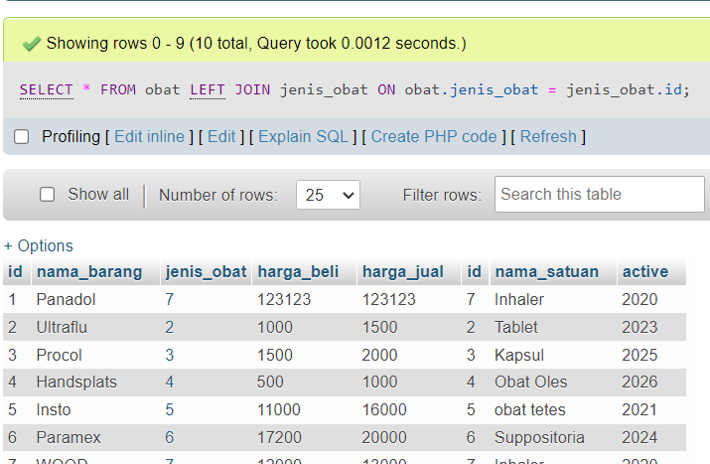

1. **Right Join**

**Syntax** [SELECT](http://localhost/phpmyadmin/url.php?url=https://dev.mysql.com/doc/refman/8.0/en/select.html" \t "http://localhost/phpmyadmin/index.php?route=/table/mysql_doc) \* FROM obat [RIGHT](http://localhost/phpmyadmin/url.php?url=https://dev.mysql.com/doc/refman/8.0/en/string-functions.html" \l "function_right" \t "http://localhost/phpmyadmin/index.php?route=/table/mysql_doc) JOIN jenis\_obat ON obat.jenis\_obat = jenis\_obat.id;

**Hasil :**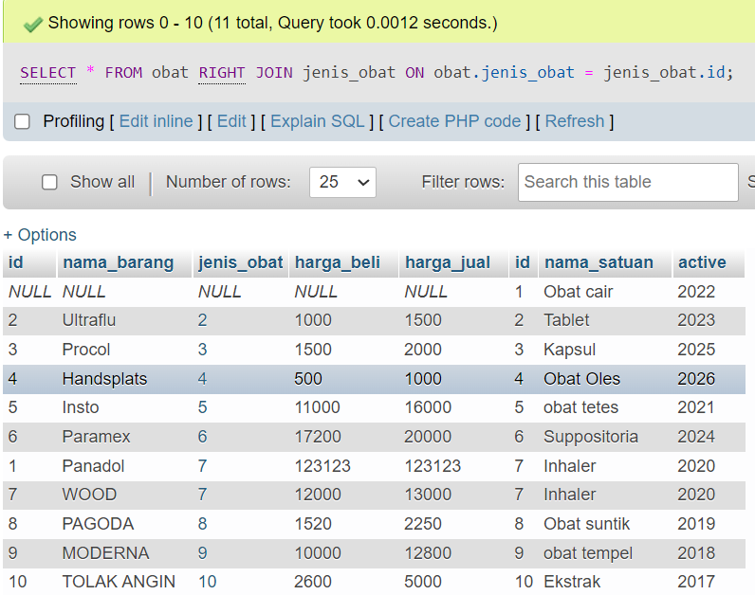

1. **JOIN WITH CLAUSE (WHERE & ORDER)**

**Syntax :**

[SELECT](http://localhost/phpmyadmin/url.php?url=https://dev.mysql.com/doc/refman/8.0/en/select.html" \t "http://localhost/phpmyadmin/index.php?route=/table/mysql_doc) \* FROM obat INNER JOIN jenis\_obat ON obat.jenis\_obat = jenis\_obat.id WHERE obat.id = 1 ORDER BY obat.id ASC;

**Hasil :**

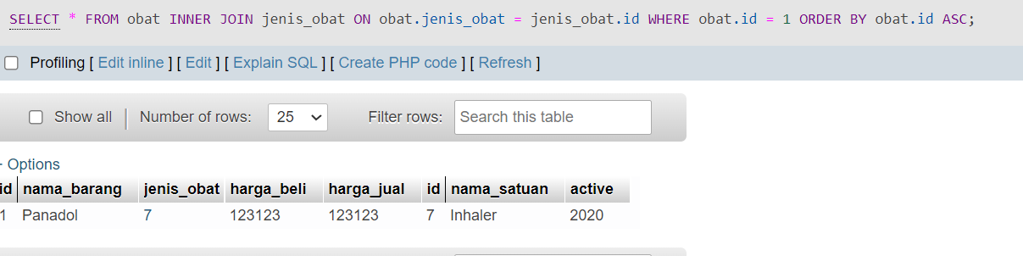

1. **JOIN WITH CLAUSE (WHERE, ORDER, GROUP BY)**

**Syntax :**

SELECT \* FROM obat INNER JOIN jenis\_obat ON obat.jenis\_obat = jenis\_obat.id WHERE obat.id = 1 ORDER BY obat.id DESC;

**Hasil :**

