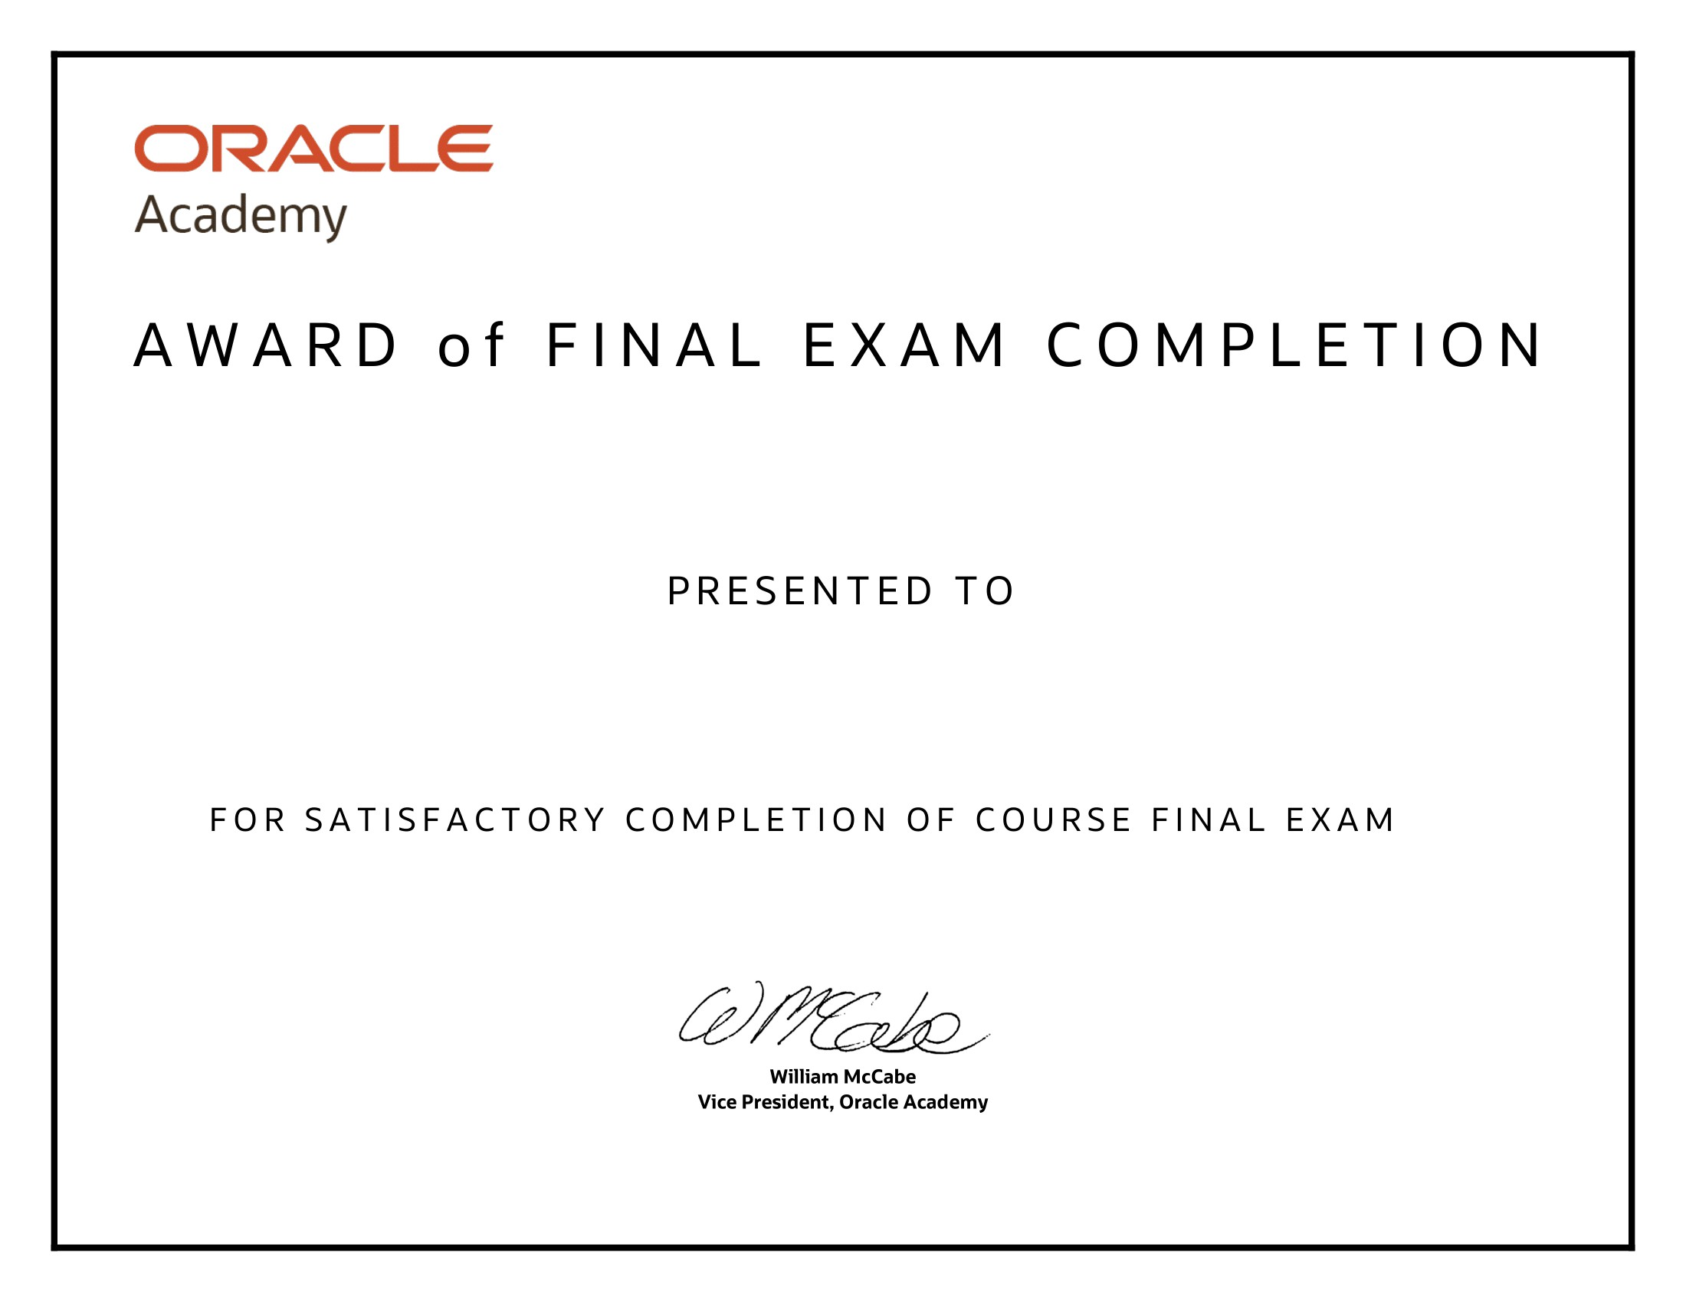

Database Programming with SQL

Dimas Irsyad Maulana

14th July 2023

