Whois
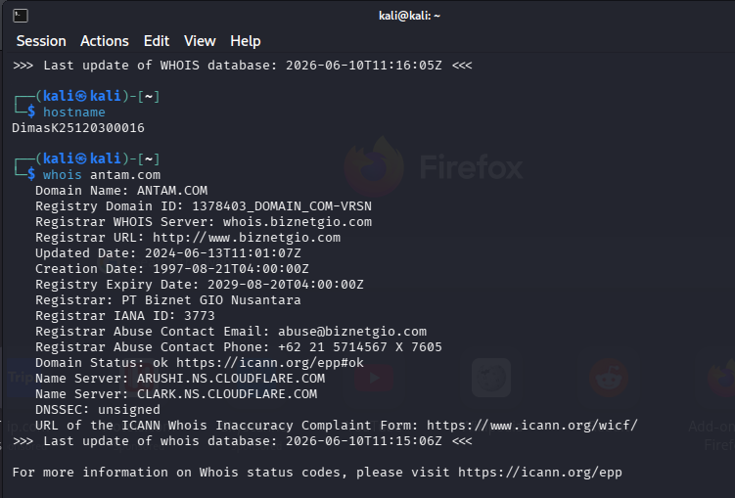
Mendapatkan data registrasi domain: registrar, tanggal, name server, status
Domain Name: ANTAM.COM
Registry Domain ID: 1378403_DOMAIN_COM-VRSN
Registrar WHOIS Server: whois.biznetgio.com
Registrar URL: http://www.biznetgio.com
Updated Date: 2024-06-13T11:01:07Z
Creation Date: 1997-08-21T04:00:00Z
Registry Expiry Date: 2029-08-20T04:00:00Z
Registrar: PT Biznet GIO Nusantara
Registrar IANA ID: 3773
Registrar Abuse Contact Email: abuse@biznetgio.com
Registrar Abuse Contact Phone: +62 21 5714567 X 7605
Domain Status: ok https://icann.org/epp#ok
Name Server: ARUSHI.NS.CLOUDFLARE.COM
Name Server: CLARK.NS.CLOUDFLARE.COM
DNSSEC: unsigned
URL of the ICANN Whois Inaccuracy Complaint Form: https://www.icann.org/wicf/

Mendapatkan Mail Server (MX record)

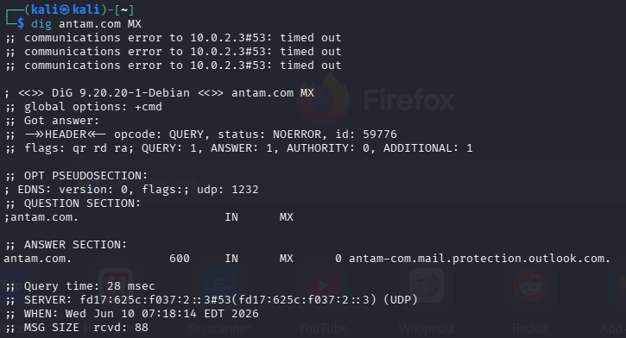

Mendapatkan IPv4 (A record)

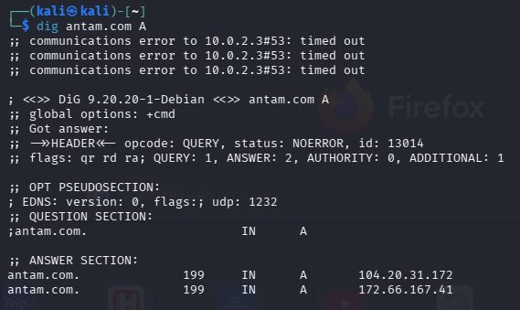

Mendapatkan TXT Record (termasuk SPF, verifikasi domain)

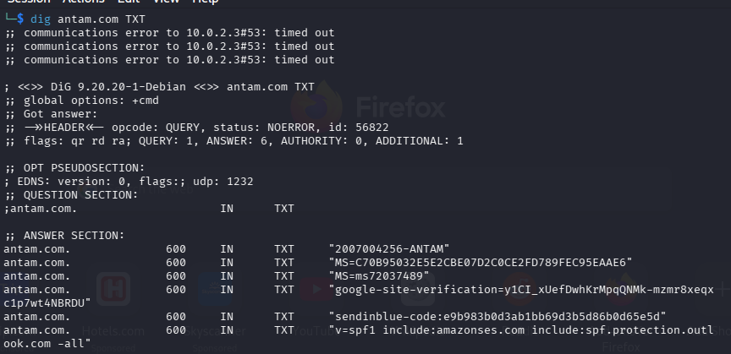

Menemukan subdomain yang tidak terdaftar di DNS publik.

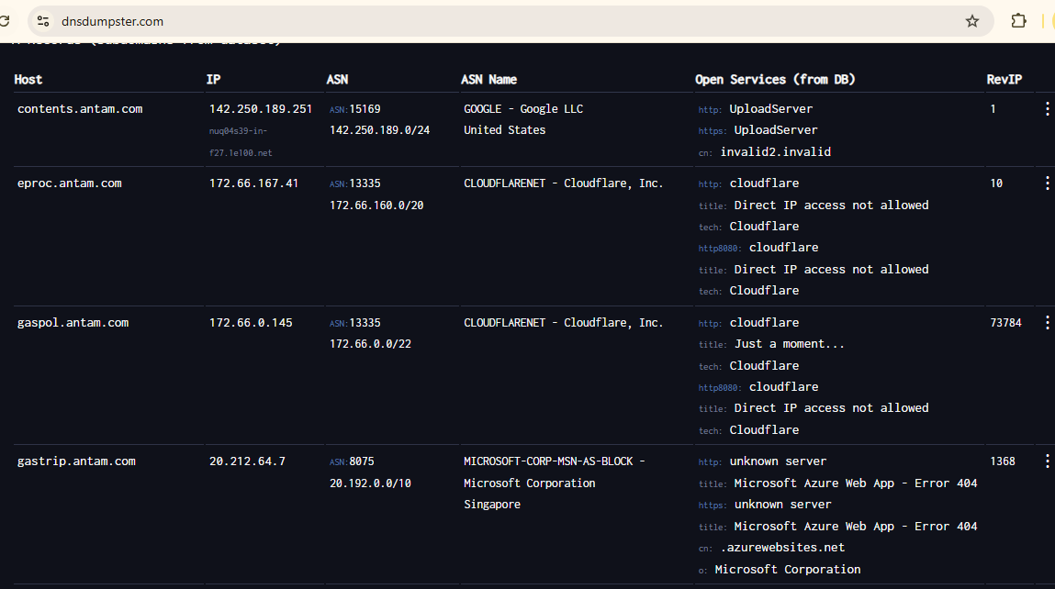

A Records (subdomains from dataset)
Host | IP | ASN | ASN Name | Open Services (from DB) | RevIP
contents.antam.com | 142.250.189.251  nuq04s39-in-f27.1e100.net | ASN:15169  142.250.189.0/24 | GOOGLE - Google LLC  United States | http: UploadServer  https: UploadServer  cn: invalid2.invalid | 1 | ⋮
eproc.antam.com | 172.66.167.41 | ASN:13335  172.66.160.0/20 | CLOUDFLARENET - Cloudflare, Inc. | http: cloudflare  title: Direct IP access not allowed  tech: Cloudflare  http8080: cloudflare  title: Direct IP access not allowed  tech: Cloudflare | 10 | ⋮
gaspol.antam.com | 172.66.0.145 | ASN:13335  172.66.0.0/22 | CLOUDFLARENET - Cloudflare, Inc. | http: cloudflare  title: Just a moment...  tech: Cloudflare  http8080: cloudflare  title: Direct IP access not allowed  tech: Cloudflare | 73784 | ⋮
gastrip.antam.com | 20.212.64.7 | ASN:8075  20.192.0.0/10 | MICROSOFT-CORP-MSN-AS-BLOCK - Microsoft Corporation  Singapore | http: unknown server  title: Microsoft Azure Web App - Error 404  https: unknown server  title: Microsoft Azure Web App - Error 404  cn: .azurewebsites.net  o: Microsoft Corporation | 1368 | ⋮
ictcare.antam.com | 136.143.186.127 | ASN:2639  136.143.186.0/23 | ZOHO-AS - ZOHO  United States | https: ZGS  title: 400 Bad Request  cn: www.dicenetwork.org |  | ⋮
mailer.antam.com | 212.146.235.108  mailer.antam.com | ASN:200484  212.146.192.0/18 | SENDINBLUE-ASN - Sendinblue SAS, FR  France |  | 1 | ⋮
img.mailer.antam.com | 104.17.158.243 | ASN:13335  104.17.144.0/20 | CLOUDFLARENET - Cloudflare, Inc. | http: cloudflare  title: Direct IP access not allowed  tech: Cloudflare  https: cloudflare  title: 403 Forbidden  cn: mailin.fr  tech: Cloudflare  http8080: cloudflare  title: Direct IP access not allowed  tech: Cloudflare | 7602 | ⋮
r.mailer.antam.com | 1.179.112.197 | ASN:396982  1.179.112.0/20 | GOOGLE-CLOUD-PLATFORM - Google LLC  France |  |  | ⋮
ppid.antam.com | 172.66.167.41 | ASN:13335  172.66.160.0/20 | CLOUDFLARENET - Cloudflare, Inc. | http: cloudflare  title: Direct IP access not allowed  tech: Cloudflare  http8080: cloudflare  title: Direct IP access not allowed  tech: Cloudflare | 10 | ⋮
wayafli.antam.com | 172.66.167.41 | ASN:13335  172.66.160.0/20 | CLOUDFLARENET - Cloudflare, Inc. | http: cloudflare  title: Direct IP access not allowed  tech: Cloudflare  http8080: cloudflare  title: Direct IP access not allowed  tech: Cloudflare | 10 | ⋮
www.antam.com | 104.20.31.172 | ASN:13335  104.20.16.0/20 | CLOUDFLARENET - Cloudflare, Inc. | http: cloudflare  title: Direct IP access not allowed  tech: Cloudflare  http8080: cloudflare  title: Direct IP access not allowed  tech: Cloudflare | 11 | ⋮
MX Records
0 antam-com.mail.protection.outlook.com | 52.101.137.0  mail-sg2pr03cu00500.inbound.protection.outlook.com | ASN:8075  52.96.0.0/12 | MICROSOFT-CORP-MSN-AS-BLOCK - Microsoft Corporation  Singapore |  |  | ⋮
NS Records
clark.ns.cloudflare.com | 108.162.193.87 | ASN:13335  108.162.193.0/24 | CLOUDFLARENET - Cloudflare, Inc. | http: cloudflare  title: Direct IP access not allowed  tech: Cloudflare  http8080: cloudflare  title: Direct IP access not allowed  tech: Cloudflare |  | ⋮
arushi.ns.cloudflare.com | 108.162.194.61  arushi.ns.cloudflare.com | ASN:13335  108.162.194.0/24 | CLOUDFLARENET - Cloudflare, Inc. | http: cloudflare  title: Direct IP access not allowed  tech: Cloudflare  http8080: cloudflare  title: Direct IP access not allowed  tech: Cloudflare |  | ⋮
TXT Records
"MS=ms72037489"
"google-site-verification=y1CI_xUefDwhKrMpqQNMk-mzmr8xeqxc1p7wt4NBRDU"
"sendinblue-code:e9b983b0d3ab1bb69d3b5d86b0d65e5d"
"v=spf1 include:amazonses.com include:spf.protection.outlook.com -all"
"2007004256-ANTAM"
"MS=C70B95032E5E2CBE07D2C0CE2FD789FEC95EAAE6"
Download xlsx
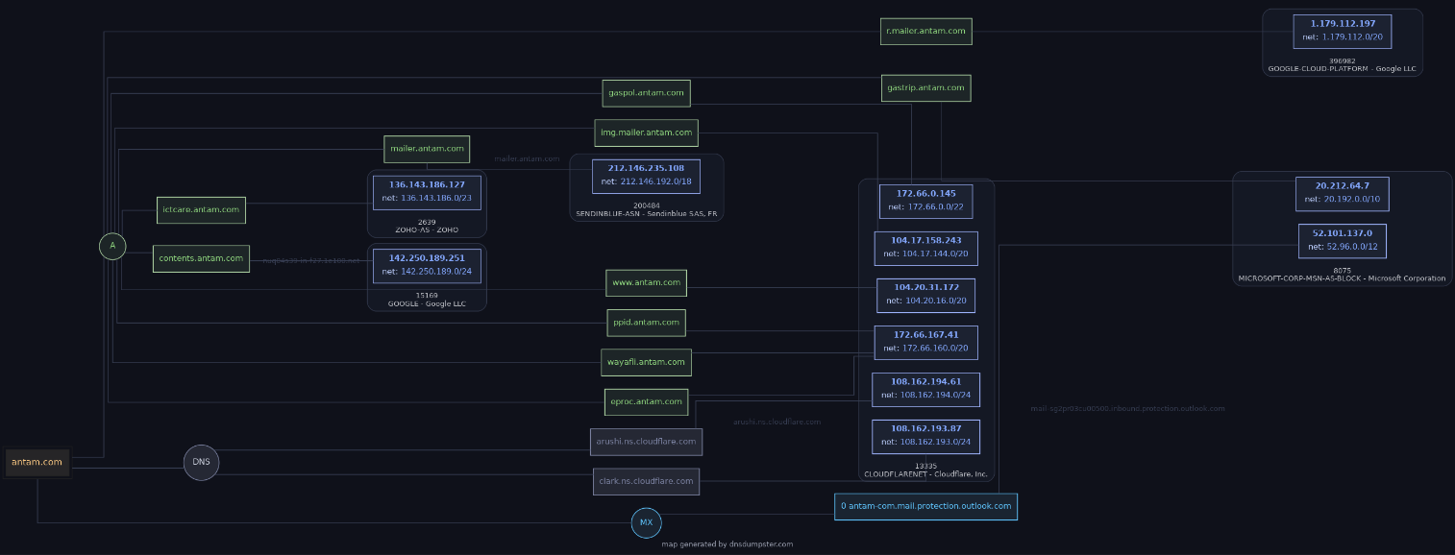
DNSDumpster.com
Shodan.io : Melihat layanan yang terbuka ke publik, port, banner, dan potensi CVE.
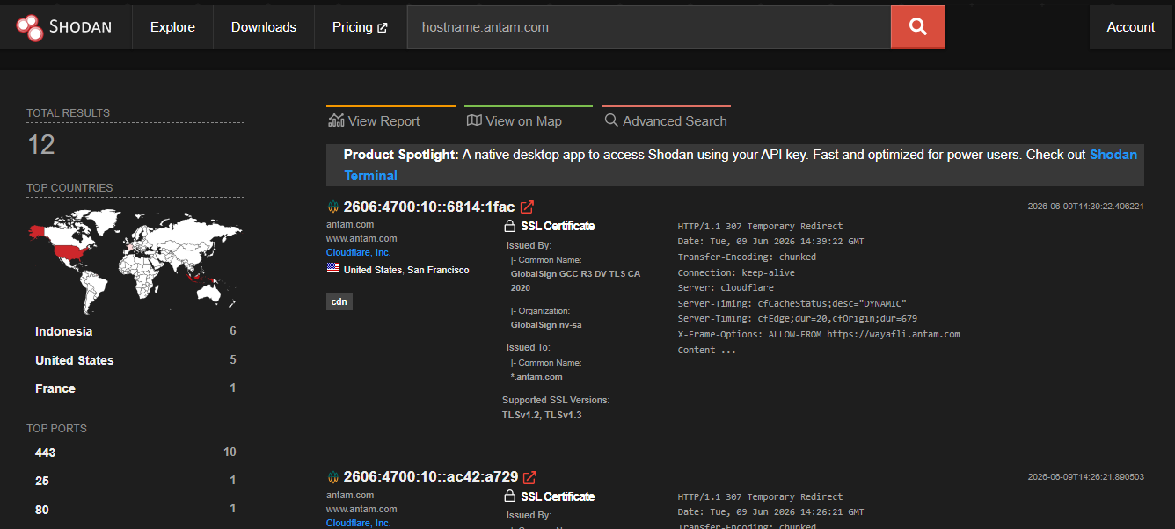

Total Results

12

Top Countries
- Indonesia6
- United States5
- France1

Top Ports
- 44310
- 251
- 801

Top Organizations
- Cloudflare, Inc.5
- PT iForte Global Internet2
- Amazon Data Services Jakarta1
- Amazon.com, Inc.1
- Google Asia Pacific Pte. Ltd. (GAPPL)1
- More...

Top Products
- AWS ELB1
- nginx1
View Report View on Map Advanced Search
Product Spotlight: A native desktop app to access Shodan using your API key. Fast and optimized for power users. Check out Shodan Terminal
2606:4700:10::6814:1fac
2026-06-09T14:39:22.406221
- antam.com
- www.antam.com
- Cloudflare, Inc.
- United States, San Francisco

cdn

SSL Certificate
- Issued By:
  - |- Common Name: GlobalSign GCC R3 DV TLS CA 2020
  - |- Organization: GlobalSign nv-sa
- Issued To:
  - |- Common Name:*.antam.com
Supported SSL Versions:
TLSv1.2, TLSv1.3
HTTP/1.1 307 Temporary Redirect
Date: Tue, 09 Jun 2026 14:39:22 GMT
Transfer-Encoding: chunked
Connection: keep-alive
Server: cloudflare
Server-Timing: cfCacheStatus;desc="DYNAMIC"
Server-Timing: cfEdge;dur=20,cfOrigin;dur=679
X-Frame-Options: ALLOW-FROM https://wayafli.antam.com
Content-...
2606:4700:10::ac42:a729
2026-06-09T14:26:21.890503
- antam.com
- www.antam.com
- Cloudflare, Inc.
- United States, San Francisco

cdn

SSL Certificate
- Issued By:
  - |- Common Name: GlobalSign GCC R3 DV TLS CA 2020
  - |- Organization: GlobalSign nv-sa
- Issued To:
  - |- Common Name:*.antam.com
Supported SSL Versions:
TLSv1.2, TLSv1.3
HTTP/1.1 307 Temporary Redirect
Date: Tue, 09 Jun 2026 14:26:21 GMT
Transfer-Encoding: chunked
Connection: keep-alive
Server: cloudflare
Server-Timing: cfCacheStatus;desc="DYNAMIC"
Server-Timing: cfEdge;dur=14,cfOrigin;dur=681
X-Frame-Options: ALLOW-FROM https://wayafli.antam.com
Content-...
Home | PT ANTAM Tbk
2026-06-09T09:13:00.177376
- 104.20.31.172
- antam.com
- Cloudflare, Inc.
- United States, San Francisco
cdn

SSL Certificate
- Issued By:
  - |- Common Name: GlobalSign GCC R3 DV TLS CA 2020
  - |- Organization: GlobalSign nv-sa
- Issued To:
  - |- Common Name:*.antam.com
Supported SSL Versions:
TLSv1.2, TLSv1.3
HTTP/1.1 200 OK
Date: Tue, 09 Jun 2026 09:12:59 GMT
Content-Type: text/html; charset=utf-8
Transfer-Encoding: chunked
Connection: keep-alive
Server: cloudflare
Server-Timing: cfCacheStatus;desc="DYNAMIC"
Server-Timing: cfEdge;dur=17,cfOrigin;dur=237
X-Frame-Options: ALLOW-FROM https://way...
Home | PT ANTAM Tbk
2026-06-08T21:38:31.369943
- 172.66.167.41
- antam.com
- Cloudflare, Inc.
- United States, San Francisco
cdn

SSL Certificate
- Issued By:
  - |- Common Name: GlobalSign GCC R3 DV TLS CA 2020
  - |- Organization: GlobalSign nv-sa
- Issued To:
  - |- Common Name:*.antam.com
Supported SSL Versions:
TLSv1.2, TLSv1.3
HTTP/1.1 200 OK
Date: Mon, 08 Jun 2026 21:38:30 GMT
Content-Type: text/html; charset=utf-8
Transfer-Encoding: chunked
Connection: keep-alive
Server: cloudflare
Server-Timing: cfCacheStatus;desc="DYNAMIC"
Server-Timing: cfEdge;dur=12,cfOrigin;dur=2120
X-Frame-Options: ALLOW-FROM https://wa...
Precious Metal Sourcing Platform - Precious Metal Sourcing Platform
2026-06-08T02:07:49.509457
- 15.232.106.52
- antam.com
- ec2-15-232-106-52.ap-southeast-3.compute.amazonaws.com
- Amazon.com, Inc.
- Indonesia, Jakarta
- 
cloud

SSL Certificate
- Issued By:
  - |- Common Name: GlobalSign GCC R3 DV TLS CA 2020
  - |- Organization: GlobalSign nv-sa
- Issued To:
  - |- Common Name:*.antam.com
Supported SSL Versions:
TLSv1.2, TLSv1.3
HTTP/1.1 200 OK
Date: Mon, 08 Jun 2026 02:09:23 GMT
Content-Type: text/html;charset=utf-8
Content-Length: 12940
Connection: keep-alive
x-powered-by: Nuxt
Home | PPID PT ANTAM Tbk
2026-06-07T00:07:11.738667
- 34.101.40.250
- antam.com
- 250.40.101.34.bc.googleusercontent.com
- Google Asia Pacific Pte. Ltd. (GAPPL)
- Indonesia, Jakarta
cloud

SSL Certificate
- Issued By:
  - |- Common Name: GlobalSign GCC R3 DV TLS CA 2020
  - |- Organization: GlobalSign nv-sa
- Issued To:
  - |- Common Name:*.antam.com
Supported SSL Versions:
TLSv1.2, TLSv1.3
HTTP/1.1 200 OK
Server: nginx
Date: Sun, 07 Jun 2026 00:07:10 GMT
Content-Type: text/html; charset=utf-8
Transfer-Encoding: chunked
Connection: keep-alive
X-Frame-Options: ALLOW-FROM https://wayafli.antam.com
Content-Security-Policy: frame-ancestors 'self' https://wayafli.antam.com;
link:...
301 Moved Permanently
2026-06-05T00:55:06.619476
- 2606:4700:10::ac42:a729
- eproc.antam.com
- Cloudflare, Inc.
- United States, San Francisco

cdn
HTTP/1.1 301 Moved Permanently
Date: Fri, 05 Jun 2026 00:55:06 GMT
Content-Type: text/html; charset=UTF-8
Transfer-Encoding: chunked
Connection: keep-alive
Server-Timing: cfEdge;dur=14,cfOrigin;dur=0
Location: https://eproc.antam.com/
Server: cloudflare
CF-RAY: a06b35b9b8c7cf1a-SJC
Server Unavailable
2026-06-03T10:12:04.966003
- 103.164.111.229
- 229.111.164.103.net.iforte.net.id
- antam.com
- PT iForte Global Internet
- Indonesia, Jakarta

SSL Certificate
- Issued By:
  - |- Common Name: GlobalSign GCC R3 DV TLS CA 2020
  - |- Organization: GlobalSign nv-sa
- Issued To:
  - |- Common Name:*.antam.com
Supported SSL Versions:
TLSv1.2, TLSv1.3
HTTP/1.1 503 Service Unavailable
Date: Wed Jun 3 10:12:04 2026 GMT
Content-Length: 57488
Connection: close
Content-Type: text/html
212.146.235.108
2026-06-01T13:29:37.190298
- sendinblue.com
- mailer.antam.com
- Sendinblue SAS
- France, Calais
starttls

SSL Certificate
- Issued By:
  - |- Common Name: Sectigo Public Server Authentication CA DV R36
  - |- Organization: Sectigo Limited
- Issued To:
  - |- Common Name:*.sendinblue.com
220 ESMTP Sendinblue SMTP 2.0
250-sendinblue_returnpath at your service, [224.124.84.184]
250-8BITMIME
250-ENHANCEDSTATUSCODES
250 STARTTLS
Server Unavailable
2026-05-25T21:12:33.403225
- 202.137.8.228
- antam.com
- ln-static-202-137-8-228.link.net.id
- ISP LINKNET
- Indonesia, Jakarta

SSL Certificate
- Issued By:
  - |- Common Name: GlobalSign GCC R3 DV TLS CA 2020
  - |- Organization: GlobalSign nv-sa
- Issued To:
  - |- Common Name:*.antam.com
Supported SSL Versions:
TLSv1.2, TLSv1.3
HTTP/1.1 503 Service Unavailable
Date: Mon May 25 21:14:04 2026 GMT
Content-Length: 57486
Connection: close
Content-Type: text/html
Next
Access Granted: Want to get more out of your existing Shodan account? Check outeverything you have access to.
403 Forbidden
2026-05-25T16:02:58.618902
- 16.78.37.76
- antam.com
- ec2-16-78-37-76.ap-southeast-3.compute.amazonaws.com
- Amazon Data Services Jakarta
- Indonesia, Jakarta
- 
cloud

SSL Certificate
- Issued By:
  - |- Common Name: GlobalSign GCC R3 DV TLS CA 2020
  - |- Organization: GlobalSign nv-sa
- Issued To:
  - |- Common Name:*.antam.com
Supported SSL Versions:
TLSv1.2, TLSv1.3
HTTP/1.1 403 Forbidden
Server: awselb/2.0
Date: Mon, 25 May 2026 16:02:58 GMT
Content-Type: text/html
Content-Length: 520
Connection: keep-alive
Server Unavailable
2026-05-19T05:37:19.812323
- 103.164.111.228
- antam.com
- 228.111.164.103.net.iforte.net.id
- PT iForte Global Internet
- Indonesia, Jakarta

SSL Certificate
- Issued By:
  - |- Common Name: GlobalSign GCC R3 DV TLS CA 2020
  - |- Organization: GlobalSign nv-sa
- Issued To:
  - |- Common Name:*.antam.com
Supported SSL Versions:
TLSv1.2, TLSv1.3
HTTP/1.1 503 Service Unavailable
Date: Tue May 19 05:37:19 2026 GMT
Content-Length: 57489
Connection: close
Content-Type: text/html

WhatWeb – Identifikasi Teknologi Website
WhatWeb berfungsi untuk mengidentifikasi teknologi yang digunakan oleh sebuah website
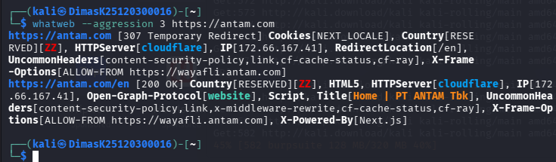
whatweb --aggression 3 https://antam.com
https://antam.com [307 Temporary Redirect] Cookies[NEXT_LOCALE], Country[RESERVED][ZZ], HTTPServer[cloudflare], IP[172.66.167.41], RedirectLocation[/en], UncommonHeaders[content-security-policy,link,cf-cache-status,cf-ray], X-Frame-Options[ALLOW-FROM https://wayafli.antam.com]
https://antam.com/en [200 OK] Country[RESERVED][ZZ], HTML5, HTTPServer[cloudflare], IP[172.66.167.41], Open-Graph-Protocol[website], Script, Title[Home | PT ANTAM Tbk], UncommonHeaders[content-security-policy,link,x-middleware-rewrite,cf-cache-status,cf-ray], X-Frame-Options[ALLOW-FROM https://wayafli.antam.com], X-Powered-By[Next.js]

Nikto – Pemindaian Kerentanan Web Server
Nikto adalah pemindai kerentanan web server yang kuat, mendeteksi file berbahaya, konfigurasi yang salah, dan versi perangkat lunak yang sudah usang
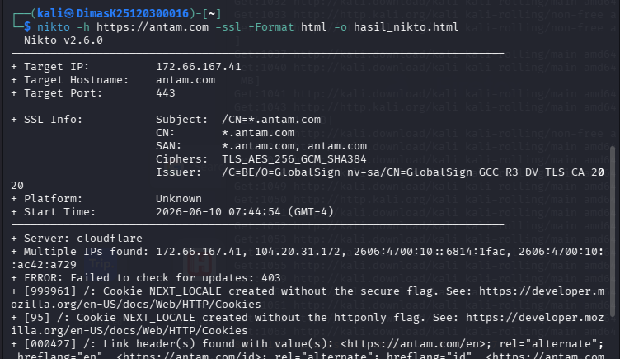
ikto -h https://antam.com -ssl -Format html -o hasil_nikto.html
- Nikto v2.6.0
---------------------------------------------------------------------------
+ Target IP: 172.66.167.41
+ Target Hostname: antam.com
+ Target Port: 443
---------------------------------------------------------------------------
+ SSL Info: Subject: /CN=*.antam.com
CN: *.antam.com
SAN: *.antam.com, antam.com
Ciphers: TLS_AES_256_GCM_SHA384
Issuer: /C=BE/O=GlobalSign nv-sa/CN=GlobalSign GCC R3 DV TLS CA 2020
+ Platform: Unknown
+ Start Time: 2026-06-10 07:44:54 (GMT-4)
---------------------------------------------------------------------------
+ Server: cloudflare
+ Multiple IPs found: 172.66.167.41, 104.20.31.172, 2606:4700:10::6814:1fac, 2606:4700:10::ac42:a729
+ ERROR: Failed to check for updates: 403
+ [999961] /: Cookie NEXT_LOCALE created without the secure flag. See: https://developer.mozilla.org/en-US/docs/Web/HTTP/Cookies
+ [95] /: Cookie NEXT_LOCALE created without the httponly flag. See: https://developer.mozilla.org/en-US/docs/Web/HTTP/Cookies
+ [000427] /: Link header(s) found with value(s): <https://antam.com/en>; rel="alternate"; hreflang="en", <https://antam.com/id>; rel="alternate"; hreflang="id", <https://antam.com/>; rel="alternate"; hreflang="x-default". See: https://developer.mozilla.org/en-US/docs/Web/HTTP/Headers/Link
+ [999106] /: Cloudflare detected via cf-ray header. Recommend proxying via Burp or mitmproxy to avoid TLS fingerprint blocks. See: https://github.com/sullo/nikto/wiki/Using-a-Proxy
+ [999100] /icons/: Uncommon header(s) 'refresh' found, with contents: 0;url=/icons.
+ [999986] /trace.axd: Retrieved x-powered-by header: Next.js.

antam.com / 172.66.167.41 port 443

Target IP |  | 172.66.167.41
Target hostname |  | antam.com
Target Port |  | 443
HTTP Server |  | cloudflare
Site Link (Name) |  | https://antam.com:443
Site Link (IP) |  | https://172.66.167.41:443/
SSL Certificate Subject |  | /CN=*.antam.com
SSL Certificate CN |  | *.antam.com
SSL Certificate SAN |  | *.antam.com, antam.com
SSL Ciphers |  | TLS_AES_256_GCM_SHA384
SSL Certificate Issuer |  | /C=BE/O=GlobalSign nv-sa/CN=GlobalSign GCC R3 DV TLS CA 2020
URI | /
HTTP Method | GET
Description | /: Cookie NEXT_LOCALE created without the secure flag.
Link | https://antam.com:443/
Reference(s) | https://developer.mozilla.org/en-US/docs/Web/HTTP/Cookies

URI | /
HTTP Method | GET
Description | /: Cookie NEXT_LOCALE created without the httponly flag.
Link | https://antam.com:443/
Reference(s) | https://developer.mozilla.org/en-US/docs/Web/HTTP/Cookies

URI | /
HTTP Method | GET
Description | /: Link header(s) found with value(s): <https://antam.com/en>; rel="alternate"; hreflang="en", <https://antam.com/id>; rel="alternate"; hreflang="id", <https://antam.com/>; rel="alternate"; hreflang="x-default".
Link | https://antam.com:443/
Reference(s) | https://developer.mozilla.org/en-US/docs/Web/HTTP/Headers/Link

URI | /
HTTP Method | GET
Description | /: Cloudflare detected via cf-ray header. Recommend proxying via Burp or mitmproxy to avoid TLS fingerprint blocks.
Link | https://antam.com:443/
Reference(s) | https://github.com/sullo/nikto/wiki/Using-a-Proxy

URI | /icons/
HTTP Method | GET
Description | /icons/: Uncommon header(s) 'refresh' found, with contents: 0;url=/icons.
Link | https://antam.com:443/icons/
Reference(s)

URI | /trace.axd
HTTP Method | GET
Description | /trace.axd: Retrieved x-powered-by header: Next.js.
Link | https://antam.com:443/trace.axd
Reference(s)

wafw00f – Deteksi Web Application Firewall
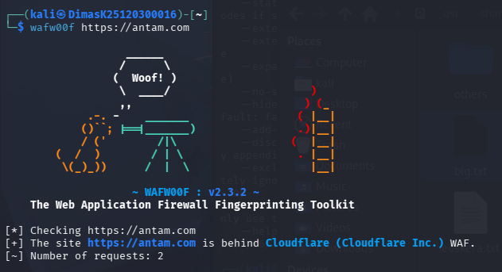
wafw00f https://antam.com
The Web Application Firewall Fingerprinting Toolkit

[*] Checking https://antam.com
[+] The site https://antam.com is behind Cloudflare (Cloudflare Inc.) WAF.
[~] Number of requests: 2

Menunjukkan alias dari satu nama domain ke nama domain lainnya.
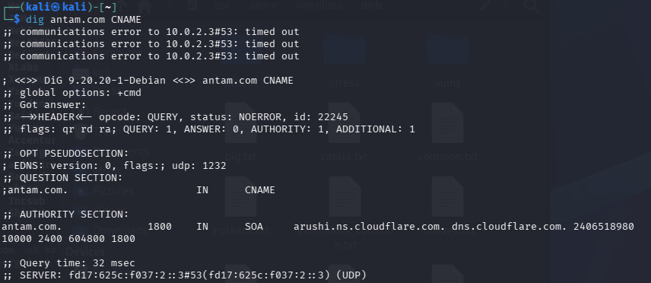
<<>> DiG 9.20.20-1-Debian <<>> antam.com CNAME
;; global options: +cmd
;; Got answer:
;; ->>HEADER<<- opcode: QUERY, status: NOERROR, id: 22245
;; flags: qr rd ra; QUERY: 1, ANSWER: 0, AUTHORITY: 1, ADDITIONAL: 1

;; OPT PSEUDOSECTION:
; EDNS: version: 0, flags:; udp: 1232
;; QUESTION SECTION:
;antam.com. IN CNAME

;; AUTHORITY SECTION:
antam.com. 1800 IN SOA arushi.ns.cloudflare.com. dns.cloudflare.com. 2406518980 10000 2400 604800 1800

NMAP
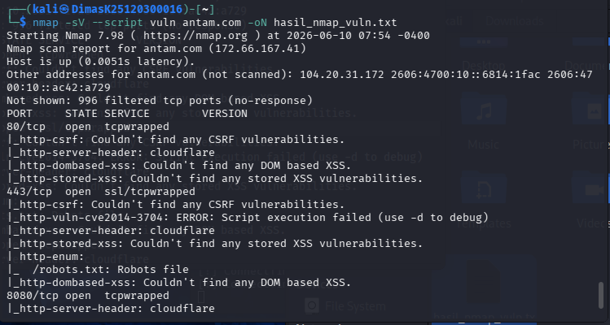
nmap -sV --script vuln antam.com -oN hasil_nmap_vuln.txt
Starting Nmap 7.98 ( https://nmap.org ) at 2026-06-10 07:54 -0400
Nmap scan report for antam.com (172.66.167.41)
Host is up (0.0051s latency).
Other addresses for antam.com (not scanned): 104.20.31.172 2606:4700:10::6814:1fac 2606:4700:10::ac42:a729
Not shown: 996 filtered tcp ports (no-response)
PORT STATE SERVICE VERSION
80/tcp open tcpwrapped
|_http-csrf: Couldn't find any CSRF vulnerabilities.
|_http-server-header: cloudflare
|_http-dombased-xss: Couldn't find any DOM based XSS.
|_http-stored-xss: Couldn't find any stored XSS vulnerabilities.
443/tcp open ssl/tcpwrapped
|_http-csrf: Couldn't find any CSRF vulnerabilities.
|_http-vuln-cve2014-3704: ERROR: Script execution failed (use -d to debug)
|_http-server-header: cloudflare
|_http-stored-xss: Couldn't find any stored XSS vulnerabilities.
| http-enum:
|_ /robots.txt: Robots file
|_http-dombased-xss: Couldn't find any DOM based XSS.
8080/tcp open tcpwrapped
|_http-server-header: cloudflare
8443/tcp open ssl/tcpwrapped
|_http-server-header: cloudflare

Service detection performed. Please report any incorrect results at https://nmap.org/submit/ .
Nmap done: 1 IP address (1 host up) scanned in 358.83 seconds

