Business Requirements Document
Data Warehouse Data Retention and Archiving using Azure Data Factory
Attribute | Value
Document ID | BRD-DWH-RET-001
Version | 0.1
Status | Draft for Review
Date | 29 October 2026
Prepared by | Agus Laksono
Approval status | Pending approval (version 0.1 approved on 29 October 2026)

Document Control

Revision History
Version | Date | Author | Description
0.1 | 29 October 2026 | Agus Laksono | Initial draft.

Approval
Role | Name | Signature | Date | Decision
Business / Data Owner | Agus Laksono |  |  | Pending
Project Sponsor | Agus Laksono |  |  | Pending
Database Administrator | Agus Laksono |  |  | Pending
Solution Architect / Lead Data Engineer | Agus Laksono |  |  | Pending

Document Conventions
Item | Meaning
OBJ-nn | Business objective
IS-nn / OS-nn | In-scope item / out-of-scope item
IC-nn / DR-nn | Process step of the Initial Cut-off Run / Daily Routine
BR-nn | Business rule
BRQ-nn | Business requirement
NFR-nn | Non-functional requirement
A-nn / C-nn / D-nn | Assumption / constraint / dependency
R-nn | Risk
AC-nn / SC-nn | Acceptance criterion / success criterion
TBC-nn | Item requiring confirmation. Its resolution and status are recorded in Section 11.
Table of Contents
Document Control 2
Revision History 2
Approval 2
Document Conventions 2
1. Introduction 7
1.1 Purpose 7
1.2 Background 7
1.3 Business Objectives 7
1.4 Terms and Abbreviations 7
2. Scope 7
2.1 In Scope 7
2.2 Out of Scope 8
3. Stakeholders 8
4. Current State and Future State 9
4.1 Current State 9
4.2 Future State 9
4.3 Data Lifecycle 9
4.4 System Context 10
4.5 High-Level Data Flow 11
5. Business Processes 12
5.1 Table Onboarding 12
5.2 Initial Cut-off Run 13
5.3 Daily Routine 14
6. Business Rules 15
7. Business Requirements 16
7.1 Functional Requirements 16
7.2 Non-Functional Requirements 17
7.3 Configuration Table 17
7.4 Execution Log 17
8. Assumptions, Constraints and Dependencies 18
8.1 Assumptions 18
8.2 Constraints 18
8.3 Dependencies 18
9. Risks 19
10. Acceptance and Success Criteria 20
10.1 Acceptance Criteria 20
10.2 Success Criteria 21

List of Figures
Figure 1 – System context 11
Figure 2 – High-level data flow 12
Figure 3 – Business process flow – Initial Cut-off Run (initial implementation) 14
Figure 4 – Business process flow – Daily Routine 15

List of Tables
Table 1 – Business objectives 8
Table 2 – In-scope items 9
Table 3 – Out-of-scope items 9
Table 4 – Stakeholder roles and responsibilities 10
Table 5 – Data lifecycle segments 11
Table 6 – Initial Cut-off Run steps 15
Table 7 – Daily Routine steps 17
Table 8 – Business rules 18
Table 9 – Functional requirements 19
Table 10 – Non-functional requirements 20
Table 11 – Configuration table attributes 20
Table 12 – Assumptions 21
Table 13 – Constraints 21
Table 14 – Dependencies 21
Table 15 – Risks 22
Table 16 – Acceptance criteria 23
Table 17 – Success criteria 24
Table 18 – Items to be confirmed 25
Table 19 – Requirement traceability matrix 26

Glossary
Abbreviations
Abbreviation | Meaning
ADF | Azure Data Factory, the service that orchestrates the retention process.
BRD | Business Requirements Document.
DBA | Database Administrator.
DWH | Data Warehouse: the database on Azure SQL Database that is subject to retention.
ETL | Extract, Transform and Load: the processes that load data into the DWH.
FSD | Functional Specification Document.
UTC | Coordinated Universal Time. All dates in this document are evaluated in UTC+7.
SLA | Service Level Agreement.
Terms
Term | Definition
Active flag | Configuration attribute that indicates whether a table is processed.
Agreed baseline | The reference ETL execution time and report response time agreed with the Customer, against which NFR-04 and NFR-06 are measured.
Archive | Parquet files in Azure Blob Storage that hold data more than three and up to eight years old.
Archive cut-off date | Run date minus the total retention period (default eight years). Data and archive files with a business date before this date are removed.
Archived segment | Data with a business date on or after the archive cut-off date and before the DWH cut-off date. It is exported to Parquet and then deleted from the DWH.
Azure Blob Storage | Azure storage service that holds the Parquet archive files.
Azure SQL Database | The Azure managed database service that hosts the DWH database, including schema ret.
Batch delete | Deleting eligible rows in repeated batches of a limited number of rows, with a short pause between batches.
Business date | The date on which the business event occurred, for example dtmDate. Retention is measured against this date.
Configuration table | Central table that defines, for each table, the settings used by the retention process (Section 7.3).
Daily Routine | The scheduled daily process that archives and removes data as it ages beyond the cut-off dates. It starts on the day after the Initial Cut-off Run has been completed for all in-scope tables of the initial implementation. A table added later is included from the day after its own Initial Cut-off Run is completed.
DWH cut-off date | Run date minus the DWH retention period (default three years). Data with a business date before this date leaves the DWH.
Execution log | Records written to the log tables for each table and execution (Section 7.4).
Expired segment | Data with a business date before the archive cut-off date.
Hypercare | The period of support after deployment, until 31 March 2027.
Initial Cut-off Run | Initial implementation (cut-off): the process, executed once for each in-scope table, that archives historical data and removes data beyond the retention period. It is executed for all in-scope tables during the initial implementation, and for each table added to the configuration table later, before that table enters the Daily Routine.
Integration Runtime | The ADF component that provides connectivity between ADF and the data stores. It is provided by the Customer infrastructure team.
Parquet | Columnar file format used for the archive files.
Retained segment | Data with a business date on or after the DWH cut-off date. It stays in the DWH.
Retention column | The business date column of a table, registered in the configuration table. It must be of a date or datetime data type and must not contain NULL values.
Retention period | The number of years data is kept: the DWH retention period (default three years) and the total retention period covering the DWH and the archive (default eight years: three years in the DWH and five years in Azure Blob Storage).
Rolling window | A retention window that is recalculated relative to the run date on every daily run.
Row-count validation | Comparison of the number of rows in the Parquet files with the number of rows in the DWH for the same data, performed before any data is removed from the DWH.
Run date | The current date in UTC+7 at the time of execution.
Schema ret | The database schema in the DWH database that holds the configuration table, log tables, and stored procedures of the retention solution.
Stored procedure | A program stored in the DWH database under schema ret that implements part of the retention logic.
Table rebuild | Creating a new table that contains only the retained data and using it to replace the original table.
Technical assessment | The assessment that determines the table size limits (small, medium, large) and any exceptions to the default Initial Cut-off Run method.

1. Introduction

1.1 Purpose
This document defines the business requirements for an automated, configuration-driven data retention and archiving process for the Data Warehouse (DWH). Once approved, it is the baseline for the Functional Specification Document (FSD), development, and user acceptance testing.

1.2 Background
The DWH runs on Azure SQL Database. The Customer requires an automated mechanism that keeps the most recent three years of data in the DWH, keeps data from the following five years as Parquet files in Azure Blob Storage, and removes data older than eight years. The process will be orchestrated by Azure Data Factory (ADF) and controlled through a central configuration table, so that multiple tables can be managed without code changes.

1.3 Business Objectives
ID | Objective
OBJ-01 | Keep only the most recent three years of data in the DWH, based on the business date.
OBJ-02 | Keep data that is more than three and up to eight years old as Parquet files in Azure Blob Storage.
OBJ-03 | Run retention and archiving automatically every day.
OBJ-04 | Manage retention for multiple tables through configuration rather than code.
OBJ-05 | Delete data in a way that minimises impact on ETL and reporting workloads.
OBJ-06 | Record every execution in log tables for operational follow-up.
Table 1 – Business objectives

1.4 Terms and Abbreviations
Terms and abbreviations used in this document are defined in the Glossary at the beginning of this document.

2. Scope

2.1 In Scope
ID | Item
IS-01 | Review and analysis of business and technical requirements.
IS-02 | Identification of in-scope DWH tables and their retention columns.
IS-03 | Configuration-driven approach supporting multiple tables.
IS-04 | Data retention logic in the DWH, implemented through stored procedures and scripts in schema ret of the DWH database.
IS-05 | Archiving of eligible DWH data as Parquet files in Azure Blob Storage.
IS-06 | Deletion of archived Parquet files older than the total retention period.
IS-07 | Batch deletion mechanism, and table rebuild for the Initial Cut-off Run.
IS-08 | Initial Cut-off Run and Daily Routine as separate processes.
IS-09 | ADF pipelines for automated daily execution.
IS-10 | Execution logging and log-based monitoring.
IS-11 | Documentation covering design, configuration, setup, and operational guidance.
IS-12 | Knowledge transfer to the operations team.
IS-13 | Hypercare support after deployment until 31 March 2027.
Table 2 – In-scope items

2.2 Out of Scope
ID | Item
OS-01 | Any archive platform other than Parquet files in Azure Blob Storage (for example, data lake or SharePoint).
OS-02 | Changes to source systems.
OS-03 | Major schema redesign of DWH tables.
OS-04 | Changes to reports or dashboards.
OS-05 | Network and infrastructure, including connectivity, Integration Runtime, database service, and storage account provisioning.
OS-06 | Automated alerts and notifications (for example, email or Microsoft Teams), performance reporting, and monitoring integration. Any such requirement is subject to separate assessment and approval.
OS-07 | Removal of deleted data from database backups.
OS-08 | Development or modification of dedicated performance reports, dashboards, or additional monitoring interfaces, unless explicitly agreed by the relevant stakeholders.
Table 3 – Out-of-scope items

3. Stakeholders
Names are recorded for the roles confirmed to date. Other names will be added when available.
Role | Name | Responsibilities
Business / Data Owner | Agus Laksono | Approves retention periods. Determines the in-scope tables and retention columns, which Customer users enter in the configuration table. Takes part, as business process owner, in agreeing the Daily Routine execution time. Signs off user acceptance testing.
Project Sponsor | Agus Laksono | Approves scope and this document.
Business Analyst |  | Maintains this document and requirement traceability.
Solution Architect / Data Engineer | Agus Laksono | Designs and builds the ADF pipelines, stored procedures, and configuration. Prepares the FSD.
Database Administrator | Agus Laksono | Reviews deletion and rebuild scripts. Takes part in agreeing the Daily Routine execution time.
ETL / Reporting Team |  | The ETL Owner schedules the Initial Cut-off Run together with the project team so that ETL and reporting SLAs are not disrupted, and takes part in agreeing the Daily Routine execution time.
Infrastructure Team |  | Provides network connectivity, Integration Runtime, and storage.
Operations / Support Team |  | Reviews execution logs and receives knowledge transfer.
Table 4 – Stakeholder roles and responsibilities

4. Current State and Future State

4.1 Current State
- The DWH runs on Azure SQL Database.
- Daily database backups are scheduled.
- No in-scope table is partitioned.

4.2 Future State
- The DWH holds only data with a business date on or after the DWH cut-off date.
- Data with a business date from the archive cut-off date up to the day before the DWH cut-off date is held as Parquet files in Azure Blob Storage.
- Data with a business date before the archive cut-off date is removed from the DWH and from Azure Blob Storage.
- A central configuration table defines which tables are processed and how. The configuration table, log tables, and stored procedures reside in the DWH database under schema ret.
- The Initial Cut-off Run is executed once for each in-scope table. The Daily Routine starts on the day after the Initial Cut-off Run has been completed for all in-scope tables of the initial implementation. A table added later goes through its own Initial Cut-off Run before it enters the Daily Routine.
- Every execution is recorded in log tables.

4.3 Data Lifecycle
Example for run date 27 October 2026 with the default retention periods: DWH cut-off date = 27 October 2023; archive cut-off date = 27 October 2018.
Segment | Business date | Treatment | Example
Retained in DWH | On or after the DWH cut-off date | Kept in the DWH | 27 Oct 2023 onwards
Archived | On or after the archive cut-off date and before the DWH cut-off date | Exported to Parquet, validated, then deleted from the DWH | 27 Oct 2018 to 26 Oct 2023
Expired | Before the archive cut-off date | Initial Cut-off Run: deleted from the DWH without archiving.  Daily Routine: Parquet files deleted from Azure Blob Storage. | Before 27 Oct 2018
Table 5 – Data lifecycle segments

4.4 System Context
The solution involves three platform components. Azure Data Factory orchestrates the process. The DWH database on Azure SQL Database holds both the DWH tables and, under schema ret, the configuration table, log tables, and stored procedures of the retention solution. ADF reads the configuration and eligible data from the DWH database, writes Parquet files to Azure Blob Storage, invokes the stored procedures that remove data from the DWH tables, and writes execution logs to the log tables. Network connectivity and the Integration Runtime are provided by the Customer infrastructure team and are outside the project scope.
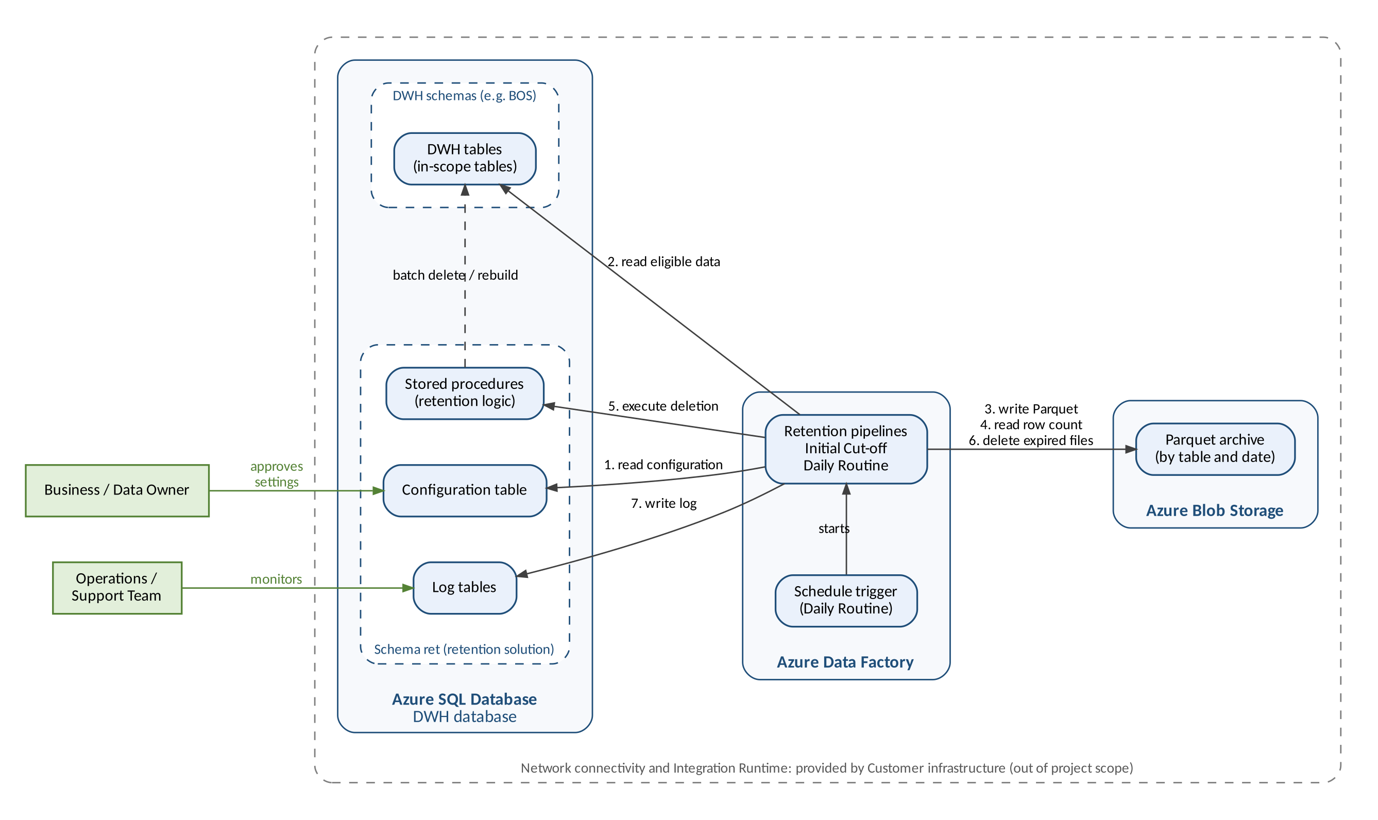
Figure 1 – System context

4.5 High-Level Data Flow
Each row of an in-scope table is classified by its business date. Retained data stays in the DWH. Archive-segment data is exported to Parquet and validated by row count. Data is removed from the DWH only when validation succeeds; otherwise nothing is deleted and the failure is recorded. Expired data is removed without archiving during the Initial Cut-off Run only, and expired Parquet files are deleted by the Daily Routine.
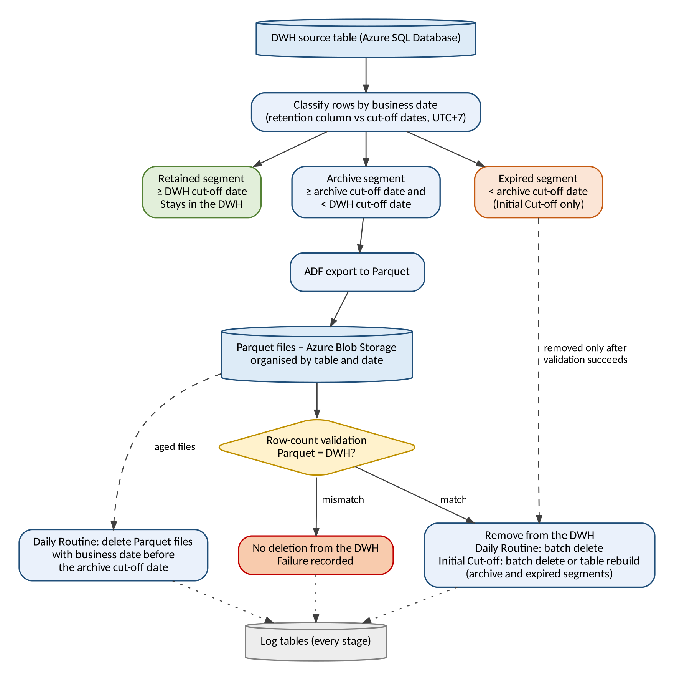
Figure 2 – High-level data flow

5. Business Processes

5.1 Table Onboarding
- Analyse DWH tables to support the identification of in-scope tables and their retention columns.
- Determine the table size category (small, medium, or large), the size limits, and any exceptions in the technical assessment. This sets the Initial Cut-off Run method for each table (BR-11).
- Customer users enter each in-scope table, its retention column, and its Initial Cut-off Run method in the configuration table.
- Execute the Initial Cut-off Run (Section 5.2): small and medium tables first, then large tables once the downtime has been determined (BR-16).
- After the Initial Cut-off Run has been completed for all in-scope tables, the Daily Routine starts on the following day (Section 5.3).
- A table added to the configuration table after the initial implementation goes through steps 2 to 4 for that table, including its own Initial Cut-off Run, and enters the Daily Routine from the day after its Initial Cut-off Run is completed.

The Initial Cut-off Run and the Daily Routine are separate processes and are shown in separate diagrams. The Initial Cut-off Run is executed once for each table to archive its historical data; during the initial implementation it is executed for all in-scope tables before the Daily Routine starts. The Daily Routine then archives data periodically. A table added later goes through its own Initial Cut-off Run before it is included in the Daily Routine.

5.2 Initial Cut-off Run
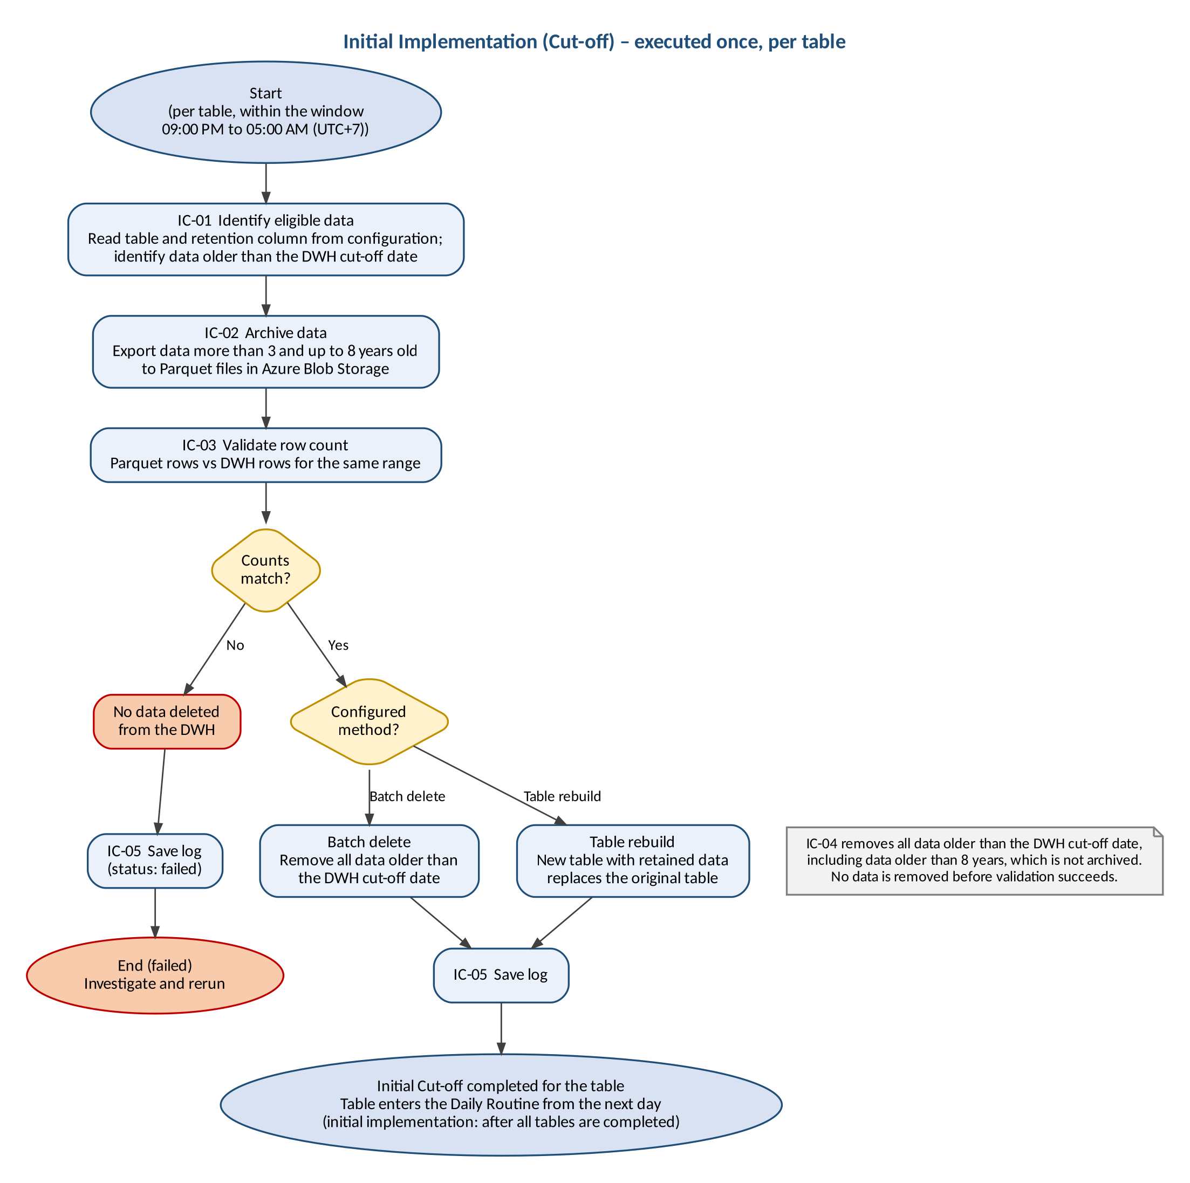
Figure 3 – Business process flow – Initial Cut-off Run (initial implementation)
Step | Activity | Description
IC-01 | Identify eligible data | Read the table and retention column from the configuration table and identify data older than the DWH cut-off date.
IC-02 | Archive data | Export data in the Archived segment (more than three and up to eight years old) to Parquet files in Azure Blob Storage.
IC-03 | Validate row count | Compare the number of rows in the Parquet files with the number of rows in the DWH for the same range. If the counts do not match, no data is deleted and the failure is logged.
IC-04 | Remove data from the DWH | Only after IC-03 succeeds: remove all data older than the DWH cut-off date, including expired data older than eight years, using the method configured for the table (batch delete or table rebuild).
IC-05 | Save log | Record the execution result in the log tables.
Table 6 – Initial Cut-off Run steps

5.3 Daily Routine
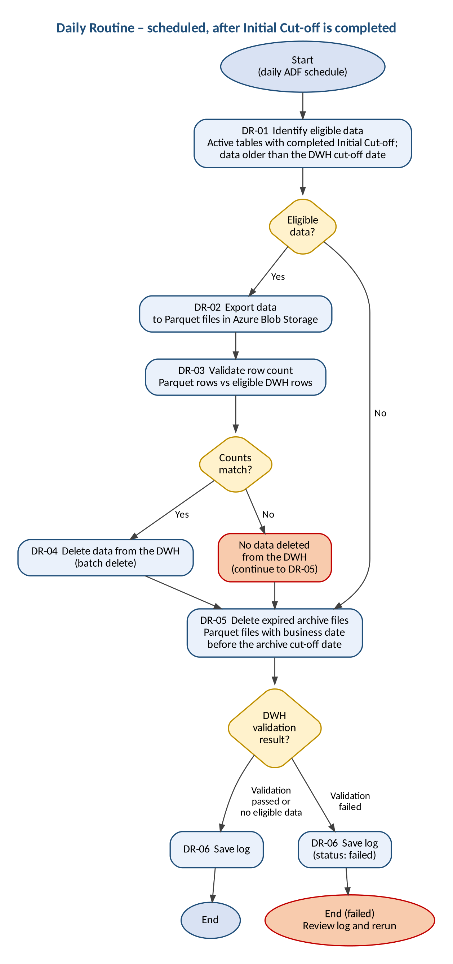
Figure 4 – Business process flow – Daily Routine
Step | Activity | Description
DR-01 | Identify eligible data | Read active tables and their retention columns from the configuration table and identify data older than the DWH cut-off date. If there is no eligible data, steps DR-02 to DR-04 are skipped.
DR-02 | Export data | Export the eligible data to Parquet files in Azure Blob Storage.
DR-03 | Validate row count | Compare the number of rows in the Parquet files with the number of eligible rows in the DWH. If the counts do not match, no data is deleted from the DWH, the failure is logged, and the process continues with DR-05.
DR-04 | Delete data from the DWH | Only after DR-03 succeeds: delete the exported data from the DWH using batch delete.
DR-05 | Delete expired archive files | Delete Parquet files with a business date before the archive cut-off date. This step runs whether or not DR-03 succeeds, and also when there is no eligible data.
DR-06 | Save log | Record the execution result in the log tables.
Table 7 – Daily Routine steps

6. Business Rules
ID | Rule
BR-01 | The DWH retains data with a business date within the last three years. The period is configurable.
BR-02 | Total retention is eight years from the business date: the most recent three years in the DWH and the following five years as Parquet files in Azure Blob Storage. The period is configurable.
BR-03 | DWH cut-off date = run date − DWH retention period. Archive cut-off date = run date − total retention period.
BR-04 | The run date is determined in UTC+7.
BR-05 | Retention is based on the business date in the retention column. Only the date part is used; the time part is ignored.
BR-06 | The retention column must be of a date or datetime data type and must not contain NULL values.
BR-07 | Retention is applied as a rolling window that is recalculated on every daily run.
BR-08 | Data is removed from the DWH only after the archive has been validated successfully, that is, the row count of the Parquet files matches the row count in the DWH. During the Initial Cut-off Run this also applies to expired data: no data is removed until validation of the archived data succeeds.
BR-09 | During the Initial Cut-off Run, data with a business date before the archive cut-off date is deleted from the DWH without archiving.
BR-10 | Table rebuild is used only for the Initial Cut-off Run. The Daily Routine always uses batch delete.
BR-11 | Default Initial Cut-off Run method: small and medium tables use batch delete; large tables use table rebuild. Table size limits and exceptions are determined in the technical assessment. The method for each table is recorded in the configuration table.
BR-12 | The Initial Cut-off Run is executed once for each in-scope table. During the initial implementation it is executed for all in-scope tables, and the Daily Routine starts on the day after it has been completed for all of them. A table added to the configuration table later goes through its own Initial Cut-off Run and is included in the Daily Routine from the day after that run is completed.
BR-13 | The tables and their retention columns are taken from the configuration table. The process does not detect columns automatically.
BR-14 | Parquet files with a business date before the archive cut-off date are deleted by the Daily Routine, including when row-count validation of the DWH data fails.
BR-15 | Execution results are recorded in log tables, which are the basis for operational monitoring and troubleshooting. No alert or notification is sent.
BR-16 | The Initial Cut-off Run starts with small and medium tables. Large tables follow once the downtime has been determined.
BR-17 | The Initial Cut-off Run is executed within the window 09:00 PM to 05:00 AM (UTC+7), scheduled together with the ETL Owner, and must not disrupt ETL or reporting SLAs. The duration of each run is confirmed through performance testing.
BR-18 | The Daily Routine starts every day at 09:00 PM (UTC+7).
Table 8 – Business rules

7. Business Requirements

7.1 Functional Requirements
ID | Requirement
BRQ-01 | The project shall review and analyse the business and technical requirements for data retention.
BRQ-02 | The project shall analyse DWH tables to support the identification of in-scope tables and their retention columns. The final list of tables and retention columns is entered in the configuration table by Customer users.
BRQ-03 | The solution shall provide a central configuration table in schema ret of the DWH database containing, for each table, the attributes listed in Section 7.3.
BRQ-04 | Tables shall be added to, changed in, or removed from the retention process by updating the configuration table, without changing the pipelines.
BRQ-05 | The solution shall provide an Initial Cut-off Run for each table as described in Section 5.2.
BRQ-06 | The solution shall export data in the Archived segment to Parquet files in Azure Blob Storage, organised by table and date.
BRQ-07 | Before deleting archived data from the DWH, the solution shall validate that the row count in the Parquet files equals the row count in the DWH, and shall not delete data if the counts differ.
BRQ-08 | The solution shall delete DWH data in batches of 10,000 rows with a pause of 3 seconds between batches. These values may be adjusted based on performance monitoring.
BRQ-09 | The solution shall support table rebuild as a method for the Initial Cut-off Run. The rebuilt table shall replace the original table with the same table definition.
BRQ-10 | The solution shall provide a Daily Routine as described in Section 5.3, executed automatically by an ADF schedule every day at 09:00 PM (UTC+7).
BRQ-11 | The Daily Routine shall delete Parquet files with a business date before the archive cut-off date.
BRQ-12 | The solution shall record each execution in log tables in schema ret of the DWH database, as described in Section 7.4.
BRQ-13 | Basic operational monitoring and troubleshooting shall use the information recorded in the log tables, including execution status, start and end timestamps, records processed, and error details where applicable.
BRQ-14 | The retention logic in the DWH shall be implemented through stored procedures and scripts in schema ret of the DWH database.
BRQ-15 | The project shall deliver documentation covering design, configuration, setup, and operational guidance.
BRQ-16 | The project shall deliver knowledge transfer sessions to the operations team.
BRQ-17 | The project shall provide hypercare support after deployment until 31 March 2027.
Table 9 – Functional requirements

7.2 Non-Functional Requirements
ID | Requirement
NFR-01 | Deletion shall be performed incrementally in batches, avoiding long-running transactions, to minimise locking and impact on ETL and reporting processes (thresholds: NFR-04 to NFR-08).
NFR-02 | Retention periods shall be configurable without changing the pipelines.
NFR-03 | The Daily Routine shall run without manual intervention.
NFR-04 | ETL duration: ETL execution time shall not exceed the agreed baseline by more than 10%.
NFR-05 | ETL completion: all critical ETL jobs shall complete within their agreed processing windows and SLAs.
NFR-06 | Reporting performance: report response time shall not degrade by more than 10% from the agreed baseline.
NFR-07 | Reporting availability: archive and cut-off activities shall cause no unplanned reporting downtime.
NFR-08 | Data integrity: data reconciliation and validation shall meet the agreed acceptance criteria, with no unexplained data loss or inconsistency.
Table 10 – Non-functional requirements

7.3 Configuration Table
The configuration table shall contain at least the following attributes for each table. The physical design, including naming and any additional technical attributes, will be defined in the FSD.
Attribute | Description | Example
Database name | Database that contains the table | DWH
Schema name | Schema of the table | RET
Table name | Table under retention | JTI_SD_BrandDistDetail
Retention column | Business date column; date or datetime data type; no NULL values | dtmDate
DWH retention (years) | Number of years kept in the DWH | 3
Total retention (years) | Number of years kept in total: DWH retention plus archive retention in Azure Blob Storage | 8 (3 + 5)
Blob path | Location of the Parquet files for the table in Azure Blob Storage | –
Initial Cut-off Run method | Batch delete or table rebuild, according to BR-11 | Batch delete
Active flag | Indicates whether the table is processed | Active
Table 11 – Configuration table attributes

7.4 Execution Log
For each table and each execution, the log shall record at least: the process type (Initial Cut-off Run or Daily Routine), run date, DWH cut-off date, archive cut-off date, number of eligible rows, number of rows exported, number of rows deleted from the DWH, number of archive files deleted, execution status, start and end time, and error details where applicable.

8. Assumptions, Constraints and Dependencies

8.1 Assumptions
ID | Assumption
A-01 | The retention periods (three years in the DWH, five years in Azure Blob Storage, eight years in total) are agreed by the business.
A-02 | The required database and storage access will be provided.
A-03 | Back-dated transactions do not occur.
A-04 | The retention columns of in-scope tables contain no NULL values.
A-05 | Daily database backups remain in place.
Table 12 – Assumptions

8.2 Constraints
ID | Constraint
C-01 | The DWH platform is Azure SQL Database.
C-02 | Archive files are in Parquet format in Azure Blob Storage.
C-03 | All dates are evaluated in UTC+7.
C-04 | No changes to source systems and no major schema redesign.
C-05 | The configuration table, log tables, and stored procedures are created in the DWH database and are separated from the DWH tables only by the schema name ret.
Table 13 – Constraints

8.3 Dependencies
ID | Dependency | Responsible
D-01 | Network connectivity and Integration Runtime between ADF, the DWH, and Azure Blob Storage | Customer infrastructure team
D-02 | Azure Blob Storage account and container for the archive | Customer infrastructure team
D-03 | In-scope tables and retention columns entered in the configuration table | Customer users
D-04 | Scheduling of each Initial Cut-off Run with the ETL Owner within the 09:00 PM to 05:00 AM (UTC+7) window | ETL Owner, project team
D-05 | Technical assessment of table size limits and exceptions (BR-11) | Project team, Customer
D-06 | Agreed baseline for ETL execution time and report response time (NFR-04, NFR-06) | Business / Data Owner, ETL team, DBA
D-07 | Downtime for the table rebuild of large tables (BR-16) | ETL Owner, Business / Data Owner
Table 14 – Dependencies

9. Risks
ID | Risk | Likelihood | Impact | Mitigation
R-01 | As no alerts are sent, a failed execution is noticed only when the log is reviewed. | Medium | Medium | Include a daily log review in the operational guidance.
R-02 | Data older than eight years is deleted without archiving during the Initial Cut-off Run and can be recovered only from database backups. | Low | High | Confirm that a valid backup or restore point exists before each Initial Cut-off Run.
R-03 | Deleted data remains in database backups for the backup retention period. | High | Low | Accepted by the Customer.
R-04 | Network and infrastructure are outside the project scope; delays in their provision delay the project. | Medium | High | Agree delivery dates for D-01 and D-02 at project start.
R-05 | Table rebuild may affect dependent database objects and ETL availability. | Medium | High | Rebuild large tables only within the determined downtime (BR-16), schedule with the ETL Owner (BR-17), and review dependent objects before rebuild.
R-06 | Large volumes deleted during the Initial Cut-off Run may increase transaction log usage. | Medium | High | Plan the execution with the DBA.
R-07 | An incorrect retention column in the configuration could remove data that should be kept. | Low | High | Customer users are responsible for the configuration entries (BRQ-02); the retention column must be of a date or datetime data type (BR-06).
R-08 | Hypercare ends on a fixed date (31 March 2027); a later go-live shortens the hypercare period. | Medium | Medium | Track the go-live date against the hypercare end date.
R-09 | Without an agreed baseline, NFR-04 and NFR-06 cannot be verified. | Medium | High | Agree the baseline (D-06) before performance testing.
R-10 | The Initial Cut-off Run for a table added after the initial implementation (09:00 PM to 05:00 AM) may run at the same time as the Daily Routine for other tables (09:00 PM), increasing load on the DWH. | Medium | Medium | Include this case in performance testing and schedule each such run with the ETL Owner (BR-17).
R-11 | With an eight-year total retention, the Initial Cut-off Run exports up to five years of data per table, which may not fit in the 09:00 PM to 05:00 AM window for large tables. | Medium | High | Confirm run durations through performance testing and split the Initial Cut-off Run of a table across several windows where needed (BR-17).
R-12 | Retention processing runs in the same Azure SQL Database as the DWH workload and shares its resources. | Medium | Medium | Use batch delete (BRQ-08) and verify NFR-04 to NFR-07 in performance testing.
Table 15 – Risks

10. Acceptance and Success Criteria

10.1 Acceptance Criteria
ID | Criterion | Requirement
AC-01 | The table analysis is delivered, and the in-scope tables and their retention columns are entered in the configuration table. | BRQ-01, BRQ-02
AC-02 | A table can be added to or removed from the retention process by updating the configuration table only. | BRQ-03, BRQ-04, NFR-02
AC-03 | After the Initial Cut-off Run on run date D, the table contains no data with a business date before D − 3 years, and all data on or after D − 3 years is unchanged. | BRQ-05, BRQ-09
AC-04 | After the Initial Cut-off Run, Azure Blob Storage contains Parquet files for the data from D − 8 years to the day before D − 3 years, and their row count equals the row count removed from the DWH for that range. | BRQ-06, BRQ-07
AC-05 | When the Parquet row count does not match the DWH row count, no data (including expired data in the Initial Cut-off Run) is deleted from the DWH and the execution is logged as failed. | BRQ-07
AC-06 | Batch delete removes no more than 10,000 rows per batch and pauses 3 seconds between batches, or the adjusted values where these have been changed based on performance monitoring. | BRQ-08, NFR-01
AC-07 | The Daily Routine starts at 09:00 PM (UTC+7) without manual intervention and, for each processed table, leaves no data in the DWH with a business date before the DWH cut-off date. | BRQ-10, NFR-03
AC-08 | After the Daily Routine, Azure Blob Storage contains no Parquet files with a business date before the archive cut-off date, including on days when row-count validation of the DWH data fails. | BRQ-11
AC-09 | Each execution produces log records containing the information listed in Section 7.4. | BRQ-12, BRQ-13
AC-10 | Retention logic is delivered as stored procedures and scripts, and the configuration table, log tables, and stored procedures exist in schema ret of the DWH database. | BRQ-03, BRQ-12, BRQ-14
AC-11 | The documentation is delivered and reviewed, and knowledge transfer sessions are completed. | BRQ-15, BRQ-16
AC-12 | Hypercare support is available from deployment until 31 March 2027. | BRQ-17
AC-13 | Performance testing shows that ETL execution time and report response time remain within 10% of the agreed baseline and that critical ETL jobs complete within their processing windows and SLAs. | NFR-04 to NFR-06
AC-14 | Small and medium tables complete the Initial Cut-off Run before large tables; each Initial Cut-off Run runs within 09:00 PM to 05:00 AM (UTC+7), and large tables are rebuilt only within the determined downtime without unplanned reporting downtime. | BRQ-05, BRQ-09, NFR-07
AC-15 | The first Daily Routine runs on the day after the Initial Cut-off Run has been completed for all in-scope tables, and no Daily Routine runs before then. | BRQ-05, BRQ-10
AC-16 | A table added after the initial implementation is not processed by the Daily Routine until the day after its own Initial Cut-off Run has been completed. | BRQ-04, BRQ-05
Table 16 – Acceptance criteria

10.2 Success Criteria
ID | Measure
SC-01 | After each Daily Routine, 100% of active tables contain no DWH data with a business date before the DWH cut-off date.
SC-02 | 100% of archived data passes row-count validation before deletion from the DWH.
SC-03 | After each Daily Routine, no Parquet file with a business date before the archive cut-off date remains in Azure Blob Storage.
SC-04 | 100% of executions are recorded in the log tables.
SC-05 | During the Initial Cut-off Run and the Daily Routine, ETL and reporting stay within NFR-04 to NFR-07.
SC-06 | Reconciliation and validation show no unexplained data loss or inconsistency (NFR-08).
Table 17 – Success criteria

11. Items to Be Confirmed
The table below records the resolution and status of each item. Items with status Open must be confirmed before the related project stage.
ID | Item | Resolution | Status
TBC-01 | Execution time of the Daily Routine (UTC+7). | 09:00 PM (UTC+7) (BRQ-10, BR-18). | Closed
TBC-02 | Final list of in-scope tables and their retention columns. | Entered in the configuration table by Customer users (BRQ-02). | Closed
TBC-03 | Initial Cut-off Run method for each table. | Default: batch delete for small and medium tables; table rebuild for large tables. Size limits and exceptions are determined in the technical assessment. Small and medium tables are processed first; large tables follow once the downtime has been determined (BR-11, BR-16). | Closed
TBC-04 | Batch size and pause between batches. | 10,000 rows per batch; 3 seconds between batches; adjusted based on performance monitoring (BRQ-08). | Closed
TBC-05 | Measurable thresholds for acceptable impact on ETL and reporting. | Defined in NFR-04 to NFR-08. Measurement requires an agreed baseline (D-06). | Closed
TBC-06 | Monitoring or performance reporting beyond the log tables. | Monitoring and troubleshooting use the log tables (BRQ-13). Dedicated reports, dashboards, monitoring interfaces, alerting, and monitoring integration are out of scope unless separately assessed and approved (OS-06, OS-08). | Closed
TBC-07 | Hypercare support after deployment. | Included until 31 March 2027 (IS-13, BRQ-17). | Closed
TBC-08 | Execution window for the Initial Cut-off Run. | 09:00 PM to 05:00 AM (UTC+7), scheduled with the ETL Owner without disrupting ETL or reporting SLAs (BR-17, D-04). | Closed
TBC-09 | Names of stakeholders and approvers. | Business / Data Owner, Project Sponsor, Database Administrator, and Solution Architect / Lead Data Engineer: Agus Laksono (Approval table, Section 3). | Closed
TBC-10 | Handling of tables added to the configuration table after the initial implementation. | Each such table goes through its own Initial Cut-off Run before it enters the Daily Routine (BR-12). | Closed
TBC-11 | Whether all in-scope tables reside in the same database as schema ret. | Not yet confirmed. Azure SQL Database does not support cross-database queries with three-part names, so stored procedures in schema ret can process only tables in the same database. If all in-scope tables are in that database, the Database name attribute of the configuration table (Section 7.3) identifies that database only. | Open (before FSD approval)
Table 18 – Items to be confirmed

