FSD · Data Retention and Archiving · Version 0.1
Functional Specification Document
Data Warehouse Data Retention and Archiving using Azure Data Factory
Document ID | FSD-DWH-RET-001 (proposed)
Version | 0.1
Status | Draft for Review
Date | 25 October 2026
Source BRD | BRD-DWH-RET-001 v0.5
Prepared by | TBD
Approval status | Not approved

Table of Contents
Table of Contents 1
List of Figures 4
List of Tables 4
Glossary and References 6
Acronyms 6
Technical Terms Introduced by this FSD 6
Referenced Documents 6
Related BRD Sections 7
1. Document Information 8
2. Document Control 8
2.1 Revision History 8
2.2 Review History 8
2.3 Approval History 8
2.4 Distribution List 9
2.5 Document Conventions 9
3. Introduction 10
3.1 Purpose of the Document 10
3.2 Objectives 10
3.3 Intended Audience 10
3.4 Document Scope 10
3.5 Relationship Between BRD and FSD 10
4. Business Context and Requirements Overview 11
4.1 Business Background 11
4.2 Business Objectives 11
4.3 Business Requirements Summary 11
4.4 Business Process Overview 12
4.5 Business Constraints 12
4.6 Assumptions and Dependencies 13
5. Scope 13
5.1 In-Scope Functionalities 13
5.2 Out-of-Scope Functionalities 13
5.3 System Boundaries 14
5.4 Upstream and Downstream Systems 14
5.5 External Dependencies 14
6. Solution Overview 14
6.1 Solution Summary 14
6.2 System Context 15
6.3 Component Interaction 15
6.4 Data Flow 16
6.5 High-Level Process Flow 17
6.6 Key Design Decisions Summary 17
7. Functional Requirements 17
7.1 Functional Requirements Overview 17
7.2 Functional Requirement Specifications 18
8. Detailed Functional Design 32
8.1 PRC-01 Table Onboarding 32
8.2 PRC-02 Initial Cut-off Run 33
8.3 PRC-03 Daily Routine 35
8.4 Table Rebuild Procedure (part of PRC-02) 37
8.5 PRC-04 Expired Archive File Deletion 37
8.6 PRC-05 Rerun and Recovery 38
8.7 PRC-06 Configuration Change 38
9. Business Rules 39
9.1 Business Rules from the BRD 39
9.2 Derived Business Rules (Require Confirmation) 40
10. Data Requirements and Data Processing 41
10.1 Data Sources and Source Data Objects 41
10.2 Required Attributes 41
10.3 Data Selection and Filtering Rules 41
10.4 Cut-off Date Calculation Examples 41
10.5 Data Validation 42
10.6 Configuration Table (Logical Specification) 42
10.7 Global Processing Parameters 43
10.8 Log Tables (Logical Specification) 43
10.9 Data Transformation, Retention and Deletion Rules 44
10.10 Data Reconciliation and Data Quality Controls 44
10.11 Data Lineage 45
10.12 Processing Frequency and Expected Data Volume 45
11. Interface and Integration Specifications 45
12. Processing Flow and Sequence Diagrams 46
12.1 Daily Routine – Sequence Diagram 46
12.2 Table Rebuild – Sequence Diagram 47
12.3 Initial Cut-off Status – State Diagram 48
12.4 Restart and Recovery – Decision Flow 49
13. Error Handling and Recovery 50
13.1 Error Categories and Codes 50
13.2 Error Detection 50
13.3 Error Logging 50
13.4 Retry Rules 51
13.5 Partial Failure Scenarios 51
13.6 Duplicate Processing Prevention 51
13.7 Restart and Rerun Behaviour 51
13.8 Operational Escalation 51
14. Non-Functional Requirements 52
14.1 Additional Quality Attributes 52
15. Security and Audit Requirements 53
16. Scheduling and Operational Requirements 53
16.1 Execution Schedule 53
16.2 Daily Routine Activation 54
16.3 Processing Dependencies and Execution Order 54
16.4 Monitoring 54
16.5 Operational Alerts 54
16.6 Manual Intervention 54
16.7 Rerun Procedure 54
16.8 Stale Run Handling 55
16.9 Operational Responsibilities 55
16.10 Project Deliverables Related to Operations 55
17. Assumptions, Constraints, Dependencies, and Open Questions 55
17.1 Assumptions 55
17.2 Technical Constraints 56
17.3 Dependencies 56
17.4 Open Questions 56
17.5 Decisions Required 58
17.6 Risks and Potential Impacts 59

List of Figures
Figure 1 System context 15
Figure 2 Component interaction (logical components) 15
Figure 3 High-level data flow by segment 16
Figure 4 Initial Cut-off Run – functional process flow (per table) 33
Figure 5 Daily Routine – functional process flow (per table) 35
Figure 6 Daily Routine – sequence of interactions for one run 46
Figure 7 Table rebuild – sequence (Initial Cut-off Run, method Table rebuild) 47
Figure 8 Initial Cut-off status lifecycle per table 48
Figure 9 Restart and recovery decision flow (FR-017, FR-018) 49

List of Tables
Table 1 Document information 8
Table 2 Revision history 8
Table 3 Review history 8
Table 4 Approval history 8
Table 5 Distribution list 9
Table 6 Document conventions 9
Table 7 Source documents and hierarchy 11
Table 8 Business objectives and FSD coverage 11
Table 9 Business requirements summary 12
Table 10 Data lifecycle segments (BRD 4.3) 12
Table 11 Business constraints 12
Table 12 In-scope functionalities 13
Table 13 Out-of-scope functionalities 13
Table 14 System boundaries 14
Table 15 Upstream and downstream systems 14
Table 16 Logical solution components 16
Table 17 Key design decisions requiring approval 17
Table 18 Functional requirements overview 18
Table 19 FR-001 – Retention Configuration Table 19
Table 20 FR-002 – Configuration and Metadata Validation 19
Table 21 FR-003 – Run Date and Cut-off Date Calculation 20
Table 22 FR-004 – Table Selection for Processing 21
Table 23 FR-005 – Eligible Data Identification 21
Table 24 FR-006 – Archive Export to Parquet 22
Table 25 FR-007 – Archive Storage Organisation and Naming 23
Table 26 FR-008 – Archive Row-Count Validation 23
Table 27 FR-009 – Batch Delete 24
Table 28 FR-010 – Table Rebuild (Initial Cut-off Run Only) 25
Table 29 FR-011 – Initial Cut-off Run Orchestration 25
Table 30 FR-012 – Daily Routine Orchestration 26
Table 31 FR-013 – Expired Archive File Deletion 27
Table 32 FR-014 – Execution Logging 27
Table 33 FR-015 – Log-Based Monitoring Support 28
Table 34 FR-016 – Concurrency Control 28
Table 35 FR-017 – Restart, Rerun and Resume 29
Table 36 FR-018 – Cleanup of Archive Files from Failed Runs 29
Table 37 FR-019 – Execution Window Control for the Initial Cut-off Run 30
Table 38 FR-020 – Initial Cut-off Status and Daily Routine Activation 31
Table 39 FR-021 – Retention Logic as Stored Procedures and Scripts 31
Table 40 FR-022 – Table Analysis Support 32
Table 41 PRC-01 Table Onboarding – process specification 32
Table 42 PRC-02 Initial Cut-off Run – process specification 34
Table 43 PRC-03 Daily Routine – process specification 36
Table 44 Table rebuild steps 37
Table 45 PRC-04 Expired Archive File Deletion – process specification 38
Table 46 PRC-05 Rerun and Recovery – process specification 38
Table 47 Configuration change behaviour 39
Table 48 Business rules from the BRD 40
Table 49 Derived business rules 40
Table 50 Known source data objects 41
Table 51 Selection predicates 41
Table 52 Cut-off date examples (default retention periods) 41
Table 53 Validation checks 42
Table 54 Configuration table attributes 42
Table 55 Global processing parameters 43
Table 56 Run log attributes 43
Table 57 Table log attributes 44
Table 58 Step log attributes 44
Table 59 Reconciliation controls 44
Table 60 Interface specifications 45
Table 61 Manual interfaces 45
Table 62 Error categories and codes 50
Table 63 Retry rules 51
Table 64 Partial failure scenarios 51
Table 65 Non-functional requirements 52
Table 66 Additional quality attributes 52
Table 67 Security and audit requirements 53
Table 68 Execution schedule 53
Table 69 Manual intervention activities 54
Table 70 Operations-related project deliverables 55
Table 71 Assumptions 56
Table 72 Dependencies 56
Table 73 Open questions 58
Table 74 Decisions required 58
Table 75 Additional FSD risks 59

Glossary and References

Acronyms
Acronym | Meaning
ADF | Azure Data Factory
BRD | Business Requirements Document
CDC | Change Data Capture
DBA | Database Administrator
DDL | Data Definition Language
DWH | Data Warehouse
ETL | Extract, Transform and Load
FSD | Functional Specification Document
IC | Initial Cut-off Run
DR | Daily Routine
RTM | Requirements Traceability Matrix
SLA | Service Level Agreement
SP | Stored procedure
TBC / TBD | To Be Confirmed / To Be Determined
UTC | Coordinated Universal Time
VM | Virtual Machine

Technical Terms Introduced by this FSD
Term | Definition
Business-date folder | Folder in the archive containing all Parquet files for one table and one business date (FR-007).
Export unit | Export of one table for one business date by one Copy activity.
Initial Cut-off status | System-maintained state of a table: Pending, Running, Failed, Stopped, Completed (FR-020).
Pending resume | State in which an earlier run validated a range but did not complete its deletion (FR-017).
Pre-delete recount | Recount of DWH rows in the validated range immediately before deletion (DBR-06).
RunId | Unique identifier of a pipeline execution, used in logs and archive file names.
Snapshot | Per-business-date row counts recorded before export; the validation baseline (FR-005).
Table processing lock | Mechanism ensuring only one run processes a table at a time (FR-016).
Validated range | Business-date range whose export passed validation and may be deleted.

Referenced Documents
Reference | Document | Version / date | Status
REF-01 | BRD-DWH-RET-001 Business Requirements Document – Data Warehouse Data Retention and Archiving using Azure Data Factory | 0.5 / 25 October 2026 | Draft for Review (see OQ-01)
REF-02 | Presentation material: Central Configuration; Deletion Strategy; ADF Pipeline Flow; Deliverables; Scope, Out of Scope and Assumptions; Retention Logic; Solution Approach | Undated | Supporting material
REF-03 | Microsoft Azure Data Factory product documentation (Copy activity, Parquet format, Get Metadata, Delete activity, schedule triggers) | Current at implementation | External reference; limits to be verified in a proof of concept

Related BRD Sections
FSD section | BRD sections
4 Business Context | 1.2, 1.3, 4.1–4.3, 8
5 Scope | 2.1, 2.2, 4.4, 8.3
6 Solution Overview | 4.4, 4.5
7, 8 Functional Requirements and Design | 5.1–5.3, 6, 7.1, 7.3, 7.4
9 Business Rules | 6
10 Data | 4.3, 6, 7.3, 7.4
14 Non-Functional | 7.2
17 Testing | 10.1, 10.2
18 RTM | 7.1, 7.2, 12
19 Open items | 8, 9, 11

1. Document Information
Document Title | Functional Specification Document – Data Warehouse Data Retention and Archiving using Azure Data Factory
Document ID | FSD-DWH-RET-001 (proposed identifier, aligned with BRD-DWH-RET-001; to be confirmed by document control)
Project Name | Data Warehouse Data Retention and Archiving using Azure Data Factory
Document Version | 0.1
Document Status | Draft for Review
Approval Status | Not approved. No review or approval evidence exists for this FSD.
Author | TBD. BRD Section 3 assigns preparation of the FSD to the Solution Architect / Data Engineer role (Agus Laksono). The actual author of this version is to be recorded by document control.
Reviewer | TBD
Approver | TBD
Creation Date | 25 October 2026
Last Updated Date | 25 October 2026
Source BRD | BRD-DWH-RET-001, “Data Warehouse Data Retention and Archiving using Azure Data Factory”, version 0.5, dated 25 October 2026 (file BRD_DWH_Data_Retention_v0.5.docx). Header status: Draft for Review / Pending approval. See OQ-01 regarding the inconsistent approval status of the BRD.
Table 1 Document information

2. Document Control

2.1 Revision History
Version | Date | Author | Description
0.1 | 25 October 2026 | TBD | Initial draft derived from BRD v0.5 and the supporting presentation material (seven slides). Contains derived design details, recommendations and open questions that require review.
Table 2 Revision history

2.2 Review History
Version | Review Date | Reviewer | Role | Outcome / Comments
0.1 | TBD | TBD | TBD | No review has been performed yet.
Table 3 Review history

2.3 Approval History
Role | Name | Signature | Date | Decision
Business / Data Owner | TBD |  |  | Pending
Project Sponsor | TBD |  |  | Pending
Database Administrator | TBD |  |  | Pending
Solution Architect / Lead Data Engineer | TBD |  |  | Pending
Table 4 Approval history
The approver roles above mirror the approval roles in the BRD. Names are left as TBD because no approval of this FSD has been given; BRD Section 3 records Agus Laksono for several of these roles, and confirmation is required whether the same individuals approve the FSD (OQ-02).

2.4 Distribution List
Role (from BRD Section 3) | Purpose of Distribution
Business / Data Owner | Review of business rules, retention behaviour and acceptance criteria.
Project Sponsor | Approval of the FSD baseline.
Business Analyst | Traceability maintenance.
Solution Architect / Data Engineer | Design owner; implementation basis.
Database Administrator | Review of deletion, rebuild, security and transaction-log handling.
ETL / Reporting Team | Review of scheduling, impact and execution windows.
Infrastructure Team | Review of dependencies D-01 and D-02 and the security model.
Operations / Support Team | Review of logging, monitoring and rerun procedures.
QA / Test Team | Basis for test design (role not listed in the BRD; included as an intended audience).
Table 5 Distribution list

2.5 Document Conventions
Item | Meaning
FR-nnn | Functional requirement defined in this FSD.
PRC-nn | Functional process described in Section 8.
BR-nn | Business rule taken from the BRD (unchanged identifier).
DBR-nn | Derived business rule introduced by this FSD. Not approved; requires confirmation.
CFG-nn / GP-nn | Configuration table attribute / global processing parameter.
LOG-R-nn, LOG-T-nn, LOG-S-nn | Attribute of the run log, table log and step log respectively (logical).
PL-nn / SP-nn | Logical ADF pipeline / logical stored procedure. Physical names are TBD.
V-nn | Validation check performed before processing (FR-002).
ERR-xxx-nn | Error code (Section 13).
INT-nn | Interface (Section 11).
SEC-nn | Security or audit requirement (Section 15).
TS-nnn | Test scenario (Section 17).
OQ-nn / DEC-nn | Open question / decision required (Section 19).
ASM-nn / RSK-nn | FSD assumption / FSD risk (in addition to the BRD A-nn and R-nn).
[BRD] | Content stated explicitly in the BRD.
[DER] | Design detail derived from a BRD requirement; requires review.
[REC] | Technical recommendation; requires approval before it becomes a requirement.
TBD / TBC | To Be Determined (value not yet available) / To Be Confirmed (proposed value that requires confirmation).
Table 6 Document conventions
All dates are written as DD Month YYYY or YYYY-MM-DD (in technical content). All times are in UTC+7 unless stated otherwise. 21:00 corresponds to the BRD notation 09:00 PM and 05:00 to 05:00 AM.

3. Introduction

3.1 Purpose of the Document
This document translates the business requirements in BRD-DWH-RET-001 v0.5 into functional specifications for the automated, configuration-driven data retention and archiving solution of the Data Warehouse (DWH). It defines the functional behaviour, processing logic, decision rules, data handling, error handling, logging, security, scheduling, test scenarios and traceability that the development, database, data engineering, QA and operations teams need to build, verify and operate the solution.

3.2 Objectives
- Specify each functional requirement with a unique identifier, processing logic and testable acceptance criteria.
- Describe the Initial Cut-off Run and the Daily Routine as separate, fully specified processes, including exception paths.
- Define the logical configuration, parameters and log structures required by the BRD, without fixing physical names that have not been decided.
- Make every derived design decision visible and separate it from what the BRD states.
- Provide traceability from BRD requirements to functional requirements, processes, business rules and test scenarios.
- Record conflicts, gaps and decisions required before the design can be baselined.

3.3 Intended Audience
Solution architects, data engineers, database engineers and DBAs, QA and test analysts, the operations and support team, the ETL and reporting team, the infrastructure team, and the business stakeholders who review and approve the specification (see Section 2.4).

3.4 Document Scope
This FSD covers the functional design of the retention and archiving process described in the BRD: configuration, table onboarding, the Initial Cut-off Run, the Daily Routine, archive export and validation, batch deletion, table rebuild, deletion of expired archive files, logging and log-based monitoring, and the related non-functional, security, operational and testing requirements. Infrastructure provisioning, alerting and reporting changes are outside scope, consistent with BRD Section 2.2.
This document is a functional specification. Physical object names (tables, columns, stored procedures, pipelines, datasets, linked services, container names) are deliberately left as TBD where they have not been decided; logical identifiers are used instead.

3.5 Relationship Between BRD and FSD
The BRD is the primary source of business needs and scope. Each functional requirement in this FSD references the BRD items it implements. Where the BRD does not define an implementation detail that is needed to make the requirement buildable or testable, this FSD proposes a design detail and marks it as [DER] or [REC]; such items are not approved requirements until the decision in Section 19 is closed. Where the supporting presentation material differs from the BRD, the BRD prevails in line with the document hierarchy, and the difference is recorded in Appendix A.
Source | Hierarchy level | Use in this FSD
BRD-DWH-RET-001 v0.5 | Level 3 – business requirements (approval status to be confirmed, OQ-01) | Primary source of requirements, rules, scope and acceptance criteria.
Presentation slides (Central Configuration, Deletion Strategy, ADF Pipeline Flow, Deliverables, Scope/Assumptions, Retention Logic, Solution Approach) | Level 5 – supporting material | Context only. Used where consistent with the BRD; conflicts listed in Appendix A.
Table 7 Source documents and hierarchy

4. Business Context and Requirements Overview

4.1 Business Background
The DWH runs on SQL Server on an Azure Virtual Machine. Daily database backups are scheduled and none of the in-scope tables is partitioned (BRD 4.1). The Customer requires an automated mechanism that keeps the most recent three years of data in the DWH, keeps the following two years as Parquet files in Azure Blob Storage, and removes data older than five years. The process is orchestrated by Azure Data Factory (ADF) and controlled through a central configuration table so that multiple tables can be managed without code changes (BRD 1.2).

4.2 Business Objectives
ID | Objective (BRD 1.3) | Primary FSD coverage
OBJ-01 | Keep only the most recent three years of data in the DWH, based on the business date. | FR-003, FR-009, FR-010, FR-011, FR-012
OBJ-02 | Keep data more than three and up to five years old as Parquet files in Azure Blob Storage. | FR-006, FR-007, FR-008, FR-013
OBJ-03 | Run retention and archiving automatically every day. | FR-012, FR-020
OBJ-04 | Manage retention for multiple tables through configuration rather than code. | FR-001, FR-002, FR-004
OBJ-05 | Delete data in a way that minimises impact on ETL and reporting workloads. | FR-009, FR-016, FR-019, Section 14
OBJ-06 | Record every execution in log tables for operational follow-up. | FR-014, FR-015
Table 8 Business objectives and FSD coverage

4.3 Business Requirements Summary
BRD ID | Summary | FSD reference
BRQ-01 | Review and analyse business and technical requirements. | This FSD; FR-022
BRQ-02 | Analyse DWH tables to identify in-scope tables and retention columns; Customer users enter them in the configuration table. | FR-022, FR-001
BRQ-03 | Central configuration table with the attributes in BRD 7.3. | FR-001
BRQ-04 | Add, change or remove tables by updating configuration only. | FR-001, FR-004
BRQ-05 | Initial Cut-off Run per table (BRD 5.2). | FR-011, PRC-02
BRQ-06 | Export archived data to Parquet, organised by table and date. | FR-006, FR-007
BRQ-07 | Row-count validation before deletion; no deletion on mismatch. | FR-008
BRQ-08 | Batch delete: 10,000 rows per batch, 3-second pause, adjustable. | FR-009
BRQ-09 | Table rebuild for the Initial Cut-off Run with the same table definition. | FR-010
BRQ-10 | Daily Routine by ADF schedule at 21:00 UTC+7. | FR-012
BRQ-11 | Daily Routine deletes Parquet files older than the archive cut-off date. | FR-013
BRQ-12 | Record each execution in log tables (BRD 7.4). | FR-014
BRQ-13 | Log-based monitoring and troubleshooting. | FR-015
BRQ-14 | Retention logic in stored procedures and scripts. | FR-021
BRQ-15 | Documentation (design, configuration, setup, operational guidance). | Section 16.10 (project deliverable)
BRQ-16 | Knowledge transfer to the operations team. | Section 16.10 (project deliverable)
BRQ-17 | Hypercare until 31 March 2027. | Section 16.10 (project deliverable)
Table 9 Business requirements summary

4.4 Business Process Overview
The BRD defines three business processes:
- Table onboarding (BRD 5.1) – analysis of tables, technical assessment of size category and Initial Cut-off Run method, and entry of each in-scope table in the configuration table by Customer users.
- Initial Cut-off Run (BRD 5.2, IC-01 to IC-05) – executed once per in-scope table. Archives the archived segment (more than three and up to five years old), validates the row count, and then removes all data older than the DWH cut-off date, including expired data, using batch delete or table rebuild.
- Daily Routine (BRD 5.3, DR-01 to DR-06) – scheduled daily at 21:00 UTC+7. Exports newly eligible data, validates it, deletes it from the DWH using batch delete, and deletes expired Parquet files. It starts on the day after the Initial Cut-off Run has been completed for all in-scope tables of the initial implementation; a table added later is included from the day after its own Initial Cut-off Run.
Segment | Business date condition | Initial Cut-off Run | Daily Routine
Retained | ≥ DWH cut-off date | Unchanged in DWH | Unchanged in DWH
Archived | ≥ archive cut-off date and < DWH cut-off date | Exported, validated, deleted from DWH | Exported, validated, deleted from DWH (normally one business date per day)
Expired | < archive cut-off date | Deleted from DWH without archiving, only after validation of the archived segment (BR-08, BR-09) | Parquet folders deleted from Azure Blob Storage (BR-14)
Table 10 Data lifecycle segments (BRD 4.3)

4.5 Business Constraints
ID | Constraint (BRD 8.2) | Design implication
C-01 | The DWH platform is SQL Server on an Azure Virtual Machine. | Retention logic runs in SQL Server stored procedures; connectivity via an Integration Runtime (D-01).
C-02 | Archive files are Parquet in Azure Blob Storage. | ADF Copy activity with Parquet sink (FR-006).
C-03 | All dates are evaluated in UTC+7. | Run date is derived from UTC + 7 hours, not from the server clock (FR-003).
C-04 | No changes to source systems and no major schema redesign. | No partitioning or redesign of in-scope tables; index additions require approval (OQ-23).
Table 11 Business constraints

4.6 Assumptions and Dependencies
The BRD assumptions A-01 to A-05 and dependencies D-01 to D-07 apply unchanged. They are listed in Section 19 together with the additional assumptions made by this FSD (ASM-nn).

5. Scope

5.1 In-Scope Functionalities
BRD ID | In-scope item (BRD 2.1) | FSD coverage
IS-01 | Review and analysis of business and technical requirements. | This document; FR-022
IS-02 | Identification of in-scope tables and retention columns. | FR-022, FR-001, PRC-01
IS-03 | Configuration-driven approach supporting multiple tables. | FR-001, FR-002, FR-004
IS-04 | Retention logic in the DWH through stored procedures and scripts. | FR-021, Section 10.9
IS-05 | Archiving of eligible data as Parquet in Azure Blob Storage. | FR-006, FR-007, FR-008
IS-06 | Deletion of archived Parquet files older than the total retention period. | FR-013
IS-07 | Batch deletion, and table rebuild for the Initial Cut-off Run. | FR-009, FR-010
IS-08 | Initial Cut-off Run and Daily Routine as separate processes. | FR-011, FR-012, PRC-02, PRC-03
IS-09 | ADF pipelines for automated daily execution. | FR-012, Section 6.3
IS-10 | Execution logging and log-based monitoring. | FR-014, FR-015
IS-11 | Documentation. | Section 16.10
IS-12 | Knowledge transfer. | Section 16.10
IS-13 | Hypercare until 31 March 2027. | Section 16.10
Table 12 In-scope functionalities

5.2 Out-of-Scope Functionalities
BRD ID | Out-of-scope item (BRD 2.2) | FSD treatment
OS-01 | Archive platforms other than Parquet in Azure Blob Storage. | Not designed.
OS-02 | Changes to source systems. | Not designed.
OS-03 | Major schema redesign of DWH tables. | No partitioning or redesign. Possible index addition raised as OQ-23.
OS-04 | Changes to reports or dashboards. | Not designed. Impact of reduced data history raised as OQ-27.
OS-05 | Network and infrastructure provisioning, including Integration Runtime, VM and storage account. | Treated as dependencies D-01, D-02.
OS-06 | Automated alerts and notifications, performance reporting, monitoring integration. | No alert is specified. Monitoring is log-based (FR-015).
OS-07 | Removal of deleted data from database backups. | Not designed (R-03 accepted).
OS-08 | Dedicated performance reports, dashboards, monitoring interfaces. | Only documented SQL queries over the log tables are provided (FR-015).
Table 13 Out-of-scope functionalities
Note: The Solution Approach slide lists “Performance reporting” and “Success and failure monitoring” under Operation and Monitoring. These are excluded by OS-06 and OS-08 and are therefore not specified (Appendix A, SCR-05).

5.3 System Boundaries
Component | Inside boundary (built by project) | Outside boundary
Azure Data Factory | Pipelines, datasets, linked-service definitions, schedule trigger, parameters. | ADF instance provisioning (TBC), Integration Runtime (D-01).
SQL Server DWH | Configuration table, log tables, retention stored procedures, deployment and analysis scripts. | VM, SQL Server installation, backups, in-scope table definitions (other than the controlled rebuild), ETL processes.
Azure Blob Storage | Folder structure and Parquet files written by the process; deletion of expired folders. | Storage account and container provisioning (D-02), networking, storage-level policies (OQ-18).
Table 14 System boundaries

5.4 Upstream and Downstream Systems
Type | System | Relationship to the retention process
Upstream | ETL processes loading the DWH | Continue to load data unchanged. Share DWH resources with the retention process; impact limited by NFR-04 and NFR-05. Back-dated transactions are assumed not to occur (A-03).
Downstream | Reports and dashboards reading the DWH | Will only find data with a business date on or after the DWH cut-off date after the Initial Cut-off Run. No report changes are in scope (OS-04).
Downstream | Consumers of the Parquet archive | No archive retrieval or query capability is required by the BRD (OQ-19).
Table 15 Upstream and downstream systems

5.5 External Dependencies
External dependencies are D-01 (network connectivity and Integration Runtime), D-02 (storage account and container), D-04 (scheduling with the ETL Owner), D-05 (technical assessment), D-06 (agreed performance baseline) and D-07 (downtime for table rebuild). They are listed with their impact in Section 19.3.

6. Solution Overview

6.1 Solution Summary
The solution consists of a central configuration table and a set of retention stored procedures in the DWH, four logical ADF pipelines, and a Parquet archive in Azure Blob Storage. ADF orchestrates the processing table by table: it obtains the list of tables and cut-off dates from the stored procedures, exports eligible data to Parquet with the Copy activity, invokes the stored procedures that validate counts and remove data, deletes expired archive folders, and records every step in the log tables.
- Configuration-driven – tables, retention columns, retention periods, blob paths and Initial Cut-off Run methods are read from the configuration table (BR-13).
- Archive before delete – data is removed from the DWH only after a successful row-count validation (BR-08).
- Incremental deletion – batch delete with a pause between batches; table rebuild only for large tables in the Initial Cut-off Run (BR-10, BR-11).
- Fail-safe and resumable [DER] – a failed run never deletes unvalidated data and can be rerun without creating duplicate or incomplete archive files (FR-017, FR-018).
- Deterministic dates [DER] – the run date is fixed at the start of a run and calculated in UTC+7 (FR-003).

6.2 System Context
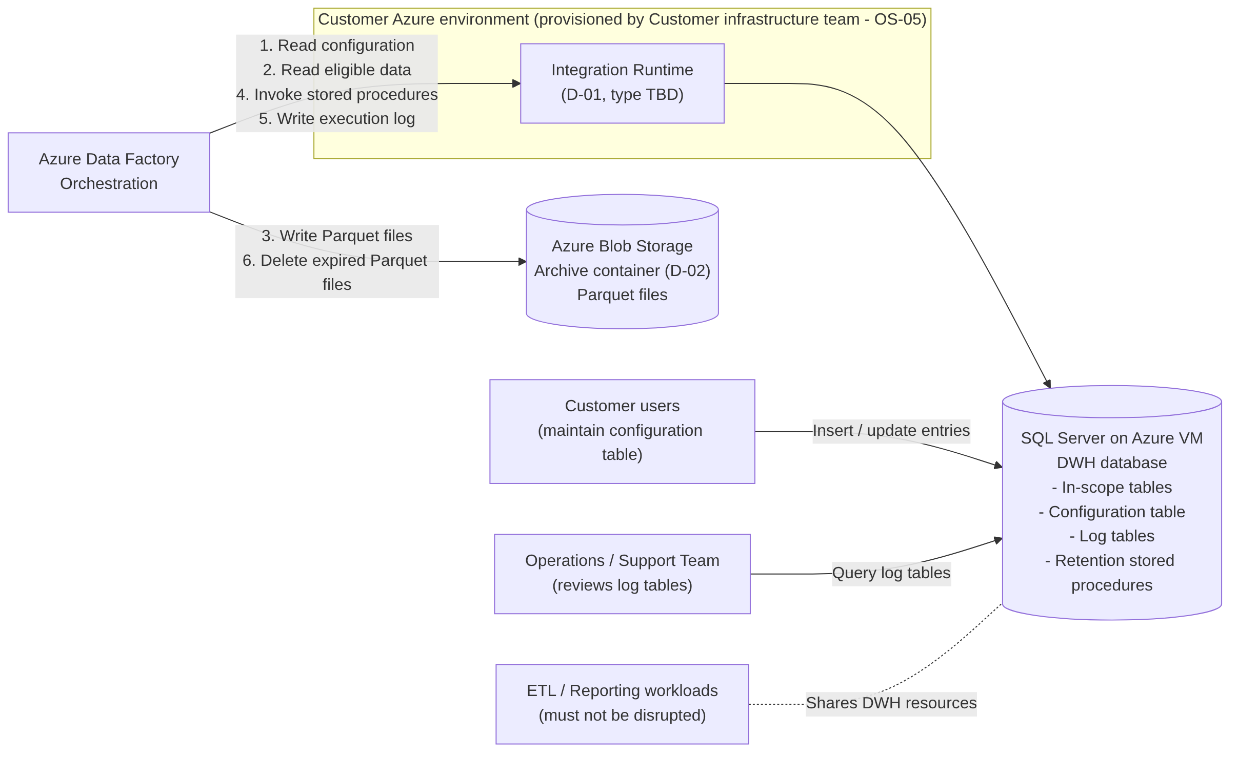
Figure 1 System context
ADF reaches the DWH through the Integration Runtime provided by the Customer infrastructure team. It reads configuration and eligible data, writes Parquet files to the archive container, invokes the retention stored procedures that remove data, and writes execution logs. Customer users maintain the configuration table directly in the DWH; the operations team reviews the log tables. ETL and reporting workloads share the DWH and must not be disrupted.

6.3 Component Interaction
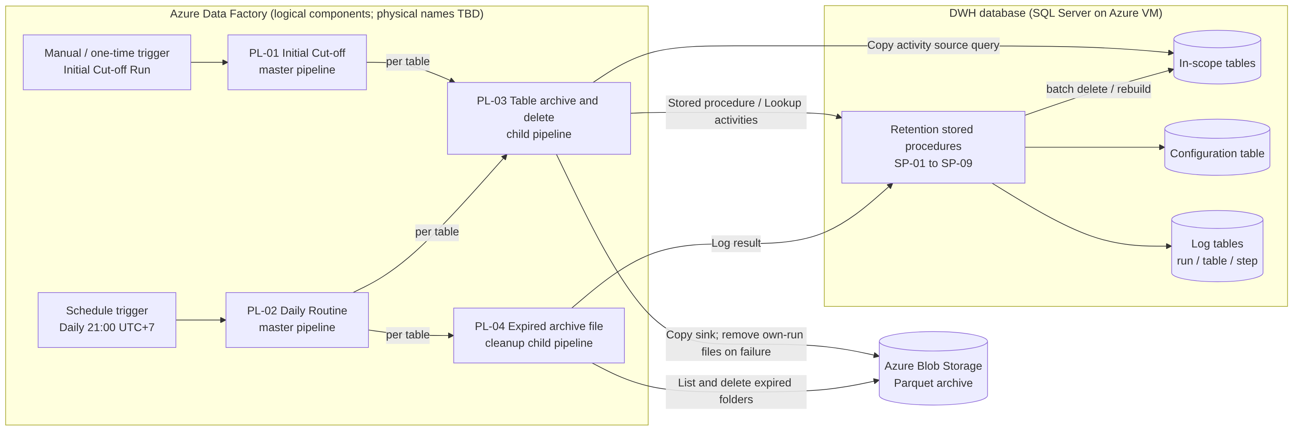
Figure 2 Component interaction (logical components)
Physical names of all components are TBD. The logical components and their responsibilities are:
ID | Component | Type | Responsibility | Source
PL-01 | Initial Cut-off master pipeline | ADF pipeline | Runs the Initial Cut-off Run for an explicitly supplied list of tables, sequentially; triggered manually within the agreed window. | BRQ-05, BR-12, BR-16, BR-17
PL-02 | Daily Routine master pipeline | ADF pipeline | Scheduled daily at 21:00 UTC+7; selects eligible tables and runs PL-03 and PL-04 for each. | BRQ-10, BR-18
PL-03 | Table archive-and-delete child pipeline | ADF pipeline | Per table: pre-checks, counting, export per business date, validation, deletion (batch delete or rebuild), cleanup of own files on failure. | IC-01 to IC-04, DR-01 to DR-04
PL-04 | Expired archive file cleanup child pipeline | ADF pipeline | Per table: lists business-date folders and deletes those older than the archive cut-off date. | DR-05, BRQ-11
SP-01 | Start run | Stored procedure | Validates the run date, creates the run log record and returns the RunId. | BRQ-12, BR-04
SP-02 | Get tables to process | Stored procedure | Returns tables with their cut-off dates and paths for the requested process type. | BRQ-04, BR-12, BR-13
SP-03 | Begin table | Stored procedure | Acquires the table processing lock, runs validation checks V-01 to V-09, detects a pending resume, counts eligible rows per business date and records the snapshot. | IC-01, DR-01
SP-04 | Validate archive | Stored procedure | Compares exported and expected counts per business date and performs the pre-delete recount. | BRQ-07, BR-08
SP-05 | Batch delete | Stored procedure | Deletes rows in the validated range in batches with a pause; records progress. | BRQ-08, NFR-01
SP-06 | Table rebuild | Stored procedure | Creates a new table with the retained rows and the same definition and swaps it with the original. | BRQ-09
SP-07 | Complete Initial Cut-off | Stored procedure | Post-checks that no rows older than the DWH cut-off date remain and sets the Initial Cut-off status and completion date. | BR-12, AC-03
SP-08 | Log step / end table | Stored procedure | Writes step and table log records and releases the processing lock. | BRQ-12
SP-09 | End run | Stored procedure | Closes the run log record with the aggregated status. | BRQ-12
SP-10 | Release stale lock (administrative) | Stored procedure | Allows an authorised operator to release a lock left by an aborted run after investigation. | [DER] FR-016
– | Configuration table | SQL table | Per-table retention settings (Section 10.6). | BRQ-03
– | Global parameters | Settings table or ADF global parameters (DEC-09) | Batch size, pause, window times and other global values (Section 10.7). | BRQ-08, BR-17
– | Log tables (run, table, step) | SQL tables | Execution history (Section 10.8). | BRQ-12
– | Archive container | Azure Blob Storage | Parquet files organised by table and business date (FR-007). | BRQ-06, D-02
Table 16 Logical solution components

6.4 Data Flow
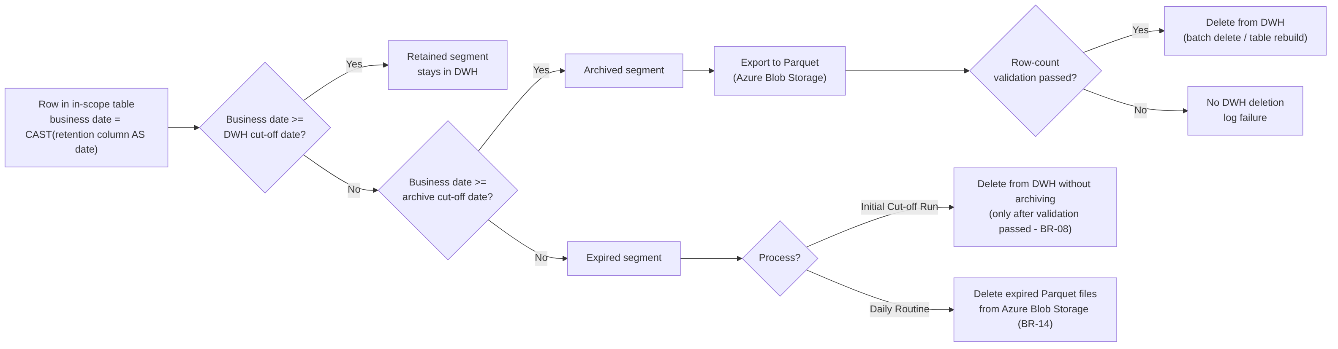
Figure 3 High-level data flow by segment
Every row of an in-scope table is classified by its business date into the retained, archived or expired segment. The archived segment is exported and validated before any deletion. Expired rows are deleted from the DWH only during the Initial Cut-off Run and only after the archived segment has been validated. In the Daily Routine, expired data exists only as Parquet folders, which are deleted from Azure Blob Storage.

6.5 High-Level Process Flow
- Table onboarding (PRC-01): analysis, technical assessment and entry in the configuration table.
- Initial Cut-off Run (PRC-02): executed once per table, small and medium tables first, then large tables within the approved downtime.
- Activation of the Daily Routine (FR-020): the schedule trigger is started for the day after the last initial table has completed its Initial Cut-off Run.
- Daily Routine (PRC-03, PRC-04): daily archive, validation, deletion and expired archive cleanup.
- Recovery and rerun (PRC-05) and configuration changes (PRC-06) when required.

6.6 Key Design Decisions Summary
The following design choices are proposed by this FSD and require approval (details in Section 19.5):
ID | Proposed design | Reason
DEC-01 | Run date supplied by ADF from the trigger time converted to UTC+7 and verified in SQL using SYSUTCDATETIME() + 7 hours. | BR-04 requires UTC+7; the slide formula uses GETDATE(), which returns the server time zone.
DEC-02 | System-maintained Initial Cut-off status and completion date per table. | Required to implement AC-15 and AC-16; not in the BRD attribute list.
DEC-03 | Row-count validation based on DWH counts per business date versus ADF Copy activity rows written. | BRQ-07 requires a Parquet-to-DWH count comparison; the counting method is not defined.
DEC-04 | One archive folder per table and business date; files tagged with the RunId and never overwritten. | DR-05 deletes by business date; resume must not overwrite archived data.
DEC-05 | Export unit = one business date per Copy activity, looped by ADF. | Supports per-date folders without requiring Mapping Data Flows.
DEC-06 | Resume of an incomplete validated deletion without re-export. | Prevents duplicate or truncated archive files after a partial failure.
Table 17 Key design decisions requiring approval

7. Functional Requirements
This section lists the functional requirements. Each requirement references the BRD items it implements. Requirements whose origin is “[DER]” are derived controls that the BRD does not state explicitly; they are proposed to make the BRD requirements safe and testable, and they require approval (Section 19). Detailed process behaviour is described in Section 8; this section defines what must be achieved.

7.1 Functional Requirements Overview
FR ID | Name | BRD reference | Origin
FR-001 | Retention configuration table | BRQ-02, BRQ-03, BRQ-04, NFR-02, BR-13 | BRD (+ derived attributes)
FR-002 | Configuration and metadata validation | BR-06, BR-13, A-04, R-07 | BRD / DER
FR-003 | Run date and cut-off date calculation | BR-03, BR-04, BR-05, BR-07, C-03 | BRD
FR-004 | Table selection for processing | BRQ-04, BR-12, BR-16, AC-15, AC-16 | BRD / DER
FR-005 | Eligible data identification | IC-01, DR-01 | BRD
FR-006 | Archive export to Parquet | BRQ-06, IC-02, DR-02, C-02 | BRD
FR-007 | Archive storage organisation and naming | BRQ-06, BRQ-11 | BRD / DER
FR-008 | Archive row-count validation | BRQ-07, BR-08, IC-03, DR-03 | BRD
FR-009 | Batch delete | BRQ-08, NFR-01, BR-10, IC-04, DR-04 | BRD
FR-010 | Table rebuild (Initial Cut-off Run only) | BRQ-09, BR-10, BR-11, BR-16 | BRD
FR-011 | Initial Cut-off Run orchestration | BRQ-05, IC-01 to IC-05, BR-08, BR-09, BR-12, BR-17 | BRD
FR-012 | Daily Routine orchestration | BRQ-10, NFR-03, DR-01 to DR-06, BR-07, BR-18 | BRD
FR-013 | Expired archive file deletion | BRQ-11, BR-14, IS-06 | BRD
FR-014 | Execution logging | BRQ-12, BR-15, BRD 7.4 | BRD
FR-015 | Log-based monitoring support | BRQ-13, R-01 | BRD
FR-016 | Concurrency control | Supports NFR-08, R-10 | DER
FR-017 | Restart, rerun and resume | Supports NFR-03, NFR-08, BR-08 | DER
FR-018 | Cleanup of archive files from failed runs | Supports BR-08, NFR-08 | DER
FR-019 | Execution window control for the Initial Cut-off Run | BR-17 | DER
FR-020 | Initial Cut-off status and Daily Routine activation | BR-12, BR-16, AC-15, AC-16 | BRD / DER
FR-021 | Retention logic as stored procedures and scripts | BRQ-14 | BRD
FR-022 | Table analysis support | BRQ-01, BRQ-02 | BRD / DER
Table 18 Functional requirements overview

7.2 Functional Requirement Specifications

FR-001 Retention Configuration Table
Functional Requirement ID | FR-001
Requirement Name | Retention Configuration Table
Origin | [BRD] BRQ-03 attributes; [DER] additional attributes CFG-10 to CFG-14 (DEC-02).
Description | The solution shall provide a central configuration table holding one entry per table under retention, containing the attributes defined in BRD 7.3 and the derived attributes listed in Section 10.6.
Business Requirement Reference | BRQ-02, BRQ-03, BRQ-04, NFR-02, BR-01, BR-02, BR-11, BR-13; BRD 7.3
Trigger | Customer users insert, update or deactivate an entry (manual maintenance; the maintenance tool, e.g. SQL script, is TBD).
Preconditions | Configuration table deployed. Customer users have write permission on the configuration table only (SEC-03).
Input | Database name, schema name, table name, retention column, DWH retention (years), total retention (years), blob path, Initial Cut-off Run method, active flag, size category.
Processing Logic | - Enforce structural rules in the database: unique entry per database, schema and table; DWH retention integer ≥ 1; total retention integer > DWH retention (DBR-01); method ∈ {Batch delete, Table rebuild}; active flag ∈ {Yes, No}; mandatory attributes not null.  - System-maintained attributes (Initial Cut-off status, completion date) are not editable by Customer users [DER].  - The process never detects tables or columns automatically; it uses only configured values (BR-13).  - Object existence and data-type checks are performed at run time by FR-002.
Output | Persisted configuration entry; change audit columns populated [REC].
Postconditions | A new entry has Initial Cut-off status = Pending and is not processed by the Daily Routine until FR-020 conditions are met.
Business Rules | BR-01, BR-02, BR-11, BR-13, DBR-01, DBR-11
Exception Handling | Constraint violation: the database rejects the insert or update with an error; no partial entry is stored. Semantic errors (non-existent object, wrong data type) are detected by FR-002 and logged at processing time.
Acceptance Criteria | - A table can be added to or removed from processing by changing configuration only, without any pipeline change (AC-02).  - An entry with total retention ≤ DWH retention is rejected.  - A duplicate entry for the same database, schema and table is rejected.  - Setting the active flag to No excludes the table from the next Daily Routine.  - Customer users cannot modify system-maintained attributes.
Priority | Not specified in the BRD (TBD).
Table 19 FR-001 – Retention Configuration Table

FR-002 Configuration and Metadata Validation
Functional Requirement ID | FR-002
Requirement Name | Configuration and Metadata Validation
Origin | [BRD] BR-06, BR-13; [DER] check set V-01 to V-09.
Description | Before any data is exported or deleted for a table, the solution shall validate the configuration entry and the table metadata. A table that fails validation shall not be exported or modified.
Business Requirement Reference | BR-06, BR-13, A-04, R-07, BRQ-02
Trigger | Start of processing of each table in PL-01 and PL-02 (executed by SP-03).
Preconditions | Run record exists (SP-01). Table lock acquired (FR-016).
Input | Configuration entry; SQL Server catalog metadata; global parameters.
Processing Logic | Execute checks V-01 to V-09 as defined in Section 10.5. Checks V-04 (NULL values, full count) and V-08 (Parquet compatibility) are mandatory in the Initial Cut-off Run; in the Daily Routine V-04 is performed as a metadata check plus a data check whose form is TBC (OQ-14).
Output | Validation result per check, written to the step log.
Postconditions | Validated table proceeds; failed table is logged with status Failed and error category CFG.
Business Rules | BR-06, BR-13, DBR-11
Exception Handling | Any failed check: no export, no deletion, table status Failed (ERR-CFG-nn), lock released, processing continues with the next table. In the Daily Routine, expired archive deletion (FR-013) still runs if checks V-05 and V-06 passed, because it does not depend on the DWH table (BR-14).
Acceptance Criteria | - A table whose retention column is not of an allowed date or datetime type is rejected with ERR-CFG-03 and no data is changed.  - A table whose retention column contains NULL values is rejected in the Initial Cut-off Run with ERR-CFG-04.  - A configured table that does not exist is rejected with ERR-CFG-01 and other tables are still processed.
Priority | Not specified in the BRD (TBD).
Table 20 FR-002 – Configuration and Metadata Validation

FR-003 Run Date and Cut-off Date Calculation
Functional Requirement ID | FR-003
Requirement Name | Run Date and Cut-off Date Calculation
Origin | [BRD] Derived from the referenced BRD requirements.
Description | The solution shall determine the run date in UTC+7 and calculate the DWH cut-off date and archive cut-off date for each table from the configured retention periods.
Business Requirement Reference | BR-03, BR-04, BR-05, BR-07, C-03; Glossary (Run date, DWH cut-off date, Archive cut-off date)
Trigger | Start of every PL-01 and PL-02 execution.
Preconditions | Global time-zone parameter GP-03 configured.
Input | Trigger time (UTC) supplied by ADF; optional run-date override for manual reruns (DBR-15); DWH retention and total retention per table.
Processing Logic | - RunDate = calendar date of (trigger time UTC converted to UTC+7), computed in ADF and passed to SP-01 [DER, DEC-01].  - SP-01 verifies RunDate ≤ CAST(DATEADD(HOUR, 7, SYSUTCDATETIME()) AS date). An override later than the current UTC+7 date is rejected.  - DwhCutoffDate = DATEADD(YEAR, −DWH retention, RunDate).  - ArchiveCutoffDate = DATEADD(YEAR, −Total retention, RunDate).  - RunDate and cut-off dates are fixed for the whole run, including runs that continue after midnight (DBR-02).  - Selection predicates compare the retention column directly with the date-typed cut-off (RetentionColumn < @DwhCutoffDate), which ignores the time part (BR-05) and keeps the predicate index-friendly. The column is not wrapped in a function.  - The server clock function GETDATE() shall not be used for the run date (Appendix A, SCR-01).
Output | RunDate, DwhCutoffDate, ArchiveCutoffDate per table; stored in the run and table logs.
Postconditions | All subsequent steps of the run use the fixed dates.
Business Rules | BR-03, BR-04, BR-05, BR-07, DBR-02, DBR-15
Exception Handling | Run-date override in the future: SP-01 rejects the run (ERR-SYS-02); nothing is processed.
Acceptance Criteria | - For run date 25 October 2026 with default periods, DwhCutoffDate = 25 October 2023 and ArchiveCutoffDate = 25 October 2021 (BRD 4.3).  - A row with business date-time 24 October 2023 23:59:59 is eligible; a row with 25 October 2023 00:00:00 is retained.  - The run date is correct regardless of the time zone of the SQL Server VM.  - Leap-day cases in Section 10.4 produce the documented dates.
Priority | Not specified in the BRD (TBD).
Table 21 FR-003 – Run Date and Cut-off Date Calculation

FR-004 Table Selection for Processing
Functional Requirement ID | FR-004
Requirement Name | Table Selection for Processing
Origin | [BRD] BR-12, BR-16; [DER] selection conditions using Initial Cut-off status (DEC-02).
Description | The solution shall select the tables processed in each run according to the process type, the configuration and the Initial Cut-off status.
Business Requirement Reference | BRQ-04, BR-12, BR-13, BR-16, AC-15, AC-16
Trigger | Start of PL-01 and PL-02 (SP-02).
Preconditions | Run record created; RunDate fixed.
Input | Process type; for PL-01 an explicit list of table identifiers; configuration table; global parameters.
Processing Logic | - Initial Cut-off Run: process only the listed tables where Active = Yes (DBR-11) and Initial Cut-off status ∈ {Pending, Failed, Stopped}. A Large table is accepted only when all Small and Medium tables of the initial implementation are Completed and a downtime approval reference is supplied (DBR-05).  - Daily Routine: process tables where Active = Yes AND Initial Cut-off status = Completed AND Initial Cut-off completion date < RunDate (DBR-04).  - Processing order: Initial Cut-off Run in the order supplied; Daily Routine in ascending table identifier order [DER]. Sequential by default; parallelism per GP-07 (OQ-16).
Output | Ordered table list with cut-off dates and blob paths.
Postconditions | Tables not selected are not touched by the run (no log record other than in the selection summary).
Business Rules | BR-12, BR-16, DBR-04, DBR-05, DBR-11
Exception Handling | Listed table not eligible for the Initial Cut-off Run: logged as Skipped with reason (ERR-CFG-07). Empty selection: run completes with status Succeeded and zero tables.
Acceptance Criteria | - A table whose Initial Cut-off Run completed on day D is first processed by the Daily Routine with run date D+1 (AC-16).  - An inactive table is not processed.  - A Large table is rejected by PL-01 while a Small or Medium table of the initial implementation is not yet Completed.
Priority | Not specified in the BRD (TBD).
Table 22 FR-004 – Table Selection for Processing

FR-005 Eligible Data Identification
Functional Requirement ID | FR-005
Requirement Name | Eligible Data Identification
Origin | [BRD] Derived from the referenced BRD requirements.
Description | The solution shall count, per table and per business date, the rows in the archived segment (and, in the Initial Cut-off Run, the expired segment) and store this snapshot as the validation baseline.
Business Requirement Reference | IC-01, DR-01, BRQ-07
Trigger | After successful validation (FR-002) and resume handling (FR-017).
Preconditions | Cut-off dates fixed.
Input | Table, retention column, DwhCutoffDate, ArchiveCutoffDate.
Processing Logic | - Initial Cut-off Run: ArchivedCount per business date for col >= ArchiveCutoffDate AND col < DwhCutoffDate; ExpiredCount for col < ArchiveCutoffDate; RetainedCount for col >= DwhCutoffDate (for AC-03 verification).  - Daily Routine: EligibleCount per business date for col < DwhCutoffDate.  - Store the per-date counts in the step log as the expected values (snapshot).  - If the eligible (DR) or archived (IC) count is zero, export and validation are skipped. In the Initial Cut-off Run, expired rows are then still deleted (DBR-03).
Output | Per-date expected counts; totals; minimum and maximum business date.
Postconditions | Snapshot available for FR-006 and FR-008.
Business Rules | BR-03, BR-05, DBR-03
Exception Handling | Query failure or timeout: retried per Section 13.4; on final failure the table is Failed (ERR-SYS-01) with no data change.
Acceptance Criteria | - The per-date counts equal the result of an independent COUNT query on the same range.  - With no eligible rows in the Daily Routine, DR-02 to DR-04 are skipped and DR-05 is executed.
Priority | Not specified in the BRD (TBD).
Table 23 FR-005 – Eligible Data Identification

FR-006 Archive Export to Parquet
Functional Requirement ID | FR-006
Requirement Name | Archive Export to Parquet
Origin | [BRD] Derived from the referenced BRD requirements.
Description | The solution shall export eligible rows to Parquet files in Azure Blob Storage, one export unit per table and business date, without transforming the data.
Business Requirement Reference | BRQ-06, IC-02, DR-02, OBJ-02, C-02
Trigger | After FR-005 when the eligible (DR) or archived (IC) count is greater than zero.
Preconditions | Snapshot recorded; blob path valid; ADF has write access to the archive container (SEC-05).
Input | Per-date list from the snapshot; table column list from metadata; target path from FR-007.
Processing Logic | - For each business date d in ascending order: ADF Copy activity with source query selecting all columns of the table where col >= d AND col < DATEADD(DAY, 1, d); sink = Parquet dataset at the path defined in FR-007 [DEC-05].  - Columns are selected explicitly from the catalog in ordinal order [DER].  - Fault tolerance (skipping incompatible rows) is disabled, so any rejected row fails the activity.  - Compression codec: TBC (snappy proposed, [REC]).  - Parallel execution of dates within a table is governed by GP-08 (default sequential, OQ-16).  - In the Initial Cut-off Run, the window check (FR-019) is performed before each date.
Output | Parquet file(s) per business date; per-date rows read and rows written recorded in the step log.
Postconditions | All dates of the snapshot exported, or the export is marked failed.
Business Rules | BR-02, DBR-07, DBR-13
Exception Handling | Copy failure after retries: remaining dates are not exported, files written by this run are removed (FR-018), table status Failed (ERR-EXP-01), no deletion.
Acceptance Criteria | - For each exported business date, one folder exists containing only rows of that business date.  - Column names, column count and values in the Parquet files match the source rows for sampled dates (TS-042).  - An incompatible row causes the export to fail rather than being skipped.
Priority | Not specified in the BRD (TBD).
Table 24 FR-006 – Archive Export to Parquet

FR-007 Archive Storage Organisation and Naming
Functional Requirement ID | FR-007
Requirement Name | Archive Storage Organisation and Naming
Origin | [BRD] BRQ-06 “organised by table and date”; [DER] folder and file convention (DEC-04).
Description | The solution shall store Parquet files in a folder per table and business date and shall name each file so that it identifies the table, business date and run that produced it.
Business Requirement Reference | BRQ-06, BRQ-11, BR-14
Trigger | Every export unit (FR-006).
Preconditions | Container and blob path configured (D-02, CFG-07).
Input | Blob path (table root folder), schema, table, business date, RunId.
Processing Logic | - Proposed folder: <container>/<BlobPath>/business_date=<yyyy-MM-dd>/ [DER].  - Proposed file name: <schema>_<table>_<yyyyMMdd>_<RunId>[_<n>].parquet [DER].  - Blob path must be unique per configuration entry (V-06).  - Files are never overwritten; a rerun or resume writes new file names (DBR-07).  - A business-date folder is the unit of expiry deletion (FR-013).
Output | Deterministic archive layout.
Postconditions | Each archived row is located in exactly one business-date folder.
Business Rules | DBR-07, DBR-12
Exception Handling | Name collision (file already exists): export fails (ERR-EXP-02); not expected because the RunId is unique.
Acceptance Criteria | - The archive for a table contains one folder per exported business date with the agreed naming pattern.  - No file from an earlier run is overwritten by a later run.
Priority | Not specified in the BRD (TBD).
Table 25 FR-007 – Archive Storage Organisation and Naming

FR-008 Archive Row-Count Validation
Functional Requirement ID | FR-008
Requirement Name | Archive Row-Count Validation
Origin | [BRD] Derived from the referenced BRD requirements.
Description | Before deleting any data from the DWH, the solution shall confirm that the number of rows written to Parquet equals the number of rows in the DWH for the same range, per business date and in total. No data shall be deleted if the counts differ.
Business Requirement Reference | BRQ-07, BR-08, IC-03, DR-03, AC-05, SC-02
Trigger | After all export units of the table have completed.
Preconditions | Snapshot and per-date export results available.
Input | Expected counts (FR-005); Copy activity rows read and rows written per date (DEC-03); current DWH count (pre-delete recount).
Processing Logic | - Per business date: pass if expected count = rows read = rows written.  - Total: pass if the sum of rows written = total expected count.  - Pre-delete recount: immediately before deletion, recount the rows in the validated range; pass if equal to the validated total (DBR-06).  - Record the result per date and in total; set the table log attribute “validated” only when all checks pass.  - The counting method for the Parquet side (copy metrics versus independent read-back of the files) requires a decision (DEC-03, OQ-09).
Output | Validation result (Passed / Failed) with per-date details.
Postconditions | Passed: deletion may start (FR-009 or FR-010). Failed: no deletion of any data, including expired data in the Initial Cut-off Run.
Business Rules | BR-08, DBR-06
Exception Handling | Mismatch: files of this run removed (FR-018), table status Failed (ERR-VAL-01 or ERR-VAL-02). In the Daily Routine processing continues with FR-013 (DR-05).
Acceptance Criteria | - A simulated mismatch results in zero rows deleted from the DWH, including expired rows during the Initial Cut-off Run, and a log record with status Failed (AC-05).  - A row inserted into the validated range between export and deletion causes the pre-delete recount to fail and no deletion.
Priority | Not specified in the BRD (TBD).
Table 26 FR-008 – Archive Row-Count Validation

FR-009 Batch Delete
Functional Requirement ID | FR-009
Requirement Name | Batch Delete
Origin | [BRD] Derived from the referenced BRD requirements.
Description | The solution shall delete rows from the DWH in batches of a configurable size with a configurable pause between batches, each batch in its own short transaction.
Business Requirement Reference | BRQ-08, NFR-01, BR-10, BR-11, IC-04, DR-04, AC-06
Trigger | After validation passes (Daily Routine; Initial Cut-off Run with method Batch delete) or on resume (FR-017).
Preconditions | Validation passed for the range; table lock held.
Input | Table, retention column, delete range (lower bound optional, upper bound = DwhCutoffDate), GP-01 batch size (default 10,000), GP-02 pause (default 3 seconds).
Processing Logic | - Loop: delete at most GP-01 rows within the range; record rows affected; if fewer than GP-01 rows were deleted, stop; otherwise wait GP-02 seconds and repeat (pseudocode in Section 8.3).  - Each batch is an autocommit transaction; no transaction spans batches.  - Progress (cumulative rows deleted) is written to the step log at an interval TBD.  - Initial Cut-off Run: range = all rows with col < DwhCutoffDate (archived and expired).  - Daily Routine: range = col < DwhCutoffDate limited to the validated snapshot range.  - Lock-timeout and deadlock errors on a batch are retried per GP-09 (count TBD).  - After the loop, the remaining row count in the range must be zero, and the total deleted must equal the validated total (IC: archived + expired count).
Output | Rows deleted; number of batches; duration.
Postconditions | No rows remain in the range; table log updated.
Business Rules | BR-08, BR-10, DBR-09, DBR-14
Exception Handling | Error after retries: stop, status Failed (ERR-DEL-01); the validated range remains recorded as “delete not completed” for resume (FR-017). Deleted total ≠ validated total: warning ERR-DEL-03 and reconciliation flag (deletion cannot be reversed).
Acceptance Criteria | - Deleting 25,000 eligible rows with default parameters results in three batches of 10,000, 10,000 and 5,000 rows with a pause of at least 3 seconds between batches (AC-06).  - Changing GP-01 or GP-02 changes the behaviour without code change.  - No single transaction deletes more than GP-01 rows.
Priority | Not specified in the BRD (TBD).
Table 27 FR-009 – Batch Delete

FR-010 Table Rebuild (Initial Cut-off Run Only)
Functional Requirement ID | FR-010
Requirement Name | Table Rebuild (Initial Cut-off Run Only)
Origin | [BRD] Derived from the referenced BRD requirements.
Description | For tables configured with the method Table rebuild, the Initial Cut-off Run shall create a new table containing only the retained rows and replace the original table, preserving the table definition.
Business Requirement Reference | BRQ-09, BR-10, BR-11, BR-16, R-05, D-07, AC-03, AC-14
Trigger | Initial Cut-off Run after validation passed, for a table with method = Table rebuild.
Preconditions | - Approved downtime window active and its reference supplied to PL-01 (D-07).  - Writes to the table by ETL stopped for the downtime (ETL Owner).  - Valid backup confirmed (R-02).  - Dependent objects reviewed (R-05), including incoming foreign keys, schema-bound views, triggers, replication or change tracking (OQ-11).  - Sufficient data and log space for the retained rows (R-06).
Input | Table, retention column, DwhCutoffDate, downtime reference.
Processing Logic | Steps in Section 8.4: script the full definition; create the new table under a temporary name; insert rows with col >= DwhCutoffDate; validate the row count; swap names in one short transaction; re-apply permissions, constraints and triggers; verify the definition; handle the old table per DEC-08.
Output | Rebuilt table with the original name; old table retained or dropped per DEC-08.
Postconditions | No rows older than the DWH cut-off date in the table; definition identical to the original.
Business Rules | BR-10, BR-11, BR-16, BR-17, DBR-05
Exception Handling | Failure before the swap: staging table dropped, original unchanged (ERR-RBD-01). Failure during the swap: transaction rolled back (ERR-RBD-02). Failure after the swap (e.g. permission re-apply): status Failed (ERR-RBD-03) and DBA manual procedure.
Acceptance Criteria | - After the rebuild, the table contains exactly the rows with business date ≥ DWH cut-off date and their values are unchanged (AC-03).  - Columns, data types, nullability, identity, keys, indexes, constraints, triggers and permissions match the pre-rebuild definition.  - The rebuild runs only within the approved downtime (AC-14).
Priority | Not specified in the BRD (TBD).
Table 28 FR-010 – Table Rebuild (Initial Cut-off Run Only)

FR-011 Initial Cut-off Run Orchestration
Functional Requirement ID | FR-011
Requirement Name | Initial Cut-off Run Orchestration
Origin | [BRD] Derived from the referenced BRD requirements.
Description | The solution shall provide a pipeline that executes the Initial Cut-off Run (IC-01 to IC-05) once for each selected table.
Business Requirement Reference | BRQ-05, IC-01 to IC-05, BR-08, BR-09, BR-11, BR-12, BR-16, BR-17, AC-03, AC-04, AC-05, AC-14
Trigger | Manual trigger (or one-time schedule trigger) of PL-01 by an authorised operator within 21:00–05:00 UTC+7, as scheduled with the ETL Owner (D-04).
Preconditions | Tables onboarded (PRC-01); backup confirmed; ETL Owner agreement recorded (reference TBD).
Input | Table list; optional run date; downtime reference for Large tables; window end time (GP-05).
Processing Logic | Per table: lock (FR-016) → validation (FR-002) → resume check (FR-017) → counts (FR-005) → export of archived segment (FR-006) → validation (FR-008) → deletion by configured method (FR-009 or FR-010) → post-check and completion (FR-020) → log (FR-014). Detailed flow in PRC-02.
Output | Archive files for the archived segment; DWH table reduced to the retained segment; IC status Completed; logs.
Postconditions | AC-03 and AC-04 satisfied for each completed table.
Business Rules | BR-08, BR-09, BR-10, BR-11, BR-12, BR-16, BR-17, DBR-03, DBR-05, DBR-13
Exception Handling | Per-table failures do not stop the remaining tables [DER]. Window end reached: FR-019.
Acceptance Criteria | - AC-03, AC-04, AC-05 and AC-14 of the BRD are met (TS-012 to TS-019).
Priority | Not specified in the BRD (TBD).
Table 29 FR-011 – Initial Cut-off Run Orchestration

FR-012 Daily Routine Orchestration
Functional Requirement ID | FR-012
Requirement Name | Daily Routine Orchestration
Origin | [BRD] Derived from the referenced BRD requirements.
Description | The solution shall provide a pipeline, triggered by an ADF schedule every day at 21:00 UTC+7, that executes DR-01 to DR-06 for every selected table without manual intervention.
Business Requirement Reference | BRQ-10, NFR-03, DR-01 to DR-06, BR-07, BR-10, BR-12, BR-14, BR-18, AC-07, AC-15
Trigger | ADF schedule trigger, daily at 21:00, time zone SE Asia Standard Time (UTC+7).
Preconditions | Schedule trigger started per FR-020; pipeline concurrency limited to 1 (FR-016).
Input | Trigger time; configuration; global parameters.
Processing Logic | Per selected table (FR-004): lock → validation → resume (FR-017) → counts → export → validation → batch delete → expired archive deletion (FR-013, always) → log. Detailed flow in PRC-03. Table method is always batch delete (BR-10).
Output | Archive files for newly eligible dates; DWH rows older than the DWH cut-off date deleted; expired archive folders deleted; logs.
Postconditions | Run status Succeeded if every table ended Succeeded or NoData; otherwise Completed with errors, and the ADF pipeline run is marked failed [REC] so that it is visible in ADF monitoring.
Business Rules | BR-07, BR-10, BR-12, BR-14, BR-18, DBR-04
Exception Handling | A failure of one table does not stop processing of other tables. A run that is still active at the next trigger time causes the next run to queue (concurrency 1).
Acceptance Criteria | - The pipeline starts at 21:00 UTC+7 without manual action (AC-07).  - After a successful run, no processed table contains rows older than the DWH cut-off date (AC-07, SC-01; see OQ-06 for failed-validation days).
Priority | Not specified in the BRD (TBD).
Table 30 FR-012 – Daily Routine Orchestration

FR-013 Expired Archive File Deletion
Functional Requirement ID | FR-013
Requirement Name | Expired Archive File Deletion
Origin | [BRD] Derived from the referenced BRD requirements.
Description | The Daily Routine shall delete, for each processed table, all archive folders whose business date is before the archive cut-off date.
Business Requirement Reference | BRQ-11, BR-14, DR-05, IS-06, AC-08, SC-03
Trigger | Daily Routine, per table, after DR-04 or after any earlier outcome of the table (including validation failure or no eligible data).
Preconditions | V-05 and V-06 passed (cut-off and path determinable).
Input | Table root folder; ArchiveCutoffDate.
Processing Logic | - List child folders of the table root folder (ADF Get Metadata).  - Parse the business date from folders matching business_date=yyyy-MM-dd.  - Select folders with business date < ArchiveCutoffDate.  - For each selected folder: count files, delete the folder recursively (ADF Delete activity).  - Folders not matching the pattern are not deleted and are logged as a warning (DBR-12).
Output | Number of folders and files deleted; warnings.
Postconditions | No folder with business date < ArchiveCutoffDate remains for the table.
Business Rules | BR-14, DBR-12
Exception Handling | Listing or deletion error after retries: status Failed (ERR-ARC-01) for this step; DWH processing result of the table is preserved; the next Daily Routine retries automatically because the step is idempotent.
Acceptance Criteria | - After the Daily Routine, no Parquet file with business date before the archive cut-off date remains, including on days when validation of DWH data failed (AC-08).  - Folders on or after the archive cut-off date are untouched.
Priority | Not specified in the BRD (TBD).
Table 31 FR-013 – Expired Archive File Deletion

FR-014 Execution Logging
Functional Requirement ID | FR-014
Requirement Name | Execution Logging
Origin | [BRD] Derived from the referenced BRD requirements.
Description | The solution shall record every execution in log tables at run, table and step level, including all attributes listed in BRD 7.4.
Business Requirement Reference | BRQ-12, BRQ-13, BR-15, BRD 7.4, AC-09, SC-04
Trigger | Start and end of every run, table and step.
Preconditions | Log tables deployed.
Input | Process context and results of each step.
Processing Logic | - Run log: created as the first activity (SP-01) with status Running; closed by SP-09.  - Table log: one record per table per run with the BRD 7.4 attributes (Section 10.8).  - Step log: one record per step and, for export and validation, per business date.  - On any failure path, ADF failure branches call SP-08/SP-09 to set the final status and error details.  - Status values: Running, Succeeded, NoData, Failed, Skipped, Stopped; run level additionally Completed with errors.
Output | Log records.
Postconditions | Every run and table processed has a final status.
Business Rules | BR-15
Exception Handling | If the log tables cannot be written (e.g. DWH unreachable), the ADF run fails and the failure is visible only in ADF monitoring (RSK-17). A run left in status Running after an aborted pipeline is corrected per Section 16.8.
Acceptance Criteria | - Every Initial Cut-off Run and Daily Routine execution produces a run record and a table record per processed table containing all BRD 7.4 attributes (AC-09).  - Failed executions include an error code and error message.
Priority | Not specified in the BRD (TBD).
Table 32 FR-014 – Execution Logging

FR-015 Log-Based Monitoring Support
Functional Requirement ID | FR-015
Requirement Name | Log-Based Monitoring Support
Origin | [BRD] Derived from the referenced BRD requirements.
Description | The solution shall support basic operational monitoring and troubleshooting from the log tables through documented SQL queries in the operational guide.
Business Requirement Reference | BRQ-13, R-01, OS-06, OS-08
Trigger | Operator review (daily, per R-01 mitigation).
Preconditions | Read access to the log tables for the operations team (SEC-04).
Input | Log tables.
Processing Logic | Provide documented queries for: latest run status; failed or stopped tables in the last N days; tables with pending resume; Initial Cut-off status overview; reconciliation of exported versus deleted rows; tables still containing rows older than the DWH cut-off date. Whether these are delivered as read-only views is TBC (OS-08).
Output | Query results.
Postconditions | None.
Business Rules | BR-15
Exception Handling | Not applicable.
Acceptance Criteria | - Each documented query returns the expected rows for a prepared set of log records (TS-043).
Priority | Not specified in the BRD (TBD).
Table 33 FR-015 – Log-Based Monitoring Support

FR-016 Concurrency Control
Functional Requirement ID | FR-016
Requirement Name | Concurrency Control
Origin | [DER] Not stated in the BRD. Proposed to protect data integrity (NFR-08) and to handle R-10. Requires approval (DEC-11).
Description | The solution shall prevent the same table from being processed by more than one run at a time and shall prevent overlapping executions of the same master pipeline.
Business Requirement Reference | Supports NFR-08, R-10, BR-08
Trigger | Start of each table and each master pipeline.
Preconditions | None.
Input | Table identifier, RunId.
Processing Logic | - PL-01 and PL-02 configured with pipeline concurrency = 1.  - SP-03 acquires a table processing lock atomically (e.g. a lock row or a unique constraint on “table in Running state”; mechanism per DEC-11). If the lock is held, the table is Skipped (ERR-LCK-01).  - SP-08 releases the lock at the end of table processing, on success and on handled failure.  - Locks left by aborted runs are released only by SP-10 by an authorised operator after investigation.
Output | Lock state.
Postconditions | At most one active processing per table.
Business Rules | DBR-10
Exception Handling | Stale lock: table skipped until released (manual).
Acceptance Criteria | - Starting PL-01 for a table currently processed by PL-02 results in the table being Skipped by the second run with ERR-LCK-01 and no data change.
Priority | Not specified in the BRD (TBD).
Table 34 FR-016 – Concurrency Control

FR-017 Restart, Rerun and Resume
Functional Requirement ID | FR-017
Requirement Name | Restart, Rerun and Resume
Origin | [DER] Not stated in the BRD. Required so that reruns never lose archived data or create duplicates. Requires approval (DEC-06).
Description | The solution shall support safe reruns: a rerun after any failure shall not delete unvalidated data, shall not overwrite existing archive files and shall not export the same rows twice.
Business Requirement Reference | Supports NFR-03, NFR-08, BR-08
Trigger | Every table processing (resume check in SP-03); manual rerun by an operator.
Preconditions | Log records of earlier runs available.
Input | Last table log for the table (validated flag, delete status, validated range, exported rows).
Processing Logic | Decision logic in Section 8.6 (PRC-05) and Figure 9: if an earlier run validated a range but did not complete its deletion, delete the remaining rows of that range only (no re-export), provided the remaining row count is not greater than the exported count; then continue with normal processing for the current run.
Output | Completed deletion of the earlier range; normal processing.
Postconditions | No pending resume remains for the table.
Business Rules | DBR-06, DBR-07, DBR-08, DBR-09
Exception Handling | Remaining rows > exported rows: integrity error ERR-VAL-03, no deletion, manual investigation.
Acceptance Criteria | - After a deletion is interrupted, the next run completes it without writing new archive files for that range and the archive contains each row exactly once (TS-032).  - A rerun after a successful run for the same run date performs no export and no deletion (TS-033).
Priority | Not specified in the BRD (TBD).
Table 35 FR-017 – Restart, Rerun and Resume

FR-018 Cleanup of Archive Files from Failed Runs
Functional Requirement ID | FR-018
Requirement Name | Cleanup of Archive Files from Failed Runs
Origin | [DER] Required to avoid duplicates in the archive after a failed export or validation. Requires approval.
Description | When export or validation fails, the solution shall delete only the archive files written by the current run for the affected table.
Business Requirement Reference | Supports BR-08, NFR-08
Trigger | Export failure (FR-006), validation failure (FR-008) or window stop during export (FR-019).
Preconditions | Files are tagged with the RunId (FR-007).
Input | Table root folder, RunId, list of dates exported in this run.
Processing Logic | Delete files whose name contains the current RunId in the affected business-date folders; delete a folder only if it becomes empty; log the number of files removed.
Output | Archive state equal to the state before the run.
Postconditions | Rerun can export the same dates without duplicates.
Business Rules | DBR-08
Exception Handling | Cleanup failure: table flagged with ERR-EXP-03 (orphan files); the next run for this table is blocked by V-09 until an operator removes the files and clears the flag.
Acceptance Criteria | - After a forced validation failure, the archive contains no file with the failed RunId.
Priority | Not specified in the BRD (TBD).
Table 36 FR-018 – Cleanup of Archive Files from Failed Runs

FR-019 Execution Window Control for the Initial Cut-off Run
Functional Requirement ID | FR-019
Requirement Name | Execution Window Control for the Initial Cut-off Run
Origin | [DER] Derived from BR-17 (window 21:00–05:00). The stop behaviour is a proposal (DEC-10).
Description | The Initial Cut-off Run shall not continue processing past the end of the agreed window and shall stop in a resumable state.
Business Requirement Reference | BR-17, D-04, NFR-05, NFR-07
Trigger | Before each export date and between delete batches.
Preconditions | GP-05 window end configured (default 05:00).
Input | Current UTC+7 time; GP-05.
Processing Logic | - Export phase: if the window end is reached, stop exporting, remove this run's files (FR-018), status Stopped (ERR-WIN-01); nothing is deleted.  - Batch-delete phase: finish the current batch, stop, status Stopped; the validated range is resumed by the next run (FR-017).  - Table rebuild: not interruptible; started only if the estimated duration fits the remaining downtime (operator precondition).
Output | Stopped status with progress recorded.
Postconditions | Table can be resumed in a later window.
Business Rules | BR-17, DBR-13
Exception Handling | Not applicable.
Acceptance Criteria | - No export or delete batch of the Initial Cut-off Run starts after the window end (TS-017, TS-018).
Priority | Not specified in the BRD (TBD).
Table 37 FR-019 – Execution Window Control for the Initial Cut-off Run

FR-020 Initial Cut-off Status and Daily Routine Activation
Functional Requirement ID | FR-020
Requirement Name | Initial Cut-off Status and Daily Routine Activation
Origin | [BRD] BR-12, BR-16, AC-15, AC-16; [DER] status attributes and trigger activation procedure (DEC-02).
Description | The solution shall maintain the Initial Cut-off status per table and shall ensure that the Daily Routine starts only on the day after the Initial Cut-off Run has been completed for all in-scope tables of the initial implementation, and that later-added tables enter the Daily Routine only on the day after their own Initial Cut-off Run.
Business Requirement Reference | BR-12, BR-16, BRD 5.1, AC-15, AC-16
Trigger | Completion of an Initial Cut-off Run for a table; go-live activation.
Preconditions | SP-07 post-check passed.
Input | Table, RunId, completion time (UTC+7).
Processing Logic | - SP-07 sets Initial Cut-off status = Completed and completion date = UTC+7 calendar date at completion (not the run date) when no rows older than the DWH cut-off date remain.  - Status lifecycle per Figure 8: Pending → Running → Completed, or Failed / Stopped.  - Activation: the Daily Routine schedule trigger is created in stopped state and started by an authorised operator with first execution on the day after the last initial table completed (operational control, Section 16.2).  - Safety net: FR-004 excludes any table whose status is not Completed or whose completion date is not before the run date.
Output | Status and completion date.
Postconditions | Table eligible for the Daily Routine from the next calendar day.
Business Rules | BR-12, BR-16, DBR-04, DBR-05
Exception Handling | Post-check fails: status Failed (ERR-DEL-02).
Acceptance Criteria | - No Daily Routine runs before the day after the last initial table completed (AC-15).  - A table added later is not processed by the Daily Routine until the day after its Initial Cut-off Run completed, including when the run finishes after midnight (AC-16).
Priority | Not specified in the BRD (TBD).
Table 38 FR-020 – Initial Cut-off Status and Daily Routine Activation

FR-021 Retention Logic as Stored Procedures and Scripts
Functional Requirement ID | FR-021
Requirement Name | Retention Logic as Stored Procedures and Scripts
Origin | [BRD] Derived from the referenced BRD requirements.
Description | All database-side retention logic shall be implemented as stored procedures and versioned deployment scripts.
Business Requirement Reference | BRQ-14, IS-04, AC-10
Trigger | Deployment.
Preconditions | Deployment permissions granted to the deploying principal.
Input | Source scripts.
Processing Logic | - Deliver SP-01 to SP-10 and DDL for the configuration, parameter and log tables, permissions and the table analysis script (FR-022).  - Dynamic SQL: object names validated against the catalog and quoted with QUOTENAME; values passed as parameters through sp_executesql; no concatenation of unvalidated configuration values (SEC-07).  - Scripts are re-runnable (idempotent) [REC] and kept under version control [REC].
Output | Deployed database objects.
Postconditions | Objects available in the target environment.
Business Rules | Not applicable.
Exception Handling | Deployment error: deployment script stops and reports the failing object; no partial deployment is left unreported.
Acceptance Criteria | - Retention logic is delivered as stored procedures and scripts (AC-10) and can be deployed to an empty environment reproducibly (TS-040).
Priority | Not specified in the BRD (TBD).
Table 39 FR-021 – Retention Logic as Stored Procedures and Scripts

FR-022 Table Analysis Support
Functional Requirement ID | FR-022
Requirement Name | Table Analysis Support
Origin | [BRD] BRQ-01, BRQ-02; [DER] form of the analysis output.
Description | The project shall provide an analysis of DWH tables that supports identification of in-scope tables, candidate retention columns and size category.
Business Requirement Reference | BRQ-01, BRQ-02, IS-01, IS-02, D-05, AC-01
Trigger | Onboarding (PRC-01).
Preconditions | Read access to the DWH catalog and data.
Input | DWH catalog; table data.
Processing Logic | For each candidate table report: row count and size; date and datetime columns; NULL count per candidate column; row distribution by business-date year; presence of indexes on candidate columns; incoming foreign keys and schema-bound dependencies; Parquet-incompatible columns. The final selection is made by the Business / Data Owner and entered by Customer users (BRQ-02).
Output | Table analysis deliverable.
Postconditions | Input available for the technical assessment (D-05).
Business Rules | BR-06, BR-11, BR-13
Exception Handling | Not applicable.
Acceptance Criteria | - The table analysis is delivered and the in-scope tables and retention columns are entered in the configuration table (AC-01).
Priority | Not specified in the BRD (TBD).
Table 40 FR-022 – Table Analysis Support

8. Detailed Functional Design
This section describes how each process is executed. Normal flow and exception flow are described separately. Pseudocode is illustrative and defines the required logic, not the final code.

8.1 PRC-01 Table Onboarding
1. Process ID and Name | PRC-01 Table Onboarding
2. Process Objective | Bring a table under retention: confirm it is in scope, register its configuration and determine its Initial Cut-off Run method.
3. Trigger and Execution Frequency | Initial implementation, and whenever a new table is added later (BRD 5.1). Manual, event-driven.
4. Preconditions | Table analysis available (FR-022). Retention periods agreed (A-01).
5. Required Inputs | Table analysis; technical assessment thresholds (D-05, TBD); Business / Data Owner decision.
6. Processing Steps | 1. Analyse candidate tables (FR-022).  2. Business / Data Owner confirms the table and its retention column.  3. Technical assessment assigns the size category and Initial Cut-off Run method (BR-11) and records exceptions.  4. Customer users insert the configuration entry (FR-001); status Initial Cut-off = Pending.  5. Data engineer runs a dry validation (FR-002 checks V-01 to V-08, no data change) [REC] and records the result.  6. Initial Cut-off Run is scheduled with the ETL Owner (D-04); Large tables additionally require the downtime (D-07).
7. Decision Points | Is the retention column valid (date or datetime, no NULLs)? If not, the table is not onboarded until resolved (A-04, R-07).  Is the table Large or an exception? Determines batch delete versus table rebuild.
8. Business Rules | BR-06, BR-11, BR-13, BR-16
9. Data Validation | V-01 to V-08 (Section 10.5).
10. Output | Configuration entry with status Pending; dry-validation evidence.
11. Error Handling | Validation failure: entry corrected by Customer users or the table is deactivated.
12. Logging and Monitoring | Dry validation results recorded in the step log with process type “Validation” [DER].
13. Postconditions | Table ready for the Initial Cut-off Run.
14. Acceptance Criteria | AC-01, AC-02.
Table 41 PRC-01 Table Onboarding – process specification

8.2 PRC-02 Initial Cut-off Run
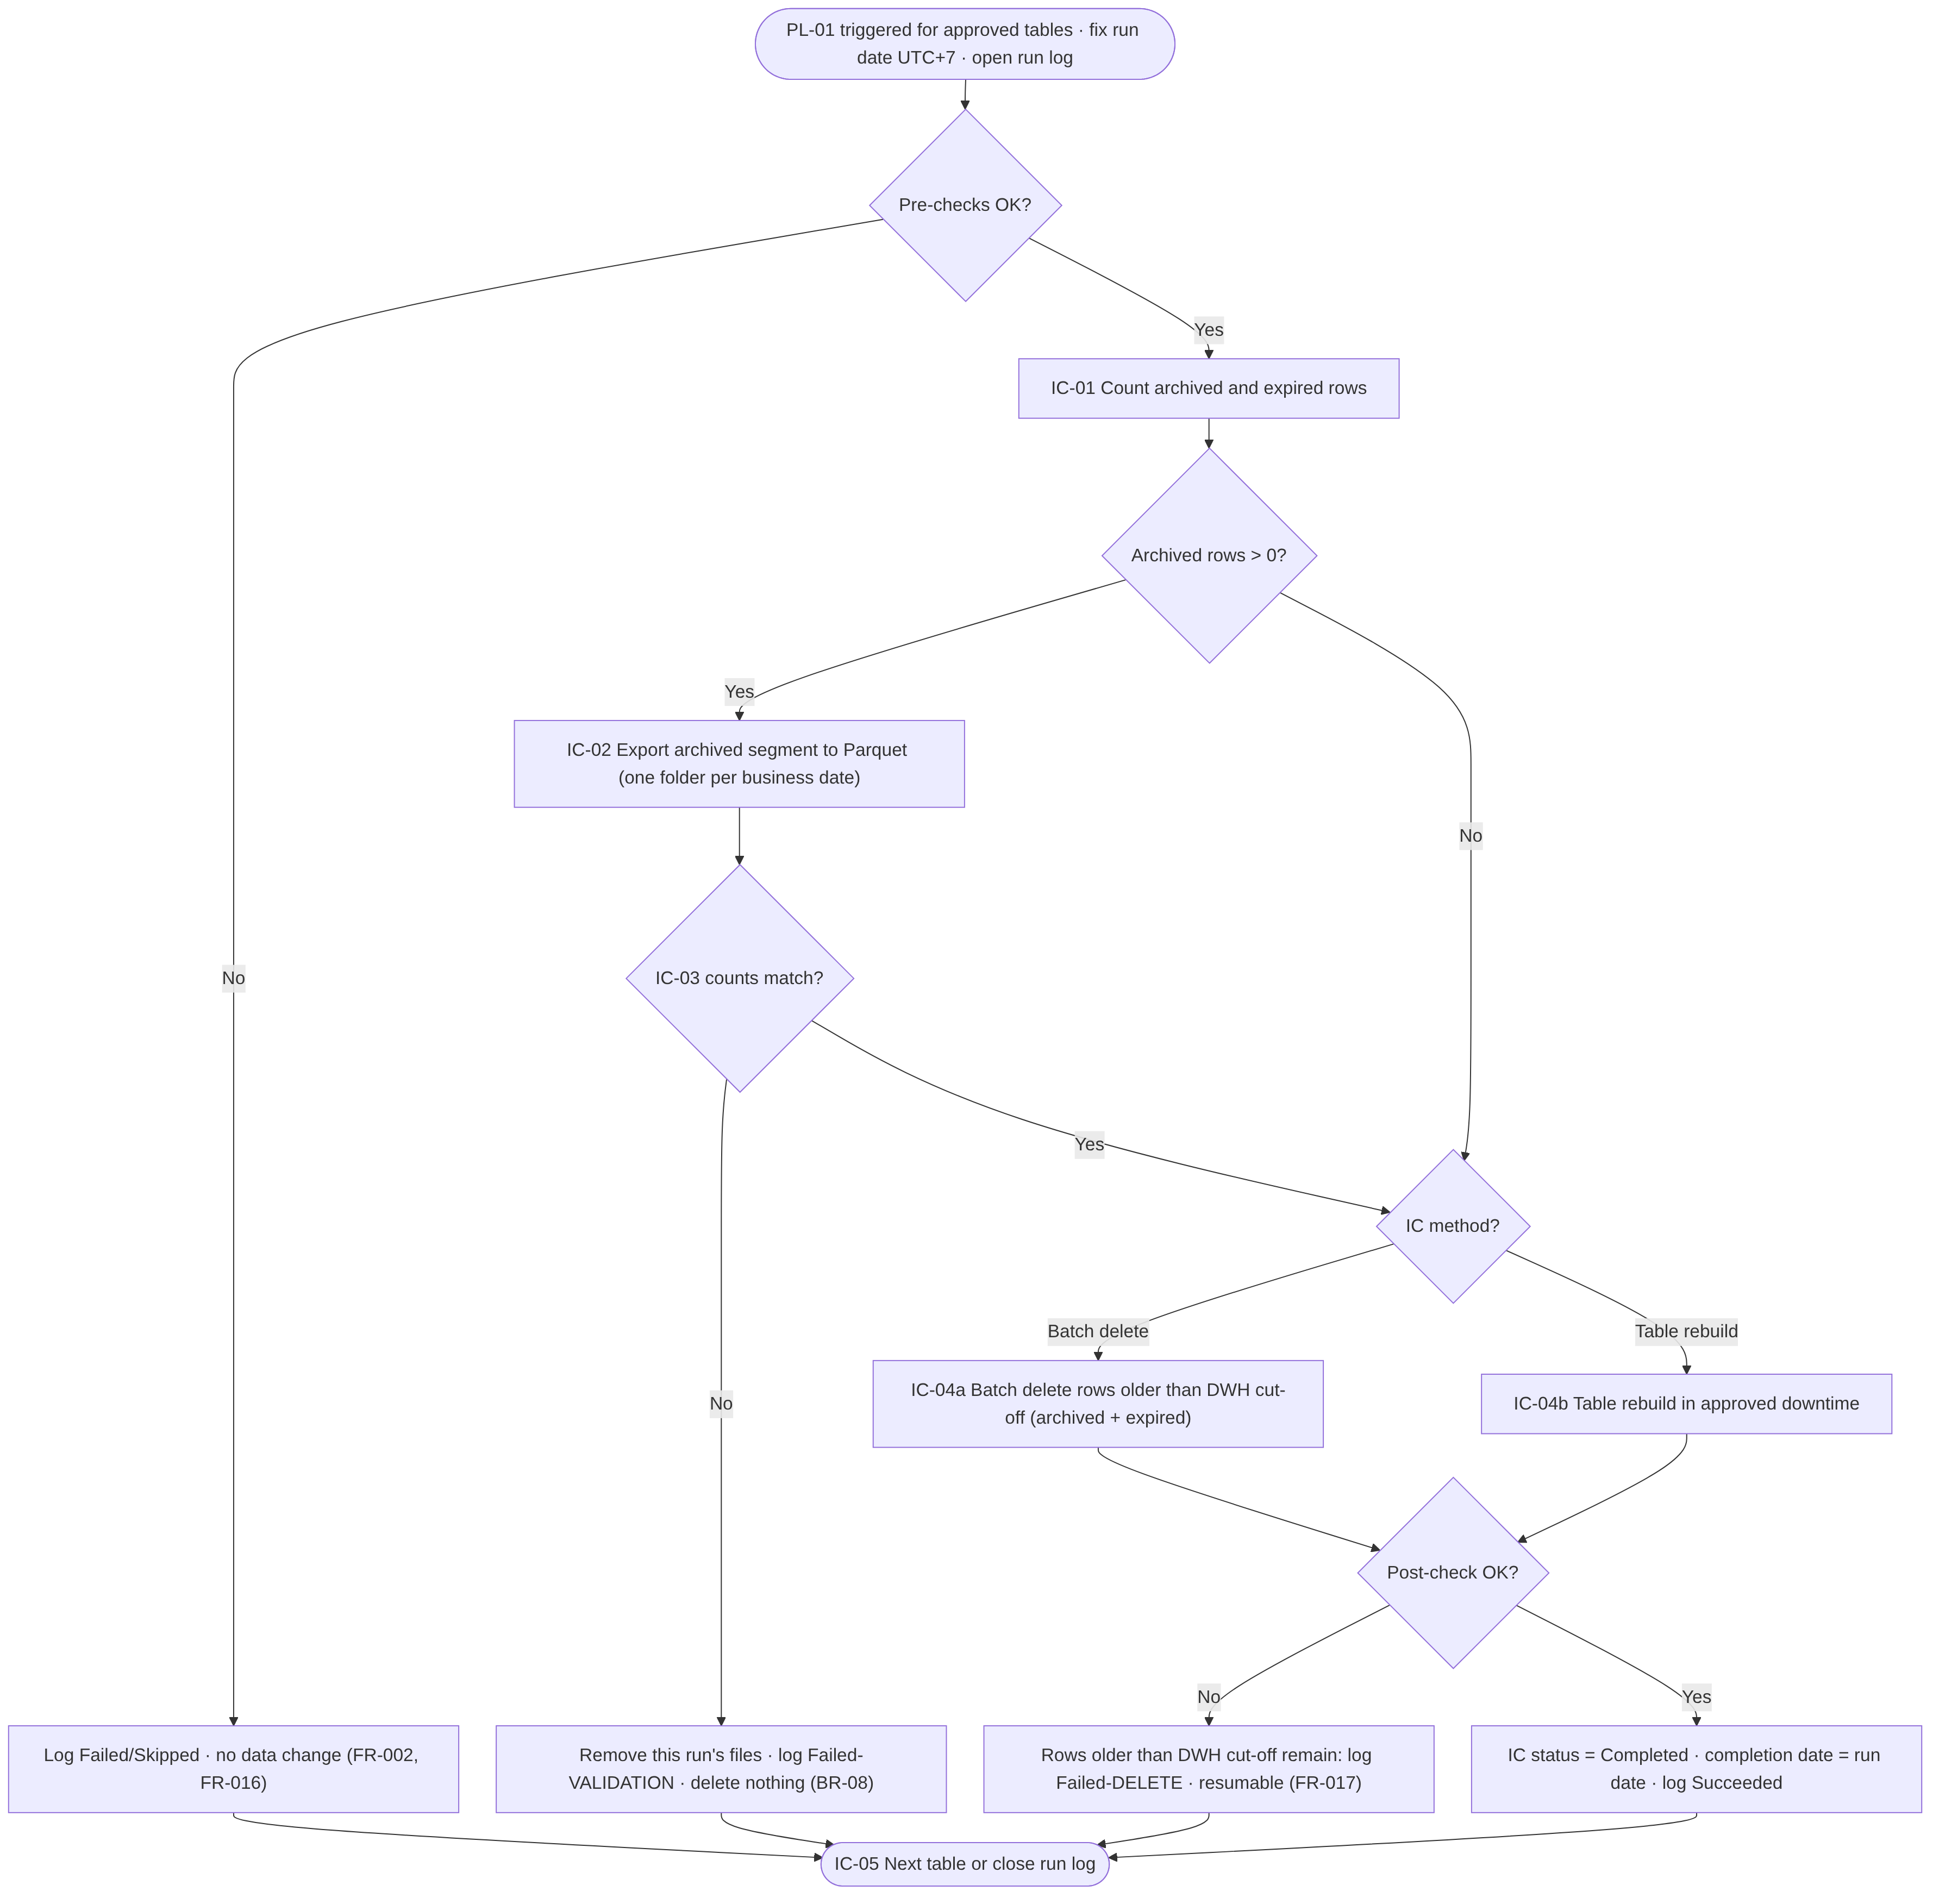
Figure 4 Initial Cut-off Run – functional process flow (per table)
The flow is executed by PL-01 for each table in the supplied list, sequentially. The IC step identifiers from the BRD are shown in the boxes.
1. Process ID and Name | PRC-02 Initial Cut-off Run
2. Process Objective | Archive the archived segment of a table once, then remove all data older than the DWH cut-off date, including expired data (BRD 5.2).
3. Trigger and Execution Frequency | Manual or one-time trigger of PL-01 within 21:00–05:00 UTC+7 (BR-17). Once per table (BR-12); repeated only after a failure or stop.
4. Preconditions | PRC-01 complete; Initial Cut-off status ∈ {Pending, Failed, Stopped}; valid backup confirmed (R-02); ETL Owner agreement; for Large tables all Small/Medium tables Completed and downtime reference supplied (DBR-05); transaction-log plan agreed with the DBA (R-06).
5. Required Inputs | Table list, optional run date, downtime reference, configuration, global parameters.
6. Processing Steps | Normal flow:  1. SP-01: fix RunDate, create run record.  2. SP-02: validate the table list (FR-004).  3. For each table: SP-03 acquires the lock, runs V-01 to V-09, checks for a pending resume, records counts per business date (IC-01).  4. If archived count > 0: export each business date (IC-02, FR-006).  5. SP-04: validate per date and in total (IC-03, FR-008).  6. Deletion (IC-04): method Batch delete → SP-05 with range col < DwhCutoffDate; method Table rebuild → SP-06 (Section 8.4).  7. SP-07: post-check (no rows < DwhCutoffDate; retained count unchanged); set status Completed and completion date.  8. SP-08: close table log, release lock (IC-05).  9. SP-09: close run record after the last table.  Exception flow:  E1. Pre-check failure → Failed/Skipped, no change (step 3).  E2. Export failure → own files removed, Failed, nothing deleted.  E3. Validation failure → own files removed, Failed, nothing deleted (including expired data).  E4. Window end reached → Stopped (FR-019).  E5. Delete/rebuild failure → Failed; resumable (FR-017) or original unchanged (rebuild before swap).
7. Decision Points | D1 Pre-checks pass? D2 Pending resume? D3 Archived count > 0? D4 Counts match? D5 Method = Batch delete or Table rebuild? D6 Window end reached? D7 Post-check passed?
8. Business Rules | BR-03, BR-05, BR-08, BR-09, BR-10, BR-11, BR-12, BR-16, BR-17, DBR-02, DBR-03, DBR-05, DBR-06, DBR-13
9. Data Validation | V-01 to V-09; per-date and total row-count validation; pre-delete recount; post-check of remaining rows and retained count.
10. Output | Parquet folders from ArchiveCutoffDate to the day before DwhCutoffDate; reduced DWH table; status Completed.
11. Error Handling | Section 13. A failed table never blocks other tables in the list.
12. Logging and Monitoring | Run, table and step log records; per-date export and validation details; batch progress.
13. Postconditions | Table contains only rows with business date ≥ DwhCutoffDate; Parquet row count equals rows removed for the archived range (AC-03, AC-04).
14. Acceptance Criteria | AC-03, AC-04, AC-05, AC-14; TS-012 to TS-019.
Table 42 PRC-02 Initial Cut-off Run – process specification
Pseudocode – Initial Cut-off Run per table (PL-01 / PL-03 with stored procedures):
runDate = toDateUtc7(triggerTimeUtc) -- FR-003, fixed for whole run
FOR EACH t IN validatedTableList(runDate) SEQUENTIAL: -- FR-004
IF NOT acquireLock(t, runId) THEN log(t, SKIPPED, ERR-LCK-01); CONTINUE
chk = validate(t, mode='IC') -- V-01..V-09
IF chk.failed THEN log(t, FAILED, chk.err); release(t); CONTINUE
resumePendingDeletion(t) -- FR-017
dwhCut = DATEADD(YEAR, -t.dwhYears, runDate)
arcCut = DATEADD(YEAR, -t.totalYears, runDate)
snap = countPerDate(t, col >= arcCut AND col < dwhCut) -- IC-01
expired = count(t, col < arcCut); retained = count(t, col >= dwhCut)
IF snap.total > 0 THEN
FOR EACH d IN snap.dates ASC:
IF now() >= windowEnd THEN removeRunFiles(t, runId); log(t, STOPPED); GOTO next
res = copyToParquet(t, d, path(t, d, runId)) -- IC-02
IF res.failed THEN removeRunFiles(t, runId); log(t, FAILED, ERR-EXP-01); GOTO next
IF NOT validate(snap, copyResults) OR recount(t) <> snap.total THEN -- IC-03
removeRunFiles(t, runId); log(t, FAILED, ERR-VAL-01); GOTO next
markValidated(t, range=(arcCut, dwhCut), exported=snap.total)
IF t.method = 'Batch delete' THEN batchDelete(t, col < dwhCut) -- IC-04 incl. expired
ELSE tableRebuild(t, keep col >= dwhCut, downtimeRef)
IF count(t, col < dwhCut) = 0 AND count(t, col >= dwhCut) = retained
THEN setIcCompleted(t, todayUtc7()); log(t, SUCCEEDED) -- IC-05
ELSE log(t, FAILED, ERR-DEL-02)
next: release(t)

8.3 PRC-03 Daily Routine
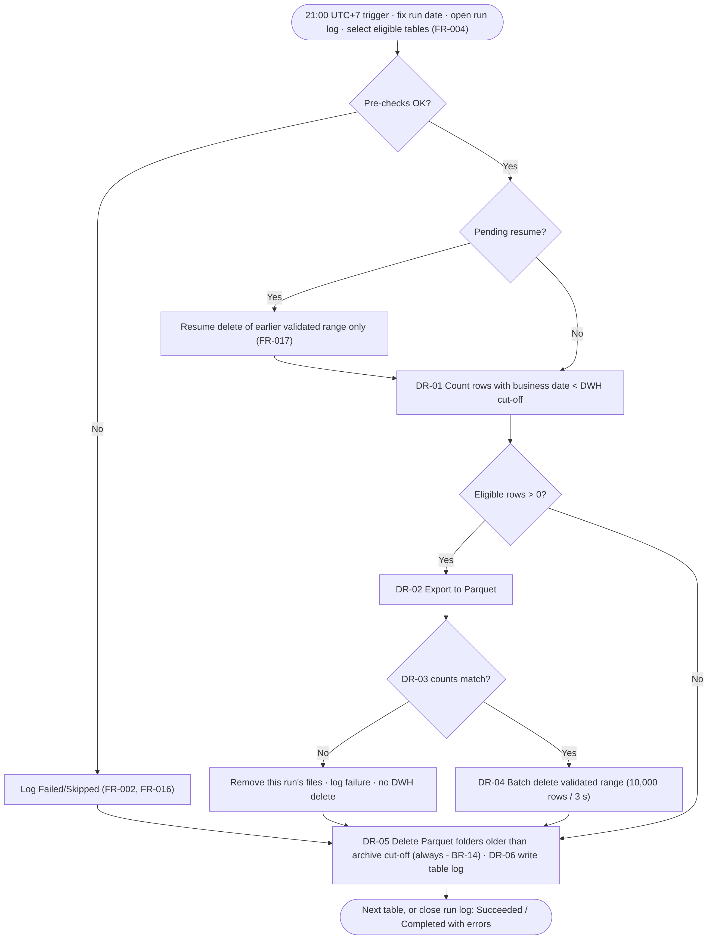
Figure 5 Daily Routine – functional process flow (per table)
PL-02 runs the flow for each selected table. DR-05 (expired archive deletion) and DR-06 (logging) are executed for every table that passed V-05 and V-06, whatever happened earlier in the flow.
1. Process ID and Name | PRC-03 Daily Routine
2. Process Objective | Keep each table within the rolling retention window every day: archive and delete newly eligible data and delete expired archive files (BRD 5.3).
3. Trigger and Execution Frequency | ADF schedule trigger every day at 21:00 UTC+7 (BR-18).
4. Preconditions | Trigger activated per FR-020; tables selected per FR-004.
5. Required Inputs | Configuration, global parameters, last table log per table (resume).
6. Processing Steps | Normal flow:  1. SP-01: fix RunDate, create run record.  2. SP-02: select tables (Active, IC Completed, completion date < RunDate).  3. For each table: SP-03 lock, V-01 to V-09, resume (FR-017).  4. DR-01: count eligible rows per business date (col < DwhCutoffDate). If 0 → step 8.  5. DR-02: export each business date (normally one date per day).  6. DR-03: validate per date, total and recount.  7. DR-04: SP-05 batch delete of the validated range.  8. DR-05: PL-04 deletes folders with business date < ArchiveCutoffDate.  9. DR-06: SP-08 table log, release lock.  10. SP-09 closes the run record.  Exception flow:  E1. Pre-check failure → skip steps 4–7, run step 8 if V-05/V-06 passed, log Failed.  E2. Export failure → own files removed; continue at step 8.  E3. Validation failure → own files removed, no deletion; continue at step 8 (BR-14).  E4. Delete failure → Failed, resumable next day; step 8 still executed.  E5. Expired deletion failure → Failed for step 8; retried automatically next day.
7. Decision Points | D1 Pre-checks pass? D2 Pending resume? D3 Eligible rows > 0? D4 Counts match? D5 Folder older than archive cut-off?
8. Business Rules | BR-03 to BR-08, BR-10, BR-12, BR-14, BR-18, DBR-02, DBR-04, DBR-06 to DBR-10, DBR-12
9. Data Validation | V-01 to V-09 (V-04 per OQ-14); per-date and total count; pre-delete recount; post-delete remaining-row check.
10. Output | New Parquet folders; rows removed from the DWH; expired folders removed; logs.
11. Error Handling | Section 13. One table's failure never stops other tables.
12. Logging and Monitoring | Run, table, step records; ADF pipeline marked failed when any table failed [REC].
13. Postconditions | Each successfully processed table has no rows with business date < DwhCutoffDate and no archive folder with business date < ArchiveCutoffDate.
14. Acceptance Criteria | AC-07, AC-08, AC-15, AC-16; TS-020 to TS-028.
Table 43 PRC-03 Daily Routine – process specification
Pseudocode – batch delete (SP-05):
-- parameters: @Table (validated, quoted), @Col, @Lower DATE NULL, @Upper DATE,
-- @BatchSize INT = GP-01 (10,000), @PauseSec INT = GP-02 (3), @WindowEnd TIME NULL
SET @total = 0;
WHILE 1 = 1
BEGIN
-- each statement is its own autocommit transaction
DELETE TOP (@BatchSize) FROM <table>
WHERE <col> < @Upper AND (@Lower IS NULL OR <col> >= @Lower);
SET @rc = @@ROWCOUNT; SET @total += @rc;
EXEC logProgress @RunId, @TableId, @total; -- interval TBD
IF @rc < @BatchSize BREAK;
IF @WindowEnd IS NOT NULL AND CAST(DATEADD(HOUR,7,SYSUTCDATETIME()) AS time) >= @WindowEnd
BEGIN EXEC logStatus 'STOPPED'; RETURN; END -- FR-019 (IC only)
WAITFOR DELAY <@PauseSec as hh:mm:ss>;
END
-- on error 1205 (deadlock) / 1222 (lock timeout): retry the batch up to GP-09 times

8.4 Table Rebuild Procedure (part of PRC-02)
The rebuild sequence is shown in Figure 7 (Section 12.2). It is executed by SP-06 only during an Initial Cut-off Run, only for tables with method Table rebuild, and only after IC-03 validation passed.
Step | Activity | Control
RB-01 | Confirm preconditions: downtime reference, ETL writes stopped, backup confirmed, dependent-object review completed, space available. | Operator checklist; downtime reference is a mandatory PL-01 parameter for Large tables.
RB-02 | Script the full definition of the original table: columns (types, nullability, defaults, identity with current value, computed columns), primary key, unique and check constraints, outgoing foreign keys, clustered and non-clustered indexes (including filters, included columns, compression, filegroup), triggers, permissions, extended properties. | Definition snapshot stored for verification.
RB-03 | Create the new table under a temporary name with the same definition. Non-clustered indexes may be created after the load [REC]. | Name pattern TBD.
RB-04 | Insert rows with col >= DwhCutoffDate from the original table (identity values preserved). | Recovery-model-dependent logging; plan with DBA (R-06, OQ-24).
RB-05 | Validate: count in new table = retained count of the original. | Mismatch → drop new table, ERR-RBD-01.
RB-06 | In one short transaction: rename the original table to a backup name, rename the new table to the original name, rename constraints and indexes to the original names. | Rollback on any error, ERR-RBD-02.
RB-07 | Re-apply permissions and triggers; recreate or re-point dependent objects per the approved script (OQ-11). | Error → ERR-RBD-03, DBA manual procedure.
RB-08 | Verify that the definition matches the snapshot of RB-02. | Difference → ERR-RBD-03.
RB-09 | Keep the backup table until sign-off or drop it immediately, per DEC-08. | Decision pending.
Table 44 Table rebuild steps
Open point: Tables referenced by foreign keys from other tables, schema-bound views, replication, change data capture or change tracking cannot be swapped by simple renaming. Such cases must be identified in the technical assessment and handled by an approved table-specific script or the batch-delete method (OQ-11).

8.5 PRC-04 Expired Archive File Deletion
1. Process ID and Name | PRC-04 Expired Archive File Deletion
2. Process Objective | Remove archive folders whose business date is before the archive cut-off date (DR-05).
3. Trigger and Execution Frequency | Daily Routine, per table, after the DWH steps (always executed when V-05 and V-06 passed).
4. Preconditions | Table root folder known; ArchiveCutoffDate calculated.
5. Required Inputs | Table root folder; ArchiveCutoffDate.
6. Processing Steps | 1. Get Metadata (child items) of the table root folder.  2. Filter folder names matching business_date=yyyy-MM-dd with date < ArchiveCutoffDate (ISO dates compare correctly as strings).  3. For each folder: Get Metadata (child items) to count files; Delete activity (recursive).  4. Log folders and files deleted; log non-matching folder names as warnings.
7. Decision Points | Folder name matches pattern? Business date < ArchiveCutoffDate?
8. Business Rules | BR-14, DBR-12
9. Data Validation | Pattern match and date parse before deletion; no deletion outside the table root folder.
10. Output | Counts of folders and files deleted.
11. Error Handling | Listing/deletion error → retry per Section 13.4; then Failed (ERR-ARC-01). Idempotent: the next run deletes what remains.
12. Logging and Monitoring | Step log: folders deleted, files deleted, warnings.
13. Postconditions | No expired folder remains for the table.
14. Acceptance Criteria | AC-08, SC-03; TS-025, TS-044.
Table 45 PRC-04 Expired Archive File Deletion – process specification
Volume note: In the first Daily Routine after an Initial Cut-off Run, one folder normally expires per day. ADF Get Metadata output is limited in size; the number of folders per table (about 730 for two years of daily folders) is expected to be within limits but must be confirmed in performance testing (RSK-13).

8.6 PRC-05 Rerun and Recovery
1. Process ID and Name | PRC-05 Rerun and Recovery
2. Process Objective | Return a table to a consistent state after a failure without data loss or duplicate archive content.
3. Trigger and Execution Frequency | Automatically at the start of each table processing (resume check); manually by an operator after investigation.
4. Preconditions | Root cause of the failure understood and resolved (manual reruns); no stale lock (or released through SP-10).
5. Required Inputs | Last table log for the table; current DWH counts.
6. Processing Steps | 1. Read the last table log of the table.  2. If validated = Yes and delete not completed: check remaining rows in the validated range ≤ exported rows; delete the remaining rows of that range only (no export).  3. Mark the earlier range completed; continue with normal processing of the current run.  4. For Initial Cut-off Run tables with status Failed or Stopped before validation: the next run starts from IC-01 (the earlier files were already removed).  5. For a table rebuild that failed before the swap: rerun from IC-01 is not needed for the archive (resume detects the validated range) and the rebuild is repeated.
7. Decision Points | Pending resume? Remaining ≤ exported? Orphan-file flag set?
8. Business Rules | DBR-06 to DBR-10
9. Data Validation | Remaining-rows check; post-delete check.
10. Output | Completed deletion of the earlier range.
11. Error Handling | Remaining > exported → ERR-VAL-03, manual investigation; nothing deleted.
12. Logging and Monitoring | Resume recorded as a separate step with a reference to the original RunId.
13. Postconditions | No pending resume for the table.
14. Acceptance Criteria | TS-032 to TS-036.
Table 46 PRC-05 Rerun and Recovery – process specification

8.7 PRC-06 Configuration Change
Change | Required behaviour | Source
Add table | Onboarding (PRC-01), own Initial Cut-off Run, Daily Routine from the next day. | BR-12, AC-16
Deactivate table (Active = No) | Not processed from the next run. Behaviour of existing archive folders (expiry continues or stops) is TBC (OQ-07). | BRQ-04, OQ-07
Reactivate table | If the table was inactive for more than one day, rows older than the DWH cut-off date may have accumulated; the next Daily Routine processes them as normal eligible data. Whether a new Initial Cut-off Run is required is TBC (OQ-07). | OQ-07
Remove table | Set Active = No rather than deleting the entry, to keep traceability with the logs [REC]. | BRQ-04
Increase DWH retention | Fewer rows become eligible; already archived and deleted data is not restored to the DWH (no restore requirement in the BRD). | NFR-02, OQ-21
Decrease DWH retention | Next Daily Routine archives and deletes the additional eligible dates. | NFR-02, OQ-21
Change total retention | Next Daily Routine deletes folders per the new archive cut-off; an increase does not restore deleted folders. | NFR-02, OQ-21
Change retention column or blob path | Not allowed after the Initial Cut-off Run without an approved change procedure (risk of inconsistent archive) [REC]. | OQ-22
Table 47 Configuration change behaviour

9. Business Rules

9.1 Business Rules from the BRD
The following rules are stated explicitly in BRD Section 6. Their identifiers are unchanged.
ID | Rule description | Related FR | Condition | Expected behaviour | Exception / boundary | BRD ref.
BR-01 | DWH keeps data within the last three years; configurable. | FR-001, FR-003 | Business date ≥ DWH cut-off date | Row retained | Boundary: business date = cut-off date is retained | BRD 6
BR-02 | Total retention five years; three in DWH, two in Parquet; configurable. | FR-001, FR-006, FR-013 | Archive cut-off ≤ business date < DWH cut-off | Row archived then deleted from DWH | Total must exceed DWH retention (DBR-01) | BRD 6
BR-03 | Cut-off dates = run date − retention periods. | FR-003 | Every run | Dates calculated per table | Leap day: 29 Feb minus years → 28 Feb (Section 10.4) | BRD 6
BR-04 | Run date determined in UTC+7. | FR-003 | Every run | Run date = UTC+7 calendar date at start | Server time zone may differ (DEC-01) | BRD 6
BR-05 | Only the date part of the business date is used. | FR-003, FR-005 | Datetime retention column | Compare with date-typed cut-off | 23:59:59 on the day before cut-off is eligible | BRD 6
BR-06 | Retention column is date/datetime and not NULL. | FR-002 | Each table | Validation V-03, V-04 | datetimeoffset TBC (OQ-13) | BRD 6
BR-07 | Rolling window recalculated daily. | FR-003, FR-012 | Daily Routine | Cut-offs move with run date | – | BRD 6
BR-08 | Delete only after successful validation; in IC also expired data. | FR-008, FR-011 | Before any deletion | No deletion on mismatch | Zero archived rows in IC: DBR-03 | BRD 6
BR-09 | IC deletes expired data without archiving. | FR-011 | IC, business date < archive cut-off | Deleted with archived range | Only after BR-08 satisfied | BRD 6
BR-10 | Table rebuild only in IC; Daily Routine always batch delete. | FR-009, FR-010, FR-012 | Daily Routine | Batch delete regardless of configured IC method | – | BRD 6
BR-11 | Default IC method by size; exceptions per technical assessment. | FR-001, FR-010 | Onboarding | Method recorded in configuration | Size thresholds TBD (D-05, OQ-12) | BRD 6
BR-12 | IC once per table; Daily Routine starts day after all initial ICs; later tables after own IC. | FR-004, FR-020 | Table selection | Status-based eligibility | Completion after midnight: DBR-04 | BRD 6
BR-13 | Tables and columns come from configuration; no auto-detection. | FR-001, FR-002 | Every run | Only configured entries processed | – | BRD 6
BR-14 | Expired Parquet deleted daily, also when validation fails. | FR-013 | Daily Routine | DR-05 always runs | Requires V-05, V-06; inactive tables OQ-07 | BRD 6
BR-15 | Results in log tables; no alerts. | FR-014, FR-015 | Every run | Log records | – | BRD 6
BR-16 | IC: small/medium first, large after downtime determined. | FR-004, FR-010 | Large table IC | Rejected until conditions met (DBR-05) | – | BRD 6
BR-17 | IC within 21:00–05:00 UTC+7, scheduled with ETL Owner. | FR-011, FR-019 | IC execution | Stop at window end | Rebuild not interruptible | BRD 6
BR-18 | Daily Routine starts at 21:00 UTC+7. | FR-012 | Daily | Schedule trigger 21:00 | Overrun → next run queued | BRD 6
Table 48 Business rules from the BRD

9.2 Derived Business Rules (Require Confirmation)
The following rules are not stated in the BRD. They are derived by this FSD to make the BRD requirements implementable and safe. Each requires confirmation before the FSD is baselined.
ID | Rule description | Related FR | Condition | Expected behaviour | Exception / boundary | Basis
DBR-01 | Retention periods are integers; DWH ≥ 1; total > DWH. | FR-001, FR-002 | Configuration entry | Invalid entry rejected | – | BR-01, BR-02
DBR-02 | Run date and cut-off dates are fixed at run start and calculated as UTC + 7 hours (Indonesia has no daylight saving). | FR-003 | Every run | Same dates for whole run | Run crossing midnight | BR-04, C-03
DBR-03 | IC with zero archived rows may delete expired rows (validation vacuously satisfied). | FR-005, FR-011 | Archived count = 0 | Expired rows deleted | – | BR-08
DBR-04 | Daily Routine includes a table only if run date > IC completion date (UTC+7 calendar date of completion). | FR-004, FR-020 | Table selection | Excluded on completion day | Completion after midnight | BR-12, AC-16
DBR-05 | Large-table IC requires all Small/Medium tables of the initial implementation Completed and a downtime reference. | FR-004, FR-010 | PL-01 with Large table | Rejected otherwise | Tables added later: TBC | BR-16
DBR-06 | Pre-delete recount must equal the validated total. | FR-008 | Before deletion | No deletion on difference | – | BR-08, A-03
DBR-07 | Archive files are never overwritten and carry the RunId. | FR-007 | Every export | New file names | – | BRQ-06
DBR-08 | On export or validation failure, files of the current run are removed. | FR-018 | Failure | Archive returns to prior state | Cleanup failure blocks rerun | BR-08
DBR-09 | A validated but incompletely deleted range is resumed without re-export. | FR-017 | Pending resume | Delete remaining rows only | Remaining > exported → stop | BR-08
DBR-10 | At most one active processing per table. | FR-016 | Table start | Second run skips the table | Stale lock manual release | NFR-08
DBR-11 | Only Active tables are processed, including in the IC. | FR-004 | Selection | Inactive skipped | – | BRD 7.3 Active flag
DBR-12 | Archive folders not matching the naming pattern are never deleted. | FR-013 | Expiry deletion | Warning logged | – | BR-14
DBR-13 | IC stops at window end in a resumable state. | FR-019 | Time ≥ window end | Stopped | Rebuild not interruptible | BR-17
DBR-14 | Deleted total ≠ validated total → warning and reconciliation flag. | FR-009 | After deletion | Flagged for investigation | Deletion not reversible | NFR-08
DBR-15 | A run-date override may not be later than the current UTC+7 date. | FR-003 | Manual run | Rejected otherwise | – | BR-04
Table 49 Derived business rules

10. Data Requirements and Data Processing

10.1 Data Sources and Source Data Objects
The data source is the DWH database on SQL Server on an Azure Virtual Machine. The in-scope tables are those entered in the configuration table by Customer users (TBC-02 resolution). The final list is not part of the BRD. Known examples:
Schema | Table | Retention column | Source | Status
BOS | JTI_SD_BrandDistDetail | dtmDate | BRD 7.3 (example) and Central Configuration slide | Example; to be confirmed in configuration
BOS | JTI_SPV_FSurvey | dtmDate | Central Configuration slide only | Example from supporting material; TBC
TBD | Further in-scope tables | TBD | Table analysis (FR-022) | TBD
Table 50 Known source data objects

10.2 Required Attributes
For each table the process requires only the retention column for selection; all columns of the table are exported unchanged. Column metadata (name, ordinal position, data type, nullability) is read from the SQL Server catalog at run time.

10.3 Data Selection and Filtering Rules
Purpose | Predicate (logical) | Process
Retained segment | col >= DwhCutoffDate | IC post-check, rebuild insert
Archived segment | col >= ArchiveCutoffDate AND col < DwhCutoffDate | IC-01, IC-02
Expired segment | col < ArchiveCutoffDate | IC-04
Eligible (Daily Routine) | col < DwhCutoffDate | DR-01, DR-02, DR-04
Export unit | col >= d AND col < DATEADD(DAY, 1, d) | FR-006
Expired folders | folder business date < ArchiveCutoffDate | DR-05
Table 51 Selection predicates
All predicates use date-typed boundaries against the unmodified column (BR-05). No other filtering is applied: every row of the configured table is subject to retention.

10.4 Cut-off Date Calculation Examples
Run date | DWH cut-off (−3 years) | Archive cut-off (−5 years) | Comment
25 Oct 2026 | 25 Oct 2023 | 25 Oct 2021 | BRD 4.3 example.
28 Feb 2027 | 28 Feb 2024 | 28 Feb 2022 | Rows of 29 Feb 2024 retained.
01 Mar 2027 | 01 Mar 2024 | 01 Mar 2022 | Rows of 28 and 29 Feb 2024 become eligible together.
29 Feb 2028 | 28 Feb 2025 | 28 Feb 2023 | DATEADD maps 29 Feb to 28 Feb; same cut-off as 28 Feb 2028.
01 Mar 2028 | 01 Mar 2025 | 01 Mar 2023 | Normal progression.
Table 52 Cut-off date examples (default retention periods)

10.5 Data Validation
ID | Check | Rule | IC | DR | On failure
V-01 | Object exists | Database, schema and table exist in the catalog. | Yes | Yes | ERR-CFG-01
V-02 | Retention column exists | Column exists in the table. | Yes | Yes | ERR-CFG-02
V-03 | Data type | date, datetime, datetime2 or smalldatetime. datetimeoffset excluded pending OQ-13. | Yes | Yes | ERR-CFG-03
V-04 | No NULL values | IC: COUNT of NULL values = 0. DR: column nullability check; data check approach TBC (OQ-14). | Yes (full) | TBC | ERR-CFG-04
V-05 | Retention periods | DBR-01. | Yes | Yes | ERR-CFG-05
V-06 | Blob path | Present, well-formed, unique across entries. | Yes | Yes | ERR-CFG-06
V-07 | IC method / eligibility | Method valid; selection rules of FR-004. | Yes | n/a | ERR-CFG-07
V-08 | Parquet compatibility | No column type or column name unsupported by the ADF Parquet format (exact list to be confirmed in a proof of concept). | Yes | Yes (metadata only) | ERR-CFG-08
V-09 | No blocking flag | No orphan-file flag (FR-018) and no integrity flag outstanding. | Yes | Yes | ERR-CFG-09
Table 53 Validation checks

10.6 Configuration Table (Logical Specification)
Physical table and column names are TBD (the Central Configuration slide shows dbo.DataRetentionConfig with columns SchemaName, TableName, RetentionColumn, RetentionYears and isActive; this is supporting material and not adopted, see Appendix A, SCR-02).
ID | Attribute | Description | Logical type | Mandatory | Maintained by | Source
CFG-01 | Database name | Database containing the table | Text | Yes | Customer users | BRD 7.3
CFG-02 | Schema name | Schema of the table | Text | Yes | Customer users | BRD 7.3
CFG-03 | Table name | Table under retention | Text | Yes | Customer users | BRD 7.3
CFG-04 | Retention column | Business date column (date/datetime, no NULLs) | Text | Yes | Customer users | BRD 7.3
CFG-05 | DWH retention (years) | Years kept in the DWH; default 3 | Integer | Yes | Customer users | BRD 7.3
CFG-06 | Total retention (years) | Years kept in total; default 5 | Integer | Yes | Customer users | BRD 7.3
CFG-07 | Blob path | Table root folder in the archive container | Text | Yes | Customer users | BRD 7.3
CFG-08 | Initial Cut-off Run method | Batch delete / Table rebuild | Code | Yes | Customer users | BRD 7.3
CFG-09 | Active flag | Whether the table is processed | Yes/No | Yes | Customer users | BRD 7.3
CFG-10 | Size category | Small / Medium / Large from the technical assessment | Code | Yes | Customer users | [DER] BR-11, BR-16
CFG-11 | Initial Cut-off status | Pending / Running / Failed / Stopped / Completed | Code | Yes | System only | [DER] DEC-02
CFG-12 | Initial Cut-off completion date | UTC+7 date of completion | Date | No | System only | [DER] DEC-02
CFG-13 | Table identifier | Surrogate key referenced by logs | Integer | Yes | System | [DER]
CFG-14 | Change audit attributes | Created/modified by and at | Text/Datetime | Yes | System | [REC] SEC-08
Table 54 Configuration table attributes
Whether system-only attributes (CFG-11, CFG-12) are stored in the configuration table or in a separate status table is part of DEC-02. A separate table keeps Customer-maintained and system-maintained data apart [REC].

10.7 Global Processing Parameters
ID | Parameter | Value | Source
GP-01 | Batch size | 10,000 rows; adjustable | BRQ-08
GP-02 | Pause between batches | 3 seconds; adjustable | BRQ-08
GP-03 | Time zone | UTC+7 (ADF trigger time zone “SE Asia Standard Time”; SQL: UTC + 7 hours) | BR-04, C-03
GP-04 | Initial Cut-off Run window start | 21:00 | BR-17
GP-05 | Initial Cut-off Run window end | 05:00 | BR-17
GP-06 | Daily Routine start time | 21:00 (trigger setting) | BR-18
GP-07 | Table parallelism | TBD (1 proposed) | OQ-16
GP-08 | Export date parallelism | TBD (to be set by performance testing) | OQ-16
GP-09 | Retry count for deadlock / lock timeout per batch | TBD | Section 13.4
GP-10 | Lock timeout for delete statements | TBD | OQ-24
GP-11 | Archive container | TBD | D-02
Table 55 Global processing parameters
Storage of global parameters (settings table versus ADF global parameters) is DEC-09. A settings table allows adjustment of GP-01 and GP-02 without redeploying ADF [REC].

10.8 Log Tables (Logical Specification)
BRD 7.4 requires the attributes marked [BRD]; the others are derived. Physical names are TBD.
ID | Run log attribute | Description | Source
LOG-R-01 | RunId | Unique identifier of the execution (ADF run ID or generated) | [DER]
LOG-R-02 | Process type | Initial Cut-off Run / Daily Routine / Validation | [BRD]
LOG-R-03 | Run date | UTC+7 run date | [BRD]
LOG-R-04 | Trigger type / triggered by | Schedule or manual; operator identity for manual runs | [DER] SEC-08
LOG-R-05 | Start time, end time | UTC+7 timestamps | [BRD]
LOG-R-06 | Status | Running / Succeeded / Completed with errors / Failed | [BRD]
LOG-R-07 | Tables selected / succeeded / failed | Counters | [DER]
Table 56 Run log attributes
ID | Table log attribute | Description | Source
LOG-T-01 | RunId, table identifier | Links to run and configuration | [DER]
LOG-T-02 | Process type | As run | [BRD]
LOG-T-03 | Run date | As run | [BRD]
LOG-T-04 | DWH cut-off date | Calculated | [BRD]
LOG-T-05 | Archive cut-off date | Calculated | [BRD]
LOG-T-06 | Number of eligible rows | Snapshot total (IC: archived + expired, shown separately) | [BRD]
LOG-T-07 | Number of rows exported | Sum of rows written | [BRD]
LOG-T-08 | Number of rows deleted from the DWH | Total deleted (or removed by rebuild) | [BRD]
LOG-T-09 | Number of archive files deleted | From PRC-04 | [BRD]
LOG-T-10 | Execution status | Succeeded / NoData / Failed / Skipped / Stopped | [BRD]
LOG-T-11 | Start time, end time | UTC+7 | [BRD]
LOG-T-12 | Error code, error details | Where applicable | [BRD]
LOG-T-13 | Validated flag, validated range, delete status | Resume control (FR-017) | [DER]
LOG-T-14 | Method used | Batch delete / Table rebuild | [DER]
LOG-T-15 | Retained rows before / after (IC) | AC-03 verification | [DER]
Table 57 Table log attributes
ID | Step log attribute | Description | Source
LOG-S-01 | RunId, table identifier, step code | Step code e.g. VALIDATE, COUNT, EXPORT, VALIDATE-ARCHIVE, DELETE, REBUILD, EXPIRE, RESUME | [DER]
LOG-S-02 | Business date | For export and validation steps | [DER]
LOG-S-03 | Expected rows, rows read, rows written | Per business date | [DER]
LOG-S-04 | File path(s) | Written or deleted | [DER]
LOG-S-05 | Batches, rows processed | Batch delete progress | [DER]
LOG-S-06 | Status, start/end time, error | Per step | [DER]
Table 58 Step log attributes

10.9 Data Transformation, Retention and Deletion Rules
- Transformation – none. Rows are copied as-is. SQL Server types are mapped to Parquet types by ADF; precision of datetime2, decimal and Unicode text must be verified in a proof of concept (TS-042).
- Archival rules – archived segment only (BR-02); one folder per business date (FR-007).
- Deletion rules – DWH deletion only after validation (BR-08); batch delete in the Daily Routine (BR-10); table rebuild only in the Initial Cut-off Run; expired archive folders deleted daily (BR-14).
- Retention of the logs themselves – not defined in the BRD (OQ-20).

10.10 Data Reconciliation and Data Quality Controls
Control | Formula | When
Export completeness | Σ rows written = Σ expected rows (per date and total) | After export
Pre-delete stability | Recount in validated range = validated total | Before deletion
Deletion completeness (DR) | Rows deleted = rows exported; remaining in range = 0 | After deletion
Deletion completeness (IC) | Rows deleted = archived count + expired count; remaining < DWH cut-off = 0 | After deletion
Retained data unchanged (IC) | Retained count after = retained count before | IC post-check (AC-03)
Archive coverage (IC) | Folders exist for every business date with archived rows between ArchiveCutoffDate and DwhCutoffDate − 1 | IC post-check (AC-04)
Archive expiry | No folder with business date < ArchiveCutoffDate | After DR-05 (AC-08)
Table 59 Reconciliation controls

10.11 Data Lineage
Each archived row can be traced from its DWH table (configuration entry, CFG-13) to a business-date folder and a file whose name carries the RunId, and to the run, table and step log records of that RunId. Deletion of the row from the DWH and later deletion of the folder are recorded under the RunIds of the respective runs.

10.12 Processing Frequency and Expected Data Volume
Initial Cut-off Run: once per table. Daily Routine: once per day. Expected data volumes (rows per table, rows per business date, archive size) are not available in the BRD and are TBD; they are an input to the technical assessment (D-05) and performance testing.

11. Interface and Integration Specifications
All interfaces are internal to the Customer Azure environment. Endpoints, credentials and Integration Runtime details are TBD and are not recorded in this document (SEC-06).
Attribute | INT-01 ADF ↔ DWH (control) | INT-02 DWH → Blob (archive export) | INT-03 ADF → Blob (list and delete)
Source system | ADF | DWH (SQL Server on Azure VM) | ADF
Target system | DWH | Azure Blob Storage | Azure Blob Storage
Description | Read configuration, call stored procedures SP-01 to SP-10, write logs | Copy eligible rows per business date to Parquet | List business-date folders; delete expired folders and failed-run files
Integration method | ADF Lookup and Stored Procedure activities through the Integration Runtime | ADF Copy activity (SQL Server source, Parquet sink) | ADF Get Metadata and Delete activities
Input / output | Parameters per Section 10; result sets with table lists and counts | Rows → Parquet files | Folder list → deletion result
Data contract | Stored procedure signatures (to be defined in the technical design) | All table columns, ordinal order, ADF type mapping | Folder pattern business_date=yyyy-MM-dd
Execution trigger | PL-01 / PL-02 | PL-03 | PL-03 (cleanup), PL-04
Scheduling | Daily 21:00 UTC+7; IC manual | As above | As above
Authentication / authorisation | TBD (OQ-17); least privilege SEC-02 | TBD (OQ-17) | Managed identity with container-scoped role proposed [REC]
Timeout and retry | Activity timeout and retry TBD (Section 13.4) | TBD | TBD
Error handling | Section 13 | Section 13 | Section 13
Reconciliation | – | Section 10.10 | Counts of folders and files deleted
Dependencies | D-01 | D-01, D-02 | D-02
Table 60 Interface specifications
ID | Interface | Description
INT-04 | Customer users → configuration table | Manual maintenance of configuration entries (tool TBD).
INT-05 | Operator → ADF | Manual triggering of PL-01 and reruns; activation of the Daily Routine trigger.
INT-06 | Operations team → log tables | Read-only queries (FR-015).
Table 61 Manual interfaces

12. Processing Flow and Sequence Diagrams
The business-level and functional process flows of the Initial Cut-off Run and the Daily Routine are shown in Figure 4 and Figure 5 (Section 8). This section adds the interaction, state and exception views.

12.1 Daily Routine – Sequence Diagram
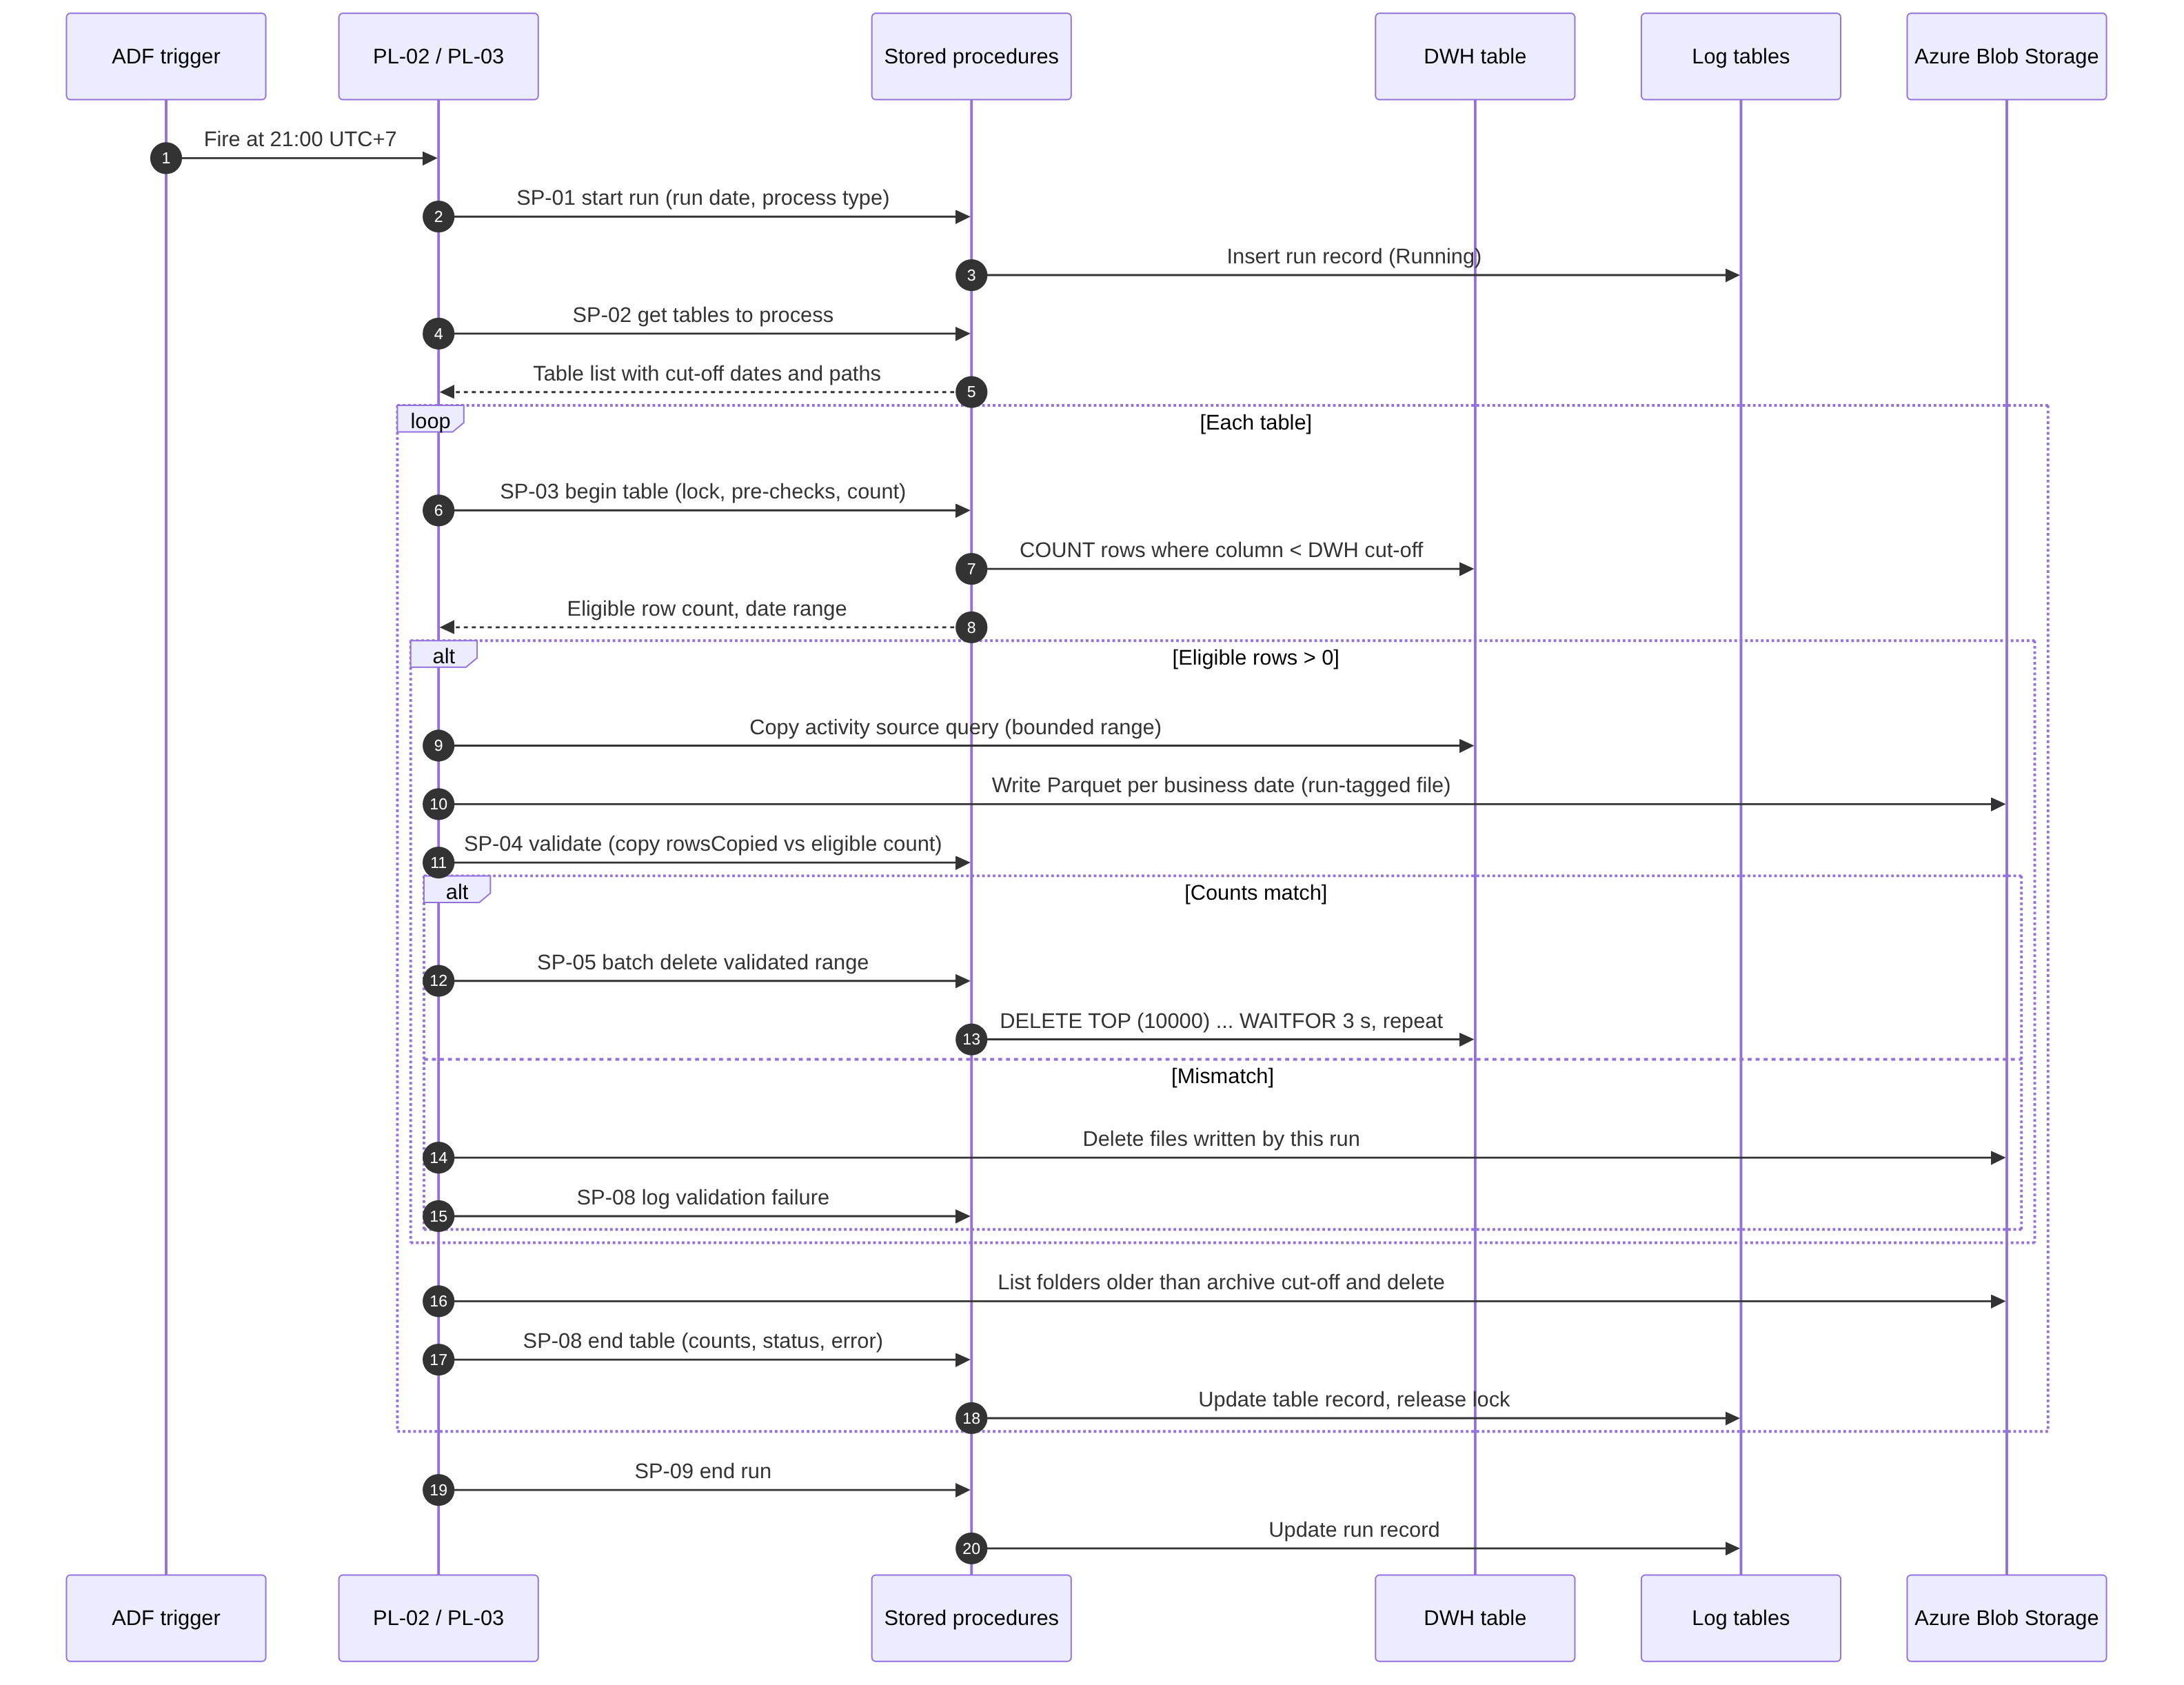
Figure 6 Daily Routine – sequence of interactions for one run
The sequence shows the order of calls between the trigger, the pipelines, the stored procedures, the DWH table, the log tables and the archive. Deletion is reached only through the “counts match” branch. Expired folder deletion is executed for every table after the DWH branch.

12.2 Table Rebuild – Sequence Diagram
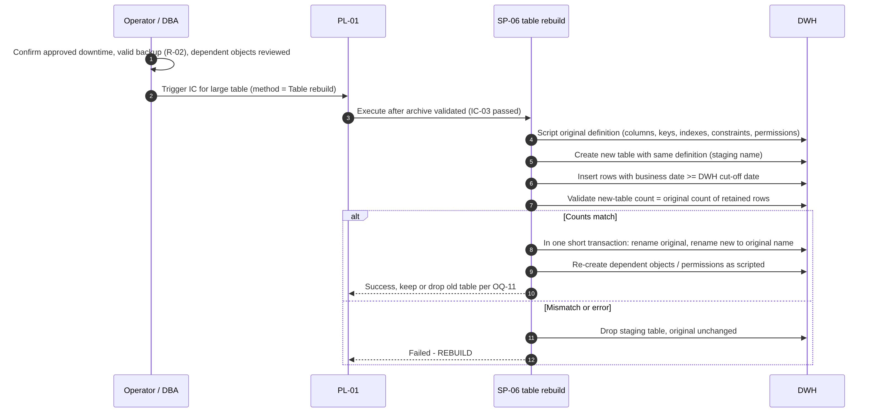
Figure 7 Table rebuild – sequence (Initial Cut-off Run, method Table rebuild)
The original table remains unchanged until the swap transaction. Any failure before the swap leaves the original table intact.

12.3 Initial Cut-off Status – State Diagram
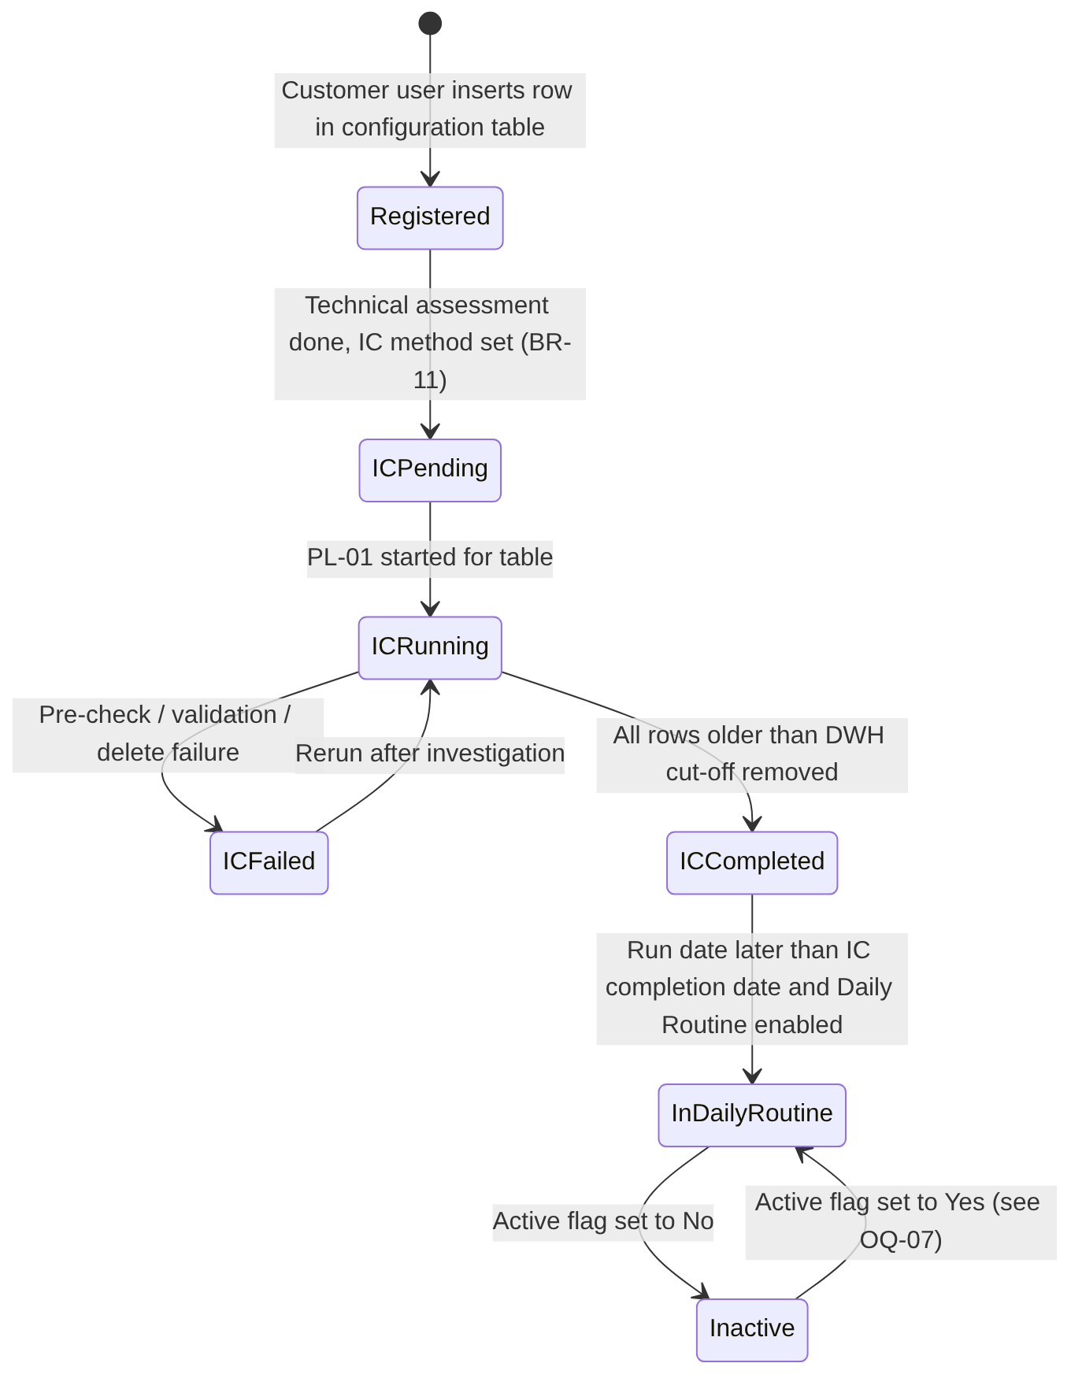
Figure 8 Initial Cut-off status lifecycle per table
The state determines whether a table can be processed by the Initial Cut-off Run and when it enters the Daily Routine (FR-004, FR-020). The Stopped state (window end, FR-019) behaves like Failed for selection purposes and is omitted from the figure for readability.

12.4 Restart and Recovery – Decision Flow
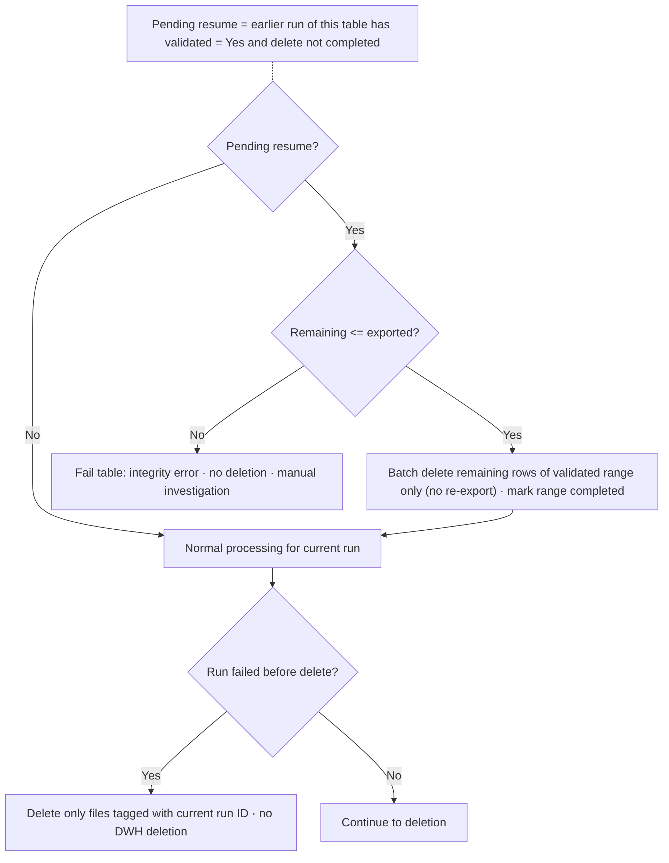
Figure 9 Restart and recovery decision flow (FR-017, FR-018)
At the start of every table processing, the resume check completes any deletion that was validated but not finished, without exporting again. During the current run, a failure before deletion removes only the files tagged with the current RunId.

13. Error Handling and Recovery

13.1 Error Categories and Codes
Error codes are proposed by this FSD [DER]. The table status set by each error is recorded in the table log; the run continues with the next table unless stated otherwise.
Code | Category | Description | Detection | Handling | Data change
ERR-CFG-01..09 | Configuration / metadata | Validation checks V-01 to V-09 failed | SP-03 | Table Failed or Skipped | None
ERR-LCK-01 | Concurrency | Table lock held by another run | SP-03 | Table Skipped | None
ERR-SYS-01 | Database / connectivity | Query, procedure or connection failure after retries | ADF activity failure | Table Failed | None, or resumable state
ERR-SYS-02 | Run date | Run-date override later than current UTC+7 date | SP-01 | Run rejected | None
ERR-EXP-01 | Export | Copy activity failed after retries | ADF | Own files removed; Failed | None
ERR-EXP-02 | Export | Target file already exists | ADF | Own files removed; Failed | None
ERR-EXP-03 | Export cleanup | Own files could not be removed | ADF | Orphan flag; later runs blocked (V-09) | Archive contains orphan files
ERR-VAL-01 | Validation | Per-date or total count mismatch | SP-04 | Own files removed; Failed | None
ERR-VAL-02 | Validation | Pre-delete recount differs from validated total | SP-04 | Own files removed; Failed | None
ERR-VAL-03 | Integrity | Resume: remaining rows > exported rows | SP-03 | Failed; manual investigation | None
ERR-DEL-01 | Deletion | Batch delete failed after retries | SP-05 | Failed; resumable | Partial deletion of validated range
ERR-DEL-02 | Post-check | Rows older than DWH cut-off remain, or retained count changed | SP-07 | Failed; investigation | Depends on cause
ERR-DEL-03 | Reconciliation (warning) | Deleted total ≠ validated total | SP-05 | Warning; reconciliation flag | Already deleted
ERR-RBD-01..03 | Table rebuild | Before swap / during swap / after swap failure | SP-06 | See FR-010 | None / none / table swapped
ERR-ARC-01 | Expired archive deletion | Listing or deletion failed after retries | ADF | Step Failed; retried next day | Partial folder deletion possible
ERR-WIN-01 | Window | IC window end reached | ADF / SP-05 | Stopped; resumable | None or partial validated deletion
Table 62 Error categories and codes

13.2 Error Detection
- ADF activity outcomes (success, failure, completion paths) on every activity of PL-01 to PL-04.
- Return codes and result sets of SP-01 to SP-10; stored procedures use TRY…CATCH and return the error number, message and procedure name.
- Count comparisons and post-checks (Section 10.10).

13.3 Error Logging
Every handled error is written to the table log (LOG-T-12) and step log (LOG-S-06) with the error code, the SQL Server or ADF error number and message, and the step. Unhandled ADF failures are visible in ADF monitoring; the run record remains in Running state and must be closed by the operator (Section 16.8).

13.4 Retry Rules
Item | Retry approach | Values
ADF Lookup, Stored Procedure, Copy, Get Metadata, Delete activities | ADF activity retry for transient failures | Retry count and interval TBD [REC: configure non-zero values]
Delete batch (deadlock 1205, lock timeout 1222) | Retry the same batch inside SP-05 | GP-09 TBD
Validation mismatch | No automatic retry (deterministic failure) | –
Table rebuild | No automatic retry | –
Table 63 Retry rules

13.5 Partial Failure Scenarios
Scenario | State after failure | Next run behaviour
Failure during export of some dates | Files of this run removed; DWH unchanged | Full export from the first eligible date
Validation mismatch | Files of this run removed; DWH unchanged | Full export; repeated mismatch requires investigation
Delete interrupted after some batches | Archive complete for validated range; part of the range still in DWH | Resume deletes remaining rows of the range without export (FR-017)
Rebuild failed before swap | Archive validated; original table unchanged | Resume detects validated range; rebuild repeated without export
Rebuild failed after swap | Table swapped; permissions or dependents incomplete | DBA manual procedure; table Failed until verified
Expired folder deletion interrupted | Some expired folders remain | Deleted in the next Daily Routine
Pipeline aborted (infrastructure) | Run record Running; lock held | Operator closes run and releases lock (SP-10) after checking the step log; then resume logic applies
Cleanup of own files failed | Orphan files; flag set | Blocked until manual cleanup
Table 64 Partial failure scenarios

13.6 Duplicate Processing Prevention
- Pipeline concurrency = 1 for PL-01 and PL-02; table lock (FR-016).
- Unique file names with RunId; no overwrite (DBR-07).
- Removal of own files on export or validation failure (DBR-08).
- Resume without re-export for validated ranges (DBR-09).
- Initial Cut-off status prevents a second Initial Cut-off Run for a Completed table (FR-004).

13.7 Restart and Rerun Behaviour
Reruns are always performed by starting the master pipeline again (PL-01 with the affected table list, or PL-02 manually) after the cause has been resolved. There is no restart from the middle of a pipeline run; correctness is guaranteed by the resume check and the idempotent design. A rerun of the Daily Routine for the current day uses the same run date and processes only what is still eligible. A manual run-date override may be used only for an earlier date (DBR-15).

13.8 Operational Escalation
No automated alerts are sent (BR-15, OS-06). Failures are found by the daily log review (R-01). Proposed escalation path: Operations / Support Team → Solution Architect / Data Engineer → Database Administrator (deletion, rebuild, integrity) or Infrastructure Team (connectivity, storage). Named contacts and response times are TBD; during hypercare (until 31 March 2027) the project team supports investigation (BRQ-17).

14. Non-Functional Requirements
BRD ID | Requirement | FSD design response | Verification
NFR-01 | Incremental deletion in batches, no long transactions. | FR-009: autocommit batches of GP-01 rows with GP-02 pause; rebuild limited to IC within downtime. | TS-024
NFR-02 | Retention periods configurable without pipeline changes. | FR-001: CFG-05, CFG-06 per table. | TS-001, TS-007
NFR-03 | Daily Routine without manual intervention. | FR-012 schedule trigger; FR-017 automatic resume. | TS-020, TS-032
NFR-04 | ETL duration ≤ agreed baseline + 10%. | Sequential processing, batch pause, scheduling with ETL Owner. Baseline TBD (D-06). | TS-038
NFR-05 | Critical ETL jobs within processing windows and SLAs. | IC window control (FR-019). Daily Routine has no end time in the BRD (OQ-15). | TS-038
NFR-06 | Report response time degradation ≤ 10% of baseline. | As NFR-04. Baseline TBD (D-06). | TS-038
NFR-07 | No unplanned reporting downtime. | Rebuild only within approved downtime; batch delete online. | TS-039
NFR-08 | No unexplained data loss or inconsistency. | FR-008, FR-016 to FR-018, reconciliation controls (Section 10.10). | TS-012, TS-032, TS-035
Table 65 Non-functional requirements

14.1 Additional Quality Attributes
The BRD does not define numeric targets for the following attributes. The FSD states the expected qualities without inventing thresholds.
Attribute | Expectation | Target
Scalability | Adding tables requires only configuration (FR-001). Run duration grows with the number of tables and eligible dates. | Not defined in BRD (TBD)
Reliability | Fail-safe deletion and automatic resume. | Not defined in BRD
Availability | Daily execution; no availability SLA for the pipeline itself. | Not defined in BRD (no RTO/RPO)
Maintainability | Logical components with single responsibility; parameters in configuration; versioned scripts. | –
Auditability | Run, table and step logs; configuration change audit (SEC-08). | Log retention TBD (OQ-20)
Performance | Duration of each Initial Cut-off Run confirmed by performance testing (BR-17). | Measured against D-06 baseline
Table 66 Additional quality attributes

15. Security and Audit Requirements
The BRD contains no explicit security requirements. The following are recommendations [REC] based on least privilege and the nature of the process (permanent deletion of data). They require review by the DBA and infrastructure team.
ID | Area | Requirement / recommendation | Status
SEC-01 | Authentication | ADF authenticates to SQL Server and to Azure Blob Storage with a dedicated identity. Preference: managed identity where supported; otherwise credentials stored in Azure Key Vault. Method TBD (OQ-17). | REC
SEC-02 | Least privilege – SQL | The ADF principal receives EXECUTE on the retention procedures and SELECT on in-scope tables for export, but no direct DELETE or DDL permission. Because the procedures use dynamic SQL (which breaks ownership chaining), deletion and rebuild permissions are provided through module signing or EXECUTE AS on the procedures. Table rebuild permissions are restricted to SP-06. | REC
SEC-03 | Configuration maintenance | Customer users have INSERT/UPDATE on Customer-maintained configuration attributes only; no permission on system-maintained attributes, log tables or procedures. | REC
SEC-04 | Log access | Operations team has read-only access to log tables. | REC
SEC-05 | Least privilege – storage | The ADF identity has data-plane write and delete rights on the archive container only (e.g. container-scoped Storage Blob Data Contributor). Read access to the archive for other users is restricted and TBD (OQ-19). | REC
SEC-06 | Secrets | No credentials, keys or connection strings in this document, pipeline definitions or scripts. | REC
SEC-07 | Dynamic SQL safety | Object names from configuration are validated against the catalog and quoted with QUOTENAME; values passed as parameters (sp_executesql). | DER
SEC-08 | Audit trail | Configuration changes are audited (who, when, old and new values) through audit columns or a history mechanism [REC]; manual runs record the triggering identity; logs are not modifiable by operators except through SP-10. | REC
SEC-09 | Data in transit | Encrypted connections to SQL Server and HTTPS to Azure Blob Storage. | REC
SEC-10 | Data at rest | Archive protected by Azure Storage encryption at rest; data classification of archived content TBD (OQ-19). | REC
SEC-11 | Segregation of duties | Approval of the Initial Cut-off Run (irreversible deletion) and execution by different persons is recommended; the BRD names one person for all approval roles (OQ-02). | REC
Table 67 Security and audit requirements

16. Scheduling and Operational Requirements

16.1 Execution Schedule
Process | Schedule | Trigger mechanism | Source
Daily Routine (PL-02) | Every day at 21:00 UTC+7 | ADF schedule trigger, time zone SE Asia Standard Time | BR-18, BRQ-10
Initial Cut-off Run (PL-01) | Once per table within 21:00–05:00 UTC+7 on dates agreed with the ETL Owner | Manual trigger or one-time schedule trigger | BR-17, D-04
Large-table rebuild | Within approved downtime inside the IC window | Manual trigger with downtime reference | BR-16, D-07
Table 68 Execution schedule

16.2 Daily Routine Activation
- Confirm from the log tables that every table of the initial implementation has Initial Cut-off status Completed.
- Set the start time of the Daily Routine schedule trigger to 21:00 UTC+7 on the calendar day after the last completion date and start the trigger.
- Record the activation (date, operator) in the project log (format TBD).

16.3 Processing Dependencies and Execution Order
- Initial Cut-off Run: Small and Medium tables before Large tables (BR-16, DBR-05).
- Daily Routine: start only after activation (16.2); tables in ascending table identifier order, sequential by default.
- Within a table: validation → resume → count → export → validate → delete → expired archive deletion → log.
- Initial Cut-off Run of a table added later may overlap with the Daily Routine of other tables at 21:00 (R-10); the table lock prevents overlap on the same table.

16.4 Monitoring
Monitoring is based on the log tables (FR-015) and ADF monitoring. Daily log review by the Operations / Support Team is required (R-01). No dashboards or monitoring integrations are built (OS-06, OS-08).

16.5 Operational Alerts
Not applicable: no automated alert or notification is sent (BR-15, OS-06). Any alerting requirement is subject to separate assessment and approval.

16.6 Manual Intervention
Activity | When | Responsible (BRD Section 3 role)
Configuration entry maintenance | Onboarding and changes | Customer users
Trigger Initial Cut-off Run | Per agreed schedule | Project team with ETL Owner
Confirm backup before Initial Cut-off Run | Before each IC | Database Administrator
Activate Daily Routine trigger | Once | Solution Architect / Data Engineer
Daily log review | Daily | Operations / Support Team
Rerun after failure | After root-cause resolution | Operations / Support Team with Data Engineer
Release stale lock / close stale run (SP-10) | After aborted runs | Data Engineer or DBA (TBC)
Orphan file cleanup | After ERR-EXP-03 | Data Engineer (TBC)
Table 69 Manual intervention activities

16.7 Rerun Procedure
- Identify the failed table and step from the table and step logs.
- Resolve the cause (configuration, connectivity, data, permissions).
- If the run record is still Running or a lock is held, confirm in ADF monitoring that the pipeline is no longer active, then close the run and release the lock with SP-10.
- If an orphan-file flag is set, remove the files of the failed RunId and clear the flag.
- Start PL-01 for the table (Initial Cut-off Run) or PL-02 (Daily Routine) within the allowed time window.
- Verify the result in the logs and with the reconciliation queries.

16.8 Stale Run Handling
A run whose pipeline was aborted outside the handled failure paths keeps status Running. The operator closes it with status Failed and the comment “Closed manually” using SP-10. Automatic closing based on elapsed time is not proposed, because a wrong automatic release could allow concurrent processing.

16.9 Operational Responsibilities
Responsibilities follow BRD Section 3. Names are recorded only where the BRD provides them (Agus Laksono for Business / Data Owner, Project Sponsor, Solution Architect / Data Engineer and Database Administrator). Names for the Business Analyst, ETL / Reporting Team, Infrastructure Team and Operations / Support Team are TBD.

16.10 Project Deliverables Related to Operations
BRD ID | Deliverable | FSD note
BRQ-15 | Documentation covering design, configuration, setup and operational guidance | The operational guide shall contain: Sections 13 and 16 procedures, the monitoring queries of FR-015, the configuration guide (Section 10.6, PRC-06), and the IC checklist (Section 8.4 RB-01).
BRQ-16 | Knowledge transfer sessions for the operations team | Content to cover daily log review, rerun, stale-run handling and configuration changes. Schedule TBD.
BRQ-17 | Hypercare until 31 March 2027 | Start depends on go-live date (R-08). Scope of support per project agreement.
Table 70 Operations-related project deliverables

17. Assumptions, Constraints, Dependencies, and Open Questions

17.1 Assumptions
BRD assumptions (A-nn) are stated in the BRD and are not independently confirmed. FSD assumptions (ASM-nn) are made by this document.
ID | Description | Impact if false | Required decision or clarification | Responsible | Status
A-01 | Retention periods (3 years DWH, 5 years total) agreed by the business. | Wrong data removed. | None (BRD). | Business / Data Owner | BRD assumption
A-02 | Required database and storage access will be provided. | Project delay. | Confirm with D-01/D-02. | Infrastructure Team | BRD assumption
A-03 | Back-dated transactions do not occur. | Rows older than the cut-off could arrive after export; protected by the pre-delete recount (DBR-06). | None. | Business / Data Owner | BRD assumption
A-04 | Retention columns contain no NULL values. | Rows never become eligible; V-04 fails. | None. | Customer users | BRD assumption
A-05 | Daily database backups remain in place. | No recovery from IC deletion (R-02). | None. | DBA | BRD assumption
ASM-01 | Business date values are stored in UTC+7 local time. | Cut-off shifted by the time-zone difference. | OQ-13. | TBD | Open
ASM-02 | The Integration Runtime allows ADF to reach both SQL Server and the storage account. | Design change (e.g. DEC-05). | OQ-17. | Infrastructure Team | Open
ASM-03 | In-scope tables can be read by ADF while ETL is loading (no exclusive locks during the Daily Routine). | Export delays or blocking. | Verify in performance testing. | DBA | Open
ASM-04 | Number of business dates per table in the archived segment (≈ 730) is within ADF Lookup and Get Metadata limits. | Pagination needed (RSK-13). | Verify in testing. | Solution Architect | Open
ASM-05 | No in-scope table is a source of foreign keys from other tables unless identified in the technical assessment. | Batch delete or rebuild fails. | OQ-11. | DBA | Open
Table 71 Assumptions

17.2 Technical Constraints
- C-01 to C-04 from the BRD (Section 4.5).
- No partitioning of in-scope tables (BRD 4.1, C-04): deletion relies on predicate-based batches or rebuild.
- No automated alerting (OS-06).
- Network, Integration Runtime and storage provisioning outside scope (OS-05).

17.3 Dependencies
ID | Description | Impact | Required decision or clarification | Responsible | Status
D-01 | Network connectivity and Integration Runtime | Blocks all integration testing | Delivery date (R-04) | Customer infrastructure team | Open
D-02 | Storage account and container | Blocks export | Container name (OQ-08) | Customer infrastructure team | Open
D-03 | In-scope tables entered in configuration | Blocks IC | Final list | Customer users | Open
D-04 | Scheduling of each IC with ETL Owner | Blocks IC execution | Dates | ETL Owner, project team | Open
D-05 | Technical assessment of size limits and exceptions | IC method undefined | OQ-12 | Project team, Customer | Open
D-06 | Agreed performance baseline | NFR-04/06 unverifiable | OQ-25 | Business / Data Owner, ETL team, DBA | Open
D-07 | Downtime for rebuild of Large tables | Blocks Large-table IC | Downtime per table | ETL Owner, Business / Data Owner | Open
Table 72 Dependencies

17.4 Open Questions
Item ID | Description | Impact | Required decision or clarification | Responsible party | Status
OQ-01 | BRD v0.5 header shows “Draft for Review / Pending approval”, while the approval table contains “Approve” decisions with initials and dates. | The FSD cannot be baselined against a BRD whose approval status is unclear. | Confirm whether BRD v0.5 is approved; if so, update its status (or issue v1.0). | Project Sponsor | Open
OQ-02 | All four approval roles in the BRD are held by one person. | No independent review of irreversible deletion design (SEC-11). | Confirm that this is acceptable and who approves the FSD. | Project Sponsor | Open
OQ-03 | Time zone of the SQL Server VM and SQL Server version are unknown; the slide formula uses GETDATE(). | Wrong run date if the server is not UTC+7. | Confirm VM time zone and SQL Server version; approve DEC-01. | DBA, Solution Architect | Open
OQ-04 | AC-15/AC-16 require per-table Initial Cut-off status, but BRD 7.3 lists only an Active flag. | Cannot implement table eligibility without additional attributes. | Approve DEC-02 (attributes and their location). | Business / Data Owner, Solution Architect | Open
OQ-05 | Restart and resume behaviour is not defined in the BRD. | Risk of archive duplication or data loss on rerun. | Approve FR-017, FR-018 (DEC-06). | Solution Architect, DBA | Open
OQ-06 | AC-07 and SC-01 require 100% of tables to have no data older than the DWH cut-off after each Daily Routine, while BR-08 forbids deletion when validation fails. | Success criteria cannot be met on a day with a validation failure. | Define SC-01/AC-07 measurement excluding tables with a logged validation failure, or define a resolution timeframe. | Business / Data Owner | Open
OQ-07 | Behaviour for inactive tables: should DR-05 continue to delete their expired archive folders? Is a new Initial Cut-off Run needed when a table is reactivated? | Archive files of inactive tables could be kept beyond five years. | Decide expiry and reactivation behaviour. | Business / Data Owner | Open
OQ-08 | Archive container name, blob path convention and folder/file naming are not defined (D-02). | Needed for build and for DR-05. | Approve DEC-04; provide container. | Infrastructure Team, Solution Architect | Open
OQ-09 | How must “number of rows in the Parquet files” be determined? | Copy metrics may not satisfy a literal reading of BRQ-07. | Approve DEC-03. | Business / Data Owner, Solution Architect | Open
OQ-10 | Daily Routine treatment of eligible rows older than the archive cut-off (e.g. after a long outage): export then delete (BRD as written) or delete without archive. | Unnecessary export, or a deviation from BR-09. | Confirm that BRD behaviour (export, then expiry deletion) applies. | Business / Data Owner | Open
OQ-11 | Table rebuild: handling of incoming foreign keys, schema-bound views, triggers, replication/CDC/change tracking; keep or drop the old table after swap. | Rebuild may fail or break dependent objects (R-05). | Identify dependent objects per Large table; approve DEC-08. | DBA | Open
OQ-12 | Size thresholds for Small / Medium / Large are not defined. | IC method cannot be assigned. | Complete technical assessment (D-05). | Project team, Customer | Open
OQ-13 | Allowed retention-column types (datetime2, smalldatetime, datetimeoffset) and the time zone of stored business dates. | Validation V-03 and cut-off correctness. | Confirm allowed types and that stored dates are UTC+7 local. | Business / Data Owner, DBA | Open
OQ-14 | Daily NULL check on large tables requires a scan. | Performance impact vs. integrity. | Decide whether the daily check is metadata-only, sampled, or full. | DBA | Open
OQ-15 | The BRD defines no end time or maximum duration for the Daily Routine. | Possible overlap with ETL (NFR-05). | Define a latest end time or accept unbounded duration. | ETL Owner, Business / Data Owner | Open
OQ-16 | Parallelism for tables (GP-07) and export dates (GP-08). | Duration of IC vs. load on DWH. | Set values from performance testing. | Solution Architect, DBA | Open
OQ-17 | Authentication methods and Integration Runtime type for ADF to SQL Server and Blob Storage; Key Vault availability. | Security design and connectivity. | Confirm with infrastructure team (D-01). | Infrastructure Team | Open
OQ-18 | Are blob soft delete, versioning or immutability policies enabled on the archive container? | “Deleted” files may remain recoverable or deletion may fail. | Confirm storage policies and whether they are acceptable. | Infrastructure Team, Business / Data Owner | Open
OQ-19 | Data classification of archived data; who may read the archive; is any retrieval or query of archived data required? | Access control and possible scope gap. | Confirm classification and access needs. | Business / Data Owner | Open
OQ-20 | Retention period for the log tables themselves. | Unbounded log growth. | Define log retention. | Business / Data Owner, DBA | Open
OQ-21 | Expected behaviour when retention periods are changed (no restore of archived or deleted data). | Business expectation mismatch. | Confirm Section 8.7 behaviour. | Business / Data Owner | Open
OQ-22 | Handling of schema changes of in-scope tables after onboarding (column added/renamed) and of retention column changes. | Archive files with different schemas per date. | Define change procedure. | Solution Architect, DBA | Open
OQ-23 | Is adding an index on the retention column permitted under C-04 / OS-03? | Without an index, counting and deleting may scan the table. | Decide per table in the technical assessment. | DBA, Business / Data Owner | Open
OQ-24 | Recovery model, transaction-log backup frequency and log space during IC; lock timeout value. | Log growth (R-06) and blocking. | Agree execution plan with DBA. | DBA | Open
OQ-25 | Agreed baseline for ETL duration and report response time (D-06). | NFR-04/NFR-06 cannot be verified (R-09). | Agree baseline before performance testing. | Business / Data Owner, ETL team, DBA | Open
OQ-26 | Large-table gate (DBR-05) for tables added after the initial implementation. | Unclear precondition for later Large tables. | Confirm that only the downtime condition applies to later tables. | Business / Data Owner | Open
OQ-27 | Reduced history in reports after the Initial Cut-off Run (OS-04: no report changes). | Users may perceive missing data. | Confirm business acceptance and communication. | Business / Data Owner | Open
Table 73 Open questions
Responsible parties are the roles indicated by the BRD for the relevant subject; they are proposals, not assignments, until confirmed.

17.5 Decisions Required
Item ID | Decision | Options / proposal | Rationale | Related
DEC-01 | Run date source | A: ADF trigger time converted to UTC+7, verified in SQL with SYSUTCDATETIME()+7h (proposed). B: SQL Server local time (GETDATE()) — only valid if server is UTC+7. | A is independent of server configuration. | OQ-03
DEC-02 | Initial Cut-off status attributes | A: separate system-maintained status table (proposed). B: additional columns in configuration table. | A separates Customer and system data. | OQ-04
DEC-03 | Parquet row-count method | A: DWH per-date count vs Copy activity rows read/written, fault tolerance off (proposed). B: additionally read back Parquet files and count (e.g. data flow), higher cost. | A is lighter; B literally counts the files. | OQ-09
DEC-04 | Archive layout | One folder per table and business date; RunId in file names; no overwrite (proposed). Alternative monthly folders would leave expired data up to one month (conflicts with AC-08). | Daily folders allow exact expiry. | OQ-08
DEC-05 | Export mechanism | A: Copy activity per business date in a ForEach loop (proposed). B: Mapping Data Flow with folder-per-value partitioning — requires an Azure Integration Runtime with network access to the VM. | A works with the Integration Runtime expected for a VM; IC duration to be measured. | RSK-11
DEC-06 | Resume design | Resume validated range without re-export; remove own files on failure (proposed). | Prevents duplicates and loss. | OQ-05
DEC-07 | Parallelism | Sequential tables; per-date export parallelism from testing (proposed). | Minimises DWH load. | OQ-16
DEC-08 | Old table after rebuild | A: keep until sign-off then drop. B: drop immediately. | A allows fallback but needs space. | OQ-11
DEC-09 | Global parameter storage | A: settings table (proposed). B: ADF global parameters. | A allows change without redeployment. | –
DEC-10 | IC window behaviour | Stop gracefully at window end (proposed) vs. let the run complete. | Protects ETL window. | BR-17
DEC-11 | Lock mechanism | Lock row/unique constraint in SQL plus pipeline concurrency = 1 (proposed). | Works across separate ADF activity sessions. | –
DEC-12 | Authentication | Managed identity / Key Vault (proposed). | Avoids secrets in pipelines. | OQ-17
Table 74 Decisions required

17.6 Risks and Potential Impacts
BRD risks R-01 to R-10 remain valid and are addressed in this FSD as follows: R-01 (FR-015, Section 16.4), R-02 (PRC-02 precondition), R-03 (accepted), R-04 (D-01, D-02), R-05 (FR-010, OQ-11), R-06 (OQ-24), R-07 (FR-002), R-08 (Section 16.10), R-09 (OQ-25), R-10 (FR-016, TS-031). Additional risks identified by this FSD:
ID | Risk | Likelihood | Impact | Mitigation | Status
RSK-11 | Per-date export in the IC (≈ 730 Copy activities per table) takes longer than the window. | Medium | Medium | Performance test; tune GP-08; window stop and resume (FR-019). | Open
RSK-12 | Dynamic SQL with configuration values could be exploited or fail on unusual names. | Low | High | SEC-07 controls; V-01, V-02. | Open
RSK-13 | ADF Lookup / Get Metadata output limits exceeded for tables with many dates or folders. | Low | Medium | Paging by date range; testing (ASM-04). | Open
RSK-14 | Schema changes over time produce Parquet files with different schemas. | Medium | Low | OQ-22 change procedure. | Open
RSK-15 | Stale locks after aborted runs block processing. | Medium | Low | Section 16.8 procedure; daily log review. | Open
RSK-16 | Missing index on retention column makes counting and deletion slow and lock-heavy. | Medium | High | OQ-23; technical assessment. | Open
RSK-17 | Failure to write logs leaves executions unrecorded (SC-04). | Low | Medium | ADF monitoring as secondary record; daily review. | Open
RSK-18 | Copy metrics do not detect corrupt Parquet files written after counting. | Low | High | DEC-03 option B or periodic read-back sampling. | Open
Table 75 Additional FSD risks

