Business Requirements Document
Data Warehouse Data Retention and Archiving using Azure Data Factory
Attribute | Value
Document ID | BRD-DWH-RET-001
Version | 0.2
Status | Draft for Review
Date | 30 October 2026
Prepared by | Agus Laksono
Approval status | Not approved. The approval table records no approval decision. The statement in version 0.1 "version 0.1 approved on 29 October 2026" is not supported by approval evidence (TBC-12).

Document Control

Revision History
Version | Date | Author | Description
0.1 | 29 October 2026 | Agus Laksono | Initial draft.
0.2 | 30 October 2026 | TBD | Aligned with FSD-DWH-RET-001 v0.2 (30 October 2026). Records project decisions MD-01 to MD-07 (Section 1.5). Table rebuild sequence (MD-04, MD-06; Section 5.2.1, new Figure 3). Retention of child tables through their header table (MD-05; change request pending, TBC-15). Archive layout (MD-07). Configuration attributes aligned (Database name removed, Blob retention instead of Total retention, header table, join keys and Initial Cut-off status added). New rules BR-19 to BR-29, requirements BRQ-18 to BRQ-24, NFR-09 to NFR-11 and criteria AC-17 to AC-25, marked Proposed where they come from the FSD without an approved business source. AC-07 and SC-01 aligned with BR-08. TBC-11 closed; TBC-05 and TBC-07 reopened; TBC-12 to TBC-27 added. Section 12 Requirement Traceability added. Schema example corrected (bos).

Approval
No approval decision has been recorded for this document. Version 0.2 requires approval by the roles below. One person is named for all approval roles; independent approval of the irreversible deletion steps is to be confirmed (TBC-13).
Role | Name | Signature | Date | Decision
Business / Data Owner | Agus Laksono |  |  | Pending
Project Sponsor | Agus Laksono |  |  | Pending
Database Administrator | Agus Laksono |  |  | Pending
Solution Architect / Lead Data Engineer | Agus Laksono |  |  | Pending

Document Conventions
Item | Meaning
OBJ-nn | Business objective
IS-nn / OS-nn | In-scope item / out-of-scope item
IC-nn / DR-nn | Process step of the Initial Cut-off Run / Daily Routine
BR-nn | Business rule
BRQ-nn | Business requirement
NFR-nn | Non-functional requirement
A-nn / C-nn / D-nn | Assumption / constraint / dependency
R-nn | Risk
AC-nn / SC-nn | Acceptance criterion / success criterion
TBC-nn | Item requiring confirmation. Its resolution and status are recorded in Section 11.
MD-nn | Project decision (Section 1.5). Binding once formally recorded (TBC-14).
TR-nn | Step of the table rebuild (Section 5.2.1).
Proposed | Requirement, rule or criterion adopted from FSD v0.2 that has no approved business source yet. It becomes binding only when this version is approved.
FR-nnn, DBR-nn, DEC-nn, OQ-nn, DV-nn | Identifiers in FSD-DWH-RET-001 v0.2, referenced for traceability only.
Table of Contents
Document Control 2
Revision History 2
Approval 2
Document Conventions 2
1. Introduction 7
1.1 Purpose 7
1.2 Background 7
1.3 Business Objectives 7
1.4 Terms and Abbreviations 7
2. Scope 7
2.1 In Scope 7
2.2 Out of Scope 8
3. Stakeholders 8
4. Current State and Future State 9
4.1 Current State 9
4.2 Future State 9
4.3 Data Lifecycle 9
4.4 System Context 10
4.5 High-Level Data Flow 11
5. Business Processes 12
5.1 Table Onboarding 12
5.2 Initial Cut-off Run 13
5.3 Daily Routine 14
6. Business Rules 15
7. Business Requirements 16
7.1 Functional Requirements 16
7.2 Non-Functional Requirements 17
7.3 Configuration Table 17
7.4 Execution Log 17
8. Assumptions, Constraints and Dependencies 18
8.1 Assumptions 18
8.2 Constraints 18
8.3 Dependencies 18
9. Risks 19
10. Acceptance and Success Criteria 20
10.1 Acceptance Criteria 20
10.2 Success Criteria 21

List of Figures
Figure 1 – System context 9
Figure 2 – High-level data flow 10
Figure 3 – Business process flow – Initial Cut-off Run (initial implementation) 12
Figure 4 – Business process flow – Daily Routine 13

List of Tables
Table 1 – Business objectives 6
Table 2 – In-scope items 7
Table 3 – Out-of-scope items 7
Table 4 – Stakeholder roles and responsibilities 7
Table 5 – Data lifecycle segments 8
Table 6 – Initial Cut-off Run steps 12
Table 7 – Daily Routine steps 14
Table 8 – Business rules 15
Table 9 – Functional requirements 15
Table 10 – Non-functional requirements 16
Table 11 – Configuration table attributes 16
Table 12 – Assumptions 17
Table 13 – Constraints 17
Table 14 – Dependencies 17
Table 15 – Risks 18
Table 16 – Acceptance criteria 19
Table 17 – Success criteria 20
Table 18 – Items to be confirmed 21

Glossary
Abbreviations
Abbreviation | Meaning
ADF | Azure Data Factory, the service that orchestrates the retention process.
BRD | Business Requirements Document.
DBA | Database Administrator.
DWH | Data Warehouse: the database on Azure SQL Database that is subject to retention.
ETL | Extract, Transform and Load: the processes that load data into the DWH.
FSD | Functional Specification Document.
UTC | Coordinated Universal Time. All dates in this document are evaluated in UTC+7.
SLA | Service Level Agreement.
Terms
Term | Definition
Active flag | Configuration attribute that indicates whether a table is processed.
Agreed baseline | The reference ETL execution time and report response time agreed with the Customer, against which NFR-04 and NFR-06 are measured.
Archive | Parquet files in Azure Blob Storage that hold data more than three and up to eight years old.
Archive cut-off date | Run date minus the total retention period (default eight years). Data and archive files with a business date before this date are removed.
Archived segment | Data with a business date on or after the archive cut-off date and before the DWH cut-off date. It is exported to Parquet and then deleted from the DWH.
Azure Blob Storage | Azure storage service that holds the Parquet archive files.
Azure SQL Database | The Azure managed database service that hosts the DWH database, including schema ret.
Batch delete | Deleting eligible rows in repeated batches of a limited number of rows, with a short pause between batches.
Blob retention period | The number of years data is kept as Parquet files in Azure Blob Storage after the DWH retention period (default five years). Total retention period = DWH retention period + blob retention period (MD-03).
Business date | The date on which the business event occurred, for example dtmDate. Retention is measured against this date.
Child table | A table without its own business date column. Each child row takes the business date of its header row, found through the join keys configured for the child table (MD-05). Also called parent-dated table.
Configuration table | Central table that defines, for each table, the settings used by the retention process (Section 7.3).
Daily Routine | The scheduled daily process that archives and removes data as it ages beyond the cut-off dates. It starts on the day after the Initial Cut-off Run has been completed for all in-scope tables of the initial implementation. A table added later is included from the day after its own Initial Cut-off Run is completed.
DWH cut-off date | Run date minus the DWH retention period (default three years). Data with a business date before this date leaves the DWH.
Execution log | Records written to the log tables for each table and execution (Section 7.4).
Expired segment | Data with a business date before the archive cut-off date.
Header table | The table that provides the business date for one or more child tables. It has its own retention column and is not itself a child table.
Hypercare | The period of support after deployment, until 31 March 2027.
Initial Cut-off Run | Initial implementation (cut-off): the process, executed once for each in-scope table, that archives historical data and removes data beyond the retention period. It is executed for all in-scope tables during the initial implementation, and for each table added to the configuration table later, before that table enters the Daily Routine.
Initial Cut-off status | Status of a table maintained by the solution, not by users: pending, running, failed, stopped or completed, with the completion date (BRQ-19).
Integration Runtime | The ADF component that provides connectivity between ADF and the data stores. It is provided by the Customer infrastructure team.
Orphan child row | A child row without a matching header row. It has no business date and is kept in the DWH and reported (BR-22).
Parquet | Columnar file format used for the archive files.
Retained segment | Data with a business date on or after the DWH cut-off date. It stays in the DWH.
Retention column | The business date column of a table, registered in the configuration table. It must be of a date or datetime data type and must not contain NULL values. A child table uses the retention column of its header table (BR-19).
Retention period | The number of years data is kept: the DWH retention period (default three years) and the blob retention period (default five years). Their sum is the total retention period (default eight years).
Rolling window | A retention window that is recalculated relative to the run date on every daily run.
Row-count validation | Comparison of the number of rows in the Parquet files with the number of rows in the DWH for the same data, performed before any data is removed from the DWH.
Run date | The current date in UTC+7 at the time of execution. As the Azure SQL Database server time is UTC, the UTC+7 date is calculated explicitly (BR-04).
Schema ret | The database schema in the DWH database that holds the configuration table, log tables, and stored procedures of the retention solution.
Stored procedure | A program stored in the DWH database under schema ret that implements part of the retention logic.
Table rebuild | Creating a new table that contains only the retained data, archiving the older data from the original table and, after validation, truncating and dropping the original table and renaming the new table to the original name (MD-04, MD-06; Section 5.2.1).
Technical assessment | The assessment that determines the table size limits (small, medium, large) and any exceptions to the default Initial Cut-off Run method.

1. Introduction

1.1 Purpose
This document defines the business requirements for an automated, configuration-driven data retention and archiving process for the Data Warehouse (DWH). Once approved, it is the baseline for the Functional Specification Document (FSD), development, and user acceptance testing. Version 0.2 aligns this document with FSD-DWH-RET-001 v0.2. The FSD is not a source of business requirements: FSD items adopted here are marked Proposed until this version is approved.

1.2 Background
The DWH runs on Azure SQL Database. The Customer requires an automated mechanism that keeps the most recent three years of data in the DWH, keeps data from the following five years as Parquet files in Azure Blob Storage, and removes data older than eight years. The process will be orchestrated by Azure Data Factory (ADF) and controlled through a central configuration table, so that multiple tables can be managed without code changes. The DWH table list contains 102 candidate tables for retention; 32 of them have no business date column of their own and are dated through a header table (FSD v0.2, Appendix A).

1.3 Business Objectives
ID | Objective
OBJ-01 | Keep only the most recent three years of data in the DWH, based on the business date.
OBJ-02 | Keep data that is more than three and up to eight years old as Parquet files in Azure Blob Storage.
OBJ-03 | Run retention and archiving automatically every day.
OBJ-04 | Manage retention for multiple tables through configuration rather than code.
OBJ-05 | Delete data in a way that minimises impact on ETL and reporting workloads.
OBJ-06 | Record every execution in log tables for operational follow-up.
Table 1 – Business objectives

1.4 Terms and Abbreviations
Terms and abbreviations used in this document are defined in the Glossary at the beginning of this document.

1.5 Project Decisions and Referenced Documents
The following project decisions are incorporated in this version. They are treated as approved business decisions once formal minutes with date, participants and decision makers are recorded (TBC-14). Until then they are the latest stakeholder decisions communicated to the project.
ID | Decision | Communicated | Reflected in | Status
MD-01 | The DWH database runs on Azure SQL Database. | Project meeting 27 October 2026 (FSD v0.2 records 29 October 2026) | C-01, BR-04 | Minutes pending
MD-02 | The configuration table, log tables and stored procedures are created in the same database as the DWH tables and are separated only by schema name ret. | Project meeting 27 October 2026 (FSD v0.2 records 29 October 2026) | C-05, Section 7.3, TBC-11 closed | Minutes pending
MD-03 | Retention is three years in the DWH plus five years in Azure Blob Storage, eight years in total. | Project meeting 27 October 2026 (FSD v0.2 records 29 October 2026) | BR-01, BR-02, A-01, Section 7.3 | Minutes pending
MD-04 | Table rebuild sequence: (1) insert rows of the last three years into a new table; (2) add the primary key and constraints of the old table; (3) archive rows between three and eight years old from the old table; (4) truncate the old table; (5) rename the new table to the old table name. | 29 October 2026 (FSD v0.2) | Section 5.2.1, BRQ-09, BR-24 | Minutes pending
MD-05 | Child tables without their own date column are retained through their header table; the business date of a child row is the date of its header row, found through configured join keys. | 30 October 2026 (FSD v0.2) | IS-14, BR-06, BR-13, BR-19, BRQ-18, Section 7.3 | Minutes pending; change request required (TBC-15)
MD-06 | In the table rebuild, the original table is truncated and then dropped. | 30 October 2026 (FSD v0.2) | Section 5.2.1, BRQ-09 | Minutes pending
MD-07 | Archive layout <blob path>/year=YYYY/month=MM/day=DD/; the blob path is <schema>/<table> in lower case; the container name is provided by the infrastructure team. | 30 October 2026 (FSD v0.2) | BRQ-06, BRQ-11, Section 7.3, D-02 | Minutes pending
Table 2 – Project decisions
Referenced documents: FSD-DWH-RET-001 Functional Specification Document v0.2, 30 October 2026, Draft for Review, not approved; DWH table list workbook (List Table DWH); project timeline workbook; project source material (scope, solution approach, ADF pipeline flow, retention logic, deletion strategy, central configuration, deliverables).

2. Scope

2.1 In Scope
ID | Item
IS-01 | Review and analysis of business and technical requirements.
IS-02 | Identification of in-scope DWH tables and their retention columns, including child tables, their header tables and join keys.
IS-03 | Configuration-driven approach supporting multiple tables.
IS-04 | Data retention logic in the DWH, implemented through stored procedures and scripts in schema ret of the DWH database.
IS-05 | Archiving of eligible DWH data as Parquet files in Azure Blob Storage.
IS-06 | Deletion of archived Parquet files older than the total retention period.
IS-07 | Batch deletion mechanism, and table rebuild for the Initial Cut-off Run.
IS-08 | Initial Cut-off Run and Daily Routine as separate processes.
IS-09 | ADF pipelines for automated daily execution.
IS-10 | Execution logging and log-based monitoring.
IS-11 | Documentation covering design, configuration, setup, and operational guidance.
IS-12 | Knowledge transfer to the operations team.
IS-13 | Hypercare support after deployment until 31 March 2027.
IS-14 | Retention of child tables without their own business date column through their header table (MD-05; change request pending, TBC-15).
Table 3 – In-scope items

2.2 Out of Scope
ID | Item
OS-01 | Any archive platform other than Parquet files in Azure Blob Storage (for example, data lake or SharePoint).
OS-02 | Changes to source systems.
OS-03 | Major schema redesign of DWH tables.
OS-04 | Changes to reports or dashboards.
OS-05 | Network and infrastructure, including connectivity, Integration Runtime, database service, and storage account provisioning.
OS-06 | Automated alerts and notifications (for example, email or Microsoft Teams), performance reporting, and monitoring integration. Any such requirement is subject to separate assessment and approval.
OS-07 | Removal of deleted data from database backups.
OS-08 | Development or modification of dedicated performance reports, dashboards, or additional monitoring interfaces, unless explicitly agreed by the relevant stakeholders.
Table 4 – Out-of-scope items

3. Stakeholders
Names are recorded for the roles confirmed to date. Other names will be added when available.
Role | Name | Responsibilities
Business / Data Owner | Agus Laksono | Approves retention periods. Determines the in-scope tables and retention columns and, for child tables, the header table and join keys, which Customer users enter in the configuration table. Takes part, as business process owner, in agreeing the Daily Routine execution time. Signs off user acceptance testing.
Project Sponsor | Agus Laksono | Approves scope and this document.
Business Analyst |  | Maintains this document and requirement traceability.
Solution Architect / Data Engineer | Agus Laksono | Designs and builds the ADF pipelines, stored procedures, and configuration. Prepares the FSD.
Database Administrator | Agus Laksono | Reviews deletion and rebuild scripts. Confirms the restore point, database space and dependent objects before each table rebuild. Takes part in agreeing the Daily Routine execution time.
ETL / Reporting Team |  | The ETL Owner schedules the Initial Cut-off Run together with the project team so that ETL and reporting SLAs are not disrupted, stops ETL writes to a table during its table rebuild (BR-23), and takes part in agreeing the Daily Routine execution time.
Infrastructure Team |  | Provides network connectivity, Integration Runtime, and storage.
Operations / Support Team |  | Reviews execution logs and receives knowledge transfer.
Table 5 – Stakeholder roles and responsibilities

4. Current State and Future State

4.1 Current State
- The DWH runs on Azure SQL Database.
- Daily database backups are scheduled.
- No in-scope table is partitioned.
- The database server time is UTC; cross-database queries are not supported (MD-01).
- The DWH table list contains 422 tables in schemas BI, bos, sli and dbo. 102 tables are candidates for retention; 32 of them have no business date column of their own (FSD v0.2, Appendix A).

4.2 Future State
- The DWH holds only data with a business date on or after the DWH cut-off date.
- Data with a business date from the archive cut-off date up to the day before the DWH cut-off date is held as Parquet files in Azure Blob Storage, organised by table and business date.
- Data with a business date before the archive cut-off date is removed from the DWH and from Azure Blob Storage.
- A central configuration table defines which tables are processed and how. Child tables are processed through their header table. The configuration table, log tables, and stored procedures reside in the DWH database under schema ret.
- The Initial Cut-off Run is executed once for each in-scope table. The Daily Routine starts on the day after the Initial Cut-off Run has been completed for all in-scope tables of the initial implementation. A table added later goes through its own Initial Cut-off Run before it enters the Daily Routine.
- Every execution is recorded in log tables.

4.3 Data Lifecycle
Example for run date 27 October 2026 with the default retention periods: DWH cut-off date = 27 October 2023; archive cut-off date = 27 October 2018.
Segment | Business date | Treatment | Example
Retained in DWH | On or after the DWH cut-off date | Kept in the DWH | 27 Oct 2023 onwards
Archived | On or after the archive cut-off date and before the DWH cut-off date | Exported to Parquet, validated, then deleted from the DWH | 27 Oct 2018 to 26 Oct 2023
Expired | Before the archive cut-off date | Initial Cut-off Run: deleted from the DWH without archiving.  Daily Routine: Parquet files deleted from Azure Blob Storage. | Before 27 Oct 2018
Table 6 – Data lifecycle segments

4.4 System Context
The solution involves three platform components. Azure Data Factory orchestrates the process. The DWH database on Azure SQL Database holds both the DWH tables and, under schema ret, the configuration table, log tables, and stored procedures of the retention solution. ADF reads the configuration and eligible data from the DWH database, writes Parquet files to Azure Blob Storage, invokes the stored procedures that remove data from the DWH tables, and writes execution logs to the log tables. Network connectivity and the Integration Runtime are provided by the Customer infrastructure team and are outside the project scope.
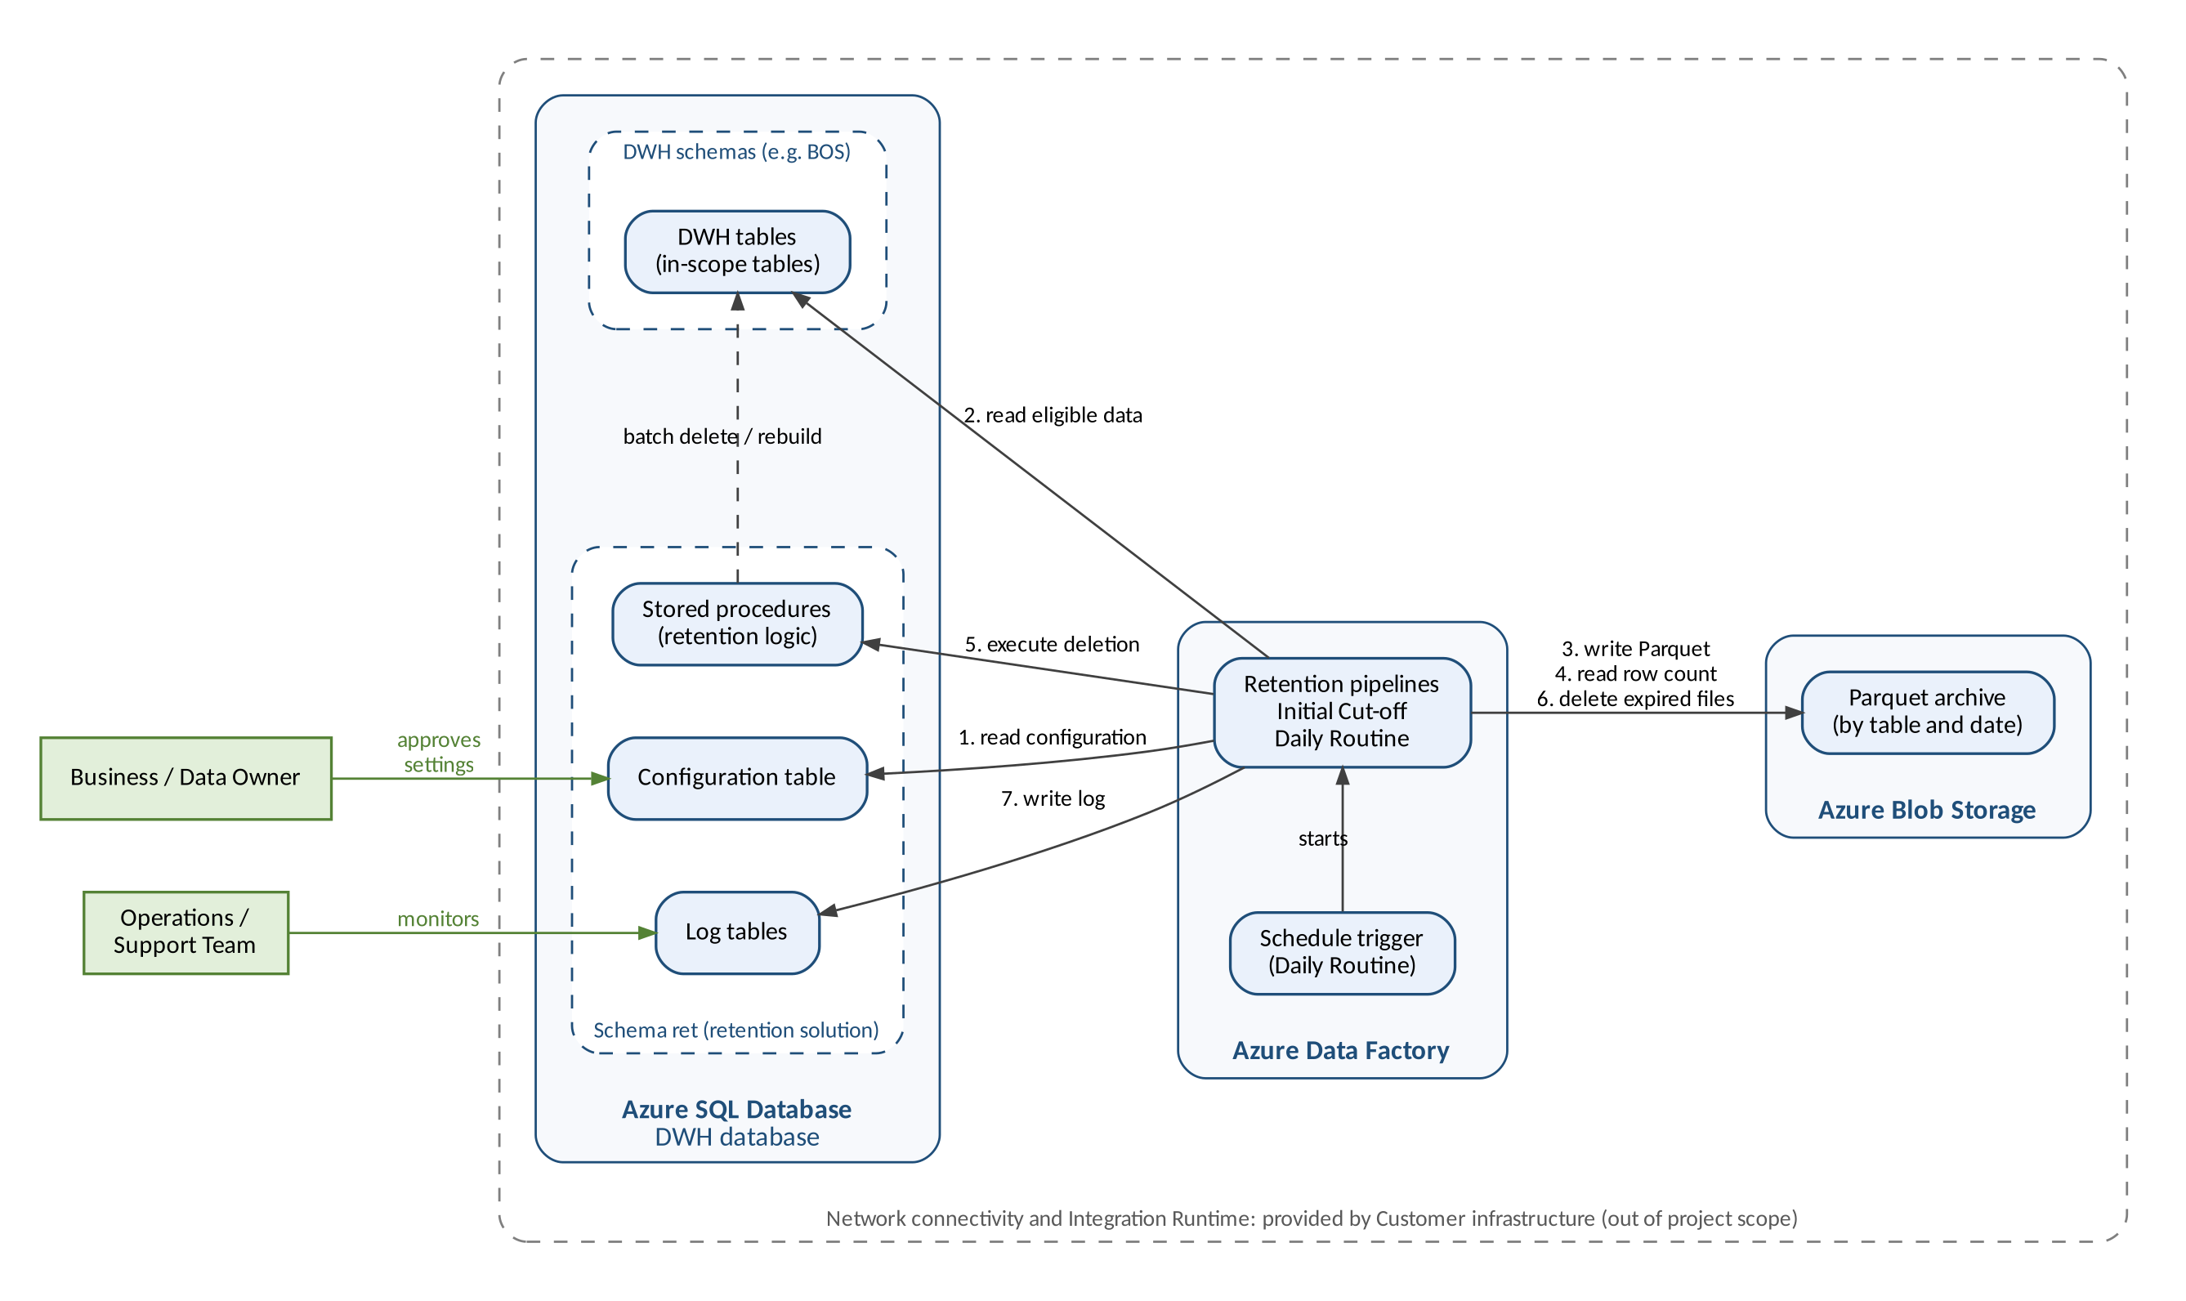
Figure 1 – System context

4.5 High-Level Data Flow
Each row of an in-scope table is classified by its business date; for a child table, this is the business date of its header row. Retained data stays in the DWH. Archive-segment data is exported to Parquet and validated by row count. Data is removed from the DWH only when validation succeeds; otherwise nothing is deleted and the failure is recorded. Expired data is removed without archiving during the Initial Cut-off Run only, and expired Parquet files are deleted by the Daily Routine.
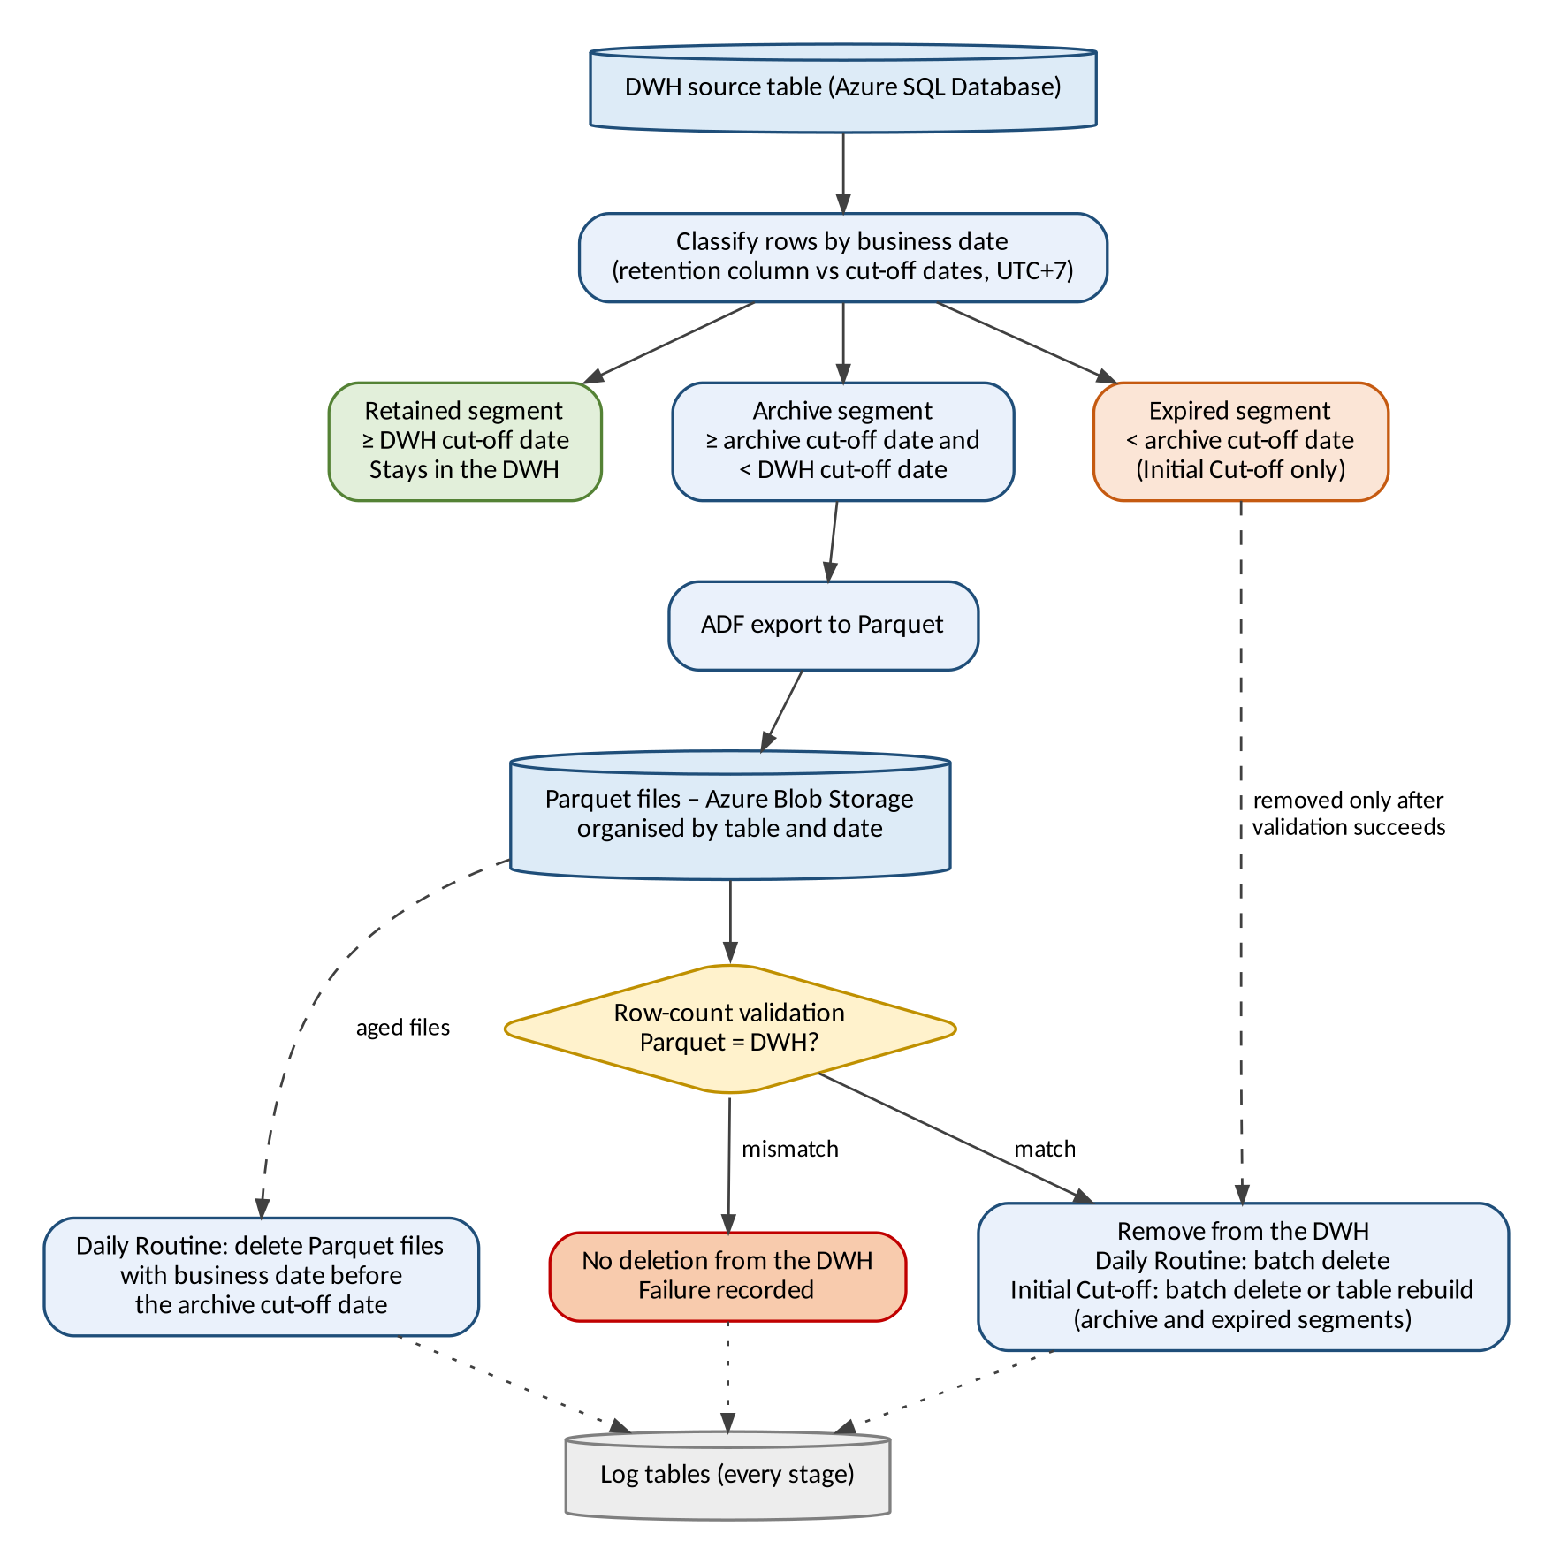
Figure 2 – High-level data flow

5. Business Processes

5.1 Table Onboarding
- Analyse DWH tables to support the identification of in-scope tables and their retention columns, and of child tables with their header tables and join keys.
- Determine the table size category (small, medium, or large), the size limits, and any exceptions in the technical assessment. This sets the Initial Cut-off Run method for each table (BR-11).
- Customer users enter each in-scope table, its retention column (for a child table: its header table and join keys), and its Initial Cut-off Run method in the configuration table. The solution validates each entry before processing (BRQ-20).
- Execute the Initial Cut-off Run (Section 5.2): small and medium tables first, then large tables once the downtime has been determined (BR-16); child tables before their header table (BR-21).
- After the Initial Cut-off Run has been completed for all in-scope tables, the Daily Routine starts on the following day (Section 5.3).
- A table added to the configuration table after the initial implementation goes through steps 2 to 4 for that table, including its own Initial Cut-off Run, and enters the Daily Routine from the day after its Initial Cut-off Run is completed.

The Initial Cut-off Run and the Daily Routine are separate processes and are shown in separate diagrams. The Initial Cut-off Run is executed once for each table to archive its historical data; during the initial implementation it is executed for all in-scope tables before the Daily Routine starts. The Daily Routine then archives data periodically. A table added later goes through its own Initial Cut-off Run before it is included in the Daily Routine.

5.2 Initial Cut-off Run
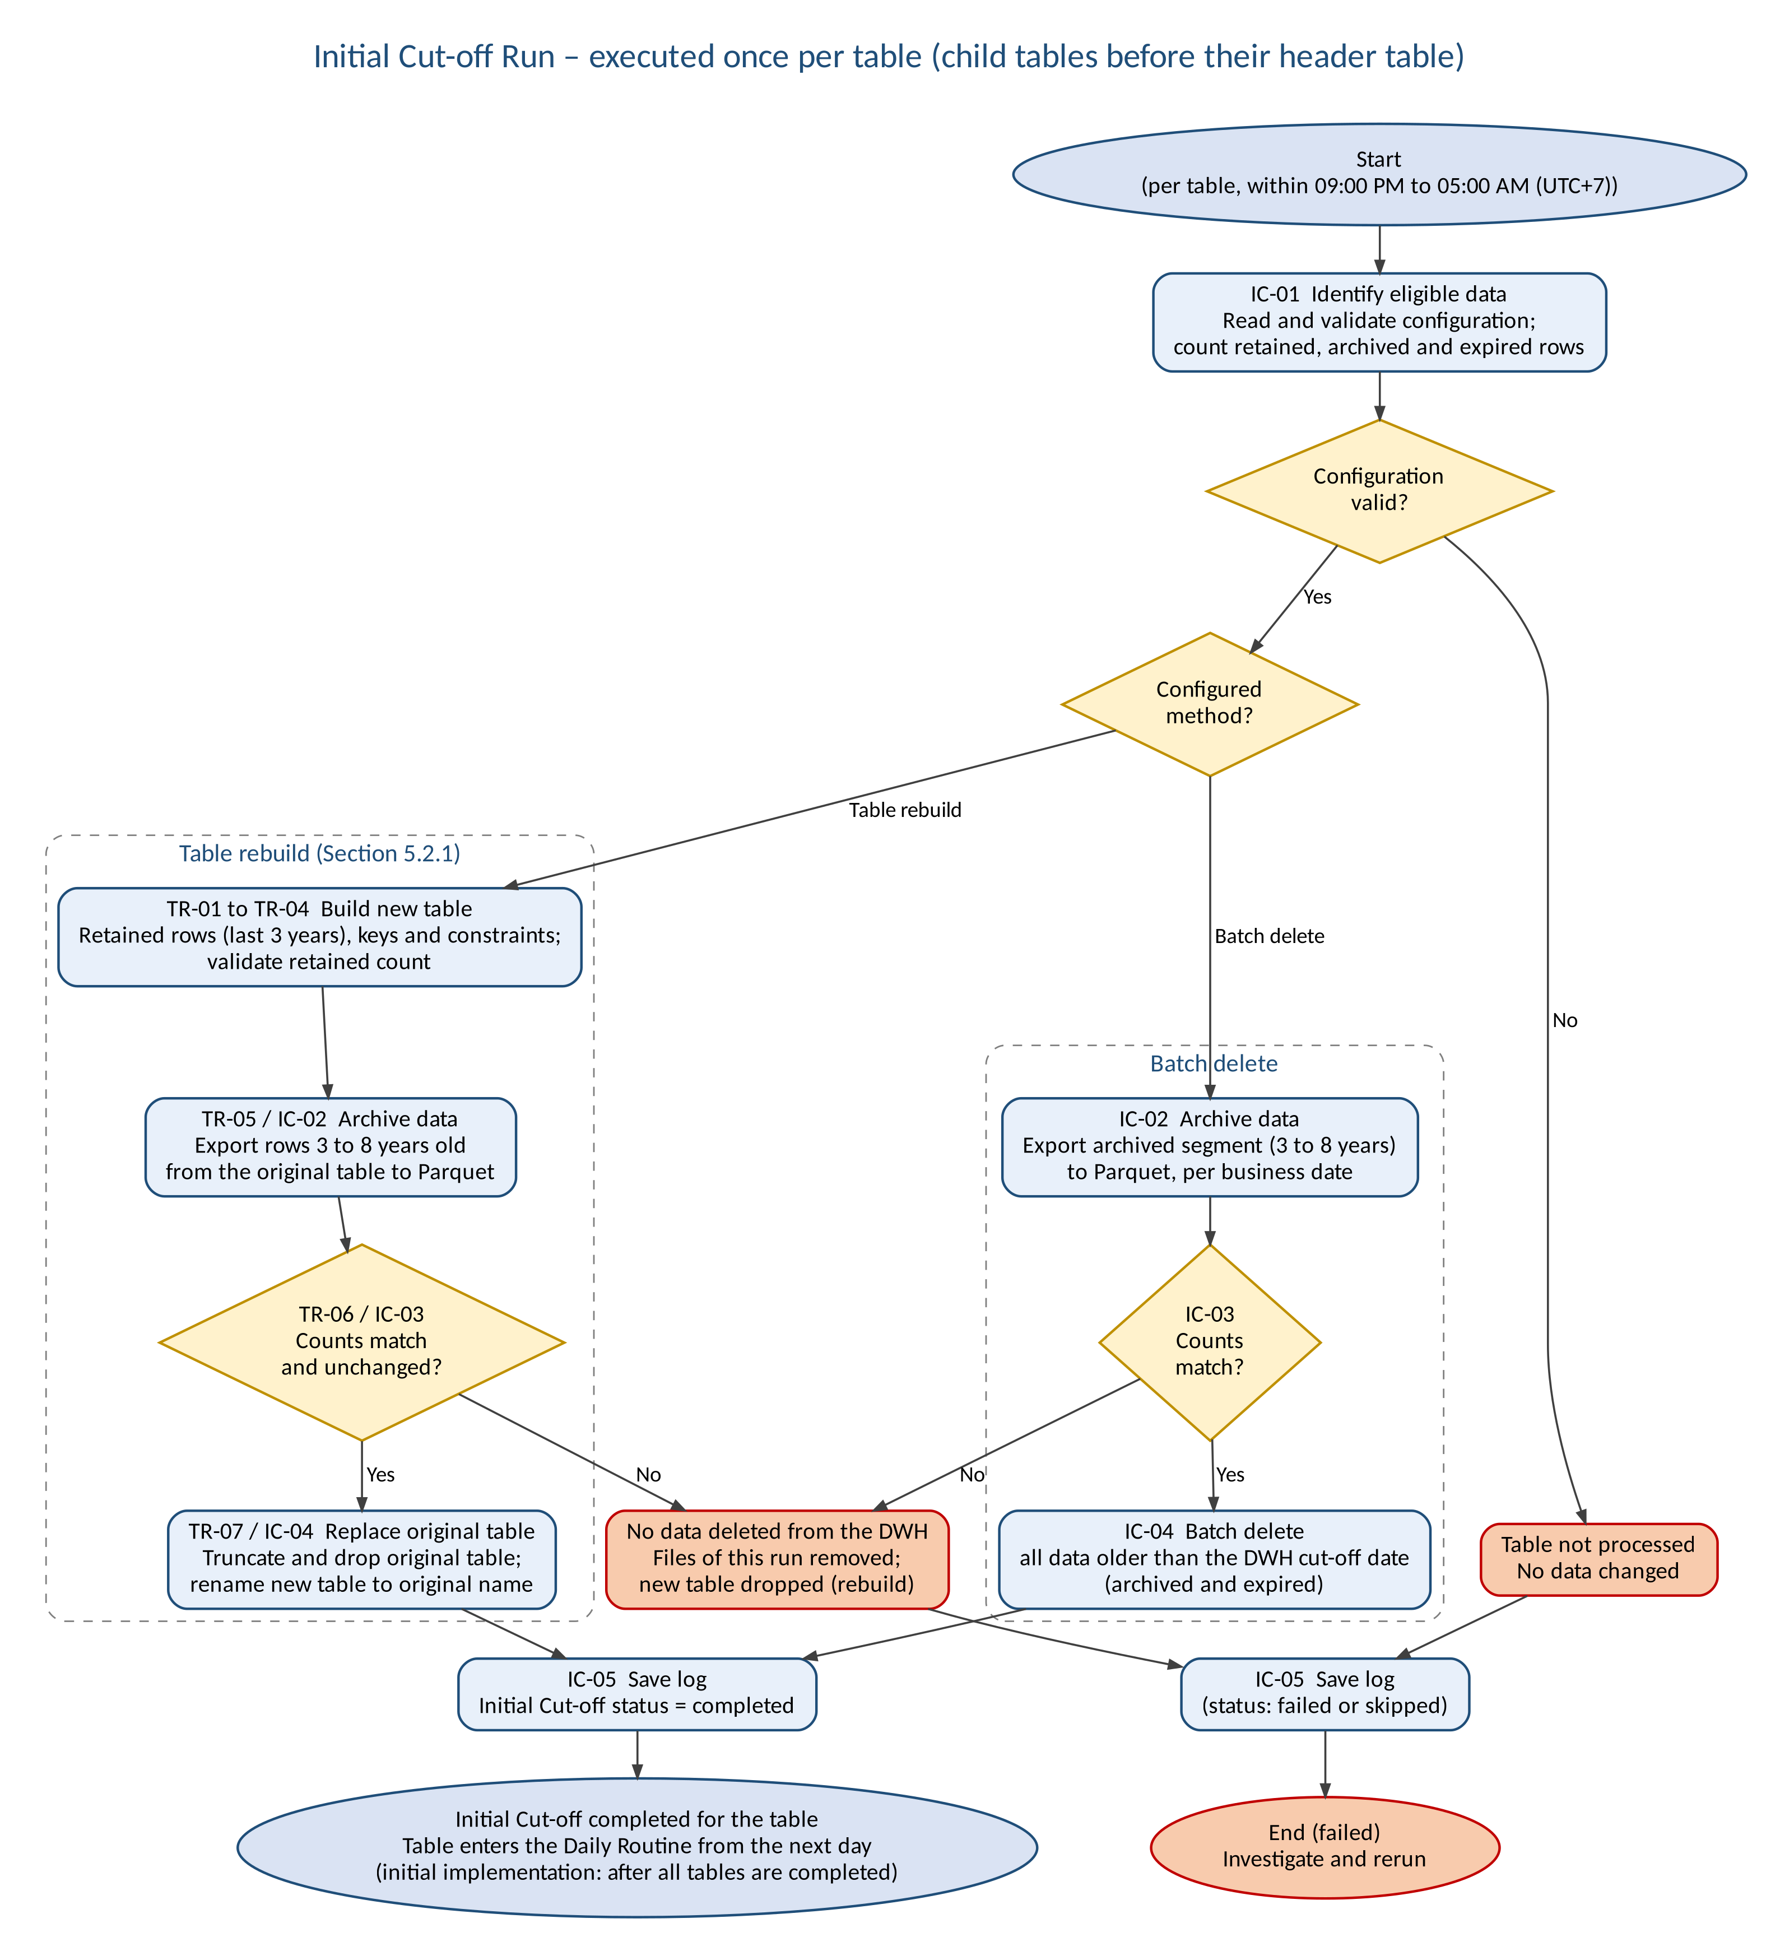
Figure 3 – Business process flow – Initial Cut-off Run (initial implementation)
Step | Activity | Description
IC-01 | Identify eligible data | Read the table and retention column (for a child table: the header table and join keys) from the configuration table, validate the configuration (BRQ-20), and count the retained, archived and expired rows.
IC-02 | Archive data | Export data in the Archived segment (more than three and up to eight years old) to Parquet files in Azure Blob Storage, organised by table and business date. For the table rebuild method this step runs after the new table has been built (TR-05).
IC-03 | Validate row count | Compare the number of rows in the Parquet files with the number of rows in the DWH for the same range. If the counts do not match, no data is deleted, the files written by this run are removed (BRQ-21), and the failure is logged.
IC-04 | Remove data from the DWH | Only after IC-03 succeeds: remove all data older than the DWH cut-off date, including expired data older than eight years, using the method configured for the table: batch delete, or table rebuild by replacing the original table with the new table (TR-07).
IC-05 | Save log | Record the execution result in the log tables. On success, set the Initial Cut-off status of the table to completed with the completion date (BRQ-19).
Table 7 – Initial Cut-off Run steps

5.2.1 Table Rebuild Sequence
The table rebuild follows the sequence decided by the project (MD-04, MD-06). Steps marked Proposed are validation and control steps added in FSD v0.2 (DEC-13, DEC-14) so that BR-08 is satisfied; they require approval.
Step | Activity | Description
TR-01 | Prepare | Confirm the approved downtime (D-07), that ETL writes to the table are stopped (BR-23, D-08), that a valid restore point exists (R-02), that database space is sufficient (R-15), and that dependent objects have been reviewed (R-05). Proposed.
TR-02 | Build new table | Create a new table with the definition of the original table and insert the rows with a business date on or after the DWH cut-off date (MD-04 step 1).
TR-03 | Add keys and constraints | Add the primary key and constraints copied from the original table to the new table (MD-04 step 2).
TR-04 | Validate retained rows | Confirm that the number of rows in the new table equals the number of retained rows in the original table. Proposed (DEC-14).
TR-05 | Archive data | Export the rows between three and eight years old from the original table to Parquet files in Azure Blob Storage (MD-04 step 3; IC-02).
TR-06 | Validate archive | Validate the archive row count (IC-03, BR-08) and confirm that the retained, archived and expired row counts of the original table have not changed since TR-02 (BR-24; Proposed, DEC-14). On failure, the new table and the files of this run are removed and the original table is unchanged.
TR-07 | Replace original table | Truncate the original table (MD-04 step 4), drop it (MD-06) and rename the new table to the original table name (MD-04 step 5), in one transaction (Proposed, DEC-13). The table keeps the original definition, including keys, constraints, indexes, triggers and permissions (BRQ-09).
TR-08 | Post-check | Confirm that the table contains no data with a business date before the DWH cut-off date and that dependent objects work. Proposed. The result is recorded in IC-05.
Table 8 – Table rebuild steps

5.3 Daily Routine
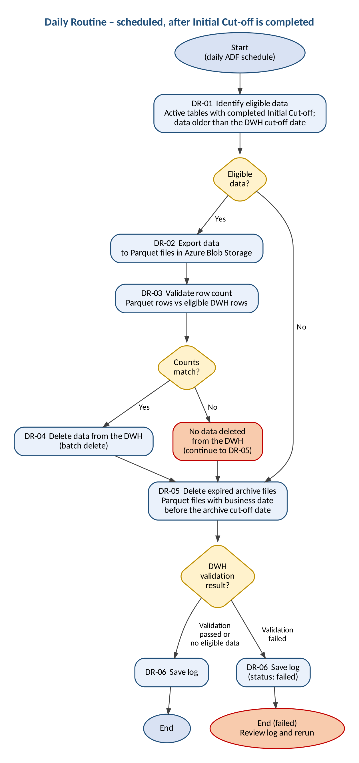
Figure 4 – Business process flow – Daily Routine
Step | Activity | Description
DR-01 | Identify eligible data | Read active tables whose Initial Cut-off Run was completed before the run date, and their retention columns, from the configuration table; child tables are processed before their header table (BR-21). Identify data older than the DWH cut-off date; for a child table, rows whose header row is older than the DWH cut-off date. If there is no eligible data, steps DR-02 to DR-04 are skipped.
DR-02 | Export data | Export the eligible data to Parquet files in Azure Blob Storage, organised by table and business date (BRQ-06).
DR-03 | Validate row count | Compare the number of rows in the Parquet files with the number of eligible rows in the DWH. If the counts do not match, no data is deleted from the DWH, the files written by this run are removed (BRQ-21), the failure is logged, and the process continues with DR-05.
DR-04 | Delete data from the DWH | Only after DR-03 succeeds: delete the exported data from the DWH using batch delete. A range validated by an earlier run but not completely deleted is completed first, without exporting it again (BRQ-22). For a header table, DWH deletion is skipped in a run in which one of its active child tables did not complete successfully (BR-21).
DR-05 | Delete expired archive files | Delete Parquet files with a business date before the archive cut-off date, by removing the expired year, month or day folders (MD-07). This step runs whether or not DR-03 succeeds, and also when there is no eligible data.
DR-06 | Save log | Record the execution result in the log tables.
Table 9 – Daily Routine steps

6. Business Rules
ID | Rule
BR-01 | The DWH retains data with a business date within the last three years. The period is configurable.
BR-02 | Total retention is eight years from the business date: the most recent three years in the DWH (DWH retention period) and the following five years as Parquet files in Azure Blob Storage (blob retention period). Both periods are configurable; the total retention period is their sum (MD-03).
BR-03 | DWH cut-off date = run date − DWH retention period. Archive cut-off date = run date − total retention period.
BR-04 | The run date is determined in UTC+7. As the Azure SQL Database server time is UTC, the UTC+7 date is calculated explicitly (MD-01). The run date and cut-off dates are fixed at the start of a run (Proposed, DBR-02).
BR-05 | Retention is based on the business date in the retention column. Only the date part is used; the time part is ignored.
BR-06 | The retention column must be of a date or datetime data type and must not contain NULL values. A child table has no retention column of its own and uses the retention column of its header table (BR-19).
BR-07 | Retention is applied as a rolling window that is recalculated on every daily run.
BR-08 | Data is removed from the DWH only after the archive has been validated successfully, that is, the row count of the Parquet files matches the row count in the DWH. During the Initial Cut-off Run this also applies to expired data: no data is removed until validation of the archived data succeeds.
BR-09 | During the Initial Cut-off Run, data with a business date before the archive cut-off date is deleted from the DWH without archiving.
BR-10 | Table rebuild is used only for the Initial Cut-off Run. The Daily Routine always uses batch delete.
BR-11 | Default Initial Cut-off Run method: small and medium tables use batch delete; large tables use table rebuild. Table size limits and exceptions are determined in the technical assessment. The method for each table is recorded in the configuration table.
BR-12 | The Initial Cut-off Run is executed once for each in-scope table. During the initial implementation it is executed for all in-scope tables, and the Daily Routine starts on the day after it has been completed for all of them. A table added to the configuration table later goes through its own Initial Cut-off Run and is included in the Daily Routine from the day after that run is completed.
BR-13 | The tables, their retention columns and, for child tables, the header table and join keys are taken from the configuration table. The process does not detect columns or relationships automatically.
BR-14 | Parquet files with a business date before the archive cut-off date are deleted by the Daily Routine, including when row-count validation of the DWH data fails.
BR-15 | Execution results are recorded in log tables, which are the basis for operational monitoring and troubleshooting. No alert or notification is sent.
BR-16 | The Initial Cut-off Run starts with small and medium tables. Large tables follow once the downtime has been determined.
BR-17 | The Initial Cut-off Run is executed within the window 09:00 PM to 05:00 AM (UTC+7), scheduled together with the ETL Owner, and must not disrupt ETL or reporting SLAs. The duration of each run is confirmed through performance testing.
BR-18 | The Daily Routine starts every day at 09:00 PM (UTC+7).
BR-19 | A child table without its own business date column is retained through its header table: the business date of a child row is the business date of its header row, found through the join keys configured for the child table (MD-05; change request pending, TBC-15).
BR-20 | Only one level of parent dating is supported: a header table has its own retention column and is not itself a child table, and a child table has the same retention periods as its header table (Proposed, DBR-20).
BR-21 | Child tables are processed before their header table. The Initial Cut-off Run of a header table starts only after the Initial Cut-off Run of all its active child tables is completed. In the Daily Routine, DWH removal from a header table is skipped in a run in which one of its active child tables did not complete successfully; deletion of expired archive files still runs (Proposed, DBR-18, DBR-19).
BR-22 | Child rows without a matching header row (orphan child rows) have no business date. They are never removed by the retention process, including in a table rebuild, and are reported in the log (Proposed, DBR-21).
BR-23 | ETL writes to a table are stopped from the start of its table rebuild until the rebuild is completed (Proposed, DBR-16).
BR-24 | In a table rebuild, the original table is truncated only after the archive has been validated and the retained, archived and expired row counts are unchanged since the new table was built. The original table is then dropped and the new table takes its name (MD-04, MD-06; conditions Proposed, DBR-17).
BR-25 | Only active tables are processed, in the Initial Cut-off Run and in the Daily Routine (Proposed, DBR-11). The treatment of archive files of inactive tables and the reactivation of a table are to be confirmed (TBC-18).
BR-26 | Immediately before data is removed from the DWH, the rows in the validated range are counted again. If the count differs from the validated count, no data is removed (Proposed, DBR-06).
BR-27 | Archive files are never overwritten. Each run writes new files that identify the run (Proposed, DBR-07).
BR-28 | A table is processed by at most one run at a time (Proposed, DBR-10).
BR-29 | The Initial Cut-off Run stops at the end of its execution window in a state from which it can be resumed. A table rebuild is not interrupted once the new table is being loaded (Proposed, DBR-13, DEC-10).
Table 10 – Business rules

7. Business Requirements

7.1 Functional Requirements
ID | Requirement
BRQ-01 | The project shall review and analyse the business and technical requirements for data retention.
BRQ-02 | The project shall analyse DWH tables to support the identification of in-scope tables and their retention columns, including child tables with their header tables and join keys. The final list is entered in the configuration table by Customer users.
BRQ-03 | The solution shall provide a central configuration table in schema ret of the DWH database containing, for each table, the attributes listed in Section 7.3.
BRQ-04 | Tables shall be added to, changed in, or removed from the retention process by updating the configuration table, without changing the pipelines.
BRQ-05 | The solution shall provide an Initial Cut-off Run for each table as described in Section 5.2.
BRQ-06 | The solution shall export data in the Archived segment to Parquet files in Azure Blob Storage, organised by table and business date in the folder structure <blob path>/year=YYYY/month=MM/day=DD/, with one file per business date per run (MD-07).
BRQ-07 | Before deleting archived data from the DWH, the solution shall validate that the row count in the Parquet files equals the row count in the DWH, and shall not delete data if the counts differ.
BRQ-08 | The solution shall delete DWH data in batches of 10,000 rows with a pause of 3 seconds between batches. These values may be adjusted based on performance monitoring.
BRQ-09 | The solution shall support table rebuild as a method for the Initial Cut-off Run, following the sequence in Section 5.2.1 (MD-04, MD-06). The new table shall replace the original table with the same table definition, including keys, constraints, indexes, triggers and permissions; the original table shall be truncated and dropped.
BRQ-10 | The solution shall provide a Daily Routine as described in Section 5.3, executed automatically by an ADF schedule every day at 09:00 PM (UTC+7).
BRQ-11 | The Daily Routine shall delete Parquet files with a business date before the archive cut-off date, by removing the expired year, month or day folders (MD-07).
BRQ-12 | The solution shall record each execution in log tables in schema ret of the DWH database, as described in Section 7.4.
BRQ-13 | Basic operational monitoring and troubleshooting shall use the information recorded in the log tables, including execution status, start and end timestamps, records processed, and error details where applicable.
BRQ-14 | The retention logic in the DWH shall be implemented through stored procedures and scripts in schema ret of the DWH database.
BRQ-15 | The project shall deliver documentation covering design, configuration, setup, and operational guidance.
BRQ-16 | The project shall deliver knowledge transfer sessions to the operations team.
BRQ-17 | The project shall provide hypercare support after deployment until 31 March 2027.
BRQ-18 | The solution shall retain child tables through their header table as defined in BR-19 to BR-22 (MD-05; change request pending, TBC-15).
BRQ-19 | The solution shall maintain, for each table, an Initial Cut-off status and completion date, and shall include a table in the Daily Routine only from the day after its Initial Cut-off Run is completed (BR-12). The status is maintained by the solution, not by users. The Daily Routine is activated once, after the Initial Cut-off Run is completed for all in-scope tables of the initial implementation (Proposed, FR-020).
BRQ-20 | Before processing a table, the solution shall validate its configuration: the table and retention column exist, the data type is allowed, there are no NULL values, the retention periods and archive path are valid, and, for a child table, the header table is valid and the join keys are unique in it. A table that fails validation shall not be processed and the failure shall be logged (Proposed, FR-002).
BRQ-21 | When export or validation fails, the solution shall remove the archive files written by the failed run, so that the archive contains no partial or duplicate data (Proposed, FR-018).
BRQ-22 | After a failure, the solution shall allow the run to be repeated without data loss and without duplicating archive content. A range that was validated but not completely removed shall be completed without exporting it again (Proposed, FR-017).
BRQ-23 | The solution shall prevent two runs from processing the same table at the same time (Proposed, FR-016).
BRQ-24 | The solution shall stop the Initial Cut-off Run at the end of its execution window (BR-17, BR-29) (Proposed, FR-019).
Table 11 – Functional requirements

7.2 Non-Functional Requirements
ID | Requirement
NFR-01 | Deletion shall be performed incrementally in batches, avoiding long-running transactions, to minimise locking and impact on ETL and reporting processes (thresholds: NFR-04 to NFR-08).
NFR-02 | Retention periods shall be configurable without changing the pipelines.
NFR-03 | The Daily Routine shall run without manual intervention.
NFR-04 | ETL duration: ETL execution time shall not exceed the agreed baseline by more than 10%.
NFR-05 | ETL completion: all critical ETL jobs shall complete within their agreed processing windows and SLAs.
NFR-06 | Reporting performance: report response time shall not degrade by more than 10% from the agreed baseline.
NFR-07 | Reporting availability: archive and cut-off activities shall cause no unplanned reporting downtime.
NFR-08 | Data integrity: data reconciliation and validation shall meet acceptance criteria AC-04, AC-05, AC-18 and AC-21, with no unexplained data loss or inconsistency.
NFR-09 | Security (Proposed, FSD SEC-01 to SEC-10): access shall follow least privilege. The ADF identity may only execute the retention procedures and write to the archive container; Customer users may maintain only the user-maintained configuration attributes; the operations team has read-only access to the log tables. No credentials are stored in documents, pipelines or scripts. Data is encrypted in transit and at rest. The security model is confirmed by the DBA and the infrastructure team (TBC-22).
NFR-10 | Auditability (Proposed, FSD SEC-08): changes to the configuration table shall be recorded with user and time, and manual runs and operator actions shall record the operator. The retention period of the log tables is to be confirmed (TBC-23).
NFR-11 | Segregation of duties (Proposed, FSD SEC-11): approval and execution of irreversible steps (Initial Cut-off Run, table rebuild) shall be performed by different persons (TBC-13).
Table 12 – Non-functional requirements

7.3 Configuration Table
The configuration table shall contain at least the following attributes for each table. The physical design, including naming and any additional technical attributes, is defined in the FSD. No database name attribute is needed: all in-scope tables are in the DWH database that holds schema ret (MD-02, C-05).
Attribute | Description | Example
Schema name | Schema of the table | bos
Table name | Table under retention | JTI_SD_BrandDistDetail
Retention column | Business date column; date or datetime data type; no NULL values. Not used for a child table (BR-19). | dtmDate
DWH retention (years) | Number of years kept in the DWH | 3
Blob retention (years) | Number of years kept in Azure Blob Storage after the DWH retention period. The total retention period is DWH retention plus blob retention (MD-03). | 5 (total 8)
Blob path | Folder of the table in the archive container: <schema>/<table> in lower case. Files are stored below it in year=YYYY/month=MM/day=DD folders (MD-07). The container name is provided under D-02. | bos/jti_sd_branddistdetail
Header table (child tables only) | Header table that provides the business date of a child table (BR-19) | – (for example bos.BOS_SD_FDo for bos.BOS_SD_FDoItem)
Join keys (child tables only) | Columns that link each child row to its header row; unique in the header table (BRQ-20) | Per child table, confirmed in the technical assessment (TBC-17)
Initial Cut-off Run method | Batch delete or table rebuild, according to BR-11 | Batch delete
Initial Cut-off status | Maintained by the solution, not entered by users: pending, running, failed, stopped or completed, and the completion date (BRQ-19) | Completed
Active flag | Indicates whether the table is processed | Active
Table 13 – Configuration table attributes

7.4 Execution Log
For each table and each execution, the log shall record at least: the process type (Initial Cut-off Run or Daily Routine), run date, DWH cut-off date, archive cut-off date, number of eligible rows, number of rows exported, number of rows deleted from the DWH, number of archive files deleted, execution status, start and end time, and error details where applicable. For a child table, the log also records the number of orphan child rows found (BR-22). Manual runs record the operator (NFR-10).

8. Assumptions, Constraints and Dependencies

8.1 Assumptions
ID | Assumption
A-01 | The retention periods (three years in the DWH, five years in Azure Blob Storage, eight years in total) are agreed by the business. Confirmed by project decision MD-03; formal minutes pending (TBC-14).
A-02 | The required database and storage access will be provided.
A-03 | Back-dated transactions do not occur.
A-04 | The retention columns of in-scope tables contain no NULL values.
A-05 | Daily database backups remain in place.
A-06 | Business dates are stored in UTC+7 local time (FSD ASM-01; TBC-20).
A-07 | The join keys of each child table are unique in its header table, and header rows are not deleted outside the retention process (FSD ASM-06; checked by BRQ-20).
Table 14 – Assumptions

8.2 Constraints
ID | Constraint
C-01 | The DWH platform is Azure SQL Database (MD-01). Its server time is UTC, and it does not support cross-database queries.
C-02 | Archive files are in Parquet format in Azure Blob Storage.
C-03 | All dates are evaluated in UTC+7.
C-04 | No changes to source systems and no major schema redesign.
C-05 | The configuration table, log tables, and stored procedures are created in the DWH database and are separated from the DWH tables only by the schema name ret (MD-02).
Table 15 – Constraints

8.3 Dependencies
ID | Dependency | Responsible
D-01 | Network connectivity and Integration Runtime between ADF, the DWH, and Azure Blob Storage | Customer infrastructure team
D-02 | Azure Blob Storage account and container for the archive, including the container name | Customer infrastructure team
D-03 | In-scope tables, retention columns and, for child tables, header tables and join keys entered in the configuration table and confirmed (TBC-17) | Customer users, Business / Data Owner
D-04 | Scheduling of each Initial Cut-off Run with the ETL Owner within the 09:00 PM to 05:00 AM (UTC+7) window | ETL Owner, project team
D-05 | Technical assessment of table size limits and exceptions (BR-11) | Project team, Customer
D-06 | Agreed baseline for ETL execution time and report response time (NFR-04, NFR-06) | Business / Data Owner, ETL team, DBA
D-07 | Downtime for the table rebuild of large tables (BR-16) | ETL Owner, Business / Data Owner
D-08 | ETL writes to each table stopped during its table rebuild (BR-23) | ETL Owner
Table 16 – Dependencies

9. Risks
ID | Risk | Likelihood | Impact | Mitigation
R-01 | As no alerts are sent, a failed execution is noticed only when the log is reviewed. | Medium | Medium | Include a daily log review in the operational guidance.
R-02 | Data older than eight years is deleted without archiving during the Initial Cut-off Run and can be recovered only from database backups. | Low | High | Confirm that a valid backup or restore point exists before each Initial Cut-off Run.
R-03 | Deleted data remains in database backups for the backup retention period. | High | Low | Accepted by the Customer.
R-04 | Network and infrastructure are outside the project scope; delays in their provision delay the project. | Medium | High | Agree delivery dates for D-01 and D-02 at project start.
R-05 | Table rebuild may affect dependent database objects and ETL availability. | Medium | High | Rebuild large tables only within the determined downtime (BR-16), schedule with the ETL Owner (BR-17), and review dependent objects before rebuild.
R-06 | Large volumes deleted during the Initial Cut-off Run may increase transaction log usage. | Medium | High | Plan the execution with the DBA.
R-07 | An incorrect retention column in the configuration could remove data that should be kept. | Low | High | Customer users are responsible for the configuration entries (BRQ-02); the retention column must be of a date or datetime data type (BR-06).
R-08 | Hypercare ends on a fixed date (31 March 2027); a later go-live shortens the hypercare period. | Medium | Medium | Track the go-live date against the hypercare end date.
R-09 | Without an agreed baseline, NFR-04 and NFR-06 cannot be verified. | Medium | High | Agree the baseline (D-06) before performance testing.
R-10 | The Initial Cut-off Run for a table added after the initial implementation (09:00 PM to 05:00 AM) may run at the same time as the Daily Routine for other tables (09:00 PM), increasing load on the DWH. | Medium | Medium | Include this case in performance testing and schedule each such run with the ETL Owner (BR-17).
R-11 | With an eight-year total retention, the Initial Cut-off Run exports up to five years of data per table, which may not fit in the 09:00 PM to 05:00 AM window for large tables. | Medium | High | Confirm run durations through performance testing and split the Initial Cut-off Run of a table across several windows where needed (BR-17).
R-12 | Retention processing runs in the same Azure SQL Database as the DWH workload and shares its resources. | Medium | Medium | Use batch delete (BRQ-08) and verify NFR-04 to NFR-07 in performance testing.
R-13 | Child and header tables become inconsistent, for example child rows left without a header row, or a header row removed before its child rows. | Medium | High | Process child tables first and gate header processing (BR-21); keep and report orphan child rows (BR-22).
R-14 | ETL writes during a table rebuild are lost when the original table is truncated. | Medium | High | Stop ETL writes during the rebuild (BR-23, D-08) and check row counts before truncation (BR-24).
R-15 | Database space is insufficient during the rebuild of a large table, because the new table and the original table exist at the same time. | Medium | High | Confirm space with the DBA before each rebuild (TR-01).
R-16 | Retention columns in the table list include last-update timestamps (16 tables) and unconfirmed entries, so rows could be archived or kept by technical update date instead of business date. | Medium | High | Confirm each retention column with the Business / Data Owner before configuration (TBC-17).
R-17 | Without an index on the retention column or on the join columns of child tables, counting and deletion on large tables are slow and hold locks longer. | Medium | High | Assess indexes in the technical assessment; index additions require approval (TBC-27).
Table 17 – Risks

10. Acceptance and Success Criteria

10.1 Acceptance Criteria
ID | Criterion | Requirement
AC-01 | The table analysis is delivered, and the in-scope tables and their retention columns are entered in the configuration table. | BRQ-01, BRQ-02
AC-02 | A table can be added to or removed from the retention process by updating the configuration table only. | BRQ-03, BRQ-04, NFR-02
AC-03 | After the Initial Cut-off Run on run date D, the table contains no data with a business date before D − 3 years, and all data on or after D − 3 years is unchanged. | BRQ-05, BRQ-09
AC-04 | After the Initial Cut-off Run, Azure Blob Storage contains Parquet files for the data from D − 8 years to the day before D − 3 years, and their row count equals the row count removed from the DWH for that range. | BRQ-06, BRQ-07
AC-05 | When the Parquet row count does not match the DWH row count, no data (including expired data in the Initial Cut-off Run) is deleted from the DWH and the execution is logged as failed. | BRQ-07
AC-06 | Batch delete removes no more than 10,000 rows per batch and pauses 3 seconds between batches, or the adjusted values where these have been changed based on performance monitoring. | BRQ-08, NFR-01
AC-07 | The Daily Routine starts at 09:00 PM (UTC+7) without manual intervention and, for each processed table whose row-count validation succeeded, leaves no data in the DWH with a business date before the DWH cut-off date. A table whose validation failed keeps its data and is logged as failed (BR-08; TBC-16). | BRQ-10, NFR-03
AC-08 | After the Daily Routine, Azure Blob Storage contains no Parquet files with a business date before the archive cut-off date, including on days when row-count validation of the DWH data fails. | BRQ-11
AC-09 | Each execution produces log records containing the information listed in Section 7.4. | BRQ-12, BRQ-13
AC-10 | Retention logic is delivered as stored procedures and scripts, and the configuration table, log tables, and stored procedures exist in schema ret of the DWH database. | BRQ-03, BRQ-12, BRQ-14
AC-11 | The documentation is delivered and reviewed, and knowledge transfer sessions are completed. | BRQ-15, BRQ-16
AC-12 | Hypercare support is available from deployment until 31 March 2027. | BRQ-17
AC-13 | Performance testing shows that ETL execution time and report response time remain within 10% of the agreed baseline and that critical ETL jobs complete within their processing windows and SLAs. | NFR-04 to NFR-06
AC-14 | Small and medium tables complete the Initial Cut-off Run before large tables; each Initial Cut-off Run runs within 09:00 PM to 05:00 AM (UTC+7), and large tables are rebuilt only within the determined downtime without unplanned reporting downtime. | BRQ-05, BRQ-09, NFR-07
AC-15 | The first Daily Routine runs on the day after the Initial Cut-off Run has been completed for all in-scope tables, and no Daily Routine runs before then. | BRQ-05, BRQ-10
AC-16 | A table added after the initial implementation is not processed by the Daily Routine until the day after its own Initial Cut-off Run has been completed. | BRQ-04, BRQ-05
AC-17 | For a child table, after the Initial Cut-off Run no child row whose header row has a business date before D − 3 years remains in the DWH; orphan child rows are kept and reported; and the Initial Cut-off Run of the header table does not start before all its active child tables are completed. | BRQ-18
AC-18 | In a table rebuild, the original table is not truncated when the retained count, the archive validation or the recount fails; the original table is then unchanged and the files of the run are removed. After a successful rebuild, the table has the original name and definition, including keys, constraints, indexes, triggers and permissions. | BRQ-09, NFR-08
AC-19 | Archive files are stored by table and business date in year/month/day folders below the blob path, one file per business date per run, and no file is overwritten. | BRQ-06
AC-20 | A table whose configuration fails validation is not processed and the failure is logged; the other tables are processed. | BRQ-20
AC-21 | After a failed run, a rerun completes the processing without data loss and without duplicate archive content, and no archive files of the failed run remain. | BRQ-21, BRQ-22, NFR-08
AC-22 | Two runs never process the same table at the same time. | BRQ-23
AC-23 | The run date and cut-off dates are calculated in UTC+7, and a row whose business date equals the DWH cut-off date is retained regardless of its time part. | BR-03, BR-04, BR-05
AC-24 | The Initial Cut-off Run stops at 05:00 AM (UTC+7) in a state from which it can be resumed. | BRQ-24
AC-25 | A permission review confirms that the ADF identity, Customer users and the operations team have only the access defined in NFR-09; a change to the configuration table is recorded with user and time; and no irreversible step is executed by the person who approved it. | NFR-09, NFR-10, NFR-11
Table 18 – Acceptance criteria

10.2 Success Criteria
ID | Measure
SC-01 | After each Daily Routine, 100% of active tables whose row-count validation succeeded contain no DWH data with a business date before the DWH cut-off date (TBC-16).
SC-02 | 100% of archived data passes row-count validation before deletion from the DWH.
SC-03 | After each Daily Routine, no Parquet file with a business date before the archive cut-off date remains in Azure Blob Storage.
SC-04 | 100% of executions are recorded in the log tables.
SC-05 | During the Initial Cut-off Run and the Daily Routine, ETL and reporting stay within NFR-04 to NFR-07.
SC-06 | Reconciliation and validation show no unexplained data loss or inconsistency (NFR-08).
Table 19 – Success criteria

11. Items to Be Confirmed
The table below records the resolution and status of each item. Items with status Open must be confirmed before the related project stage.
ID | Item | Resolution | Status
TBC-01 | Execution time of the Daily Routine (UTC+7). | 09:00 PM (UTC+7) (BRQ-10, BR-18). | Closed
TBC-02 | Final list of in-scope tables and their retention columns. | Entered in the configuration table by Customer users (BRQ-02). | Closed
TBC-03 | Initial Cut-off Run method for each table. | Default: batch delete for small and medium tables; table rebuild for large tables. Size limits and exceptions are determined in the technical assessment. Small and medium tables are processed first; large tables follow once the downtime has been determined (BR-11, BR-16). | Closed
TBC-04 | Batch size and pause between batches. | 10,000 rows per batch; 3 seconds between batches; adjusted based on performance monitoring (BRQ-08). | Closed
TBC-05 | Measurable thresholds for acceptable impact on ETL and reporting. | Thresholds defined in NFR-04 to NFR-08. The agreed baseline (D-06) is not yet available (FSD OQ-25). | Open (before performance testing)
TBC-06 | Monitoring or performance reporting beyond the log tables. | Monitoring and troubleshooting use the log tables (BRQ-13). Dedicated reports, dashboards, monitoring interfaces, alerting, and monitoring integration are out of scope unless separately assessed and approved (OS-06, OS-08). | Closed
TBC-07 | Hypercare support after deployment. | BRD: until 31 March 2027 (IS-13, BRQ-17). The project timeline workbook shows one month of hypercare ending 25 January 2027 (FSD OQ-30). Conflict to be resolved. | Open (before FSD approval)
TBC-08 | Execution window for the Initial Cut-off Run. | 09:00 PM to 05:00 AM (UTC+7), scheduled with the ETL Owner without disrupting ETL or reporting SLAs (BR-17, D-04). | Closed
TBC-09 | Names of stakeholders and approvers. | Business / Data Owner, Project Sponsor, Database Administrator, and Solution Architect / Lead Data Engineer: Agus Laksono (Approval table, Section 3). | Closed
TBC-10 | Handling of tables added to the configuration table after the initial implementation. | Each such table goes through its own Initial Cut-off Run before it enters the Daily Routine (BR-12). | Closed
TBC-11 | Whether all in-scope tables reside in the same database as schema ret. | All in-scope tables are in the DWH database that holds schema ret (MD-02). The Database name attribute is removed from the configuration table (Section 7.3). | Closed (MD-02; minutes pending, TBC-14)
TBC-12 | Approval status of the BRD. | Version 0.1 stated "version 0.1 approved on 29 October 2026" while the approval table showed all decisions pending (FSD OQ-01). No approval evidence is available; version 0.2 is not approved. | Open (before FSD approval)
TBC-13 | Approvers and segregation of duties. | One person holds all approval roles and the solution design role. Confirm the approvers and independent approval of irreversible steps (NFR-11; FSD OQ-02, SEC-11). | Open (before BRD approval)
TBC-14 | Formal record of decisions MD-01 to MD-07. | Minutes with date, participants and decision makers. Date of MD-01 to MD-03: project meeting 27 October 2026; FSD v0.2 records 29 October 2026. | Open (before BRD approval)
TBC-15 | Change request for retention of child tables (MD-05). | Amends BR-06, BR-13 and Section 7.3; adds IS-14, BR-19 to BR-22, BRQ-18 and AC-17 (FSD OQ-32, DV-04). | Open (before BRD approval)
TBC-16 | AC-07 and SC-01 on days with a validation failure. | Proposed in this version: both criteria apply to tables whose row-count validation succeeded, consistent with BR-08 (FSD OQ-06). | Open (confirm proposed resolution)
TBC-17 | Retention columns and join keys of candidate tables. | 16 tables use a last-update timestamp and 1 uses dtmLastWeek; 2 entries are unconfirmed and 1 is marked "All"; backup and duplicate tables are listed; some join queries contain errors (FSD OQ-04, OQ-05, OQ-33). | Open (before configuration, D-03)
TBC-18 | Inactive and reactivated tables. | Whether archive files of an inactive table are still deleted after eight years, and whether reactivation requires a new Initial Cut-off Run (BR-25; FSD OQ-07). | Open (before FSD approval)
TBC-19 | Method of counting rows in the Parquet files. | Proposed in the FSD: rows read and written by the ADF copy compared with the DWH count per business date; alternative: reading the files back (BRQ-07; FSD OQ-09, DEC-03). | Open (before FSD approval)
TBC-20 | Data types and time zone of stored business dates. | Allowed data types of retention columns and confirmation that stored dates are UTC+7 local time (A-06; FSD OQ-13). | Open (before FSD approval)
TBC-21 | Latest end time of the Daily Routine. | No end time or maximum duration is defined (NFR-05; FSD OQ-15). | Open (before FSD approval)
TBC-22 | Security model, data classification and archive access. | Authentication method, Integration Runtime type, classification of archived data, who may read the archive and whether retrieval is needed (NFR-09; FSD OQ-17, OQ-19). | Open (before FSD approval)
TBC-23 | Retention period of the log tables. | Not defined (NFR-10; FSD OQ-20). | Open (before FSD approval)
TBC-24 | Change of retention periods after go-live. | Proposed in the FSD: a change applies from the next run; archived or deleted data is not restored (FSD OQ-21). | Open (before FSD approval)
TBC-25 | Reduced history in reports after the Initial Cut-off Run. | Acceptance by report users and communication (OS-04; FSD OQ-27). | Open (before go-live)
TBC-26 | Rows older than the archive cut-off date found by the Daily Routine. | For example after a long outage or back-dated data: export then delete as expired, or delete without archiving (A-03, BR-09; FSD OQ-10). | Open (before FSD approval)
TBC-27 | Index additions on retention or join columns. | Whether adding indexes is allowed under C-04 and OS-03 (R-17; FSD OQ-23). | Open (before FSD approval)
Table 20 – Items to be confirmed

12. Requirement Traceability
The matrix maps each business requirement to the objectives, business rules and acceptance criteria of this document and to the FSD v0.2 functional requirements. FSD coverage for BRQ-01 to BRQ-17 and NFR-01 to NFR-08 is taken from FSD v0.2 Section 18; for items added in this version it is assessed against the FSD reference listed. Status: Baseline = unchanged from version 0.1; Amended = changed in version 0.2; Proposed = added in version 0.2 and requires approval.
ID | Objective | Business rules | Acceptance criteria | FSD v0.2 reference | FSD coverage | Status
BRQ-01 | – | – | AC-01 | FR-022 | Partial (project activity) | Baseline
BRQ-02 | OBJ-04 | BR-06, BR-13, BR-19 | AC-01 | FR-001, FR-022, FR-023 | Partial (TBC-15, TBC-17) | Amended
BRQ-03 | OBJ-04 | BR-11, BR-13 | AC-02, AC-10 | FR-001 | Partial in FSD; DV-01 and DV-02 resolved in Section 7.3 | Baseline
BRQ-04 | OBJ-04 | BR-12, BR-13, BR-25 | AC-02, AC-16 | FR-001, FR-004 | Full (TBC-18 open) | Baseline
BRQ-05 | OBJ-01, OBJ-02 | BR-08, BR-09, BR-12, BR-16, BR-17 | AC-03, AC-04, AC-14, AC-15 | FR-005 to FR-011, FR-019, FR-020 | Full | Baseline
BRQ-06 | OBJ-02 | BR-02, BR-27 | AC-04, AC-19 | FR-006, FR-007 | Full | Amended
BRQ-07 | OBJ-01, OBJ-02 | BR-08, BR-26 | AC-04, AC-05 | FR-008 | Partial (TBC-19) | Baseline
BRQ-08 | OBJ-05 | BR-10 | AC-06 | FR-009 | Full | Baseline
BRQ-09 | OBJ-01, OBJ-05 | BR-10, BR-11, BR-16, BR-23, BR-24 | AC-03, AC-14, AC-18 | FR-010 | Partial (DEC-13, DEC-14) | Amended
BRQ-10 | OBJ-03 | BR-07, BR-18 | AC-07, AC-15 | FR-012, FR-020 | Full | Baseline
BRQ-11 | OBJ-02 | BR-14 | AC-08 | FR-013 | Full | Amended
BRQ-12 | OBJ-06 | BR-15 | AC-09, AC-10 | FR-014 | Full | Baseline
BRQ-13 | OBJ-06 | BR-15 | AC-09 | FR-015 | Full | Baseline
BRQ-14 | OBJ-04 | – | AC-10 | FR-021 | Full | Baseline
BRQ-15 | – | – | AC-11 | FSD 16.10 | Partial (project deliverable) | Baseline
BRQ-16 | – | – | AC-11 | FSD 16.10 | Partial (project deliverable) | Baseline
BRQ-17 | – | – | AC-12 | FSD 16.10 | Conflict (TBC-07) | Baseline
BRQ-18 | OBJ-01, OBJ-02, OBJ-04 | BR-19 to BR-22 | AC-17 | FR-023 | Full | Proposed (TBC-15)
BRQ-19 | OBJ-03 | BR-12 | AC-15, AC-16 | FR-020 | Full | Proposed
BRQ-20 | OBJ-04 | BR-06, BR-13 | AC-20 | FR-002 | Full | Proposed
BRQ-21 | OBJ-02 | BR-08, BR-27 | AC-21 | FR-018 | Full | Proposed
BRQ-22 | OBJ-03 | BR-08, BR-26 | AC-21 | FR-017 | Full | Proposed
BRQ-23 | OBJ-05 | BR-28 | AC-22 | FR-016 | Full | Proposed
BRQ-24 | OBJ-05 | BR-17, BR-29 | AC-24 | FR-019 | Full | Proposed
NFR-01 | OBJ-05 | BR-10 | AC-06 | FR-009, FR-010 | Full | Baseline
NFR-02 | OBJ-04 | BR-01, BR-02 | AC-02 | FR-001, FR-003 | Full | Baseline
NFR-03 | OBJ-03 | BR-18 | AC-07 | FR-012, FR-017 | Full | Baseline
NFR-04 | OBJ-05 | BR-17 | AC-13 | FSD 14 | Partial (D-06, TBC-05) | Baseline
NFR-05 | OBJ-05 | BR-17 | AC-13 | FR-019, FSD 14 | Partial (TBC-21) | Baseline
NFR-06 | OBJ-05 | – | AC-13 | FSD 14 | Partial (D-06, TBC-05) | Baseline
NFR-07 | OBJ-05 | BR-16, BR-17 | AC-14 | FR-010, FR-019 | Partial (D-07) | Baseline
NFR-08 | OBJ-01, OBJ-02 | BR-08, BR-24, BR-26 | AC-04, AC-05, AC-18, AC-21 | FR-008, FR-010, FR-016 to FR-018 | Full | Amended
NFR-09 | – | – | AC-25 | FSD 15 (SEC-01 to SEC-10) | Full (FSD items are recommendations, TBC-22) | Proposed
NFR-10 | OBJ-06 | – | AC-25 | FSD 15 (SEC-08), 14.1 | Partial (TBC-23) | Proposed
NFR-11 | – | – | AC-25 | FSD 15 (SEC-11) | Partial (TBC-13) | Proposed
Table 21 – Requirement traceability matrix
Coverage summary: 35 requirements; 21 Full, 13 Partial, 1 Conflict (BRQ-17), 0 Missing. Business rules without a dedicated acceptance criterion in version 0.1 (BR-04, BR-05, BR-06, BR-13) are now covered by AC-20 and AC-23. FSD items without a direct BRD source that remain outside this BRD are listed in FSD v0.2 Section 18.2 (for example, the detailed control parameters and error codes).

