**ANALYSIS AND DESIGN SYSTEM INDIE HOME CINEMA PT DILo (DIGITAL INNOVATION LOUNGE) BANDUNG USING TOGAF**

**(Sub Modul : Desktop Apps)**

*This Report submitted to Partial Fulfillment of the Requirements*

*for course Internship Program*

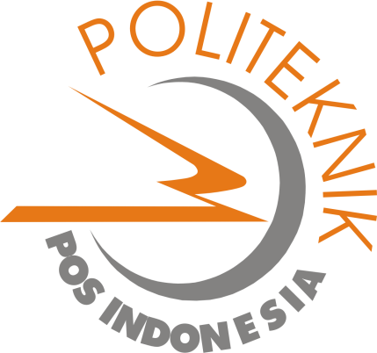

***Create by,***

**1.13.4.075 Rizki Dimas Pratama**

**DIPLOMA IV PROGRAM IN INFORMATICS ENGGINERING**

**POLITEKNIK POS INDONESIA**

**BANDUNG**

**2016**