Section 4

(Answer all questions in this section)

1. The six relational operators in Java are: Mark for Review

(1) Points

>,<,=,!,<=,>=

>,<,==,!=,<=,>= (*)

>,<,=,!=,<=,>=

>,<,=,!=,=<,=>

Correct

2. The three logic operators in Java are: Mark for Review

(1) Points

&&, ||, ! (*)

!=,=,==

&&,!=,=

&,|,=

Correct

3. What does the following program output?

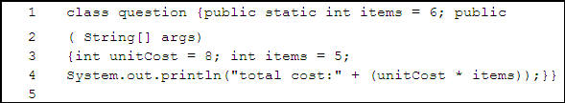

Mark for Review

(1) Points

total cost: + 40

total cost: 48

total cost: 40 (*)

"total cost: " 48

"total cost: " 40

Incorrect. Refer to Section 4 Lesson 3.

4. Which line of Java code will assign the square root of 11 to a? Mark for Review

(1) Points

double a=11^(1/2);

double a=sqrt(11);

int a=Math.sqrt(11);

double a=Math.sqrt*11;

double a=Math.sqrt(11); (*)

Correct

5. What two values can a boolean variable have? Mark for Review (1) Points

Numbers and characters

True and false (*)

Relational and logic operators

Arithmetic and logic operators

Integers and floating point types

Correct

Page 1 of 10 Next Summary

Test: Java Fundamentals Final Exam

Section 4

(Answer all questions in this section)

6. Given the following declaration, which line of Java code properly casts one type into another without data loss?

int i=3,j=4; double y=2.54; Mark for Review (1) Points

int x=(double)2.54;

double x=i/j;

double x=(double)(i/j);

double x= double i/j;

double x=(double)i/j; (*)

Correct

7. Which of the following is a legal identifier? Mark for Review

(1) Points

7up

boolean

grand Total

apple (*)

Correct

8. In a For loop the counter is not automatically incremented after each loop iteration. Code must be written to increment the counter. True or false? Mark for Review (1) Points

True (*)

False

Incorrect. Refer to Section 4 Lesson 2.

9. When the For loop condition statement is met the construct is exited. True or false? Mark for Review (1) Points

True

False (*)

Incorrect. Refer to Section 4 Lesson 2.

10. Which of the two diagrams below illustrate the general form of a Java program?

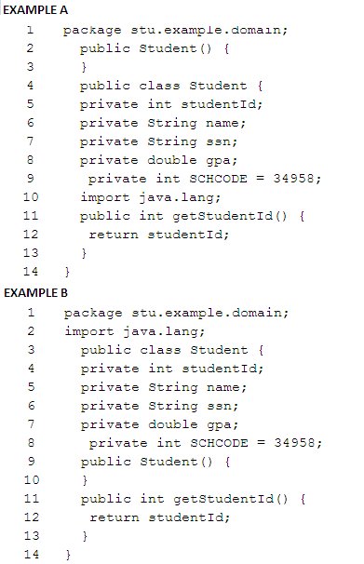

Mark for Review

(1) Points

Example A

Example B (*)

Correct

Previous Page 2 of 10 Next Summary

Test: Java Fundamentals Final Exam

Section 4

(Answer all questions in this section)

11. A counter used in a For loop cannot be initialized within the For loop header. True or false? Mark for Review (1) Points

True

False (*)

Correct

12. When you open more than one file in Eclipse the system will __________________. Mark for Review (1) Points

Close the previously opened file.

Use tabs to display all files open. (*)

Put the new file opened in a View area only.

None of the above.

Incorrect. Refer to Section 4 Lesson 1.

13. A combination of views and editors are referred to as _______________. Mark for Review

(1) Points

A workspace

A physical location

A perspective (*)

All of the above

Incorrect. Refer to Section 4 Lesson 1.

14. In Eclipse, when you run a Java Application, where may the results display? Mark for Review

(1) Points

Editor Window

Console View (*)

Debug View

Task List

None of the above

Correct

15. What are the Eclipse Editor Area and Views used for? Mark for Review (1) Points

(Choose all correct answers)

To modify elements. (*)

To navigate a hierarchy of information. (*)

To choose the file system location to delete a file.

Correct

Previous Page 3 of 10 Next Summary

Test: Java Fundamentals Final Exam

Review your answers, feedback, and question scores below. An asterisk (*) indicates a correct answer.

Section 5

16. Which of the following best describes a WHILE loop? Mark for Review (1) Points

A loop that contains a segment of code that is executed before the conditional statement is tested.

A loop that executes the code at least one time even if the conditional statement is false.

A loop that is executed repeatedly until the conditional statement is false. (*)

A loop that contains a counter in parenthesis with the conditional statement.

Correct

17. Switch statements work on all input types including, but not limited to, int, char, and String. True or false? Mark for Review (1) Points

True

False (*)

Correct

18. Why are loops useful? Mark for Review (1) Points

They save programmers from having to rewrite code.

They allow for repeating code a variable number of times.

They allow for repeating code until a certain argument is met.

All of the above. (*)

Correct

19. Which of the following correctly matches the switch statement keyword to its function? Mark for Review (1) Points

(Choose all correct answers)

switch: tells the compiler the value to compare the input against

default: signals what code to execute if the input does not match any of the cases (*)

case: signals what code is executed if the user input matches the specified element (*)

if: records the user's input and sends it to the case statements to find a possible match

switch: identifies what element will be compared to the element of the case statements to find a possible match (*)

Correct

20. What is wrong with the following class declaration?

class Account{ ;

privateint number;

privateString name;;

Account;;

}

Mark for Review (1) Points

Classes cannot include strings.

Classes cannot include mixed data types.

The constructor method has no definition. (*)

There is nothing wrong.

Correct

Previous Page 4 of 10 Next Summary

Test: Java Fundamentals Final Exam

Review your answers, feedback, and question scores below. An asterisk (*) indicates a correct answer.

Section 5

21. Which of the following may be part of a class definition? Mark for Review (1) Points

Instance variables

Instance methods

Constructors

All of the above. (*)

None of the above.

Incorrect. Refer to Section 5 Lesson 2.

22. The constructor method must always have at least one parameter. True or false? Mark for Review (1) Points

True

False (*)

Correct

23. A constructor must have the same name as the class it is declared within. True or false? Mark for Review (1) Points

True (*)

False

Correct

24. The basic unit of encapsulation in Java is the primitive data type. True or false? Mark for Review (1) Points

True

False (*)

Correct

25. In Java, an instance field referenced using the this keyword generates a compilation error. True or false? Mark for Review (1) Points

True

False (*)

Correct

Previous Page 5 of 10 Next Summary

Test: Java Fundamentals Final Exam

Review your answers, feedback, and question scores below. An asterisk (*) indicates a correct answer.

Section 5

26. A constructor is used to create objects. True or false? Mark for Review (1) Points

True (*)

False

Correct

Section 6

27. Which of the following statements adds all of the elements of the one dimensional array prices and then prints it to the screen? Mark for Review (1) Points

a) for(int i=0;i<prices.length;i++)

System.out.println(prices[i]+1);

b) System.out.println(prices);

c) int total

for(int i=1;i total+=prices[i];

System.out.println(total); (*)

d) int total=0;

for(int i=1;i total+=prices[i];

Incorrect. Refer to Section 6 Lesson 1.

28. The following array declaration is valid. True or false?

int[] y = new int[5]; Mark for Review (1) Points

True (*)

False

Correct

29. Which of the following statements is not a valid array declaration? Mark for Review

(1) Points

int number[];

float []averages;

double marks[5];

counter int[]; (*)

Incorrect. Refer to Section 6 Lesson 1.

30. What is the output of the following segment of code?

int num[]={9,8,7,6,5,4,3,2,1};

for(int i=0;i<9;i=i+3)

System.out.print(num[i]); Mark for Review

(1) Points

9630

963 (*)

987654321

97531

This code doesn't compile.

Correct

Previous Page 6 of 10 Next Summary

Test: Java Fundamentals Final Exam

Review your answers, feedback, and question scores below. An asterisk (*) indicates a correct answer.

Section 6

31. Consider the following code snippet.

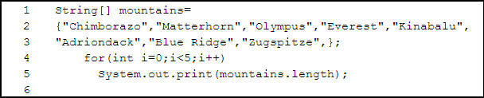

What is printed? Mark for Review (1) Points

88888 (*)

88888888

1010778

101077810109

ArrayIndexOutofBoundsException is thrown

Incorrect. Refer to Section 6 Lesson 2.

32. The following code is an example of instantiating a String object:

String str = String( "Hello" );

True or false? Mark for Review (1) Points

True

False (*)

Incorrect. Refer to Section 6 Lesson 2.

33. Suppose that str1 and str2 are two strings. Which of the statements or expressions are valid? Mark for Review (1) Points

String str3 = str1 - str2;

str1 += str2; (*)

str1 >= str2

Str1 -= str2;

Correct

34. The == operator tests if two String references are pointing to the same String object. True or false? Mark for Review (1) Points

True (*)

False

Correct

35. What does it mean to catch an exception? Mark for Review (1) Points

It means you have fixed the error.

It means to throw it.

It means to handle it. (*)

It means there was never an exception in your code.

Correct

Previous Page 7 of 10 Next Summary

Test: Java Fundamentals Final Exam

Review your answers, feedback, and question scores below. An asterisk (*) indicates a correct answer.

Section 6

36. A logic error occurs if an unintentional semicolon is placed at the end of a loop initiation because the interpreter reads this as the only line inside the loop, a line that does nothing. Everything that follows the semicolon is interpreted as code outside of the loop. True or false? Mark for Review (1) Points

True

False (*)

Incorrect. Refer to Section 6 Lesson 3.

37. Which of the following correctly matches the symbol with its function? Mark for Review

(1) Points

(Choose all correct answers)

== (two equal signs) compares values of primitive types such as int or char. (*)

== (two equal signs) compares the values of non-primitive objects.

== (two equal signs) compares the memory location of non-primitive objects. (*)

= (single equals sign) compares the value of primitive types such as int or char.

.equals() compares the value of non-primitive objects. (*)

Incorrect. Refer to Section 6 Lesson 3.

38. What is wrong with this code?

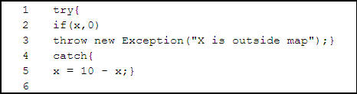

Mark for Review (1) Points

It is missing a semicolon.

It does not handle the exception.

It gives you an out of bounds exception.

There is nothing wrong with this code. (*)

Correct

Section 7

(Answer all questions in this section)

39. Identify the correct way to declare an abstract class. Mark for Review (1) Points

abstract public class ClassName{...}

public abstract ClassName(...)

public class abstract ClassName(...)

public abstract class ClassName{...} (*)

Correct

40. Which of the following are true about abstract methods? Mark for Review (1) Points

(Choose all correct answers)

They cannot have a method body. (*)

They must be overridden in a non-abstract subclass. (*)

They must be declared in an abstract class. (*)

They may contain implementation.

They must be overloaded.

Correct

Previous Page 8 of 10 Next Summary

Test: Java Fundamentals Final Exam

Review your answers, feedback, and question scores below. An asterisk (*) indicates a correct answer.

Section 7

(Answer all questions in this section)

41. What is true about the Object class? Mark for Review (1) Points

(Choose all correct answers)

It is the highest superclass. (*)

It extends other classes.

Its methods can be overridden in subclasses. (*)

Its methods can be overloaded in subclasses. (*)

Correct

42. An access modifier is a keyword that allows subclasses to access methods, data, and constructors from their parent class. True or false? Mark for Review (1) Points

True (*)

False

Correct

43. Which of the following correctly describes an Is-A relationship? Mark for Review

(1) Points

A helpful term used to conceptualize the relationships among nodes or leaves in an inheritance hierarchy. (*)

A programming philosophy that promotes simpler, more efficient coding by using exiting code for new applications.

It restricts access to a specified segment of code.

A programming philosophy that promotes protecting data and hiding implementation in order to preserve the integrity of data and methods.

Correct

44. If a variable in a superclass is private, could it be directly accessed or modified by a subclass? Why or why not? Mark for Review (1) Points

Yes. A subclass inherits full access to all contents of its super class.

Yes. Any variable passed through inheritance can be changed, but private methods cannot.

No. A private variable can only be modified by the same class with which it is declared regardless of its inheritance. (*)

No. Nothing inherited by the super class can be changed in the subclass.

Correct

45. Which of the following are access specifiers? Mark for Review (1) Points

(Choose all correct answers)

protected (*)

public (*)

secured

default (no access modifier) (*)

private (*)

Correct

Previous Page 9 of 10 Next Summary

Test: Java Fundamentals Final Exam

Review your answers, feedback, and question scores below. An asterisk (*) indicates a correct answer.

Section 7

(Answer all questions in this section)

46. Which of the following correctly defines overloading? Mark for Review (1) Points

Having more than one constructor with the same name but different arguments. (*)

Having more than one constructor with different names and the same arguments.

A variable argument method that returns an array.

A type of access specifier that only allows access from inside the same class.

Correct

47. Which of the following is the correct way to code a method with a return type an object Automobile? Mark for Review (1) Points

a) Automobile upgrade(String carA){

carA="Turbo";

return carA;}

b) Automobile upgrade(Automobile carA){

carA.setTurbo("yes");

return carA;} (*)

c) String upgrade(String carA){

carA="Turbo";

return carA;}

d) upgrade(Automobile carA) Automobile{

carA.setTurbo("yes");

return carA;}

None of the above. It is not possible to return an object.

Correct

48. Static methods can't act like "setter" methods. True or false? Mark for Review

(1) Points

True

False (*)

Incorrect. Refer to Section 7 Lesson 2.

49. Static classes are designed as thread safe class instances. True or false? Mark for Review

(1) Points

True

False (*)

Correct

50. Static methods can read instance variables. True or false? Mark for Review (1) Points

True

False (*)

Correct

Previous Page 10 of 10 Summary