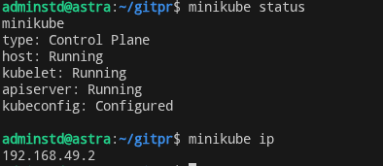
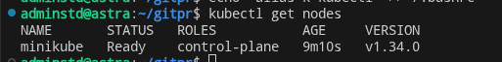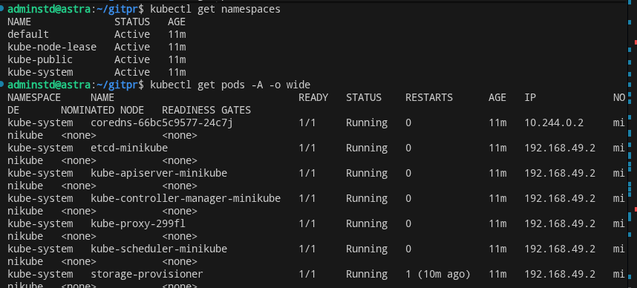
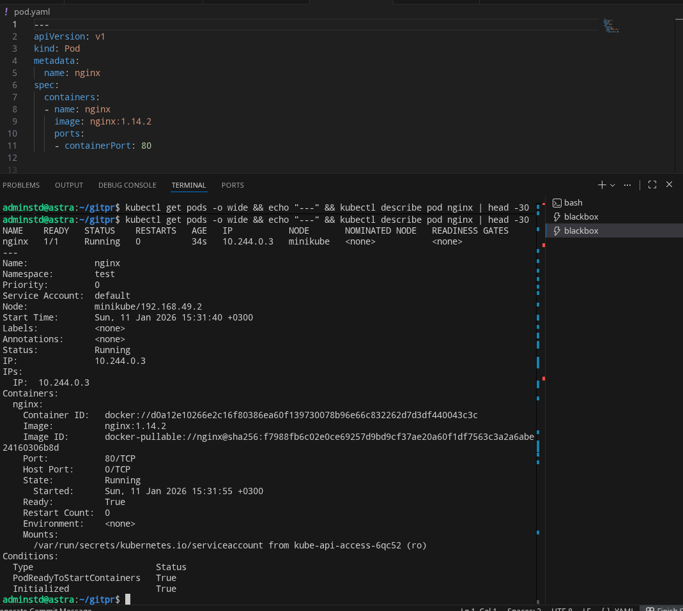
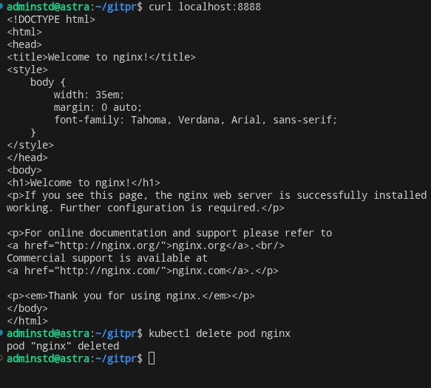

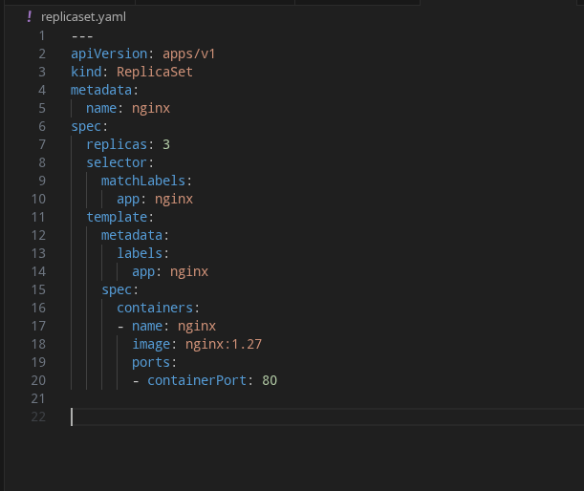
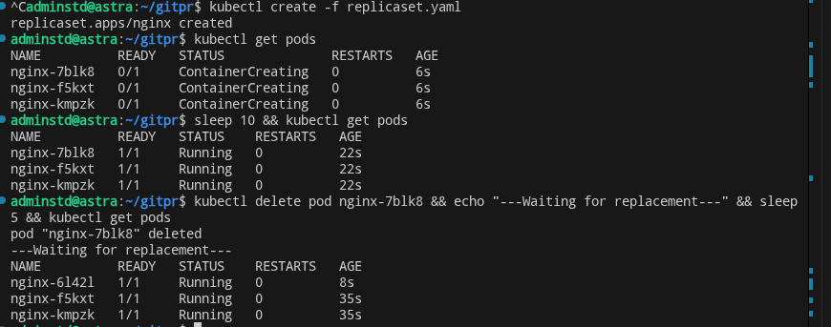
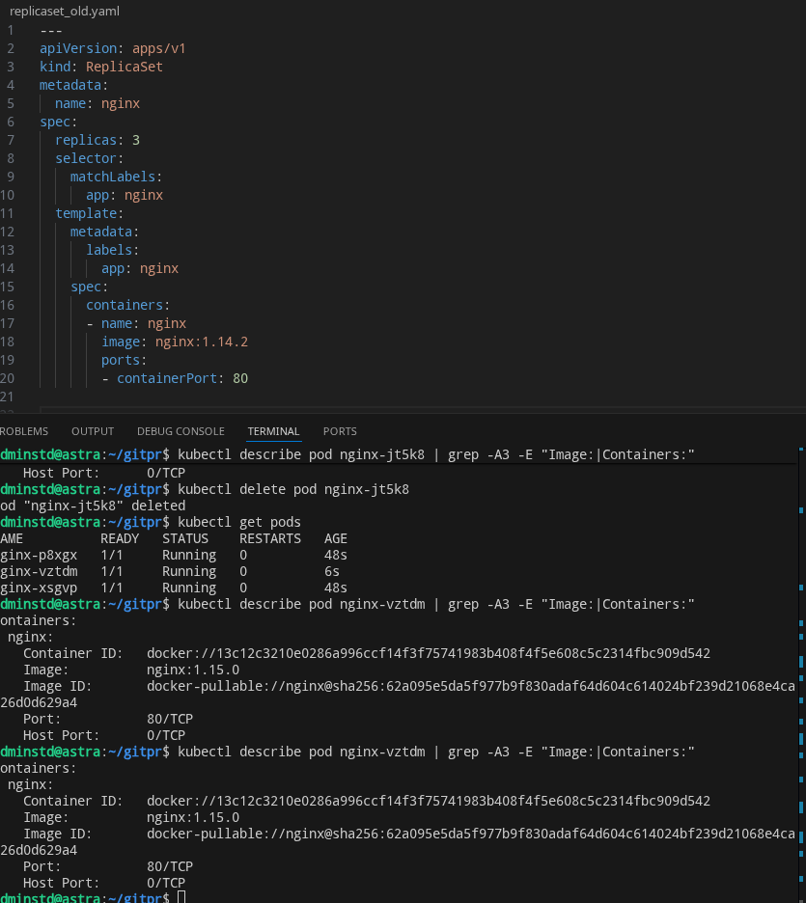
Почему podes???? в методичке это как?
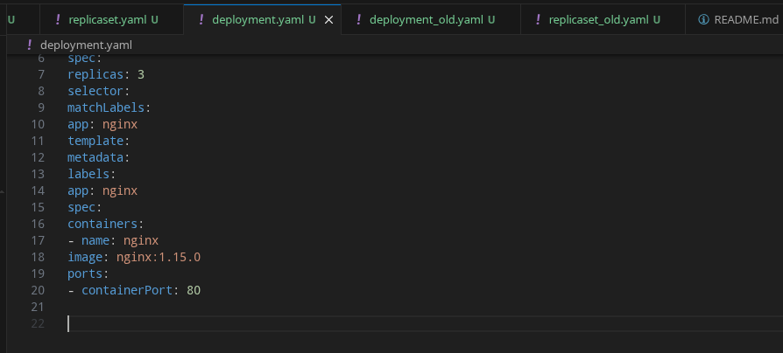

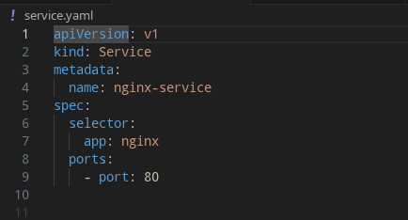

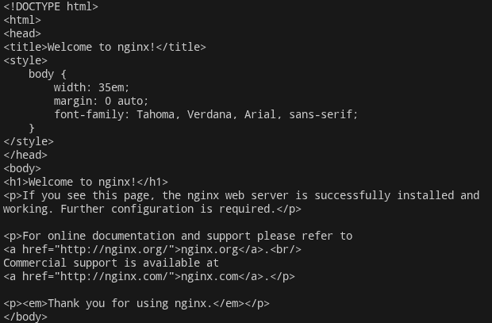

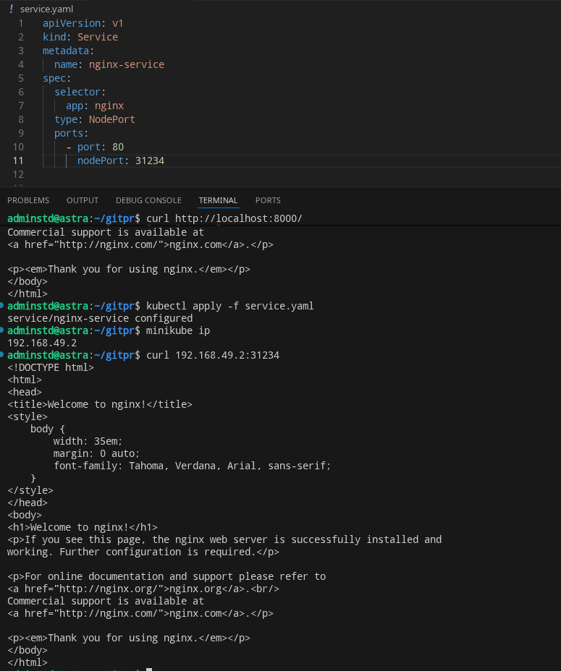
Вопрос, почему тогда в лабнике без пробела????
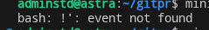

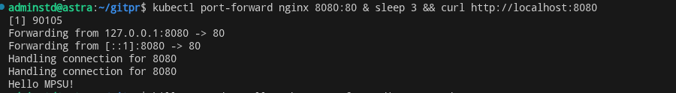

Так ну это ещё ладно. А вот это 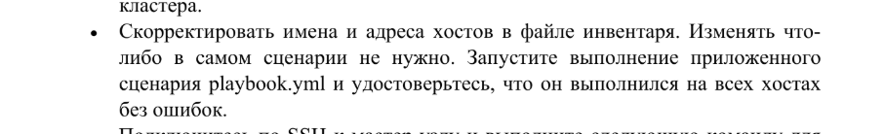
docker run --rm -e ANSIBLE_HOST_KEY_CHECKING=False -v c:/alvs:/ansible williamyeh/ansible:ubuntu18.04 ansible-playbook -i /ansible/inventory.ini /ansible/playbook.yml
ssh adminstd@192.168.1.74
sudo tee /etc/kubernetes/kubeadm-config.yaml << 'EOF'
apiVersion: kubeadm.k8s.io/v1beta3
kind: InitConfiguration
nodeRegistration:
criSocket: "unix:///var/run/dockershim/dockershim.sock"
kubeletExtraArgs:
cgroup-driver: "systemd"
---
apiVersion: kubeadm.k8s.io/v1beta3
kind: ClusterConfiguration
kubernetesVersion: "v1.24.0"
controlPlaneEndpoint: "192.168.1.74:6443"
apiServer:
extraArgs:
authorization-mode: "Node,RBAC"
networking:
podSubnet: "10.244.0.0/16"
serviceSubnet: "10.96.0.0/12"
dnsDomain: "cluster.local"
imageRepository: "registry.k8s.io"
EOF
apiVersion: kubeadm.k8s.io/v1beta3
kind: InitConfiguration
nodeRegistration:
criSocket: "unix:///var/run/dockershim/dockershim.sock"
kubeletExtraArgs:
cgroup-driver: "systemd"
---
apiVersion: kubeadm.k8s.io/v1beta3
kind: ClusterConfiguration
kubernetesVersion: "v1.24.0"
controlPlaneEndpoint: "192.168.1.74:6443"
apiServer:
extraArgs:
authorization-mode: "Node,RBAC"
networking:
podSubnet: "10.244.0.0/16"
serviceSubnet: "10.96.0.0/12"
dnsDomain: "cluster.local"
imageRepository: "registry.k8s.io"
Возможно это не надо, покане понятно
sudo /usr/local/bin/kubeadm init --config /etc/kubernetes/kubeadm-config.yaml --ignore-preflight-errors=all
sudo apt-get install -y conntrack socat
sudo curl -L https://github.com/kubernetes-sigs/cri-tools/releases/download/v1.24.0/crictl-v1.24.0-linux-amd64.tar.gz | sudo tar zx -C /usr/local/bin

Топ 10 анекдотов
1 место новый куб не использует докер
Пу пу пу а использует cri-docker

adminstd@server:~$ sudo /usr/local/bin/kubeadm init --config /etc/kubernetes/kubeadm-config.yaml --ignore-preflight-errors=all
[init] Using Kubernetes version: v1.24.0
[preflight] Running pre-flight checks
[WARNING Port-6443]: Port 6443 is in use
[WARNING Port-10259]: Port 10259 is in use
[WARNING Port-10257]: Port 10257 is in use
[WARNING FileAvailable--etc-kubernetes-manifests-kube-apiserver.yaml]: /etc/kubernetes/manifests/kube-apiserver.yaml already exists
[WARNING FileAvailable--etc-kubernetes-manifests-kube-controller-manager.yaml]: /etc/kubernetes/manifests/kube-controller-manager.yaml already exists
[WARNING FileAvailable--etc-kubernetes-manifests-kube-scheduler.yaml]: /etc/kubernetes/manifests/kube-scheduler.yaml already exists
[WARNING FileAvailable--etc-kubernetes-manifests-etcd.yaml]: /etc/kubernetes/manifests/etcd.yaml already exists
[WARNING SystemVerification]: missing optional cgroups: blkio
[WARNING Port-10250]: Port 10250 is in use
[WARNING Port-2379]: Port 2379 is in use
[WARNING Port-2380]: Port 2380 is in use
[WARNING DirAvailable--var-lib-etcd]: /var/lib/etcd is not empty
[preflight] Pulling images required for setting up a Kubernetes cluster
[preflight] This might take a minute or two, depending on the speed of your internet connection
[preflight] You can also perform this action in beforehand using 'kubeadm config images pull'
[certs] Using certificateDir folder "/etc/kubernetes/pki"
[certs] Using existing ca certificate authority
[certs] Using existing apiserver certificate and key on disk
[certs] Using existing apiserver-kubelet-client certificate and key on disk
[certs] Using existing front-proxy-ca certificate authority
[certs] Using existing front-proxy-client certificate and key on disk
[certs] Using existing etcd/ca certificate authority
[certs] Using existing etcd/server certificate and key on disk
[certs] Using existing etcd/peer certificate and key on disk
[certs] Using existing etcd/healthcheck-client certificate and key on disk
[certs] Using existing apiserver-etcd-client certificate and key on disk
[certs] Using the existing "sa" key
[kubeconfig] Using kubeconfig folder "/etc/kubernetes"
[kubeconfig] Using existing kubeconfig file: "/etc/kubernetes/admin.conf"
[kubeconfig] Using existing kubeconfig file: "/etc/kubernetes/kubelet.conf"
[kubeconfig] Using existing kubeconfig file: "/etc/kubernetes/controller-manager.conf"
[kubeconfig] Using existing kubeconfig file: "/etc/kubernetes/scheduler.conf"
[kubelet-start] Writing kubelet environment file with flags to file "/var/lib/kubelet/kubeadm-flags.env"
[kubelet-start] Writing kubelet configuration to file "/var/lib/kubelet/config.yaml"
[kubelet-start] Starting the kubelet
[control-plane] Using manifest folder "/etc/kubernetes/manifests"
[control-plane] Creating static Pod manifest for "kube-apiserver"
[control-plane] Creating static Pod manifest for "kube-controller-manager"
[control-plane] Creating static Pod manifest for "kube-scheduler"
[etcd] Creating static Pod manifest for local etcd in "/etc/kubernetes/manifests"
[wait-control-plane] Waiting for the kubelet to boot up the control plane as static Pods from directory "/etc/kubernetes/manifests". This can take up to 4m0s
[apiclient] All control plane components are healthy after 0.030792 seconds
[upload-config] Storing the configuration used in ConfigMap "kubeadm-config" in the "kube-system" Namespace
[kubelet] Creating a ConfigMap "kubelet-config" in namespace kube-system with the configuration for the kubelets in the cluster
[upload-certs] Skipping phase. Please see --upload-certs
[mark-control-plane] Marking the node server as control-plane by adding the labels: [node-role.kubernetes.io/control-plane node.kubernetes.io/exclude-from-external-load-balancers]
[mark-control-plane] Marking the node server as control-plane by adding the taints [node-role.kubernetes.io/master:NoSchedule node-role.kubernetes.io/control-plane:NoSchedule]
[bootstrap-token] Using token: g9fcre.jk0j4b71k09dqpp3
[bootstrap-token] Configuring bootstrap tokens, cluster-info ConfigMap, RBAC Roles
[bootstrap-token] Configured RBAC rules to allow Node Bootstrap tokens to get nodes
[bootstrap-token] Configured RBAC rules to allow Node Bootstrap tokens to post CSRs in order for nodes to get long term certificate credentials
[bootstrap-token] Configured RBAC rules to allow the csrapprover controller automatically approve CSRs from a Node Bootstrap Token
[bootstrap-token] Configured RBAC rules to allow certificate rotation for all node client certificates in the cluster
[bootstrap-token] Creating the "cluster-info" ConfigMap in the "kube-public" namespace
[kubelet-finalize] Updating "/etc/kubernetes/kubelet.conf" to point to a rotatable kubelet client certificate and key
[addons] Applied essential addon: CoreDNS
[addons] Applied essential addon: kube-proxy

Your Kubernetes control-plane has initialized successfully!

To start using your cluster, you need to run the following as a regular user:

mkdir -p $HOME/.kube
sudo cp -i /etc/kubernetes/admin.conf $HOME/.kube/config
sudo chown $(id -u):$(id -g) $HOME/.kube/config

Alternatively, if you are the root user, you can run:

export KUBECONFIG=/etc/kubernetes/admin.conf

You should now deploy a pod network to the cluster.
Run "kubectl apply -f [podnetwork].yaml" with one of the options listed at:
https://kubernetes.io/docs/concepts/cluster-administration/addons/

You can now join any number of control-plane nodes by copying certificate authorities
and service account keys on each node and then running the following as root:

kubeadm join 192.168.1.74:6443 --token g9fcre.jk0j4b71k09dqpp3 \
--discovery-token-ca-cert-hash sha256:5c2445614bb70c64f368369d931bae9afbfca7d418dab27eff81c114e4a16868 \
--control-plane

Then you can join any number of worker nodes by running the following on each as root:

kubeadm join 192.168.1.74:6443 --token g9fcre.jk0j4b71k09dqpp3 \
--discovery-token-ca-cert-hash sha256:5c2445614bb70c64f368369d931bae9afbfca7d418dab27eff81c114e4a16868

