Laboratory Work #3
on PPC
“Distributed programming”

Done by: Ursu Dumitru
Verified by: Ciorbă Dumitru

Chișinău, 2014
Task:
Se cere un program care sa creeze 15 threaduri 'studenti'. Programul principal (adica profesorul) are o lista de intrebari (adica un vector cu 15 valori numerice arbitrare). Studenti intra pe rand la examen si primesc cate o intrebare la care trebuie sa raspunda. Raspunsul corect este dat de o functie f(k) pe care doar profesorul o cunoaste (pentru ca studentii nu au fost la cursuri). Deci studentul examinat va raspunde cu o valoare aleatoare, incercand sa ghiceasca si primind o nota in functie de cat de aproape a fost de raspunsul corect. In final, dupa ce toti studenti au fost examinati, profesorul va chema in sala primii 3 studenti cu cele mai bune note pentru a le nota numele (adica threadurile studenti vor afisa pe ecran numele/numarul lor, plini de bucurie).

Domain of the problem:
We have lots of threads that need to be syncronized: it's time to use a mutex and a Condition Variable! ConditionVariable objects augment class Mutex. Using condition variables, it is possible to suspend while in the middle of a critical section until a resource becomes available.

Source code analysis:
require 'thread'

def examen(student, true_answer)
# the student and the "distance" of it's guess are returned
[student[0], (student[1] - true_answer).abs]
end

def f(k)
k * k + 20
end

questions = Array.new 15
questions.map! { rand 100 }
We store some random numbers as the questions...

mutex = Mutex.new
teacher = ConditionVariable.new
$answers = []
students = []
15.times do |n|
students << Thread.new(n) {
# one student at a time, please
mutex.synchronize {
# wait the teacher
teacher.wait(mutex)
$answers << [n, rand(9000)]
}
}
end
To find out who are the best students, we make a register, where we store the number of the student, and how close he was to guess the answer.

the_register = []
15.times do |n|
# the teacher gives the signal that it's done with the student
teacher.signal
end
teacher.broadcast

students.each(&:join)
$answers.each {|answer| number = rand 15; the_register << examen(answer, f(questions[number])) }

# sorting the registry
the_register.sort_by!{|e| e[1]}

# and, the best students are...
the_register[0..2].each do |best|
puts "#{best[0]} : #{best[1]} <- plin de bucurie"
end

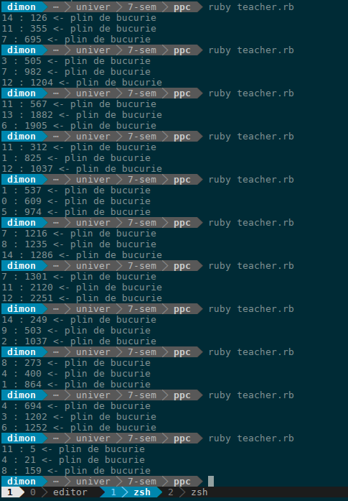

Conclusion:
Doing this laboratory work I've learned how to manage an array of workers (students), and how to make sure they work in the fashion I need.
Bibliography:
1. http://ruby-doc.org/stdlib-2.0.0/libdoc/thread/rdoc/ConditionVariable.html
2. http://www.ruby-doc.org/core-2.0.0/Thread.html

