Robotic Gamma-ray spectrometer
based on HPGe detector

Delivery Set and Price
Item | Item price, EUR |  | Q-ty | Unit price, EUR
Gamma-ray detection unit | 189 070.00 |  | 1 | 189 070.00
HPGe detector GCDX-50190 in U-type cryostat with LN2 |  |  | 1 | 189 070.00
State-Of-Health Preamplifier SHP |  |  | 1 | 189 070.00
Cable set with connectors |  |  | 1 | 189 070.00
State-Of-Health Preamplifier |  |  | 1 | 189 070.00
Electronics |  |  | 1 | 189 070.00
Multichannel Analyzer Boson |  |  | 1 | 189 070.00
Software packages |  |  | 1 | 189 070.00
Analytical software GammaPRO |  |  | 1 | 189 070.00
Sample management software |  |  | 1 | 189 070.00
Special purpose software |  |  | 1 | 189 070.00
HPGe detector characterization |  |  | 1 | 189 070.00
Automatic sample changer based on Robot arm |  |  | 1 | 189 070.00
Robot arm with controller |  |  | 1 | 189 070.00
Table for sample placement |  |  | 1 | 189 070.00
Safety cabinet |  |  | 1 | 189 070.00
Barcode printer and barcode scanner |  |  | 1 | 189 070.00
Low background lead shielding |  |  | 1 | 189 070.00
Modern and up-to-date working station |  |  | 1 | 189 070.00
Other |  |  | 1 | 189 070.00
Computer I7 with 8Gb memory and 512 Gb hard disk |  |  | 1 | 189 070.00
Installation commissioning and training (visit of 1-2 specialist for 10-11 working days)** | 13 160.00 |  | 1 | 13 160.00
Total price, EUR |  |  |  | 202 230.00
Options
Advanced software package MCC-MT |  | + 6 240.00 | 1 | + 6 240.00
Electro-Mechanical cooling system Monolith |  | + 22 200.00 | 1 | + 22 200.00

Terms and Conditions
Delivery conditions | FCA, Riga
Payment terms: | Wire transfer, prepayment
Delivery terms: | 9-12 months ARO *
Warranty on labor and parts: | 1 year
Quotation validity: | 4 months
Country of Origin | Latvia
* - to be specifies in case of order.
**- Expected assistance from the End-User (unpacking and operational activities)

Gamma-ray detection unit GCDX-50190

APPLICATION
Gamma-ray detection unit based on p-type high-purity germanium (HPGe) detector is cooled with integrated electrical cooler and is designed for transformation of gamma-quanta flux into electrical signals, carrying the information about their energies. It can be used in nuclear energetics, environmental control, in industry and scientific research, medicine and for other applications.

TECHNICAL PARAMETERS

# | Parameter | Value
 | Relative registration efficiency (with respect to 3’’ x 3’’ NaI detector and Co-60 source mounted 25 cm above the detector) at 1.33 MeV γ-photon,% | > 50
 | Energy resolution, keV  - 122 keV  - 1.33 MeV | < 0.95  < 1.9
 | Peak shape  • FWTM/FWHM  • FW.02M/FWHM | < 1.9  < 2.65
 | Peak to Compton ratio | 64 : 1
 | Energy range of detector operation, keV | 10 keV-10 MeV
 | End cap diameter | 95 mm
 | Material of end cap window | Carbon Fiber
 | Cooling time of the detector, hours | 12
 | Autonomous operation time at filled Dewar, not less | > 15 days
 | Dewar volume | > 30 l
Preamplifier (built – in detector capsule) with cooled FET and resistive feedback
- Preamplifier power supply is ±12 V with 9 pin connector compatible with NIM standards
- TTL signal to shut down the HV: - detector warm -0V; - detector cold: +5V
- HV INHIBIT – BNC
2LEDs on the separate cable end from preamplifier:
- GREEN – detector is cooled down
- RED – high count rate
Cable connectors:
- 9 pin – PA Power supply;
- 11 SHV - detector power supply;
- BNC - signal output of detector
* measured with BSI multi-channel analyzer.

State of Health Preamplifier (SHP)

State of Health Preamplifier (SHP) is a low noise and fast resistive-feedback preliminary amplifier intended for operation within gamma- and X-ray Detection Unit based on HPGe detector.
SHP module allows to perform monitoring of detection unit basic parameters in real-time mode or per request of the operator. Analysis of the performance in the long run allows to predict possible failure of the detector and to perform timely preventive maintenance.

SHP module provides information for basic users:
- Preamplifier serial number
- Detector serial number
- Detector type
- Cryostat model
- Recommended HV value
- HV polarity
- Output signal polarity
- Shaping time recommended value
- Flat top time recommended value
- ADC parameters
- Recommended cooling time

SHP module provides information for advanced users:
- FET voltage
- FET current
- FET drain voltage
- Preamplifier output voltage
- Resistive-feedback output voltage of the preamplifier
- Preamplifier power supply voltage
- Detector leakage current
- Test generator frequency
- Test generator amplitude
- HPGe crystal temperature
- SHP module internal temperature

SHP module has two operating modes:
- Constant parameter measurement. In this mode ADC of SHP module is constantly monitoring parameters listed above.
- Parameter measurement per request. In this mode ADC of SHP module is in standby mode before while user is not monitoring parameters listed above.

Multichannel analyser

COMPLETE SET

- Spectrometric device with software;
- Color LCD display with touchscreen;
- HV power supply unit;
- Preamplifier power supply unit (+/-12 V; +/-24 V);
- Spectrometer state display indicator;
- Connectors: linear input (SCD); control output analogue and digital. Available interface to connect to computer: USB, LAN, RS-232. Connector for preamplifier power supply unit. Two HV connectors for the detector power supply. GATE signal connector. Outer power supply connector;
- Outer supply unit for AD current;
- Spectrometric device “BOSON” has control for all operation modes by the program installed in remote computer;
- Cable set;

FEATURES
- Spectrometric device “BOSON” acquires and displays spectra with overlapping by energy up to 1000 times.
- No resolution deterioration at operation in the beginning of spectrum energy range.
- Stable operation with preamplifiers of TRP type with output voltage swing up to +/- 10 V and reset duration up to 250 us.
- P/Z adjustment.
- Improved dead time correction.
- Setting and control of all parameters using colour LCD display with touch screen.
- Complete remote control of “Boson” via software on PC.
- Analogue time dependent shaping.
- Spectrum stabilization.
- Dead time correction.
- Operation with preamplifier TPR.
- Analog time dependent shaping.
- Dead time correction.

Analytical software GammaPRO

GammaPRO provides all the tools necessary for separate peak analysis, namely:
- Energy calibration;
- Direct peak search in spectrum and peak search considering the radionuclides and their peak energies specified in the library;
- Peak and multiplet fit by Gaussian and other functions;
- Automatic identification of peaks;
- Considering count sample density as a calculation parameter; considering background as a calculation parameter;
- Calculation of efficiency curves (efficiency calibration), FWHM calibration, peak shape calibration;

GammaPRO software enables solution of specific spectrometric problems such as:
- Calculation of activity of naturally occurring radionuclides and effective specific activity in situ and in samples calculation of conformity factors for food and materials;
- Calculation of radon flux density and volumetric activity in different conditions;
- Calculation of radionuclide activity applying methods of physical and radiochemical concentrating;
- Calculation of radionuclides activity in a human body and its organs as a part of whole body spectrometer measurements;

GammaPRO software features multiple window interface and enables a number of opportunities for spectrum analysis such as:
- Visualization of spectra and spectrum acquisition progress;
- Peak search and identification of radionuclides;
- Calculation of efficiency curves and sensitivities;
- Mathematical operations (sum, subtraction, normalization, etc.);
- Processing of set of spectra;
- Calculation of integral nonlinearity;
- Conversion into other formats and translation into other applications such as MS Word, Excel, MS Access, MatLab;
- Calculation of ambient dose equivalent rate in auto mode.

LEAD SHIELD
Cylindrical top-opening lead shield characteristics:
- 100 mm thickness of the lead walls;
- Lined with 9.0 mm copper covered with 1 mm tin;
- Outer jacket – 1.5 mm low carbon steel;
- Internal diameter – 200-220 mm (without liners);
- Inner height – 280 mm (without liners);
- Suitable for sample like Marinelli beakers, petri vessels, etc.

Automatic Sample Changer
The seven-axis robot handles a payload of up to 3kg and with, practically, unlimited reach, the robot is able to carry out a series of operations using flexible rather than hard automated solutions. In addition to a horizontal reach, the robot has the ability to reach below its base. Furthermore, the robot has a very compact turning radius, which is enabled by the robots symmetric architecture, without offset on axis 2. This ensures the robot can be mounted close to other equipment.
The Robotic spectrometer is placed on the aluminum frame made of profile, equipped with protective cabinet with plastic windows and protective sensors indicating if the door is open.
The size of the aluminum profile frame is approximately 3800mm x 1300mm x 2400mm.

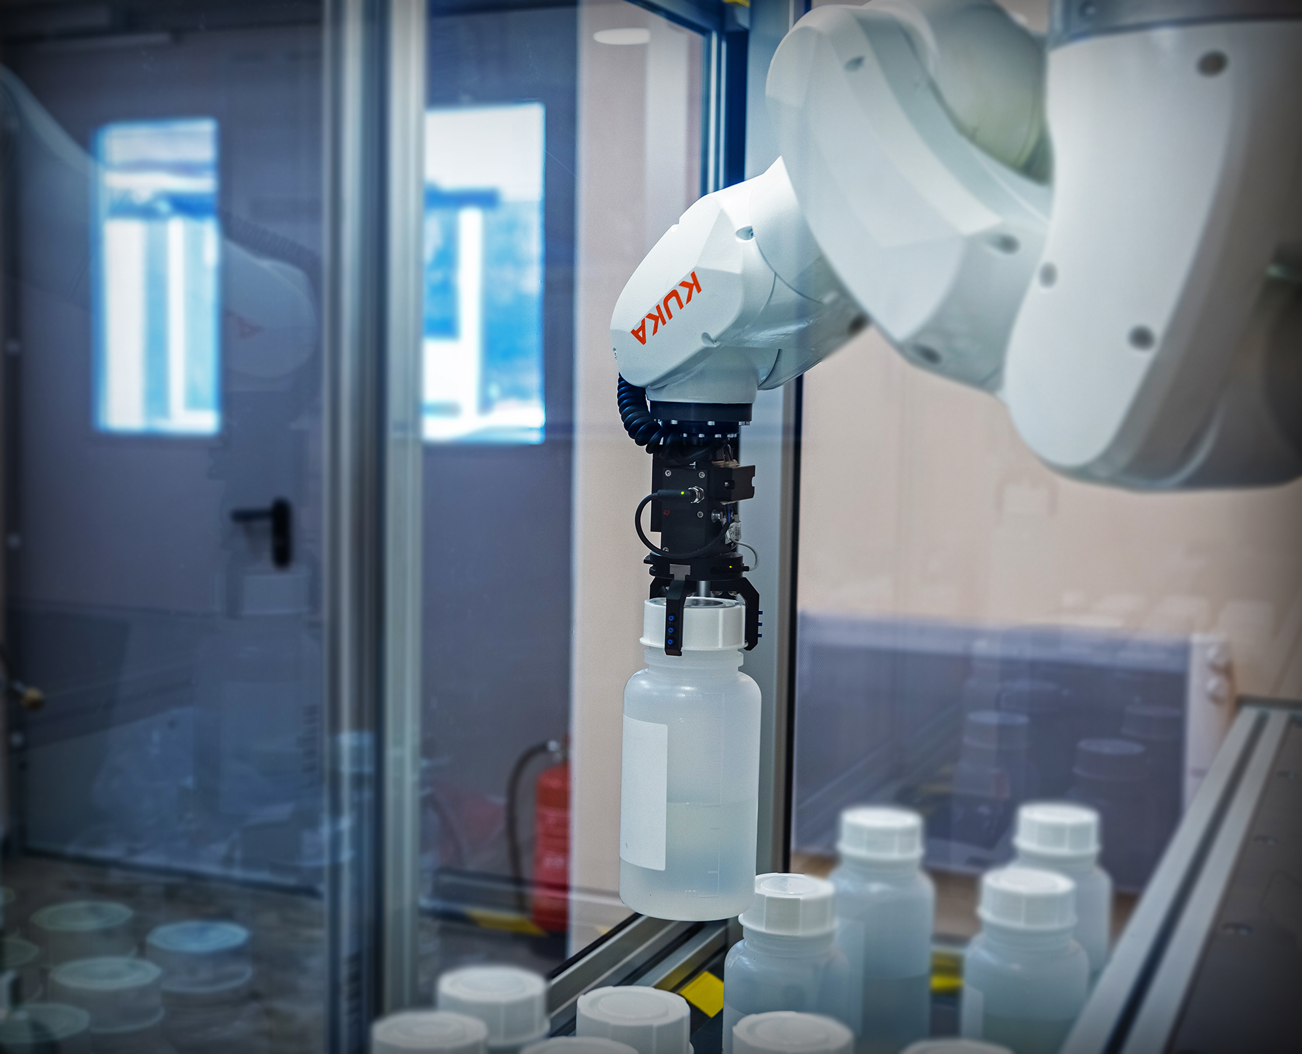
Robot arm basic characteristics:
- Seven-axis manipulator
- Machine vision
- Payload: up to 3 kg
- Reach: per request
- Fastest 7-axis robot
- Accuracy: +-0.01 mm
- Weight: 25 kg
- IP30 protected
- All motors and cablings enclosed
- Compact controller
- Sample holder tool for vessels with diameter in range 30 – 160 mm.
- Barcode Reader and Writer

To assure the correct processing of all data during the measurement and analysis process, the samples are marked by using a barcode printer that is connected to the workstation. Here all necessary information about the sample is stored in a database. Using the bar code reader, the information stored in the database is retrieved for each sample before the measurement process is started. This fully automated process delivers all necessary information for the measurement and analysis process.

Compact controller
The Compact controller delivers space saving benefits and easy commissioning through one phase power input, external connectors for all signals. It supports the state-of-the-art field busses for I/O. Sensor interface functionality, remote disk access and socket messaging are examples of the many powerful networking features. Remote monitoring of the robot is available through standard communication network (Ethernet). Advanced diagnostic methods allow fast investigation on failure as well as monitoring of the robot condition throughout the life cycle.

Barcode printer and Barcode reader
Printer is located outside of frame and intended for barcode printing and manual sticking of label on the sample before fixture is loaded inside. Reader is located inside the frame for automatic reading the sample information before loading into lead chamber.

Samples table
Samples table is designed to accommodate up to 50 samples or mote. Sample size and amount directly influence on table size. Special holding tool of Robot arm can be designed to hold:
- Marinelli beakers 1l,
- Petri vessels.

Advanced software package MCC-MT
Software package MCC-MT (Monte Carlo Calculation Multi Thread) is intended for 3D-modelling of physical experiments and calculation of radiation detectors response functions using Monte Carlo simulation method. Software MCC-MT based on multi-threading technology providing significant increasing the rate of simulation and getting fast result as spectrum.
Application
- Monte Carlo simulation spectra of gamma, beta and alpha radiation
- calibration of instruments used for ionizing radiation detection and measurements
- calculation of detection limits and minimum detectable activity of radionuclides
- determination of a characteristics of a registration system for inaccessible radioactive sources
- reduction of experimental investigations with using the hazardous ionizing radiation for human health
- obtaining clear picture of the internal processes of radiation transfer in order to optimize the design of the measuring devices and their protection
- comparative demonstration of the different systems of protection against ionizing radiation and its detection systems
- training of personnel in working with ionizing radiation detection systems without using of an expensive equipment and radioactive sources
- training of specialists in the field of measurement and protection from ionizing radiation
- acceleration, simplification and reduction in the cost of design and optimization of ionizing radiation detection systems
- characterization detectors and detection systems
Features
- high accuracy of calculations
- simplicity of using for a wide range of tasks
- detailed 3D-scene based on Open GL graphics technology providing maximum representation and visibility of modeling
- availability of replenished database of sources and materials
- possibility of creating the maximally complex measuring systems
- forming multidetector systems and schemes of coincidence
- display of the results in the form of an ideal and real spectrum
- tracing and drawing trajectories of particles during calculation process
- availability of the ready and test projects in the software package
- accounting cascade summation ('Full cascade' source type)
- using of the specified number of computer processors in order to implement multithreading and speed up the calculation
- automatic creation of efficiency curves

Workstation – PC based*
- 24 inch LCD Monitors  - CPU : core I-7 or better  - RAM : 8GB DDR3 or better  - HDD : 1 TB or better  - Uninterruptable Power Supply (UPS) for 30 minute backup (except for HPGe detector) | - ODD : SUPER-MULTI S-ATA or better  - OS : WINDOWS 10  - Laser Printer  - RAID system
* Please note that these values are for reference only. Precise specification may change to more advanced system.

Electro-Mechanical cooling system Monolith

Application

The Monolith system provides electro-mechanical cooling for HPGe detectors, eliminating the need for liquid nitrogen. Based on a Stirling cooler with a mean time to failure for thousands of hours, Monolith offers efficient, low-power operation with minimal heat output. Unlike LN2 systems, Monolith enables instant recovery after power loss and ensures continuous performance without thermal cycling. Integrated Active Vibration Cancellation maintains resolution quality close to LN2-cooled systems. The Monolith system is suitable for a range of applications requiring stable, maintenance-free cryogenic operation, including laboratory, field, and industrial environments.

# | Parameter Monolith | Value
 | Relative efficiency (with respect to 3’’ x 3’’ NaI detector and Co-60 source mounted 25 cm above the detector) at 1.33 MeV γ-photon, % | > 50
 | Energy resolution, keV  - at 122 keV  - at 1.33 MeV | < 0.95  < 1.9
 | Peak shape  •FWTM/FWHM  •FW.02M/FWHM | < 1.9  < 2.65
 | Peak to Compton ratio | 64:1
 | Energy range of detector operation, keV | 10 keV-10MeV
 | End cap diameter | 95 mm
 | Cooling time of the detector, hours | <12
 | Orientation in space | At any angle
 | AC Power supply | 230 V 50/60 Hz
 | Power consumption, max | 140 W
 | Power consumption, normal | 70 W
 | The range of the operating temperatures, ° С | 0 --- +40

