# **Application of MALDI-MS and Machine Learning to Detection of SARS-CoV-2 and non-SARS-CoV-2 Respiratory Infections.**

# Sergey Yegorov1,2^, Irina Kadyrova3 , Ilya Korshukov3,Aidana Sultanbekova3, Yevgeniya Kolesnikova3, Valentina Barkhanskaya 3, Tatiana Bashirova 6, Yerzhan Zhunusov7 ,Yevgeniya Li 7, Viktoriya Parakhina7,8,Svetlana Kolesnichenko3, Yeldar Baiken2,4,5, Bakhyt Matkarimov4, Dmitriy Vazenmiller3, Matthew S. Miller1, Gonzalo H. Hortelano2, Anar Turmuhambetova3, Antonella E. Chesca 9, Dmitriy Babenko3.

**APPENDIX**

**Table S1.** Mass spectrometry peaks selected for ML training using the Nachtigall et al. strategy (see Methods) in the South American (SA) samples (Analysis I). Shown are peak median intensities and interquartile ranges (IQR). A total of 88 peaks identical to those used by Nachtigall et al were detected and then used in Analysis I (See Table S2 for the comparison of these same 88 peaks across the dataset from Kazakhstan). p-values were calculated using the two-tailed Wilcoxon rank sum test. NCARI= non-COVID acute respiratory infection.

| **South American samples** | | | |
| --- | --- | --- | --- |
| **Peak (*m/z*)** | **NCARI, N = 151** | **SARS-CoV-2+, N = 211** | **p-value** |
| 3044 | 1.1e-04 [6.1e-05; 1.8e-04] | 6.5e-05 [1.9e-05; 1.3e-04] | <0.001*** |
| 3095 | 2.3e-04 [1.3e-04; 4.3e-04] | 1.2e-04 [6.2e-05; 2.2e-04] | <0.001*** |
| 3112 | 1.6e-04 [8.4e-05; 2.5e-04] | 1.1e-04 [5.0e-05; 1.8e-04] | <0.001*** |
| 3139 | 1.5e-04 [7.4e-05; 2.5e-04] | 1.6e-04 [5.6e-05; 2.6e-04] | 0.8 |
| 3152 | 1.2e-04 [3.4e-05; 2.5e-04] | 2.3e-04 [1.2e-04; 4.6e-04] | <0.001*** |
| 3193 | 5.5e-05 [6.9e-06; 1.6e-04] | 4.3e-05 [1.1e-05; 1.1e-04] | 0.2 |
| 3242 | 1.0e-04 [5.9e-05; 1.5e-04] | 1.1e-04 [6.5e-05; 1.7e-04] | 0.3 |
| 3256 | 8.6e-05 [3.4e-05; 1.4e-04] | 1.1e-04 [3.9e-05; 2.2e-04] | 0.023* |
| 3297 | 1.2e-04 [3.4e-05; 2.7e-04] | 1.4e-04 [4.1e-05; 3.0e-04] | 0.6 |
| 3318 | 9.6e-05 [1.3e-05; 3.2e-04] | 1.7e-04 [1.2e-05; 3.4e-04] | 0.5 |
| 3337 | 3.0e-04 [1.2e-04; 5.4e-04] | 1.7e-04 [2.6e-05; 3.2e-04] | <0.001*** |
| 3358 | 2.3e-04 [1.3e-04; 3.4e-04] | 9.9e-05 [4.1e-05; 1.7e-04] | <0.001*** |
| 3372 | 2e-03 [6.6e-04; 3.2e-03] | 1e-03 [4.8e-04; 2.5e-03] | 0.002** |
| 3392 | 3.4e-04 [1.8e-04; 5.6e-04] | 3.9e-04 [1.7e-04; 7.1e-04] | 0.2 |
| 3443 | 2.4e-03 [7.4e-04; 3.9e-03] | 1.3e-03 [5.3e-04; 3.2e-03] | 0.010* |
| 3464 | 6.6e-04 [3.2e-04; 1.3e-03] | 4.6e-04 [2.4e-04; 8.5e-04] | 0.010** |
| 3476 | 3.8e-04 [2.4e-04; 6.2e-04] | 3.5e-04 [2.0e-04; 5.5e-04] | 0.032* |
| 3487 | 1.2e-03 [5.9e-04; 2.8e-03] | 5.9e-04 [2.7e-04; 1.4e-03] | <0.001*** |
| 3516 | 4.1e-05 [0e+00; 2.6e-04] | 5.6e-05 [0e+00; 1.7e-04] | 0.9 |
| 3609 | 1.1e-04 [4.1e-05; 1.8e-04] | 1.1e-04 [4.2e-05; 1.7e-04] | 0.4 |
| 3651 | 1.1e-04 [5.5e-05; 1.8e-04] | 8.5e-05 [3.7e-05; 1.5e-04] | 0.022* |
| 3710 | 3.6e-04 [1.9e-04; 6.9e-04] | 2.7e-04 [1.1e-04; 6.8e-04] | 0.061 |
| 3732 | 9.7e-05 [2.3e-05; 1.8e-04] | 8.7e-05 [3.8e-05; 1.5e-04] | 0.8 |
| 3754 | 7.6e-05 [8.5e-06; 1.6e-04] | 1.1e-04 [1.7e-05; 2.3e-04] | 0.020* |
| 3779 | 1.5e-04 [3.5e-05; 3.1e-04] | 1.5e-04 [6.6e-05; 2.8e-04] | 0.8 |
| 3792 | 1.4e-04 [5.9e-05; 3.7e-04] | 1.4e-04 [4.2e-05; 3.0e-04] | 0.4 |
| 3804 | 1.5e-04 [3.4e-05; 3.2e-04] | 1.6e-04 [4.0e-05; 2.9e-04] | 0.7 |
| 3827 | 1.6e-04 [5.2e-05; 3.8e-04] | 1.4e-04 [4.5e-05; 2.7e-04] | 0.12 |
| 3915 | 1.4e-04 [8.0e-05; 1.9e-04] | 1.1e-04 [6.1e-05; 1.8e-04] | 0.015* |
| 3934 | 1.4e-04 [4.7e-05; 2.5e-04] | 1.5e-04 [6.8e-05; 2.3e-04] | 0.5 |
| 3981 | 1.2e-04 [5.6e-05; 2.2e-04] | 1.7e-04 [1.1e-04; 2.6e-04] | <0.001*** |
| 4138 | 3.2e-04 [1.7e-04; 7.2e-04] | 2.0e-04 [1.0e-04; 3.9e-04] | <0.001*** |
| 4160 | 2.5e-04 [1.0e-04; 7.0e-04] | 1.6e-04 [8.6e-05; 3.2e-04] | <0.001*** |
| 4192 | 1.8e-04 [4.5e-05; 4.3e-04] | 2.2e-04 [3.9e-05; 7.1e-04] | 0.2 |
| 4229 | 1.4e-04 [5.6e-05; 3.2e-04] | 1.5e-04 [8.7e-05; 2.7e-04] | 0.5 |
| 4356 | 2.8e-04 [1.7e-04; 4.1e-04] | 2.9e-04 [1.9e-04; 4.1e-04] | 0.5 |
| 4374 | 2.1e-04 [1.2e-04; 3.9e-04] | 2.1e-04 [1.2e-04; 6.2e-04] | 0.6 |
| 4393 | 1.5e-04 [8.4e-05; 2.7e-04] | 1.2e-04 [5.2e-05; 2.7e-04] | 0.2 |
| 4428 | 7.5e-05 [2.0e-05; 1.7e-04] | 7.0e-05 [2.1e-05; 1.3e-04] | 0.5 |
| 4473 | 9.9e-05 [4.4e-05; 1.5e-04] | 9.0e-05 [3.9e-05; 1.4e-04] | 0.3 |
| 4532 | 5.7e-05 [1.8e-05; 1.3e-04] | 1.3e-04 [8.4e-05; 2.1e-04] | <0.001*** |
| 4551 | 1.8e-04 [8.3e-05; 5.6e-04] | 2.4e-04 [9.1e-05; 3.7e-04] | 0.8 |
| 4574 | 1.1e-04 [4.1e-05; 1.7e-04] | 1.4e-04 [4.6e-05; 2.3e-04] | 0.032* |
| 4636 | 9.3e-05 [4.9e-05; 1.8e-04] | 1.2e-04 [7.0e-05; 2.0e-04] | 0.021* |
| 4715 | 9.6e-05 [4.5e-05; 2.0e-04] | 1.2e-04 [6.1e-05; 2.2e-04] | 0.11 |
| 4738 | 5.7e-05 [1.7e-05; 1.6e-04] | 6.0e-05 [2.0e-05; 1.4e-04] | 0.8 |
| 4811 | 5.3e-05 [1.4e-05; 1.2e-04] | 5.0e-05 [2.3e-05; 8.8e-05] | 0.4 |
| 4842 | 1.3e-04 [5.2e-05; 2.4e-04] | 1.2e-04 [5.7e-05; 2.4e-04] | 0.9 |
| 4901 | 9.0e-05 [2.5e-05; 2.1e-04] | 1.3e-04 [5.5e-05; 2.5e-04] | 0.012* |
| 4940 | 2.5e-04 [1.2e-04; 4.6e-04] | 2.1e-04 [1.3e-04; 3.8e-04] | 0.6 |
| 4966 | 1.0e-03 [5.6e-04; 2.2e-03] | 6.4e-04 [3.8e-04; 1.4e-03] | <0.001*** |
| 4986 | 8.0e-04 [4.2e-04; 1.4e-03] | 6.9e-04 [3.4e-04; 1.3e-03] | 0.3 |
| 5005 | 4.2e-04 [2.1e-04; 7.5e-04] | 3.6e-04 [1.6e-04; 7.0e-04] | 0.2 |
| 5047 | 9.1e-05 [2.3e-05; 2.0e-04] | 7.7e-05 [1.6e-05; 1.6e-04] | 0.3 |
| 5147 | 5.7e-05 [8.6e-06; 2.2e-04] | 6.0e-05 [9.2e-06; 1.8e-04] | 0.5 |
| 5218 | 1.7e-04 [7.9e-05; 3.0e-04] | 1.3e-04 [5.1e-05; 2.8e-04] | 0.036* |
| 5236 | 2.9e-04 [8.0e-05; 7.6e-04] | 1.4e-04 [4.9e-05; 5.8e-04] | 0.005** |
| 5256 | 1.1e-04 [2.9e-05; 2.6e-04] | 8.1e-05 [2.7e-05; 2.1e-04] | 0.2 |
| 5285 | 4.1e-05 [2.4e-06; 1.5e-04] | 4.7e-05 [1.6e-05; 1.1e-04] | 0.3 |
| 5382 | 2.1e-04 [1.0e-04; 3.7e-04] | 1.6e-04 [7.2e-05; 3.0e-04] | 0.012* |
| 5402 | 1.4e-04 [7.2e-05; 2.5e-04] | 1.3e-04 [7.2e-05; 2.8e-04] | 0.9 |
| 5423 | 2.6e-04 [1.3e-04; 5.3e-04] | 2.1e-04 [1.2e-04; 4.3e-04] | 0.11 |
| 5530 | 7.0e-05 [1.6e-05; 1.8e-04] | 5.7e-05 [1.5e-05; 1.7e-04] | 0.6 |
| 5594 | 1.1e-04 [3.1e-05; 1.8e-04] | 9.6e-05 [4.6e-05; 3.4e-04] | 0.10 |
| 5869 | 2.2e-04 [1.4e-04; 5.3e-04] | 2.5e-04 [1.3e-04; 4.9e-04] | 0.9 |
| 5950 | 5.2e-05 [2.1e-05; 1.0e-04] | 7.8e-05 [3.1e-05; 1.5e-04] | 0.004** |
| 6192 | 1.6e-04 [1.2e-04; 2.3e-04] | 2.3e-04 [1.1e-04; 3.7e-04] | <0.001*** |
| 6361 | 1.2e-04 [4.5e-05; 2.3e-04] | 8.9e-05 [3.4e-05; 1.6e-04] | 0.008** |
| 6639 | 8.8e-05 [4.2e-05; 1.6e-04] | 9.0e-05 [5.0e-05; 1.5e-04] | 0.9 |
| 6964 | 1.1e-04 [3.6e-05; 2.9e-04] | 7.1e-05 [2.2e-05; 2.0e-04] | 0.002** |
| 7349 | 5.2e-04 [2.0e-04; 8.9e-04] | 5.3e-04 [2.6e-04; 1.1e-03] | 0.3 |
| 7612 | 1.6e-04 [5.5e-05; 4.6e-04] | 7.7e-05 [2.3e-05; 1.9e-04] | <0.001*** |
| 7654 | 5.2e-05 [1.9e-05; 1.1e-04] | 3.4e-05 [1.2e-05; 7.3e-05] | 0.005** |
| 7765 | 2.6e-05 [6.3e-06; 6.1e-05] | 3.5e-05 [8.1e-06; 7.4e-05] | 0.2 |
| 8215 | 3.5e-05 [1.3e-05; 8.2e-05] | 6.1e-05 [3.1e-05; 1.1e-04] | <0.001*** |
| 8452 | 9.7e-05 [5.1e-05; 1.7e-04] | 1.3e-04 [7.3e-05; 2.4e-04] | 0.007** |
| 8469 | 5.2e-05 [2.5e-05; 8.8e-05] | 6.2e-05 [2.5e-05; 1.1e-04] | 0.2 |
| 8568 | 1.6e-04 [9.9e-05; 3.2e-04] | 1.6e-04 [7.6e-05; 2.9e-04] | 0.5 |
| 8589 | 5.5e-05 [2.6e-05; 1.0e-04] | 4.8e-05 [8.8e-06; 1.1e-04] | 0.4 |
| 8742 | 3.3e-05 [1.2e-05; 6.7e-05] | 4.0e-05 [1.5e-05; 7.6e-05] | 0.11 |
| 9956 | 5.8e-05 [3.4e-05; 1.0e-04] | 8.2e-05 [4.9e-05; 1.2e-04] | <0.001*** |
| 10096 | 7.7e-05 [3.9e-05; 1.5e-04] | 8.9e-05 [4.2e-05; 1.6e-04] | 0.5 |
| 10116 | 4.3e-05 [1.9e-05; 9.9e-05] | 6.9e-05 [3.5e-05; 1.3e-04] | 0.002** |
| 10444 | 1.6e-04 [7.6e-05; 2.8e-04] | 1.0e-04 [5.1e-05; 1.5e-04] | <0.001*** |
| 10837 | 2.5e-04 [1.1e-04; 6.4e-04] | 1.8e-04 [1.1e-04; 4.5e-04] | 0.085 |
| 11011 | 2.6e-05 [2.7e-06; 1.1e-04] | 9.7e-05 [3.3e-05; 1.5e-04] | <0.001*** |
| 11735 | 1.8e-04 [6.0e-05; 2.6e-04] | 1.6e-04 [7.9e-05; 3.2e-04] | 0.5 |
| 14692 | 2.7e-04 [1.9e-04; 5.1e-04] | 3.5e-04 [1.7e-04; 6.5e-04] | 0.024* |

**Table S2.** Mass spectrometry peaks identified using the Nachtigall et al. strategy (see Methods) in the Kazakhstan samples (Analysis I). Shown are peak median intensities and interquartile ranges (IQR). A total of 88 peaks identical to those used by Nachtigall et al were detected and then used in Analysis I (See Table S1 for the comparison of these same 88 peaks for the South American samples). p-values were calculated using the two-tailed Wilcoxon rank sum test. NCARI= non-COVID acute respiratory infection. AC=asymptomatic controls.

| **Kazakhstan samples** | | | | | |
| --- | --- | --- | --- | --- | --- |
| **Peak (*m/z*)** | **NCARI,**  **N = 98** | **AC,**  **N = 39** | **SARS-CoV-2/2020,**  **N = 108** | **SARS-CoV-2/2022,**  **N = 7** | **p-value** |
| 3044 | 4.5e-05 [2.3e-05; 8.1e-05] | 7.2e-05 [2.7e-05; 1.1e-04] | 8.4e-05 [4.8e-05; 1.1e-04] | 1.5e-04 [7.7e-05; 1.9e-04] | <0.001*** |
| 3095 | 8.4e-05 [4.5e-05; 1.3e-04] | 1.1e-04 [7.6e-05; 1.5e-04] | 1.1e-04 [7.5e-05; 1.4e-04] | 1.1e-04 [5.7e-05; 2.0e-04] | 0.035* |
| 3112 | 5.9e-05 [2.4e-05; 1.2e-04] | 9.6e-05 [8.2e-05; 1.3e-04] | 9.0e-05 [5.2e-05; 1.3e-04] | 1.2e-05 [3.1e-06; 3.1e-05] | <0.001*** |
| 3139 | 1.6e-04 [1.2e-04; 2.4e-04] | 1.1e-04 [7.7e-05; 1.4e-04] | 1.1e-04 [8.2e-05; 1.7e-04] | 1.8e-04 [1.2e-04; 2.3e-04] | <0.001*** |
| 3152 | 5.4e-05 [1.6e-05; 1.5e-04] | 8.5e-05 [3.2e-05; 1.3e-04] | 7.5e-05 [4.4e-05; 1.1e-04] | 2.1e-05 [1.9e-06; 1.5e-04] | 0.7 |
| 3193 | 1.2e-04 [7.2e-05; 1.9e-04] | 1.1e-04 [8.1e-05; 1.3e-04] | 1.2e-04 [9.5e-05; 1.9e-04] | 1.5e-04 [1.2e-04; 1.6e-04] | 0.046* |
| 3242 | 8.8e-05 [5.3e-05; 1.4e-04] | 1.1e-04 [7.9e-05; 1.4e-04] | 1.1e-04 [8.9e-05; 1.6e-04] | 7.5e-05 [5.6e-05; 1.7e-04] | 0.008** |
| 3256 | 9.7e-05 [5.2e-05; 1.5e-04] | 1.1e-04 [7.5e-05; 1.5e-04] | 7.1e-05 [4.0e-05; 1.2e-04] | 1.2e-04 [7.6e-05; 1.3e-04] | 0.005** |
| 3297 | 1.6e-04 [1.0e-04; 2.8e-04] | 1.1e-04 [6.9e-05; 1.3e-04] | 1.0e-04 [7.2e-05; 1.4e-04] | 1.9e-04 [7.3e-05; 2.8e-04] | <0.001*** |
| 3318 | 1.1e-04 [4.4e-05; 1.6e-04] | 1.0e-04 [3.9e-05; 1.6e-04] | 6.8e-05 [1.9e-05; 1.0e-04] | 1.4e-04 [1.1e-04; 2.2e-04] | <0.001*** |
| 3337 | 1.6e-04 [7.5e-05; 4.5e-04] | 3.3e-04 [1.6e-04; 4.3e-04] | 1.5e-04 [9.9e-05; 2.7e-04] | 2.3e-04 [1.8e-04; 4.0e-04] | 0.019* |
| 3358 | 1.4e-04 [7.6e-05; 2.0e-04] | 1.1e-04 [7.3e-05; 1.6e-04] | 8.9e-05 [5.3e-05; 1.3e-04] | 1.3e-04 [8.0e-05; 1.7e-04] | <0.001*** |
| 3372 | 6.5e-04 [2.4e-04; 3.0e-03] | 4.8e-04 [2.5e-04; 1.8e-03] | 3.8e-04 [1.8e-04; 1.9e-03] | 1.0e-03 [2.0e-04; 1.8e-03] | 0.3 |
| 3392 | 1.6e-04 [8.1e-05; 3.1e-04] | 9.5e-05 [6.6e-05; 1.3e-04] | 1.1e-04 [5.8e-05; 1.8e-04] | 1.9e-04 [1.1e-04; 2.8e-04] | 0.004** |
| 3443 | 7.2e-04 [2.2e-04; 3.3e-03] | 9.7e-04 [2.5e-04; 2.8e-03] | 5.7e-04 [2.7e-04; 2.9e-03] | 1.3e-03 [2.3e-04; 1.6e-03] | 0.9 |
| 3464 | 3.9e-04 [2.0e-04; 8.3e-04] | 1.8e-04 [1.5e-04; 3.0e-04] | 1.9e-04 [1.3e-04; 5.6e-04] | 4.9e-04 [1.3e-04; 9.0e-04] | <0.001*** |
| 3476 | 5.2e-04 [1.8e-04; 8.7e-04] | 3.5e-04 [2.3e-04; 5.1e-04] | 3.4e-04 [1.8e-04; 5.4e-04] | 2.7e-04 [1.5e-04; 9.3e-04] | 0.048* |
| 3487 | 7.3e-04 [3.0e-04; 2.0e-03] | 5.7e-04 [1.8e-04; 1.8e-03] | 3.8e-04 [1.6e-04; 1.1e-03] | 7.8e-04 [2.0e-04; 1.6e-03] | 0.027* |
| 3516 | 8.7e-05 [4.1e-05; 1.5e-04] | 1.1e-04 [7.6e-05; 1.4e-04] | 1.1e-04 [7.7e-05; 1.6e-04] | 2.4e-04 [1.6e-04; 3.1e-04] | 0.034* |
| 3609 | 1.5e-04 [1.1e-04; 2.1e-04] | 7.6e-05 [4.7e-05; 1.1e-04] | 1.0e-04 [5.4e-05; 1.3e-04] | 2.2e-04 [1.7e-04; 3.4e-04] | <0.001*** |
| 3651 | 8.6e-05 [2.9e-05; 1.3e-04] | 1.1e-04 [8.1e-05; 1.3e-04] | 1.2e-04 [8.8e-05; 1.5e-04] | 1.1e-04 [7.9e-05; 1.3e-04] | 0.004** |
| 3710 | 3.5e-04 [1.5e-04; 5.1e-04] | 1.4e-04 [9.7e-05; 2.3e-04] | 1.4e-04 [8.2e-05; 2.3e-04] | 4.6e-04 [1.8e-04; 6.3e-04] | <0.001*** |
| 3732 | 1.6e-04 [1.1e-04; 3.0e-04] | 1.5e-04 [1.1e-04; 2.0e-04] | 9.1e-05 [6.0e-05; 1.3e-04] | 8.8e-05 [8.0e-05; 2.2e-04] | <0.001*** |
| 3754 | 1.2e-04 [6.1e-05; 1.8e-04] | 8.1e-05 [5.4e-05; 1.1e-04] | 1.5e-04 [1.1e-04; 2.0e-04] | 2.1e-04 [1.2e-04; 2.4e-04] | <0.001*** |
| 3779 | 6.6e-05 [2.0e-05; 1.2e-04] | 1.0e-04 [5.2e-05; 1.4e-04] | 1.1e-04 [7.1e-05; 1.7e-04] | 3.0e-05 [1.2e-06; 4.9e-05] | <0.001*** |
| 3792 | 4.7e-05 [1.2e-05; 1.1e-04] | 7.3e-05 [4.8e-05; 1.0e-04] | 6.5e-05 [2.9e-05; 1.0e-04] | 1.4e-05 [4.8e-06; 8.3e-05] | 0.3 |
| 3804 | 1.9e-04 [1.1e-04; 5.3e-04] | 1.9e-04 [1.3e-04; 2.9e-04] | 1.4e-04 [1.1e-04; 2.4e-04] | 1.3e-04 [6.7e-05; 2.8e-04] | 0.053 |
| 3827 | 3.5e-04 [1.4e-04; 7.2e-04] | 1.8e-04 [1.4e-04; 2.7e-04] | 1.6e-04 [1.0e-04; 2.5e-04] | 8.0e-04 [1.6e-04; 2.1e-03] | <0.001*** |
| 3915 | 1.1e-04 [6.9e-05; 1.5e-04] | 1.1e-04 [7.6e-05; 1.2e-04] | 8.4e-05 [5.4e-05; 1.3e-04] | 1.9e-04 [1.3e-04; 1.9e-04] | 0.033* |
| 3934 | 8.5e-05 [1.7e-05; 1.5e-04] | 7.6e-05 [5.6e-05; 1.0e-04] | 9.4e-05 [6.6e-05; 1.4e-04] | 9.4e-05 [1.1e-05; 1.2e-04] | 0.10 |
| 3981 | 2.3e-04 [1.2e-04; 7.0e-04] | 4.8e-04 [3.5e-04; 6.1e-04] | 3.7e-04 [1.6e-04; 6.8e-04] | 6.6e-04 [1.6e-04; 1.9e-03] | 0.021* |
| 4138 | 3.1e-04 [1.6e-04; 8.5e-04] | 7.5e-04 [4.1e-04; 1.1e-03] | 1.2e-04 [6.9e-05; 2.2e-04] | 5.7e-04 [2.2e-04; 1.4e-03] | <0.001*** |
| 4160 | 1.8e-04 [1.4e-04; 2.8e-04] | 1.5e-04 [1.2e-04; 2.0e-04] | 1.1e-04 [5.9e-05; 1.5e-04] | 2.5e-04 [1.9e-04; 3.6e-04] | <0.001*** |
| 4192 | 1.4e-04 [8.5e-05; 1.9e-04] | 1.2e-04 [1.1e-04; 1.5e-04] | 1.1e-04 [7.1e-05; 1.6e-04] | 1.8e-04 [1.5e-04; 4.2e-04] | 0.041* |
| 4229 | 6.1e-05 [1.7e-05; 1.0e-04] | 6.7e-05 [4.3e-05; 1.1e-04] | 8.2e-05 [4.7e-05; 1.1e-04] | 2.6e-05 [5.4e-06; 1.0e-04] | 0.086 |
| 4356 | 1.2e-04 [6.0e-05; 1.7e-04] | 1.2e-04 [1.1e-04; 1.5e-04] | 1.4e-04 [9.8e-05; 2.5e-04] | 6.0e-05 [5.2e-05; 8.7e-05] | <0.001*** |
| 4374 | 1.1e-04 [6.6e-05; 1.4e-04] | 1.2e-04 [1.0e-04; 1.5e-04] | 4.4e-04 [1.3e-04; 2.4e-03] | 1.2e-04 [5.9e-05; 1.4e-04] | <0.001*** |
| 4393 | 9.8e-05 [5.0e-05; 1.3e-04] | 1.1e-04 [9.3e-05; 1.3e-04] | 1.5e-04 [1.1e-04; 2.6e-04] | 5.1e-05 [3.6e-05; 9.8e-05] | <0.001*** |
| 4428 | 1.7e-04 [1.2e-04; 2.2e-04] | 1.4e-04 [1.2e-04; 1.7e-04] | 1.4e-04 [9.8e-05; 1.8e-04] | 1.3e-04 [1.1e-04; 1.6e-04] | 0.014* |
| 4473 | 9.5e-05 [4.9e-05; 1.3e-04] | 8.9e-05 [4.3e-05; 9.9e-05] | 8.6e-05 [5.0e-05; 1.1e-04] | 9.2e-05 [8.1e-05; 1.4e-04] | 0.3 |
| 4532 | 8.6e-05 [5.2e-05; 1.2e-04] | 1.0e-04 [7.4e-05; 1.2e-04] | 1.3e-04 [9.7e-05; 2.0e-04] | 7.5e-05 [6.6e-05; 1.1e-04] | <0.001*** |
| 4551 | 2.7e-04 [1.6e-04; 4.6e-04] | 1.2e-04 [1.1e-04; 1.4e-04] | 1.3e-04 [1.0e-04; 1.7e-04] | 3.3e-04 [1.3e-04; 4.6e-04] | <0.001*** |
| 4574 | 1.3e-04 [7.8e-05; 1.7e-04] | 1.0e-04 [8.1e-05; 1.3e-04] | 9.2e-05 [5.0e-05; 1.2e-04] | 1.5e-04 [1.1e-04; 1.9e-04] | <0.001*** |
| 4636 | 2.0e-04 [1.2e-04; 3.4e-04] | 1.0e-04 [7.4e-05; 1.3e-04] | 1.5e-04 [1.2e-04; 2.4e-04] | 2.5e-04 [2.1e-04; 3.2e-04] | <0.001*** |
| 4715 | 3.1e-04 [1.3e-04; 8.3e-04] | 1.3e-04 [1.0e-04; 1.6e-04] | 1.2e-04 [8.4e-05; 1.5e-04] | 4.9e-04 [1.7e-04; 9.0e-04] | <0.001*** |
| 4738 | 1.3e-04 [9.8e-05; 1.9e-04] | 9.3e-05 [5.7e-05; 1.2e-04] | 1.0e-04 [5.2e-05; 1.4e-04] | 1.6e-04 [1.2e-04; 1.9e-04] | <0.001*** |
| 4811 | 7.5e-05 [1.7e-05; 1.5e-04] | 7.7e-05 [4.2e-05; 1.2e-04] | 9.2e-05 [5.9e-05; 1.2e-04] | 5.3e-05 [1.1e-05; 1.0e-04] | 0.4 |
| 4842 | 2.6e-04 [1.3e-04; 5.9e-04] | 1.2e-04 [9.1e-05; 1.5e-04] | 8.9e-05 [5.5e-05; 1.2e-04] | 2.9e-04 [1.7e-04; 8.7e-04] | <0.001*** |
| 4901 | 1.9e-04 [1.3e-04; 2.9e-04] | 7.4e-05 [5.4e-05; 1.0e-04] | 9.5e-05 [5.7e-05; 2.0e-04] | 8.2e-05 [2.4e-05; 1.5e-04] | <0.001*** |
| 4940 | 1.6e-04 [1.1e-04; 2.6e-04] | 3.2e-04 [1.8e-04; 4.2e-04] | 2.4e-04 [1.7e-04; 3.7e-04] | 1.4e-04 [1.0e-04; 1.8e-04] | <0.001*** |
| 4966 | 2.9e-04 [1.3e-04; 6.4e-04] | 3.4e-04 [1.8e-04; 8.5e-04] | 2.9e-04 [1.6e-04; 4.6e-04] | 4.2e-04 [1.3e-04; 5.2e-04] | 0.4 |
| 4986 | 1.3e-04 [7.4e-05; 2.1e-04] | 1.2e-04 [8.7e-05; 1.5e-04] | 9.5e-05 [3.8e-05; 1.3e-04] | 7.2e-05 [5.9e-05; 1.5e-04] | <0.001*** |
| 5005 | 7.1e-05 [1.9e-05; 1.3e-04] | 1.1e-04 [6.7e-05; 2.0e-04] | 1.0e-04 [7.4e-05; 1.5e-04] | 8.4e-05 [8.2e-06; 1.0e-04] | <0.001*** |
| 5047 | 1.3e-04 [7.2e-05; 1.7e-04] | 1.2e-04 [8.6e-05; 1.4e-04] | 7.3e-05 [3.3e-05; 1.2e-04] | 1.1e-04 [7.9e-05; 1.8e-04] | <0.001*** |
| 5147 | 3.8e-04 [1.6e-04; 7.9e-04] | 1.3e-04 [1.0e-04; 1.8e-04] | 6.8e-05 [3.9e-05; 1.0e-04] | 2.1e-04 [1.7e-04; 2.9e-04] | <0.001*** |
| 5218 | 2.5e-04 [1.3e-04; 5.0e-04] | 1.7e-04 [1.1e-04; 2.5e-04] | 1.7e-04 [1.0e-04; 2.4e-04] | 4.3e-04 [1.7e-04; 6.7e-04] | <0.001*** |
| 5236 | 1.7e-03 [2.5e-04; 3.2e-03] | 3.4e-04 [2.0e-04; 4.6e-04] | 2.4e-04 [1.5e-04; 3.3e-04] | 3.9e-03 [1.5e-04; 4.5e-03] | <0.001*** |
| 5256 | 2.3e-04 [1.3e-04; 5.1e-04] | 6.7e-05 [1.9e-05; 1.3e-04] | 9.8e-05 [6.8e-05; 1.4e-04] | 5.3e-04 [1.3e-04; 8.5e-04] | <0.001*** |
| 5285 | 2.4e-04 [1.3e-04; 8.5e-04] | 3.7e-04 [2.2e-04; 5.4e-04] | 1.7e-04 [9.7e-05; 3.3e-04] | 4.7e-04 [1.6e-04; 1.4e-03] | <0.001*** |
| 5382 | 1.9e-03 [2.8e-04; 5.8e-03] | 1.5e-03 [9.2e-04; 2.6e-03] | 7.1e-04 [1.9e-04; 1.6e-03] | 3.2e-03 [1.9e-04; 7.0e-03] | <0.001*** |
| 5402 | 3.8e-04 [1.5e-04; 1.1e-03] | 2.0e-04 [1.3e-04; 3.0e-04] | 1.6e-04 [9.0e-05; 4.5e-04] | 7.9e-04 [1.5e-04; 1.2e-03] | <0.001*** |
| 5423 | 3.9e-04 [1.6e-04; 7.0e-04] | 6.4e-05 [3.1e-05; 9.1e-05] | 7.9e-05 [4.0e-05; 1.1e-04] | 3.3e-04 [1.6e-04; 6.7e-04] | <0.001*** |
| 5530 | 1.8e-04 [9.5e-05; 4.0e-04] | 2.1e-04 [1.3e-04; 2.3e-04] | 1.7e-04 [1.3e-04; 2.5e-04] | 1.6e-04 [1.1e-04; 5.1e-04] | 0.9 |
| 5594 | 8.9e-05 [1.6e-05; 1.6e-04] | 1.3e-04 [9.3e-05; 2.1e-04] | 2.0e-04 [9.3e-05; 9.6e-04] | 3.0e-05 [0.0e+00; 3.8e-05] | <0.001*** |
| 5869 | 2.8e-04 [1.2e-04; 4.8e-04] | 3.1e-04 [2.1e-04; 3.9e-04] | 2.1e-04 [1.3e-04; 3.4e-04] | 2.5e-04 [9.3e-05; 3.2e-04] | 0.3 |
| 5950 | 1.0e-04 [4.6e-05; 1.4e-04] | 2.1e-04 [1.7e-04; 2.7e-04] | 3.2e-04 [2.1e-04; 6.2e-04] | 1.3e-04 [9.3e-05; 1.3e-04] | <0.001*** |
| 6192 | 1.0e-04 [5.4e-05; 1.5e-04] | 1.5e-04 [1.2e-04; 2.1e-04] | 1.5e-04 [1.1e-04; 2.0e-04] | 9.3e-05 [4.3e-05; 1.2e-04] | <0.001*** |
| 6361 | 1.1e-04 [4.4e-05; 1.9e-04] | 7.6e-05 [3.0e-05; 1.1e-04] | 1.2e-04 [9.4e-05; 1.5e-04] | 1.1e-04 [2.0e-05; 1.5e-04] | <0.001*** |
| 6639 | 8.2e-05 [2.1e-05; 1.4e-04] | 9.9e-05 [7.8e-05; 1.3e-04] | 1.2e-04 [7.9e-05; 1.6e-04] | 3.5e-06 [1.4e-06; 3.5e-05] | <0.001*** |
| 6964 | 5.5e-04 [1.6e-04; 1.5e-03] | 2.0e-04 [9.9e-05; 3.4e-04] | 1.5e-04 [7.5e-05; 2.6e-04] | 1.5e-04 [1.5e-04; 1.9e-03] | <0.001*** |
| 7349 | 4.6e-04 [1.8e-04; 1.1e-03] | 1.2e-04 [8.9e-05; 1.7e-04] | 1.3e-04 [8.4e-05; 2.1e-04] | 1.3e-04 [1.1e-04; 3.9e-04] | <0.001*** |
| 7612 | 2.9e-04 [9.9e-05; 8.2e-04] | 7.0e-04 [3.0e-04; 8.3e-04] | 3.4e-04 [1.7e-04; 7.3e-04] | 1.7e-04 [1.5e-04; 7.1e-04] | 0.073 |
| 7654 | 4.5e-05 [1.8e-05; 1.0e-04] | 4.5e-05 [2.5e-05; 8.2e-05] | 7.6e-05 [3.4e-05; 1.1e-04] | 8.8e-05 [2.1e-05; 1.2e-04] | 0.010** |
| 7765 | 2.7e-05 [8.8e-06; 6.6e-05] | 8.0e-05 [6.6e-05; 1.1e-04] | 1.1e-04 [7.6e-05; 1.8e-04] | 1.7e-05 [7.8e-06; 1.2e-04] | <0.001*** |
| 8215 | 1.1e-04 [4.6e-05; 1.7e-04] | 9.4e-05 [6.8e-05; 1.4e-04] | 9.9e-05 [5.7e-05; 1.3e-04] | 7.6e-05 [5.9e-05; 1.1e-04] | 0.6 |
| 8452 | 1.0e-04 [2.4e-05; 1.4e-04] | 1.1e-04 [7.7e-05; 1.2e-04] | 9.5e-05 [7.2e-05; 1.2e-04] | 5.5e-05 [2.6e-05; 8.4e-05] | 0.2 |
| 8469 | 4.5e-05 [2.2e-05; 9.8e-05] | 6.7e-05 [4.3e-05; 1.1e-04] | 6.0e-05 [3.6e-05; 9.4e-05] | 4.6e-05 [1.5e-05; 1.0e-04] | 0.11 |
| 8568 | 1.3e-04 [7.1e-05; 2.1e-04] | 7.1e-05 [4.1e-05; 9.4e-05] | 6.8e-05 [4.0e-05; 9.4e-05] | 1.0e-04 [8.6e-05; 1.3e-04] | <0.001*** |
| 8589 | 7.3e-05 [2.3e-05; 1.3e-04] | 9.3e-05 [5.9e-05; 1.1e-04] | 7.7e-05 [2.9e-05; 1.1e-04] | 2.8e-05 [1.9e-05; 9.0e-05] | 0.3 |
| 8742 | 1.3e-04 [3.3e-05; 1.9e-04] | 7.7e-05 [5.2e-05; 1.0e-04] | 7.9e-05 [5.1e-05; 9.9e-05] | 1.4e-04 [1.1e-04; 1.6e-04] | 0.001** |
| 9956 | 5.3e-05 [2.5e-05; 1.1e-04] | 6.8e-05 [4.3e-05; 8.8e-05] | 9.1e-05 [6.8e-05; 1.1e-04] | 5.6e-05 [2.5e-05; 1.2e-04] | <0.001*** |
| 10096 | 1.0e-04 [3.5e-05; 1.5e-04] | 7.0e-05 [4.6e-05; 1.1e-04] | 8.7e-05 [4.9e-05; 1.1e-04] | 3.8e-05 [1.7e-05; 8.5e-05] | 0.2 |
| 10116 | 3.4e-05 [1.4e-05; 8.3e-05] | 7.2e-05 [5.0e-05; 8.7e-05] | 8.3e-05 [4.0e-05; 1.1e-04] | 1.3e-05 [1.0e-05; 1.3e-04] | <0.001*** |
| 10444 | 1.7e-04 [1.0e-04; 3.0e-04] | 2.0e-04 [1.4e-04; 3.0e-04] | 2.1e-04 [1.4e-04; 3.4e-04] | 1.4e-04 [1.1e-04; 2.5e-04] | 0.059 |
| 10837 | 1.3e-04 [4.6e-05; 1.8e-04] | 8.8e-05 [6.0e-05; 1.0e-04] | 9.1e-05 [6.0e-05; 1.2e-04] | 8.9e-05 [3.6e-05; 1.3e-04] | 0.001** |
| 11011 | 5.1e-05 [1.1e-05; 1.3e-04] | 7.3e-05 [4.6e-05; 9.8e-05] | 1.0e-04 [7.4e-05; 1.4e-04] | 4.8e-05 [1.7e-05; 9.2e-05] | <0.001*** |
| 11735 | 2.3e-04 [1.4e-04; 3.3e-04] | 3.2e-04 [2.4e-04; 5.0e-04] | 1.6e-04 [9.9e-05; 2.5e-04] | 2.0e-04 [8.5e-05; 3.1e-04] | <0.001*** |
| 14692 | 2.8e-04 [1.6e-04; 4.8e-04] | 1.1e-04 [8.4e-05; 1.4e-04] | 1.2e-04 [9.2e-05; 1.8e-04] | 2.2e-04 [1.4e-04; 3.3e-04] | <0.001*** |

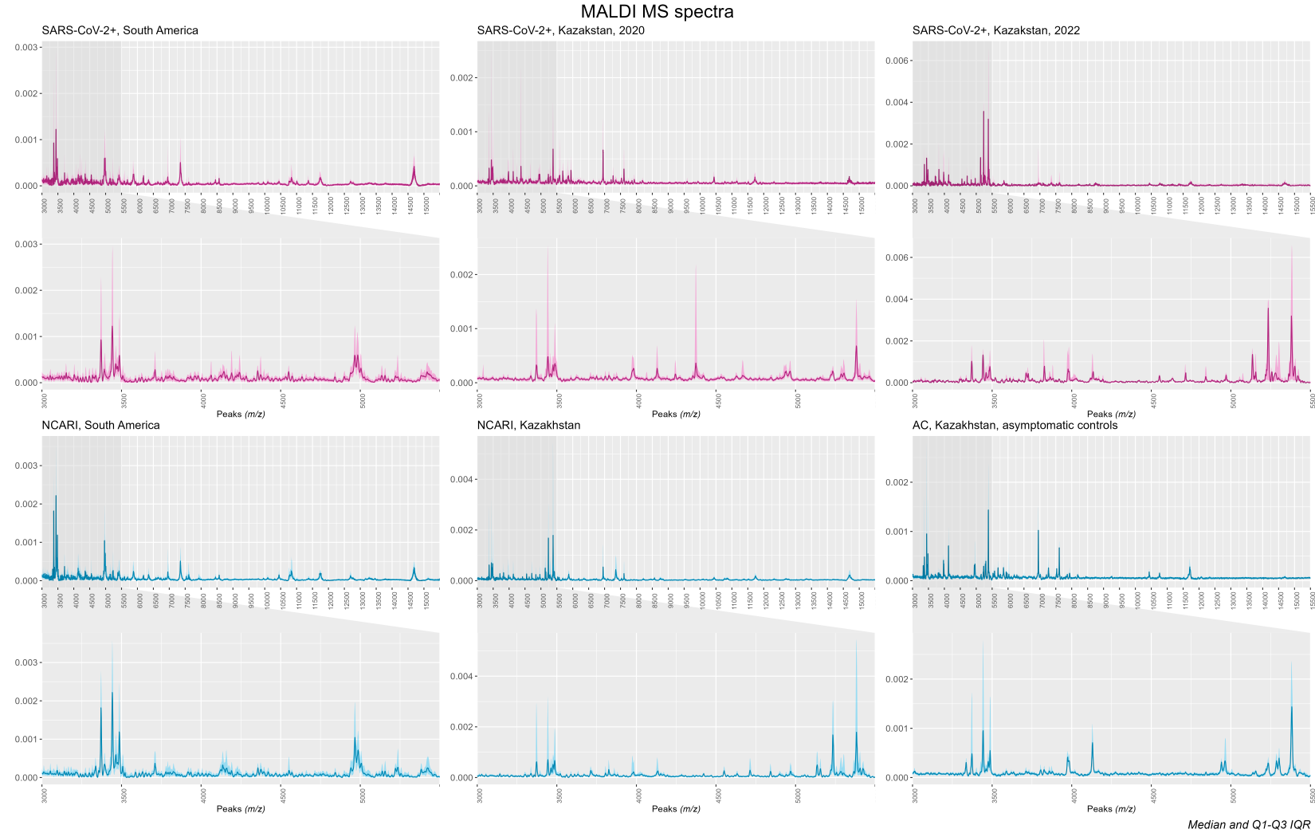

**Figure S1.** Representative MALDI-MS spectra within each of the participant sub-groups from Kazakhstan (samples collected in the current study) and South America (Nachtigall et al.2020). The central line indicates median value of the spectra, while the shaded region on either side represents the interquartile interval. Insets depict a range from 3000 to 5500 m/z encompassing 70% (62/88) of the identified peaks. NCARI= non-COVID acute respiratory infection. AC= asymptomatic controls.

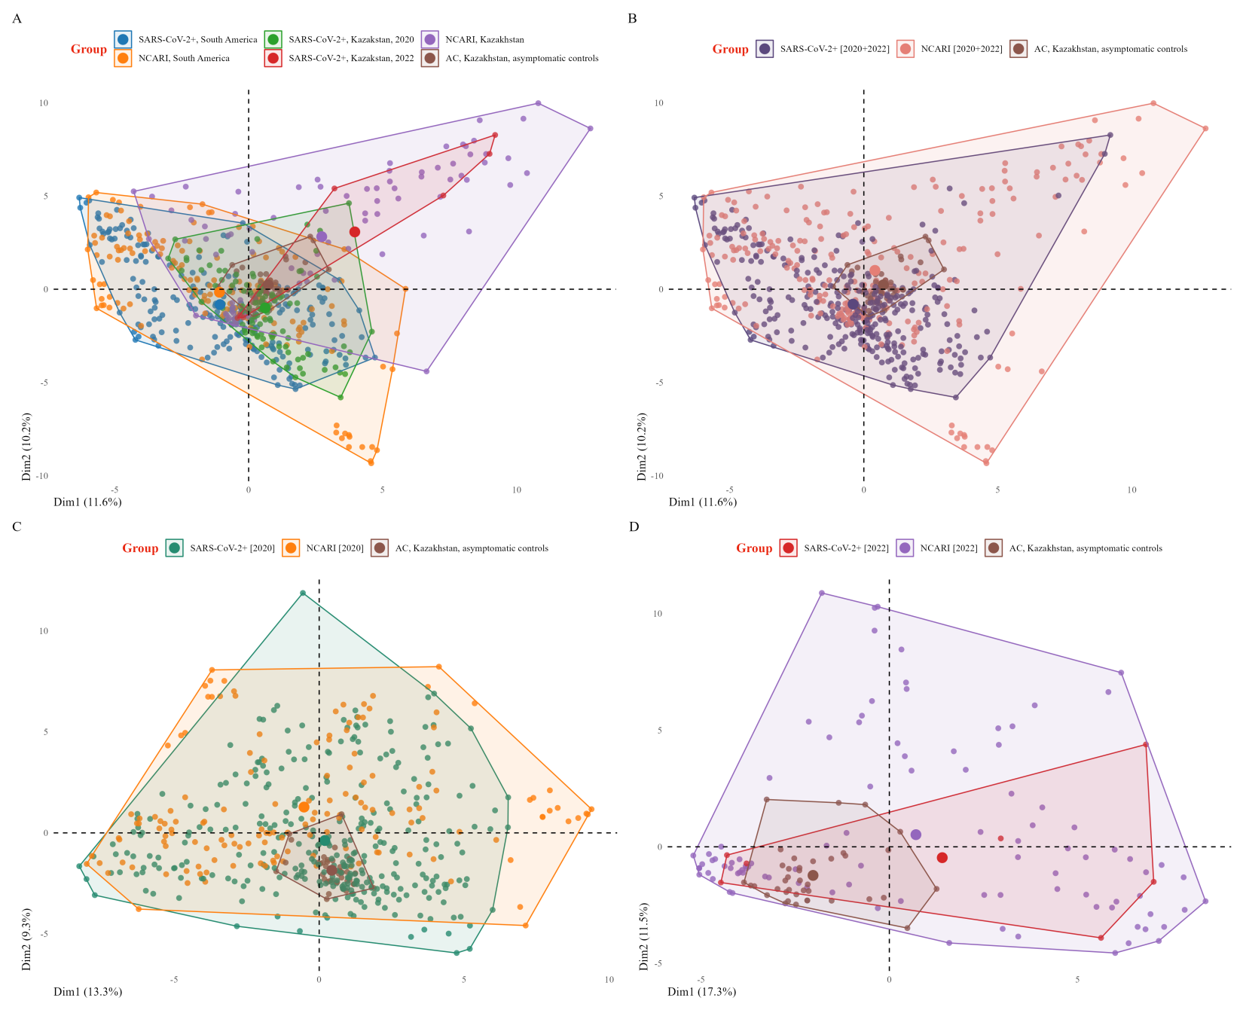**Figure S2.** Principal component analysis graphs depicting the first two dimensions of the mass spectra, stratified by sub-group, from the combined dataset based on the peak intensity matrix for Analysis I.

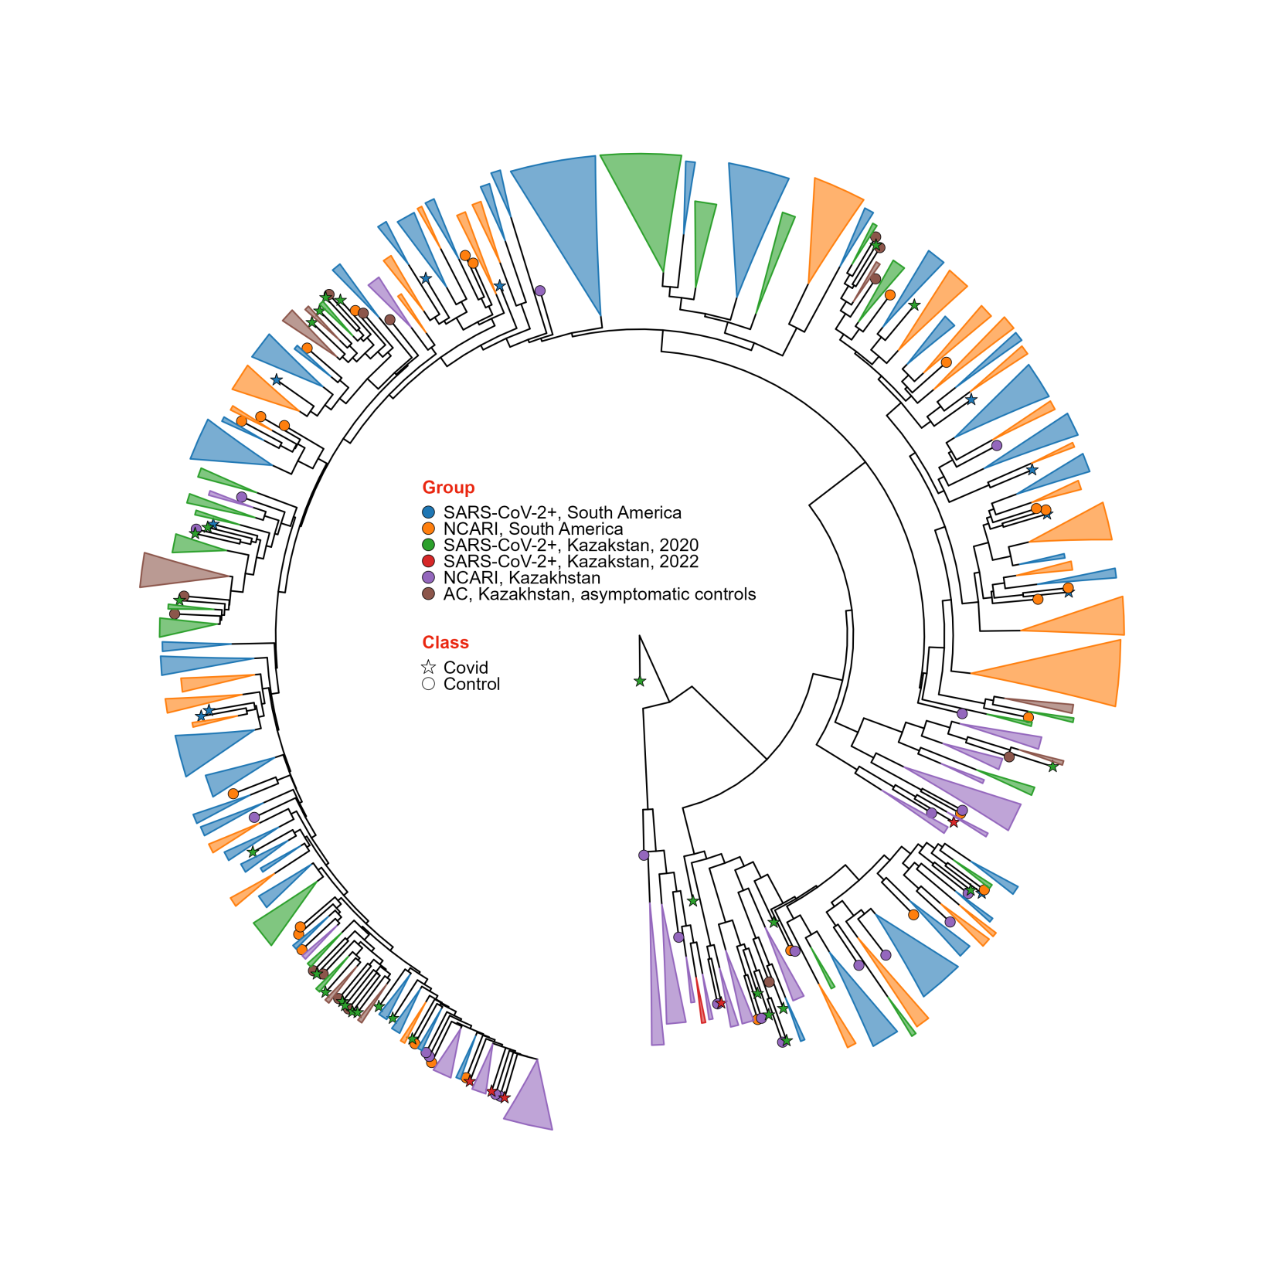

**Figure S3.** Dendrogram of the mass spectra stratified by sub-group from the combined dataset based on the peak intensity matrix for Analysis I.

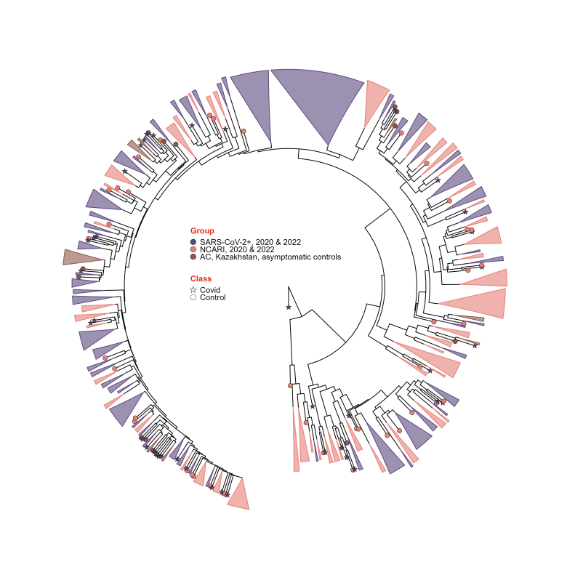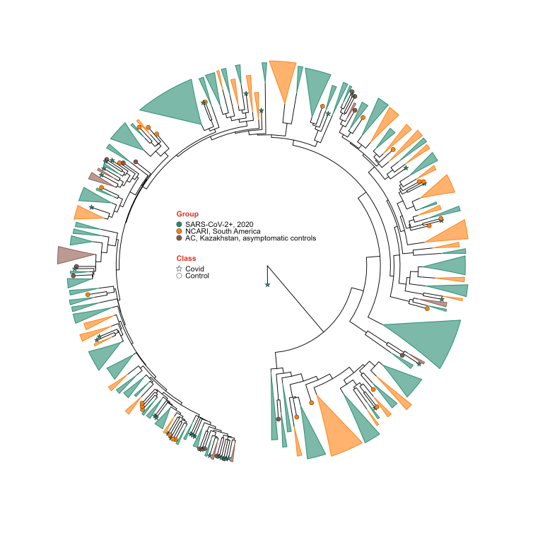

**Figure S4.** Dendrogram of the mass spectra stratified by sub-group from the combined dataset based on the peak intensity matrix for Analysis I.

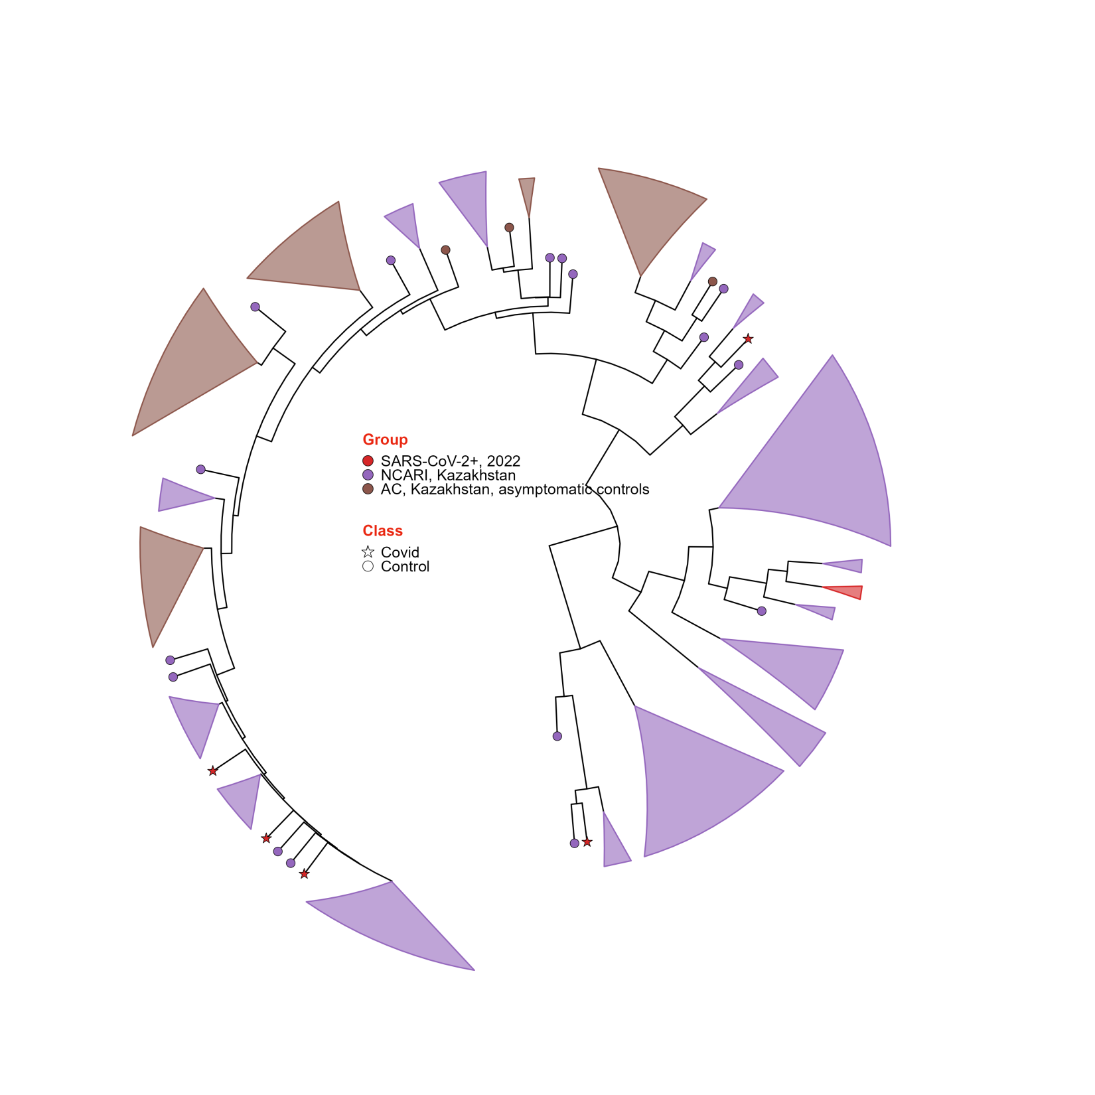

**Figure S5.** Dendrogram of the mass spectra stratified by sub-group from the combined dataset based on the peak intensity matrix for Analysis I.

**Table S3**. Performance of seven ML models when tested only on the South American (SA) dataset (Analysis I). This analysis replicated the testing experiment performed by Nachtigall et al. Each metric is presented as a median and interquartile range. Each model was tested 5 times on 20% of the SA dataset.

| **Classification metric** | **DT** | **KNN** | **NB** | **RF** | **SVM-L** | **SVM-R** | **XGBoost** |
| --- | --- | --- | --- | --- | --- | --- | --- |
| **F means** | 0.95 [0.94; 0.95] | 0.90 [0.88; 0.94] | 0.88 [0.86; 0.88] | 0.95 [0.93; 0.96] | 0.93 [0.91; 0.94] | 0.96 [0.95; 0.98] | 0.93 [0.93; 0.93] |
| **Recall** | 0.976 [0.953; 0.976] | 0.952 [0.951; 0.953] | 0.905 [0.857; 0.907] | 0.976 [0.976; 0.977] | 0.953 [0.951; 0.976] | 0.953 [0.952; 0.953] | 0.952 [0.907; 0.976] |
| **Accuracy** | 0.94 [0.93; 0.95] | 0.88 [0.85; 0.93] | 0.85 [0.85; 0.86] | 0.94 [0.92; 0.95] | 0.92 [0.89; 0.93] | 0.96 [0.94; 0.97] | 0.92 [0.92; 0.92] |
| **Specificity** | 0.90 [0.87; 0.90] | 0.83 [0.68; 0.90] | 0.81 [0.80; 0.87] | 0.87 [0.83; 0.90] | 0.83 [0.81; 0.87] | 0.97 [0.97; 1.00] | 0.84 [0.83; 0.93] |
| **Sensitivity** | 0.976 [0.953; 0.976] | 0.952 [0.951; 0.953] | 0.905 [0.857; 0.907] | 0.976 [0.976; 0.977] | 0.953 [0.951; 0.976] | 0.953 [0.952; 0.953] | 0.952 [0.907; 0.976] |
| **PPV** | 0.93 [0.91; 0.93] | 0.89 [0.80; 0.93] | 0.86 [0.86; 0.89] | 0.91 [0.89; 0.93] | 0.89 [0.87; 0.91] | 0.98 [0.97; 1.00] | 0.89 [0.89; 0.95] |
| **NPV** | 0.96 [0.94; 0.96] | 0.93 [0.89; 0.94] | 0.85 [0.81; 0.86] | 0.96 [0.96; 0.97] | 0.94 [0.92; 0.96] | 0.94 [0.93; 0.94] | 0.93 [0.88; 0.96] |
| **ROC AUC** | 0.99 [0.99; 0.99] | 0.87 [0.83; 0.93] | 0.92 [0.91; 0.93] | 0.99 [0.97; 1.00] | 0.97 [0.97; 0.97] | 1.00 [0.99; 1.00] | 0.98 [0.98; 0.99] |

**Table S4.** ROC AUC values for comparisons of all Kazakhstan (KZ) SARS-CoV-2+ samples collected in 2020 and 2022 versus the controls (either NCARI or pooled NCARI+AC group, Analysis I). Median [25%; 75%]. Each model was tested 5 times on the complete KZ dataset. NCARI= non-COVID acute respiratory infection. AC=asymptomatic controls.

| **Pairwise comparisons** | | | | | | |
| --- | --- | --- | --- | --- | --- | --- |
| **Model** | **SARS-CoV-2/2020 vs NCARI** | **SARS-CoV-2/2020 vs NCARI+AC** | **SARS-CoV-2/2022 vs NCARI** | **SARS-CoV-2/2022 vs NCARI+AC** | **SARS-CoV-2 [2020 + 2022] vs NCARI** | **SARS-CoV-2 [2020 + 2022] vs NCARI+AC** |
| **DT** | 0.65 [0.65; 0.66] | 0.64 [0.63; 0.64] | 0.46 [0.42; 0.48] | 0.43 [0.38; 0.44] | 0.64 [0.64; 0.64] | 0.62 [0.62; 0.63] |
| **KNN** | 0.57 [0.55; 0.64] | 0.57 [0.55; 0.61] | 0.51 [0.47; 0.53] | 0.52 [0.48; 0.52] | 0.57 [0.54; 0.63] | 0.56 [0.55; 0.61] |
| **NB** | 0.68 [0.65; 0.70] | 0.66 [0.66; 0.68] | 0.52 [0.51; 0.52] | 0.51 [0.50; 0.51] | 0.67 [0.64; 0.69] | 0.65 [0.65; 0.67] |
| **RF** | 0.71 [0.70; 0.73] | 0.69 [0.68; 0.70] | 0.48 [0.44; 0.48] | 0.43 [0.41; 0.44] | 0.70 [0.69; 0.71] | 0.67 [0.67; 0.68] |
| **SVM-L** | 0.74 [0.72; 0.75] | 0.76 [0.72; 0.76] | 0.57 [0.56; 0.58] | 0.54 [0.52; 0.57] | 0.73 [0.71; 0.74] | 0.74 [0.71; 0.75] |
| **SVM-R** | 0.60 [0.57; 0.62] | 0.60 [0.59; 0.63] | 0.58 [0.58; 0.59] | 0.61 [0.59; 0.64] | 0.60 [0.57; 0.62] | 0.60 [0.59; 0.63] |
| **XG-Boost** | 0.65 [0.63; 0.67] | 0.64 [0.62; 0.67] | 0.30 [0.29; 0.35] | 0.29 [0.26; 0.32] | 0.62 [0.61; 0.65] | 0.62 [0.60; 0.66] |

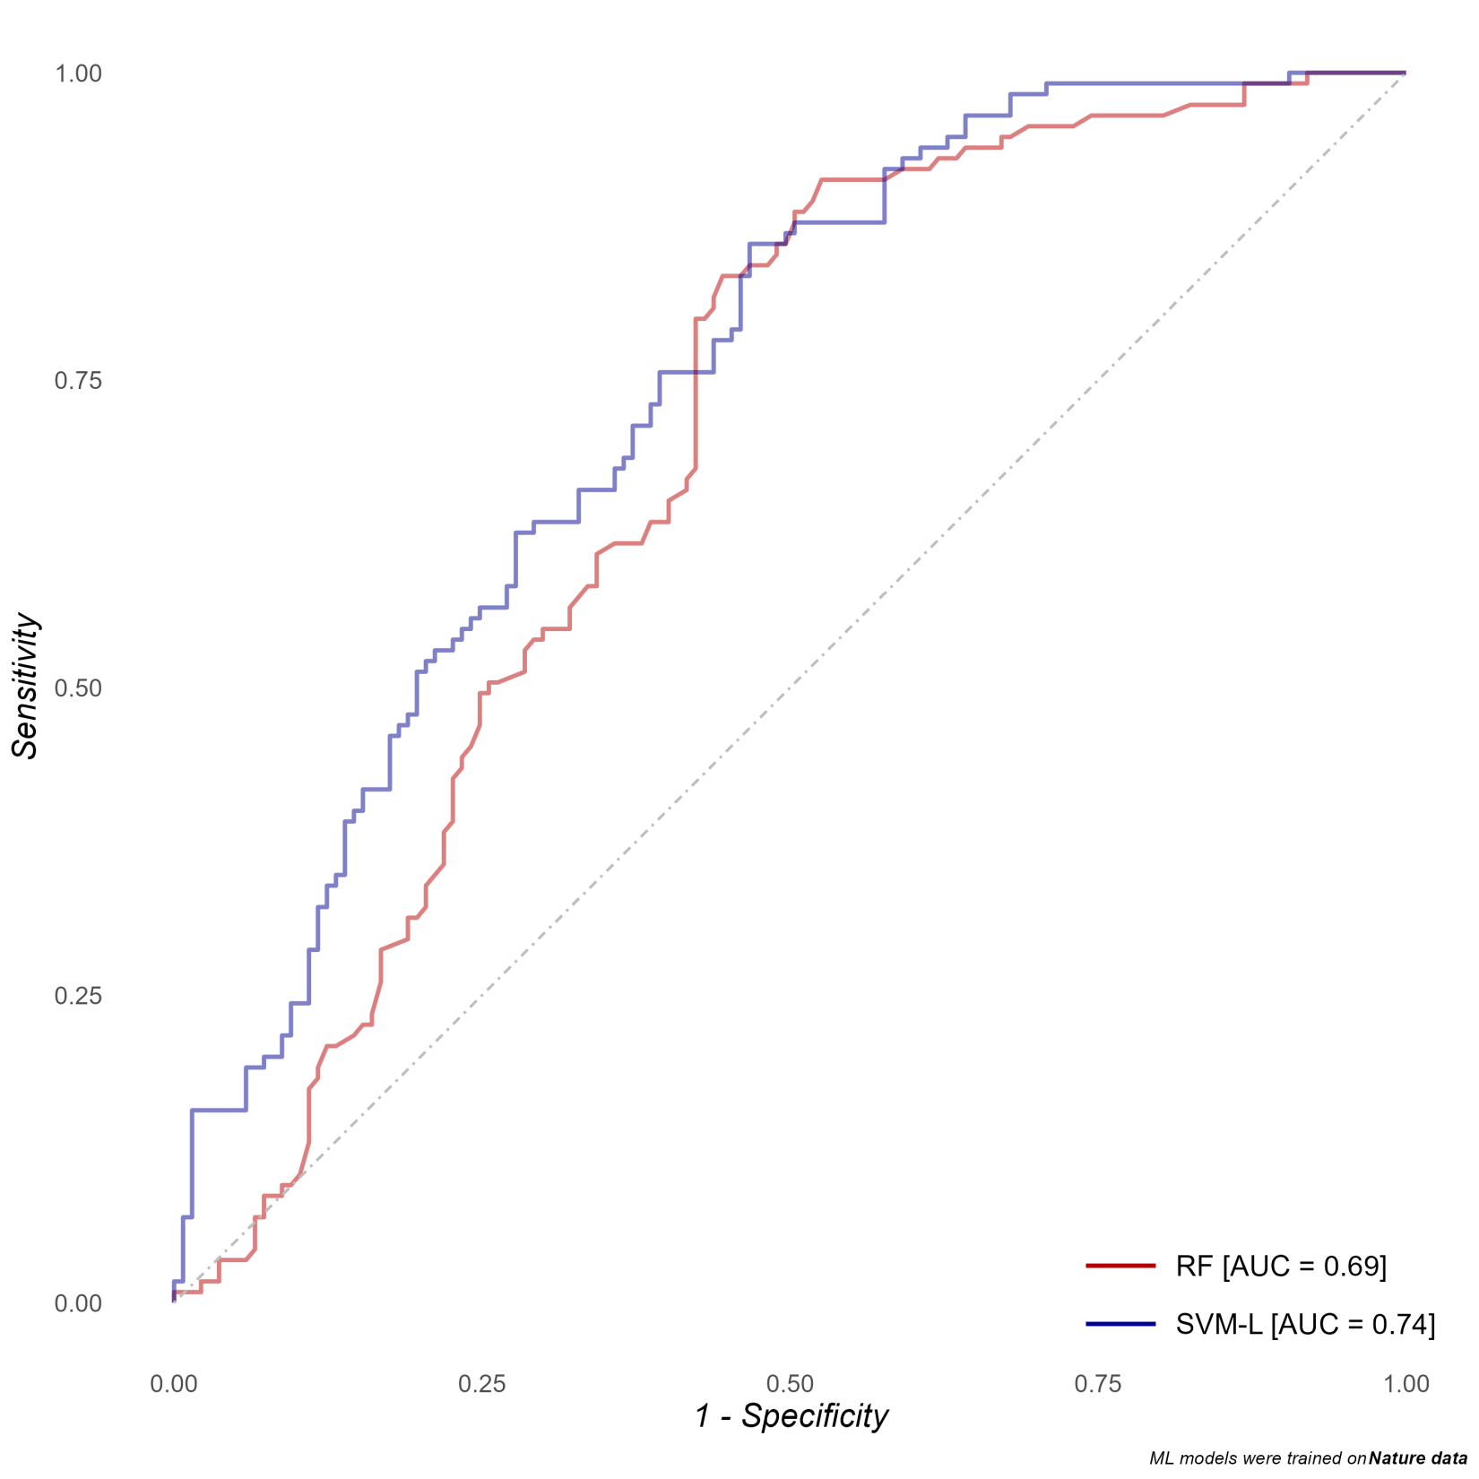

**Figure S6.** ROC curves for the detection of Kazakhstan SARS-CoV-2 [combined samples from both 2020 and 2022, n=115] vs only NCARI as a control (n=98) for the top two best-performing models (Also see Table S4 for the ROC-AUC values pertaining to each of the seven models). RF=random forest. SVM-L: Support Vector Machine with linear kernel.

**Table S5.** Mass spectrometry peaks detected across the combined dataset containing both Kazakhstan and South American samples and present in at least 80% of each sub-group. Shown are peak median intensities and interquartile ranges (IQR). p-values were calculated using the two-tailed Wilcoxon rank sum test. NCARI= non-COVID acute respiratory infection. АC=asymptomatic controls.

| **Peak (*m/z*)** | **South American samples** | | | | | | **Kazakhstan samples** | | | | **p-value** |
| --- | --- | --- | --- | --- | --- | --- | --- | --- | --- | --- | --- |
| **SARS-CoV-2+** | | | **NCARI** | | | **NCARI** | **АC** | **SARS-CoV-2** | |
| **Chile**  **N = 10** | **Argentina**  **N = 167** | **Peru**  **N = 34** | **Chile,**  **N = 20** | **Argentina,**  **N = 114** | **Peru,**  **N = 17** | **N = 71** | **N = 66** | **2020,**  **N = 108** | **2023,**  **N = 7** |
| 3013 | 8.6e-05 [3.4e-05; 1.8e-04] | 1.0e-04 [6.2e-05; 1.6e-04] | 1.6e-04 [1.1e-04; 2.0e-04] | 8.6e-05 [5.3e-05; 1.1e-04] | 1.6e-04 [6.6e-05; 3.6e-04] | 1.5e-04 [1.1e-04; 1.8e-04] | 9.8e-05 [5.3e-05; 1.8e-04] | 1.2e-04 [7.8e-05; 2.0e-04] | 9.0e-05 [6.0e-05; 1.4e-04] | 1.2e-04 [1.1e-04; 1.6e-04] | <0.001*** |
| 3037 | 8.4e-05 [2.3e-05; 1.5e-04] | 1.2e-04 [6.7e-05; 2.2e-04] | 1.1e-04 [5.8e-05; 1.4e-04] | 9.8e-05 [5.7e-05; 1.2e-04] | 1.1e-04 [5.1e-05; 2.1e-04] | 2.4e-04 [1.5e-04; 4.6e-04] | 6.2e-05 [3.4e-05; 1.1e-04] | 5.7e-05 [4.1e-05; 9.0e-05] | 1.0e-04 [5.5e-05; 3.3e-04] | 1.5e-04 [7.7e-05; 1.9e-04] | <0.001*** |
| 3052 | 1.5e-04 [9.9e-05; 2.3e-04] | 1.6e-04 [8.9e-05; 2.9e-04] | 1.4e-04 [7.3e-05; 2.0e-04] | 1.7e-04 [1.5e-04; 2.1e-04] | 2.1e-04 [8.9e-05; 4.3e-04] | 1.3e-04 [1.0e-04; 2.2e-04] | 9.4e-05 [6.4e-05; 1.6e-04] | 7.6e-05 [5.5e-05; 1.1e-04] | 6.5e-05 [4.3e-05; 1.1e-04] | 1.6e-04 [1.2e-04; 3.1e-04] | <0.001*** |
| 3095 | 2.0e-04 [1.6e-04; 2.5e-04] | 1.2e-04 [5.5e-05; 2.2e-04] | 1.2e-04 [7.0e-05; 1.7e-04] | 1.2e-04 [8.2e-05; 1.5e-04] | 2.6e-04 [1.5e-04; 5.0e-04] | 2.4e-04 [1.5e-04; 2.8e-04] | 8.1e-05 [4.5e-05; 1.2e-04] | 8.8e-05 [6.7e-05; 1.3e-04] | 9.4e-05 [6.6e-05; 1.3e-04] | 5.9e-05 [4.0e-05; 1.1e-04] | <0.001*** |
| 3113 | 2.2e-04 [1.3e-04; 3.6e-04] | 8.3e-05 [4.0e-05; 1.8e-04] | 7.8e-05 [3.3e-05; 1.3e-04] | 9.1e-05 [7.1e-05; 1.2e-04] | 2.1e-04 [1.3e-04; 2.8e-04] | 6.1e-05 [2.7e-05; 9.8e-05] | 5.6e-05 [2.1e-05; 9.6e-05] | 1.2e-04 [8.3e-05; 1.5e-04] | 4.9e-05 [3.1e-05; 8.4e-05] | 4.0e-05 [1.3e-05; 4.3e-05] | <0.001*** |
| 3128 | 1.1e-04 [3.7e-05; 1.1e-04] | 1.1e-04 [3.8e-05; 2.1e-04] | 1.0e-04 [4.3e-05; 1.5e-04] | 8.1e-05 [4.3e-05; 1.3e-04] | 9.3e-05 [3.8e-05; 1.5e-04] | 5.8e-05 [2.4e-05; 9.9e-05] | 7.7e-05 [4.2e-05; 1.3e-04] | 7.5e-05 [4.2e-05; 1.0e-04] | 5.4e-05 [2.9e-05; 7.6e-05] | 1.1e-04 [5.6e-05; 2.1e-04] | <0.001*** |
| 3147 | 7.9e-05 [1.9e-05; 1.6e-04] | 3.1e-04 [1.5e-04; 5.1e-04] | 2.6e-04 [1.7e-04; 3.5e-04] | 5.4e-05 [1.8e-05; 1.4e-04] | 8.3e-05 [3.1e-05; 1.5e-04] | 3.2e-04 [2.2e-04; 3.7e-04] | 1.7e-04 [1.3e-04; 2.4e-04] | 6.4e-05 [3.8e-05; 9.3e-05] | 7.4e-05 [5.0e-05; 1.1e-04] | 1.8e-04 [1.4e-04; 2.3e-04] | <0.001*** |
| 3192 | 7.4e-05 [4.0e-05; 1.0e-04] | 4.0e-05 [8.8e-06; 1.1e-04] | 4.5e-05 [1.5e-05; 1.1e-04] | 8.9e-05 [3.1e-05; 1.2e-04] | 4.0e-05 [1.1e-06; 1.2e-04] | 2.1e-04 [1.5e-04; 3.1e-04] | 8.6e-05 [5.4e-05; 1.6e-04] | 7.0e-05 [5.2e-05; 1.0e-04] | 9.8e-05 [6.5e-05; 1.6e-04] | 1.5e-04 [1.2e-04; 1.6e-04] | <0.001*** |
| 3218 | 1.7e-04 [1.0e-04; 2.8e-04] | 4.9e-05 [6.5e-06; 1.3e-04] | 7.7e-05 [4.7e-05; 1.4e-04] | 2.0e-04 [1.3e-04; 2.4e-04] | 1.2e-04 [5.2e-05; 1.8e-04] | 7.5e-05 [4.3e-05; 1.5e-04] | 8.5e-05 [4.7e-05; 1.3e-04] | 8.0e-05 [6.8e-05; 9.6e-05] | 7.6e-05 [4.3e-05; 9.9e-05] | 1.0e-04 [7.4e-05; 1.3e-04] | <0.001*** |
| 3242 | 1.0e-04 [8.8e-05; 1.9e-04] | 1.0e-04 [5.2e-05; 1.8e-04] | 1.3e-04 [9.3e-05; 1.7e-04] | 9.7e-05 [6.9e-05; 1.5e-04] | 9.3e-05 [5.0e-05; 1.5e-04] | 1.4e-04 [1.1e-04; 1.6e-04] | 7.1e-05 [5.0e-05; 1.1e-04] | 6.7e-05 [5.3e-05; 1.1e-04] | 7.5e-05 [4.9e-05; 1.3e-04] | 7.5e-05 [5.6e-05; 1.7e-04] | <0.001*** |
| 3256 | 8.9e-05 [5.5e-05; 1.8e-04] | 1.1e-04 [4.0e-05; 2.4e-04] | 1.1e-04 [3.5e-05; 1.4e-04] | 5.3e-05 [3.2e-05; 1.1e-04] | 7.7e-05 [3.1e-05; 1.3e-04] | 1.5e-04 [1.1e-04; 1.8e-04] | 5.9e-05 [3.4e-05; 8.7e-05] | 7.1e-05 [5.5e-05; 1.2e-04] | 5.4e-05 [3.7e-05; 8.1e-05] | 6.4e-05 [5.7e-05; 9.3e-05] | <0.001*** |
| 3300 | 1.0e-04 [5.7e-05; 1.9e-04] | 1.3e-04 [2.4e-05; 3.1e-04] | 1.2e-04 [5.8e-05; 2.1e-04] | 8.4e-05 [1.7e-05; 1.3e-04] | 1.0e-04 [1.1e-05; 3.0e-04] | 2.3e-04 [1.6e-04; 3.3e-04] | 1.1e-04 [6.7e-05; 2.2e-04] | 7.8e-05 [3.9e-05; 1.1e-04] | 6.8e-05 [4.2e-05; 8.9e-05] | 2.0e-04 [1.9e-04; 3.7e-04] | <0.001*** |
| 3318 | 1.1e-04 [6.5e-05; 1.5e-04] | 1.6e-04 [1.0e-07; 3.6e-04] | 2.1e-04 [1.5e-04; 3.1e-04] | 6.5e-05 [3.0e-06; 2.0e-04] | 7.9e-05 [6.7e-06; 3.6e-04] | 2.4e-04 [1.8e-04; 3.5e-04] | 8.7e-05 [3.8e-05; 1.4e-04] | 5.7e-05 [2.0e-05; 1.0e-04] | 6.3e-05 [1.9e-05; 9.9e-05] | 1.3e-04 [6.5e-05; 1.5e-04] | <0.001*** |
| 3337 | 2.4e-04 [2.0e-04; 3.0e-04] | 1.3e-04 [7.2e-06; 3.3e-04] | 1.8e-04 [1.5e-04; 2.4e-04] | 4.0e-04 [3.2e-04; 6.1e-04] | 2.5e-04 [7.5e-05; 5.5e-04] | 2.6e-04 [2.1e-04; 4.8e-04] | 1.4e-04 [7.2e-05; 4.5e-04] | 3.3e-04 [1.6e-04; 4.3e-04] | 1.3e-04 [7.8e-05; 2.4e-04] | 2.3e-04 [1.8e-04; 4.0e-04] | <0.001*** |
| 3358 | 6.5e-05 [2.2e-06; 9.8e-05] | 1.1e-04 [4.0e-05; 1.9e-04] | 9.2e-05 [5.3e-05; 1.4e-04] | 6.6e-05 [1.7e-05; 1.8e-04] | 2.6e-04 [1.9e-04; 3.8e-04] | 1.1e-04 [8.6e-05; 1.4e-04] | 9.6e-05 [6.2e-05; 1.8e-04] | 8.4e-05 [6.3e-05; 1.5e-04] | 5.8e-05 [3.0e-05; 1.1e-04] | 9.3e-05 [6.2e-05; 1.7e-04] | <0.001*** |
| 3372 | 1.2e-03 [8.6e-04; 2.0e-03] | 1.2e-03 [5.7e-04; 3.0e-03] | 4.7e-04 [2.9e-04; 6.2e-04] | 1.2e-03 [4.4e-04; 2.3e-03] | 2.3e-03 [1.2e-03; 3.6e-03] | 5.6e-04 [4.2e-04; 6.2e-04] | 6.5e-04 [2.4e-04; 3.0e-03] | 4.8e-04 [2.5e-04; 1.8e-03] | 3.6e-04 [1.8e-04; 1.9e-03] | 1.0e-03 [2.0e-04; 1.8e-03] | <0.001*** |
| 3393 | 2.7e-04 [2.0e-04; 5.1e-04] | 5.0e-04 [2.5e-04; 8.6e-04] | 1.1e-04 [7.8e-05; 1.4e-04] | 2.4e-04 [1.5e-04; 3.7e-04] | 4.3e-04 [2.6e-04; 7.4e-04] | 1.1e-04 [7.7e-05; 1.3e-04] | 1.1e-04 [5.1e-05; 2.9e-04] | 1.3e-04 [9.3e-05; 2.3e-04] | 8.2e-05 [3.5e-05; 1.3e-04] | 1.8e-04 [1.1e-04; 2.7e-04] | <0.001*** |
| 3443 | 1.5e-03 [7.5e-04; 2.3e-03] | 1.7e-03 [7.5e-04; 4.1e-03] | 5.0e-04 [3.1e-04; 6.5e-04] | 1.5e-03 [7.3e-04; 2.6e-03] | 3.0e-03 [1.5e-03; 4.5e-03] | 6.7e-04 [4.7e-04; 8.3e-04] | 7.2e-04 [2.2e-04; 3.3e-03] | 9.7e-04 [2.2e-04; 2.8e-03] | 5.7e-04 [2.7e-04; 2.9e-03] | 1.3e-03 [2.3e-04; 1.6e-03] | <0.001*** |
| 3463 | 5.6e-04 [3.7e-04; 7.1e-04] | 5.7e-04 [3.0e-04; 1.1e-03] | 2.0e-04 [1.5e-04; 2.6e-04] | 4.5e-04 [2.7e-04; 6.9e-04] | 9.0e-04 [4.2e-04; 1.5e-03] | 3.0e-04 [2.1e-04; 4.3e-04] | 3.9e-04 [2.0e-04; 8.3e-04] | 1.6e-04 [1.2e-04; 2.5e-04] | 1.9e-04 [1.3e-04; 5.7e-04] | 4.7e-04 [1.0e-04; 8.0e-04] | <0.001*** |
| 3476 | 2.7e-04 [2.1e-04; 3.2e-04] | 3.9e-04 [2.2e-04; 6.0e-04] | 2.3e-04 [1.7e-04; 3.2e-04] | 3.9e-04 [2.5e-04; 6.2e-04] | 3.9e-04 [2.4e-04; 6.8e-04] | 3.2e-04 [2.1e-04; 4.6e-04] | 5.2e-04 [1.4e-04; 8.7e-04] | 3.0e-04 [2.1e-04; 4.9e-04] | 3.3e-04 [1.5e-04; 5.1e-04] | 2.7e-04 [1.2e-04; 9.2e-04] | 0.001** |
| 3487 | 1.1e-03 [7.8e-04; 1.7e-03] | 7.5e-04 [3.0e-04; 2.0e-03] | 2.8e-04 [1.6e-04; 5.1e-04] | 9.4e-04 [3.2e-04; 2.2e-03] | 1.5e-03 [7.4e-04; 3.4e-03] | 3.5e-04 [3.0e-04; 6.4e-04] | 7.3e-04 [2.9e-04; 2.0e-03] | 5.7e-04 [1.8e-04; 1.8e-03] | 3.4e-04 [1.4e-04; 1.1e-03] | 7.8e-04 [2.0e-04; 1.6e-03] | <0.001*** |
| 3516 | 2.1e-04 [1.2e-04; 4.6e-04] | 4.4e-05 [0.0e+00; 1.7e-04] | 1.1e-04 [5.2e-05; 1.4e-04] | 5.7e-05 [6.5e-06; 1.3e-04] | 1.9e-05 [0.0e+00; 3.7e-04] | 2.1e-04 [1.5e-04; 2.7e-04] | 8.5e-05 [4.1e-05; 1.5e-04] | 7.0e-05 [3.6e-05; 1.0e-04] | 6.6e-05 [3.8e-05; 1.0e-04] | 1.2e-04 [6.9e-05; 1.7e-04] | <0.001*** |
| 3560 | 1.6e-05 [4.9e-06; 3.4e-05] | 1.6e-06 [0.0e+00; 5.8e-05] | 7.1e-05 [3.0e-05; 1.2e-04] | 3.3e-05 [6.4e-06; 1.0e-04] | 2.1e-05 [0.0e+00; 1.2e-04] | 1.1e-04 [2.5e-05; 1.7e-04] | 1.1e-04 [7.1e-05; 1.5e-04] | 5.9e-05 [4.7e-05; 7.2e-05] | 5.2e-05 [1.9e-05; 9.0e-05] | 1.7e-04 [1.2e-04; 2.2e-04] | <0.001*** |
| 3589 | 1.3e-04 [6.2e-05; 1.7e-04] | 7.9e-05 [2.1e-05; 1.6e-04] | 8.1e-05 [6.2e-05; 1.2e-04] | 1.4e-04 [8.8e-05; 2.2e-04] | 1.2e-04 [5.0e-05; 2.2e-04] | 1.7e-04 [8.0e-05; 2.7e-04] | 1.3e-04 [8.4e-05; 2.5e-04] | 1.6e-04 [1.2e-04; 2.1e-04] | 9.0e-05 [4.9e-05; 1.4e-04] | 2.1e-04 [1.6e-04; 4.0e-04] | <0.001*** |
| 3610 | 7.2e-05 [5.8e-05; 1.4e-04] | 1.1e-04 [3.8e-05; 1.8e-04] | 8.7e-05 [3.8e-05; 1.5e-04] | 1.4e-04 [6.1e-05; 2.3e-04] | 1.0e-04 [5.0e-05; 2.0e-04] | 1.3e-04 [1.2e-04; 1.8e-04] | 1.2e-04 [6.6e-05; 1.7e-04] | 6.7e-05 [4.6e-05; 8.9e-05] | 6.1e-05 [2.8e-05; 9.1e-05] | 2.2e-04 [1.7e-04; 3.4e-04] | <0.001*** |
| 3633 | 1.1e-04 [7.8e-05; 1.5e-04] | 6.9e-05 [1.5e-05; 1.3e-04] | 1.1e-04 [4.8e-05; 2.1e-04] | 1.2e-04 [5.3e-05; 1.8e-04] | 1.7e-04 [8.3e-05; 2.8e-04] | 1.1e-04 [6.2e-05; 1.4e-04] | 1.3e-04 [8.7e-05; 2.6e-04] | 1.3e-04 [1.0e-04; 1.7e-04] | 9.2e-05 [6.2e-05; 1.3e-04] | 1.7e-04 [1.2e-04; 3.2e-04] | <0.001*** |
| 3658 | 1.3e-04 [1.0e-04; 1.4e-04] | 2.3e-05 [3.5e-06; 7.4e-05] | 6.2e-05 [2.1e-05; 1.1e-04] | 4.0e-05 [4.5e-07; 1.0e-04] | 6.5e-05 [1.5e-05; 1.4e-04] | 7.5e-05 [4.9e-05; 1.1e-04] | 4.5e-05 [2.1e-05; 8.3e-05] | 6.8e-05 [2.9e-05; 8.7e-05] | 7.0e-05 [5.1e-05; 1.1e-04] | 1.6e-04 [1.5e-04; 2.7e-04] | <0.001*** |
| 3711 | 2.4e-04 [1.2e-04; 4.8e-04] | 3.3e-04 [1.3e-04; 7.4e-04] | 1.4e-04 [6.5e-05; 2.3e-04] | 3.1e-04 [2.1e-04; 5.5e-04] | 4.2e-04 [2.2e-04; 8.7e-04] | 1.1e-04 [6.1e-05; 2.4e-04] | 2.2e-04 [1.0e-04; 4.2e-04] | 1.1e-04 [8.2e-05; 2.0e-04] | 1.0e-04 [6.2e-05; 1.9e-04] | 4.6e-04 [1.8e-04; 6.3e-04] | <0.001*** |
| 3732 | 1.4e-04 [1.2e-04; 3.4e-04] | 8.8e-05 [3.4e-05; 1.7e-04] | 8.0e-05 [4.7e-05; 1.0e-04] | 1.1e-04 [4.1e-05; 1.8e-04] | 1.1e-04 [2.2e-05; 2.0e-04] | 6.0e-05 [1.5e-05; 9.6e-05] | 9.0e-05 [4.5e-05; 1.4e-04] | 9.8e-05 [7.2e-05; 1.7e-04] | 9.1e-05 [6.0e-05; 1.3e-04] | 8.8e-05 [8.0e-05; 2.2e-04] | 0.034* |
| 3752 | 6.2e-05 [4.5e-06; 8.9e-05] | 1.2e-04 [2.1e-05; 2.5e-04] | 1.7e-04 [8.9e-05; 3.4e-04] | 8.5e-05 [4.3e-05; 1.3e-04] | 8.2e-05 [4.1e-06; 1.6e-04] | 2.6e-04 [1.5e-04; 3.7e-04] | 8.7e-05 [5.3e-05; 1.4e-04] | 8.1e-05 [5.6e-05; 1.2e-04] | 1.0e-04 [6.0e-05; 1.7e-04] | 2.1e-04 [1.2e-04; 2.4e-04] | <0.001*** |
| 3776 | 1.1e-04 [5.0e-05; 2.3e-04] | 1.3e-04 [7.0e-05; 2.6e-04] | 1.3e-04 [7.8e-05; 2.6e-04] | 1.2e-04 [8.0e-05; 1.8e-04] | 1.2e-04 [5.6e-05; 2.5e-04] | 2.1e-04 [1.6e-04; 3.6e-04] | 4.4e-05 [2.0e-05; 7.8e-05] | 7.4e-05 [4.5e-05; 9.0e-05] | 8.3e-05 [4.9e-05; 1.4e-04] | 1.3e-04 [1.1e-04; 2.1e-04] | <0.001*** |
| 3792 | 2.8e-04 [1.2e-04; 1.1e-03] | 1.6e-04 [5.2e-05; 3.5e-04] | 6.7e-05 [2.6e-05; 9.0e-05] | 2.2e-04 [1.3e-04; 5.7e-04] | 1.6e-04 [6.5e-05; 3.7e-04] | 5.7e-05 [1.3e-05; 8.0e-05] | 3.5e-05 [9.2e-06; 8.0e-05] | 6.2e-05 [4.0e-05; 8.3e-05] | 5.3e-05 [2.6e-05; 7.7e-05] | 1.4e-05 [4.8e-06; 5.0e-05] | <0.001*** |
| 3805 | 1.4e-04 [1.2e-04; 1.5e-04] | 1.4e-04 [2.3e-05; 2.6e-04] | 2.5e-04 [1.8e-04; 4.2e-04] | 2.3e-04 [1.9e-04; 3.0e-04] | 9.5e-05 [2.2e-05; 3.0e-04] | 2.6e-04 [1.3e-04; 4.9e-04] | 1.7e-04 [8.4e-05; 4.4e-04] | 1.9e-04 [1.2e-04; 2.9e-04] | 1.2e-04 [7.7e-05; 2.3e-04] | 1.7e-04 [1.3e-04; 2.8e-04] | <0.001*** |
| 3827 | 7.7e-05 [3.2e-05; 1.1e-04] | 1.2e-04 [4.4e-05; 2.7e-04] | 1.8e-04 [1.0e-04; 3.4e-04] | 9.9e-05 [5.2e-05; 2.4e-04] | 1.5e-04 [5.5e-05; 3.6e-04] | 3.8e-04 [1.6e-04; 5.8e-04] | 3.5e-04 [1.4e-04; 7.2e-04] | 1.7e-04 [1.3e-04; 2.6e-04] | 1.3e-04 [6.5e-05; 2.1e-04] | 8.0e-04 [1.5e-04; 2.1e-03] | <0.001*** |
| 3848 | 3.7e-05 [1.7e-05; 5.8e-05] | 5.6e-05 [1.3e-05; 1.3e-04] | 8.2e-05 [3.0e-05; 1.5e-04] | 9.7e-06 [0.0e+00; 6.2e-05] | 9.1e-05 [3.4e-05; 1.7e-04] | 9.7e-05 [5.7e-05; 2.2e-04] | 8.7e-05 [5.1e-05; 1.5e-04] | 6.5e-05 [5.4e-05; 1.0e-04] | 4.6e-05 [1.7e-05; 8.6e-05] | 1.4e-04 [1.0e-04; 2.9e-04] | <0.001*** |
| 3862 | 3.2e-05 [1.9e-06; 5.8e-05] | 3.3e-05 [7.6e-07; 7.2e-05] | 4.8e-05 [1.7e-05; 1.2e-04] | 5.6e-05 [3.4e-05; 1.4e-04] | 7.8e-05 [1.6e-05; 1.3e-04] | 9.8e-05 [6.7e-05; 1.6e-04] | 1.3e-04 [8.4e-05; 3.5e-04] | 1.2e-04 [8.8e-05; 2.0e-04] | 9.0e-05 [4.6e-05; 1.5e-04] | 2.7e-04 [1.4e-04; 6.0e-04] | <0.001*** |
| 3877 | 4.1e-05 [2.5e-05; 9.0e-05] | 5.5e-05 [2.3e-05; 1.2e-04] | 2.9e-05 [4.8e-06; 8.4e-05] | 7.9e-05 [5.4e-05; 1.4e-04] | 6.9e-05 [2.0e-05; 1.3e-04] | 8.6e-05 [4.4e-05; 1.3e-04] | 8.5e-05 [4.2e-05; 1.2e-04] | 1.5e-04 [9.7e-05; 2.5e-04] | 1.1e-04 [7.2e-05; 1.9e-04] | 2.1e-04 [2.0e-04; 8.9e-04] | <0.001*** |
| 3901 | 2.6e-05 [9.3e-06; 4.4e-05] | 2.6e-05 [2.7e-06; 7.1e-05] | 4.2e-05 [1.5e-05; 6.1e-05] | 7.0e-05 [1.6e-05; 9.3e-05] | 1.5e-05 [0.0e+00; 6.9e-05] | 1.9e-05 [7.4e-06; 4.1e-05] | 4.5e-05 [1.3e-05; 1.0e-04] | 7.6e-05 [4.4e-05; 9.8e-05] | 5.4e-05 [1.9e-05; 7.6e-05] | 1.7e-04 [1.0e-04; 1.9e-04] | <0.001*** |
| 3917 | 1.5e-04 [7.9e-05; 2.0e-04] | 1.2e-04 [5.3e-05; 1.8e-04] | 9.1e-05 [4.8e-05; 1.5e-04] | 2.2e-04 [1.5e-04; 2.7e-04] | 1.6e-04 [8.9e-05; 2.4e-04] | 9.6e-05 [3.7e-05; 1.2e-04] | 7.5e-05 [4.6e-05; 1.2e-04] | 7.4e-05 [5.1e-05; 1.0e-04] | 7.9e-05 [5.0e-05; 1.1e-04] | 1.9e-04 [1.5e-04; 1.9e-04] | <0.001*** |
| 3934 | 1.8e-04 [1.4e-04; 3.2e-04] | 1.4e-04 [5.6e-05; 2.3e-04] | 1.6e-04 [1.2e-04; 2.2e-04] | 1.1e-04 [6.9e-05; 1.6e-04] | 1.4e-04 [4.4e-05; 2.8e-04] | 1.6e-04 [8.5e-05; 2.3e-04] | 4.0e-05 [6.6e-06; 1.0e-04] | 7.3e-05 [5.6e-05; 9.8e-05] | 9.4e-05 [6.6e-05; 1.4e-04] | 1.2e-05 [1.0e-05; 7.6e-05] | <0.001*** |
| 3980 | 6.8e-05 [1.6e-05; 1.1e-04] | 1.9e-04 [1.2e-04; 2.7e-04] | 1.7e-04 [1.1e-04; 2.7e-04] | 1.4e-05 [1.0e-07; 1.9e-04] | 1.1e-04 [5.2e-05; 1.8e-04] | 3.0e-04 [1.4e-04; 4.8e-04] | 2.0e-04 [8.8e-05; 5.8e-04] | 4.4e-04 [2.9e-04; 5.9e-04] | 2.5e-04 [1.1e-04; 4.8e-04] | 6.6e-04 [1.3e-04; 1.8e-03] | <0.001*** |
| 4000 | 1.0e-04 [4.2e-05; 1.8e-04] | 5.9e-05 [2.9e-05; 1.1e-04] | 4.8e-05 [2.5e-05; 1.0e-04] | 5.4e-05 [5.5e-06; 1.2e-04] | 5.9e-05 [2.5e-05; 1.0e-04] | 1.2e-04 [6.8e-05; 3.2e-04] | 8.0e-05 [4.8e-05; 1.3e-04] | 1.0e-04 [7.6e-05; 1.3e-04] | 8.4e-05 [4.7e-05; 1.3e-04] | 1.8e-04 [1.3e-04; 2.8e-04] | <0.001*** |
| 4136 | 2.7e-04 [1.9e-04; 5.4e-04] | 1.9e-04 [1.1e-04; 4.2e-04] | 1.3e-04 [6.5e-05; 2.0e-04] | 1.1e-04 [5.9e-05; 2.7e-04] | 4.7e-04 [2.2e-04; 9.3e-04] | 2.1e-04 [1.3e-04; 3.3e-04] | 2.5e-04 [1.1e-04; 4.7e-04] | 7.5e-04 [4.1e-04; 1.1e-03] | 1.5e-04 [7.2e-05; 3.1e-04] | 5.7e-04 [2.2e-04; 1.4e-03] | <0.001*** |
| 4157 | 2.3e-04 [1.8e-04; 4.1e-04] | 1.4e-04 [6.8e-05; 3.2e-04] | 8.3e-05 [2.2e-05; 1.3e-04] | 1.4e-04 [3.5e-05; 2.4e-04] | 3.6e-04 [1.0e-04; 9.0e-04] | 1.6e-04 [5.6e-05; 2.4e-04] | 1.1e-04 [6.0e-05; 1.9e-04] | 1.0e-04 [8.1e-05; 1.3e-04] | 6.2e-05 [3.0e-05; 1.0e-04] | 2.5e-04 [1.9e-04; 3.6e-04] | <0.001*** |
| 4171 | 9.9e-05 [6.2e-05; 1.5e-04] | 5.1e-05 [8.2e-06; 1.1e-04] | 6.7e-05 [3.6e-05; 1.2e-04] | 8.6e-05 [4.8e-05; 1.2e-04] | 1.3e-04 [3.3e-05; 4.0e-04] | 9.7e-05 [5.0e-05; 2.0e-04] | 1.2e-04 [6.9e-05; 2.2e-04] | 1.2e-04 [9.7e-05; 1.7e-04] | 7.5e-05 [4.0e-05; 1.2e-04] | 1.9e-04 [1.6e-04; 3.4e-04] | <0.001*** |
| 4193 | 6.2e-05 [1.8e-05; 8.0e-05] | 1.4e-04 [2.2e-05; 5.8e-04] | 6.4e-04 [3.8e-04; 8.5e-04] | 7.3e-05 [2.4e-05; 1.7e-04] | 1.7e-04 [5.5e-05; 3.5e-04] | 3.7e-04 [2.6e-04; 5.8e-04] | 8.7e-05 [5.1e-05; 1.3e-04] | 9.2e-05 [6.7e-05; 1.2e-04] | 8.5e-05 [5.7e-05; 1.4e-04] | 1.8e-04 [1.5e-04; 4.2e-04] | <0.001*** |
| 4229 | 3.7e-04 [1.7e-04; 6.8e-04] | 1.5e-04 [8.7e-05; 2.9e-04] | 1.3e-04 [6.6e-05; 2.1e-04] | 2.9e-04 [2.0e-04; 5.9e-04] | 1.3e-04 [4.8e-05; 3.1e-04] | 7.8e-05 [2.6e-05; 1.0e-04] | 4.8e-05 [1.6e-05; 8.8e-05] | 6.4e-05 [4.3e-05; 8.2e-05] | 6.6e-05 [4.0e-05; 1.0e-04] | 2.6e-05 [5.4e-06; 4.3e-05] | <0.001*** |
| 4305 | 1.4e-05 [6.3e-07; 4.2e-05] | 3.2e-05 [8.1e-06; 6.9e-05] | 6.4e-05 [1.2e-05; 9.1e-05] | 4.0e-05 [1.6e-05; 1.0e-04] | 2.0e-05 [1.2e-06; 1.0e-04] | 1.7e-04 [1.2e-05; 2.8e-04] | 7.7e-05 [4.1e-05; 1.1e-04] | 8.3e-05 [5.4e-05; 1.1e-04] | 5.9e-05 [2.5e-05; 8.7e-05] | 7.7e-05 [6.7e-05; 1.1e-04] | <0.001*** |
| 4356 | 1.8e-04 [1.3e-04; 2.2e-04] | 3.0e-04 [1.9e-04; 4.3e-04] | 2.3e-04 [1.9e-04; 2.8e-04] | 1.8e-04 [4.9e-05; 2.2e-04] | 3.4e-04 [2.1e-04; 4.5e-04] | 1.8e-04 [1.5e-04; 2.3e-04] | 7.0e-05 [3.6e-05; 1.2e-04] | 8.8e-05 [6.1e-05; 1.2e-04] | 1.2e-04 [7.6e-05; 2.3e-04] | 5.9e-05 [3.9e-05; 5.9e-05] | <0.001*** |
| 4374 | 1.6e-04 [1.4e-04; 4.2e-04] | 1.8e-04 [1.2e-04; 5.7e-04] | 3.6e-04 [1.3e-04; 6.8e-04] | 2.3e-04 [1.4e-04; 3.9e-04] | 1.9e-04 [8.9e-05; 3.5e-04] | 6.2e-04 [2.3e-04; 1.0e-03] | 7.7e-05 [4.9e-05; 1.0e-04] | 8.7e-05 [6.4e-05; 1.3e-04] | 4.4e-04 [1.2e-04; 2.3e-03] | 4.7e-05 [3.8e-05; 6.0e-05] | <0.001*** |
| 4393 | 1.8e-04 [1.7e-04; 2.2e-04] | 9.5e-05 [4.7e-05; 2.4e-04] | 1.9e-04 [1.4e-04; 3.3e-04] | 1.6e-04 [1.1e-04; 2.6e-04] | 1.4e-04 [8.3e-05; 2.3e-04] | 2.9e-04 [4.4e-05; 5.3e-04] | 6.2e-05 [3.6e-05; 9.8e-05] | 8.6e-05 [6.2e-05; 1.0e-04] | 1.1e-04 [6.8e-05; 2.0e-04] | 4.6e-05 [3.6e-05; 6.5e-05] | <0.001*** |
| 4428 | 1.4e-04 [1.1e-04; 2.2e-04] | 6.0e-05 [1.7e-05; 1.3e-04] | 7.3e-05 [4.0e-05; 9.8e-05] | 6.1e-05 [7.4e-06; 1.1e-04] | 6.3e-05 [1.8e-05; 1.5e-04] | 2.9e-04 [2.0e-04; 3.5e-04] | 7.7e-05 [4.7e-05; 1.2e-04] | 8.7e-05 [5.8e-05; 1.2e-04] | 9.7e-05 [6.6e-05; 1.4e-04] | 7.4e-05 [4.1e-05; 8.4e-05] | <0.001*** |
| 4471 | 1.7e-04 [1.6e-04; 1.9e-04] | 9.2e-05 [4.3e-05; 1.4e-04] | 1.2e-04 [6.1e-05; 1.8e-04] | 1.0e-04 [6.8e-05; 1.2e-04] | 1.1e-04 [4.8e-05; 2.0e-04] | 1.1e-04 [3.1e-05; 1.3e-04] | 8.6e-05 [4.7e-05; 1.1e-04] | 6.7e-05 [4.0e-05; 9.2e-05] | 6.7e-05 [3.6e-05; 9.4e-05] | 9.2e-05 [8.1e-05; 1.4e-04] | <0.001*** |
| 4532 | 5.9e-05 [3.1e-05; 1.6e-04] | 1.2e-04 [8.3e-05; 1.8e-04] | 2.0e-04 [1.6e-04; 2.6e-04] | 7.7e-05 [1.4e-05; 1.2e-04] | 3.8e-05 [1.2e-05; 9.6e-05] | 2.5e-04 [1.5e-04; 3.7e-04] | 5.7e-05 [2.9e-05; 9.1e-05] | 7.5e-05 [5.9e-05; 1.0e-04] | 1.1e-04 [7.2e-05; 1.7e-04] | 7.4e-05 [6.6e-05; 8.2e-05] | <0.001*** |
| 4551 | 2.5e-04 [6.6e-05; 2.9e-04] | 2.1e-04 [8.2e-05; 3.2e-04] | 5.2e-04 [2.6e-04; 8.0e-04] | 3.2e-04 [2.1e-04; 5.6e-04] | 1.3e-04 [6.1e-05; 3.7e-04] | 5.9e-04 [4.8e-04; 6.6e-04] | 2.7e-04 [1.6e-04; 4.6e-04] | 8.5e-05 [7.0e-05; 1.1e-04] | 9.4e-05 [6.7e-05; 1.3e-04] | 3.3e-04 [1.3e-04; 4.6e-04] | <0.001*** |
| 4574 | 1.6e-04 [1.3e-04; 2.2e-04] | 1.4e-04 [4.2e-05; 2.3e-04] | 1.5e-04 [9.6e-05; 2.5e-04] | 1.4e-04 [9.6e-05; 2.6e-04] | 9.6e-05 [3.5e-05; 1.5e-04] | 1.7e-04 [1.4e-04; 2.3e-04] | 8.6e-05 [5.1e-05; 1.2e-04] | 6.7e-05 [5.4e-05; 1.0e-04] | 5.1e-05 [3.5e-05; 8.4e-05] | 1.5e-04 [1.1e-04; 1.9e-04] | <0.001*** |
| 4635 | 1.3e-04 [7.2e-05; 2.4e-04] | 1.2e-04 [7.5e-05; 1.8e-04] | 1.7e-04 [1.0e-04; 3.5e-04] | 1.8e-04 [1.3e-04; 2.4e-04] | 7.9e-05 [4.3e-05; 1.2e-04] | 3.0e-04 [1.5e-04; 4.3e-04] | 1.4e-04 [8.6e-05; 2.5e-04] | 9.6e-05 [7.8e-05; 1.2e-04] | 1.1e-04 [7.9e-05; 1.4e-04] | 2.5e-04 [2.1e-04; 3.2e-04] | <0.001*** |
| 4714 | 2.0e-04 [1.6e-04; 4.3e-04] | 1.1e-04 [5.7e-05; 1.8e-04] | 1.4e-04 [8.2e-05; 2.9e-04] | 2.3e-04 [7.7e-05; 5.1e-04] | 8.6e-05 [4.0e-05; 1.5e-04] | 1.3e-04 [7.9e-05; 4.5e-04] | 2.9e-04 [1.2e-04; 8.1e-04] | 1.0e-04 [8.2e-05; 1.3e-04] | 8.4e-05 [4.8e-05; 1.1e-04] | 4.9e-04 [1.7e-04; 9.0e-04] | <0.001*** |
| 4738 | 1.7e-04 [1.2e-04; 3.1e-04] | 6.0e-05 [2.0e-05; 1.4e-04] | 3.7e-05 [1.3e-05; 1.0e-04] | 2.5e-04 [1.3e-04; 2.6e-04] | 4.1e-05 [1.0e-05; 1.0e-04] | 9.6e-05 [7.4e-05; 1.2e-04] | 9.8e-05 [5.8e-05; 1.5e-04] | 6.7e-05 [5.2e-05; 9.8e-05] | 5.9e-05 [2.6e-05; 9.6e-05] | 1.1e-04 [7.1e-05; 1.2e-04] | <0.001*** |
| 4763 | 8.9e-05 [3.1e-05; 2.0e-04] | 7.5e-05 [3.8e-05; 1.2e-04] | 5.6e-05 [3.5e-05; 9.2e-05] | 1.2e-04 [3.9e-05; 1.7e-04] | 9.6e-05 [2.3e-05; 1.9e-04] | 4.3e-05 [3.2e-05; 1.1e-04] | 7.6e-05 [3.7e-05; 1.2e-04] | 5.2e-05 [3.7e-05; 8.2e-05] | 5.1e-05 [2.2e-05; 8.4e-05] | 1.4e-04 [9.7e-05; 1.6e-04] | <0.001*** |
| 4811 | 1.4e-04 [8.5e-05; 1.7e-04] | 4.6e-05 [1.7e-05; 8.0e-05] | 8.3e-05 [4.9e-05; 1.1e-04] | 5.3e-05 [2.8e-05; 9.9e-05] | 4.8e-05 [1.4e-05; 1.3e-04] | 7.1e-05 [4.0e-05; 1.2e-04] | 4.7e-05 [1.5e-05; 1.1e-04] | 6.2e-05 [3.4e-05; 8.5e-05] | 6.6e-05 [4.4e-05; 9.4e-05] | 3.9e-05 [1.1e-05; 9.5e-05] | <0.001*** |
| 4842 | 1.8e-04 [1.1e-04; 3.0e-04] | 1.0e-04 [5.3e-05; 2.3e-04] | 1.5e-04 [6.7e-05; 2.4e-04] | 2.0e-04 [1.3e-04; 3.1e-04] | 9.9e-05 [4.2e-05; 2.4e-04] | 1.9e-04 [1.8e-04; 2.3e-04] | 2.6e-04 [1.2e-04; 5.9e-04] | 1.2e-04 [9.1e-05; 1.5e-04] | 9.1e-05 [5.3e-05; 1.3e-04] | 2.9e-04 [1.7e-04; 8.7e-04] | <0.001*** |
| 4901 | 1.8e-04 [7.3e-05; 2.8e-04] | 9.9e-05 [4.3e-05; 1.9e-04] | 3.3e-04 [1.8e-04; 5.1e-04] | 2.0e-04 [1.3e-04; 2.6e-04] | 5.4e-05 [2.1e-05; 1.2e-04] | 2.8e-04 [2.0e-04; 4.4e-04] | 1.3e-04 [7.3e-05; 2.6e-04] | 6.9e-05 [5.2e-05; 9.5e-05] | 9.2e-05 [5.3e-05; 1.9e-04] | 4.4e-05 [1.7e-05; 8.9e-05] | <0.001*** |
| 4941 | 2.7e-04 [1.2e-04; 8.4e-04] | 1.9e-04 [1.3e-04; 3.8e-04] | 2.4e-04 [1.5e-04; 3.5e-04] | 3.1e-04 [1.8e-04; 4.8e-04] | 2.5e-04 [1.1e-04; 4.9e-04] | 2.6e-04 [1.3e-04; 3.0e-04] | 1.2e-04 [6.5e-05; 2.3e-04] | 3.2e-04 [1.8e-04; 4.2e-04] | 2.2e-04 [1.4e-04; 3.4e-04] | 1.2e-04 [8.6e-05; 1.7e-04] | <0.001*** |
| 4966 | 1.4e-03 [3.7e-04; 2.4e-03] | 6.8e-04 [3.8e-04; 1.4e-03] | 5.1e-04 [4.1e-04; 6.9e-04] | 1.3e-03 [9.5e-04; 1.8e-03] | 1.2e-03 [6.4e-04; 2.4e-03] | 3.6e-04 [2.5e-04; 8.0e-04] | 1.9e-04 [7.2e-05; 5.3e-04] | 3.4e-04 [1.4e-04; 8.5e-04] | 2.0e-04 [9.8e-05; 4.0e-04] | 4.2e-04 [1.3e-04; 5.2e-04] | <0.001*** |
| 4986 | 9.7e-04 [6.2e-04; 1.5e-03] | 8.7e-04 [4.7e-04; 1.4e-03] | 3.1e-04 [2.3e-04; 3.7e-04] | 9.1e-04 [6.0e-04; 1.1e-03] | 9.2e-04 [5.1e-04; 1.6e-03] | 3.4e-04 [1.6e-04; 4.2e-04] | 1.1e-04 [5.0e-05; 2.0e-04] | 8.6e-05 [6.9e-05; 1.4e-04] | 4.7e-05 [2.2e-05; 9.5e-05] | 7.1e-05 [5.9e-05; 1.2e-04] | <0.001*** |
| 5005 | 3.5e-04 [2.1e-04; 6.6e-04] | 4.7e-04 [2.0e-04; 7.5e-04] | 1.7e-04 [1.2e-04; 2.3e-04] | 3.7e-04 [2.8e-04; 4.5e-04] | 5.2e-04 [2.4e-04; 9.0e-04] | 1.9e-04 [3.4e-05; 2.5e-04] | 4.5e-05 [1.8e-05; 9.1e-05] | 9.4e-05 [4.1e-05; 1.7e-04] | 7.1e-05 [3.3e-05; 1.0e-04] | 1.6e-05 [2.1e-07; 7.9e-05] | <0.001*** |
| 5043 | 1.5e-04 [1.2e-04; 2.9e-04] | 8.0e-05 [2.8e-05; 1.6e-04] | 5.2e-05 [2.4e-05; 8.2e-05] | 4.4e-05 [9.3e-06; 1.6e-04] | 7.8e-05 [2.8e-05; 2.1e-04] | 2.3e-05 [1.1e-05; 6.4e-05] | 6.7e-05 [2.6e-05; 1.0e-04] | 7.3e-05 [5.4e-05; 1.0e-04] | 5.9e-05 [2.3e-05; 8.8e-05] | 1.1e-04 [7.9e-05; 1.8e-04] | <0.001*** |
| 5059 | 5.0e-05 [3.5e-05; 8.4e-05] | 4.0e-05 [9.2e-06; 7.2e-05] | 6.3e-05 [3.6e-05; 1.2e-04] | 7.4e-05 [4.0e-05; 1.6e-04] | 5.4e-05 [5.5e-06; 1.9e-04] | 6.2e-05 [9.3e-06; 1.3e-04] | 9.4e-05 [5.7e-05; 1.4e-04] | 5.6e-05 [2.6e-05; 8.5e-05] | 5.6e-05 [3.0e-05; 8.4e-05] | 1.4e-04 [1.2e-04; 3.1e-04] | <0.001*** |
| 5136 | 1.6e-04 [4.7e-05; 2.6e-04] | 1.4e-04 [4.2e-05; 4.1e-04] | 2.9e-04 [1.6e-04; 3.7e-04] | 1.9e-04 [1.1e-04; 2.6e-04] | 8.5e-05 [2.2e-05; 3.4e-04] | 2.3e-04 [1.6e-04; 3.9e-04] | 5.4e-04 [1.6e-04; 1.2e-03] | 8.9e-05 [6.6e-05; 1.2e-04] | 7.4e-05 [4.7e-05; 1.1e-04] | 1.4e-03 [1.3e-04; 1.6e-03] | <0.001*** |
| 5156 | 1.2e-04 [7.7e-05; 2.4e-04] | 1.6e-04 [4.4e-05; 3.3e-04] | 1.6e-04 [6.2e-05; 2.9e-04] | 3.2e-04 [1.6e-04; 4.0e-04] | 1.2e-04 [5.4e-05; 4.6e-04] | 3.0e-04 [1.9e-04; 4.2e-04] | 3.8e-04 [1.5e-04; 7.9e-04] | 1.3e-04 [8.3e-05; 1.6e-04] | 9.2e-05 [7.0e-05; 1.3e-04] | 6.4e-04 [1.7e-04; 1.4e-03] | <0.001*** |
| 5177 | 2.9e-05 [1.4e-05; 9.7e-05] | 8.2e-05 [4.0e-05; 1.6e-04] | 8.5e-05 [5.0e-05; 1.3e-04] | 9.2e-05 [4.4e-05; 1.4e-04] | 3.7e-05 [1.1e-05; 2.0e-04] | 1.2e-04 [6.7e-05; 1.7e-04] | 7.1e-05 [4.0e-05; 1.3e-04] | 2.6e-05 [4.8e-06; 6.0e-05] | 6.1e-05 [3.1e-05; 1.0e-04] | 1.4e-04 [1.3e-04; 1.7e-04] | <0.001*** |
| 5191 | 2.8e-06 [0.0e+00; 6.2e-05] | 2.6e-05 [4.9e-06; 6.8e-05] | 6.2e-05 [3.2e-05; 9.0e-05] | 3.0e-05 [2.1e-06; 8.3e-05] | 2.0e-05 [9.0e-07; 5.6e-05] | 5.1e-05 [3.1e-05; 6.7e-05] | 7.6e-05 [2.9e-05; 1.0e-04] | 4.9e-05 [3.3e-05; 7.1e-05] | 5.9e-05 [2.9e-05; 9.3e-05] | 1.1e-04 [7.7e-05; 1.2e-04] | <0.001*** |
| 5218 | 7.7e-05 [3.7e-05; 1.3e-04] | 9.9e-05 [4.1e-05; 2.7e-04] | 2.7e-04 [1.6e-04; 3.3e-04] | 1.7e-04 [9.7e-05; 2.0e-04] | 1.7e-04 [7.6e-05; 3.2e-04] | 1.6e-04 [7.6e-05; 2.7e-04] | 2.2e-04 [1.0e-04; 4.3e-04] | 1.3e-04 [7.8e-05; 1.8e-04] | 1.2e-04 [7.3e-05; 1.7e-04] | 3.9e-04 [1.4e-04; 6.7e-04] | <0.001*** |
| 5235 | 1.3e-04 [6.4e-05; 4.9e-04] | 1.0e-04 [3.8e-05; 5.9e-04] | 3.2e-04 [1.7e-04; 6.3e-04] | 5.3e-04 [2.1e-04; 9.9e-04] | 2.1e-04 [6.8e-05; 6.1e-04] | 4.2e-04 [3.0e-04; 5.9e-04] | 1.7e-03 [2.5e-04; 3.2e-03] | 3.4e-04 [2.0e-04; 4.6e-04] | 2.1e-04 [1.3e-04; 3.1e-04] | 3.9e-03 [1.5e-04; 4.5e-03] | <0.001*** |
| 5256 | 6.2e-05 [2.6e-05; 1.9e-04] | 7.4e-05 [2.3e-05; 2.2e-04] | 1.4e-04 [5.4e-05; 2.3e-04] | 1.8e-04 [8.5e-05; 2.9e-04] | 7.6e-05 [2.0e-05; 2.8e-04] | 1.8e-04 [1.3e-04; 2.1e-04] | 1.7e-04 [8.0e-05; 4.3e-04] | 5.1e-05 [1.4e-05; 8.4e-05] | 6.3e-05 [2.9e-05; 9.1e-05] | 5.3e-04 [1.3e-04; 8.5e-04] | <0.001*** |
| 5286 | 9.8e-05 [5.5e-05; 1.2e-04] | 3.7e-05 [7.8e-06; 9.1e-05] | 1.0e-04 [5.7e-05; 2.6e-04] | 7.6e-05 [4.0e-05; 1.5e-04] | 2.3e-05 [2.3e-09; 9.6e-05] | 1.8e-04 [1.5e-04; 3.0e-04] | 2.3e-04 [1.1e-04; 7.9e-04] | 3.7e-04 [2.2e-04; 5.4e-04] | 1.6e-04 [7.1e-05; 3.2e-04] | 4.7e-04 [1.6e-04; 1.4e-03] | <0.001*** |
| 5303 | 4.5e-05 [8.7e-06; 9.2e-05] | 5.0e-05 [2.1e-05; 9.7e-05] | 9.3e-05 [5.1e-05; 1.6e-04] | 6.9e-05 [1.4e-05; 1.3e-04] | 3.2e-05 [4.9e-06; 1.3e-04] | 1.8e-04 [8.8e-05; 3.0e-04] | 1.7e-04 [8.0e-05; 9.3e-04] | 4.3e-04 [2.6e-04; 6.6e-04] | 1.7e-04 [6.4e-05; 4.1e-04] | 2.4e-04 [1.8e-04; 2.0e-03] | <0.001*** |
| 5382 | 1.8e-04 [1.0e-04; 4.9e-04] | 1.3e-04 [5.4e-05; 2.3e-04] | 4.5e-04 [2.1e-04; 7.6e-04] | 3.8e-04 [2.1e-04; 5.7e-04] | 1.7e-04 [9.4e-05; 2.7e-04] | 8.7e-04 [6.3e-04; 1.0e-03] | 1.9e-03 [2.8e-04; 5.8e-03] | 1.5e-03 [9.2e-04; 2.6e-03] | 7.0e-04 [1.9e-04; 1.6e-03] | 3.2e-03 [1.9e-04; 7.0e-03] | <0.001*** |
| 5403 | 2.0e-04 [8.5e-05; 2.9e-04] | 1.3e-04 [6.8e-05; 2.5e-04] | 2.3e-04 [8.4e-05; 3.4e-04] | 1.8e-04 [1.3e-04; 2.1e-04] | 1.2e-04 [5.3e-05; 2.3e-04] | 3.7e-04 [2.5e-04; 4.8e-04] | 3.3e-04 [9.1e-05; 9.5e-04] | 1.6e-04 [1.0e-04; 2.8e-04] | 1.3e-04 [5.0e-05; 3.5e-04] | 7.9e-04 [1.5e-04; 1.2e-03] | <0.001*** |
| 5423 | 3.7e-04 [1.9e-04; 6.1e-04] | 2.1e-04 [1.0e-04; 4.6e-04] | 2.0e-04 [1.4e-04; 2.8e-04] | 3.6e-04 [2.0e-04; 8.4e-04] | 2.7e-04 [8.7e-05; 5.4e-04] | 2.1e-04 [1.7e-04; 3.3e-04] | 3.6e-04 [1.3e-04; 6.0e-04] | 6.4e-05 [3.3e-05; 9.1e-05] | 7.9e-05 [4.0e-05; 1.1e-04] | 3.3e-04 [1.5e-04; 6.7e-04] | <0.001*** |
| 5510 | 1.7e-05 [4.8e-06; 3.4e-05] | 6.0e-05 [1.6e-05; 1.2e-04] | 1.1e-04 [7.3e-05; 1.8e-04] | 3.4e-05 [4.1e-06; 9.5e-05] | 2.2e-05 [3.9e-06; 6.1e-05] | 1.2e-04 [3.1e-05; 1.8e-04] | 5.0e-05 [1.1e-05; 8.2e-05] | 5.5e-05 [3.0e-05; 7.3e-05] | 5.5e-05 [2.5e-05; 8.7e-05] | 1.1e-04 [7.2e-05; 1.4e-04] | <0.001*** |
| 5529 | 3.7e-05 [3.7e-07; 1.1e-04] | 5.1e-05 [4.9e-06; 1.4e-04] | 1.5e-04 [7.6e-05; 2.3e-04] | 6.4e-05 [2.7e-05; 1.6e-04] | 5.2e-05 [9.9e-06; 1.5e-04] | 2.0e-04 [1.3e-04; 3.4e-04] | 1.4e-04 [6.9e-05; 3.1e-04] | 1.8e-04 [1.3e-04; 2.2e-04] | 1.3e-04 [9.4e-05; 1.9e-04] | 1.6e-04 [1.1e-04; 5.1e-04] | <0.001*** |
| 5594 | 8.6e-05 [5.0e-05; 1.9e-04] | 8.6e-05 [4.5e-05; 3.2e-04] | 2.0e-04 [9.3e-05; 4.6e-04] | 1.5e-04 [9.6e-05; 2.4e-04] | 6.6e-05 [2.3e-05; 1.6e-04] | 2.3e-04 [1.7e-04; 5.3e-04] | 5.0e-05 [1.3e-05; 1.3e-04] | 7.4e-05 [5.3e-05; 1.6e-04] | 1.9e-04 [7.9e-05; 8.8e-04] | 3.0e-05 [0.0e+00; 3.8e-05] | <0.001*** |
| 5687 | 1.3e-04 [4.7e-05; 2.1e-04] | 1.2e-04 [5.6e-05; 2.1e-04] | 2.2e-04 [1.2e-04; 4.3e-04] | 8.9e-05 [7.2e-05; 1.7e-04] | 7.7e-05 [3.1e-05; 1.5e-04] | 1.1e-04 [4.9e-05; 2.5e-04] | 9.2e-05 [5.2e-05; 1.6e-04] | 3.1e-04 [2.1e-04; 4.2e-04] | 3.2e-04 [1.8e-04; 4.8e-04] | 9.7e-05 [6.2e-05; 1.2e-04] | <0.001*** |
| 5763 | 5.0e-05 [1.9e-05; 8.0e-05] | 3.7e-05 [5.9e-06; 8.1e-05] | 7.9e-05 [4.6e-05; 1.3e-04] | 6.5e-05 [4.4e-05; 1.0e-04] | 4.4e-05 [9.8e-06; 9.3e-05] | 5.6e-05 [2.3e-05; 8.9e-05] | 7.0e-05 [3.3e-05; 1.6e-04] | 1.5e-04 [1.1e-04; 2.2e-04] | 9.1e-05 [5.4e-05; 1.6e-04] | 4.1e-05 [6.7e-06; 9.8e-05] | <0.001*** |
| 5864 | 3.4e-04 [1.5e-04; 5.2e-04] | 1.9e-04 [1.0e-04; 5.7e-04] | 5.0e-04 [3.5e-04; 6.6e-04] | 3.8e-04 [2.9e-04; 5.2e-04] | 1.3e-04 [7.5e-05; 3.7e-04] | 4.8e-04 [2.2e-04; 5.6e-04] | 1.7e-04 [6.3e-05; 3.4e-04] | 3.1e-04 [2.1e-04; 3.9e-04] | 1.9e-04 [1.0e-04; 3.0e-04] | 1.3e-04 [6.6e-05; 3.0e-04] | <0.001*** |
| 5948 | 5.9e-05 [5.1e-05; 2.1e-04] | 6.9e-05 [3.0e-05; 1.3e-04] | 1.9e-04 [1.0e-04; 3.1e-04] | 6.3e-05 [3.6e-05; 8.1e-05] | 4.5e-05 [8.9e-06; 8.2e-05] | 2.3e-04 [1.3e-04; 3.2e-04] | 6.8e-05 [3.8e-05; 1.1e-04] | 1.6e-04 [1.1e-04; 2.1e-04] | 2.6e-04 [1.6e-04; 5.0e-04] | 9.0e-05 [6.7e-05; 1.2e-04] | <0.001*** |
| 5971 | 6.6e-05 [6.8e-06; 2.3e-04] | 4.8e-05 [3.3e-06; 1.4e-04] | 1.1e-04 [6.0e-05; 1.5e-04] | 6.4e-05 [9.0e-06; 3.0e-04] | 1.7e-05 [4.4e-07; 6.8e-05] | 9.9e-05 [8.3e-05; 2.2e-04] | 4.4e-05 [1.1e-05; 1.1e-04] | 1.5e-04 [8.3e-05; 2.0e-04] | 9.5e-05 [5.2e-05; 1.4e-04] | 1.1e-04 [8.5e-05; 2.5e-04] | <0.001*** |
| 6192 | 2.1e-04 [1.1e-04; 2.5e-04] | 2.3e-04 [9.8e-05; 4.1e-04] | 1.8e-04 [1.3e-04; 2.8e-04] | 1.4e-04 [1.3e-04; 1.8e-04] | 1.8e-04 [1.2e-04; 2.5e-04] | 1.2e-04 [5.3e-05; 1.4e-04] | 8.1e-05 [4.7e-05; 1.2e-04] | 1.1e-04 [7.8e-05; 1.5e-04] | 9.6e-05 [5.9e-05; 1.4e-04] | 6.5e-05 [2.3e-05; 9.1e-05] | <0.001*** |
| 6227 | 4.2e-05 [2.2e-05; 9.4e-05] | 3.1e-05 [1.1e-05; 7.5e-05] | 5.9e-05 [3.8e-05; 9.0e-05] | 4.2e-05 [2.1e-05; 9.0e-05] | 3.4e-05 [8.3e-06; 7.3e-05] | 5.1e-05 [1.8e-05; 8.4e-05] | 2.8e-05 [7.4e-06; 5.2e-05] | 7.9e-05 [5.2e-05; 1.0e-04] | 6.5e-05 [3.7e-05; 1.0e-04] | 7.9e-05 [6.0e-05; 1.3e-04] | <0.001*** |
| 6278 | 6.0e-05 [2.8e-05; 8.8e-05] | 3.7e-05 [9.5e-06; 6.5e-05] | 6.5e-05 [2.8e-05; 9.5e-05] | 4.6e-05 [1.3e-05; 7.1e-05] | 2.3e-05 [5.9e-06; 4.7e-05] | 8.3e-05 [6.4e-05; 1.0e-04] | 3.6e-05 [1.9e-05; 8.3e-05] | 1.3e-04 [9.9e-05; 1.7e-04] | 8.2e-05 [5.6e-05; 1.1e-04] | 2.7e-05 [1.5e-05; 4.8e-05] | <0.001*** |
| 6361 | 2.2e-04 [1.7e-04; 2.5e-04] | 8.9e-05 [3.4e-05; 1.6e-04] | 6.5e-05 [2.5e-05; 1.1e-04] | 1.4e-04 [5.1e-05; 2.7e-04] | 1.4e-04 [4.7e-05; 2.4e-04] | 8.4e-05 [1.7e-05; 1.2e-04] | 6.5e-05 [2.1e-05; 1.5e-04] | 5.7e-05 [2.6e-05; 7.3e-05] | 6.9e-05 [4.7e-05; 1.0e-04] | 1.6e-05 [4.3e-06; 8.7e-05] | <0.001*** |
| 6639 | 7.1e-05 [3.3e-05; 1.0e-04] | 8.2e-05 [4.7e-05; 1.2e-04] | 2.3e-04 [1.5e-04; 3.5e-04] | 1.3e-04 [1.1e-04; 1.5e-04] | 7.1e-05 [3.9e-05; 1.6e-04] | 9.5e-05 [6.0e-05; 2.0e-04] | 3.8e-05 [1.3e-05; 1.0e-04] | 6.2e-05 [4.6e-05; 9.7e-05] | 8.4e-05 [6.2e-05; 1.4e-04] | 3.5e-06 [1.4e-06; 3.1e-05] | <0.001*** |
| 6953 | 4.5e-04 [1.7e-04; 6.5e-04] | 1.4e-04 [3.4e-05; 8.2e-04] | 2.8e-04 [1.2e-04; 8.4e-04] | 4.5e-04 [1.8e-04; 1.5e-03] | 1.9e-04 [5.2e-05; 7.3e-04] | 1.4e-04 [7.0e-05; 1.2e-03] | 5.5e-04 [1.5e-04; 1.5e-03] | 1.2e-03 [4.9e-04; 1.6e-03] | 7.2e-04 [2.9e-04; 1.4e-03] | 1.5e-04 [1.5e-04; 1.9e-03] | <0.001*** |
| 6974 | 2.5e-04 [1.6e-04; 4.4e-04] | 8.3e-05 [2.4e-05; 2.9e-04] | 1.4e-04 [9.5e-05; 3.3e-04] | 1.9e-04 [9.3e-05; 6.3e-04] | 9.8e-05 [4.2e-05; 4.4e-04] | 1.9e-04 [1.1e-04; 6.4e-04] | 1.5e-04 [7.2e-05; 4.1e-04] | 1.2e-04 [7.7e-05; 1.9e-04] | 9.6e-05 [6.4e-05; 1.6e-04] | 1.1e-04 [7.4e-05; 3.4e-04] | <0.001*** |
| 7093 | 3.6e-05 [1.3e-05; 7.0e-05] | 4.0e-05 [1.1e-05; 7.9e-05] | 7.0e-05 [3.9e-05; 9.8e-05] | 8.5e-05 [3.6e-05; 1.5e-04] | 2.3e-05 [5.6e-06; 4.4e-05] | 4.8e-05 [2.5e-05; 5.7e-05] | 7.9e-05 [3.3e-05; 1.3e-04] | 7.2e-05 [4.6e-05; 1.0e-04] | 9.9e-05 [7.2e-05; 1.4e-04] | 8.3e-05 [4.1e-05; 1.3e-04] | <0.001*** |
| 7207 | 2.2e-05 [1.4e-05; 3.5e-05] | 2.5e-05 [3.8e-06; 5.3e-05] | 2.2e-05 [4.5e-06; 5.2e-05] | 5.7e-05 [3.3e-06; 8.7e-05] | 7.8e-06 [1.2e-07; 2.8e-05] | 1.5e-05 [4.3e-06; 4.9e-05] | 1.4e-05 [1.9e-06; 5.1e-05] | 1.4e-04 [1.0e-04; 1.9e-04] | 1.1e-04 [6.5e-05; 1.7e-04] | 2.5e-05 [1.2e-05; 2.9e-05] | <0.001*** |
| 7270 | 1.3e-05 [0.0e+00; 3.1e-05] | 6.1e-05 [2.1e-05; 1.1e-04] | 9.4e-05 [1.9e-05; 1.6e-04] | 2.9e-05 [0.0e+00; 6.2e-05] | 2.1e-05 [3.0e-08; 5.7e-05] | 6.5e-05 [3.0e-05; 1.1e-04] | 5.6e-05 [2.3e-05; 1.1e-04] | 2.8e-04 [1.5e-04; 5.6e-04] | 2.1e-04 [1.1e-04; 3.7e-04] | 5.0e-05 [1.6e-05; 1.8e-04] | <0.001*** |
| 7349 | 1.3e-03 [8.0e-04; 1.7e-03] | 4.8e-04 [2.2e-04; 1.0e-03] | 6.7e-04 [4.1e-04; 1.0e-03] | 8.5e-04 [6.9e-04; 1.1e-03] | 4.6e-04 [1.8e-04; 8.5e-04] | 5.5e-04 [2.5e-04; 7.6e-04] | 4.1e-04 [1.3e-04; 1.0e-03] | 7.3e-05 [4.7e-05; 1.6e-04] | 1.1e-04 [5.7e-05; 1.7e-04] | 1.2e-04 [1.0e-04; 3.9e-04] | <0.001*** |
| 7531 | 9.6e-05 [4.8e-05; 1.5e-04] | 4.4e-05 [3.0e-06; 1.6e-04] | 9.3e-05 [3.6e-05; 2.2e-04] | 1.6e-04 [7.8e-05; 3.2e-04] | 8.8e-05 [2.6e-05; 1.8e-04] | 1.3e-04 [7.8e-05; 2.4e-04] | 9.4e-05 [3.5e-05; 2.1e-04] | 2.5e-04 [1.7e-04; 3.4e-04] | 1.4e-04 [8.7e-05; 2.2e-04] | 8.5e-05 [4.2e-05; 2.3e-04] | <0.001*** |
| 7611 | 9.8e-05 [7.3e-05; 1.9e-04] | 5.8e-05 [1.8e-05; 1.5e-04] | 2.1e-04 [9.8e-05; 6.9e-04] | 3.1e-04 [2.5e-04; 6.7e-04] | 9.1e-05 [3.5e-05; 3.5e-04] | 6.0e-04 [1.5e-04; 1.1e-03] | 2.8e-04 [8.1e-05; 7.3e-04] | 7.0e-04 [3.0e-04; 8.3e-04] | 3.4e-04 [1.7e-04; 7.3e-04] | 1.6e-04 [1.1e-04; 7.1e-04] | <0.001*** |
| 7654 | 2.1e-05 [0.0e+00; 7.0e-05] | 3.0e-05 [9.3e-06; 6.1e-05] | 8.2e-05 [4.7e-05; 1.2e-04] | 6.9e-05 [2.8e-05; 1.3e-04] | 4.1e-05 [1.5e-05; 8.9e-05] | 1.6e-04 [1.1e-04; 2.4e-04] | 4.3e-05 [1.8e-05; 7.2e-05] | 3.4e-05 [2.3e-05; 5.5e-05] | 4.5e-05 [3.1e-05; 7.9e-05] | 2.3e-05 [1.8e-05; 8.0e-05] | <0.001*** |
| 7765 | 2.1e-05 [6.7e-06; 4.2e-05] | 2.8e-05 [5.9e-06; 6.6e-05] | 9.8e-05 [5.3e-05; 1.5e-04] | 5.4e-05 [1.3e-05; 1.0e-04] | 1.9e-05 [3.7e-06; 3.7e-05] | 1.3e-04 [1.0e-04; 3.4e-04] | 2.1e-05 [7.9e-06; 5.3e-05] | 4.5e-05 [2.9e-05; 6.9e-05] | 5.6e-05 [2.7e-05; 9.3e-05] | 1.6e-05 [7.8e-06; 2.8e-05] | <0.001*** |
| 7932 | 1.9e-04 [1.1e-04; 2.0e-04] | 4.8e-05 [1.5e-05; 8.9e-05] | 6.9e-05 [3.6e-05; 1.1e-04] | 1.5e-04 [5.3e-05; 2.3e-04] | 5.8e-05 [2.6e-05; 2.1e-04] | 7.9e-05 [1.1e-05; 1.1e-04] | 4.2e-05 [1.7e-05; 6.9e-05] | 1.8e-04 [1.2e-04; 2.8e-04] | 1.2e-04 [8.0e-05; 2.1e-04] | 4.1e-05 [2.5e-05; 8.2e-05] | <0.001*** |
| 8215 | 1.3e-04 [1.1e-04; 1.9e-04] | 5.5e-05 [2.7e-05; 1.0e-04] | 6.9e-05 [4.4e-05; 1.0e-04] | 7.0e-05 [5.0e-05; 1.1e-04] | 2.8e-05 [1.1e-05; 6.7e-05] | 1.8e-04 [3.3e-05; 6.6e-04] | 6.7e-05 [3.6e-05; 1.3e-04] | 7.9e-05 [6.2e-05; 1.1e-04] | 7.2e-05 [5.2e-05; 1.0e-04] | 6.2e-05 [4.5e-05; 7.6e-05] | <0.001*** |
| 8452 | 2.5e-04 [1.4e-04; 7.2e-04] | 1.5e-04 [7.5e-05; 2.6e-04] | 8.1e-05 [5.6e-05; 1.2e-04] | 2.9e-04 [1.5e-04; 5.2e-04] | 9.3e-05 [5.4e-05; 1.5e-04] | 5.1e-05 [2.7e-05; 7.2e-05] | 5.8e-05 [2.2e-05; 1.1e-04] | 6.9e-05 [5.7e-05; 1.0e-04] | 6.6e-05 [4.0e-05; 9.4e-05] | 4.1e-05 [1.9e-05; 4.9e-05] | <0.001*** |
| 8469 | 1.8e-04 [1.3e-04; 3.9e-04] | 6.1e-05 [2.4e-05; 1.1e-04] | 5.4e-05 [1.8e-05; 8.4e-05] | 1.2e-04 [5.0e-05; 2.0e-04] | 4.2e-05 [2.2e-05; 8.4e-05] | 5.3e-05 [2.7e-05; 7.4e-05] | 4.4e-05 [2.2e-05; 9.2e-05] | 6.1e-05 [4.2e-05; 8.1e-05] | 5.4e-05 [3.4e-05; 7.2e-05] | 2.2e-05 [1.5e-05; 5.6e-05] | <0.001*** |
| 8568 | 1.0e-04 [7.6e-05; 1.3e-04] | 1.4e-04 [6.4e-05; 2.3e-04] | 3.1e-04 [2.6e-04; 4.9e-04] | 1.5e-04 [6.9e-05; 3.1e-04] | 1.6e-04 [9.6e-05; 3.1e-04] | 2.4e-04 [1.4e-04; 4.1e-04] | 1.1e-04 [5.3e-05; 1.8e-04] | 4.4e-05 [3.4e-05; 6.7e-05] | 6.4e-05 [4.0e-05; 8.3e-05] | 1.5e-04 [1.0e-04; 1.5e-04] | <0.001*** |
| 8589 | 3.5e-05 [1.0e-05; 4.3e-05] | 4.0e-05 [6.7e-06; 8.6e-05] | 1.4e-04 [1.1e-04; 1.7e-04] | 1.1e-04 [5.6e-05; 1.8e-04] | 4.6e-05 [1.7e-05; 7.8e-05] | 9.7e-05 [5.5e-05; 1.5e-04] | 4.8e-05 [2.1e-05; 8.3e-05] | 4.0e-05 [2.4e-05; 6.6e-05] | 4.3e-05 [2.4e-05; 6.9e-05] | 2.0e-05 [1.3e-05; 3.0e-05] | <0.001*** |
| 8742 | 1.1e-04 [8.7e-05; 1.5e-04] | 3.9e-05 [1.3e-05; 6.6e-05] | 4.7e-05 [2.9e-05; 8.4e-05] | 7.2e-05 [4.4e-05; 1.0e-04] | 2.6e-05 [9.3e-06; 5.0e-05] | 5.9e-05 [1.7e-05; 9.0e-05] | 5.7e-05 [2.1e-05; 1.5e-04] | 6.2e-05 [4.4e-05; 8.1e-05] | 4.9e-05 [3.3e-05; 6.9e-05] | 5.7e-05 [1.5e-05; 1.5e-04] | <0.001*** |
| 9956 | 1.4e-04 [1.2e-04; 1.7e-04] | 7.4e-05 [4.0e-05; 1.1e-04] | 9.9e-05 [7.8e-05; 1.3e-04] | 9.3e-05 [7.4e-05; 1.1e-04] | 5.2e-05 [3.1e-05; 7.9e-05] | 6.6e-05 [3.1e-05; 1.1e-04] | 4.4e-05 [2.3e-05; 7.0e-05] | 6.0e-05 [4.3e-05; 8.2e-05] | 6.7e-05 [5.2e-05; 8.8e-05] | 5.0e-05 [2.5e-05; 7.6e-05] | <0.001*** |
| 10096 | 2.3e-04 [5.2e-05; 4.0e-04] | 9.1e-05 [4.2e-05; 1.7e-04] | 8.2e-05 [4.6e-05; 9.8e-05] | 2.6e-04 [1.7e-04; 4.8e-04] | 6.1e-05 [3.3e-05; 1.2e-04] | 9.1e-05 [5.4e-05; 1.1e-04] | 5.8e-05 [3.1e-05; 1.0e-04] | 5.5e-05 [4.2e-05; 8.8e-05] | 5.5e-05 [3.7e-05; 7.4e-05] | 3.5e-05 [1.7e-05; 4.2e-05] | <0.001*** |
| 10116 | 1.5e-04 [6.1e-05; 1.9e-04] | 6.7e-05 [3.6e-05; 1.3e-04] | 6.8e-05 [2.8e-05; 8.9e-05] | 1.5e-04 [1.2e-04; 2.2e-04] | 3.6e-05 [1.6e-05; 7.2e-05] | 4.4e-05 [2.0e-05; 7.5e-05] | 3.4e-05 [1.4e-05; 7.2e-05] | 6.5e-05 [4.6e-05; 7.8e-05] | 5.7e-05 [3.0e-05; 8.2e-05] | 1.0e-05 [9.4e-06; 2.0e-05] | <0.001*** |
| 10437 | 7.1e-05 [3.1e-05; 1.3e-04] | 6.8e-05 [3.6e-05; 1.3e-04] | 9.4e-05 [5.8e-05; 1.8e-04] | 1.7e-04 [1.3e-04; 2.6e-04] | 9.5e-05 [4.8e-05; 1.8e-04] | 1.3e-04 [7.8e-05; 2.7e-04] | 1.1e-04 [5.5e-05; 2.1e-04] | 2.0e-04 [1.4e-04; 3.0e-04] | 1.6e-04 [1.0e-04; 2.6e-04] | 1.3e-04 [1.0e-04; 2.2e-04] | <0.001*** |
| 10760 | 8.3e-05 [3.0e-05; 2.0e-04] | 9.2e-05 [1.6e-05; 1.7e-04] | 1.4e-04 [7.4e-05; 2.0e-04] | 1.5e-04 [2.9e-05; 2.2e-04] | 8.0e-05 [1.8e-05; 3.6e-04] | 9.5e-05 [5.2e-05; 1.8e-04] | 7.1e-05 [2.9e-05; 1.3e-04] | 1.6e-04 [1.2e-04; 2.1e-04] | 5.5e-05 [2.5e-05; 1.0e-04] | 1.5e-04 [1.2e-04; 2.8e-04] | <0.001*** |
| 10837 | 2.2e-04 [2.0e-04; 4.7e-04] | 1.8e-04 [1.1e-04; 5.2e-04] | 1.7e-04 [7.8e-05; 2.7e-04] | 1.8e-04 [1.2e-04; 4.9e-04] | 3.0e-04 [1.7e-04; 6.8e-04] | 7.7e-05 [6.1e-05; 9.7e-05] | 8.5e-05 [3.8e-05; 1.3e-04] | 5.0e-05 [3.1e-05; 6.8e-05] | 5.8e-05 [3.5e-05; 7.8e-05] | 3.2e-05 [1.5e-05; 5.9e-05] | <0.001*** |
| 11011 | 5.5e-05 [5.7e-06; 7.7e-05] | 8.6e-05 [2.7e-05; 1.3e-04] | 2.4e-04 [1.6e-04; 3.1e-04] | 3.3e-05 [1.3e-05; 7.7e-05] | 1.3e-05 [4.3e-08; 6.6e-05] | 1.5e-04 [1.1e-04; 2.4e-04] | 2.7e-05 [9.2e-06; 6.5e-05] | 4.7e-05 [3.1e-05; 6.6e-05] | 7.2e-05 [4.7e-05; 1.0e-04] | 4.8e-05 [1.7e-05; 6.5e-05] | <0.001*** |
| 11725 | 2.9e-04 [1.2e-04; 4.1e-04] | 1.2e-04 [5.2e-05; 2.5e-04] | 3.5e-04 [1.8e-04; 4.1e-04] | 2.3e-04 [1.2e-04; 2.8e-04] | 1.2e-04 [5.9e-05; 2.0e-04] | 2.9e-04 [2.0e-04; 3.6e-04] | 1.3e-04 [7.6e-05; 2.3e-04] | 3.1e-04 [2.2e-04; 4.7e-04] | 1.6e-04 [8.8e-05; 2.4e-04] | 9.3e-05 [6.7e-05; 2.6e-04] | <0.001*** |
| 14692 | 6.0e-04 [3.1e-04; 6.9e-04] | 3.3e-04 [1.6e-04; 6.6e-04] | 3.8e-04 [1.9e-04; 5.5e-04] | 3.0e-04 [2.5e-04; 4.0e-04] | 2.6e-04 [1.8e-04; 5.3e-04] | 2.6e-04 [1.2e-04; 3.4e-04] | 1.8e-04 [9.9e-05; 4.1e-04] | 7.7e-05 [5.5e-05; 1.0e-04] | 8.1e-05 [5.4e-05; 1.3e-04] | 1.4e-04 [1.3e-04; 2.6e-04] | <0.001*** |

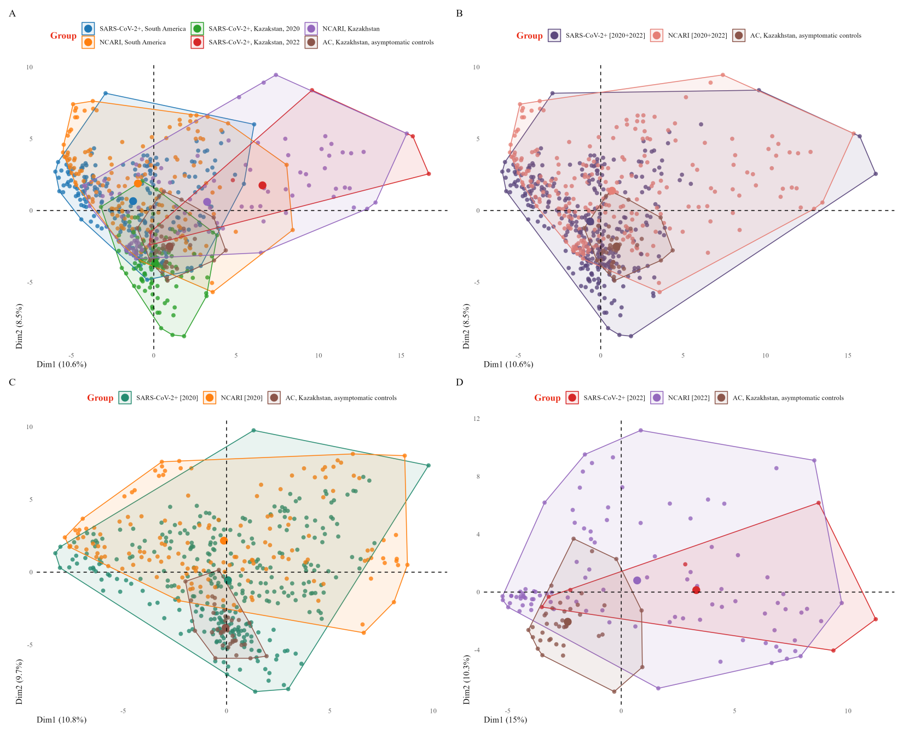

**Figure S7.** PCA of the mass spectra of all sub-groups from the combined dataset based on the peak intensity matrix for Analysis II.

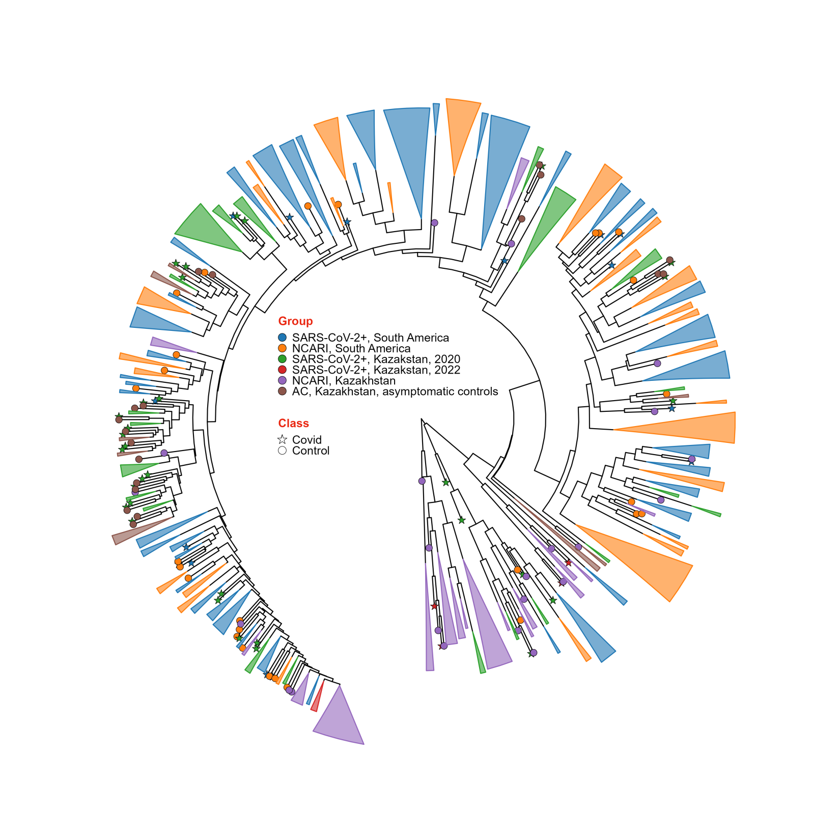

**Figure S8.** Dendrogram of the mass spectra stratified by sub-group from the combined dataset based on the peak intensity matrix for Analysis II.

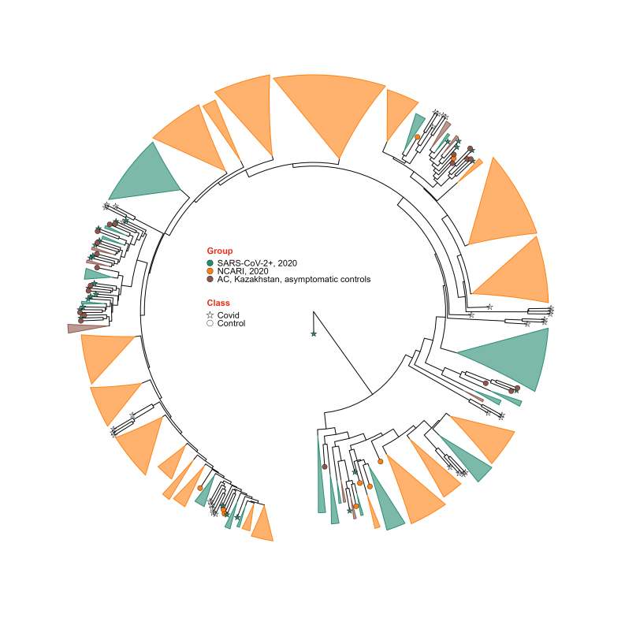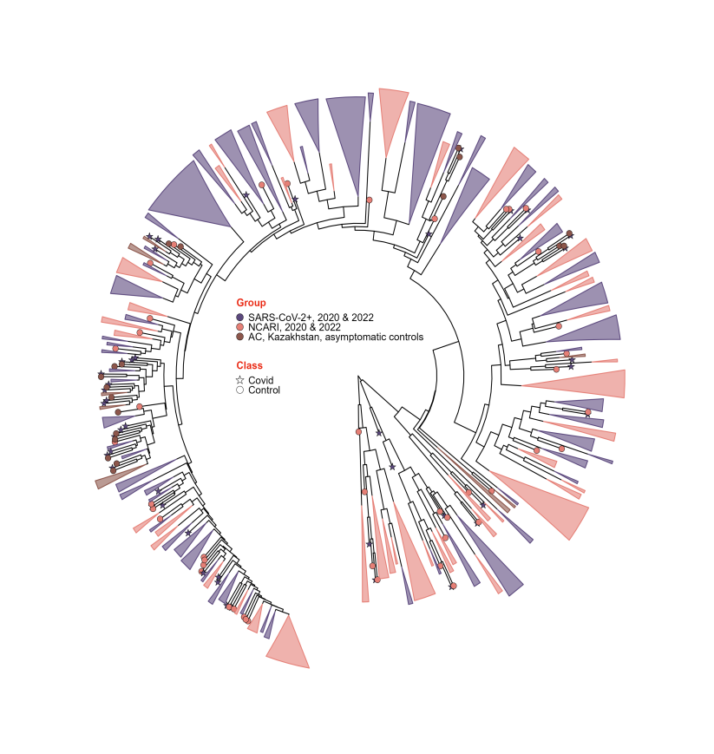

**Figure S9.** Dendrogram of the mass spectra stratified by sub-group from the combined dataset based on the peak intensity matrix for Analysis II.

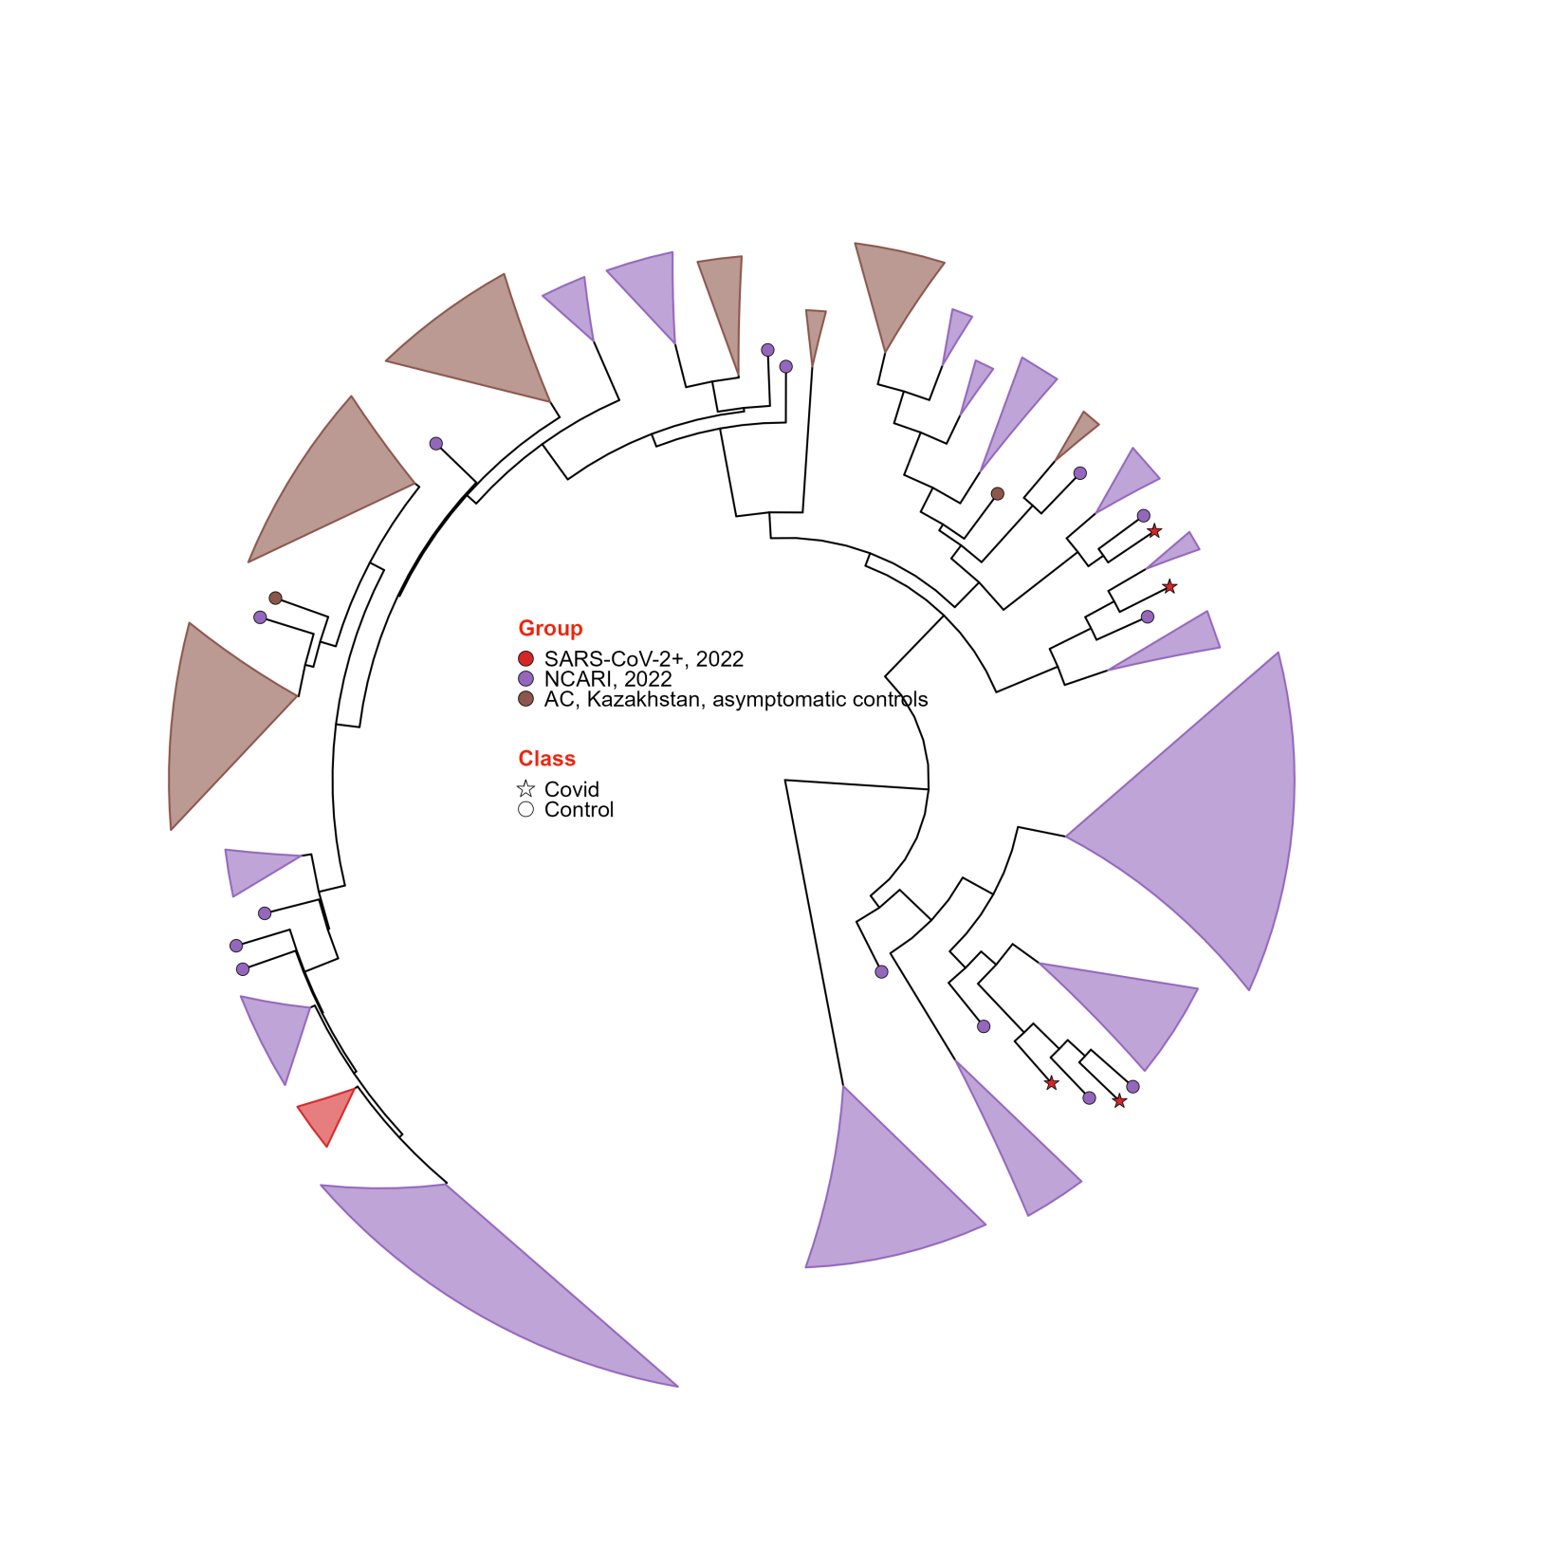

**Figure S10.** Dendrogram of the mass spectra stratified by sub-group from the combined dataset based on the peak intensity matrix for Analysis II.

**Table S5.** ROC AUC values of 7 ML models trained in Analysis II to differentiate each sub-group within the Kazakhstan (KZ) dataset. Median [25%; 75%]. Each model was tested 5 times on a 20% subset of Kazakhstan samples (the rest 80% were used to train the ML models). NCARI= non-COVID acute respiratory infection. AC=asymptomatic controls.

| Paired comparisons | DT | KNN | NB | RF | SVM-L | SVM-R | XGBoost |
| --- | --- | --- | --- | --- | --- | --- | --- |
| SARS-CoV-2 vs rest | 0.972 | 0.92 | 0.801 | 0.93 | 0.94 | 0.983 | 0.958 |
| [0.966; 0.979] | [0.88; 0.92] | [0.769; 0.808] | [0.90; 0.96] | [0.93; 0.95] | [0.958; 0.987] | [0.943; 0.970] |
| NCARI vs rest | 0.996 | 0.95 | 0.90 | 0.984 | 0.964 | 0.995 | 0.986 |
| [0.979; 1.000] | [0.93; 0.97] | [0.83; 0.92] | [0.983; 1.000] | [0.954; 0.984] | [0.964; 0.996] | [0.981; 0.996] |
| AC vs rest | 0.979 | 0.898 | 0.82 | 0.972 | 0.986 | 0.995 | 0.981 |
| [0.979; 0.984] | [0.886; 0.955] | [0.79; 0.85] | [0.966; 0.984] | [0.976; 0.992] | [0.990; 0.996] | [0.979; 0.988] |
| Micro-averaged | 0.977 | 0.93 | 0.785 | 0.951 | 0.965 | 0.991 | 0.960 |
| [0.966; 0.981] | [0.90; 0.94] | [0.775; 0.834] | [0.925; 0.968] | [0.958; 0.966] | [0.965; 0.991] | [0.956; 0.977] |
| Macro-averaged | 0.971 | 0.91 | 0.806 | 0.962 | 0.961 | 0.983 | 0.972 |
| [0.965; 0.981] | [0.90; 0.92] | [0.794; 0.857] | [0.941; 0.972] | [0.955; 0.961] | [0.955; 0.986] | [0.951; 0.977] |