**Genetic analysis based on mitochondrial DNA in tench,**

***Tinca tinca* L., populations**

**Abstract**

Three mitochondrial DNA segments, D-loop, COXI and *Cyt-b* were analyzed in 50 tench (*Tinca tinca* L.) individuals from five European populations. In addition, several *Cyt-b* sequences were retrieved from GenBank and added into the data set. Based on the concatenated alignments of the three mtDNA segments and from *Cyt-b* markers, two phylogenetic trees were reconstructed. The analysis split the data set in two phylogroups and indicates a hybridization zone in the region of the Danube river. Our results contribute to a better understanding on the genetic variability of tench.

Key words: mtDNA, genetic variability, *Tinca tinca*

The tench, *Tinca tinca* (L.) is a freshwater species, native to Eurasian boarders (Brylinska *et al.,*1999; Kottelat & Freyhof 2007). However, due to human-mediated translocations, it is now widely distributed across freshwater regions of the world (Lajbner *&* Kotlik*,* 2011). Tench has a great potential for aquaculture (Gela *et al.,* 2006; Celada *et al.,* 2007; Kohlmann *et al*., 2009), but its genetic structure is still limited compared to other fish species (Presti *et al.,* 2012). So far, genetic diversity within and between tench populations relied on enzyme variability, microsatellite markers (Kohlmann1998, 2005, 2007, 2008), nuclear and mitochondrial DNA (mtDNA) (Presti 2009, 2012, 2013; Lajbner 2009, 2010; Lajbner & Kotlik 2010; Lujic 2017), as well as growth hormones genes (Kocour & Kohlmann, 2014). The analysis of polymorphisms on nuclear markers and mtDNA regions is verified as an exceptional tool in the detection of genetic variability among tench species (Briolay 1998; Presti 2009, 2012) hence, the complete mtDNA sequence of *T. tinca* has already been published (Saitoh *et al.,* 2006).

Similar to many widely distributed freshwater species, tench presents deep phylogeographic subdivisions (Van Houdt *et al.,* 2005; Hanfling *et al.,* 2009; Lajbner *et al.,* 2010*)*. Recent evidence separates tench in two deeply divergent phylogroups, the Western phylogroup (W) and the Eastern (E) (Presti *et al.,* 2012; Lajbner & Kotlik 2011; Lujic *et al.,* 2017). Hybridization zone between the two phylogroups have been reported in central Europe across the Danube river while the phylogroup E is partitioned into three subclades (Lajbner *et al.,* 2011). Furthermore, human-aided translocations of *T. tinca* populations have contributed to introgressions between the two phylogroups, disturbing their independent evolution (Lajbner *et al* 2011; Lujic *et al.,* 2017).

The present study aims to investigate the variability of five wild European tench populations (England, Greece, Spain, Romania and Czech Republic), by analyzing three mtDNA segments, D-loop, COXI, and *Cytb*, (COXI has never been used before in tench phylogeographic research) and reconstructing phylogeny to unveil the evolutionary relationships within and between different tenchpopulations. In addition, seventeen *Cytb* sequences (GenBank Accession no. HM167935–HM167965) retrieved from (Lajbner *et al.,* 2011) and incorporated into our data in order to reconstruct a phylogenetic tree based on a single genetic marker.

A total of 50 tench individuals collected from five European countries (England, Greece, Spain, Romania and Czech Republic) were analyzed. Total genomic DNA was extracted from muscle using CTAB method (hexacytrimethymmonium bromide) (Hillis *et al.,* 1996)*.*

PCR amplification of D-loop using primers designed by Primer3 software ( D-loopR, 5’-TTCTCAGGGCCCATCTTAAC-3’ and D-loopL, 5’- CGCCCAGAAAAAGGAGATTT-3’;) while for the amplification of COXI and *Cytb* already published primers were used (Briolay *et al.,* 1998; Ward *et al.,* 2005); Overall, 2381 bp were amplified, 1067 bp for D-loop region, 650 bp for COXI and 664 bp for Cyt-b. The total volume of polymerase chain reaction was 25μl in which 100ng of genomic DNA was amplified, using 0.1 units of Qiagen Taq polymerase, 2mM dNTPs, 1 pmol/μl of each primer, 2.5 mM MgCl2 and 2.5 μl of 10 X Reaction Buffer. Thermal cycling amplification conditions were as follows: initial denaturation at 94oC for 3 min, followed by 33 cycles of strand denaturation at 94oC for 1 min, annealing at 51oC for 45 s and primer extension at 72oC for 40 s and a final 3min elongation time at 72oC. The PCR products were purified using the Nucleospin Extra kit (Macherey-Nagel, Duren, Germany) and sequenced by Sanger method from Macrogen Inc. (Seoul, Korea) using an ABI 3730XL DNA Analyzer.

The next step included the sequencing of PCR products. The sequences aligned by ClustalW software and the reference sequence (RefSeq), (GenBank, accession n. NC08648), derived from an individual in Lake Saône, South France. The polymorphic sites between 50 samples of *T.tinca* and RefSeq can be found in supplementary material. The nucleotide variation at three mtDNA regions originated a total of 29, 10 and 4 polymorphic sites in D-loop, COXI and *Cyt-b* regions respectively. In particular, the polymorphisms are sub-divided into 25 translocations, 9 inversions and 4 insertions. D-loop region represents higher number of polymorphisms due to the fact that unlike COXI and *Cyt-b*, it occurs mainly in the non-coding area of the mitochondrial genome. Furthermore, D-loop segments shows a pattern of rich in adenine and thymine bases in the microsatellite DNA sector. This a common issue in mtDNA control regions as a consequence of the replication slippage process (Bermingham *et al.,* 1986; Harrison *et al.,* 1985).

The analysis revealed nine composite haplotypes (H1-H9), (Table 1). Higher frequency is reported on haplotypes H1, H6, H8 and H9 covering 80% of all samples. Both Greek and Czech Republic populations express high heterozygosity as they are formed in four distinct haplotypes. In contrast, the Romanian samples are divided in three haplotypes and the English and Spanish populations are the most homogeneous as they consist of unique haplotypes.

The hypothesis of two phylogroups in tench populations is also established by the phylogenetic analysis (Fig I). Sequences of the three mtDNA markers merged into a 1588 bp segment and analyzed using MEGA version 10.0.5 (Tamura, Dudley, Nei, and Kumar 2007). In particular, the phylogenetic analysis performed under a maximum likelihood framework using Tamura 3-parameter model and the robustness of the trees was assessed by bootstrap resampling (1000 replicates; Felsenstein 1985). The phylogeny verified that the discriminatory power of D-loop, COXI and *Cytb* markers was informative enough, to clearly identify between the Western and Eastern phylogroup which has already been suggested in tench phylogeography (Lo Presti *et al.,* 2012; Kocour and Kohlmann, 2011; Kohlmann *et al.,* 2010; Lajbner *et al.,* 2007, 2011).

The Spanish, Romanian and Czech Republic samples grouped together and composed the South-East group while the English and Greek formed the North-West group. The Greek population could not be classified as *T. tinca* is not native in this region. However, the results strongly suggests that tench species in Greece have Western origin. On the other hand, our findings reveal that tench in Iberian Peninsula have been introduced by Eastern Europe or Asia and reports unique haplotypes mainly as a result of geographical isolation.

The Czech and Romanian populations display mixed haplotype patterns implying the existence of tench hybrids across the region of Danube river. In fact, it has been reported that admixed populations on this region could be probably a result of natural postglacial contact between the Eastern and Western lineages rather a cause of intentional translocations of tench populations by humans (Lajbner *et al.,* 2011).

In addition, seventeen *Cytb* sequences (GenBank Accession no. HM167935–HM167965) retrieved and merged with our data forming nine distinct haplotypes. Since *T*. *tinca* is the only species belonging to Tincidae family, we used *Barilius bendelisis* as the outgroup (GenBank Accesion no. AP011433). The phylogeny clearly splits the wide-range data set into Western and Eastern phylogroup with four and five composite haplotypes respectively. The internal structure of phylogroup E is partitioned into three subclades. Specifically, H4 haplotype in the Anzalee lagoon of the Caspian Sea Iran and H9 in the Iskar River of the Danube river in Bulgaria composing separate clades. It is as yet unclear, why these two areas illustrate some kind of divergence from the rest of the phylogroup and expose the necessity for a re-evaluation on the distribution of refugia between the Danube River and the Ponto-Caspian region.

The British samples are grouped exclusively into the Western phylogroup. In general, tench populations in UK are mainly of Western origin. However, breeds with Eastern genetic structure into the British Isle have been reported and could be a result of tench translocations for aquaculture purposes (Lajbner *et al.,* 2011). The concept of mixed populations consisting both Western and Eastern haplotypes was tested using the AseI restriction enzyme to digest COXI fragment in 30 individuals from UK. The results split the data set in Western (29 samples) and Eastern (1 samples) phylogroup. Equally, the analysis shows that the six out of forty four samples from Vodňany area (Czech Republic) and one out of fifteen samples from Costanta (Romania) demonstrate Western haplotype patterns showing that breeds with admixed genetic structure occur across the region of Danube river. Apart from these areas, hybrids have been reported in Grosser Felchowsee and Kleiner Döllnsee lakes in north-eastern Germany in an area covered by the Scandinavian ice sheet during the Weichselian glaciation (Lajbner *et al.,* 2009). These lakes are located in a relatively short distance from Vodňany (approximately 550 kilometers) and could be an explanation of the distinct haplotype patterns our analysis display on these samples.

In Turkey, tench has been introduced in central and western part of this country but it is also a native species in river drainages within the Black Sea basin (Brylinska *et al.,* 1999). Our results point out that in Turkey, *T. tinca* express Eastern haplotype patterns and grouped into phylogroup E, suggesting that the non native breeds are derived from an area within the range of the Eastern phylogroup. Unsurprisingly, the Chinese haplotype is also grouped into the Eastern phylogroup. This is fairly expected, since recently breeds from Vodňany have been imported in China as a source for stocking (Wang *et al.,* 2004). It is possible that this practice could induce introgression of tench populations with Western haplotypes into the native species of Asia since tench in Czech Republic is composed by mixed populations.

In conclusion, our study utilize new data, never used before in tench phylogeography research and contribute to a better understanding of the genetic variability within as well as between fifteen tenchpopulations. The data revealed that mtDNA markers provide a high level of discriminatory power in the application of population genetic research. The occurrence of tench hybrids across Danube river might be a valuable baseline to start selective breeding programs especially if mtDNA markers were to be combined with nuclear data (Presti *et al.,* 2012). The fact that tench phylogroups can interbreed but remain distinct has essential practical implications. Since none negative fitness consequence of mixed tench populations has been detected and tench is widely used in aquaculture, research on tench genetic structure may contribute to the identification of genes underlying crucial structural and physiological phenotypes (Allendorf *et al.,* 2001). Thus, the unique characteristics of *T. tinca* genetic structure makes this species a valuable model for applied genetic research.

**Table I**. Nucleotide and haplotype frequency based on 50 samples from 5 different European populations. The British and Spanish samples are composed by unique haplotypes. In contrast the Greek and Czech Republic samples express high heterozigosity with four distinct haplotypes.

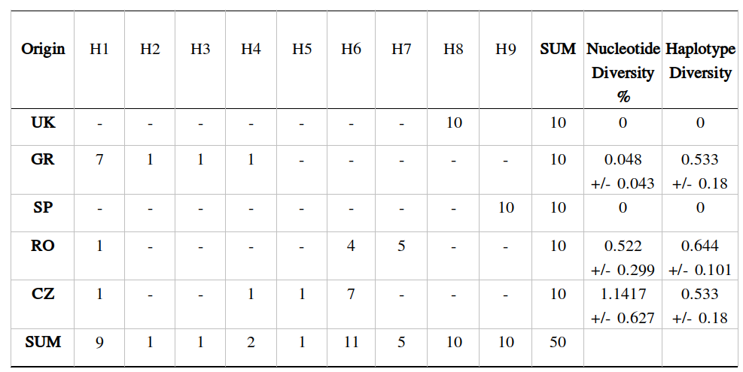

**Fig I**. The phylogenetic tree as produced by MEGA software, performed under a maximum likelihood framework using Tamura 3-parameter model. Fig I (a) display the phylogenetic tree based on the concatenated alignments of three mtDNA segments (D-loop, *Cyt-b,* COXI) for five European countries. The number of samples forming each haplotype is shown next to the origin of the haplotype. Fig I (b) illustrates the phylogeny based on a single genetic marker (*Cyt-b)* andrepresent fifteen different countries. The outgroup used for the reconstruction of the phylogeny (b) is *Barilius bendelisis.* Both trees split the data set in two phylogroups, Western (brown) and Eastern (blue). The Romanian and Czech Republic populations are composed by haplotypes of both phylogroups.

* UK in West phylogroup represent England while in East phylogroup represent Ukraine.

*(a)* *(b)*

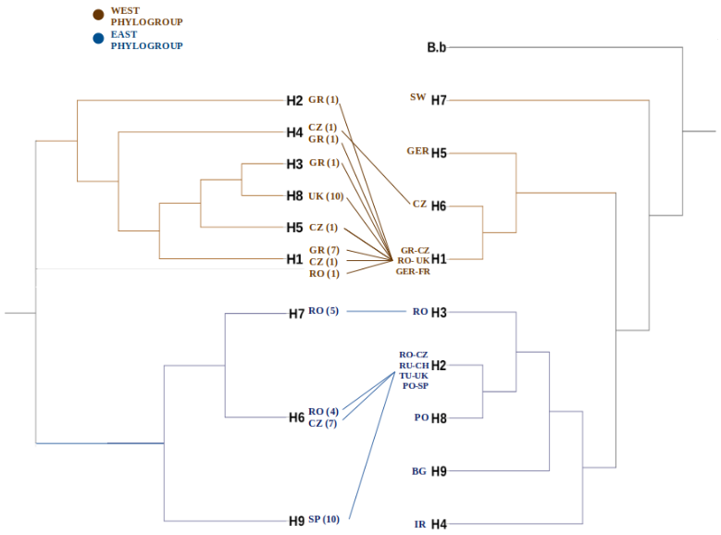

**Acknowledgments**

**...**

**References**

Allendorf, F. W., Leary R. F., Spruell P., J. K. Wenburg . 2001. The problems with hybrids: setting conservation guidelines. Trends Ecol Evol 16: 613-622.

Bataillon, P. E., & Republic, C. (2001). Phylogeography of the barbel (Barbus. *Molecular Ecology*, 2177–2185.

Bermingham, E., & Avise, J. C. (1986). <Size polymorphism and heteroplasmy in the mitochondrial DNA of lower vertebrates.pdf>, 249–252.

Briolay, Jérôme & Galtier, Nicolas & Brito, Miguel & Bouvet, Yvette. (1998). Molecular Phylogeny of Cyprinidae Infered from cytochrome b DNA Sequences. Molecular phylogenetics and evolution. 9. 100-8. 10.1006/mpev.1997.0441.

Brylińska M, Bryliński E, Bnińska M. 1999. Tinca tinca (Linnaeus,1758). In: Bănărescu PM (ed) The freshwater fishes of Europe. Cyprinidae 2: Part I: Rhodeus to Capoeta. AULA-Verlag, Wiebelsheim, p. 229-302.

Celada, J. D., Aguilera, A., Carral, J. M., Sáez-Royuela, M., Melendre, P. M., & Pérez, J. R. (2007). Effects of stocking density on survival and growth of juvenile tench (Tinca tinca L.). *Aquaculture International*, *15*(6), 461–465. https://doi.org/10.1007/s10499-007-9111-4

Chein, I. (1980). Psychological, social, and epidemiological factors in juvenile drug use. *NIDA Research Monograph*, *30*, 76–82.

Durand, J. D., Persat, H., & Bouvet, Y. (1999). Phylogeography and postglacial dispersion of the chub (Leuciscus cephalus) in Europe. *Molecular Ecology*, *8*(6), 989–997. https://doi.org/10.1046/j.1365-294X.1999.00654.x

Felsenstein, Joseph. (1985). Confidence Limits on Phylogenies: An Approach Using the Bootstrap. Evolution. 39. 783-791. 10.2307/2408678.

Gela, D., Flajšhans, M., Kocour, M., Rodina, M., & Linhart, O. (2006). Tench (Tinca tinca) broodstock management in breeding station under conditions of pond culture: A review. *Aquaculture International*, *14*(1–2), 195–202. https://doi.org/10.1007/s10499-005-9025-y

Hänfling, B., Dümpelmann, C., Bogutskaya, N. G., Brandl, R., & Brändle, M. (2009). Shallow phylogeographic structuring of Vimba vimba across Europe suggests two distinct refugia during the last glaciation. *Journal of Fish Biology*, *75*(9), 2269–2286. https://doi.org/10.1111/j.1095-8649.2009.02415.x

Harrison, R. G., Rnad D. M., W. C. Wheeler. 1985. Mitochondrial DNA size variation within individual crickets. Science 228: 1446-1448

Hillis D, Moritz C, Mable BK. Molecular systematic. Nucleic acids IV: sequencing and cloning. Sinauer Associates, Sunderland, MA. 1996. p. 321–381.

Kocour, M., & Kohlmann, K. (2011). Growth hormone gene polymorphisms in tench, Tinca tinca L. *Aquaculture*, *310*(3–4), 298–304. https://doi.org/10.1016/j.aquaculture.2010.10.006

Kocour, M., & Kohlmann, K. (2014). Distribution of five growth hormone gene haplogroups in wild and cultured tench, Tinca tinca L., populations. *Journal of Applied Ichthyology*, *30*(S1), 22–28. https://doi.org/10.1111/jai.12428

Kohlmann, K & Kersten, P. (1998). Enzyme variability in a wild population of tench (Tinca tinca). Polskie Archiwum Hydrobiologii. 45. 303-310.

Kohlmann, K., & Kersten, P. (2006). Microsatellite loci in tench: Isolation and variability in a test population. *Aquaculture International*, *14*(1–2), 3–7. https://doi.org/10.1007/s10499-005-9009-y

Kohlmann, K., Kersten, P., & Flajšhans, M. (2007). Comparison of microsatellite variability in wild and cultured tench (Tinca tinca). *Aquaculture*, *272*(SUPPL. 1), 147–151. https://doi.org/10.1016/j.aquaculture.2007.08.003

Kohlmann, K., Kersten, P., Panicz, R., Memiş, D., & Flajšhans, M. (2010). Genetic variability and differentiation of wild and cultured tench populations inferred from microsatellite loci. *Reviews in Fish Biology and Fisheries*, *20*(3), 279–288. https://doi.org/10.1007/s11160-009-9138-x

Lajbner, Z., Kohlmann, K., Linhart, O., & Kotlík, P. (2010). Lack of reproductive isolation between the Western and Eastern phylogroups of the tench. *Reviews in Fish Biology and Fisheries*, *20*(3), 289–300. https://doi.org/10.1007/s11160-009-9137-y

Lajbner, Z., & Kotlík, P. (2011). PCR-RFLP assays to distinguish the Western and Eastern phylogroups in wild and cultured tench Tinca tinca. *Molecular Ecology Resources*, *11*(2), 374–377. https://doi.org/10.1111/j.1755-0998.2010.02914.x

Lajbner, Z., Linhart, O., & Kotlík, P. (2011). Human-aided dispersal has altered but not erased the phylogeography of the tench. *Evolutionary Applications*, *4*(4), 545–561. https://doi.org/10.1111/j.1752-4571.2010.00174.x

Lo Presti, R., Gasco, L., Lisa, C., Zoccarato, I., & Di Stasio, L. (2010). PCR-RFLP analysis of mitochondrial DNA in tench Tinca tinca. *Journal of Fish Biology*, *76*(2), 401–407. https://doi.org/10.1111/j.1095-8649.2009.02495.x

Lo Presti, R., Kohlmann, K., Kersten, P., Gasco, L., Lisa, C., & di Stasio, L. (2012). Genetic variability in tench (Tinca tinca L.) as revealed by PCR-RFLP analysis of mitochondrial DNA. *Italian Journal of Animal Science*, *11*(1), 103–108. https://doi.org/10.4081/ijas.2012.e19

Lo Presti, R., Kohlmann, K., Kersten, P., Lisa, C., & Di Stasio, L. (2014). Sequence variability at the mitochondrial ND1, ND6, cyt b and D-loop segments in tench (Tinca tinca L.). *Journal of Applied Ichthyology*, *30*(S1), 15–21. https://doi.org/10.1111/jai.12423

Lujić, J., Kohlmann, K., Kersten, P., Marinović, Z., Ćirković, M., & Simić, V. (2017). Phylogeographic identification of Tench Tinca tinca (L., 1758) (Actinopterygii: Cyprinidae) from the Northern Balkans and adjacent regions and its implications for conservation. *Zoological Studies*, *56*(February). https://doi.org/10.6620/ZS.2017.56-03

Saitoh, K., Sado, T., Mayden, R. L., Hanzawa, N., Nakamura, K., Nishida, M., & Miya, M. (2006). Mitogenomic evolution and interrelationships of the cypriniformes (Actinopterygii: Ostariophysi): The first evidence toward resolution of higher-level relationships of the world’s largest freshwater fish clade based on 59 whole mitogenome sequences. *Journal of Molecular Evolution*, *63*(6), 826–841. https://doi.org/10.1007/s00239-005-0293-y

Tamura K, Dudley J, Nei M & Kumar S (2007) MEGA4: Molecular Evolutionary Genetics Analysis (MEGA) software version 4.0. Molecular Biology and Evolution 24:1596-1599.

Van Houdt, J. K. J., De Cleyn, L., Perretti, A., & Volckaert, F. A. M. (2005). A mitogenic view on the evolutionary history of the Holarctic freshwater gadoid, burbot (Lota lota). *Molecular Ecology*, *14*(8), 2445–2457. <https://doi.org/10.1111/j.1365-294X.2005.02590.x>

Wang, J., W. Min, M. Guan, and S. Hu. 2004. Tench farming in China: present status and future prospects. in S. Sakowicz, ed. Ivth International Workshop on Biology and Culture of the Tench, Tinca tinca (L.), p. 32. Wierzba, September 20-23 2004. Programme and Abstracts, Inland Fisheries Institute in Olsztyn, Olsztyn.