### Follow The Below Instruction / Steps To Create A New Instances Key-Pair.

Step # 1 – Login Your **AWS Management Console** user/credentials and select **EC2**

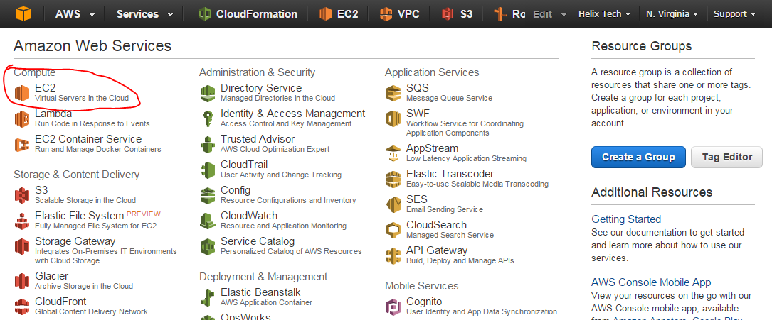

Step # 2 – On the **EC2 Dashboard**, select **KeyPair**, click **Create Key Pair** , provide the **Key pair name** on **Create** **,** e.g **webserver-keypair**.

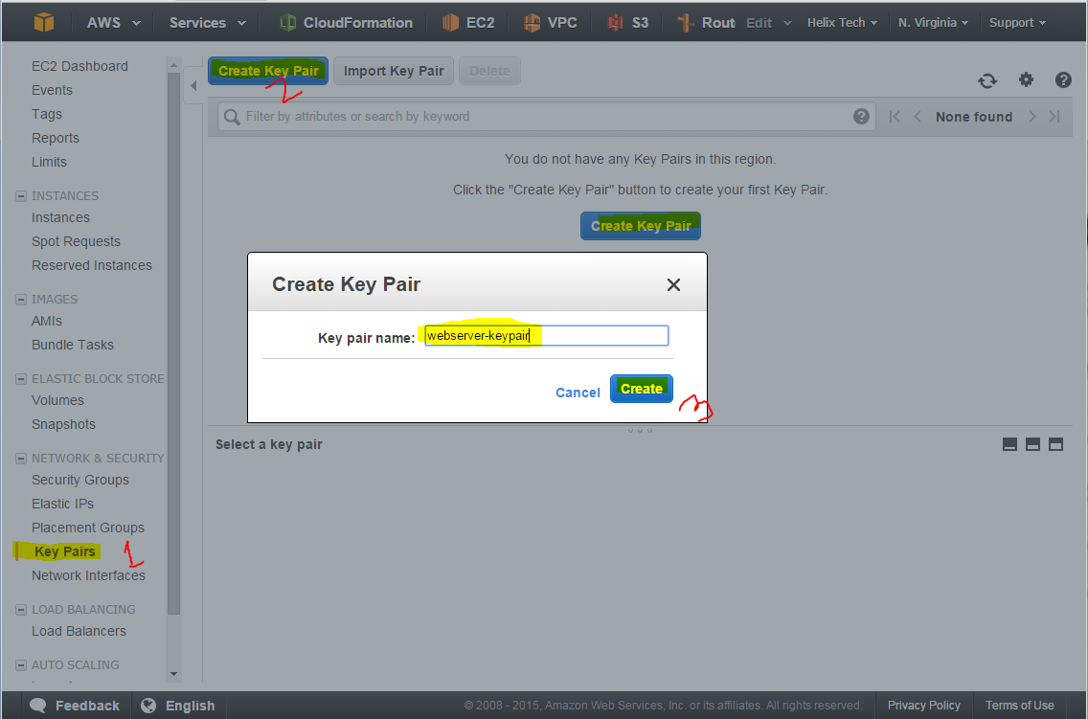

Step # 3 – Once you click on **Create** it will ask you to download the Private Key and that KeyPair you will be able to use later to access the ec2 instances. Its ready to use now with Linux/Unix or Mac Terminal.

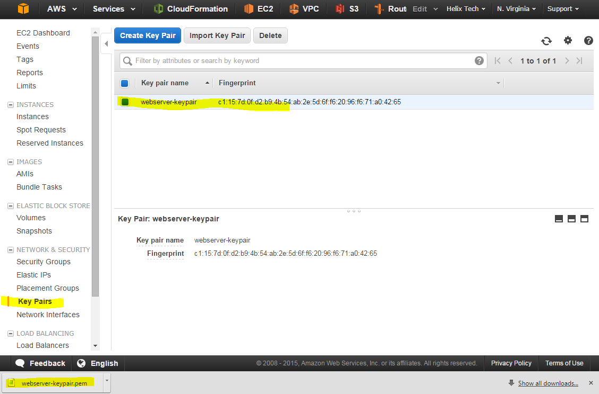

Step # 4 – If you are using Putty follow below links.

<http://docs.aws.amazon.com/AWSEC2/latest/UserGuide/putty.html>