### Follow The Below Instruction / Steps To Create A New Instances Key-Pair.

Step # 1 – Login Your **AWS Management Console** user/credentials and select **EC2**

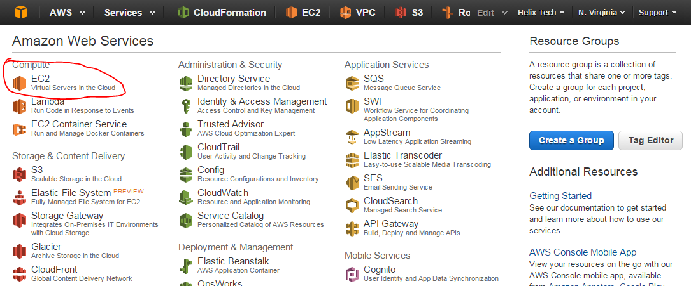

Step # 2 – On the **EC2 Dashboard**, select **Security Groups**, click **Create Security Group** , provide the **Security group name** under the **Security Group rules**, select **Inbound** and open port for **HTTP and HTTPS** for **0.0.0.0/0** and click **Create ,** e.g **SG-Webserver**

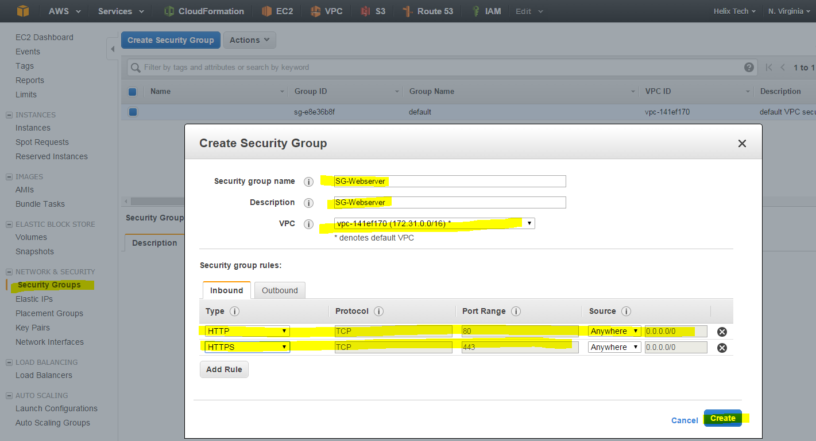

Step # 3 – Once you are done you are ready to SG for web server which has a traffic http and https.

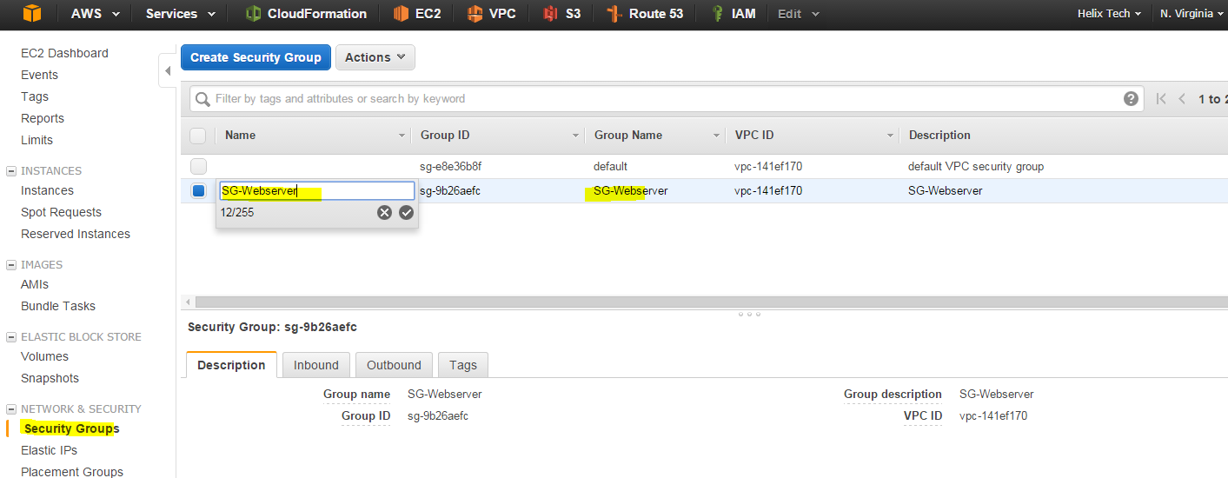

Step # 4 – for more info about the Security Groups

<http://docs.aws.amazon.com/AWSEC2/latest/UserGuide/using-network-security.html>