### Follow The Below Instruction / Steps To Create An Account ON AMAZON Web Services (AWS)

Step # 1 – Open browsser and type [www.aws.amazon.com](http://www.aws.amazon.com), on the uppler left corner, click on **My Acccount** > **AWS Management Console** .

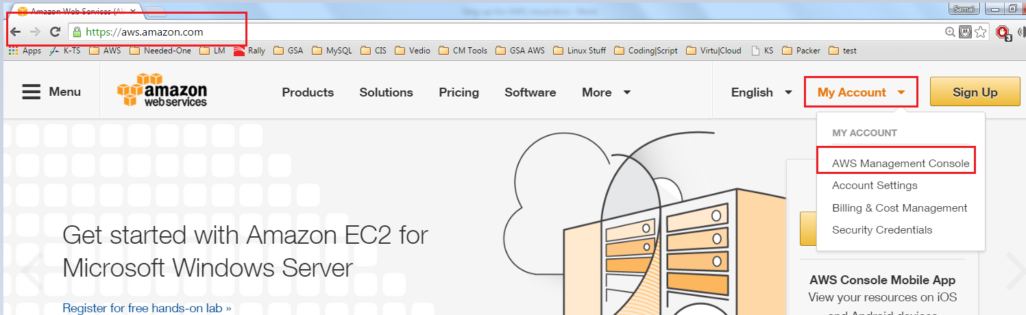

Step # 2 – On the below screen, enter the desire email address or phone number to create an account and select **I am a new user** and click on **Sign in using our secure server**.

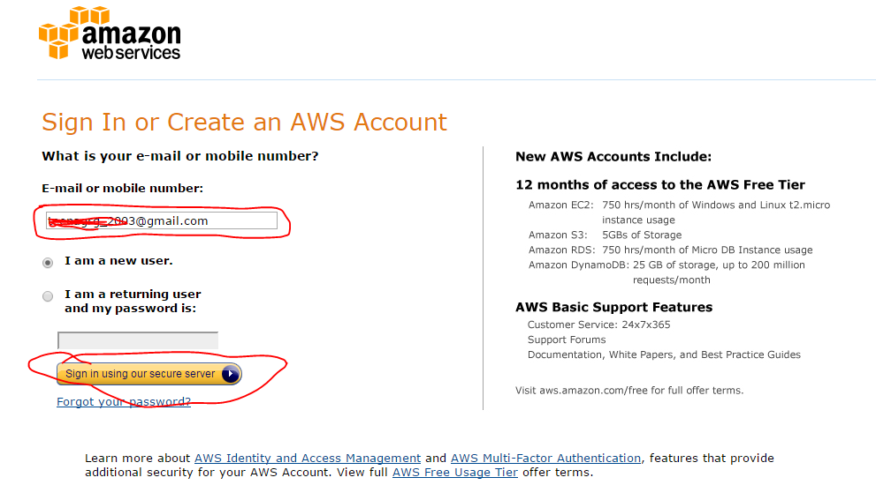

Step # 3 – Enter the below information and click **Create Account** that will be use to login to access your AWS Console

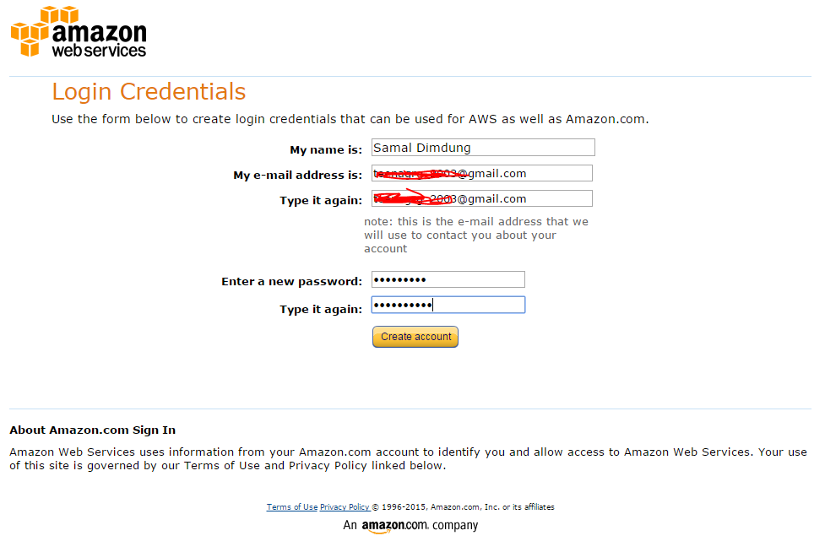

Step # 4 – Complete the below details and click **Create Account and Continue**.

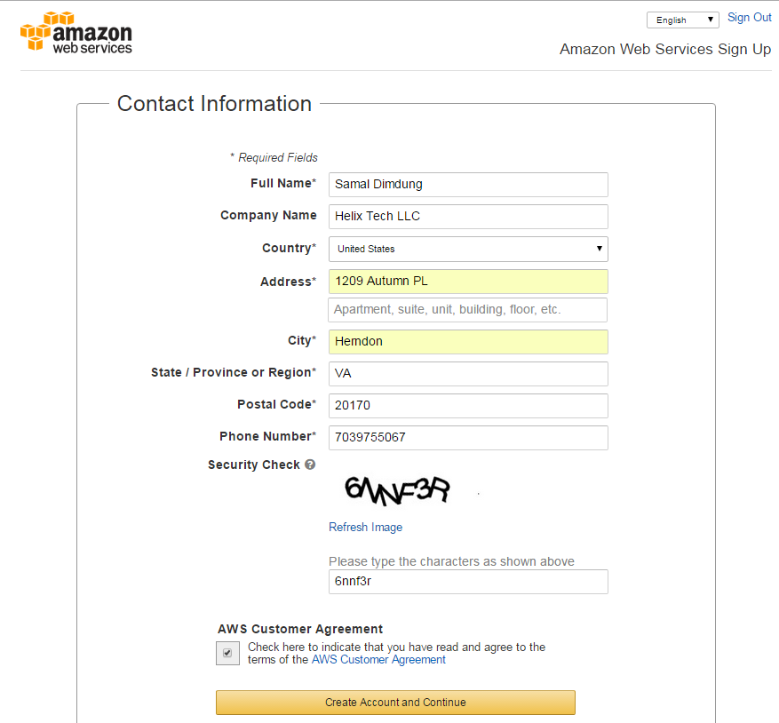

Step # 5 – Provides the Payment Information and click **Continue**

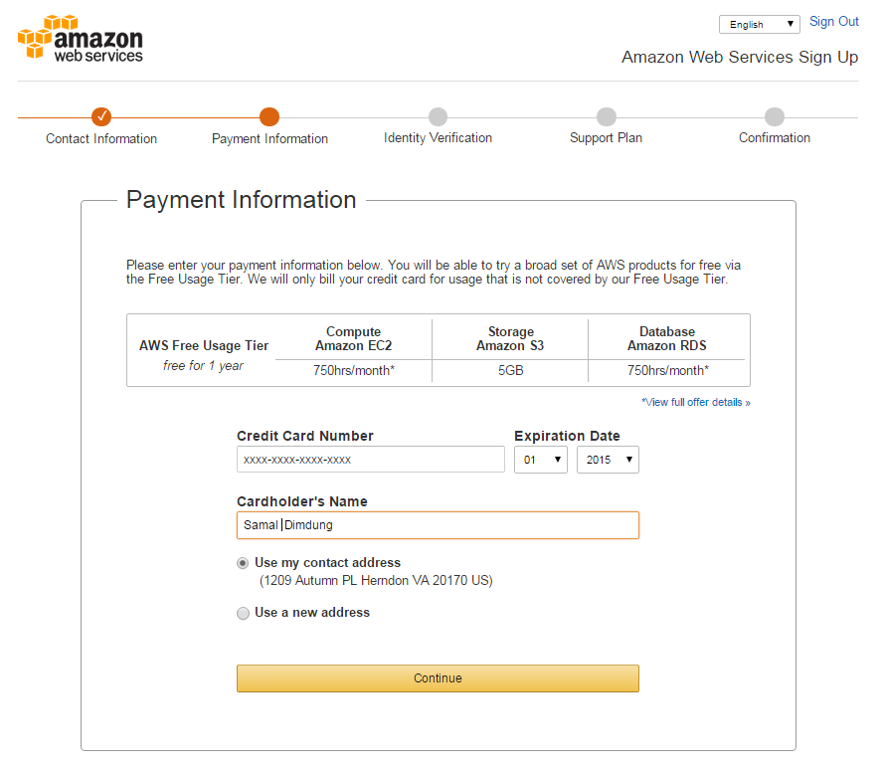

Step # 6 – Verify the Information and click on Call, then you will see call in progress window like below, you will receive call from Amazon and enter the below shown number to verify your account.

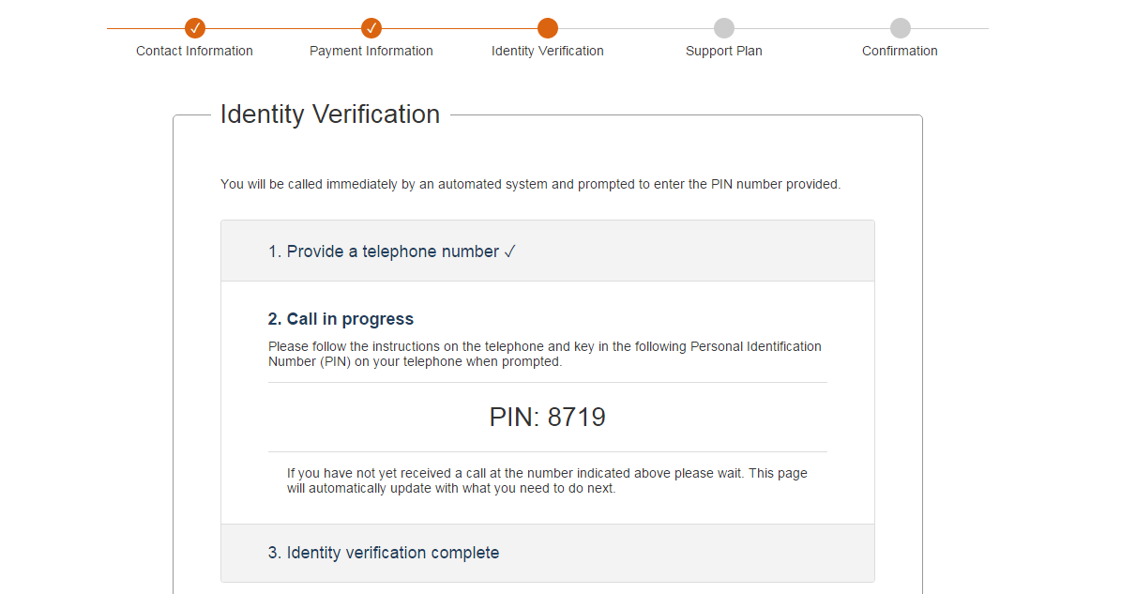

Step # 7 – Once you enter the verification code you will see the below screen. Click **Continue to select your Support Plan.**

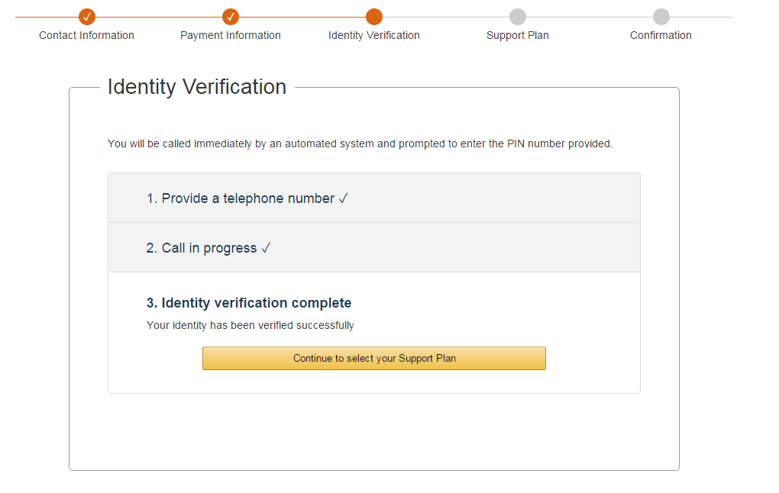

Step # 8 – Select the support plan, select **Basic (Free)** for Free tier usages and click **Continue**.

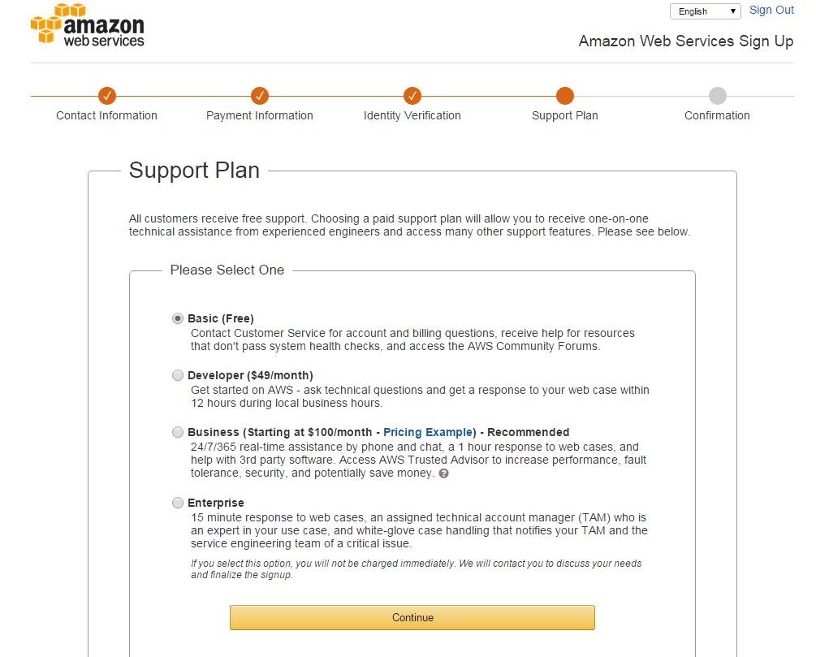

Step # 9 – Select from options to matches your profile and click **Submit**.

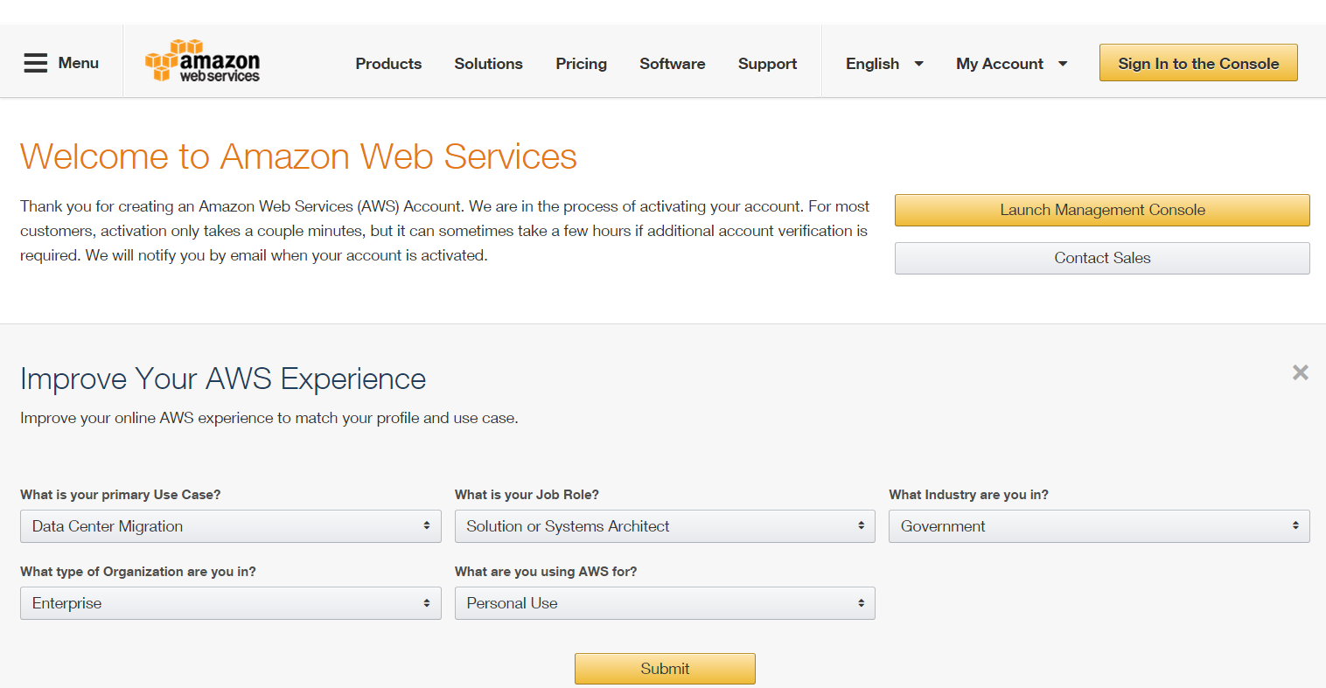

Step # 10 – Now your account is ready to login. Provide the user/credentials and Click on **Sign in using our secure server**.

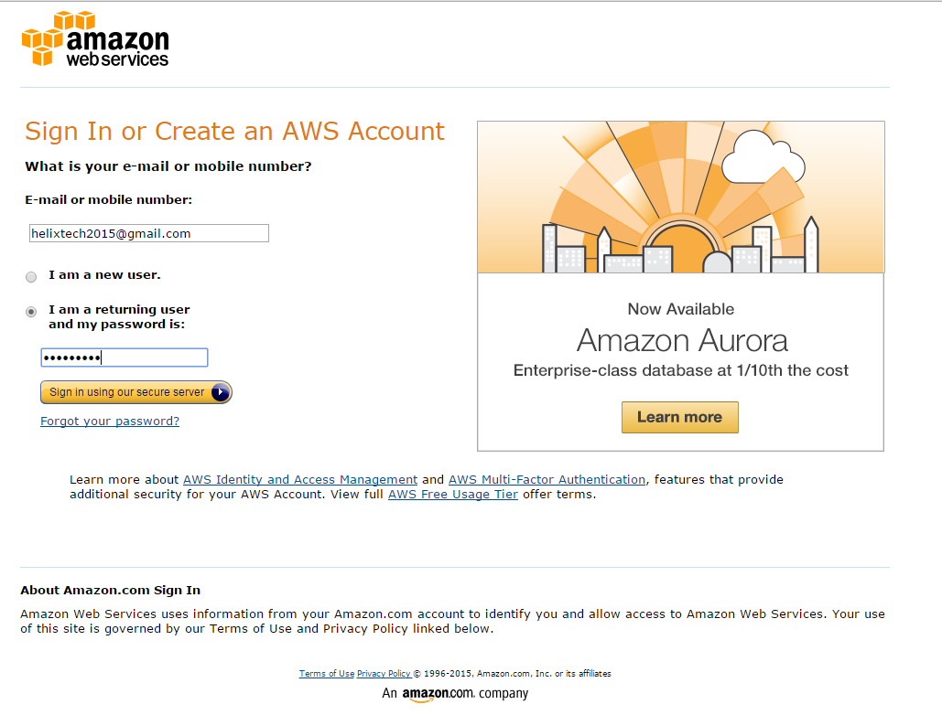

Step # 11 – Once you login, you will see the below detail on AWS Console and fully read to use Amazon Web Services for your business.

