Automated Test Engineer Technical Assignment

# **Introduction**

This document contains solutions/answers on questions list in Technical Assignment.

**Contents**

**1.** **Introduction** 2

**2.** **Task 1 - Test Concept** 2

**Task 1.1 – List of Tests** 2

**Task 1.2 – Environment selection** 3

**Task 1.3 – CI pipeline** 3

**Task 1.4 – Test equipment scheme** 3

**Task 1.5 – Test results** 3

**Task 1.6 – Test coverage** 3

**Task 1.7 – Previous test concepts experience** 3

**Task 1.8 – Additional info** 3

**3.** **Task 2 – Equipment selection** 4

**Task 2.1 – Equipment selection criteria** 4

**Task 2.2 – Equipment physical connection to DUT** 4

**4.** **Task 3 – Test automation** 4

# **Task 1 - Test Concept**

*Describe high level automated test concept for Bisly UMS Supersensor (datasheet attached). Test concept could include:*

## **Task 1.1 – List of Tests**

*List of different tests done (similar tests can be grouped together, no need to bring out each individual similar test) with brief reasoning what they achieve*

* **Power Management tests**

These tests required to be ensured that DUT performing effectively and safely in different power conditions

Various test groups on different inputs listed in requirements like:

* **Voltage Tests**

What they verify: correct operation of the device at minimum, nominal, and maximum voltages within the specified range (e.g., 16–30 VDC for UMS)

Reason: to ensure that the device won’t fail under power dips or surges and remains stable.

* **Power Consumption Tests**

What they verify: actual device consumption in different operating modes (e.g., average 0.7W, peak 1.5W with all sensors active)

Reason: important for energy efficiency requirements and to calculate the load on the building’s power system.

* **Power Reduction Tests**

What they verify: proper behavior when entering reduced power consumption mode (e.g., in idle mode or no activity).

Reason: proper behavior when entering reduced power consumption mode (e.g., in idle mode or no activity).

* **Start-Up Tests & Restart Tests**

What they verify: check proper boot-up when power is applied, and behavior after short power interruptions or restarts.

Reason: ensure the device initializes correctly without freezing and preserves its configuration.

* **Communication Encryption tests**

UMS sensor has encrypted RS485 communication and severity of these tests should be **critical(!)** (Protocol knowledge required)

* **Communication Encryption Tests**

What they verify: verify that all RS485 network traffic is properly encrypted (AES128 per device key).

Reason: to ensure data confidentiality and prevent eavesdropping or manipulation of sensor data.

* **Authentication & Authorization Tests**

What they verify: confirm that only authorized devices with valid keys can join the network and exchange data.

Reason: to prevent rogue devices from connecting to the building automation system.

* **Replay Attack Tests**

What they verify: simulate capturing and replaying valid network packets

Reason: to ensure the device rejects reused or manipulated messages.

* **Firmware / Software update**

What they verify: remote upgrades are authenticated and cannot be tampered with.

Reason: to prevent malicious firmware injection.

* **DoS Attacks**

What they verify: device behavior under malformed or excessive traffic on RS485.

Reason: to ensure device remains operational and does not crash under stress.

* **Sensor tests**
* **Temperature tests**

What they verify: correct temperature measurement across the specified operating range (–10 to 85 °C)

Reason: inaccurate readings could lead to poor energy efficiency or uncomfortable indoor climate.

* **Humidity tests**

What they verify: accurate relative humidity measurement in the range 0–80% rH

Reason: humidity control is important for comfort, energy savings, and preventing mold or equipment damage.

* **CO2 / VOC / Dust Particle tests**

What they verify: CO2 concentration, VOCs, Dust particle concentration

Reason: Air quality monitoring is critical for health, safety, and compliance with building standards. Wrong readings could compromise ventilation strategies.

* **Ambient Light (Intensity) tests**

What they verify: Proper measurement of light intensity with high resolution

Reason: Ensures that lighting automation

* **Color Sensor tests**

What they verify: Detection of ambient light color spectrum (400–680 nm, up to 16-bit resolution)

Reason: Correct color measurement allows fine control of lighting quality

* **Integration tests with other main units**

What they verify: Check that message are sent and received to other unit outside UMS

Reason: Integrity verification

## **Task 1.2 – Environment selection**

*Test environment selection with brief justification why this environment/combination of environments is beneficial*

(Here I show my view on manual automatic test concept)

Both manual and automatic:

* DUT – Device Under Test, because without it no scope for testing
* Power Supply – measure input voltage, simulate voltage
* RS485 Converter

Manual:

* Climate chamber (could be also in automatic setup, but depends on budget) – to create temperature and air conditions
* Particle Chamber or Gas – to simulate CO2/VOC conditions

Automatic:

* Adjustable Light Source - controllable light setup (intensity and spectrum etc.), to test light intensity and color sensors
* Motion simulator - mechanism or setup to imitate human movement
* (IMPORTANT) Programmable relay boxes – this is on of the major point in automation

For my opinion the best case should not only contain this list, but special software, that could simulate condition on system-software level, which will give advance for testing, because if bugs are found in such simulation test at EARLY stage – it will help to prevent bugs, which will be found on System level stage, where failure cause could be not software, but hardware and more time will be spent to identify this root cause.

## **Task 1.3 – CI pipeline**

*Overview/brief explanation how test environment interfaces/interacts with CI pipeline*

(Here I try to explain very briefly how this could look like, because these various solutions for every project could be implemented)

All fully automated test cases are linked to f.e.‘System Test’ Jenkins plan, which is started every time automatically, once the new FW/SW Release is integrated. Each regression test runs all test cases are executed.   
  
How the process could work:

1. SW Integrator builds SW/FW release
2. Binaries are copied to test server
3. Flashing of binaries is triggered automatically as a separate Jenkins job
4. Regression test is started after successful software download and flashing
5. Test Reports are generated and stored in Jenkins/Allure environment
6. Delivery preparation which should contain test results with statistics, traceability, bug or other major issue reports.
7. Summary preparation
8. Summary is sent to stakeholders

## **Task 1.4 – Test equipment scheme**

*Block schematic how different test equipment interacts with DUT (no need to pick specific  
manufacturers/models yet)*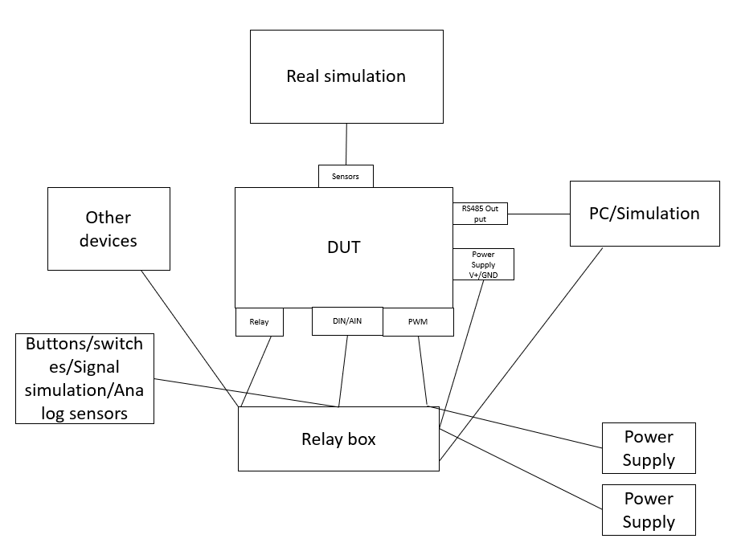

## **Task 1.5 – Test results**

*Test results visualization/storage concept*

Visualization (Allure/Jira/Bamboo):

* Pass/Fail criteria
* Suite metrics
* Trends
* Run statistics metrics
* Bug/Bug severities metrics
* Bidirectional traceability view
* Release statistics metrics
* Various table like branch/commit/date/status/suite

Storage:

* Allure results + HTML report on server (local or f.e. AWS)
* IBM Rational Doors for results and traceability

## **Task 1.6 – Test coverage**

*Test coverage tracking concept/methods*

(The Basic input here should be clear under understanding what is 100% coverage)

* Requirements coverage
* Risk coverage
* Scenarios coverage (better to be included in requirements sections)

Traceability:

* f.e System Test Specification is created in Doors and have a link to System Requirement in TRS in DOORS
* Test runs should produce a coverage report indicating which System requirements are covered by which TCs
* Jira issue reports are linked to Requirement IDs in Doors
* Jira issue reports are linked to TC ID-s in Doors

## **Task 1.7 – Previous test concepts experience**

I created multiple test plans and strategies for various test projects in automotive area (vehicles, car audio, audio amplifiers)

## **Task 1.8 – Additional info**

Test concept should be transformed into Test Plan with Test Strategies according to ISTQB (Internation Software Testing Qualifications Boards) recommendation and SPICE (Software Process Improvement and Capability Determination) standard

# **Task 2 – Equipment selection**

## **Task 2.1 – Equipment selection criteria**

*Why each equipment was selected and main selection criteria?*

## **Task 2.2 – Equipment physical connection to DUT**

*How equipment is physically connected to DUT?*

I think this is explained in task 1.4, but not in details. But give some pictures for my test step for Task 3.

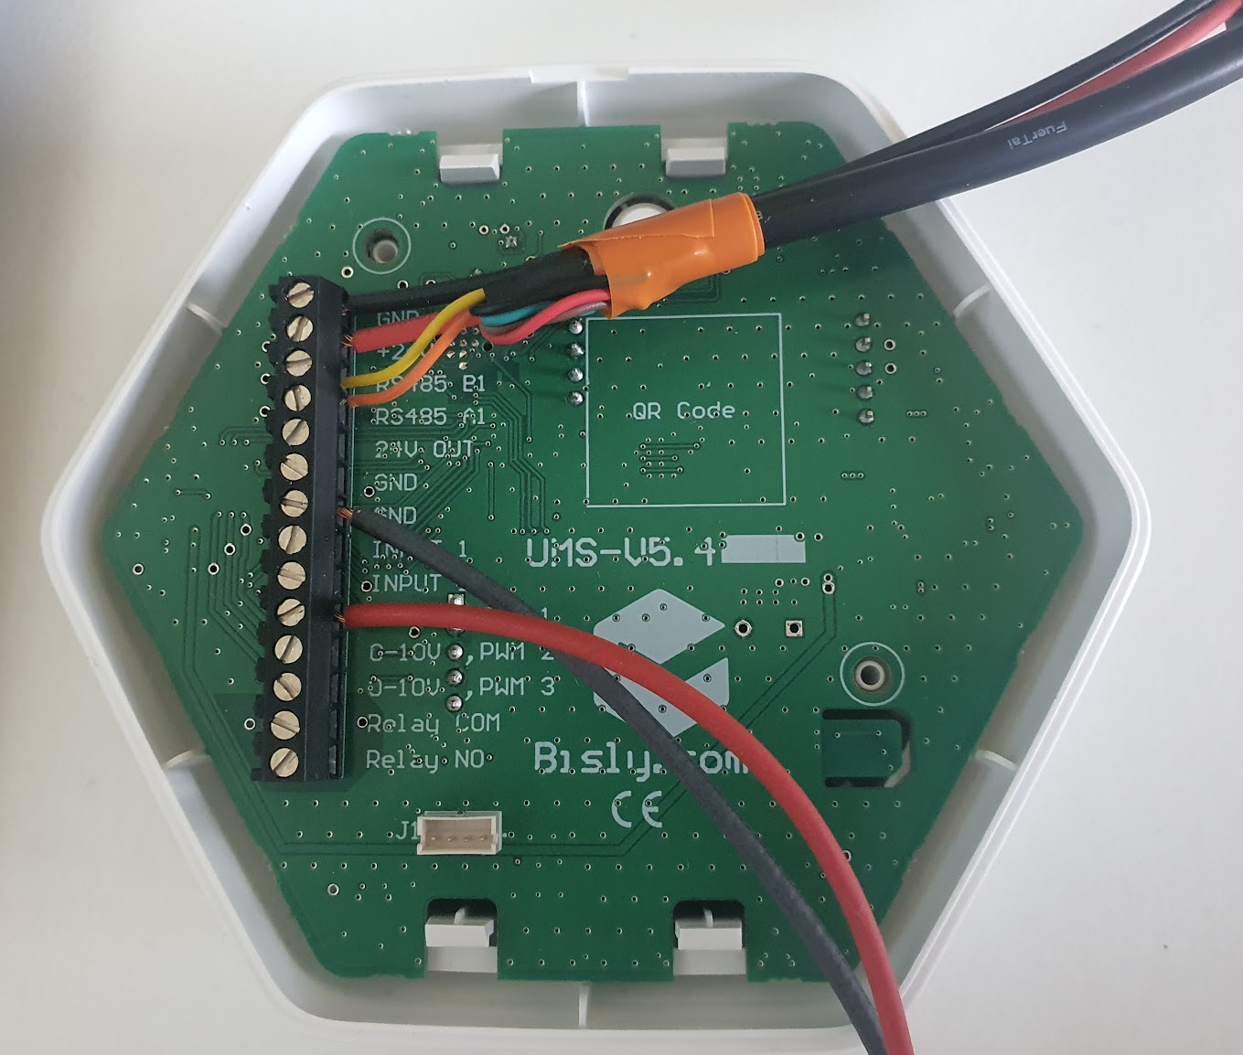

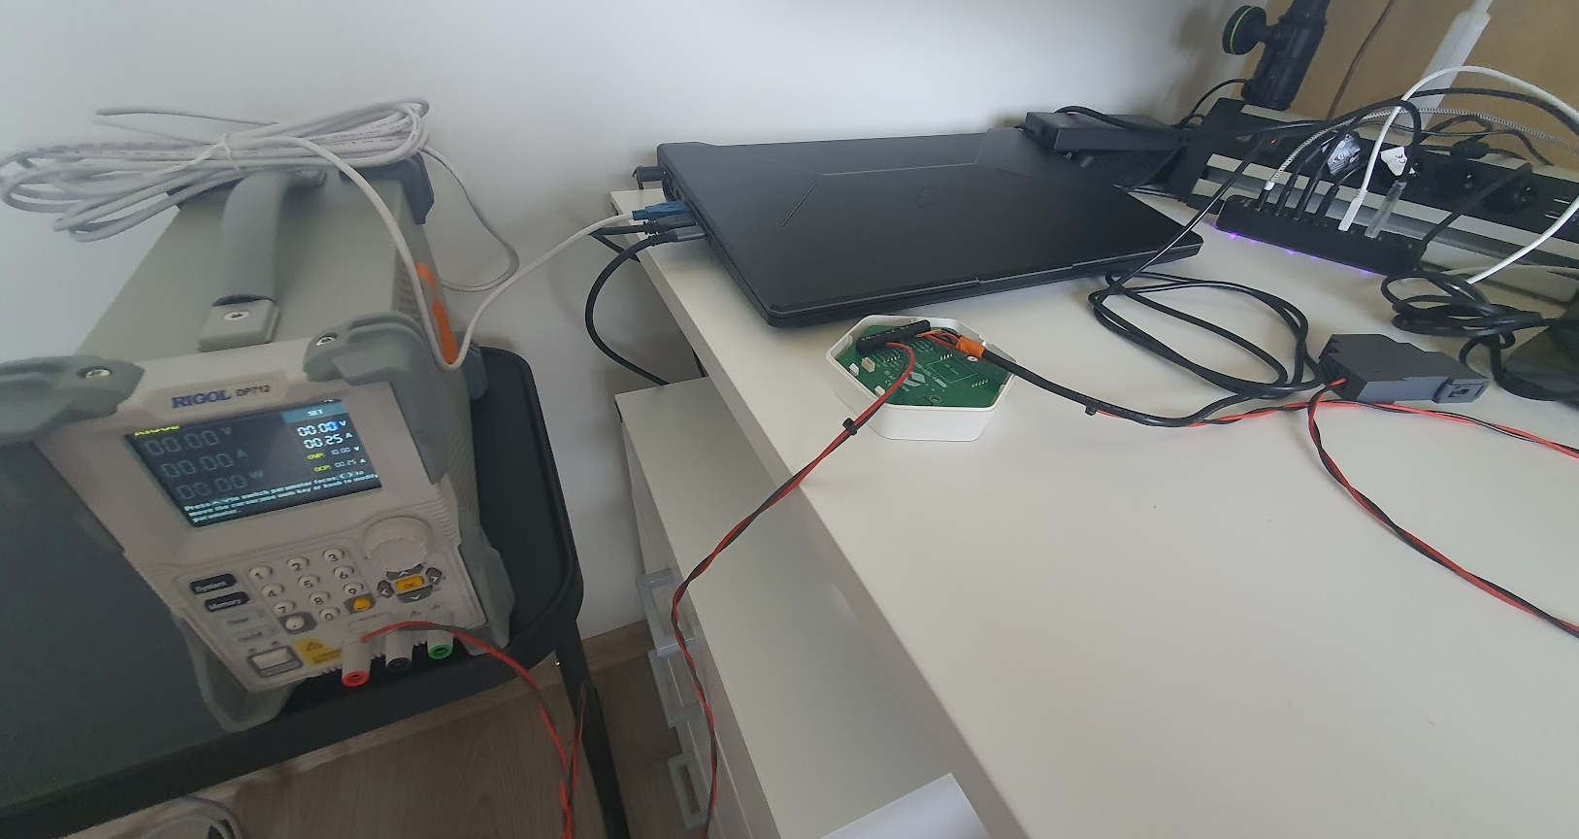

# **Task 3 – Test automation**

Please find test solution on my GitHub public repo: <https://github.com/dimeonsports/UmsTestEnv>

I created 3 simple automatic Voltage tests on PWM 1 Input.

Test Solution includes:

* Test base with Power Supply control and RS485 Listener
* Test cases with includes
* Allure tool for report

Please feel free to ask questions!