Data Engineering Summary
Generated by the exam_3 data pipeline. The report is extended as feature engineering and selection complete.

Original features in self.data
Feature | Meaning | Data type | Missing values after volume cleaning
open | Opening price for the trading session. | float64 | 0
high | Highest traded price during the trading session. | float64 | 0
low | Lowest traded price during the trading session. | float64 | 0
close | Closing price for the trading session. | float64 | 0
volume | Number of shares traded during the trading session. | int64 | 0

Loaded data and initial cleaning
Item | Result
Symbol | SPY
Requested start date | 2010-01-01
Downloaded rows | 4218
Rows removed for zero volume | 0
Rows after zero-volume cleaning | 4218
Date range after cleaning | 2010-01-04 00:00:00 to 2026-10-09 00:00:00
This section is a starter summary. The following pipeline calls append the engineered-feature, row-cleaning, and selected-feature results.

New features created
Feature | Transformation | Economic interpretation
GAP | Percentage gap up or down. | Overnight repricing between sessions.
RET | Daily log return of close. | One-session proportional price movement.
PCHG5 | Close percentage change over the window. Window = 5. | Price momentum over the specified lookback.
VCHG5 | Volume percentage change over the window. Window = 5. | Change in trading activity over the specified lookback.
RET5 | Rolling sum of daily log returns over the window. Window = 5. | Cumulative log price movement over the lookback.
GAP5 | Rolling mean of percentage gaps. Window = 5. | Average overnight repricing over the lookback.
STD5 | Rolling standard deviation of daily log returns. Window = 5. | Realized return volatility over the lookback.
BB5 | Close position: (close - lower band) / (upper band - lower band); bands use two standard deviations. Window = 5. | Relative price position within the Bollinger envelope; values can fall outside 0 to 1.
RSI5 | Relative Strength Index calculated over the window. Window = 5. | Momentum oscillator on a 0 to 100 scale.
STOCH5 | Stochastic oscillator over the window with smooth_window=1. Window = 5. | Close location within the recent high-low range, on a 0 to 100 scale.
PCHG10 | Close percentage change over the window. Window = 10. | Price momentum over the specified lookback.
VCHG10 | Volume percentage change over the window. Window = 10. | Change in trading activity over the specified lookback.
RET10 | Rolling sum of daily log returns over the window. Window = 10. | Cumulative log price movement over the lookback.
GAP10 | Rolling mean of percentage gaps. Window = 10. | Average overnight repricing over the lookback.
STD10 | Rolling standard deviation of daily log returns. Window = 10. | Realized return volatility over the lookback.
BB10 | Close position: (close - lower band) / (upper band - lower band); bands use two standard deviations. Window = 10. | Relative price position within the Bollinger envelope; values can fall outside 0 to 1.
RSI10 | Relative Strength Index calculated over the window. Window = 10. | Momentum oscillator on a 0 to 100 scale.
STOCH10 | Stochastic oscillator over the window with smooth_window=1. Window = 10. | Close location within the recent high-low range, on a 0 to 100 scale.
PCHG15 | Close percentage change over the window. Window = 15. | Price momentum over the specified lookback.
VCHG15 | Volume percentage change over the window. Window = 15. | Change in trading activity over the specified lookback.
RET15 | Rolling sum of daily log returns over the window. Window = 15. | Cumulative log price movement over the lookback.
GAP15 | Rolling mean of percentage gaps. Window = 15. | Average overnight repricing over the lookback.
STD15 | Rolling standard deviation of daily log returns. Window = 15. | Realized return volatility over the lookback.
BB15 | Close position: (close - lower band) / (upper band - lower band); bands use two standard deviations. Window = 15. | Relative price position within the Bollinger envelope; values can fall outside 0 to 1.
RSI15 | Relative Strength Index calculated over the window. Window = 15. | Momentum oscillator on a 0 to 100 scale.
STOCH15 | Stochastic oscillator over the window with smooth_window=1. Window = 15. | Close location within the recent high-low range, on a 0 to 100 scale.
Target label: 1 when the next-session log return exceeds 0.5 times the rolling 20-session standard deviation of daily log returns; otherwise 0. Rows without a valid forward return or threshold are removed.

Dropped features and data cleaning
Stage | Action and result
Raw columns removed | Dropped after deriving the technical features: open, high, low, close, volume
Missing-value rows removed | 21 of 4218 rows were dropped because at least one engineered feature or the forward label was missing. This includes lookback warm-up and the final row without a forward return.
Missing-value treatment | Rows with missing values were removed using dropna(); no imputation or explicit infinity replacement is performed.
Label treatment | Rows without a valid forward-return label were excluded; remaining labels were converted to integers.
Feature-selection input | Chronological split: 3357 in-sample rows and 840 out-of-sample rows. FeatureEngineering receives only the in-sample X and y.
Missing values before row removal by column:
Column | Missing values
GAP | 1
RET | 1
PCHG5 | 5
VCHG5 | 5
RET5 | 5
GAP5 | 5
STD5 | 5
BB5 | 4
RSI5 | 4
STOCH5 | 4
PCHG10 | 10
VCHG10 | 10
RET10 | 10
GAP10 | 10
STD10 | 10
BB10 | 9
RSI10 | 9
STOCH10 | 9
PCHG15 | 15
VCHG15 | 15
RET15 | 15
GAP15 | 15
STD15 | 15
BB15 | 14
RSI15 | 14
STOCH15 | 14
Label | 21

In-sample training data summary
Item | Result
X_train shape | 3357 rows x 23 columns
y_train length | 3357
Date range | 2010-02-02 00:00:00 to 2023-06-02 00:00:00
Missing values in X_train | 0
Missing values in y_train | 0
self.X_train descriptive statistics:
 | count | mean | std | min | 25% | 50% | 75% | max
GAP | 3357.0000 | 0.0002 | 0.0071 | -0.1045 | -0.0024 | 0.0004 | 0.0033 | 0.0604
RET | 3357.0000 | 0.0004 | 0.0111 | -0.1159 | -0.0038 | 0.0006 | 0.0058 | 0.0867
PCHG5 | 3357.0000 | 0.0023 | 0.0229 | -0.1797 | -0.0076 | 0.0041 | 0.0146 | 0.1736
VCHG5 | 3357.0000 | 0.0908 | 0.5064 | -0.8308 | -0.2329 | -0.0090 | 0.2962 | 5.4149
RET5 | 3357.0000 | 0.0020 | 0.0231 | -0.1981 | -0.0077 | 0.0041 | 0.0145 | 0.1601
GAP5 | 3357.0000 | 0.0002 | 0.0030 | -0.0322 | -0.0009 | 0.0004 | 0.0016 | 0.0188
BB5 | 3357.0000 | 0.5496 | 0.2564 | 0.0559 | 0.3094 | 0.6169 | 0.7701 | 0.9452
RSI5 | 3357.0000 | 56.5871 | 19.4481 | 2.9457 | 42.5807 | 58.7809 | 71.9117 | 97.5764
STOCH5 | 3357.0000 | 60.5870 | 31.1546 | 0.0000 | 33.7189 | 67.7129 | 89.3428 | 100.0000
PCHG10 | 3357.0000 | 0.0045 | 0.0310 | -0.2329 | -0.0090 | 0.0072 | 0.0219 | 0.1880
VCHG10 | 3357.0000 | 0.1057 | 0.5735 | -0.7841 | -0.2465 | -0.0178 | 0.3118 | 6.0635
RET10 | 3357.0000 | 0.0040 | 0.0315 | -0.2651 | -0.0091 | 0.0072 | 0.0217 | 0.1723
GAP10 | 3357.0000 | 0.0002 | 0.0021 | -0.0274 | -0.0006 | 0.0003 | 0.0012 | 0.0115
BB10 | 3357.0000 | 0.5705 | 0.2921 | -0.1844 | 0.3420 | 0.6384 | 0.8097 | 1.1509
RSI10 | 3357.0000 | 55.7345 | 13.4219 | 11.1869 | 46.2198 | 57.3824 | 65.8320 | 89.3734
STOCH10 | 3357.0000 | 62.9554 | 30.6843 | 0.0000 | 37.7704 | 70.7431 | 90.9501 | 100.0000
PCHG15 | 3357.0000 | 0.0066 | 0.0378 | -0.2787 | -0.0101 | 0.0115 | 0.0274 | 0.2729
VCHG15 | 3357.0000 | 0.1222 | 0.6375 | -0.8239 | -0.2659 | -0.0243 | 0.3310 | 6.6445
RET15 | 3357.0000 | 0.0059 | 0.0386 | -0.3267 | -0.0101 | 0.0115 | 0.0271 | 0.2413
GAP15 | 3357.0000 | 0.0002 | 0.0018 | -0.0197 | -0.0004 | 0.0003 | 0.0010 | 0.0084
BB15 | 3357.0000 | 0.5845 | 0.3084 | -0.3570 | 0.3532 | 0.6638 | 0.8297 | 1.2802
RSI15 | 3357.0000 | 55.2034 | 10.7575 | 17.7705 | 47.6663 | 56.3763 | 63.2356 | 86.5281
STOCH15 | 3357.0000 | 64.6110 | 30.4487 | 0.0000 | 41.1256 | 73.2319 | 92.0478 | 100.0000
self.y_train descriptive statistics:
 | count | mean | std | min | 25% | 50% | 75% | max
Label | 3357.0000 | 0.3223 | 0.4674 | 0.0000 | 0.0000 | 0.0000 | 1.0000 | 1.0000

Label imbalance
Label counts and percentages for the in-sample and out-of-sample splits.
split | label | count | percentage
in-sample | 0 | 2275 | 67.77%
in-sample | 1 | 1082 | 32.23%
out-of-sample | 0 | 557 | 66.31%
out-of-sample | 1 | 283 | 33.69%

Feature selection results
Selected candidates are the union of features returned by the configured selection algorithms.
Selection result | Features
Selected candidates | BB5, GAP, GAP10, GAP15, GAP5, PCHG10, PCHG15, PCHG5, RET, RSI5, VCHG10, VCHG15, VCHG5
Number selected | 13
Engineered candidates not selected | BB10, BB15, RET10, RET15, RET5, RSI10, RSI15, STD10, STD15, STD5, STOCH10, STOCH15, STOCH5
Number not selected | 13
Selection algorithms | RFE, random_forest

Selected features (self.features)
# | Feature
1 | BB5
2 | GAP
3 | GAP10
4 | GAP15
5 | GAP5
6 | PCHG10
7 | PCHG15
8 | PCHG5
9 | RET
10 | RSI5
11 | VCHG10
12 | VCHG15
13 | VCHG5

Feature correlation heatmap (self.corr)
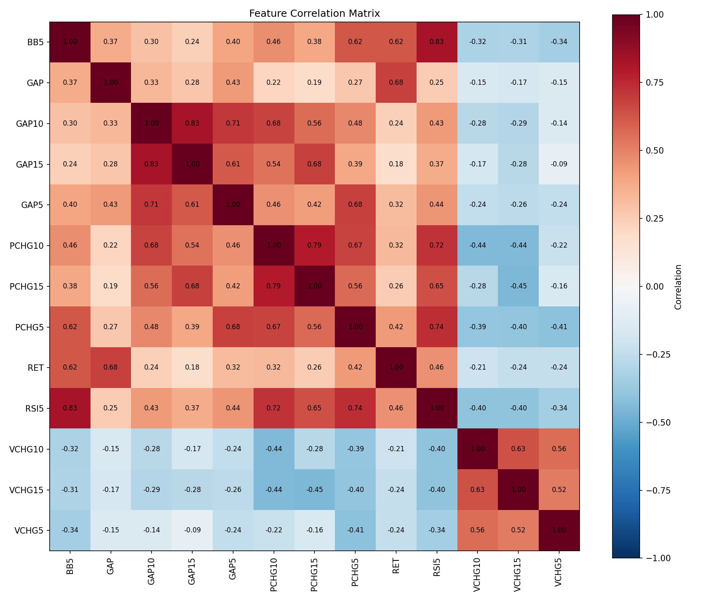

Selection by algorithm (self.feature_df)
RFE | random_forest
GAP | GAP
RET | RET
PCHG5 | PCHG5
VCHG5 | VCHG5
GAP5 | GAP5
BB5 | BB5
RSI5 | RSI5
PCHG10 | PCHG10
VCHG10 | VCHG10
GAP10 | GAP10
PCHG15 | PCHG15
VCHG15 | VCHG15
GAP15 | GAP15

summarize_engineered_data() results
Feature | count | mean | std | min | 25% | 50% | 75% | max | dtype | missing | missing_pct | unique | ADF Statistic | ADF p-value | KPSS Statistic | KPSS p-value | ADF Pass | KPSS Pass | Include
GAP | 3357.0000 | 0.0002 | 0.0071 | -0.1045 | -0.0024 | 0.0004 | 0.0033 | 0.0604 | float64 | 0 | 0.0000 | 3324 | -18.2732 | 0.0000 | 0.0511 | 0.1000 | 1 | 1 | True
RET | 3357.0000 | 0.0004 | 0.0111 | -0.1159 | -0.0038 | 0.0006 | 0.0058 | 0.0867 | float64 | 0 | 0.0000 | 3347 | -12.7126 | 0.0000 | 0.0261 | 0.1000 | 1 | 1 | True
PCHG5 | 3357.0000 | 0.0023 | 0.0229 | -0.1797 | -0.0076 | 0.0041 | 0.0146 | 0.1736 | float64 | 0 | 0.0000 | 3352 | -12.7055 | 0.0000 | 0.0263 | 0.1000 | 1 | 1 | True
VCHG5 | 3357.0000 | 0.0908 | 0.5064 | -0.8308 | -0.2329 | -0.0090 | 0.2962 | 5.4149 | float64 | 0 | 0.0000 | 3357 | -14.4365 | 0.0000 | 0.1009 | 0.1000 | 1 | 1 | True
RET5 | 3357.0000 | 0.0020 | 0.0231 | -0.1981 | -0.0077 | 0.0041 | 0.0145 | 0.1601 | float64 | 0 | 0.0000 | 3352 | -12.5926 | 0.0000 | 0.0291 | 0.1000 | 1 | 1 | True
GAP5 | 3357.0000 | 0.0002 | 0.0030 | -0.0322 | -0.0009 | 0.0004 | 0.0016 | 0.0188 | float64 | 0 | 0.0000 | 3355 | -11.0086 | 0.0000 | 0.0520 | 0.1000 | 1 | 1 | True
STD5 | 3357.0000 | 0.0089 | 0.0070 | 0.0004 | 0.0045 | 0.0072 | 0.0112 | 0.0897 | float64 | 0 | 0.0000 | 3357 | -7.8076 | 0.0000 | 0.5266 | 0.0357 | 1 | 0 | False
BB5 | 3357.0000 | 0.5496 | 0.2564 | 0.0559 | 0.3094 | 0.6169 | 0.7701 | 0.9452 | float64 | 0 | 0.0000 | 3357 | -23.1622 | 0.0000 | 0.0689 | 0.1000 | 1 | 1 | True
RSI5 | 3357.0000 | 56.5871 | 19.4481 | 2.9457 | 42.5807 | 58.7809 | 71.9117 | 97.5764 | float64 | 0 | 0.0000 | 3348 | -19.5458 | 0.0000 | 0.0833 | 0.1000 | 1 | 1 | True
STOCH5 | 3357.0000 | 60.5870 | 31.1546 | 0.0000 | 33.7189 | 67.7129 | 89.3428 | 100.0000 | float64 | 0 | 0.0000 | 3307 | -19.7597 | 0.0000 | 0.0872 | 0.1000 | 1 | 1 | True
PCHG10 | 3357.0000 | 0.0045 | 0.0310 | -0.2329 | -0.0090 | 0.0072 | 0.0219 | 0.1880 | float64 | 0 | 0.0000 | 3356 | -12.1321 | 0.0000 | 0.0299 | 0.1000 | 1 | 1 | True
VCHG10 | 3357.0000 | 0.1057 | 0.5735 | -0.7841 | -0.2465 | -0.0178 | 0.3118 | 6.0635 | float64 | 0 | 0.0000 | 3357 | -12.6951 | 0.0000 | 0.0518 | 0.1000 | 1 | 1 | True
RET10 | 3357.0000 | 0.0040 | 0.0315 | -0.2651 | -0.0091 | 0.0072 | 0.0217 | 0.1723 | float64 | 0 | 0.0000 | 3356 | -12.0026 | 0.0000 | 0.0334 | 0.1000 | 1 | 1 | True
GAP10 | 3357.0000 | 0.0002 | 0.0021 | -0.0274 | -0.0006 | 0.0003 | 0.0012 | 0.0115 | float64 | 0 | 0.0000 | 3356 | -11.2938 | 0.0000 | 0.0547 | 0.1000 | 1 | 1 | True
STD10 | 3357.0000 | 0.0092 | 0.0064 | 0.0013 | 0.0052 | 0.0077 | 0.0115 | 0.0715 | float64 | 0 | 0.0000 | 3357 | -6.1978 | 0.0000 | 0.5156 | 0.0381 | 1 | 0 | False
BB10 | 3357.0000 | 0.5705 | 0.2921 | -0.1844 | 0.3420 | 0.6384 | 0.8097 | 1.1509 | float64 | 0 | 0.0000 | 3357 | -22.5384 | 0.0000 | 0.0528 | 0.1000 | 1 | 1 | True
RSI10 | 3357.0000 | 55.7345 | 13.4219 | 11.1869 | 46.2198 | 57.3824 | 65.8320 | 89.3734 | float64 | 0 | 0.0000 | 3349 | -14.3752 | 0.0000 | 0.0907 | 0.1000 | 1 | 1 | True
STOCH10 | 3357.0000 | 62.9554 | 30.6843 | 0.0000 | 37.7704 | 70.7431 | 90.9501 | 100.0000 | float64 | 0 | 0.0000 | 3316 | -14.2325 | 0.0000 | 0.0760 | 0.1000 | 1 | 1 | True
PCHG15 | 3357.0000 | 0.0066 | 0.0378 | -0.2787 | -0.0101 | 0.0115 | 0.0274 | 0.2729 | float64 | 0 | 0.0000 | 3356 | -12.1481 | 0.0000 | 0.0316 | 0.1000 | 1 | 1 | True
VCHG15 | 3357.0000 | 0.1222 | 0.6375 | -0.8239 | -0.2659 | -0.0243 | 0.3310 | 6.6445 | float64 | 0 | 0.0000 | 3357 | -13.0686 | 0.0000 | 0.0777 | 0.1000 | 1 | 1 | True
RET15 | 3357.0000 | 0.0059 | 0.0386 | -0.3267 | -0.0101 | 0.0115 | 0.0271 | 0.2413 | float64 | 0 | 0.0000 | 3356 | -12.0162 | 0.0000 | 0.0346 | 0.1000 | 1 | 1 | True
GAP15 | 3357.0000 | 0.0002 | 0.0018 | -0.0197 | -0.0004 | 0.0003 | 0.0010 | 0.0084 | float64 | 0 | 0.0000 | 3356 | -11.3846 | 0.0000 | 0.0579 | 0.1000 | 1 | 1 | True
STD15 | 3357.0000 | 0.0094 | 0.0062 | 0.0015 | 0.0055 | 0.0078 | 0.0115 | 0.0659 | float64 | 0 | 0.0000 | 3357 | -6.7557 | 0.0000 | 0.5210 | 0.0369 | 1 | 0 | False
BB15 | 3357.0000 | 0.5845 | 0.3084 | -0.3570 | 0.3532 | 0.6638 | 0.8297 | 1.2802 | float64 | 0 | 0.0000 | 3357 | -18.5140 | 0.0000 | 0.0639 | 0.1000 | 1 | 1 | True
RSI15 | 3357.0000 | 55.2034 | 10.7575 | 17.7705 | 47.6663 | 56.3763 | 63.2356 | 86.5281 | float64 | 0 | 0.0000 | 3348 | -12.1272 | 0.0000 | 0.1010 | 0.1000 | 1 | 1 | True
STOCH15 | 3357.0000 | 64.6110 | 30.4487 | 0.0000 | 41.1256 | 73.2319 | 92.0478 | 100.0000 | float64 | 0 | 0.0000 | 3318 | -11.6355 | 0.0000 | 0.0873 | 0.1000 | 1 | 1 | True
Label | 3357.0000 | 0.3223 | 0.4674 | 0.0000 | 0.0000 | 0.0000 | 1.0000 | 1.0000 | int64 | 0 | 0.0000 | 2 |  |  |  |  | 0 | 0 | False

