SoftUni Forum Workshop – Part 3
This application is created as a workshop for the Angular Course @ Software University

Task Requirements
At this point the application has forms. Now it's the time to edit them so the given information is handled properly as expected. Implement the following validation, notification and styling rules for each form.
By default:
- The input fields are neutral (neither valid nor invalid). If some of the fields are touched, you should determinate the status of validation from the given data inside it
- Each input field is required
Notifications should be shown as paragraph ("<p>") elements below each input field or button.
The notification below each button should display the status of the form validation:
- If the status is untouched or valid, the left border of the input field must be green, in all other cases, it should be red.
- If the status is invalid, use "You can't continue until you provide a valid data" as text or the default text provided from the skeleton. The color inside that paragraph should be red and the button should be disabled.
- If the status is valid just remove the notification and enable the button.
Check the examples below for each form for more clarity.

Invalid Cases
In case some of the input fields аrе invalid, the following input field should be styled with class input-error, which has the following style:
- "border-left-color: red;"
And notification should be shown with information about the validation. The text inside that paragraph also should be red.

Valid Cases
When the input field is filled with valid information, the class input-error should be disabled / removed so the left border should be green again.

Standalone Components
Create each form component (e.g., Login, Register, etc.) as a standalone component.

Login
The login form expects as input: email and password.
Valid credentials in this case are:
- Email address must have at least 6 symbols, after that the symbol "@" is followed. The valid domain name is only "gmail" again followed by ".". Top level domain can be "bg" or "com".
  - Valid email addresses: testing@gmail.com, testing@gmail.bg, something.else@gmail.com
  - Invalid email addresses: qwe@gmail.com, 123@gmail.bg, somethingelse@abv.bg, another@abv.com
- Password should be at least 5 symbols as well
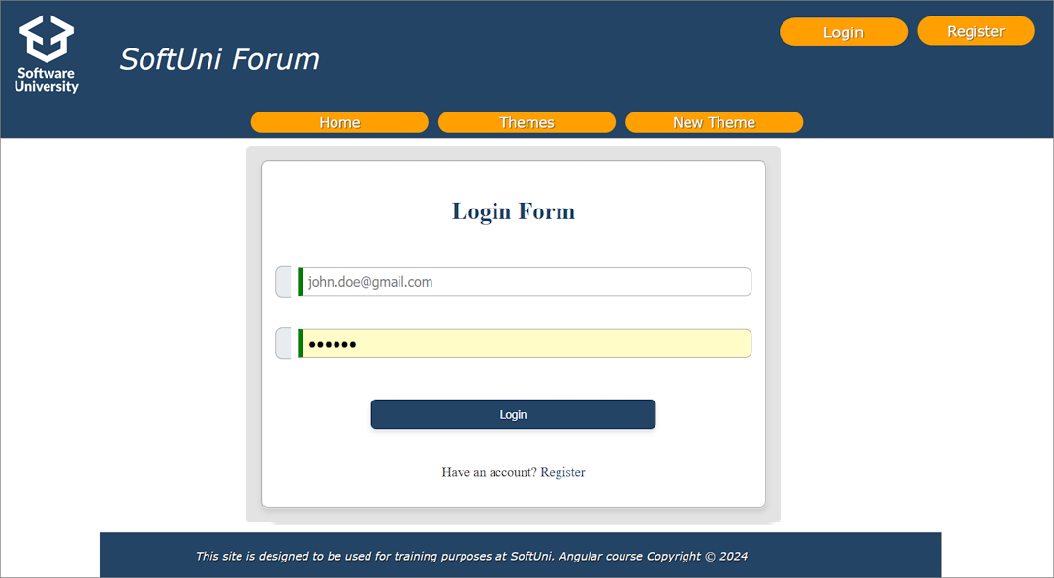
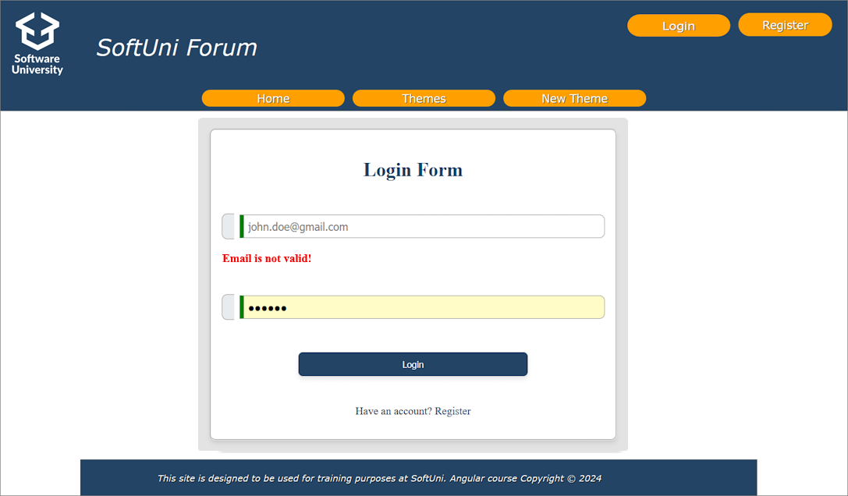
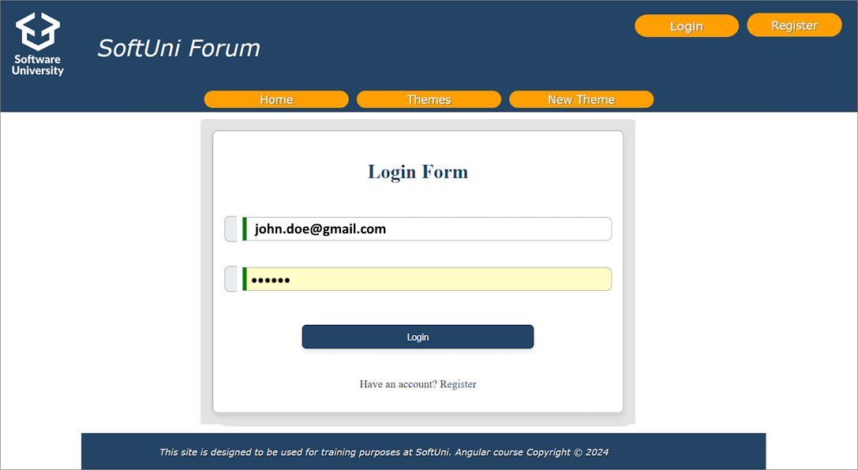

Register
The register form expects as input: username, email, password, repeat password and telephone number (not required).
Username validation here is:
- Should have at least 5 symbols and is required.
Email validation here is the same as in the login case:
- Should have at least 6 symbols, after that the symbol of "@" is followed. The valid domain name is only "gmail" again followed by ".". Top level domain can be "bg" or "com".
  - Valid email addresses: testing@gmail.com, testing@gmail.bg, something.else@gmail.com
  - Invalid email addresses: qwe@gmail.com, 123@gmail.bg, somethingelse@abv.bg, another@abv.com
Both passwords should be grouped in "passwords" group. The validation here is:
- The given password should be at least 5 characters (any English letter and digits are allowed)
- The given repeat password should be the same as the given password
Both fields are considered invalid if some of them do not cover the described validation. If that happens apply the invalid stylization for both. Otherwise, the valid stylization is applied.
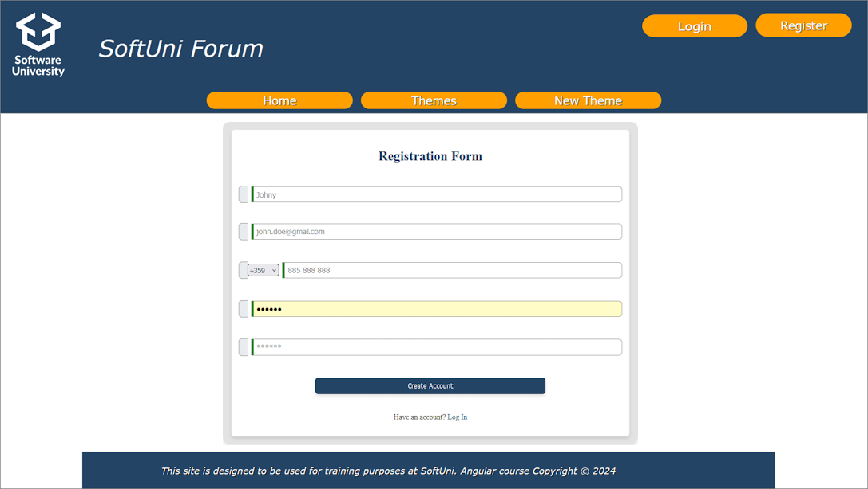
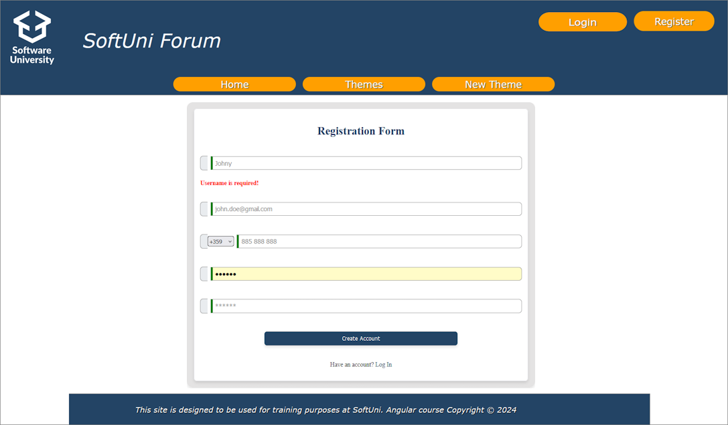
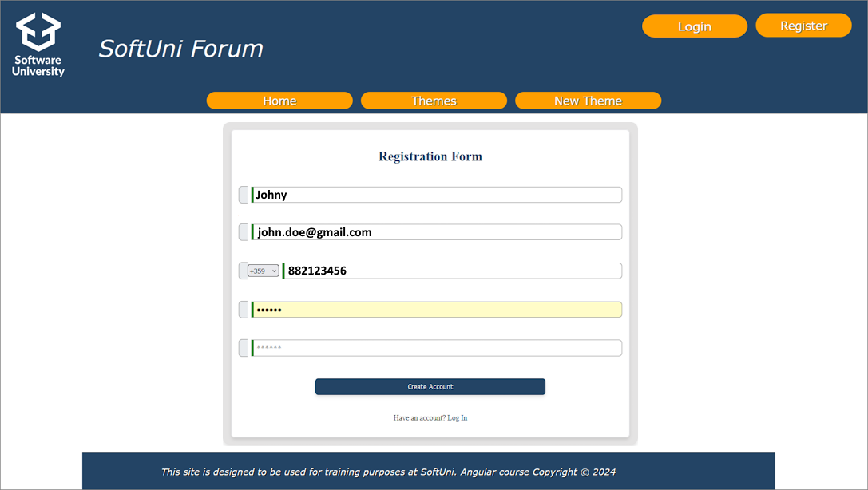

Template-driven Forms
Use the template-driven approach with standalone components for creating the new theme and change profile information forms. Create custom standalone attribute directives to handle common validation or styling needs.

New Theme
The new theme form expects as input: theme name, post text.
Valid data in this case is:
- Theme name – should be at least 5 characters
- Post text – should be at least 10 characters long
The [Post] button should be disabled if the inputs are NOT valid.
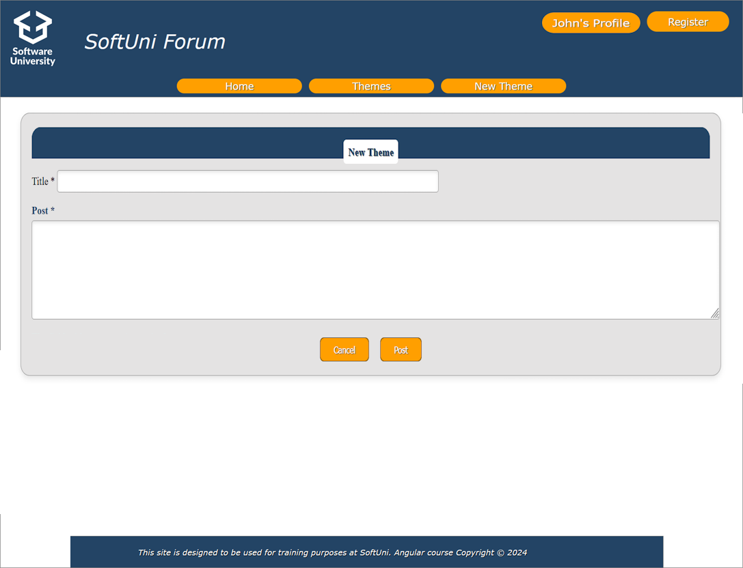
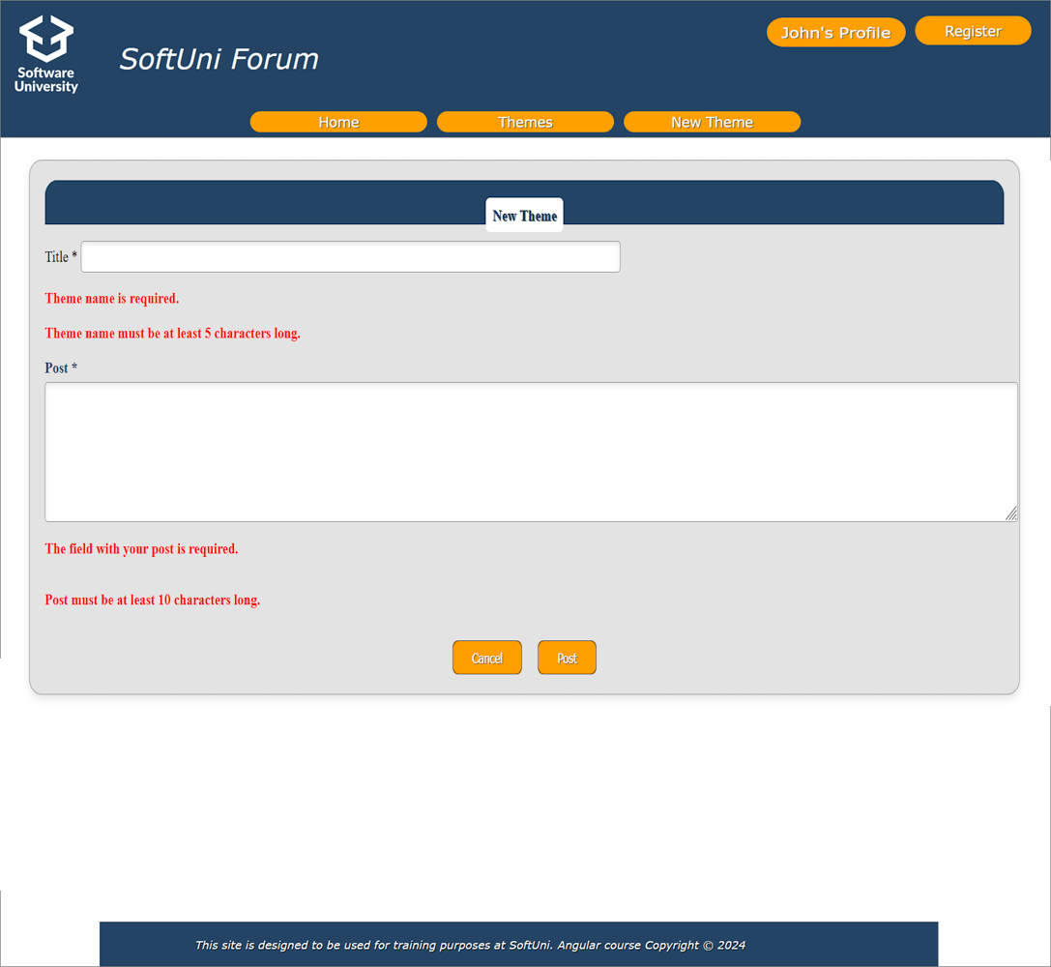

Change Profile Information
When you are logged in you can see your profile information.
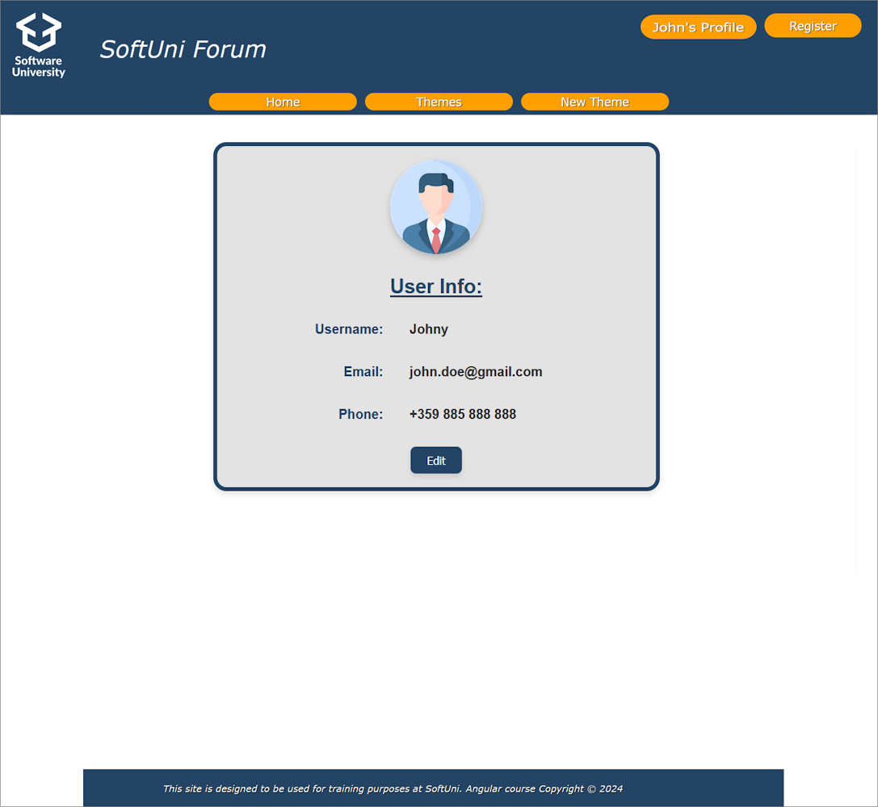
By clicking the [Edit] button, the profile information should be turned into form with editable fields. The input fields should have the current information of the user.
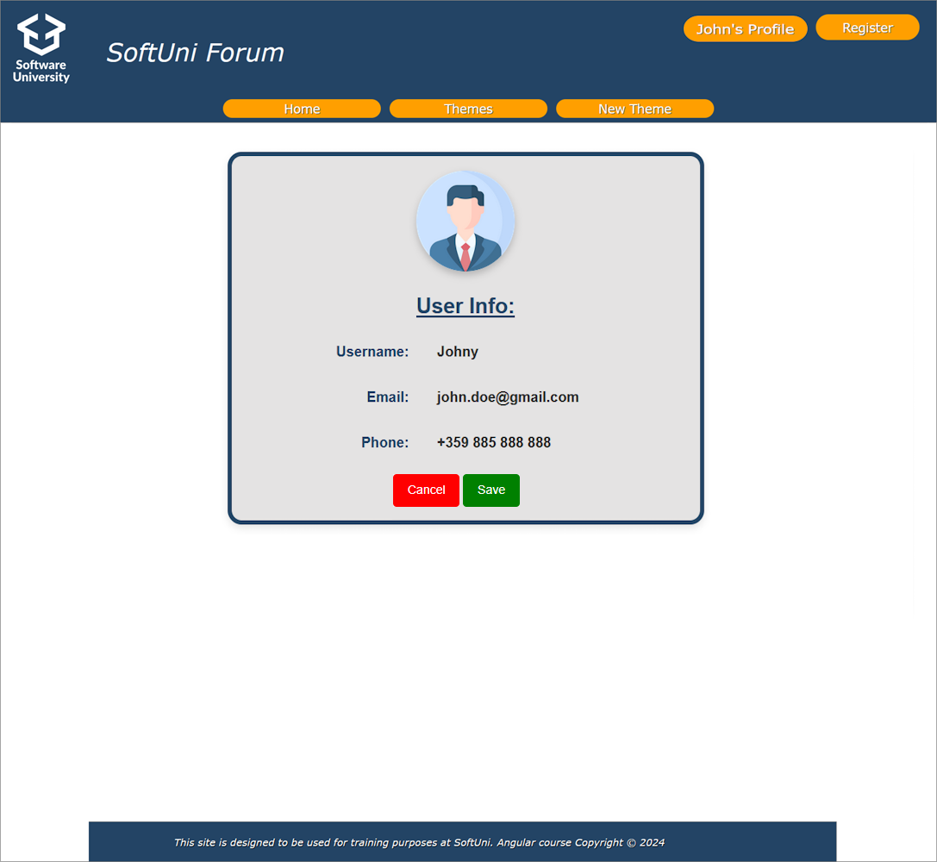
Username validation here is the same as the register case:
- Should have at least 5 symbols and is required.
Email validation is the same as the login and register cases:
- Should have at least 6 symbols, after that the symbol of "@" is followed. The valid domain name is only "gmail" again followed by ".". Top level domain can be "bg" or "com".
  - Valid email addresses: testing@gmail.com, testing@gmail.bg, somethingelse@gmail.com
  - Invalid email addresses: qwe@gmail.com, 123@gmail.bg, somethingelse@abv.bg, another@abv.com
If the validation passes, the [Save] button should be enabled, and the user can make a post request to change the information.
If the "Cancel" button is clicked all changes must be reverted, and the user information should be displayed unchanged.

Custom Directives
Think about for a second which logic can be isolated in custom directive so you avoid repeating part of the code.
Hint: Stylization / Validation

GOOD LUCK! 😊

