Discussion on the Geodesic Hypothesis and Semantic Tube Prediction
Compiled by D.Gueorguiev, 3/22/2026

Discussion on LinkedIn

Hai Huang wrote:

We knew it worked, we just didn't know why: The origin of Semantic Tube Prediction.

(I am often asked how we discovered the Geodesic Hypothesis and Semantic Tube Prediction. What follows is a rare, behind-the-scenes story at how we made sense of a surprising engineering finding.)

At the beginning, we didn't have any grand plan or vision. Instead, the project began as a pure engineering effort to remove the computing overhead of the additional forward pass required in LLM-JEPA to encode Text and Code.

Our initial idea was to approximate the embedding of Code by $h_{t} - h_{r}$, where $h$ is the hidden state, $t$ is the last token of Code, and $r$ is the token immediately preceding the first token of Code. Knowing this was a very rough approximation, we used a very weak $\lambda$, and surprisingly, it worked incredibly well. This prompted us to see if we could leverage this property to also remove another hard requirement: the explicit two-view structure. To achieve that, we randomly picked $r$, and the result was even better.

Although empirically we had identified a good regularizer, at that time we had yet to understand why it worked. We brainstormed many hypotheses and designed experiments to validate them. One thing we tried that didn't work out (and wasn't put in the paper) was plotting t-SNE just like we did for LLM-JEPA. However, we didn't see the linear separation in the representation space, nor the simplified structure in the singular values.

The real breakthrough stemmed from another simple idea: what if we first normalized the representation vectors, then drew the singular values chart? When we did, the simplified structure showed up again. That finding revealed that what matters is direction, not scale. This led to the Semantic Tube idea and the Geodesic Hypothesis.

Finally, everything made sense.

Derrick Hodge replied:

Neural representations should be viewed through the lens of conformal projective geometry rather than Euclidean space. While we often analyze these models using Euclidean metrics, the underlying manifold is more accurately described by the Real Projective Space RP^d. In this context, "rank collapse" to one or two dimensions is not a pathology; it is the emergence of the model's natural state on the null cone, where vectors function as rays.
Because the model integrates out scale (magnitude), semantic meaning is localized entirely in the angular direction. This process can be understood as a Renormalization Group (RG) flow, where the residual—captured by the $W_{2}$ (Wasserstein-2) metric—preserves the fundamental topological scale invariants of the data.

Additional Details

The Geodesic Hypothesis

Hai Huang et al ([2]) posit that token sequences trace geodesics on smooth semantic manifold and are therefore locally linear.

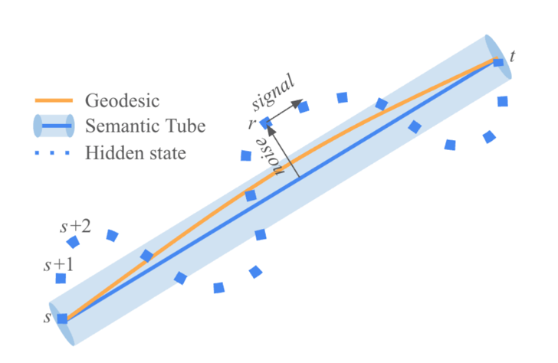

Semantic Tube

References
[1] Linked discussion on Semantic Tube Prediction, Hai Huang, March 16th, 2026
[2] Semantic Tube Prediction : Beating LLM Data Efficiency with JEPA, Hai Huang et al, 2026

