Multi-Agent Load Balancing and Collaboration via Reinforcement Learning
compiled by D.Gueorguiev with the help of Claude Opus 4.1, 1/4/2026

Table of Contents
Overview of the System 2
Agents Roles and Hierarchy 3
Understanding the Action Space for the PPO Model 3
Action Structure 4
Initializing the Agents 5
Task Generation 6
Create PPO Model 6
Set up Model Training Callbacks 7
Train the PPO Model 7
Task Processing 8
Collaboration Matrix 8
Purpose of the Collaboration Matrix 8
Update of the Collaboration Matrix 10
Observation Generation 10
Step Execution 11
Evaluate the PPO Model 12
Class Diagrams 13
Core Classes 14
Smart Agent and Tool System Classes 15
System Flowchart 15
Training Sequence 17
Training Loop 18
Parallel Vectorized Environments 19
Initialize the PPO model 19
Key PPO hyperparameters 20
PPO Hyperparameters deep dive 20
More Details on Task Processing and Task Management 20
Task Driven Work Distribution 20
Task Distribution Strategy 21
Agent Task Execution Flowchart 22
Task Lifecycle Flowchart 23
Task States 25
References 26
Appendix 27
Key Concepts in Reinforcement Learning 27
Bellman’s Equations for Markov Decision Processes 29
Actor-Critic Reinforcement Learning Algorithms 29
Policy Gradients 32
Generalized Advantage Estimation 32
Proximal Policy Optimization 32
A Note on nn.Sequential implemented with PyTorch Deep Learning library 32
Example 1: MNIST-style digit classification (0-9) using nn.Sequential 33
Example 2: Deterministic Policy in continuous action space modeled with nn.Sequential 37

Overview of the System

We will discuss application of RL algorithms such as Proximal Policy Optimization (PPO) to implement adaptive workflow which will manage learning-based task allocation. In this document we will discuss the application of the PPO for the simulated agentic workflow illustrated in the notebook [1].

Key structures are AgentRole, AgentState, and Task for tracking agent roles, agent states and tasks in the system.

class AgentRole(Enum):
"""Defines specialized agent roles in the system"""
RESEARCHER = "researcher"
ANALYZER = "analyzer"
EXECUTOR = "executor"
VALIDATOR = "validator"
COORDINATOR = "coordinator"

@dataclass
class Task:
"""Represents a task in the workflow"""
id: str
type: str
complexity: float
requirements: List[str]
deadline: float
priority: float
status: str = "pending"
assigned_agent: Optional[str] = None
completion_time: Optional[float] = None
quality_score: Optional[float] = None

@dataclass
class AgentState:
"""Tracks individual agent state"""
id: str
role: AgentRole
capacity: float
expertise: Dict[str, float]
current_load: float = 0.0
completed_tasks: int = 0
success_rate: float = 1.0
collaboration_score: float = 1.0

Agents Roles and Hierarchy
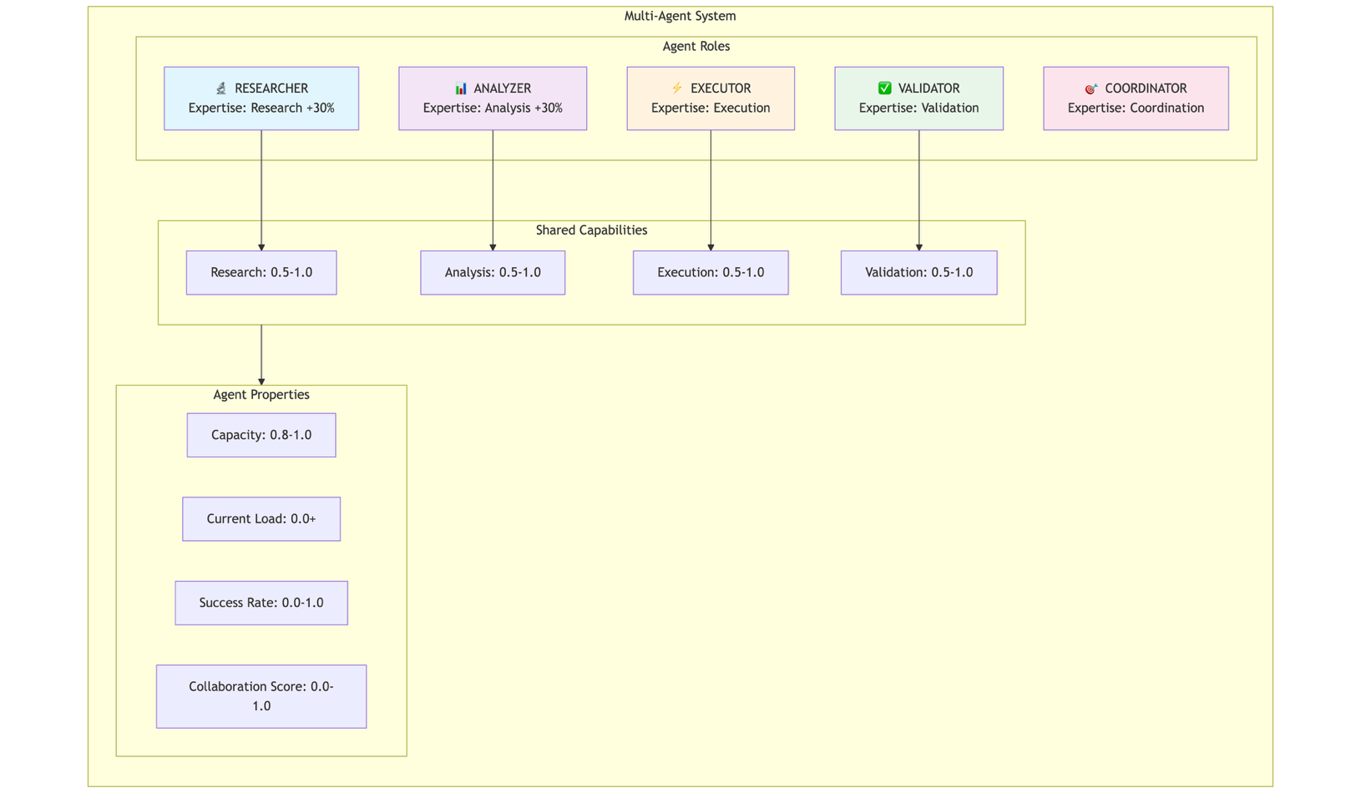

Understanding the Action Space for the PPO Model

Recall, the Action Space is defined as

self.action_space = spaces.Box(
low=0, high=1, shape=(n_agents * 3,), dtype=np.float32
)

That is, the PPO model outputs a flat vector of continuous values between 0 and 1, with a total size of n_agents × 3.

Action Structure

When the step() function receives this flat action vector, it reshapes it:

action = action.reshape(self.n_agents, 3)

This creates a 2D matrix where each row represents one agent's actions:

Agent | Action 0 (Task Assignment) | Action 1 (Resource Allocation) | Action 2 (Collab Request)
0 | action[0,0] | action[0,1] | action[0,2]
1 | action[1,0] | action[1,1] | action[1,2]
2 | action[2,0] | action[2,1] | action[2,2]
3 | action[3,0] | action[3,1] | action[3,2]

Details on the Action Components

Action Component 0: Task Assignment Decision (action[i, 0])

Determines whether agent i should take a task from the queue.
Use:
if len(self.task_queue) > 0 and action[i, 0] > 0.5:
task = self.task_queue.popleft()
self._assign_task(agent, task)

Interpretation:
- action[i, 0] > 0.5: Agent accepts the next task from the queue
- action[i, 0] <= 0.5: Agent declines to take a task this step

Example:

Scenario: Queue has tasks [research_task, analysis_task, validation_task]

PPO outputs: action[0, 0] = 0.82 → Agent 0 TAKES research_task (first in queue)
action[1, 0] = 0.34 → Agent 1 SKIPS (doesn't take any task)
action[2, 0] = 0.91 → Agent 2 TAKES analysis_task (now first in queue)
action[3, 0] = 0.12 → Agent 3 SKIPS

Result:
- research_task assigned to Agent 0
- analysis_task assigned to Agent 2
- validation_task remains in queue

Action Component 1: Resource Allocation (action[i, 1])

Intended for how much of the agent's capacity to allocate to current work.

Current Implementation: This component is defined in the action space but not currently used in the step() function. It's a placeholder for potential extensions like:
- Throttling agent effort (energy management)
- Splitting focus between multiple tasks
- Quality vs. speed trade-offs

Action Component 2: Collaboration Request Signal (action[i, 2])

//TODO: finish the section on the Action Space

Initializing the Agents

def _initialize_agents(self) -> List[AgentState]:
"""Initialize agents with diverse roles and capabilities"""
agents = []
roles = list(AgentRole)[:self.n_agents]

for i, role in enumerate(roles):
expertise = {
"research": np.random.uniform(0.5, 1.0),
"analysis": np.random.uniform(0.5, 1.0),
"execution": np.random.uniform(0.5, 1.0),
"validation": np.random.uniform(0.5, 1.0)
}

# Boost expertise based on role
if role == AgentRole.RESEARCHER:
expertise["research"] = min(1.0, expertise["research"] + 0.3)
elif role == AgentRole.ANALYZER:
expertise["analysis"] = min(1.0, expertise["analysis"] + 0.3)

agents.append(AgentState(
id=f"agent_{i}",
role=role,
capacity=np.random.uniform(0.8, 1.0),
expertise=expertise
))

return agents

Task Generation

The environment of this problem generates tasks probabilistically (30% chance per step) . The code excerpts below illustrate the task generation workflow

def _generate_task(self) -> Task:
"""Generate a new task with random properties"""
task_types = ["research", "analysis", "execution", "validation"]
task_type = np.random.choice(task_types)

return Task(
id=f"task_{np.random.randint(10000)}",
type=task_type,
complexity=np.random.uniform(0.3, 1.0),
requirements=[np.random.choice(task_types) for _ in range(np.random.randint(1, 3))],
deadline=np.random.uniform(10, 50),
priority=np.random.uniform(0.1, 1.0))

def step(self, action: np.ndarray) -> Tuple[np.ndarray, float, bool, bool, Dict]:
"""Execute action and return new state"""
self.current_step += 1
...
# Generate new tasks
if np.random.random() < 0.3:
self.task_queue.append(self._generate_task())
...

Create PPO Model

def _create_model(self) -> PPO:
"""Create PPO model with custom architecture"""
policy_kwargs = dict(
net_arch=[
dict(pi=[256, 256, 128], vf=[256, 256, 128])
],
activation_fn=nn.ReLU
)

model = PPO(
"MlpPolicy",
self.env,
learning_rate=3e-4,
n_steps=2048,
batch_size=64,
n_epochs=10,
gamma=0.99,
gae_lambda=0.95,
clip_range=0.2,
clip_range_vf=None,
ent_coef=0.01,
vf_coef=0.5,
max_grad_norm=0.5,
policy_kwargs=policy_kwargs,
verbose=1,
tensorboard_log="./tensorboard_logs/”)

return model

...
self.model = self._create_model()

Set up Model Training Callbacks
def _setup_callbacks(self):
"""Setup training callbacks for monitoring and checkpointing"""
eval_callback = EvalCallback(
self.eval_env,
best_model_save_path="./models/best_model/",
log_path="./logs/",
eval_freq=5000,
deterministic=True,
render=False,
n_eval_episodes=10
)

checkpoint_callback = CheckpointCallback(
save_freq=10000,
save_path="./models/checkpoints/",
name_prefix="agentic_rl_model"
)

return [eval_callback, checkpoint_callback]
...
self.callbacks = self._setup_callbacks()

Train the PPO Model
def train(self, total_timesteps: int = 100000):
"""Train the multi-agent system"""
logger.info(f"Starting training for {total_timesteps} timesteps")

self.model.learn(
total_timesteps=total_timesteps,
callback=self.callbacks,
log_interval=10,
progress_bar=True
)

logger.info("Training completed")
return self.model

Task Processing

def _assign_task(self, agent: AgentState, task: Task):
"""Assign a task to an agent"""
task.assigned_agent = agent.id
task.status = "active"
self.active_tasks[task.id] = (task, agent)
agent.current_load += task.complexity

def _complete_task(self, task: Task, agent: AgentState):
"""Mark a task as completed"""
task.status = "completed"
task.completion_time = self.current_step
task.quality_score = agent.expertise.get(task.type, 0.5) * agent.success_rate

self.completed_tasks.append(task)
del self.active_tasks[task.id]

agent.current_load = max(0, agent.current_load - task.complexity)
agent.completed_tasks += 1
agent.success_rate = 0.95 * agent.success_rate + 0.05 * task.quality_score

Collaboration Matrix

Purpose of the Collaboration Matrix

1. Tracking Agent Collaboration Patterns
The matrix is an n_agents × n_agents array that records collaboration history between agent pairs:

# Initialized as all 1s (neutral starting point)
self.collaboration_matrix = np.ones((n_agents, n_agents))

2. Part of the Observation Space
The flattened collaboration matrix is included in the state observation, allowing the RL policy to "see" collaboration patterns:

# In _get_observation()
obs.extend(self.collaboration_matrix.flatten())

This means the observation dimension includes n_agents * n_agents values from the matrix, letting the policy learn which agent pairs have historically collaborated well.

3. Incentivizing Collaboration via Rewards
When two agents both signal high collaboration intent (action value > 0.7), the system:
- Strengthens their collaboration bond (1% increase)
- Provides a reward bonus (+0.5)

# In step()
for i in range(self.n_agents):
for j in range(self.n_agents):
if i != j and action[i, 2] > 0.7 and action[j, 2] > 0.7:
self.collaboration_matrix[i, j] *= 1.01 # Bond strengthens
reward += 0.5 # Collaboration bonus

4. Action Space Design
Each agent's action has 3 components:

# action.reshape(n_agents, 3)
# action[i, 0] = task assignment decision
# action[i, 1] = resource allocation
# action[i, 2] = collaboration request signal ← Used for collaboration

Benefit | How the Matrix Helps
Emergent teamwork | Agents learn which pairs work well together over time
Memory of relationships | The matrix persists within an episode, encoding collaboration history
Informed decisions | Policy can use past collaboration success to make future task assignments
Reward shaping | Explicit bonus encourages agents to coordinate rather than work in isolation

Example Flow

Episode Start:
collaboration_matrix = [[1, 1, 1, 1],
[1, 1, 1, 1],
[1, 1, 1, 1],
[1, 1, 1, 1]]

After Agent 0 & Agent 2 collaborate multiple times:
collaboration_matrix = [[1.00, 1.00, 1.05, 1.00],
[1.00, 1.00, 1.00, 1.00],
[1.05, 1.00, 1.00, 1.00], ← Strengthened bond
[1.00, 1.00, 1.00, 1.00]]

The RL policy can then learn to leverage this strengthened bond, preferring to assign related tasks to agents 0 and 2 since their collaboration has been historically successful.

Update of the Collaboration Matrix

# inside evaluate(n_episodes)
action, _ = self.model.predict(obs, deterministic=True)
...
# inside function step()
...
# Update collaboration matrix based on actions
for i in range(self.n_agents):
for j in range(self.n_agents):
if i != j and action[i, 2] > 0.7 and action[j, 2] > 0.7:
self.collaboration_matrix[i, j] *= 1.01
reward += 0.5 # Collaboration bonus

Observation Generation

def _get_observation(self) -> np.ndarray:
"""Construct observation vector from current state"""
obs = []

# Agent states
for agent in self.agents:
obs.extend([
agent.capacity,
agent.current_load,
agent.completed_tasks / max(1, self.current_step),
agent.success_rate,
agent.collaboration_score,
agent.expertise.get("research", 0),
agent.expertise.get("analysis", 0)
])

# Task queue state
for i in range(self.max_tasks):
if i < len(self.task_queue):
task = list(self.task_queue)[i]
obs.extend([
task.complexity,
task.priority,
task.deadline,
1.0, # task exists
0.0 # not yet assigned
])
else:
obs.extend([0, 0, 0, 0, 0])

# Collaboration matrix (flattened)
obs.extend(self.collaboration_matrix.flatten())

return np.array(obs, dtype=np.float32)

Step Execution

def step(self, action: np.ndarray) -> Tuple[np.ndarray, float, bool, bool, Dict]:
"""Execute action and return new state"""
self.current_step += 1

# Parse actions
action = action.reshape(self.n_agents, 3)

# Process task assignments
reward = 0
for i, agent in enumerate(self.agents):
if len(self.task_queue) > 0 and action[i, 0] > 0.5:
task = self.task_queue.popleft()
self._assign_task(agent, task)

# Calculate immediate reward for assignment
match_score = agent.expertise.get(task.type, 0.5)
reward += match_score * task.priority

# Process active tasks
completed_this_step = []
for task_id, (task, agent) in list(self.active_tasks.items()):
progress = agent.expertise.get(task.type, 0.5) * agent.capacity

# Check if task completed
if np.random.random() < progress:
self._complete_task(task, agent)
completed_this_step.append(task)

# Calculate completion reward
time_bonus = max(0, 1 - (self.current_step / task.deadline))
quality = agent.expertise.get(task.type, 0.5) * agent.success_rate
reward += (quality * task.priority * (1 + time_bonus)) * 10

# Update collaboration matrix based on actions
for i in range(self.n_agents):
for j in range(self.n_agents):
if i != j and action[i, 2] > 0.7 and action[j, 2] > 0.7:
self.collaboration_matrix[i, j] *= 1.01
reward += 0.5 # Collaboration bonus

# Generate new tasks
if np.random.random() < 0.3:
self.task_queue.append(self._generate_task())

# Calculate penalties
queue_penalty = len(self.task_queue) * 0.1
overdue_penalty = sum(1 for t in self.active_tasks.values()
if self.current_step > t[0].deadline) * 0.5
reward -= (queue_penalty + overdue_penalty)

# Check termination
done = self.current_step >= self.max_steps
truncated = False

# Prepare info
info = {
"completed_tasks": len(completed_this_step),
"queue_length": len(self.task_queue),
"active_tasks": len(self.active_tasks),
"avg_success_rate": np.mean([a.success_rate for a in self.agents])
}

return self._get_observation(), reward, done, truncated, info

Evaluate the PPO Model
def evaluate(self, n_episodes: int = 10) -> Dict[str, float]:
"""Evaluate the trained model"""
env = self.env_class()

episode_rewards = []
episode_lengths = []
task_completion_rates = []

for episode in range(n_episodes):
obs, _ = env.reset()
done = False
episode_reward = 0
episode_length = 0

while not done:
action, _ = self.model.predict(obs, deterministic=True)
obs, reward, done, truncated, info = env.step(action)
episode_reward += reward
episode_length += 1

episode_rewards.append(episode_reward)
episode_lengths.append(episode_length)

if len(env.completed_tasks) > 0:
completion_rate = len(env.completed_tasks) / (len(env.completed_tasks) + len(env.task_queue))
task_completion_rates.append(completion_rate)

metrics = {
"mean_reward": np.mean(episode_rewards),
"std_reward": np.std(episode_rewards),
"mean_episode_length": np.mean(episode_lengths),
"task_completion_rate": np.mean(task_completion_rates) if task_completion_rates else 0
}

return metrics

Class Diagrams

Core Classes
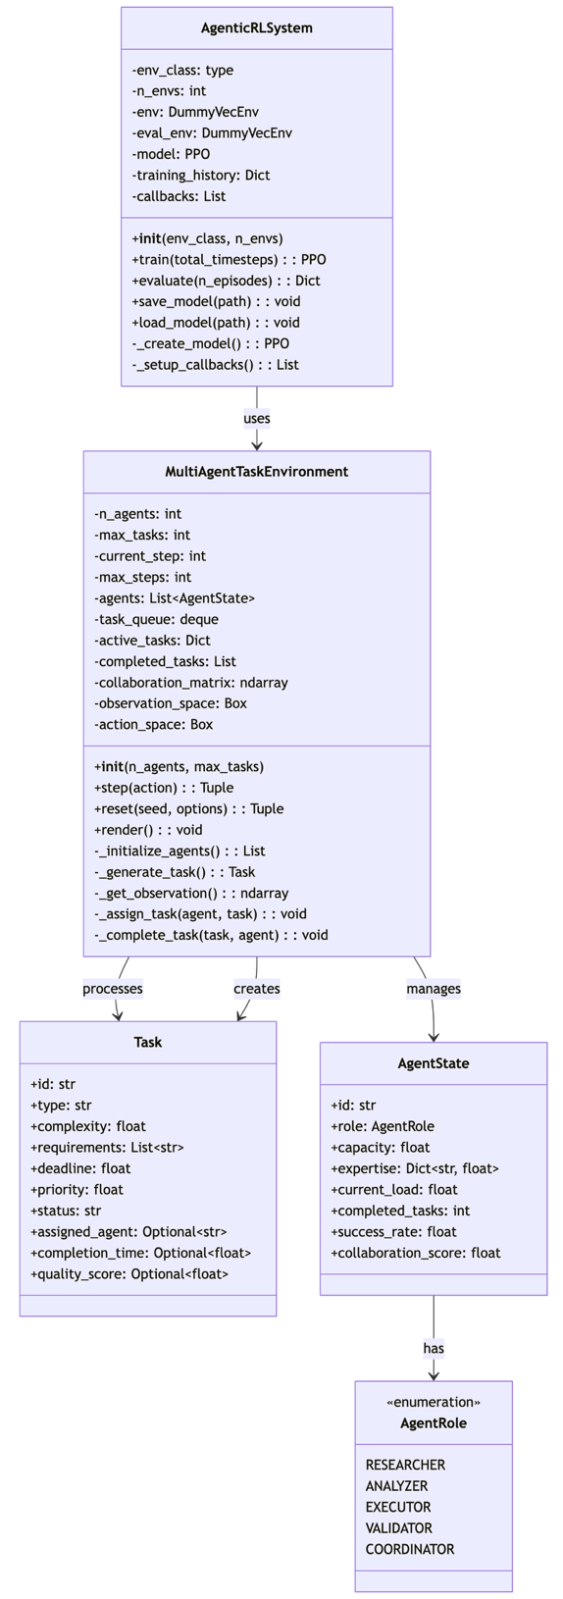

Smart Agent and Tool System Classes
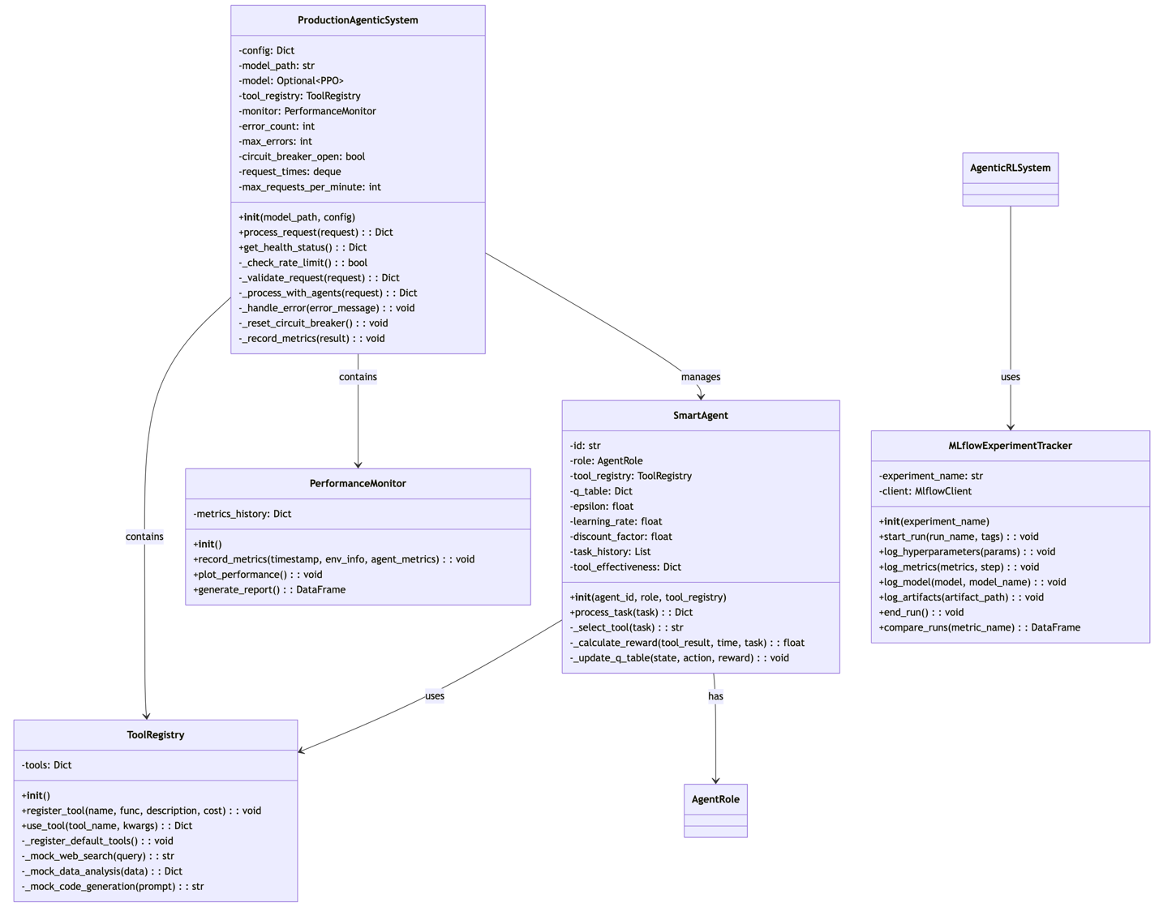

System Flowchart

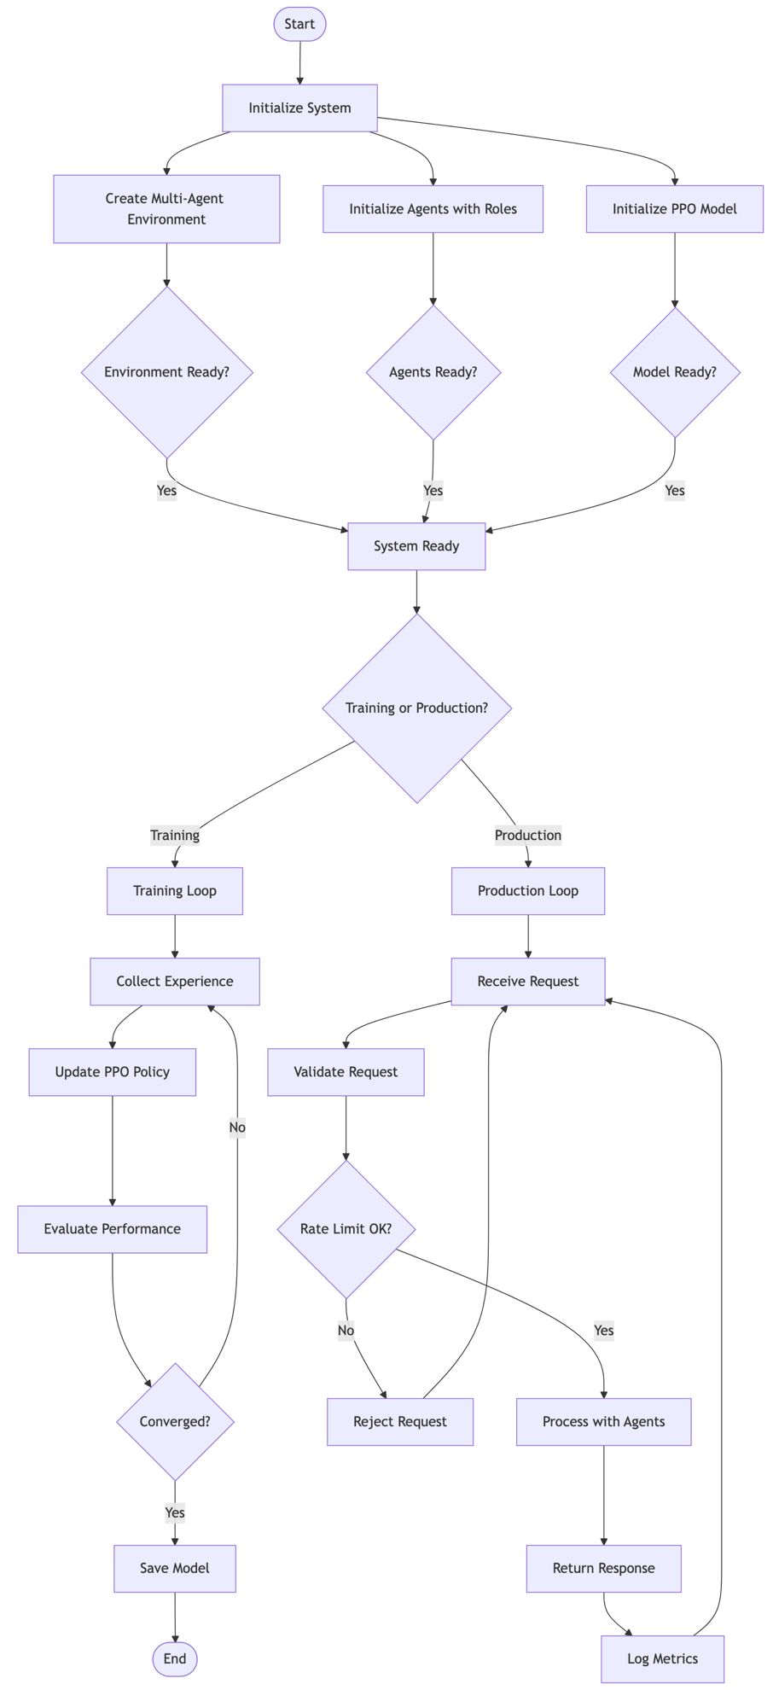

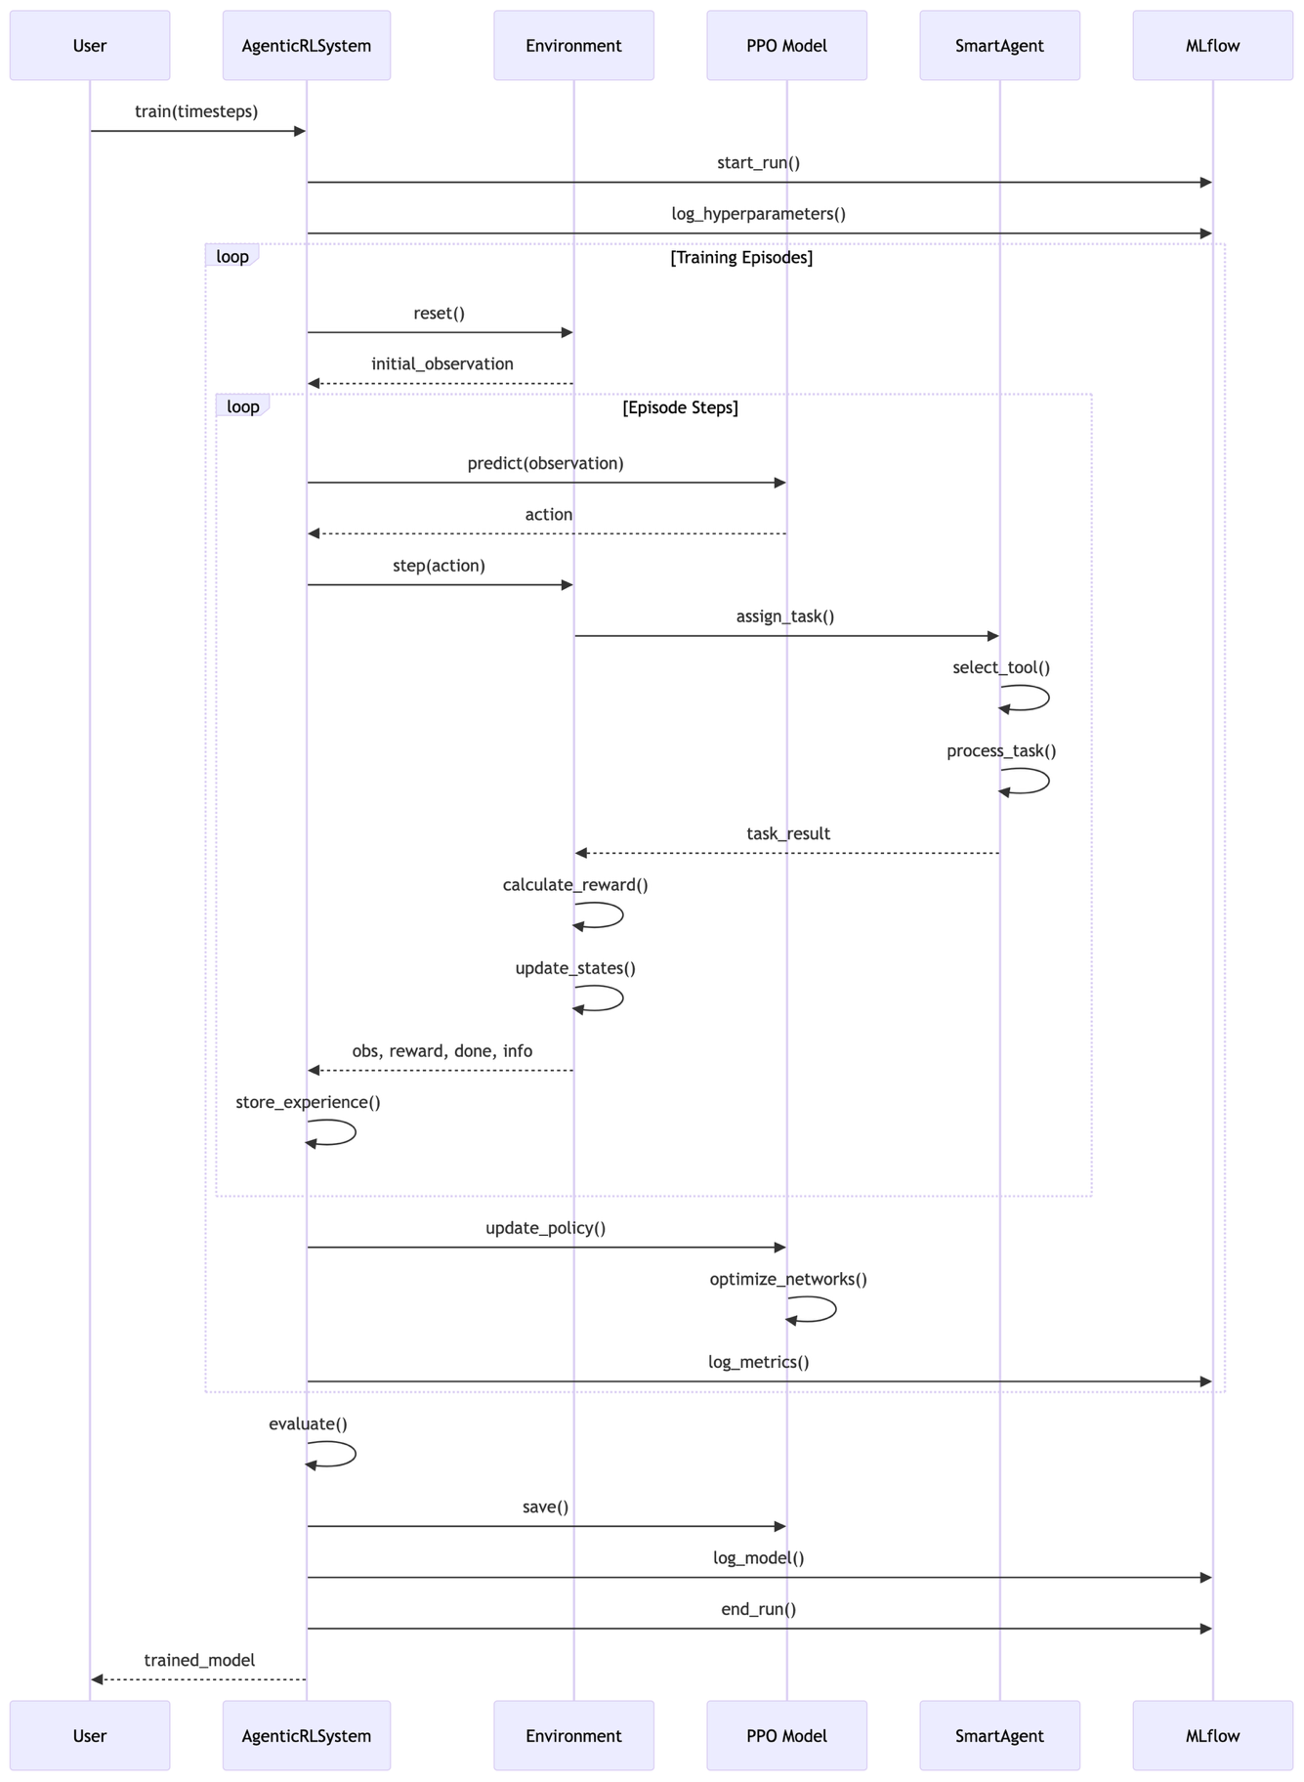
Training Sequence

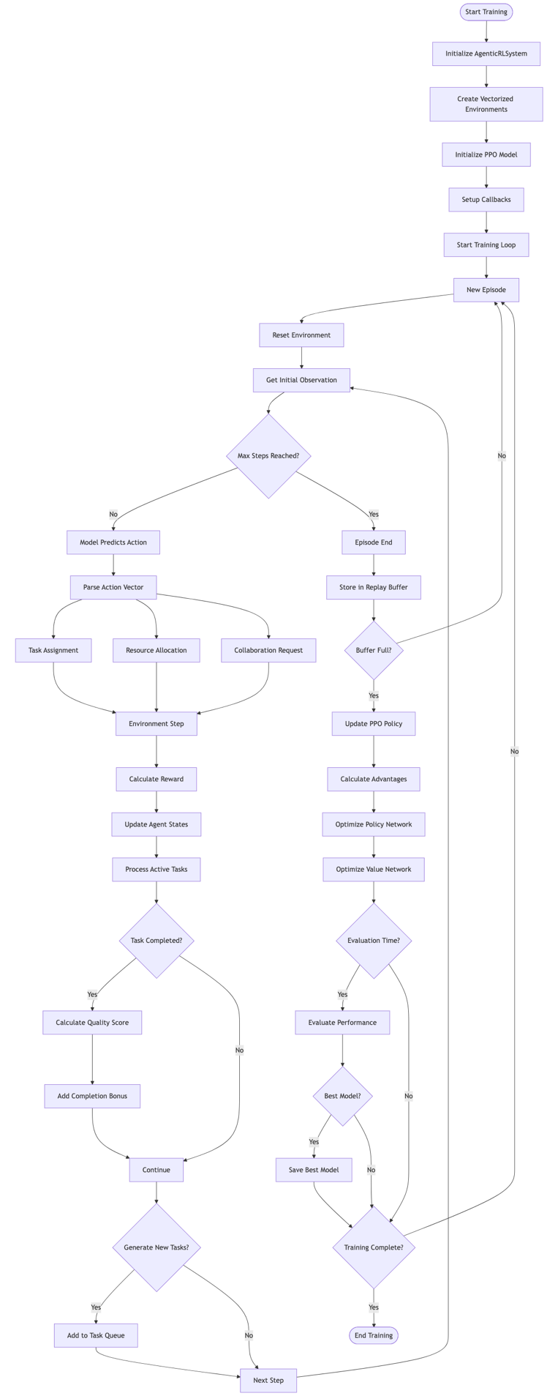
Training Loop

The training loop in the agentic reinforcement learning system combines Proximal Policy Optimization method for obtaining optimal policy and multi-agent coordination to learn optimal task allocation and collaboration strategies.

The training process begins by creating an instance of the AgenticRLSystem class which serves as an orchestrator for the entire training pipeline.

system = AgenticRLSystem(
env_class=MultiAgentTaskEnvironment,
n_envs=4 # Number of parallel environments
)

Parallel Vectorized Environments

The training process creates vectorized environments. These environments are updated in parallel for efficient experience collection. The vectorized environment paradigm allows to run multiple environment instances independently and simultaneously. Thus we speed up the training by collecting more diverse experiences per training step. Thus the vectorized environment workflow collects n_envs times more experience per step.
Each environment evolves independently, reducing correlation in training data. More diverse experiences lead to more stable policy updates due to better gradient estimates.

Example implementation:

self.env = DummyVecEnv([lambda: env_class() for _ in range(n_envs)])

Each environment maintains its own agent states (capacity, expertise, workload), task queue with varying priorities and complexities, collaboration matrix tracking inter-agent relationships, independent random seeds for task generation.

Initialize the PPO model
Creates the neural network architecture and optimization components.
The PPO model consists of two main networks:
Policy Network (Actor): outputs action probabilities
Value Network (Critic): estimates state values for advantage calculation

Architecture configuration

policy_kwargs = dict(
net_arch=[
dict(pi=[256, 256, 128], # Policy network layers
vf=[256, 256, 128]) # Value network layers
],
activation_fn=nn.ReLU
)

Key PPO hyperparameters

learning_rate=3e-4: Step size for gradient descent
n_steps=2048: Steps before policy update (trajectory length)
batch_size=64: Minibatch size for optimization
n_epochs=10: Number of optimization epochs per update
gamma=0.99: Discount factor for future rewards
gae_lambda=0.95: GAE parameter for advantage estimation
clip_range=0.2: PPO clipping parameter to limit policy changes

PPO Hyperparameters deep dive
Learning rate
The learning rate can be viewed as a step size for the gradient descent updates to both policy and value networks.
The custom policy and value networks in the example in [1] have both 3 layers with size $256→256→128$.
Conservative learning rate prevents destabilizing multi-agent coordination patterns the network learns.
Too high learning rate would cause the agents to “forget” the successful collaboration strategies.
Too low learning rate means slow adaptation to new task distributions.
With $7$ agents × multiple task types, $3×{10}^{-4}$ strikes a balance between learning speed and stability. For simpler environments, one might use $1×{10}^{-3}$; for more complex, $1×{10}^{-4}$.

Trajectory length
The trajectory length n_steps controls the number of environmental steps collected before each policy update.
The environment of this problem generates tasks probabilistically (30% chance per step) . For details refer to Task Generation in the first section of this document.

The reward structure benefits from long trajectories:
- Completion rewards (quality * priority * time_bonus) * 10
- Collaboration bonuses accumulate
- Queue penalties are time-dependent

//TODO: finish the section on key PPO parameters

More Details on Task Processing and Task Management
Refer to the markdown task_driven_agentic_workflow_with_rl_loop.md

Task Driven Work Distribution

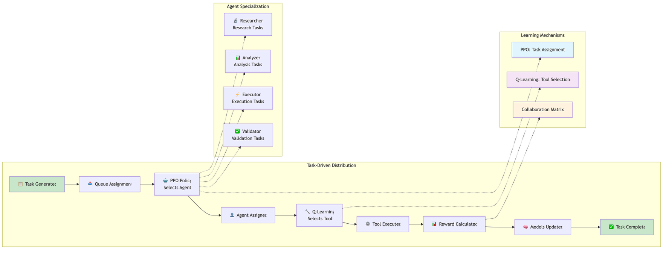

Task Distribution Strategy
- PPO Policy decides which agent receives each task based on:
  - Agent capacity and current load
  - Task complexity and requirements
  - Historical success rates
  - Collaboration opportunities
- Q-Learning enables each agent to learn optimal tool selection:
  - ε-greedy exploration balances learning vs exploitation
  - Rewards shape tool preferences per task type
  - Tool effectiveness tracking improves over time
- Collaboration Matrix captures inter-agent synergies:
  - Agents requesting collaboration simultaneously get bonuses
  - Matrix values increase with successful collaborations
  - Enables emergent team behaviors

Reward Structure
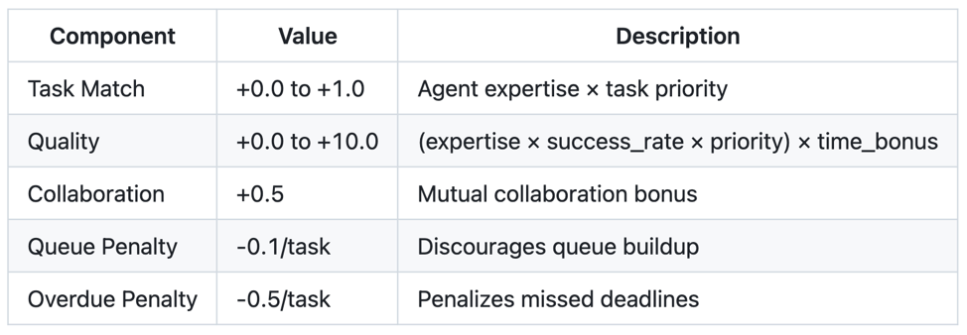

Agent Task Execution Flowchart
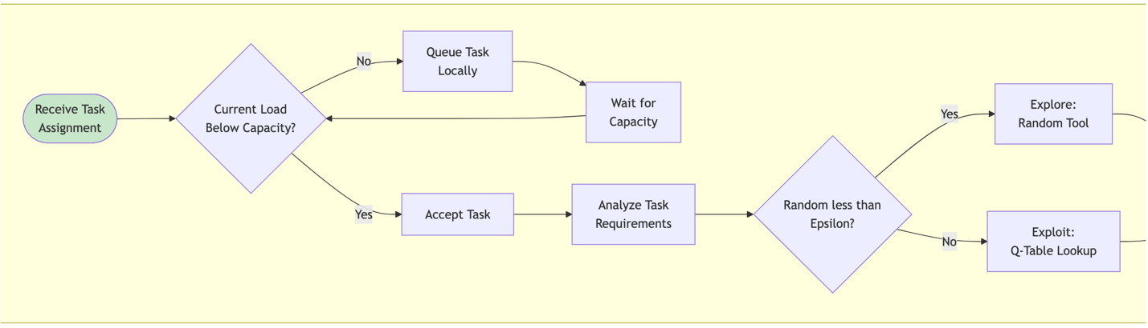

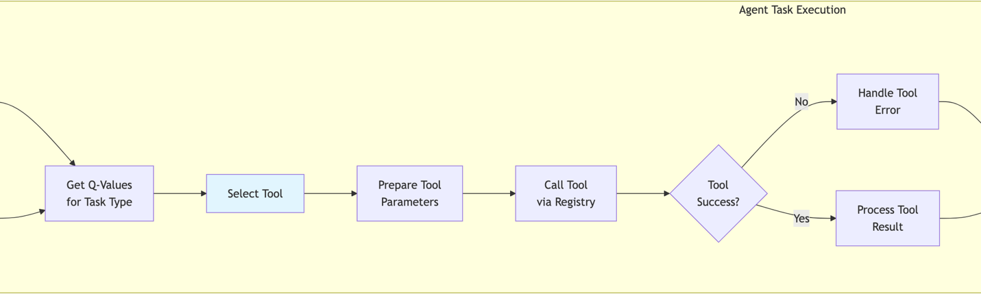

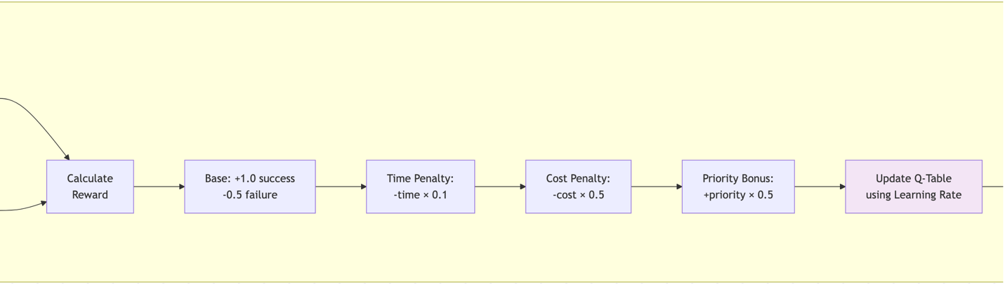
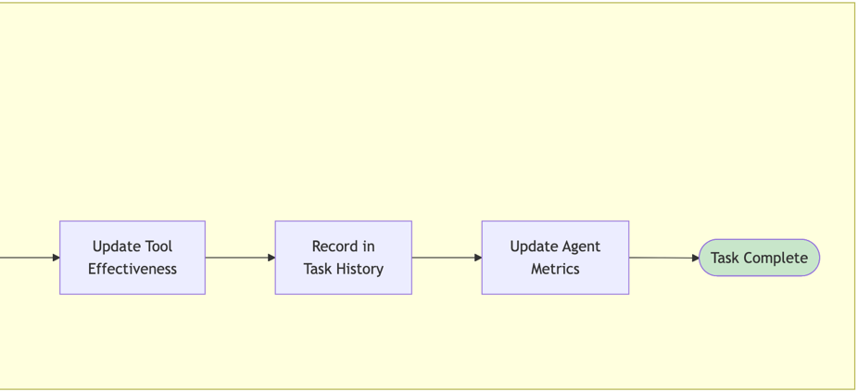

Task Lifecycle Flowchart
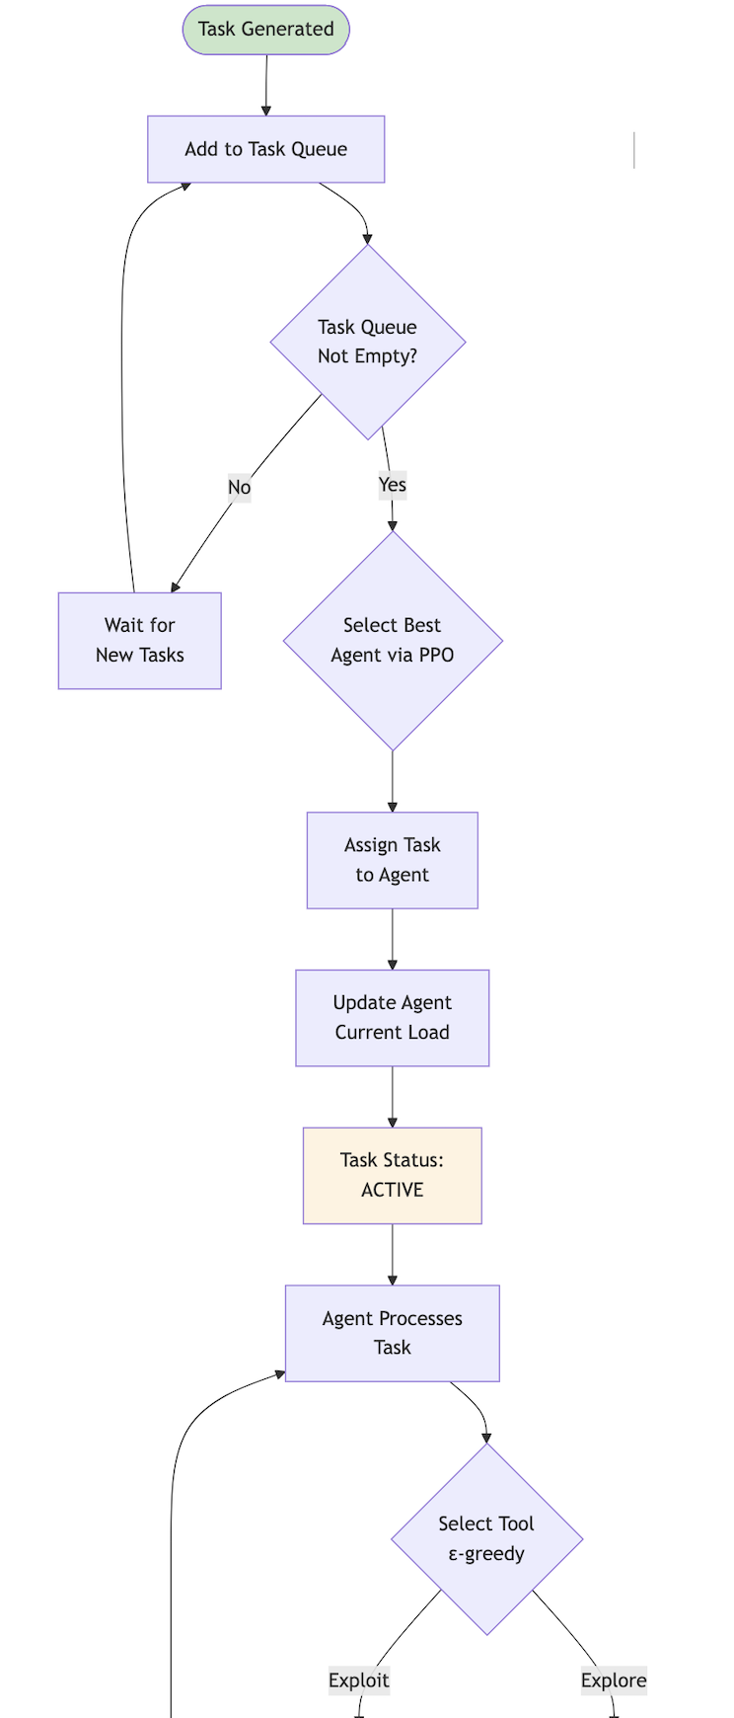
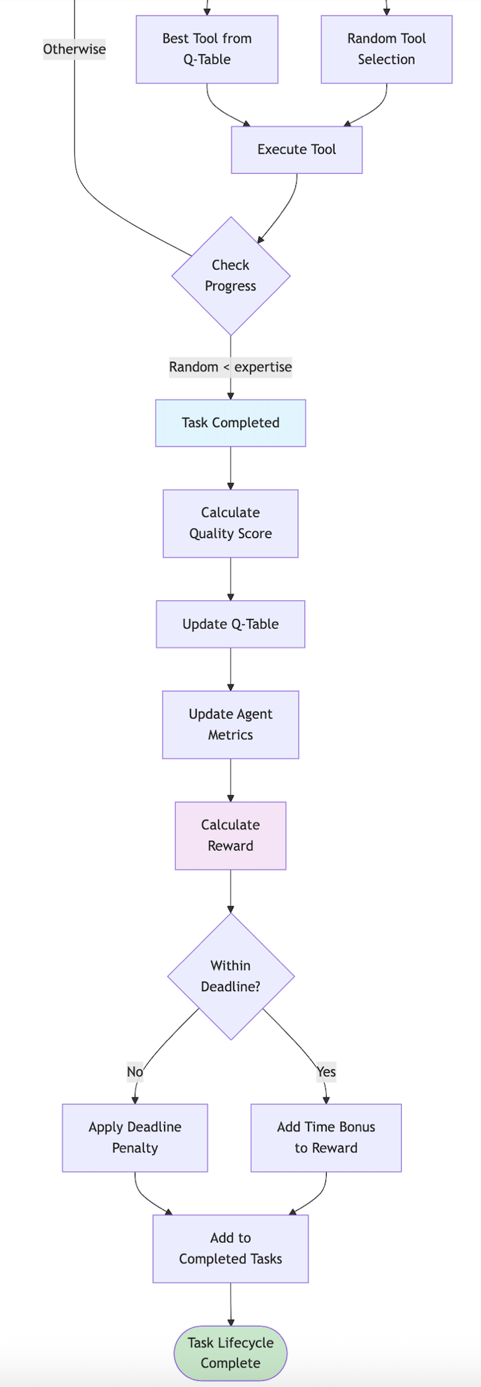

Task States
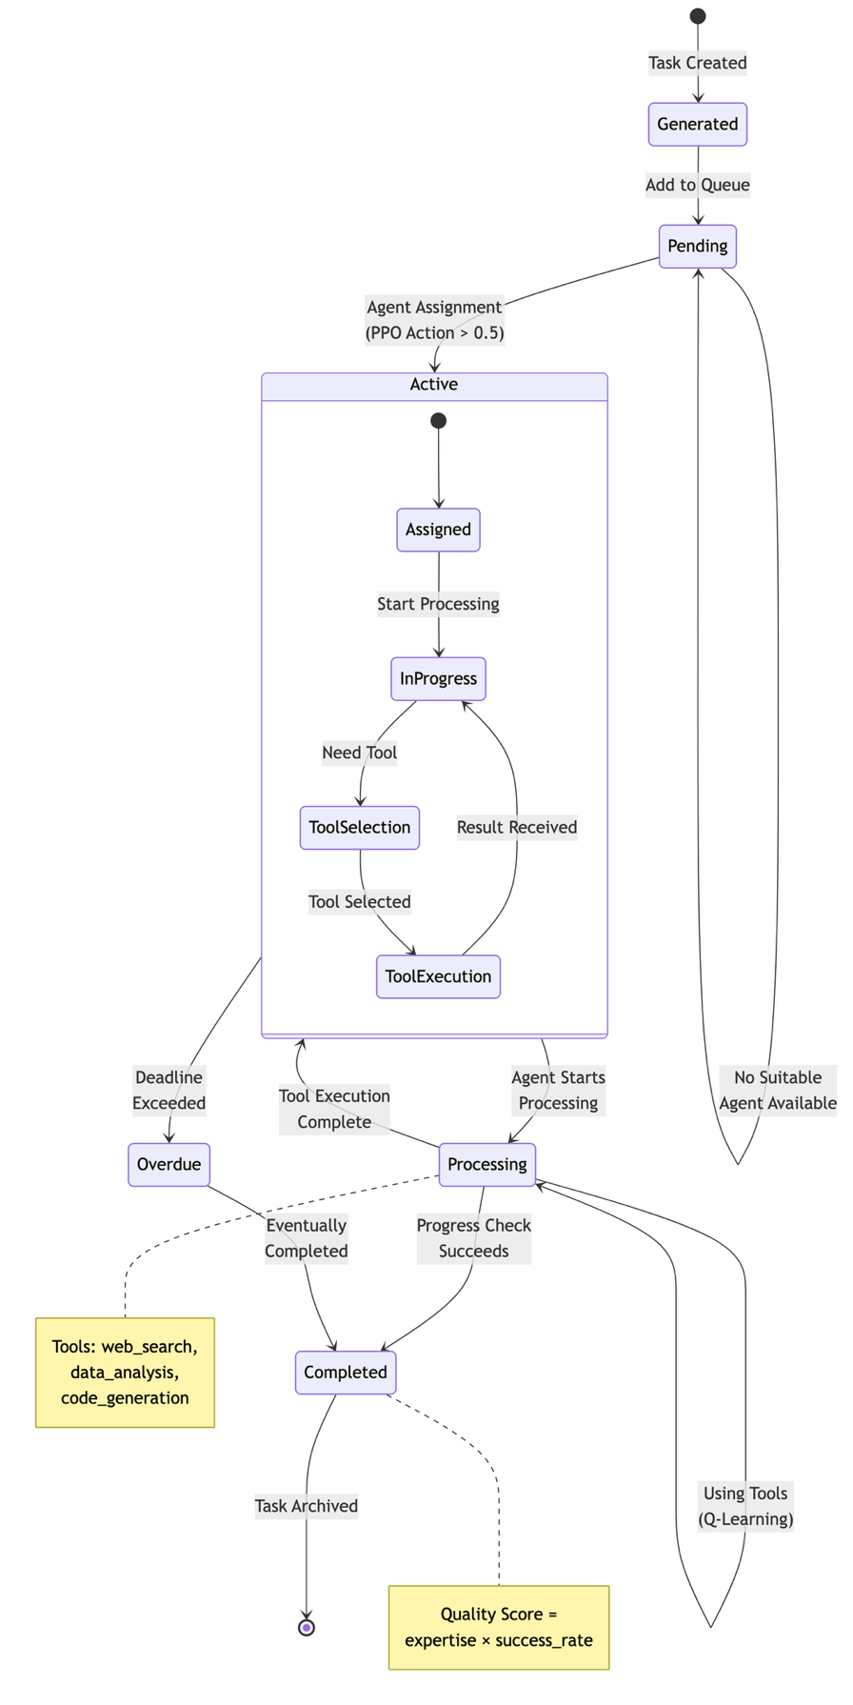

References
[1] https://github.com/dimitarpg13/agentic_architectures_and_design_patterns/blob/main/notebooks/reinforcement_learning/agentic_rl_workflow.ipynb

[2] https://github.com/dimitarpg13/agentic_architectures_and_design_patterns/blob/main/notebooks/reinforcement_learning/agentic_rl_diagrams.md

[3] https://github.com/dimitarpg13/agentic_architectures_and_design_patterns/blob/main/notebooks/reinforcement_learning/agentic_rl_training_loop.md

[4] Neuronlike Adaptive Elements That Can Solve Difficult Learning Control Problems, Andrew G. Barto et al, 1983

[5] Actor-Critic Algorithms, Vijay Konda, John N. Tsitsiklis, 1999

[6] Natural Actor-Critic, Jan Peters et al, 2005

[7] Survey of Actor-Critic Reinforcement Learning: Standard and Natural Policy Gradients, Ivo Grondman et al, 2012

[8] Policy Gradient Methods for Reinforcement Learning with Function Approximation, Richard Sutton et al, AT&T, 1999

[9] Going Deeper Into Reinforcement Learning: Fundamentals of Policy Gradients, Seita’s Place Blog, March 2017

[10] Notes on the Generalized Advantage Estimation Paper, Seita’s Place blog, April 2017

[11] High-Dimensional Continuous Control Using Generalized Advantage Estimation, John Schulman, Philipp Moritz, Sergey Levine, Michael Jordan, Pieter Abbeel, 2015

[12] Human-level control through deep reinforcement learning, Volodymyr Mnih et al, Nature, 2015

[13] Asynchronous methods for deep reinforcement learning, Volodymyr Mnih et al, Google DeepMind, 2016

[14] Trust Region Policy Optimization, John Schulman et al, OpenAI, 2017

[15] Proximal Policy Optimization Algorithms, John Schulman et al, OpenAI, 2017

[16] PPO for LLMs: A Guide for Normal People, Cameron Wolfe, Substack, Oct 27th, 2025
[17] Key Concepts in Reinforcement Learning, OpenAI Spinning Up (Part1)

[18] Kinds of Reinforcement Learning Algorithms, OpenAI Spinning Up (Part 2)

[19] Intro to Policy Optimization, OpenAI Spinning Up (Part 3)

[20] Vanila Policy Gradient, OpenAI docs

[21] Trust Region Policy Optimization, OpenAI docs

[22] Proximal Policy Optimization, OpenAI docs

[23] Note on Q functions and V functions in Reinforcement Learning, D. Gueorguiev, 2023

[24] Notes on Reinforcement Learning by David Silver (notes taken by D. Gueorguiev), 2026

[25] Notes on Reinforcement Learning and Deep Reinforcement Learning , D. Gueorguiev, 2025

Appendix

Key Concepts in Reinforcement Learning

What is Reinforcement Learning: branch of machine learning concerned with making decisions and taking sequences of actions based on some current state thereby maximizing some reward objective over time.
action

Environment
Agent

state, reward

Figure a1.f1: Feedback loop between the Agent and the Environment in RL

The main components of Reinforcement Learning are the Agent and the Environment. The Agent lives and interacts in the Environment. At every step (or moment in time) of the interaction the Agent sees a (possibly partial) observation of the state of the world and then it decides on an action to take. The environment changes when the agent acts on it but may also change on its own.
The agent also perceives a reward signal from the environment, a number that tells it how good or bad the current world state is. The goal of the agent is to maximize its cumulative reward - the return. Reinforcement learning teaches the agent patterns leading to a decision making achieving this goal.

Definition State
A state $s$ is a complete description of the state of the environment.

Definition Observation
An observation $o$ is a possibly partial description of a state $s$, which may omit some of the information pertaining to the state $s$.

Definition Fully observed and partially observed environment
Environment in which the agent can see the complete state of it. Otherwise, it is partially observed.

Definition Action space
Action space is the set $A$ of all valid actions in a given environment. The action space can be discrete or continuous. In discrete action spaces only a finite number of actions are available to the agent. In continuous action spaces the actions are real-valued vectors.

Note on continuous vs discrete state and action space models
The distinction between discrete and continuous state and action spaces have profound consequences for the methods of deep RL. Some families of algorithms can only be applied directly in one case and need substantial rework which would impose additional limitations on their performance in the other case. In this expose we will limit our attention to discrete state and action spaces governed by discrete Markov Decision Processes in order to make the presentation of the discussed algorithms as simple as possible.

Definition Policy
A policy is a rule used by an agent to decide on actions to take. It can be deterministic in which case it is denoted with $μ$:

$a_{t}=μ\left(s_{t}\right)$

or it may be stochastic in which case it is usually denoted by $π$:

$a_{t} \sim π\left(∙|s_{t}\right)$

The policy defines the agent’s behavior, and it is not uncommon to substitute the notion of an “agent” with that of a “policy”.

Definition Parametrized policy
Policy as a computable function which depends on a set of parameters which are obtained through some sort of optimization procedure (e.g. neural network training). We will denote the parameters of such policy by $θ$ or $ϕ$ and then we will use subscript to highlight the connection

$a_{t}=μ_{θ}\left(s_{t}\right)$

$a_{t} \sim π_{θ}\left(∙|s_{t}\right)$

Deterministic Policies

Example: Deterministic Policy in continuous action space in PyTorch deep learning library torch.nn

pi_net = nn.Sequential(
nn.Linear(obs_dim, 64),
nn.Tanh(),
nn.Linear(64, 64),
nn.Tanh(),
nn.Linear(64, act_dim)
)

This builds a MLP network with two hidden layers of size $64$ and tanh activation functions.
Here obs is a NumPy array which contains a batch of observations and pi_net can be used to obtain a batch of actions as:

obs_tensor = torch.as_tensor(obs, dtype=torch.float32)
actions = pi_net(obs_tensor)

For details on the MLP network pi_net constructed with the expression above see the section Example 2: Deterministic Policy in continuous action space modeled with nn.Sequential in the Appendix.

Stochastic Policies

The two most common types of stochastic policies are categorical policies and diagonal Gaussian policies.

//TODO: finish key concepts in RL (mainly from [17] and [18])

Bellman’s Equations for Markov Decision Processes

//TODO: finish Bellman’s Equations for MDP (mainly from [23])

Actor-Critic Reinforcement Learning Algorithms

Definition of MDP

MDP is a tuple $〈X,U,f,ρ〉$ where $X$ denotes the state space, $U$ the action space , $f :X×U×X⟼\left[\left.0,∞\right)\right.$ is the state transition probability density function and $ρ :X×U×X⟼R$ the reward function which represents the reward of going from state $x_{k}$ to state $x_{k+1}$ taking action $u_{k}$. Stationary MDP is such MDP in which all of the elements of the tuple $〈X,U,f,ρ〉$ are constants in time. Note that in case state space is discrete we will use state transition distribution $p\left(x_{t+1}|{u_{t}, x}_{t}\right)$ instead of density function $f\left({x_{t+1},u_{t}, x}_{t}\right)$.
For the purpose of the current exposition we will assume that the state space is continuous. This assumption implies that it is only possible to define a probability of reaching a certain state region since the probability of reaching a particular state is 0.
The probability of reaching a state $x_{k+1}$ in the region $X_{k+1}⊆X$ from state $x_{k}$ after applying action $u_{k}$ is

$P\left(x_{k+1}∈X_{k+1}|{u_{k}, x}_{k}\right)=\int_{X_{k+1}}{f\left({x^{'}, u_{k}, x}_{k}\right)dx^{'}}$ (ac.mdp.1)

After each transition to a state $x_{k+1}$, the controller receives an immediate reward

$r_{k+1}=ρ\left({x_{k+1}, u_{k}, x}_{k}\right)$ (ac.rwr.1)

which depends on the previous state, the current state and the action taken. The reward function $ρ$ is assumed to be bounded.

Policy

The action $u_{k}$ taken in a state $x_{k}$ is drawn from a stochastic policy $π :U×X⟼\left[\left.0,∞\right)\right.$. At any state $x_{k}$ the actor will choose an action $u_{k}$ by drawing it from a stochastic parametrized policy $π\left(u_{k}|x_{k}\right)=p\left(u_{k}|x_{k},θ\right)$ with parameters $θ∈R^{N}$ and the system transfers to a new state drawn from the state transition density $f\left(x_{k+1}, {u_{k}, x}_{k}\right)$ or state transition distribution $p\left(x_{t+1}|{u_{t}, x}_{t}\right)$ in the discrete case.
Policy is a map from state to action – a function $π :S→A$ which represents mapping from states to probabilities of selecting each possible action.
If the agent is following policy $π$ at time $t$, then $π\left(a|s\right)$ is the probability that $A_{t}=a$ if $S_{t}=s$. Note that $π\left(a|s\right)$ is an ordinary function which defines a probability distribution over $a∈A\left(s\right)$ for each $s∈S$.

The goal here is to find the policy $π_{opt}$ which maximizes the expected value of a certain function $g$ of the immediate rewards (usually total return) received while following the policy. This expected value is known as the cost-to-go function

$J\left(π\right)=E\left\{g\left(r_{1},r_{2},…\right)|π\right\}$ (ac.ctg.1)

In most cases, the function $g$ is either the discounted sum of rewards $\sum_{k=0}^{∞}{γ^{k}r_{k+1}}$ or the average reward received $\frac{\sum_{k=0}^{N}{r_{k}}}{N}$, as explained in the next two paragraphs.

Discounted Reward

In the discounted reward setting, the reward function $J$ is equal to the expected value of the discounted sum of rewards when starting with the initial state $x_{0}∈X$ drawn from an initial state distribution $x_{0}\sim d_{0}\left(∙\right)$, also called the discounted return:

$J\left(π\right)=E\left\{\sum_{k=0}^{∞}{γ^{k}r_{k+1}}|d_{0},π\right\}$ (ac.dsc.1)

We denote with the $r\left(x,u\right)$ the expected reward which is given with
$r\left(x,u\right)=Pr\left\{r_{k+1}|x_{k}=x,u_{k}=u\right\}=\int_{X}{f\left(x, u, x^{'}\right)ρ\left(x,u, x^{'}\right) dx^{'}}$ (ac.expr.1)

Thus we get
$J\left(π\right)=\int_{X}{d_{γ}^{π}}\left(x\right)\int_{U}{π\left(u | x\right) r\left(x,u\right) du dx}$ (ac.cfun.1)

Here $d_{γ}^{π}\left(x\right)=\sum_{k=0}^{∞}{γ^{k}p\left(x_{k}=x|d_{0},π\right)}$ is the discounted state distribution under the policy $π$ and $γ∈\left[\left.0,1\right)\right.$ denotes the reward discount factor. Note that $p\left(x_{k}=x\right)$ is a probability density function. Here we are not making an assumption of stationarity for $p\left(x_{k}=x|x_{0},π\right)$; that is $\lim_{k→ ∞}{p\left(x_{k}=x|x_{0},π\right)}$ does not necessarily exist.

During learning the agent will have to estimate the cost-to-go function $J$ for a given policy $π$. The procedure is called policy evaluation. The resulting estimate of $J$ is called the value function. We distinguish two kinds of value function: the state value function and the state-action value function. The state value function is given with

$V^{π}\left(x\right)=E\left\{\sum_{k=0}^{∞}{γ^{k}r_{k+1}|x_{0}=x,π}\right\}$ (ac.svf.1)

Notice that $V^{π}\left(x\right)$ depends only on the state $x$ and the policy $π$ is followed starting from that state.
Basically, $V^{π}\left(x\right)$ is $J\left(π\right)$, parameterized with respect to $x_{0}$ which is renamed to $x$. This can be expressed as

$V^{π}\left(x\right)=\int_{X}{d_{γ}^{π}}\left(x^{'} | x\right)\int_{U}{π\left(u | x^{'}\right) r\left(x^{'},u\right) du dx^{'}}$ (ac.svf.2)

where

$d_{γ}^{π}\left(x^{'} | x\right)=\sum_{k=0}^{∞}{γ^{k}p\left(x_{k}=x^{'} | x_{0}=x,π\right)}$ (ac.dsd.1)

is the discounted state distribution.

The state-action value function is given with

$Q^{π}\left(x,u\right)=E\left\{\sum_{k=0}^{∞}{γ^{k}r_{k+1}|x_{0}=x,u_{0}=u,π}\right\}$ (ac.savf.1)

also depends on the state $x$, but makes the action $u$ chosen in this state a free variable instead of having it generated by the policy $π$.
Looking at (ac.cfun.1) we write

$Q^{π}\left(x,u\right)=\int_{X}{d_{γ}^{π}}\left(x^{'} | x\right) π\left(u | x^{'}\right) r\left(x^{'},u\right) dx^{'}$ (ac.savf.2)

also depends on the state $x$ , but makes the action $u$ chosen in this state a free variable instead of having it generated by the policy $π$. Once the first transition onto a next state has been made $π$ governs the rest of the action selection. The relationship between the state value function and the state-action value function is given with

$V^{π}\left(x\right)=E\left\{Q^{π}\left(x,u\right)| u \sim π\left(∙|x\right)\right\}$ (ac.svf.2)

We can derive the recursive form of the latter by manipulating further (ac.svf.1) and (ac.savf.1):

$V^{π}\left(x\right)=E\left\{ρ\left(x^{'},u, x\right)+γV^{π}\left(x^{'}\right)\right\}$ (ac.bel.1)

This equation is known as the Bellman’s equation. The derivation of (ac.bel.1) is shown below:

$E_{x^{'},u}\left\{ρ\left(x^{'},u, x\right)\right\}=\int_{U}{π\left(u | x\right)}\int_{X}{f\left(x^{'},u, x\right)ρ\left(x^{'},u, x\right) dx^{'}du }$
$E_{u}\left\{r\left(x,u\right)\right\}=\int_{U}{π\left(u | x\right) r\left(x,u\right) du }$

$V^{π}\left(x\right)=\int_{X}{d_{γ}^{π}}\left(x^{'} | x\right)\int_{U}{π\left(u | x^{'}\right) r\left(x^{'},u\right) du dx^{'}}$
$d_{γ}^{π}\left(x^{'} | x\right)=\sum_{k=0}^{∞}{γ^{k}p\left(x_{k}=x^{'} | x_{0}=x,π\right)}$

From (ac.svf.1) and (ac.cfun.1)
We rewrite (dsd.1) splitting it into two terms

$d_{γ}^{π}\left(x^{'} | x\right)=p\left(x_{0}=x^{'} | x_{0}=x,π\right)+γ\sum_{k=0}^{∞}{γ^{k}p\left(x_{k+1}=x^{'} | x_{0}=x,π\right)}$ (ac.dsd.2)

Substituting (ac.dsd.2) into (ac.svf.2) gives us

$V^{π}\left(x\right)=\int_{X}{p\left(x_{k}=x^{'} | x_{0}=x,π\right)\int_{U}{π\left(u | x\right) r\left(x,u\right) du }}$

//TODO: finish the appendix section on actor-critic algorithms (mainly from [5] , [6] and [7])

Policy Gradients

Definition Trajectory
We define a trajectory $τ$ of length $T$ as
$τ=\left(s_{0},a_{0},r_{0},s_{1},a_{1},r_{1},…,s_{T-1},a_{T-1},r_{T-1},s_{T}\right)$
where $s_{0}$ starts from the starting distribution of states

//TODO: finish the appendix section on the policy gradients (mainly from [8] and [9])

Generalized Advantage Estimation

//TODO: finish the appendix section on generalized advantage estimation (mainly from [10], [11])

Proximal Policy Optimization

//TODO: finish the appendix section on the PPO (mainly from [15] and [16])

A Note on nn.Sequential implemented with PyTorch Deep Learning library

nn.Sequential is a container class in PyTorch deep learning library that stacks neural network layers in a linear order. It allows you to build models by simply passing a sequence of modules to its constructor, where the output of each module is automatically passed as the input to the next one.
This class is linear stacking, that is - it is designed for networks where data flows through the layers in strictly sequential manner, with one input and one output for each layer. The entire nn.Sequential container acts as a single nn.Module allowing it to use it just like any other layer in the network.

For more details see PyTorch docs on nn.Sequential.

Example 1: MNIST-style digit classification (0-9) using nn.Sequential

import torch.nn as nn
import torch

# Define the sequential model
model = nn.Sequential(
nn.Flatten(), # Flattens the input image from 2D to 1D
nn.Linear(28*28, 128), # A linear (fully connected) layer
nn.ReLU(), # A ReLU activation function (introduces non-linearity)
nn.Linear(128, 10), # Another linear layer to output final class scores
nn.Softmax(dim=1) # Softmax activation for probability distribution
)

# Example input (batch of 1, 28x28 image)
input_image = torch.rand(1, 28, 28)

# Pass the input through the model
output = model(input_image)
print(output)

Architecture Flow and Tensor Shape Transformations for the network on Example 1 shown below
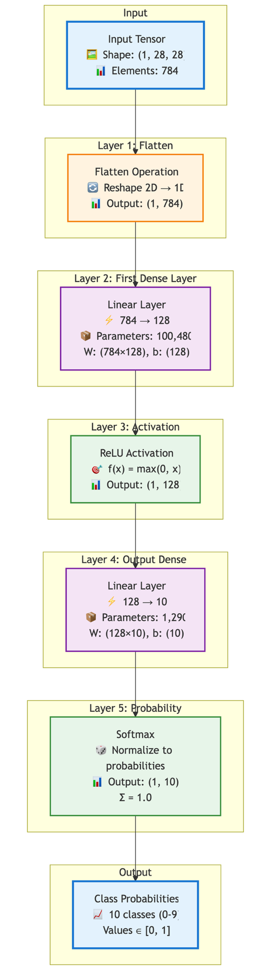
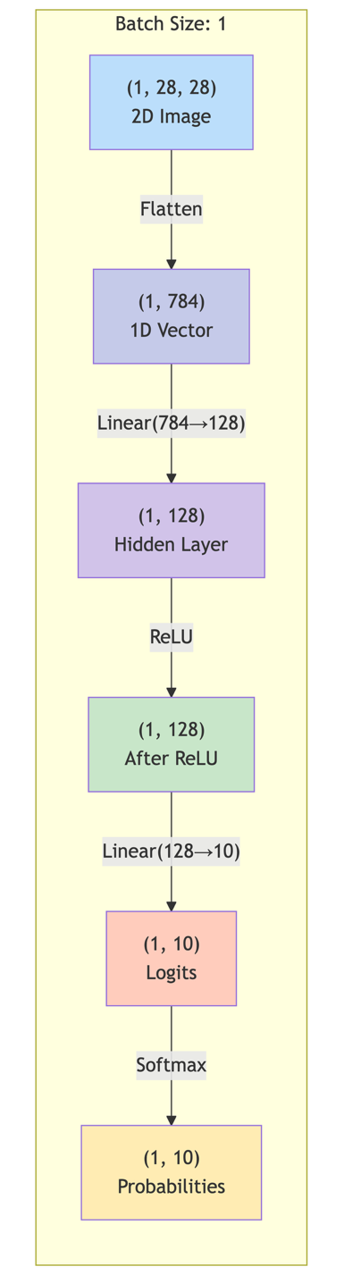
Architecture Flow
Tensor Shape Transformations
Network layer stack and Layer operations for the network on Example 1 shown below:
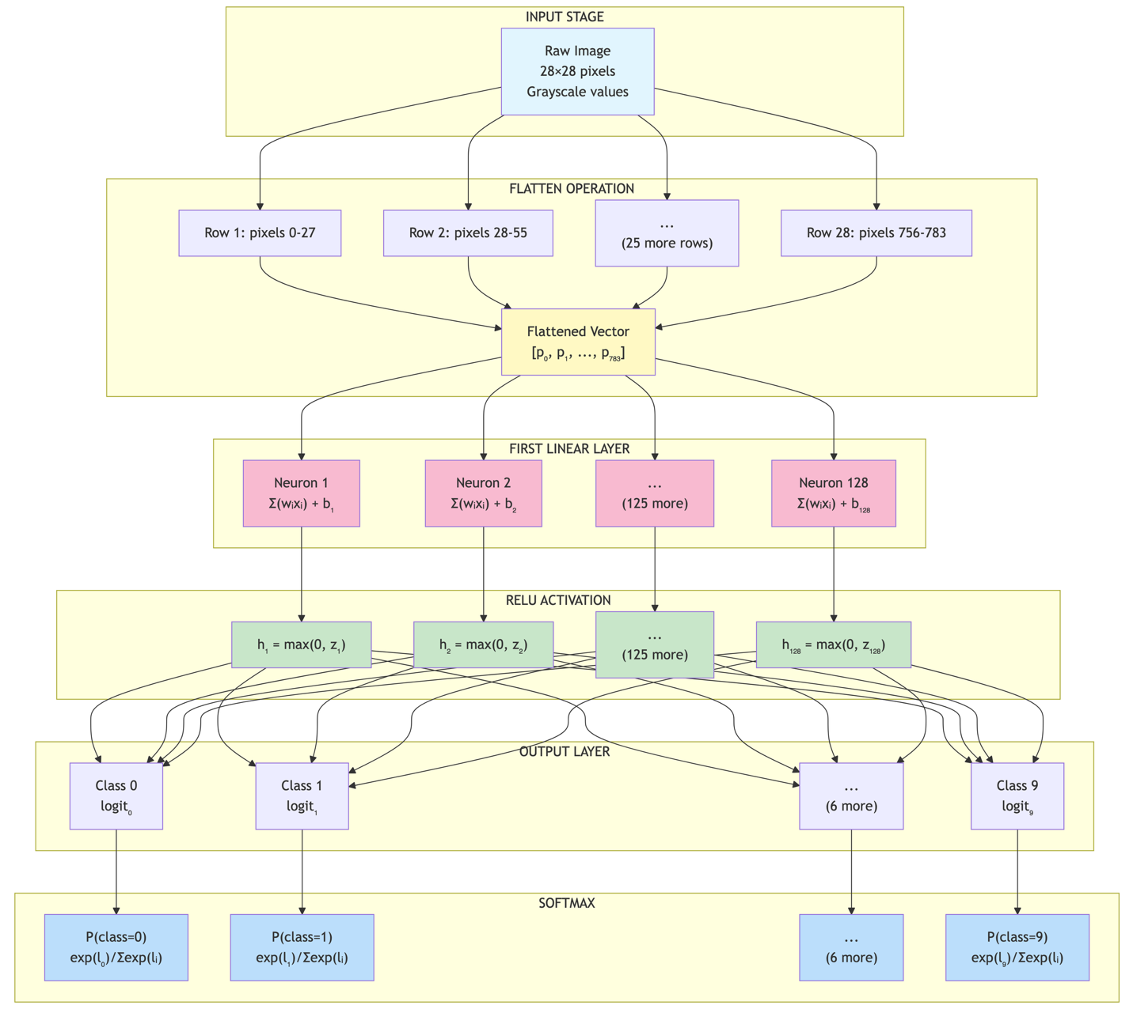
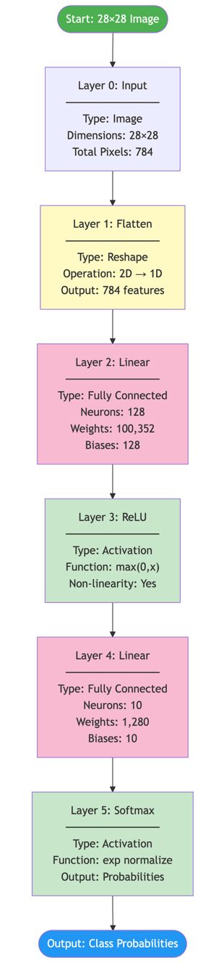

Information Flow with Dimensions for the network on Example 1 shown below:

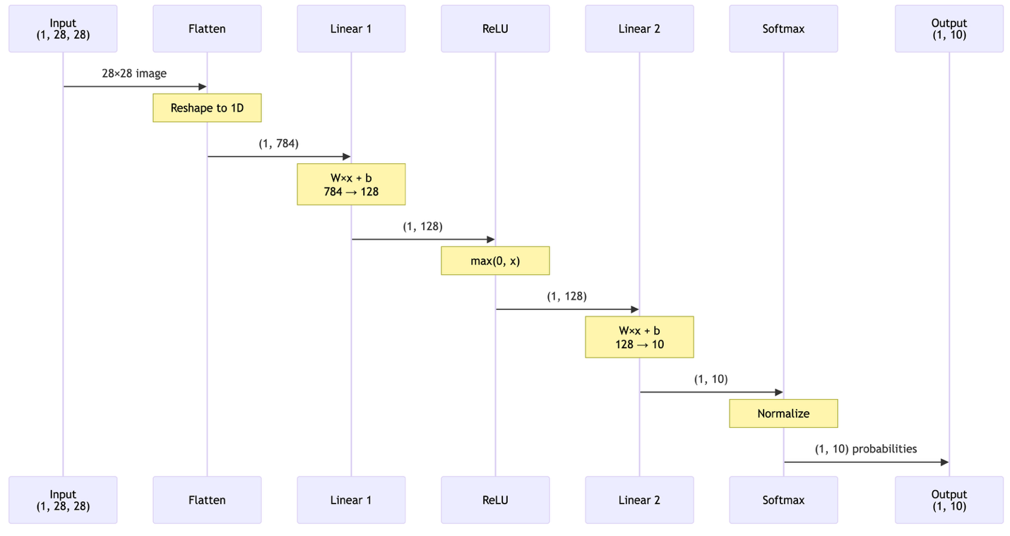

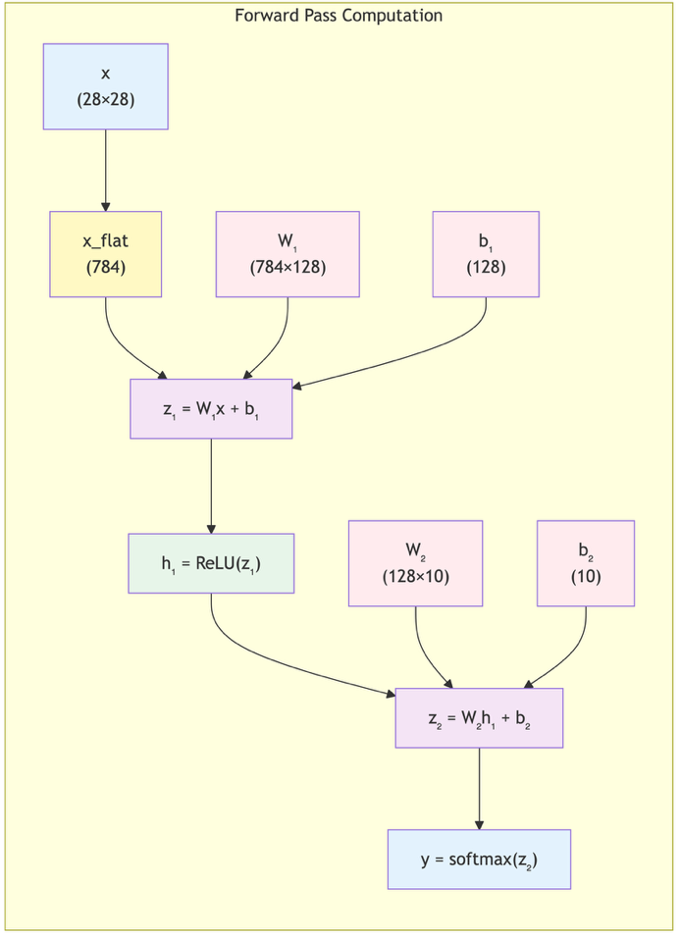
Computation Graph for the network on Example 1 shown below:

Summary Table for the network on Example 1
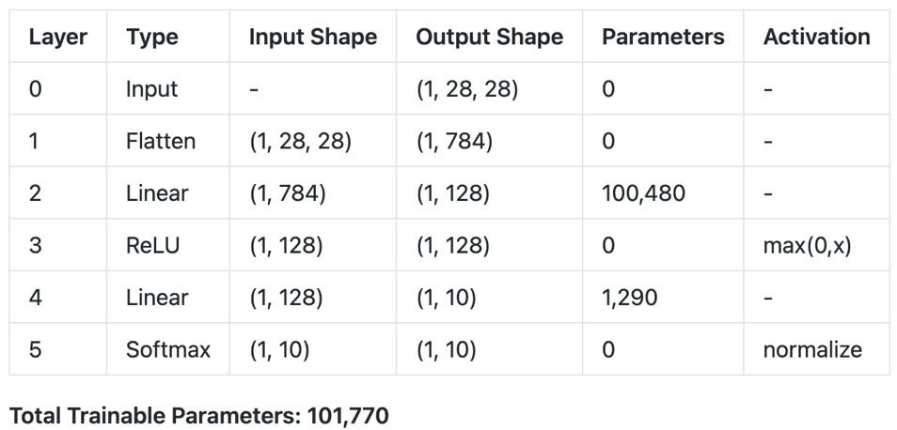

Equations for the Example 1 Network

Layer 2 (First linear)

$z_{1}=W_{1}∙x_{flat}+b_{1}$ where $W_{1}∈R^{128×784}$, $b_{1}∈R^{128}$

//TODO: finish the equations for the example network

For details see the markdown pytorch_example_neural_network_diagrams.md

Example 2: Deterministic Policy in continuous action space modeled with nn.Sequential

pi_net = nn.Sequential(
nn.Linear(obs_dim, 64),
nn.Tanh(),
nn.Linear(64, 64),
nn.Tanh(),
nn.Linear(64, act_dim)
)

This builds a MLP network with two hidden layers of size $64$ and tanh activation functions.

Architecture Flow and Tensor Shape Transformations for the network on Example 2

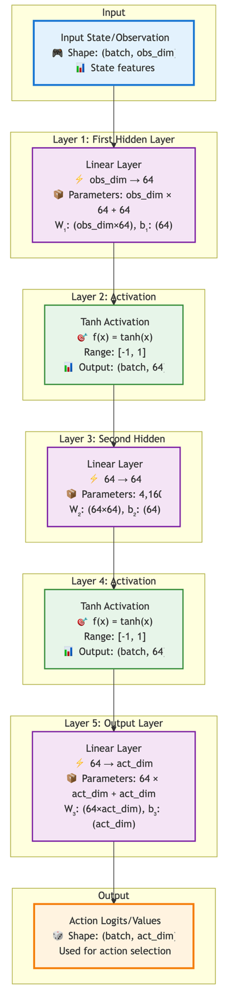
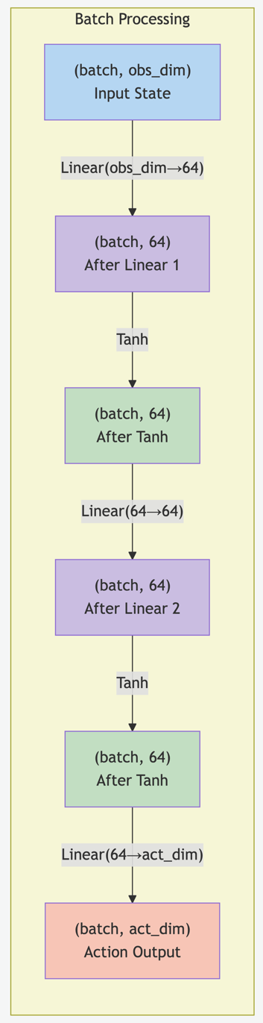
Tensor Shape Transformations
Architecture Flow

Network layer stack for the network on Example 2:
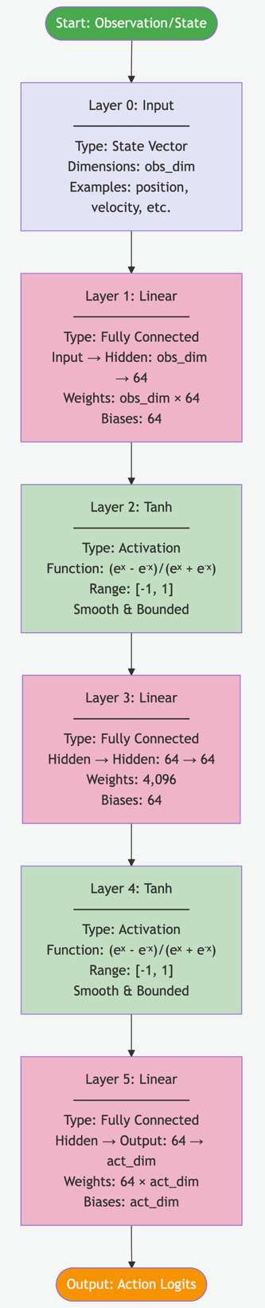

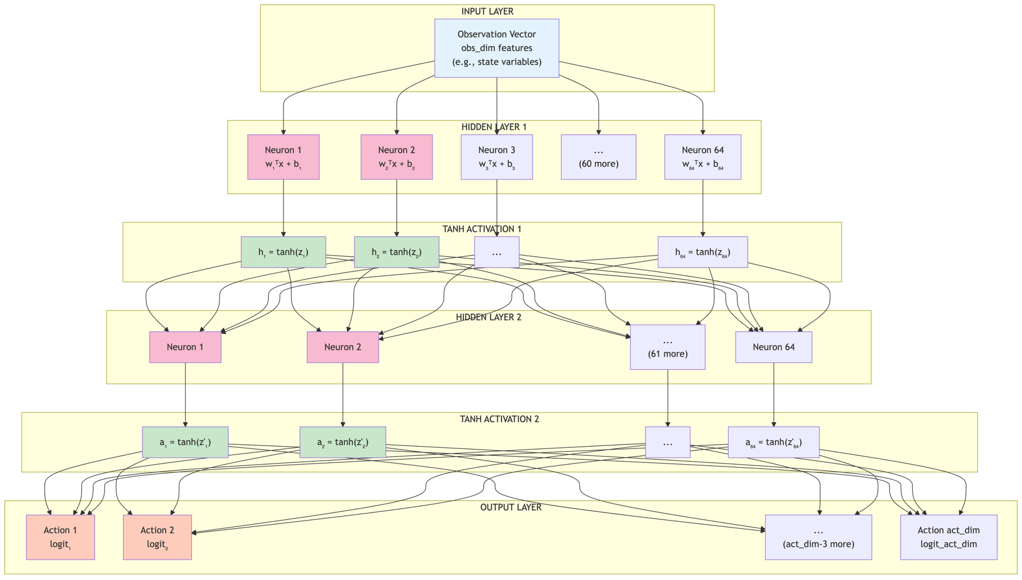
Detailed Network Architecture for Example 2:

//TODO: finish the diagrams for the deterministic policy in continuous action space

For details see the markdown pytorch_policy_net_diagrams.md

