Agentic Workflows with Reinforcement Learning Loop
compiled by D.Gueorguiev using Claude Opus 4.1

We will discuss application of RL algorithms such as PPO to implement adaptive workflow which will manage learning-based task allocation.

System Flowchart

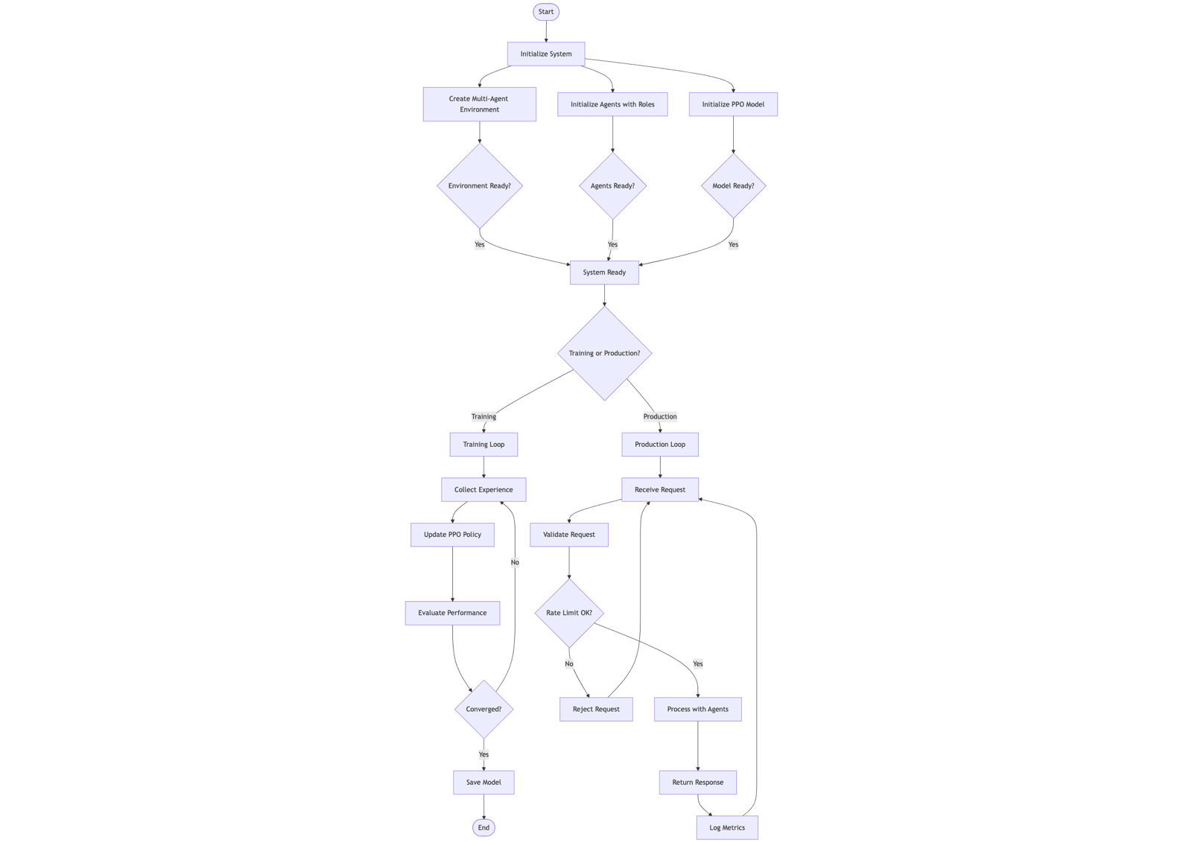

References
[1] https://github.com/dimitarpg13/agentic_architectures_and_design_patterns/blob/main/notebooks/reinforcement_learning/agentic_rl_workflow.ipynb

