# Execution of Semantic Structures

D. Gueorguiev 5/6/2022

## Execution Space

*Execution Space* is a metric space which in general has different number of dimensions than that of Semantic Space. All execution structures reside in Execution Space. Each executable semantic structure is mapped to a *target point* in execution space which is adorned with a semantic signature and mass. Each target point in execution space serves as a point of attraction to the relevant Execution Particles which will form a final Execution Structure converging around the target point.

**Definition**: *Target point*: a point in Execution Space which is mapped to a centroid of a Semantic Structure in Semantic Space. It will be denoted to with the Greek letter with appropriate subscript (from Greek σ**τ**όχος). Each target point has a mass in execution space and semantic signature represented by its semantic signature matrix .

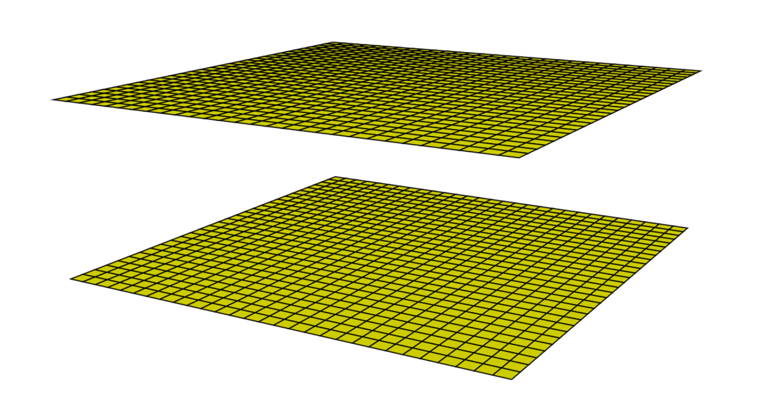

Semantic Space

Execution Space

## Executive Particles and Executive Structures

Execution of semantic structure is achieved through aggregation of *Executive Particles* around a *target point*. Every structure in execution space can be represent as an -arry tree rooted in a *target point*.

Executive particles can be *primitive* or *compound* ones. Every compound executive particle is an executive structure and it can be expressed as a tree of primitive executive particles.

Every primitive executive particle can be represented as a tree of primitive executive atoms as shown on the figure below. The structures in Execution Space will be denoted with small cap Greek letters. The primitive executive particles will be denoted with the letter with appropriate subscript (from Greek [εκτελώ](https://en.bab.la/dictionary/greek-english/%CE%B5%CE%BA%CF%84%CE%B5%CE%BB%CF%8E) ***execute***). The executive atoms will be denoted with the letter with an appropriate subscript (from Greek [άτομο](https://en.bab.la/dictionary/greek-english/%CE%AC%CF%84%CE%BF%CE%BC%CE%BF)).

--- o ---

/ | \

_

/ \ | \

|

Each arc connecting two executive atoms is assigned *executive significance* vector (Greek σημασία)

with appropriate subscript.

------

//TODO

### Executive Atoms

Each *Executive Atom* is represented by the tuple where:

is the *semantic latch* (Greek for μάνταλο for *latch*) of the atom (also *atom key*),

is the *inference template* of the atom – hence the fraktur symbol.

is the template transferring the result to semantic space a.k.a. *semantic transfer template* – hence the fraktur symbol

is the template transferring the result to executive space feeding it to associated action ; a.k.a. *executive transfer template* – hence the fraktur symbol.

(Greek δράση for *Action*) is an *Action* associated with the result of the application of . The *Action* is integer valued semantic function.

Let us have two atoms and such that the former is a parent of the latter. Let the pair is associated with the parent and is associated with the child atom. Let us denote the semantic input for with . Note that is either the result of the application of the semantic template of a parent of or it is the semantic structure of the root of the executive particle to which the atoms and belong.

~~TODO: connection between Action Code and Action.~~ ~~Therefore, each atom can be thought of as a sequence of executive actions performed atomically.~~ Recall in the discussion on the concept of *Semantic Aspect* we mentioned that the semantic aspect is mapped to a (length, direction) pair in Semantic Space. We denoted the length as *Aspect type* and the coordinates which are encoding its direction as *Aspect value*. We allowed the semantic Aspect Types and Values to be *continuous* and we introduced *Aspect Type and Value Matching functions* and which allow us to establish closeness between semantic aspects. Through the concept of *Semantic Aspect* we have defined a continuum of semantic meanings and can establish closeness which is necessary for inferring new semantic structures and performing semantic parsing. The problem is that we cannot afford the convenience of continuum when dealing with executive structures. Every executive structure will be shown to be equivalent to a non-deterministic Turing machine.

### Mapping of the output of Executive Transfer Template to Executive Action

S

Semantic Space

*,*

*,*

//TODO

## Creation of Execution Structures

### Creation of Primitive Execution Particle

Let us consider a target point in Execution Space represented by its mass and semantic signature matrix . From all already constructed atoms we select the one with the largest attraction force toward .

--- o --- <-----------

/ | \

_

/ \ | \

|

//TODO

## Inference in Execution Space

//TODO