FAISS IVF Flat Implementation Details
Compiled by D.Gueorguiev using Cursor AI with Claude Opus 4.5 in agent mode, 2/6/2026

Conceptual Overview

What is IVF Flat?

IVFFlat (Inverted File Index with Flat storage) is a fundamental approximate nearest neighbor (ANN) search index in FAISS. It combines two key ideas:

Inverted File (IVF): A technique borrowed from information retrieval that partitions the vector space into clusters and maintains an inverted index mapping each cluster to the vectors it contains.

Flat Storage: Vectors are stored in their original, uncompressed form (raw float values), providing exact distance computation within each cluster.

The core idea of IVF
Instead of: Query → Compare with all $N$ vectors → Top K results
IVFFlat: Query → Find nearest clusters → Compare with vectors in those clusters → Top K results

Example: IVF Inverted Index Structure
Imagine a database of 100,000 document vectors divided into 3 clusters (centroids $C_{1}$,$C_{2}$,$C_{3}$).

$C_{1}$ (Centroid Vector 1): $[0.1, 0.5, ...]→$ List of Vector IDs: $[105, 900, 2010, ...]$

$C_{2}$ (Centroid Vector 2): $[0.9, 0.2, ...]→$ List of Vector IDs: $[45, 1002, 5030, ...]$

$C_{3}$ (Centroid Vector 3): $[0.5, 0.8, ...]$ $→$ List of Vector IDs: $[12, 700, 3005, ...]$

Search Workflow Example

- Query: A new vector $Q$ arrives.

- Cluster Selection: $Q$ is compared to centroids $C_{1}$,$C_{2}$,$C_{3}$.

- Inverted List Lookup: $Q$ is closest to $C_{2}$. The search only checks vectors in $C_{2}$'s list ($[45, 1002, 5030, ...]$), ignoring $C_{1}$ and $C_{3}$.

How IVF Works?

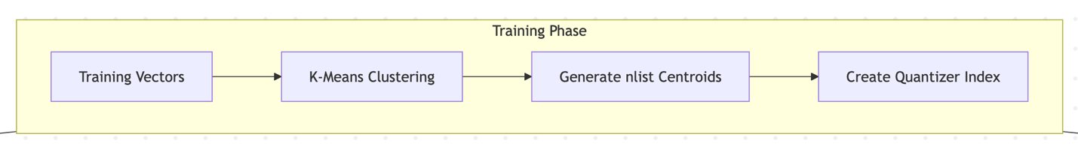

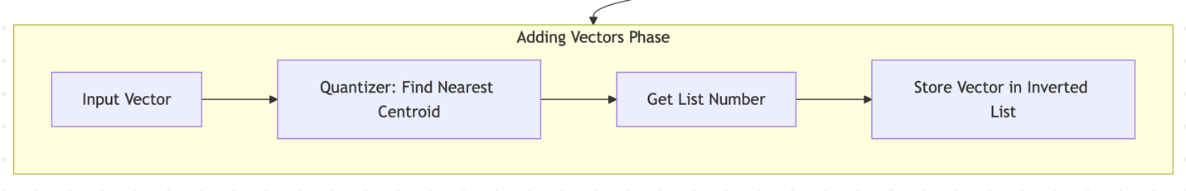
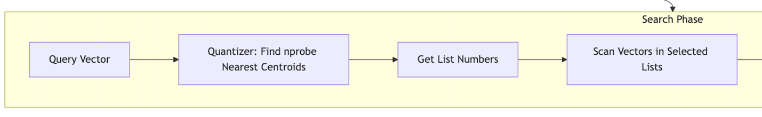

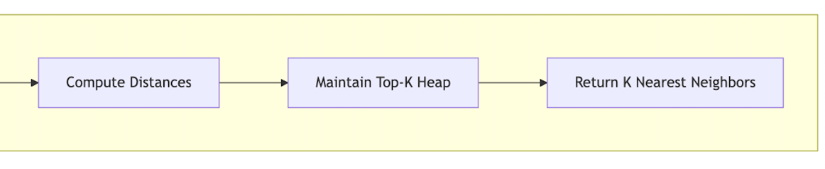

Key Parameters

Parameter | Description | Typical Values
d | Vector Dimension | $64, 128, 256$, etc.
nlist | Number of clusters/inverted lists | $\sqrt{N}$ to $4\sqrt{N}$ where $N$ is dataset size
nprobe | Number of clusters to search | 1 to nlist (higher is more accurate but slower)
metric_type | Distance metric (L2 or Inner product) | METRIC_L2, METRIC_INNER_PRODUCT

The Quantization Process

The quantization process refers to the initial coarse quantization step, which partitions the vector space into smaller, manageable regions (clusters or Voronoi cells) to enable faster Approximate Nearest Neighbor (ANN) search. Unlike Product Quantization (PQ) which compresses the vectors themselves, the quantization in IVFFlat is used for indexing (partitioning) the database.

Key Steps of the Quantization Process in IVFFlat

- Training (Centroid Generation):
The algorithm scans a subset of the dataset and uses a clustering algorithm, typically K-means, to find a set of nlist cluster centroids. These centroids represent the "center" of each partition in the high-dimensional space.

- Vector Assignment: Every vector in the dataset is assigned to its closest centroid.

- Inverted File Creation:
An inverted file structure is created, where each centroid acts as a "bucket" or "cell."
All vectors assigned to a particular centroid are stored in that cell's list.

- Coarse Search (At Query Time):
When a query vector arrives, it is compared against the nlist centroids to find the nprobe nearest clusters. The search algorithm only performs a detailed ("flat") search within the vectors in those nearest clusters, skipping the rest of the dataset.

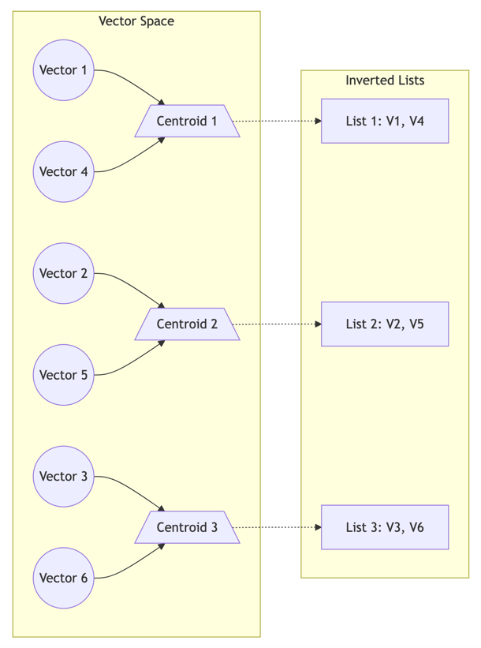

References

[1] FAISS IVFFlat Implementation Details: docs/faiss/IVFFlat_details.md
[2] Write You A Vector Database: IVFFlat Index, skyzh.github.io
[3] Write You A Vector Database: https://github.com/dimitarpg13/bustub-vectordb
[4] Product Quantization: Compressing high-dimensional vectors by 97%, FAISS: The Missing Manual, Pinecone Learn Series

Appendix

More o

