Agentic Workflows with Reinforcement Learning Loop
compiled by D.Gueorguiev with the help of Claude Opus 4.1, 1/4/2026

We will discuss application of RL algorithms such as PPO to implement adaptive workflow which will manage learning-based task allocation.

System Flowchart

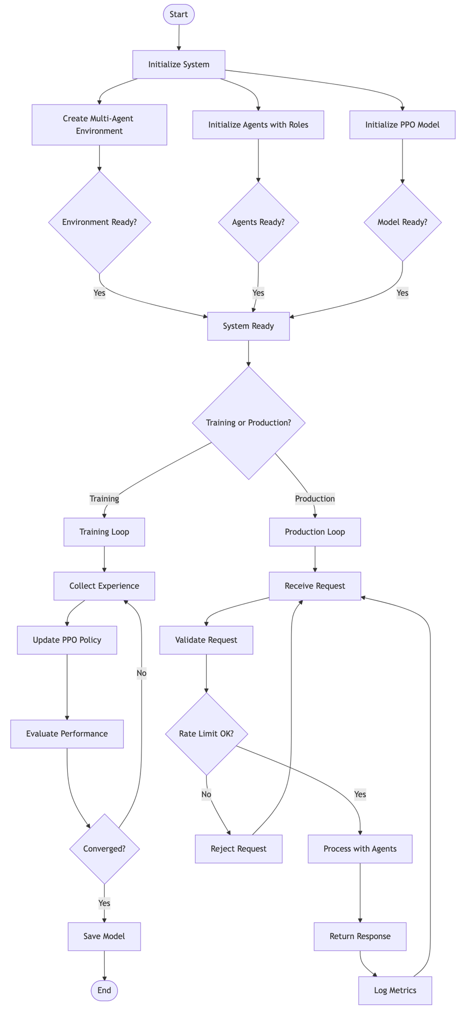

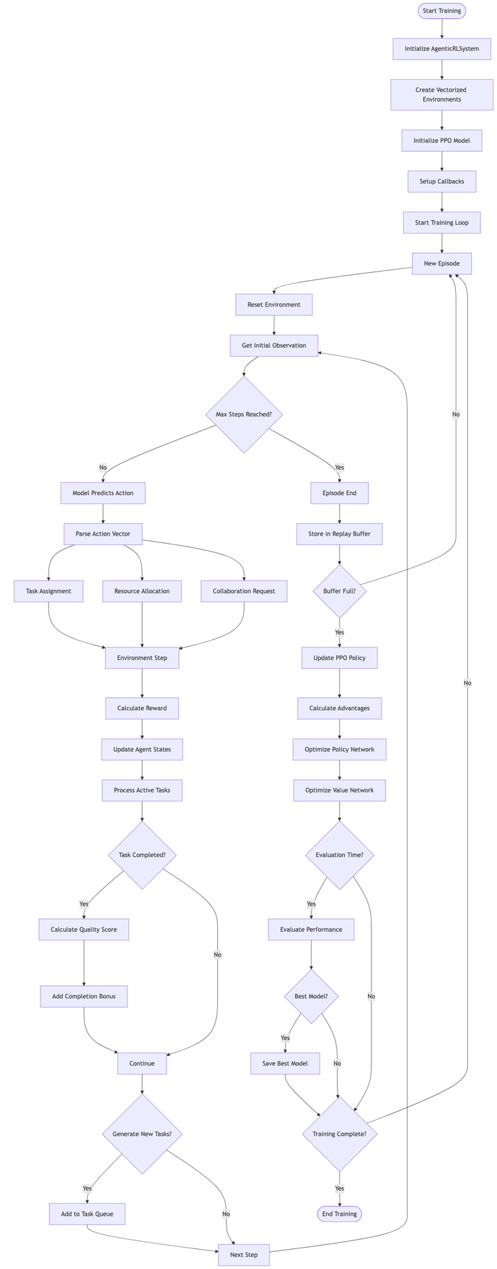
Training Loop
The training process begins by creating an instance of the AgenticRLSystem class which serves as an orchestrator for the entire training pipeline.

system = AgenticRLSystem(
env_class=MultiAgentTaskEnvironment,
n_envs=4 # Number of parallel environments
)

Parallel Vectorized Environments

The training process creates vectorized environments. These environments are updated in parallel for efficient experience collection. The vectorized environment paradigm allows to run multiple environment instances independently and simultaneously. Thus we speed up the training by collecting more diverse experiences per training step. Thus the vectorized environment workflow collects n_envs times more experience per step.
Each environment evolves independently, reducing correlation in training data. More diverse experiences lead to more stable policy updates due to better gradient estimates.

Example implementation:

self.env = DummyVecEnv([lambda: env_class() for _ in range(n_envs)])

Each environment maintains its own agent states (capacity, expertise, workload), task queue with varying priorities and complexities, collaboration matrix tracking inter-agent relationships, independent random seeds for task generation.

Initialize the PPO model
Creates the neural network architecture and optimization components.
The PPO model consists of two main networks:
Policy Network (Actor): outputs action probabilities
Value Network (Critic): estimates state values for advantage calculation

Architecture configuration

policy_kwargs = dict(
net_arch=[
dict(pi=[256, 256, 128], # Policy network layers
vf=[256, 256, 128]) # Value network layers
],
activation_fn=nn.ReLU
)

Key PPO hyperparameters

learning_rate=3e-4: Step size for gradient descent
n_steps=2048: Steps before policy update (trajectory length)
batch_size=64: Minibatch size for optimization
n_epochs=10: Number of optimization epochs per update
gamma=0.99: Discount factor for future rewards
gae_lambda=0.95: GAE parameter for advantage estimation
clip_range=0.2: PPO clipping parameter to limit policy changes

References
[1] https://github.com/dimitarpg13/agentic_architectures_and_design_patterns/blob/main/notebooks/reinforcement_learning/agentic_rl_workflow.ipynb

[2] https://github.com/dimitarpg13/agentic_architectures_and_design_patterns/blob/main/notebooks/reinforcement_learning/agentic_rl_diagrams.md

[3] https://github.com/dimitarpg13/agentic_architectures_and_design_patterns/blob/main/notebooks/reinforcement_learning/agentic_rl_training_loop.md

[4] Neuronlike Adaptive Elements That Can Solve Difficult Learning Control Problems, Andrew G. Barto et al, 1983

[5] Actor-Critic Algorithms, Vijay Konda, John N. Tsitsiklis, 1999

[6] Natural Actor-Critic, Jan Peters et al, 2005

[7] Survey of Actor-Critic Reinforcement Learning: Standard and Natural Policy Gradients, Ivo Grondman et al, 2012

[8] Policy Gradient Methods for Reinforcement Learning with Function Approximation, Richard Sutton et al, AT&T, 1999

[9] Going Deeper Into Reinforcement Learning: Fundamentals of Policy Gradients, Seita’s Place Blog, March 2017

[10] Notes on the Generalized Advantage Estimation Paper, Seita’s Place blog, April 2017

[11] High-Dimensional Continuous Control Using Generalized Advantage Estimation, John Schulman, Philipp Moritz, Sergey Levine, Michael Jordan, Pieter Abbeel, 2015

[12] Human-level control through deep reinforcement learning, Volodymyr Mnih et al, Nature, 2015

[13] Asynchronous methods for deep reinforcement learning, Volodymyr Mnih et al, Google DeepMind, 2016

[14] Trust Region Policy Optimization, John Schulman et al, OpenAI, 2017

[15] Proximal Policy Optimization Algorithms, John Schulman et al, OpenAI, 2017

[16] PPO for LLMs: A Guide for Normal People, Cameron Wolfe, Substack, Oct 27th, 2025
[17] Key Concepts in Reinforcement Learning, OpenAI Spinning Up (Part1)

[18] Kinds of Reinforcement Learning Algorithms, OpenAI Spinning Up (Part 2)

[19] Intro to Policy Optimization, OpenAI Spinning Up (Part 3)

[20] Vanila Policy Gradient, OpenAI docs

[21] Trust Region Policy Optimization, OpenAI docs

[22] Proximal Policy Optimization, OpenAI docs

[23] Note on Q functions and V functions in Reinforcement Learning, D. Gueorguiev, 2023

[24] Notes on Reinforcement Learning by David Silver (notes taken by D. Gueorguiev), 2026

[25] Notes on Reinforcement Learning and Deep Reinforcement Learning , D. Gueorguiev, 2025

Appendix

Key Concepts in Reinforcement Learning

What is Reinforcement Learning: branch of machine learning concerned with making decisions and taking sequences of actions based on some current state thereby maximizing some reward objective over time.
action

Environment
Agent

state, reward

Figure a1.f1: Feedback loop between the Agent and the Environment in RL

The main components of Reinforcement Learning are the Agent and the Environment. The Agent lives and interacts in the Environment. At every step (or moment in time) of the interaction the Agent sees a (possibly partial) observation of the state of the world and then it decides on an action to take. The environment changes when the agent acts on it but may also change on its own.
The agent also perceives a reward signal from the environment, a number that tells it how good or bad the current world state is. The goal of the agent is to maximize its cumulative reward - the return. Reinforcement learning teaches the agent patterns leading to a decision making achieving this goal.

Definition State
A state $s$ is a complete description of the state of the environment.

Definition Observation
An observation $o$ is a possibly partial description of a state $s$, which may omit some of the information pertaining to the state $s$.

Definition Fully observed and partially observed environment
Environment in which the agent can see the complete state of it. Otherwise, it is partially observed.

Definition Action space
Action space is the set $A$ of all valid actions in a given environment. The action space can be discrete or continuous. In discrete action spaces only a finite number of actions are available to the agent. In continuous action spaces the actions are real-valued vectors.

Note on continuous vs discrete state and action space models
The distinction between discrete and continuous state and action spaces have profound consequences for the methods of deep RL. Some families of algorithms can only be applied directly in one case and need substantial rework which would impose additional limitations on their performance in the other case. In this expose we will limit our attention to discrete state and action spaces governed by discrete Markov Decision Processes in order to make the presentation of the discussed algorithms as simple as possible.

Definition Policy
A policy is a rule used by an agent to decide on actions to take. It can be deterministic in which case it is denoted with $μ$:

$a_{t}=μ\left(s_{t}\right)$

or it may be stochastic in which case it is usually denoted by $π$:

$a_{t} \sim π\left(∙|s_{t}\right)$

The policy defines the agent’s behavior, and it is not uncommon to substitute the notion of an “agent” with that of a “policy”.

Definition Parametrized policy
Policy as a computable function which depends on a set of parameters which are obtained through some sort of optimization procedure (e.g. neural network training). We will denote the parameters of such policy by $θ$ or $ϕ$ and then we will use subscript to highlight the connection

$a_{t}=μ_{θ}\left(s_{t}\right)$

$a_{t} \sim π_{θ}\left(∙|s_{t}\right)$

Deterministic Policies

Example: Deterministic Policy in continuous action space in PyTorch deep learning library torch.nn

pi_net = nn.Sequential(
nn.Linear(obs_dim, 64),
nn.Tanh(),
nn.Linear(64, 64),
nn.Tanh(),
nn.Linear(64, act_dim)
)

This builds a MLP network with two hidden layers of size $64$ and tanh activation functions.

//TODO: finish key concepts in RL (mainly from [17] and [18])

Bellman’s Equations for Markov Decision Processes

//TODO: finish Bellman’s Equations for MDP (mainly from [23])

Actor-Critic Reinforcement Learning Algorithms

//TODO: finish the appendix section on actor-critic algorithms (mainly from [5] , [6] and [7])

Policy Gradients

Definition Trajectory
We define a trajectory $τ$ of length $T$ as
$τ=\left(s_{0},a_{0},r_{0},s_{1},a_{1},r_{1},…,s_{T-1},a_{T-1},r_{T-1},s_{T}\right)$
where $s_{0}$ starts from the starting distribution of states

//TODO: finish the appendix section on the policy gradients (mainly from [8] and [9])

Generalized Advantage Estimation

//TODO: finish the appendix section on generalized advantage estimation (mainly from [10], [11])

Proximal Policy Optimization

//TODO: finish the appendix section on the PPO (mainly from [15] and [16])

A Note on nn.Sequential implemented with PyTorch Deep Learning library

nn.Sequential is a container class in PyTorch deep learning library that stacks neural network layers in a linear order. It allows you to build models by simply passing a sequence of modules to its constructor, where the output of each module is automatically passed as the input to the next one.
This class is linear stacking, that is - it is designed for networks where data flows through the layers in strictly sequential manner, with one input and one output for each layer. The entire nn.Sequential container acts as a single nn.Module allowing it to use it just like any other layer in the network.

Example usage of nn.Sequential designed for MNIST-style digit classification (0-9)

import torch.nn as nn
import torch

# Define the sequential model
model = nn.Sequential(
nn.Flatten(), # Flattens the input image from 2D to 1D
nn.Linear(28*28, 128), # A linear (fully connected) layer
nn.ReLU(), # A ReLU activation function (introduces non-linearity)
nn.Linear(128, 10), # Another linear layer to output final class scores
nn.Softmax(dim=1) # Softmax activation for probability distribution
)

# Example input (batch of 1, 28x28 image)
input_image = torch.rand(1, 28, 28)

# Pass the input through the model
output = model(input_image)
print(output)

Architecture Flow and Tensor Shape Transformations shown below
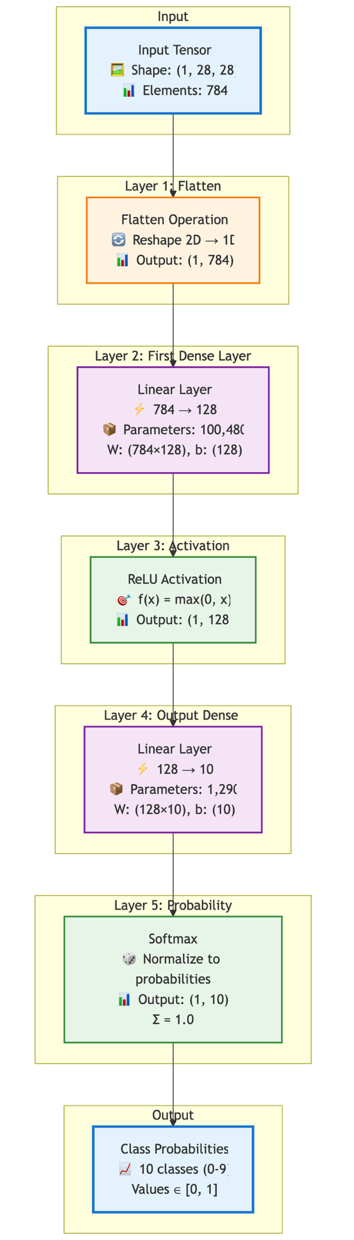
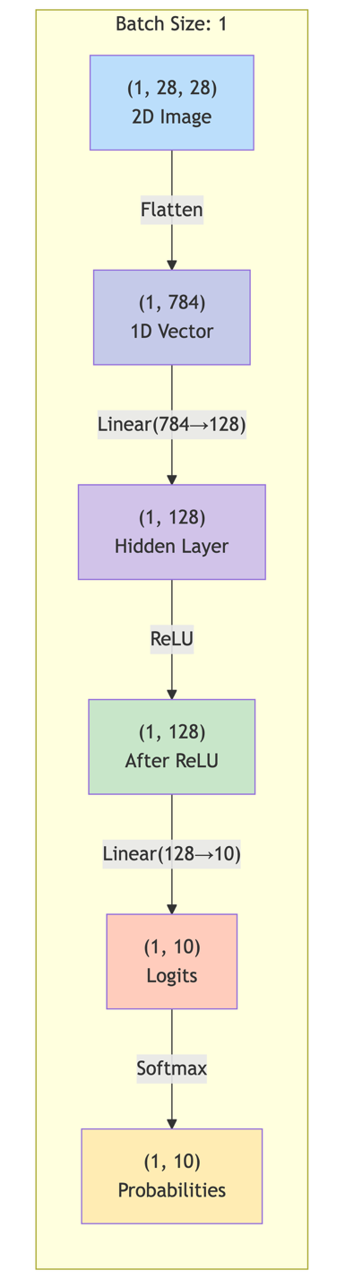
Architecture Flow
Tensor Shape Transformations
Network layer stack and Layer operations shown below:
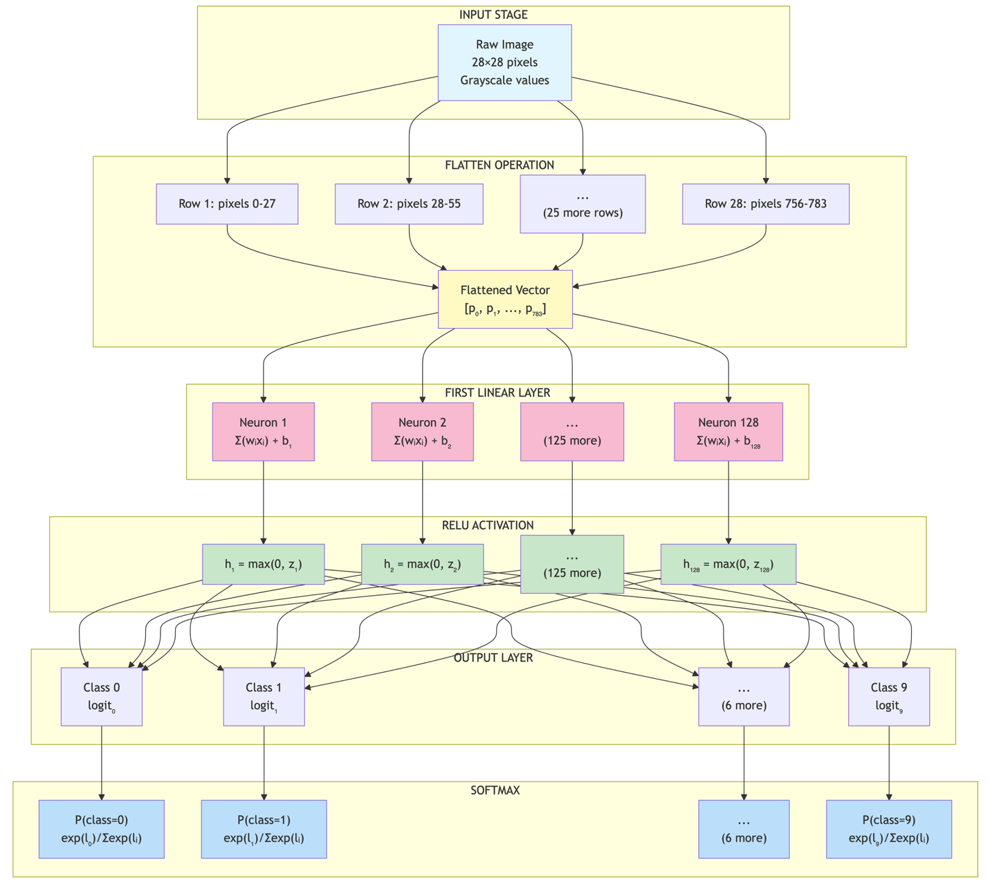
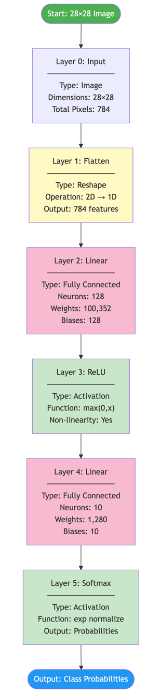

Information Flow with Dimensions shown below:

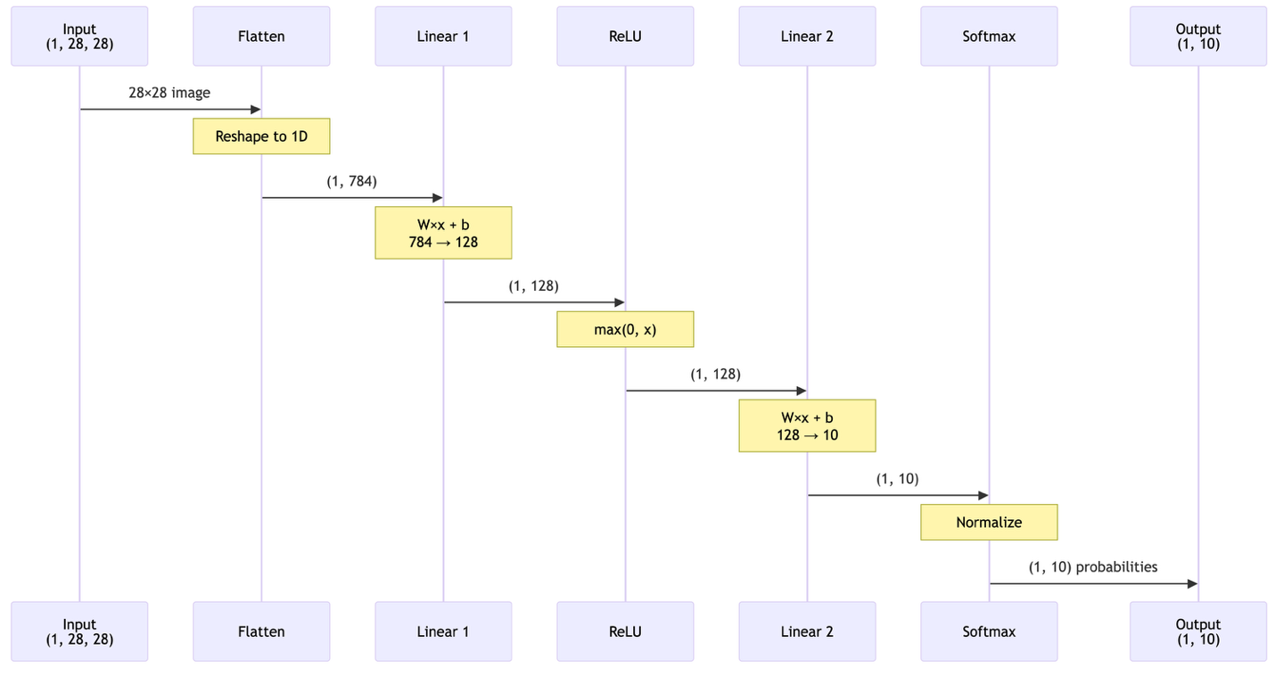

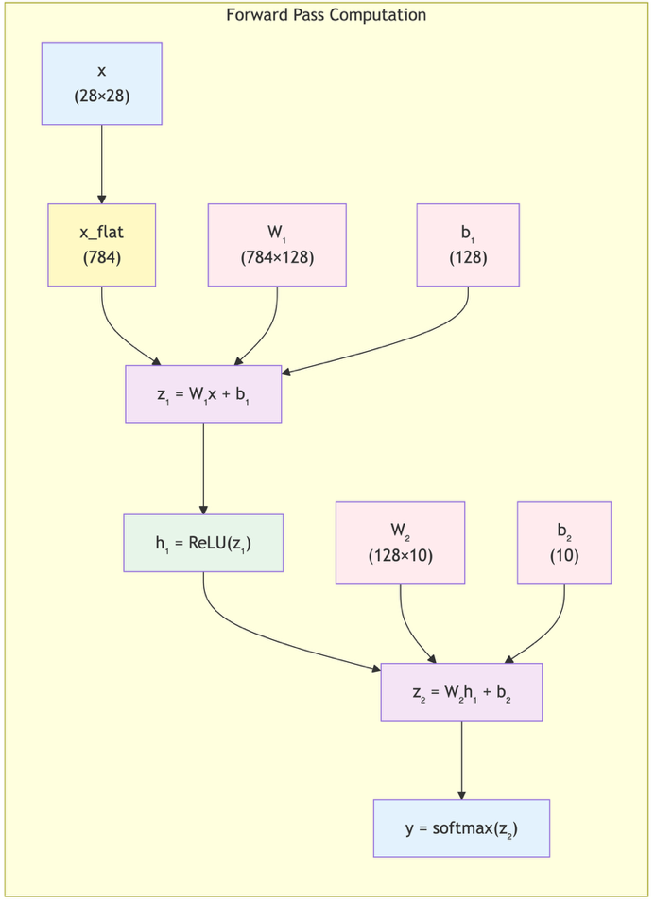
Computation Graph shown below:

Summary Table
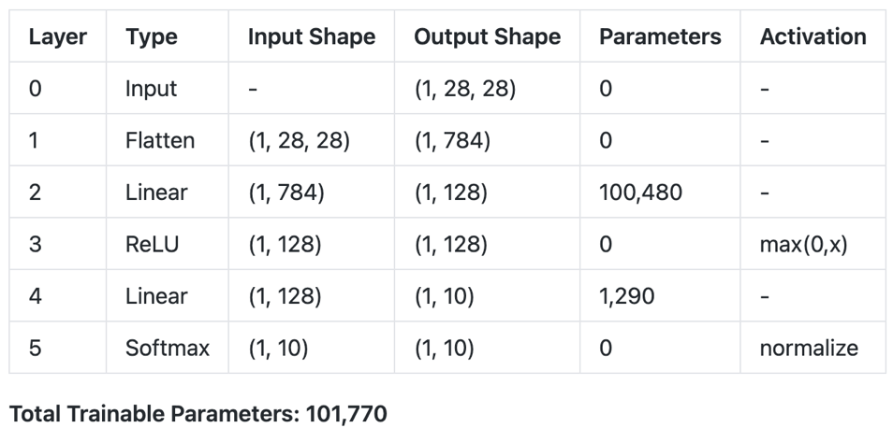

Equations for the Example Network

Layer 2 (First linear)

$z_{1}=W_{1}∙x_{flat}+b_{1}$ where $W_{1}∈R^{128×784}$, $b_{1}∈R^{128}$

For more details see PyTorch docs on nn.Sequential.

